
School of Mathematics Applied Statistics & Analytics
DEPARTMENT OF STATISTICS
M.Sc. Statistics and Data Science
Application of
Exponential-Gamma (3,$θ$) Distribution
in epidemiology

Group number-7

Linette Correia - 86062200009
Maaz Attar - 86062200022
Angela Job - 86062200028
Rohit Fuke - 86062200035
Fiza Dalwai - 86062200051

Project Mentor
DR. K S MADHAV RAO

ACKNOWLEDGMENT

We, the students of NMIMS SOMASA, Department of MSc Statistics and Data Science, Semester 1, acknowledge our gratitude to all the individuals associated with this project.
First of all, we would like to pay our respect to our mentor, Dr. KSM Rao, who has guided us and provided us with loads of knowledge, inspiration, and motivation throughout the course of the project. It would not have been possible for us to complete the same without his sincere and affectionate help.
Secondly, we would like to thank our RT professor, Dr. Pradnya Khandeparkar, for guiding us and keeping us motivated from the start till the end of this project. We would also like to extend our gratitude to our Dean, Dr. Sushil Kulkarni, for giving us an opportunity to work on such projects.
Next, we would like to thank SVKM's Library for allowing us to access the portal through which we got the required research papers, datasets, and study material needed for the project.
Lastly, we thank our faculty, parents, and friends who contributed to some extent to complete the same.

TABLE OF CONTENTS:

Sr.no | Topic | Page no.
1 | Motivation | 4
2 | Introduction | 5
3 | Objectives | 6
4 | Literature review | 7
5 | Statistical Term | 9
6 | Statistical Measures and Properties | 11
7 | Dataset and Description of the Dataset | 14
8 | Analysis | 16
9 | Results | 18
10 | Conclusions | 20
11 | References | 21

MOTIVATION:
Statistical distributions are commonly applied to describe real world phenomena. Due to the usefulness of statistical distributions, their theory is widely studied, and new distributions are developed. The quest for developing more efficient and flexible probability distribution remains strong in the field of probability theory and statistics. The obvious reason for generalizing a standard distribution is because as our world is changing dramatically, the available problems are also changing. Often with a known distribution it may not be easy to model the data, that’s why to capture more complex data we need generalizations of probability distributions. The generalized form in most cases provides greater efficiency and flexibility in modelling real life data. In this project, we study a new probability distribution called Exponential-Gamma distribution, its statistical properties and application of it with real life data sets. The aim of this project is to examine the adequacy and performance of this new distribution with some related existing distributions (such as Exponential Distribution and Exponentiated exponential distribution) using the survival data of the patients due to lung cancer.

INTRODUCTION:
The exponential and gamma are well known probability distributions used for modeling lifetime data. Both distributions possess some interesting structural properties, for example, exponential distribution possesses memory less and constant hazard rate properties. Moreover, as a special case of the gamma distribution, the exponential distribution can be used in modelling time-to-event data or modelling waiting times. Various extensions of both distributions can be obtained in the literature for describing the uncertainty behind real life phenomena arising in the area of survival modelling and reliability engineering.
But one major disadvantage of the gamma distribution is that the distribution function or survival function cannot be expressed in a closed-form. This makes the Gamma distribution a little bit unpopular as compared to the Exponential distribution whose survival functions and hazard functions are simple and easy to study. As a result, the distribution has been generalized, modified and mixed with other density functions to give more flexible density functions and to facilitate better modeling.
The introduction of new lifetime distributions or modified lifetime distributions has become a time-honoured fashion in statistical and biomedical research. Finite mixture distributions arising from the standard distributions play, in most situations, a better role in modelling real-life phenomena as compared to the standard ones. Their mathematical properties are widely studied and used on applied sciences’ experimental datasets. So, to obtain a more flexible density function, this project is aimed at deriving a new lifetime distribution which is a mixture of Exponential and Gamma distribution with shape parameter 3.

OBJECTIVES:

- To study and discuss the Exponential-Gamma (3, 𝜃) distribution.
- To study the goodness-of-fit of the Exponential –Gamma distribution and its application to real-life datasets.
- Compare the Exponential-Gamma (3, 𝜃) distribution with Exponential Distribution and Exponential-Exponential distribution.

LITERATURE REVIEW

- Exponential-Gamma (𝟑, 𝜽) Distribution and its Applications

Author: - Beenu Thomas & V M Chacko
Link: -https://www.researchgate.net/publication/358743397
Description: - This paper studies a distribution, which is a mixture of Exponential and Gamma (3) distribution, which has a bathtub shaped failure rate function. Moments, skewness, kurtosis, moment generating function, characteristic function are derived. Renyi entropy, Lorenz curve and Gini index are obtained. Reliability of stress-strength model is derived. Distribution of maximum and minimum order statistics are obtained. A simulation study is conducted to illustrate the performance of the accuracy of the estimation method used. This distribution is analysed on two real life data sets, to examine its performance it is compared with 2 other distributions namely exponential distribution and exponentiated exponential distribution. The method of maximum likelihood was used to estimate the parameters of the distributions. We compared the distributions using the criteria for selecting the best model fit such as log-likelihood function, Kolmogorov-smirnov test, Akaike information criterion (AIC), Bayesian information criterion (BIC), P-value ,and PP-plot. From the results obtained, it was observed that the Exponential-Gamma(3,Ɵ) distribution is effective in providing better fits than the Exponential and Exponentiated Exponential distribution ;this indicated that the Exponential- Gamma(3,Ɵ) distribution is more tractable and flexible in modeling and analyzing the lifetime data.

- The xgamma Distribution-Statistical Properties and Application

Author: - Subhradev Sen, Sudhansu S. Maiti, N. Chandra
Link:https://digitalcommons.wayne.edu/cgi/viewcontent.cgi?article=1916&context=jmasm
Description: - A new probability distribution, the xgamma distribution, is proposed and studied. The distribution is generated as a special finite mixture of exponential and gamma distributions and hence the name proposed. Various mathematical, structural, and survival properties of the xgamma distribution are derived, and it is found that in many cases the xgamma has more flexibility than the exponential distribution. To evaluate the comparative behavior, stochastic ordering of the distribution is studied. To estimate the model parameter, the method of moment and the method of maximum likelihood estimation are proposed. A simulation algorithm to generate random samples from the xgamma distribution is indicated along with a simulation study. A real life dataset on the remission times of patients receiving an analgesic is analysed. We compared the distributions using the criteria for selecting the best model fit such as log-likelihood function, Akaike information criterion (AIC), consistent Akaike information criteria(AICc),Bayesian information criterion (BIC) and it is found that the xgamma model provides better fit to the data as compared to the exponential model.

- Exponentiated Exponential Family: An Alternative to Gamma and Weibull Distributions

Author: - Rameshwar D. Gupta* & Debasis Kundu
Link: - https://home.iitk.ac.in/~kundu/paper59
Description: - In this paper we consider a two-parameter Exponentiated exponential distribution and study some of its properties. This distribution is quite similar in nature to Weibull or gamma distributions. The main aim of this paper is to introduce a new family of distributions and make comments both positive and negative of this family with respect to a Weibull family and a gamma family and give the practitioner one more option, with a hope that it may have a ‘better fit’ compared to a Weibull family or a gamma family in certain situations. In this paper the properties of Weibull and gamma distributions are compared with newly introduced Exponentiated exponential distribution. The maximum likelihood estimators and their asymptotic properties have been discussed. This paper analyses two uncensored data sets and fit the three models namely; gamma, Weibull and Exponentiated Exponential. These distributions are compared by estimating the parameters, the Log-likelihood (LL), the observed and the expected values and the statistics. It is observed that in one data set EE has a better fit compared to Weibull or gamma but in the other the Weibull has a better fit than EE or gamma. Therefore, it is not guaranteed that the EE will always behave better than Weibull or gamma but at least it can be said in certain circumstances EE might work better than Weibull or gamma.

STATISTICAL TERMS:

Akaike information criterion (AIC)
The Akaike information criterion (AIC) is a mathematical method for evaluating how well a model fits the data. In statistics, AIC is most often used for model selection. By calculating and comparing the AIC scores of several possible models, you can choose the one that is the best fit for the data.
AIC determines the relative information value of the model using the maximum likelihood estimate and the number of parameters (independent variables) in the model. The formula for AIC is: AIC= 2k - 2ln(L)
Where, k is the number of independent variables used by default k is 2
L is the likelihood estimate

Bayesian Information Criterion (BIC)
The Bayesian Information Criterion (BIC) is an index used in Bayesian statistics to choose between two or more alternative models.
The Bayesian Information Criterion (BIC) is defined as, BIC=k ln(n)-2ln(L).
Here n is the sample size
k is the number of parameters which your model estimates
L is the likelihood estimate

Kolmogorov-Smirnov Goodness of Fit Test (K-S test)
The Kolmogorov-Smirnov Goodness of Fit Test (K-S test) is a non-parametric goodness of fit test and is used to determine whether two distributions differ
i.e. its compares given data with a known distribution and lets us know if they have the same distribution.
The hypothesis for the test are:
- Null hypothesis (H₀): the data comes from the specified distribution.
- Alternate Hypothesis (H₁): at least one value does not match the specified distribution.

The empirical distribution Fn for n independent and identically distributed (i.i.d.) ordered observations Xi is defined as
$$F_{n}= \frac{Number of elements≤n}{n}$$
K-S Calculated: - $Dn =sup\sum_{i=0}^{n}{\left|Fn\left(x\right)-F\left(x\right)\right|}$
K-S Critical:- At level of significance i.e. $α=0.05$
Critical value = $\frac{1.36}{\sqrt{n}}$
Reject H₀ if, K-S Calculated $≥$ K-S Critical

P-P plot
In statistics, a P–P plot (probability–probability plot or percent–percent plot or P value plot) is a probability plot for assessing how closely two data sets agree, or for assessing how closely a dataset fits a particular model. This compares data using the empirical cumulative distribution function and cumulative distribution functions of probability distributions. A model which fits the data well should plot approximately as the y = x line.

STATISTICAL MEASURES AND PROPERTIES:
Exponential-Gamma (3, 𝜃) is a mixture of Exponential (𝜃) and Gamma (3, 𝜃) distributions which is denoted as EGD($θ$).
Let us study the statistical measures and properties of Exponential-Gamma (3, 𝜃) Distribution:
PDF | $$f\left(x,θ\right)=\frac{θ^{2}}{1+θ} \left[1+\frac{θ}{2} x^{2}\right]e^{-θx} , x>0, θ>0$$
CDF | $$F\left(x,θ\right)=1-\frac{\left(θ\left(x\left(θx+2\right)+2\right)+2\right)e^{-θx}}{2\left(1+θ\right)} , x>0, θ>0$$
MOMENTS | $$μ_{r}^{'}=\frac{2θr!+γ\left(r+3\right)}{2\left(1+θ\right)θ^{r}}$$
MEAN | $$μ=\frac{θ+3}{θ\left(1+θ\right)}$$
VARIANCE | $$σ^{2}=\frac{θ^{2}+8θ+3}{θ^{2}{\left(1+θ\right)}^{2}}$$
SURVIVAL FUNCTION | $$\overline{F}\left(x,θ\right)=1-F\left(x,θ\right)=\frac{\left(θ\left(x\left(θx+2\right)+2\right)+2\right)e^{-θx}}{2\left(1+θ\right)} , x>0, θ>0$$
FAILURE FUNCTION | $$h\left(x\right)=\frac{f\left(x,θ\right)}{\overline{F}\left(x,θ\right)}=\frac{2\left(1+θ\right)θ^{2}\left(1+\frac{θx^{2}}{2}\right)}{\left(θ\left(x\left(θx+2\right)+2\right)+2\right)} , x>0, θ>0$$
MEDIAN | $$\left(θ\left(x\left(θx+2\right)+2\right)+2\right)e^{-θx}=1+θ$$  $x_{0.5}$ is the solution of above monotone increasing function
MODE | $$x_{o}=\frac{1±\sqrt{1-\frac{θ}{2}}}{θ}$$
MGF | $$M_{X}\left(t\right)=\frac{θ^{2}}{1+θ}\left[-\frac{{\left(t-θ\right)}^{2}+θ}{{\left(t-θ\right)}^{3}}\right]$$
CGF | $$ϕ\left(t\right)= \frac{θ^{2}}{1+θ}\left[-\frac{{\left(it-θ\right)}^{2}+θ}{{\left(it-θ\right)}^{3}}\right]$$
SKEWNESS | $$\frac{2θ^{3}+30θ^{2}-63θ+16}{θ^{2}+8θ+3}$$
KURTOSIS | $$\frac{9θ^{4}+192θ^{3}+306θ^{2}+216θ+45}{{\left( θ^{2}+8θ+3\right)}^{2}}$$
LIKELIHOOD | $$L=\prod_{i=1}^{n}{f\left(x_{i};θ\right)= \prod_{i=1}^{n}{\frac{θ^{2}\left(1+\frac{θ}{2}x_{i}^{2}\right)e^{-θx_{i}}}{1+θ}}}$$
LOG-LIKELIHOOD | $$logL\left(x_{i},θ\right)=2nlogθ-nlog\left(1+θ\right)+\sum_{i=1}^{n}{\left[\log\left(1+\frac{θ}{2}x_{i}^{2}\right)-θx_{i}\right]}$$
FISHER INFORMATION | $$I\left(θ\right)=E\left\{-\frac{∂^{2}}{∂θ^{2}}\ln{f\left(X;θ\right)}\right\}= \frac{2}{θ^{2}}-\frac{1}{{\left(1+θ\right)}^{2}}+E\left\{\frac{x^{4}}{4}\frac{1}{{\left(1+\frac{θ}{2}x^{2}\right)}^{2}}\right\}$$

The solution of the parameter can be obtained either by numerical iterative methods using R software such as Newton Raphson method, Fisher's score function, etc and manually by Method of Moments

TO ESTIMATE θ USING METHOD OF MOMENTS:
E(X)=$\frac{θ+3}{θ(1+θ)}$
Sample mean=$\overline{x}$
$$\overline{x}=\frac{θ+3}{θ(1+θ)}$$
$$\overline{x}θ\left(1+θ\right)=θ+3$$
$$\overline{x}θ^{2}+\overline{x}θ-θ-3=0$$
$$\overline{x}θ^{2}+\left( \overline{x}-1\right)θ-3=0$$
$$Here a = \overline{x}, b=\overline{x}-1 , c=-3$$
$$by using formula \hat{θ}= \frac{-b± \sqrt{b^{2}-4ac }}{2a}$$
$$\hat{θ}= \frac{-(\overline{x}-1)± \sqrt{{(\overline{x}-1)}^{2}-4\overline{x}(-3) }}{2\overline{x}}$$
$$\hat{θ}= \frac{-(\overline{x}-1)± \sqrt{{(\overline{x}-1)}^{2}+12\overline{x} }}{2\overline{x}}$$
$$as θ>0 we take \hat{θ}= \frac{-\left(\overline{x}-1\right)+\sqrt{{\left(\overline{x}-1\right)}^{2}+12\overline{x}}}{2\overline{x}}$$
$$as negative term give θ<0$$

DATASET AND DESCRIPTION OF THE DATASET:

DATASET: - Lung-Survival Dataset from Kaggle

LINK: - https://www.kaggle.com/datasets/aysuncag/covid19-survival-dataset

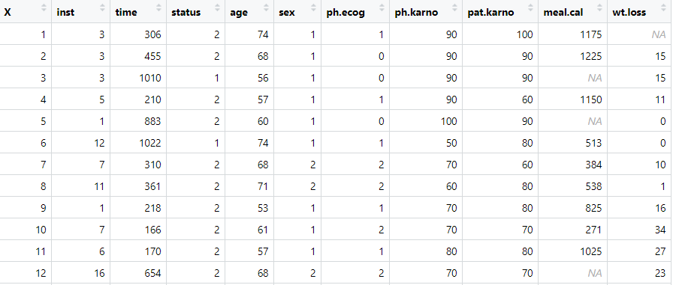
Variables of the Data:
- inst: Institution code
- time: Survival time in days
- status: Censoring status -> 1=Censored 2=Dead
- age: Age in years
- sex: Male=1 Female=2
- meal.cal: Calories consumed at meals
- wt.loss: Weight loss in last six months
The ECOG performance status is a scale used to assess how a patient's disease is progressing, assess how the disease affects the daily living abilities of the patient, and determine appropriate treatment and prognosis. It ranges from 0 to 5. A lower score means the patient is better able to carry out daily activities.
- ph.ecog: Ecog performance score -> 0=Good 5=Dead
Karnofsky Performance Status is a standard way of measuring the ability of cancer patients to perform ordinary tasks. It ranges from 0 to 100. A higher score means the patient is better able to carry out daily activities.
- ph.karno: Karnofsky performance score as rated by physician -> Bad=0 Good=100
- pat.karno: Karnofsky performance score as rated by patients -> Bad=0 Good=100

For our analysis we are interested only in Time column which tells us survival days of lung cancer patients and to get status of the patients we also see the status column which tells us Censoring status in which 1=Censored and 2=Dead.
Description: - The lung survival data consists of 228 patients' survival days with no missing values. Here 63 patients have status=1 which means they are cured i.e. they are alive or are out of the study due to some reason and 165 patients died due to lung cancer.
Here we are interested in the survival days of patients before they died. So, we created a dataset named dead in which we examine survival days of 165 patients who died due to lung cancer. Where the minimum survival days of lung cancer patients is 5 days and maximum survival of lung cancer patients is 883 days.

ANALYSIS

The data is on time (in days) of 165 lung cancer patients survived after discovering cancer.
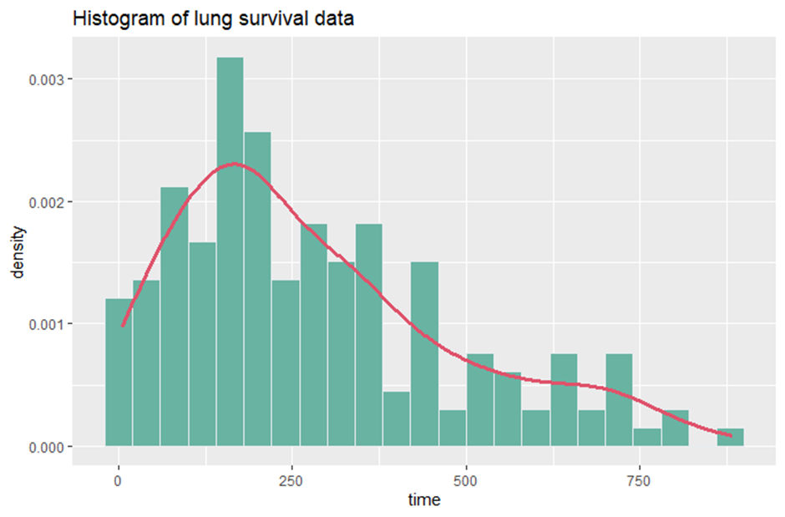
From the graph we observe that initially the lung survival data follows an exponential distribution and then it follows a gamma distribution ie it seems to follow an Exponential – Gamma distribution.
To check whether the data follows exponential- gamma distribution, we use the K-S statistics
Hypothesis:
H₀: the data comes from the exponential - gamma distribution.
v/s
H₁: at least one value does not match the exponential - gamma distribution.
Test Statistic:
K-S Calculated =0.10015, K- S Critical =0.105876
Conclusion:
Since K-S Calculated < K- S Critical, do not reject Ho and conclude that the data comes from exponential- gamma distribution.

Now let’s find some summary statistics related to this distribution
SUMMARY OF DATA
MEAN | 275.6372
VARIANCE | 25869.3676
SKEWNESS ($β_{1}$) | 4.964320
KURTOSIS ($β_{2}$) | 4.9722
MIN | 5
MAX | 883

Since, $β_{1}>0$,this implies that the distribution is postively skewed.
Also $β_{2}>3$, this implies that the distribution is leptokurtic.
Comparing Exponential, Exponentiated-Exponential and Exponential-Gamma(3,$θ$) distributions to check which provides a better fit to the data
The parameter $θ$ is obtained by an iterative method called Newton Raphson method using R software and also manually by Method of Moments. The Kolmogorov-Smirnov test is used to test whether this sample come from a specific distribution. The model selection is carried out using log-likelihood value, AIC(Akaike information criterion) and BIC(Bayesian information criterion). P-P plot is used to see how closely a dataset fits a particular model.

RESULTS

Distributions | Maximum Likelihood Estimator | K-S Calculated | K-S Critical
Exponential(θ) | $\hat{θ}=$0.003533 | 0.1402398 | 0.105876
Exponentiated-Exponential(α,β) | $\hat{α}=$1.65933  $\hat{β}=$0.004783 | 0.06017263 | 0.105876
Exponential-Gamma(3,θ) | $\hat{θ}=$0.0108063 | 0.10015 | 0.105876

Hypothesis:
H₀: the data comes from the specified distribution.
v/s
H₁: at least one value does not match the specified distribution.
Conclusion:
- For Exponential:
K-S Calculated > K-S Critical
Hence, we reject $H_{0}$ and conclude that at least one value does not match Exponential distribution.
- For Exponentiated - Exponential:
K-S Calculated < K-S Critical
Hence, we do not reject $H_{0}$ and conclude that the data comes from Exponentiated - Exponential distribution.
- For Exponential – Gamma($3,θ$):
K-S Calculated < K-S Critical
Hence, we do not reject $H_{0}$ and conclude that the data comes from Exponential – Gamma($3,θ$) distribution.
From the above test we conclude that the data follows Exponential – Gamma($3,θ$) as well as Exponentiated – Exponential distribution.

So now to check which one of the above two distributions fits the data best we make use of the model selection criteria
Distributions | Log -Likelihood | AIC | BIC
Exponentiated-Exponential(α,β) | -1087.905 | 2179.809 | 2186.021
Exponential-Gamma(3,θ) | -1074.336 | 2150.673 | 2153.76

Lower the score of log likelihood, AIC and BIC, the better the model fits the data
From the above table we can observe that Exponential-Gamma has the lowest score in all the three criteria. Hence, Exponential-Gamma provides the best fit to the data.

P-P Plot

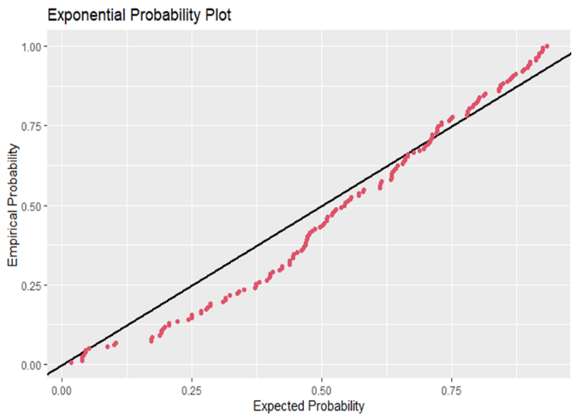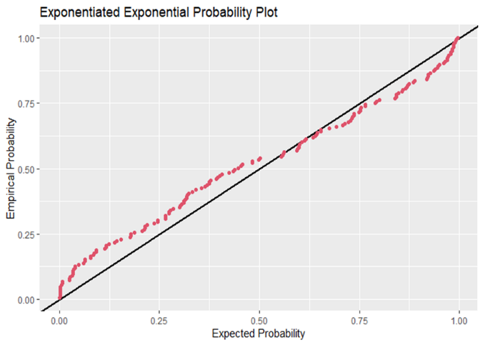
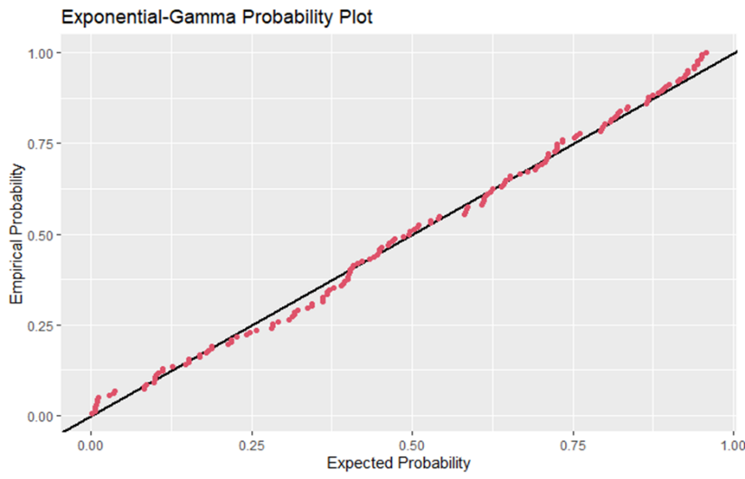
From the above plots, we observe that, the points lie very close to the reference line for Exponential- Gamma Distribution. Hence, Exponential- Gamma(3, 𝜃) Distribution provides a better fit than Exponential distribution and Exponentiated-Exponential distribution.
CONCULSION
Exponential-Gamma (3, 𝜃) distribution is considered, and its properties are studied. The parameter theta is obtained by method of maximum likelihood estimator. Maximum Likelihood Estimator was obtained by Newton –Raphson Iterative method and was verified using Method of Moments. Applications of Exponential-Gamma (3, 𝜃) distribution to real data show that Exponential-Gamma (3, 𝜃) distribution is effective in providing better fits than the Exponential and Exponentiated Exponential distribution. Kolmogrov-Smirinov test was also carried out and in the test, the hypothesis that the data belongs to Exponential-Gamma(3, 𝜃) was accepted moreover through AIC & BIC values of Exponential-Gamma(3, 𝜃) shows that it has the better fit among other two distributions. PP plot of Exponential-Gamma(3, 𝜃) indicates that data follow this particular distribution and while comparing with other two distribution Exponential-Gamma(3, 𝜃) provides better fit.

REFERENCES

https://digitalcommons.wayne.edu/cgi/viewcontent.cgi?article=1916&context=jmasm
https://www.researchgate.net/publication/358743397
https://home.iitk.ac.in/~kundu/paper59
https://www.statisticshowto.com/kolmogorov-smirnov-test/
https://en.wikipedia.org/wiki/Akaike_information_criterion
https://en.wikipedia.org/wiki/Bayesian_information_criterion
https://en.wikipedia.org/wiki/P%E2%80%93P_plot

