  - FORMAL DASHBOARD AND MODEL REPORT

Real Estate Portfolio
Intelligence Dashboard
  - Revised decision logic, financial methods, data provenance, graphs and interpretation

Report basis | Details
Prepared for | Rohen
Snapshot date | 2026-09-24
Model | economic-model-0.9.0
Coverage | All 15 dashboard tabs; 28 explanatory figures
Asset population | 10 fictional Singapore demonstration assets
Economic evidence | Official aggregate market context; synthetic/proxy asset underwriting
Publication | All-tab saved public dashboard plus a separately deployable calculation API
Report version | 2.0 — revised cashflows, risk, scheduling and evidence controls

Principal conclusion The revised model provides a more consistent comparison of retaining, improving and selling assets. Its numerical results remain conditional on fictional asset data and unvalidated action assumptions. No graph in this report demonstrates realised investment performance or proven market alpha.
All amounts are in Singapore dollars. “m” means S$ million. Current value, cash proceeds, annual NOI, incremental NPV, CVaR and annual return measure different things and must not be added or compared as interchangeable quantities.

Contents and reading guide
Contents and reading guide 2
1. Executive interpretation 4
2. Evidence, provenance and data improvement 5
3. Complete dashboard guide: portfolio and asset views 6
3.1 Complete dashboard guide: model and portfolio decisions 7
Figure 1. Populated fields do not establish verified evidence 8
Figure 2. Core portfolio scale and current operating income 9
Figure 3. Standalone rankings and portfolio decisions differ 10
Figure 4. Official price and rental indices: latest available changes 11
Figure 5. Official sector paths rebased for comparison 12
Figure 6. Selection separates expected value, risk and unsupported alpha 13
Figure 7. Digital twin sector mix and generated economic scale 14
Figure 8. Environment recommendations and constrained twin allocations 15
Figure 9. Economic value and cash released are different quantities 16
Figure 10. Twin action uncertainty: DEMO-001, base environment 17
Figure 11. Simulation coverage and hindsight agreement test different things 18
Figure 12. Regret measures missed simulated opportunity; stability measures consistency 19
Figure 13. Planning capacity is a sequence of distinct screening quantities 20
Figure 14. Binding constraints and zoning display fixtures 21
Figure 15. Development envelope screening: DEMO-001 22
Figure 16. Monthly redevelopment economics versus Hold: DEMO-001 23
Figure 17. Full rebuilding cost and reconciled development debt 24
Figure 18. En-bloc residual value reconciles known costs, not unknown charges 25
Figure 19. Core Hold DCF: operating income and terminal value separated 26
Figure 20. Core action ranges and loss probability: DEMO-001 27
Figure 21. Stored core simulation draws: DEMO-001 28
Figure 22. Input correlation and realised scenario dependence 29
Figure 23. Capital scheduling and retained income in the core allocation 30
Figure 24. Joint portfolio risk must use aligned scenario outcomes 31
Figure 25. Two-stage scenarios connect commitments with funded recourse 32
Figure 26. Optimiser stability is sensitivity, not prediction accuracy 33
Figure 27. Forecast display examples reconcile; they are not a trained-model backtest 34
Figure 28. Model pathways, evidence gates and publication boundaries 35
4. Financial method: a common Hold counterfactual 36
5. Core risk: common scenarios and exact loss tails 37
6. Digital Twins: conditional environments and independent evaluation 38
7. Portfolio optimisation: timing, cash and joint downside 39
8. Two-stage recourse and stability 40
9. Planning, capacity and evidence limits 41
10. Advanced monthly development and financing 42
11. En-bloc residual and decision readiness 43
12. Forecast validation, possible alpha and what is not established 44
13. Architecture, hosting and governance 45
14. Revision summary and verification evidence 46
15. Asset register and current decision outputs 47
16. Sources, model files and reproducibility 48
16.1 Reproduction record and remaining limitations 49

Word refreshes this contents field when the document is opened or its fields are updated. The report first establishes the evidence and decision context, then explains each figure, and finally records financial formulas, optimisation assumptions, governance, sources and reproducibility.
Reader's objective | Recommended sequence
Understand the current conclusion | Executive interpretation → portfolio and environment figures → selection/readiness
Understand one asset | Asset/Evidence → Valuation/Actions/Scenario → Zoning/Development → Audit
Understand allocation | Standalone recommendations → portfolio constraints → joint risk → recourse → stability
Assess the evidence | Data provenance → Models/forecast diagnostics → limitations → source register

Each figure is reconstructed from the same saved JSON used by the public dashboard. These are publication figures, not screenshots. Their source, units, interpretation and limitations are given immediately beside the figure. A figure can consolidate more than one dashboard panel or add a reconciliation to make the underlying calculation easier to assess.

1. Executive interpretation
The core portfolio contains S$564.00m of proxy value and S$25.84m of annual proxy NOI. Its independent action ranking produces 8 Sell and 2 Hold. Every asset remains Data Required / Monitor because numerical ranking does not supply verified underwriting, planning evidence or observed investment outcomes.
Under the default portfolio constraints, the multi-period model selects 3 Sell and 7 Hold. Expected incremental NPV is S$9.95m; the positive-loss CVaR is S$20.03m and the penalised objective is S$3.94m. The cash released of S$167.70m is a separate funding measure, not the incremental benefit.
Twin portfolio measure | Base | Stress | Structural
Expected incremental NPV, S$m | 79.80 | 66.95 | 68.10
Committed construction, S$m | 0.00 | 0.00 | 0.00
Sale cash released, S$m | 420.79 | 267.30 | 367.57
Audited constraint violations | 0 | 0 | 0
Synthetic interval coverage | 74.0% | 78.0% | 76.0%

The Digital Twins path independently generates S$1,312.90m of value and S$57.18m of annual NOI. Its levels differ from the core proxies because the generator uses different areas, rents, expenses, yields and sector profiles. The difference is not wealth created by the new model, and the two portfolios must not be summed.
Decision interpretation The absence of selected construction projects in a particular solution is an economically possible response to the assumed capex, disruption, approval and required return. It is not evidence that redevelopment cannot work in Singapore. Equally, a Sell ranking is conditional on an assumed sale price relative to retained income; it is not a transaction recommendation for an identified real building.

2. Evidence, provenance and data improvement
Evidence layer | Current content | Interpretation
Public market context | Official Singapore sector indices; snapshot as of 2026-06-30 | Aggregate price/rent context with source and vintage metadata
Asset identities and locations | 10 DEMO assets and illustrative coordinates | Fictional, not a verified ownership or holdings list
Financial underwriting | Proxy core values and generated twin values/histories | 0% independently verified underwriting
Zoning and site geometry | Fixture labels and synthetic rectangles | No statutory entitlement or title-boundary conclusion
Core risk and twin outcomes | Model-generated common scenarios and separate synthetic evaluation | Assumption sensitivity, not realised outcomes
Forecast diagnostics | Arithmetic examples whose metrics reconcile to rows | No trained public forecast model or real historical accuracy

The former context-completeness label has been separated from verified provenance. There are 0 verified real portfolio anchors and 10 fictional asset contexts. Average populated-context coverage is 80.0%; it does not measure confidence, accuracy or verified information.
Source categories now map explicitly: Office to Commercial; Logistics/Warehouse/Industrial to Industrial; Hospitality to Hotel; Mixed use to a distinct Mixed Use profile. Unknown sectors become Other. This changes underwriting assumptions as well as labels and removes the earlier silent Residential fallback.
Official quarterly index observations improve the source quality of displayed market context. They are neither property appraisals nor an estimated alpha signal. Sector mapping, observation date, retrieval date, staleness and publication/revision limitations travel with the inputs. A current downloaded historical series does not establish what an investor knew at a past decision date.

3. Complete dashboard guide: portfolio and asset views
Tab | Purpose and controls | Interpretation rule
Portfolio | Search, country scope, open an asset; value/action/source summaries | Scope controls affect the visible population; provisional action does not override readiness
Digital Twins | Environment selector and asset/action filters; common scenario comparisons | Separate independently preferred actions from the constrained portfolio selections
Asset | Selected property's identity, economics, action and status | Check asset ID and financial basis before comparing another page
Evidence | Source records, missing fields, proxy inputs and verification requirements | Populated fields and source-record counts do not establish verification
Zoning | Map radius and polygon labels; capacity waterfall/ranges and sensitivity | Fixture map geometry is illustrative; capacity is a screening calculation
Zoning ML | Label comparison, discrepancy, illustrative confidence/change displays | No public trained classifier; fixture agreement is not classification accuracy
Development | 3D envelope, view context, en-bloc residual and monthly cashflows | Read feasibility and missing-cost blockers before any return number
Selection | Ranking, hurdle, diagnostic overlays and readiness gate | An internal preferred action can coexist with Data Required / Monitor

Opening a portfolio row sets the shared selected asset. Asset, Evidence, Zoning, Development, Selection, Valuation, Scenario, Actions and Audit follow that selection. List filters should not be confused with recalculating an individual property. Plotly hover and zoom expose numeric chart details; Word figures are static snapshots of those quantities.

3.1 Complete dashboard guide: model and portfolio decisions
Tab | Purpose and controls | Interpretation rule
Valuation | Annual NOI/terminal cashflow and present-value comparison | Terminal cash is already inside DCF; current value and DCF are alternative benchmarks
Scenario | Stored action draws, quantiles, loss probability, factor correlation and approval stages | P10–P90 is a central outcome interval, not an error bar on mean NPV
Actions | Five action means, downside, capital and execution periods | Negative sale capex is cash released; it does not mean construction subsidy
Optimiser | Multi-period allocation, two-stage recourse and assumption perturbation | Read saved/live mode, request settings, risk definition and constraint audit
Models | Forecast diagnostics and market-regime availability | Unavailable training or calibration is shown as unavailable, not as measured zero skill
Architecture | Evidence-to-decision, asset, portfolio and training/governance flows | A diagrammed component is not proof that its private inputs or trained artifact exist
Audit | Model/source identifiers, verification gates and review requirements | Gate codes are categorical status, not percentage confidence or approval likelihood

The public GitHub Pages build now exposes all tabs using saved API-shaped results. Its saved optimiser panels reflect the explicit default requests recorded in the snapshot. A browser filter can explore the saved data, but cannot invoke new Python calculations on GitHub Pages.
A hosted or locally running Python backend supports the calculation endpoints. The interface must identify that mode before enabling a new optimisation run. The static transport rejects POST calls and excludes private decision/review records. This report documents the snapshot and deployable backend capability; it does not assert that an unverified external service URL is live.

Figure 1. Populated fields do not establish verified evidence
  - Evidence and Audit
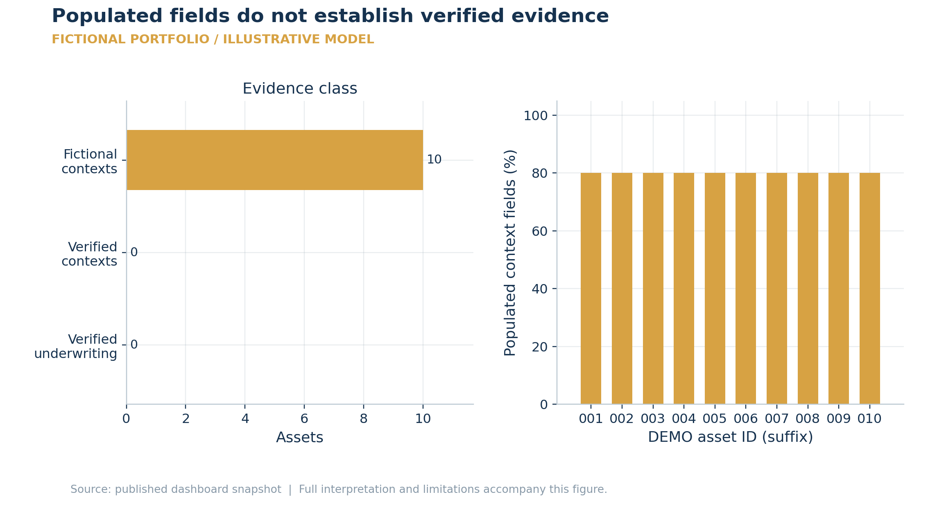
Units: Asset count; context completeness %. Source: digital_twin_dashboard.portfolio_summary and assets; /data/status. Reconstructed from saved data.
10 asset contexts are fictional and 0 have verified underwriting. Context completeness averages 80.0%; it measures populated fields, not truth, legal confirmation or financial verification.
Interpretation boundary Neither a model output nor a populated coordinate/title field upgrades a fictional input into observed evidence.

Figure 2. Core portfolio scale and current operating income
  - Portfolio and Asset
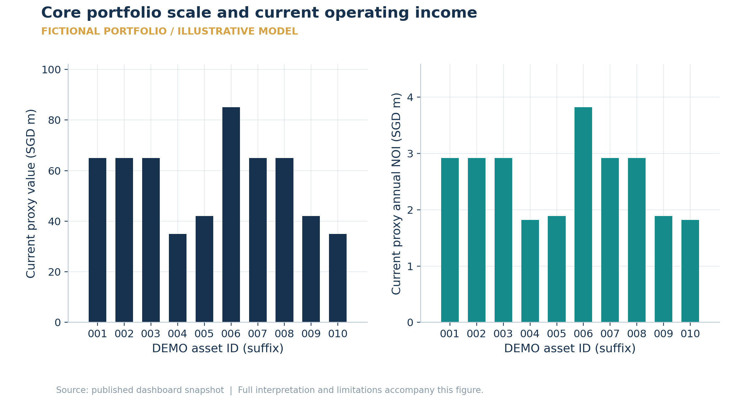
Units: SGD millions; annual NOI. Source: /assets/{id}.economics. Reconstructed from saved data.
The core proxy portfolio totals SGD 564.00m of current asset value and SGD 25.84m annual NOI, an aggregate operating yield of 4.6%. Asset values and recurring income are different quantities; these values do not include incremental action NPVs.
Interpretation boundary Core proxy and generated twin underwriting use different inputs; their portfolio totals are not interchangeable.

Figure 3. Standalone rankings and portfolio decisions differ
  - Portfolio
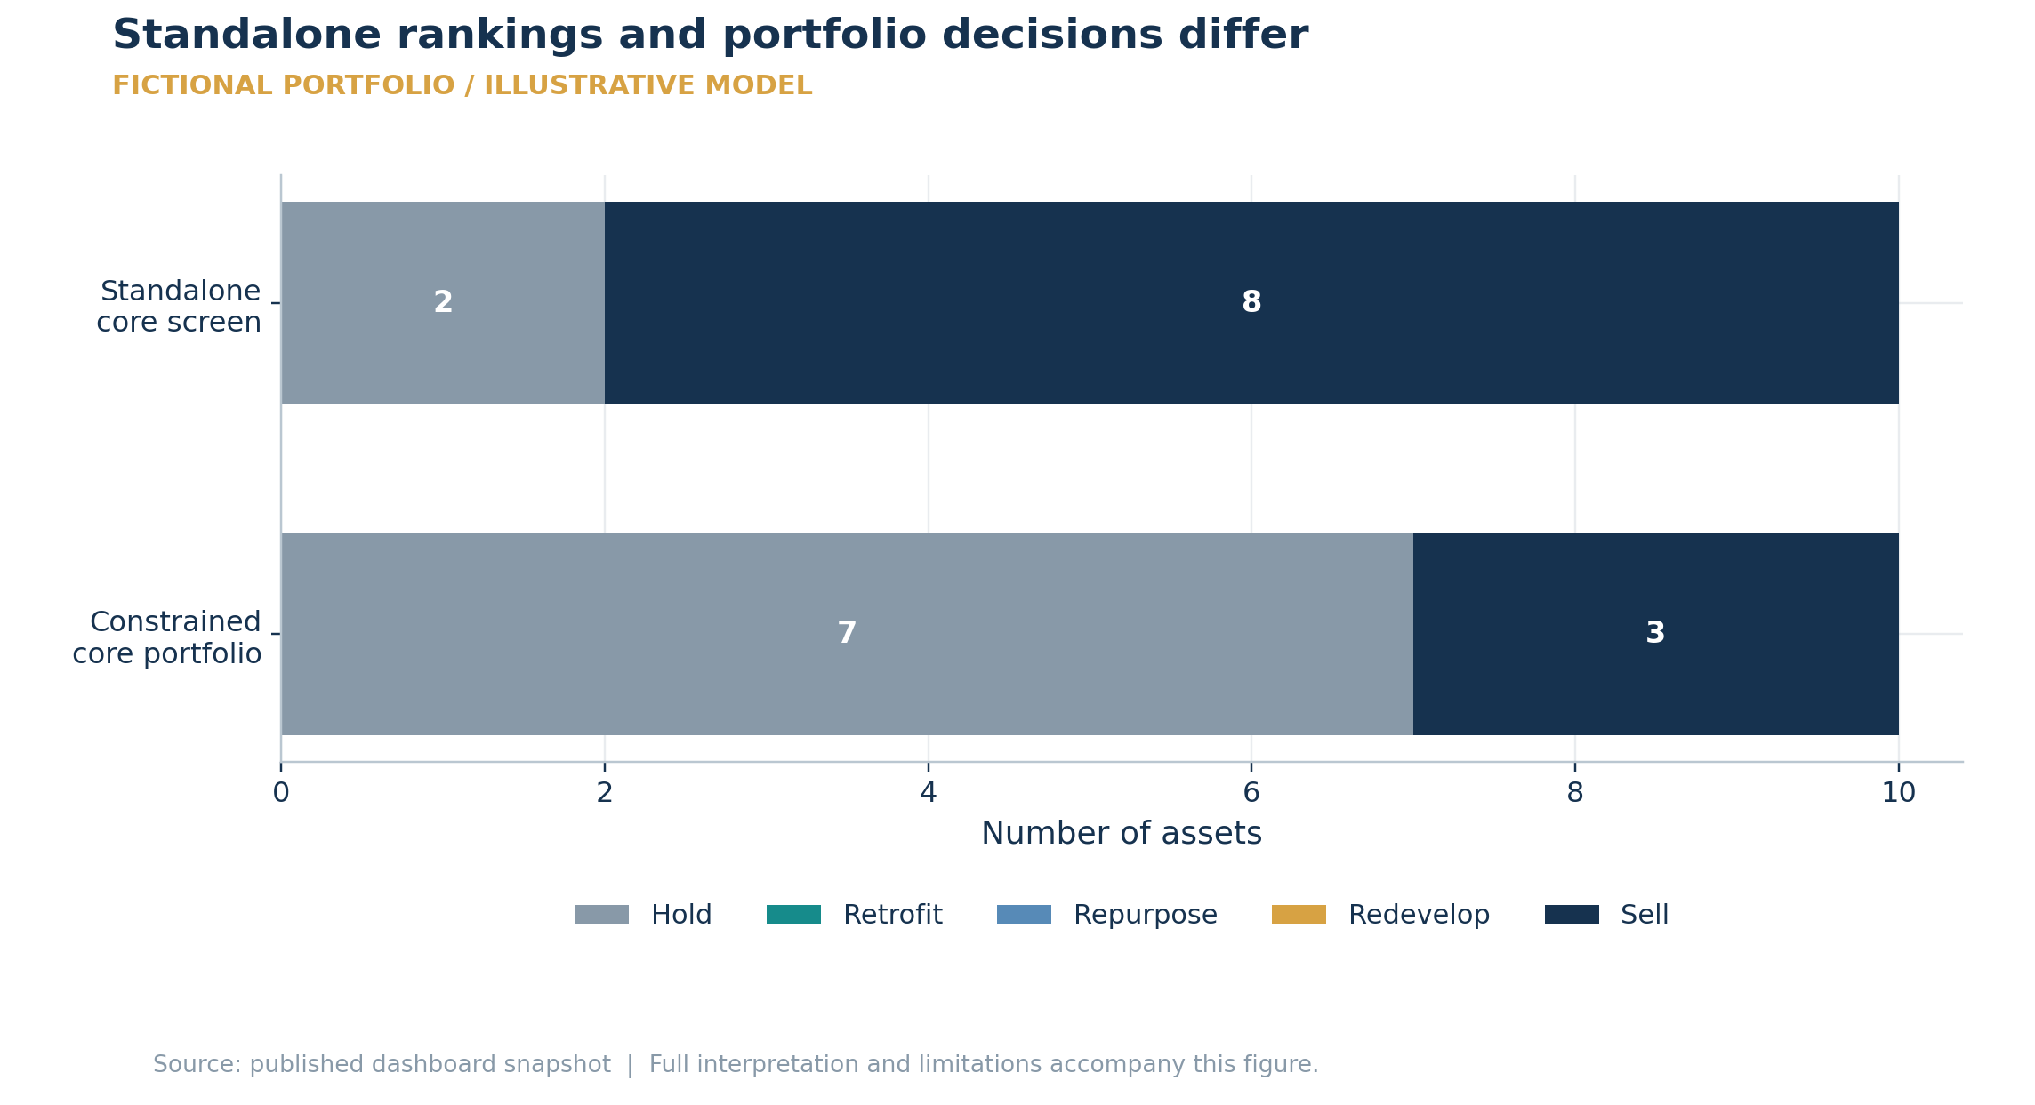
Units: Asset count. Source: /assets/{id}.recommendation; /snapshots/optimise.selections. Reconstructed from saved data.
Standalone recommendations contain 8 Sell and 2 Hold actions. The constrained plan contains 3 Sell and 7 Hold actions. Joint risk, income continuity and funding constrain the final allocation; the sum of independent recommendations is not itself an executable portfolio.
Interpretation boundary All ten assets remain subject to evidence verification. A preferred action is a provisional research ranking.

Figure 4. Official price and rental indices: latest available changes
  - Official Market Data
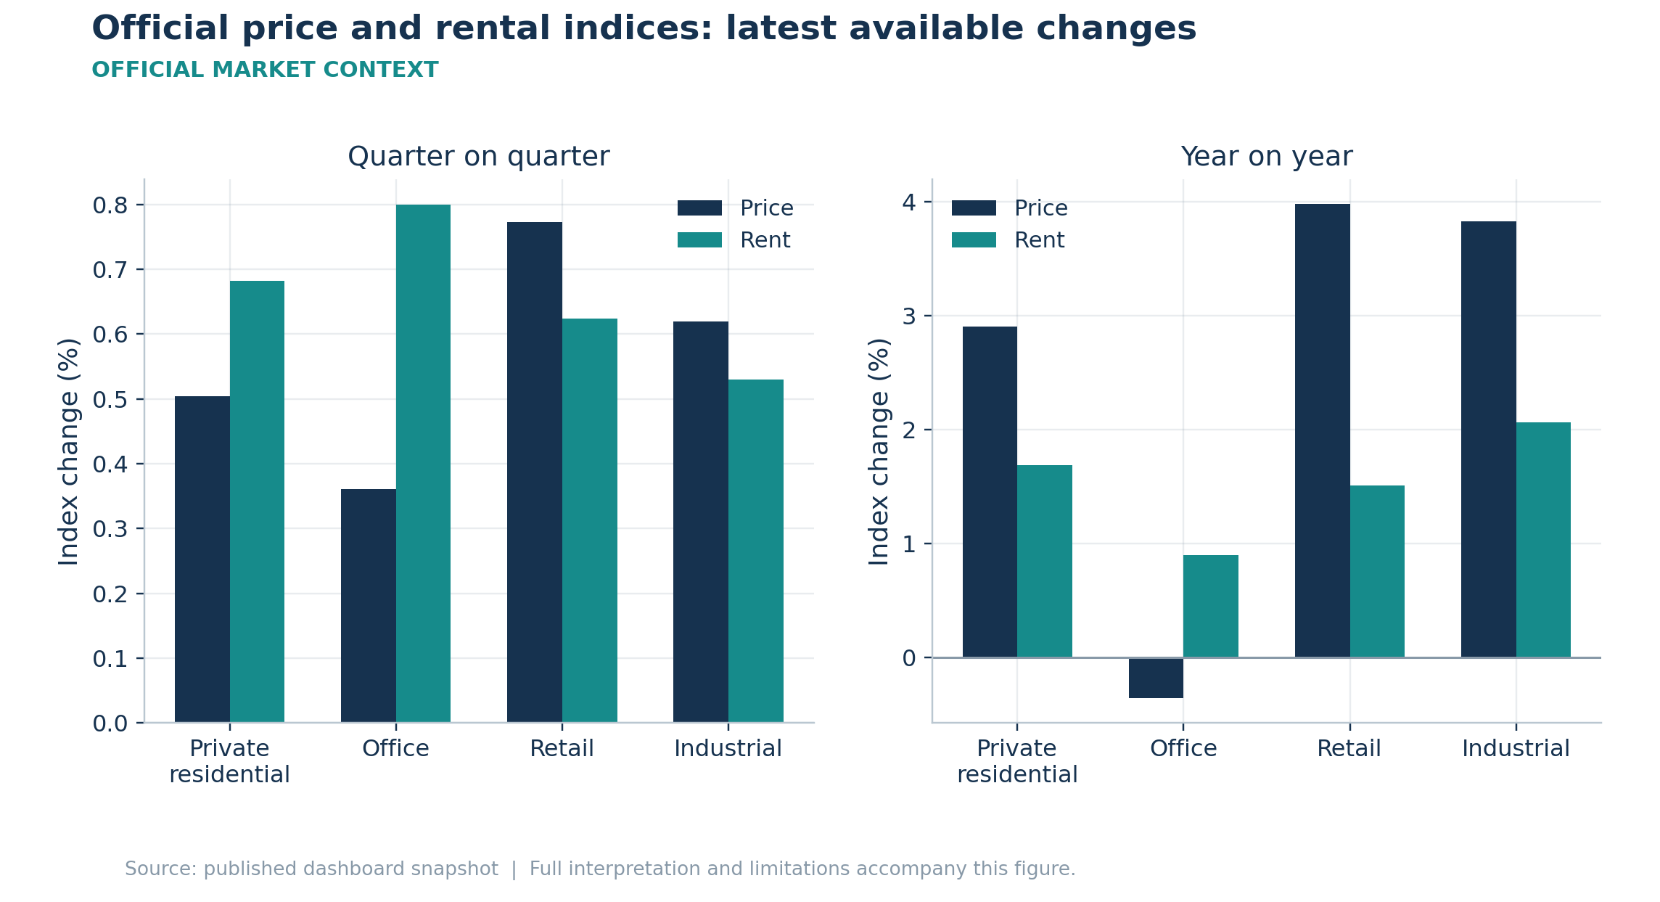
Units: Percentage change, quarterly and annual. Source: /market/public.market_indicators; official URA/JTC datasets via data.gov.sg. Reconstructed from saved data.
Latest price quarter-on-quarter movements are private residential +0.50%, office +0.36%, retail +0.77%, industrial +0.62%. Price and rental indices measure sector-level changes, not these assets. The latest snapshot period ends 2026-06-30; office and retail observations cover the Central Region.
Interpretation boundary Series can have different latest periods, are potentially revised and do not constitute asset-level forecasts or point-in-time backtests.

Figure 5. Official sector paths rebased for comparison
  - Official Market Data
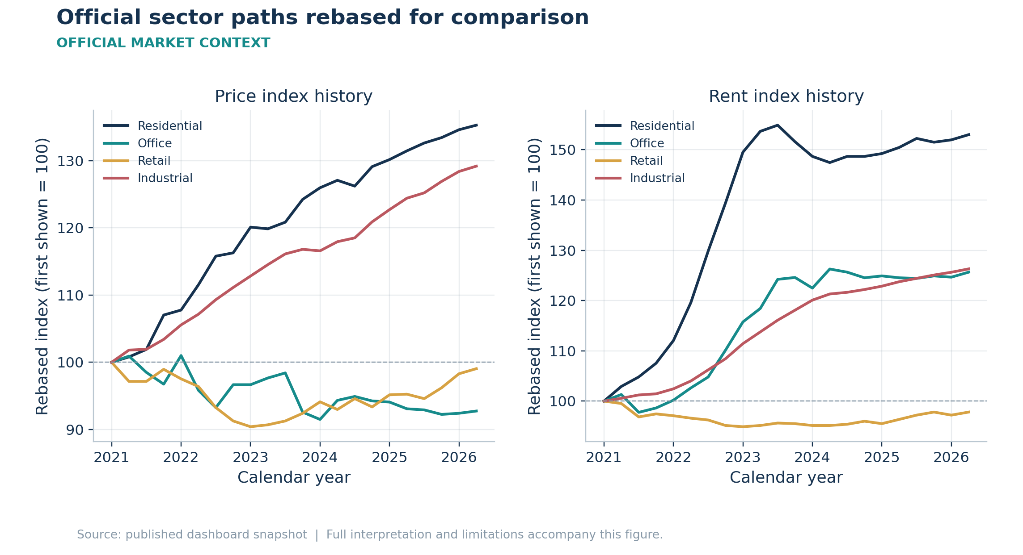
Units: Rebased index; calendar year. Source: /market/public.history. Reconstructed from saved data.
Each price or rent series is rebased to 100 at its first displayed observation from 2021 onward. A value of 120 means a 20% cumulative increase from that series-specific origin; different index bases have been removed so direction and relative movement can be compared. Divergent sector paths motivate separate underwriting assumptions rather than one market-wide growth rate.
Interpretation boundary Rebasing does not make geographic coverage, property mix or publication dates identical. Historical index growth is not a forecast of future asset returns.

Figure 6. Selection separates expected value, risk and unsupported alpha
  - Selection
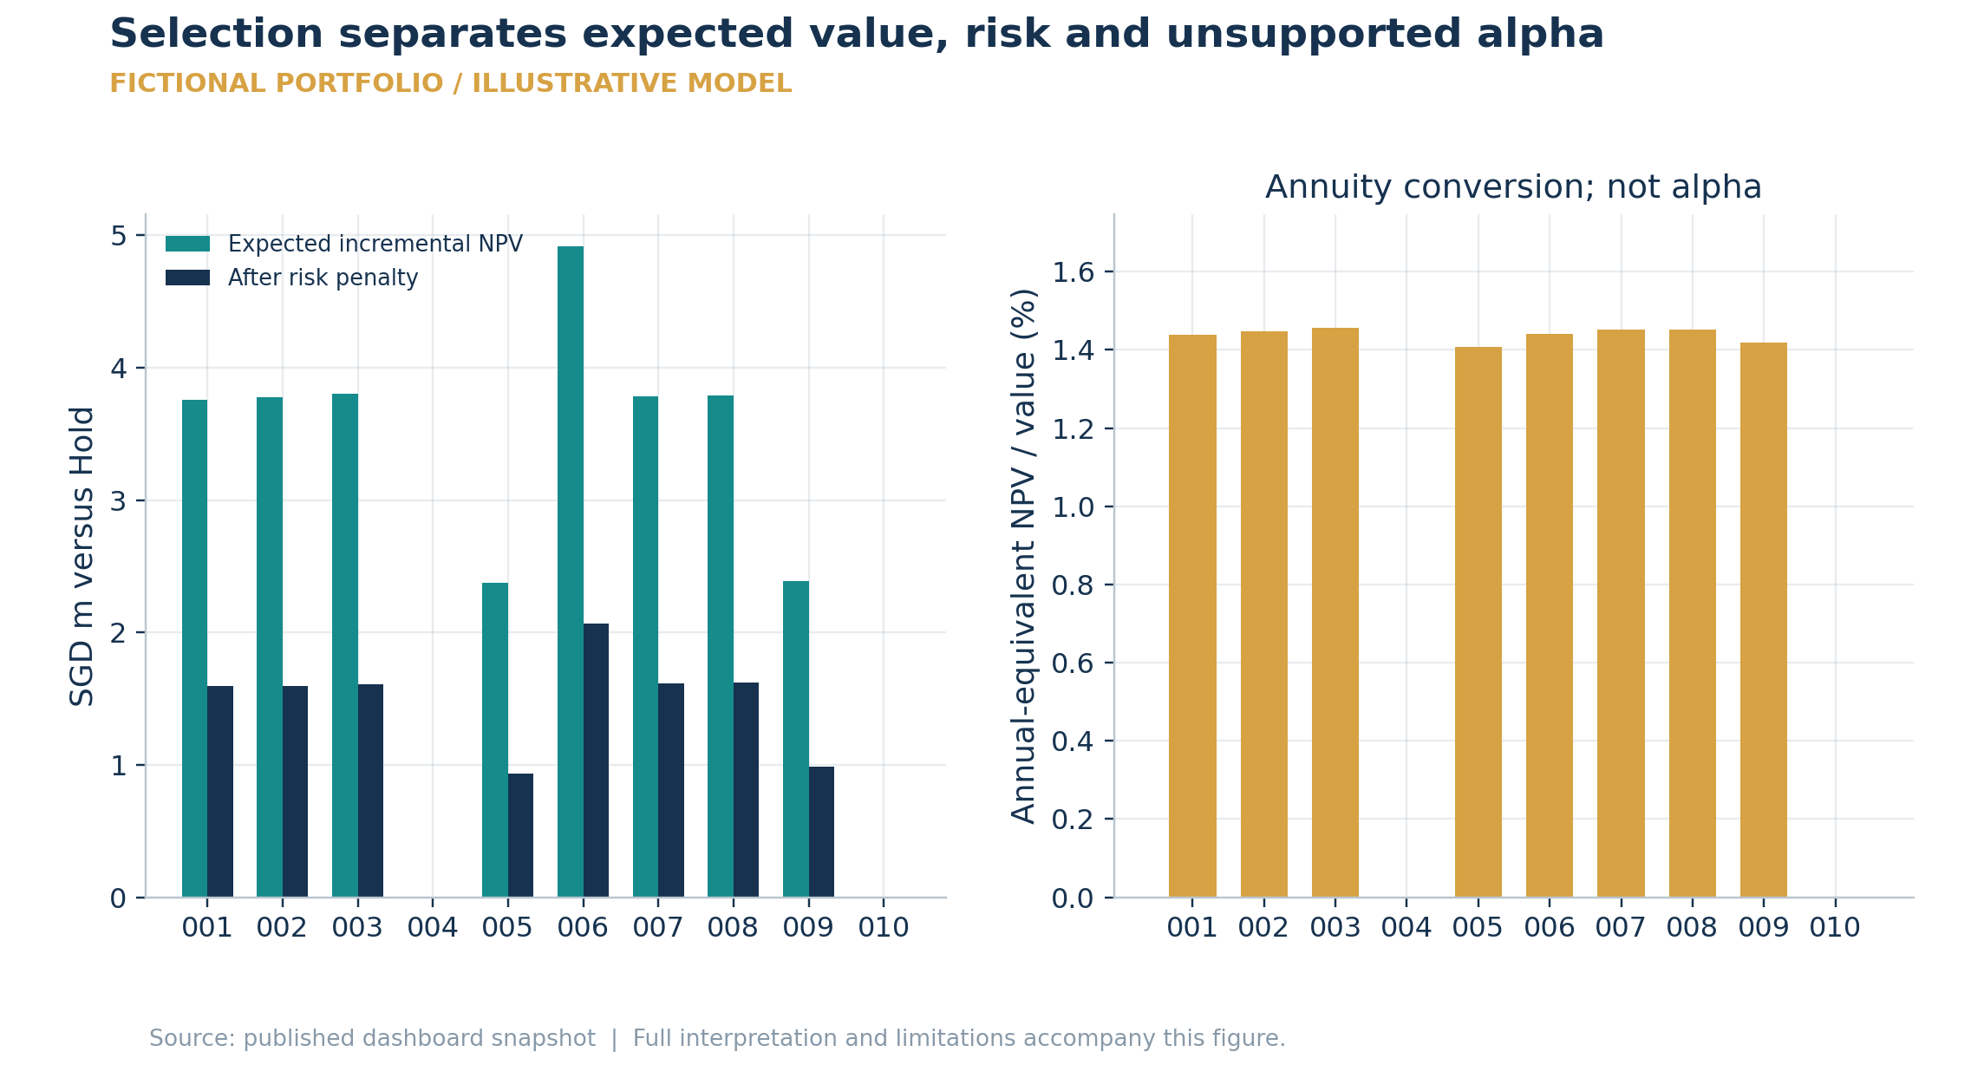
Units: SGD m; annual-equivalent proportion of current value. Source: /assets/{id}.selection. Reconstructed from saved data.
The displayed standalone expected incremental opportunities sum to SGD 28.58m; after individual risk penalties the scores sum to SGD 12.02m. The annual-equivalent yield converts an NPV into a level annual amount divided by current value. It is not an IRR and must not be added to NOI yield or historical price growth. Independent market alpha remains unestimated.
Interpretation boundary Adding asset scores ignores portfolio constraints and joint risk. Break-even additional cost is an NPV allowance, not a construction budget.

Figure 7. Digital twin sector mix and generated economic scale
  - Digital Twins
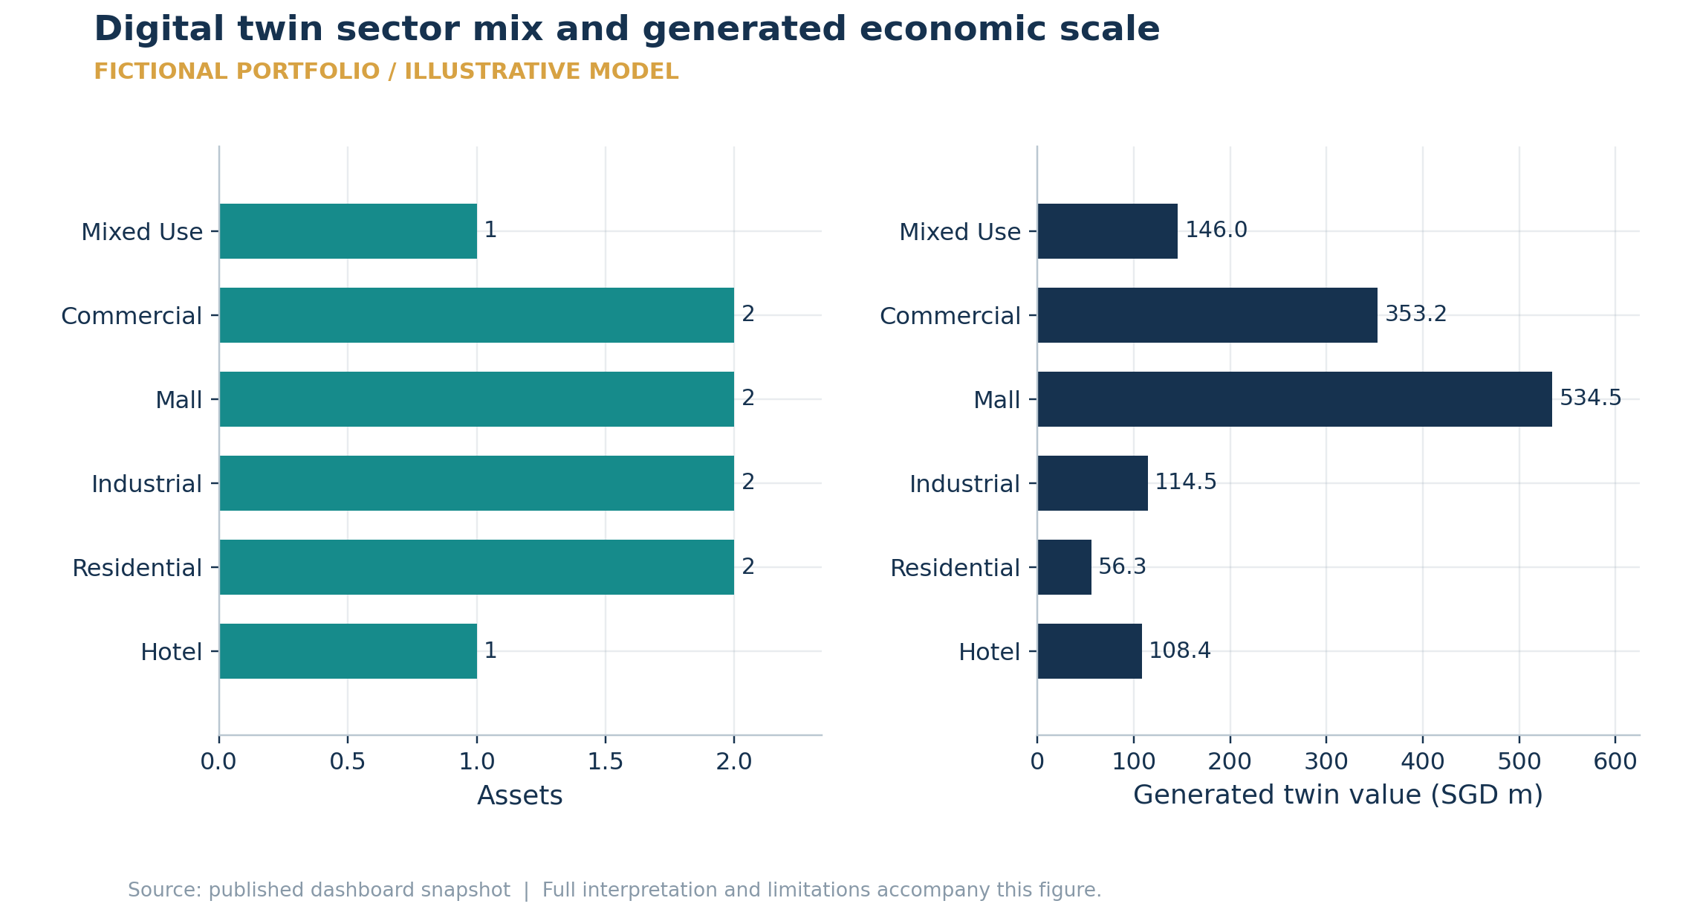
Units: Asset count; generated SGD m. Source: digital_twin_dashboard.assets. Reconstructed from saved data.
The twin portfolio contains 10 assets across 6 sectors and totals SGD 1,312.90m. This is generated twin underwriting. Sector labels preserve office, industrial, mixed-use and hospitality distinctions instead of defaulting unrecognised uses to residential.
Interpretation boundary Different sector totals reflect both the fixture mix and synthetic generation assumptions; they are not the company portfolio allocation.

Figure 8. Environment recommendations and constrained twin allocations
  - Digital Twins
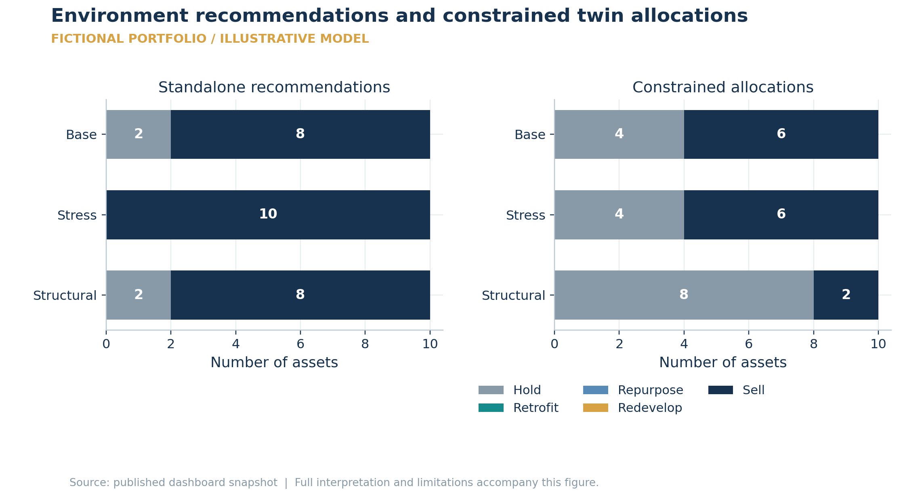
Units: Asset count by action and environment. Source: digital_twin_dashboard.environments. Reconstructed from saved data.
Base: 8 standalone Sell versus 6 constrained Sell; Stress: 10 standalone Sell versus 6 constrained Sell; Structural: 8 standalone Sell versus 2 constrained Sell. Portfolio income constraints can retain assets even when a standalone sale has the highest expected incremental score.
Interpretation boundary Three environments are separate assumption sets, not probability-weighted forecasts; there is no demonstrated real-world optimal policy.

Figure 9. Economic value and cash released are different quantities
  - Digital Twins
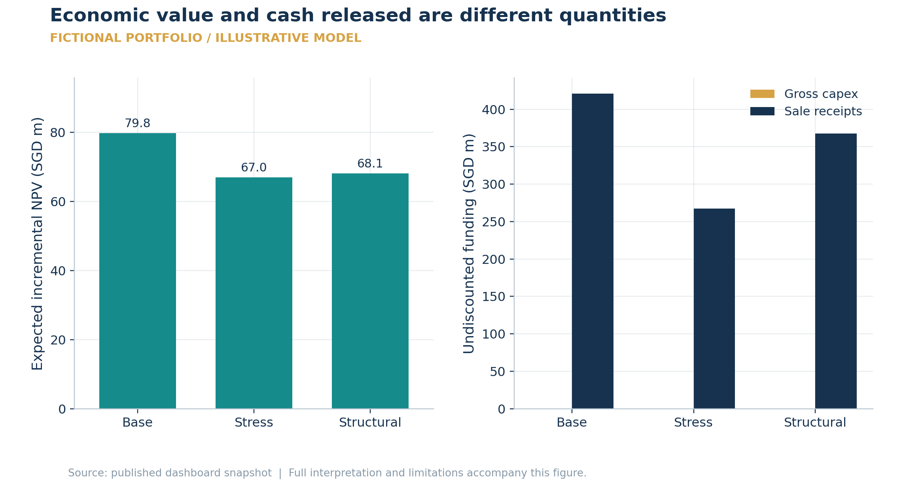
Units: SGD m: present value versus undiscounted cash. Source: digital_twin_dashboard.environments[].portfolio. Reconstructed from saved data.
Base: expected incremental NPV SGD 79.80m, sale receipts SGD 420.79m; Stress: expected incremental NPV SGD 66.95m, sale receipts SGD 267.30m; Structural: expected incremental NPV SGD 68.10m, sale receipts SGD 367.57m. Sale proceeds are large because ownership is transferred; NPV deducts the forgone Hold income and residual value. Releasing cash does not imply creating the same amount of profit.
Interpretation boundary These remain two distinct accounting bases. A zero development allocation is a valid output under costly redevelopment assumptions.

Figure 10. Twin action uncertainty: DEMO-001, base environment
  - Digital Twins
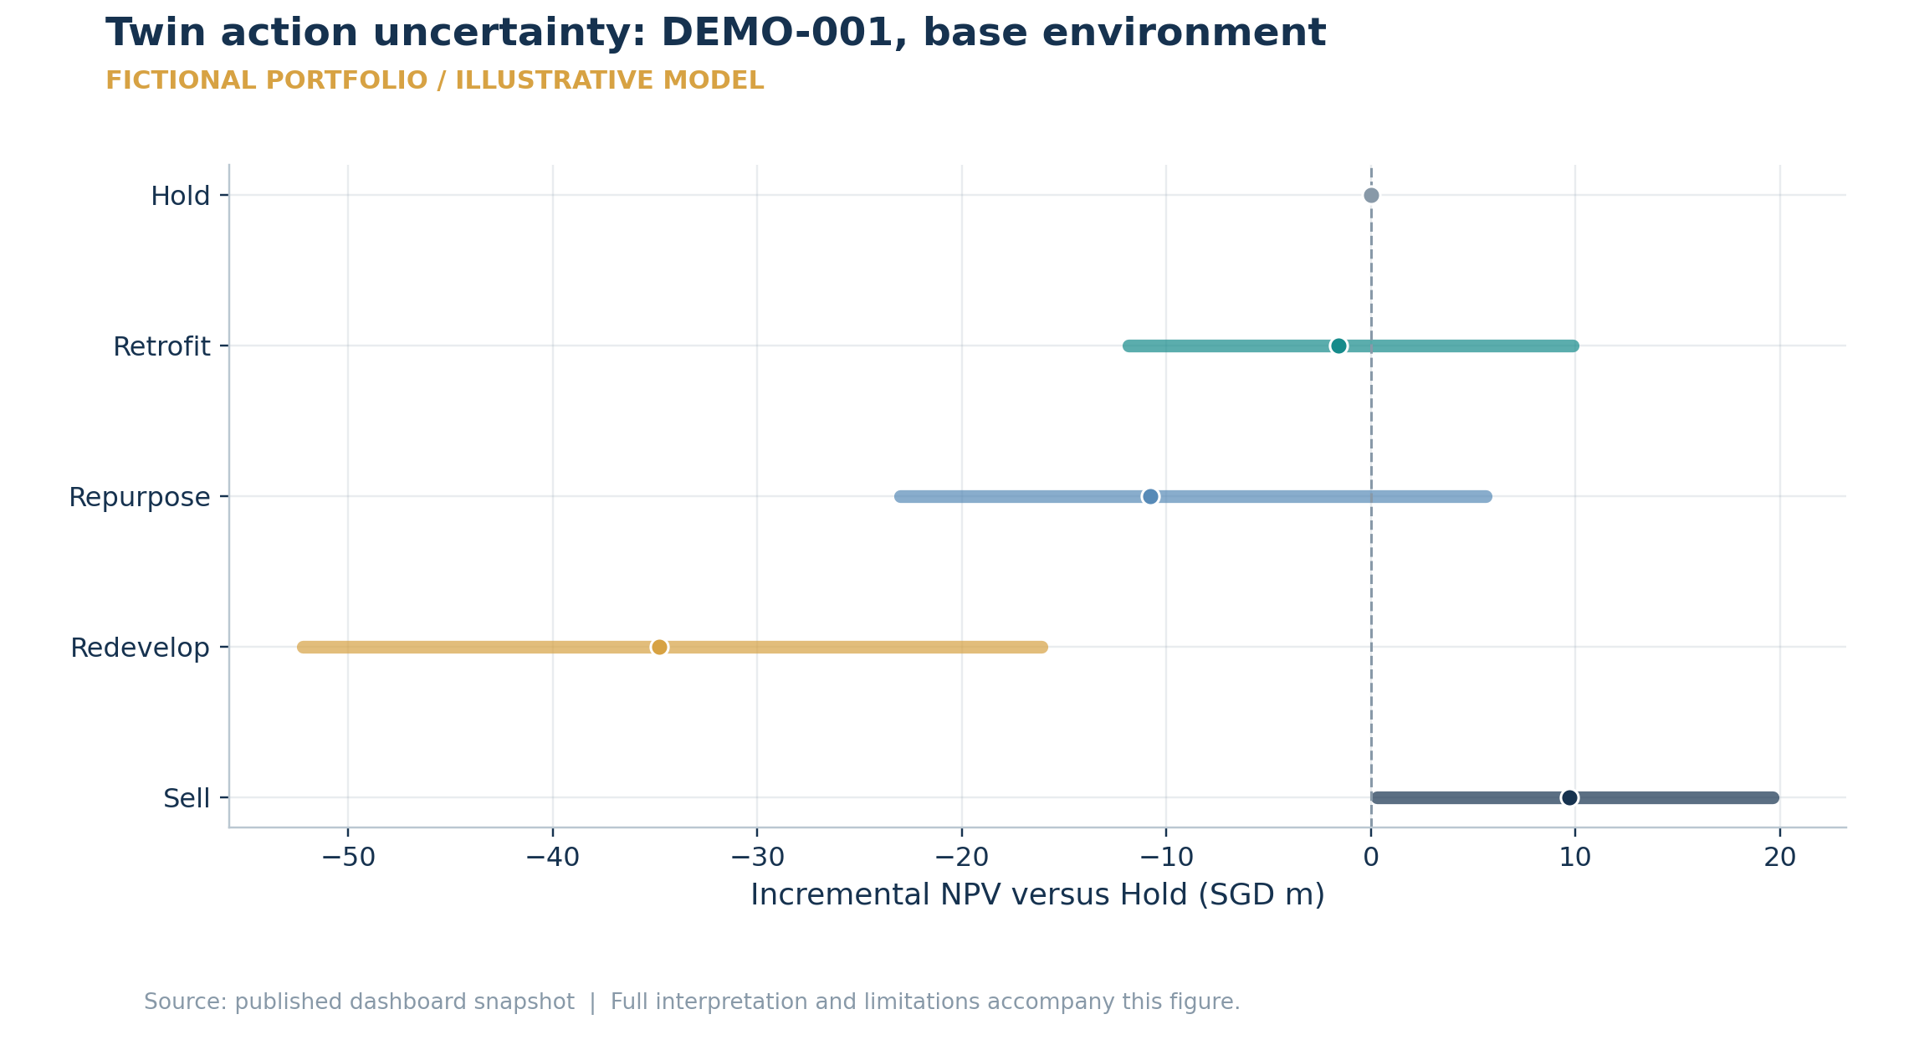
Units: Incremental NPV, SGD m. Source: digital_twin_dashboard.assets[DEMO-001].environments.base.actions. Reconstructed from saved data.
The selected twin action is Sell, with expected incremental NPV SGD 9.70m and P10–P90 range SGD 0.31m to SGD 19.67m. Lines show the central 80% of simulated outcomes and dots the sample mean. Hold stays at exactly zero because every alternative is measured against the same Hold cashflows.
Interpretation boundary Intervals combine uncalibrated action assumptions, approval branches and simulated shocks; they are not investment-grade confidence intervals.

Figure 11. Simulation coverage and hindsight agreement test different things
  - Digital Twins
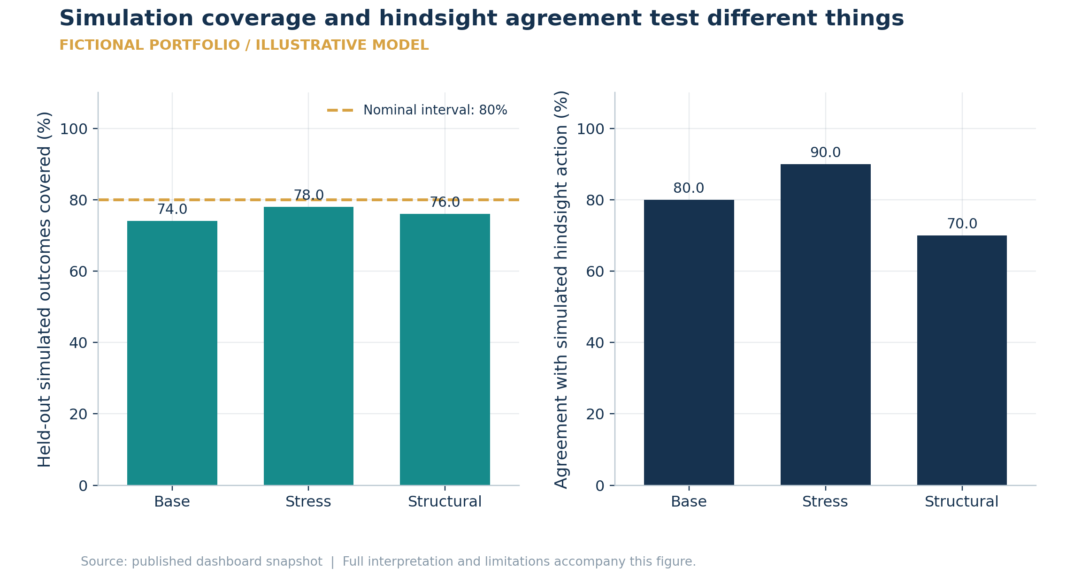
Units: Percent; nominal coverage 80%. Source: digital_twin_dashboard.environments[].p10_p90_coverage and correct_action_rate_vs_simulation. Reconstructed from saved data.
Base: interval coverage 74% and simulated action agreement 80%; Stress: interval coverage 78% and simulated action agreement 90%; Structural: interval coverage 76% and simulated action agreement 70%. Coverage tests whether generated outcomes lie within their central intervals; agreement tests whether the recommended action matches a hindsight choice. They use different denominators and cannot be compared as one accuracy metric.
Interpretation boundary The evaluation uses a separate synthetic draw and latent outcome adjustment, not observed market outcomes. Ten assets make action percentages coarse.

Figure 12. Regret measures missed simulated opportunity; stability measures consistency
  - Digital Twins
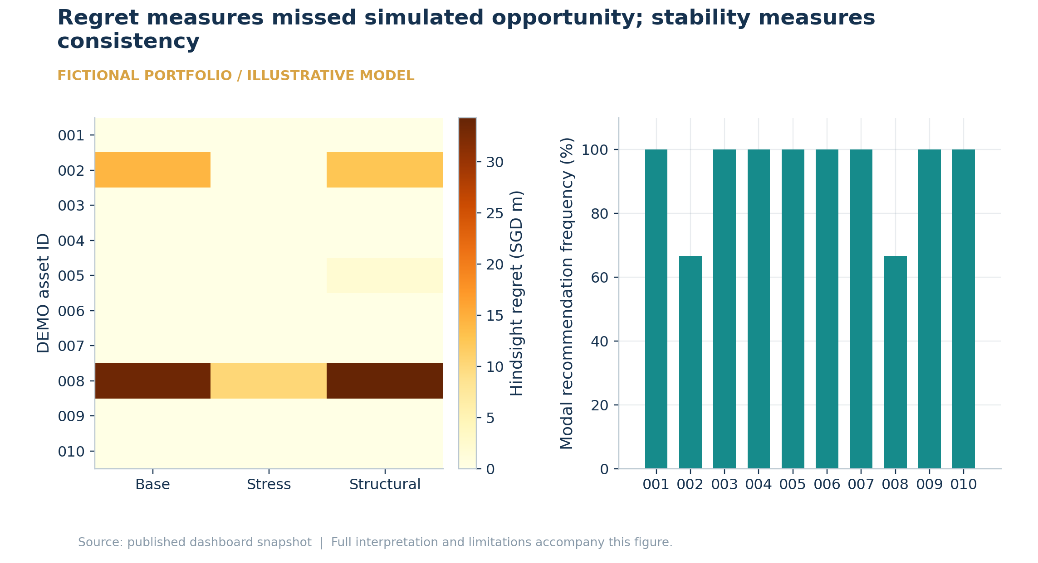
Units: SGD m regret; modal frequency %. Source: digital_twin_dashboard.assets[].environments and stability_score. Reconstructed from saved data.
There are 2 assets whose recommendations change across the three environments. The largest single asset/environment hindsight regret is SGD 34.29m. A stable action can still have regret, because consistency does not imply that the model foresaw the highest simulated outcome.
Interpretation boundary Twin stability uses three environments and a change-based fragility flag. It differs from the optimiser perturbation stability test.

Figure 13. Planning capacity is a sequence of distinct screening quantities
  - Zoning
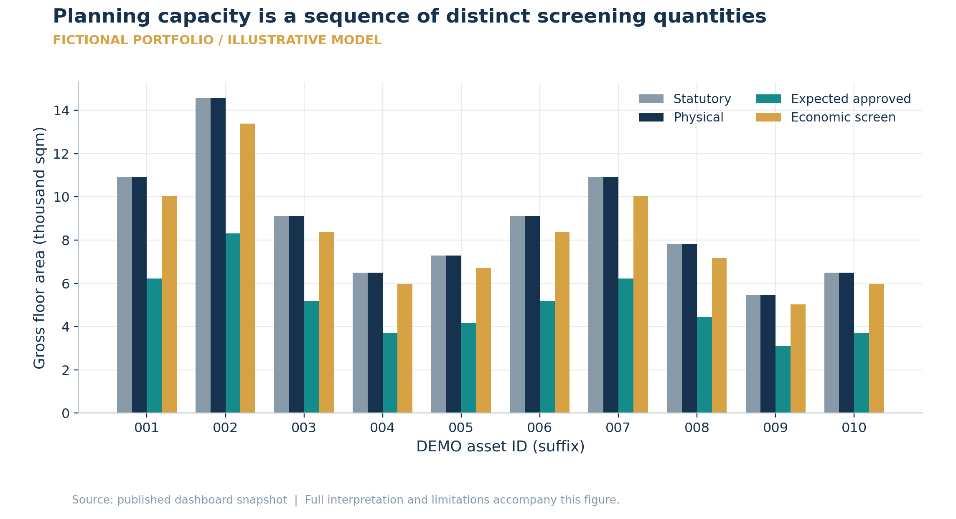
Units: Thousand square metres GFA. Source: /assets/{id}.capacity. Reconstructed from saved data.
For DEMO-001, statutory GFA is 10,920 sqm, physical GFA 10,920 sqm and expected approved GFA 6,229 sqm. The economic screen can exceed probability-weighted approved area because those quantities answer different questions; they must not be added together.
Interpretation boundary GPR labels, parcel boundaries, physical limits and approval probabilities are unverified fixture/proxy inputs; no legal development entitlement is established.

Figure 14. Binding constraints and zoning display fixtures
  - Zoning ML
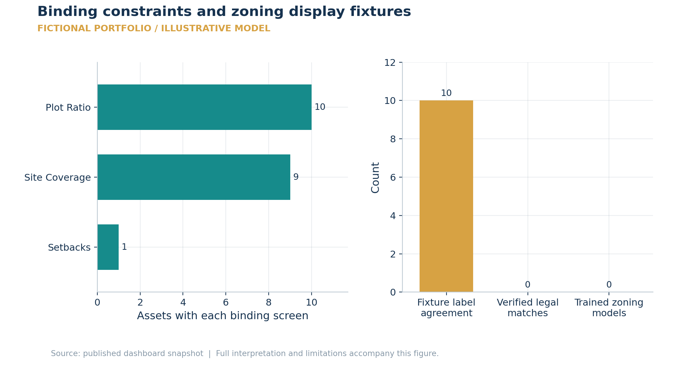
Units: Asset count; fixture label count. Source: /assets/{id}.capacity; /zoning/prediction/{id}. Reconstructed from saved data.
The most frequent binding screen is plot ratio (10 assets). 10/10 fixture labels match their supplied legal-style labels, but no zoning model was trained and these are not independently verified legal matches. Agreement is chart plumbing, not measured classification accuracy.
Interpretation boundary The displayed confidence and future-change numbers are hand-authored, uncalibrated fixtures; abstention and evidence review remain required.

Figure 15. Development envelope screening: DEMO-001
  - Development
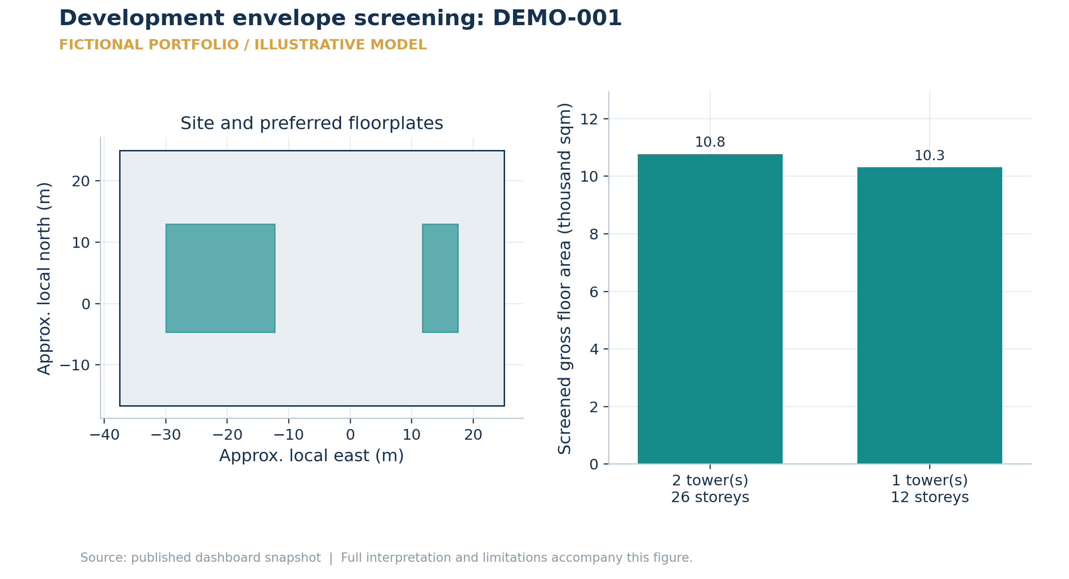
Units: Approximate local metres; thousand sqm. Source: /assets/DEMO-001/advanced-analysis.site_polygon and development_envelope. Reconstructed from saved data.
The preferred envelope has 2 tower(s), 26 storeys and 10,774 sqm GFA. The site is a synthetic rectangle and the footprint is a geometric screen constrained by GPR, height, coverage and setbacks. Surrounding-building evidence is unavailable; missing geometry does not establish an open view.
Interpretation boundary Not a surveyed cadastral plot, architect design, parking/fire approval or verified viewshed. If no feasible envelope exists, no redevelopment value is reported.

Figure 16. Monthly redevelopment economics versus Hold: DEMO-001
  - Development
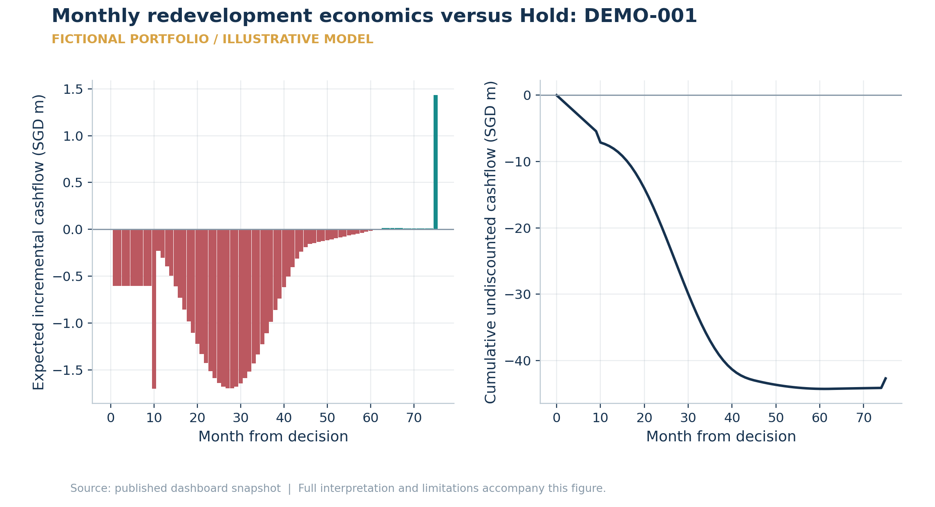
Units: SGD m; month. Source: /assets/DEMO-001/advanced-analysis.redevelopment_cashflow. Reconstructed from saved data.
The expected unlevered incremental NPV is SGD -37.02m over 75 months, before any unassessed LBC. Negative bars represent extra costs or forgone Hold income; the final month includes the difference in disposal proceeds. The cumulative line is undiscounted cash and therefore does not equal NPV. Project and Hold both include the same current-asset opportunity cost at time zero.
Interpretation boundary LBC is missing and underwriting is unverified. These displayed calculations are not decision-ready and are not levered equity cashflows.

Figure 17. Full rebuilding cost and reconciled development debt
  - Development
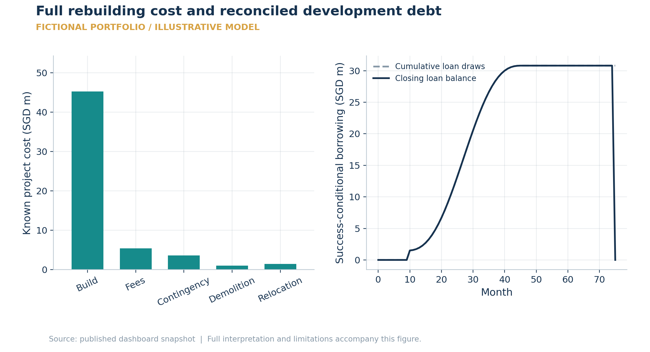
Units: SGD m; months; full rebuilt sqm. Source: /assets/DEMO-001/advanced-analysis.redevelopment_cashflow. Reconstructed from saved data.
DEMO-001 incurs SGD 45.25m construction cost on all 10,774 rebuilt sqm. Conditional debt draws total SGD 30.80m, equal to principal repayment SGD 30.80m; interest totals SGD 5.70m. Equity receives the loan draws before paying interest and repayment, while unlevered decision NPV excludes financing.
Interpretation boundary Debt series are conditional on successful development, not probability-weighted net borrowing. LBC is an unknown omitted charge, not zero.

Figure 18. En-bloc residual value reconciles known costs, not unknown charges
  - Development
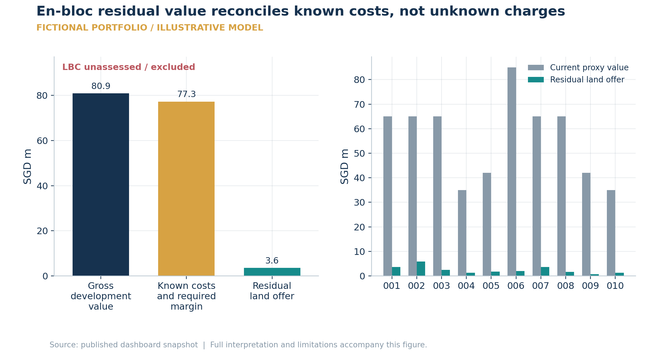
Units: SGD m, undiscounted development residual. Source: /assets/{id}/advanced-analysis.enbloc. Reconstructed from saved data.
For DEMO-001, gross development value SGD 80.92m less known costs and developer margin SGD 77.29m leaves a land offer of SGD 3.62m. Buyer duty is solved on that offer. The offer is below the current proxy value of SGD 65.00m; the chart does not infer that owners would accept it. Failure retains the asset, which is included in the separate incremental comparison.
Interpretation boundary LBC and acquisition-finance/tenure-top-up evidence are incomplete; the residual is an incomplete screening amount. Consent probabilities remain uncalibrated.

Figure 19. Core Hold DCF: operating income and terminal value separated
  - Valuation
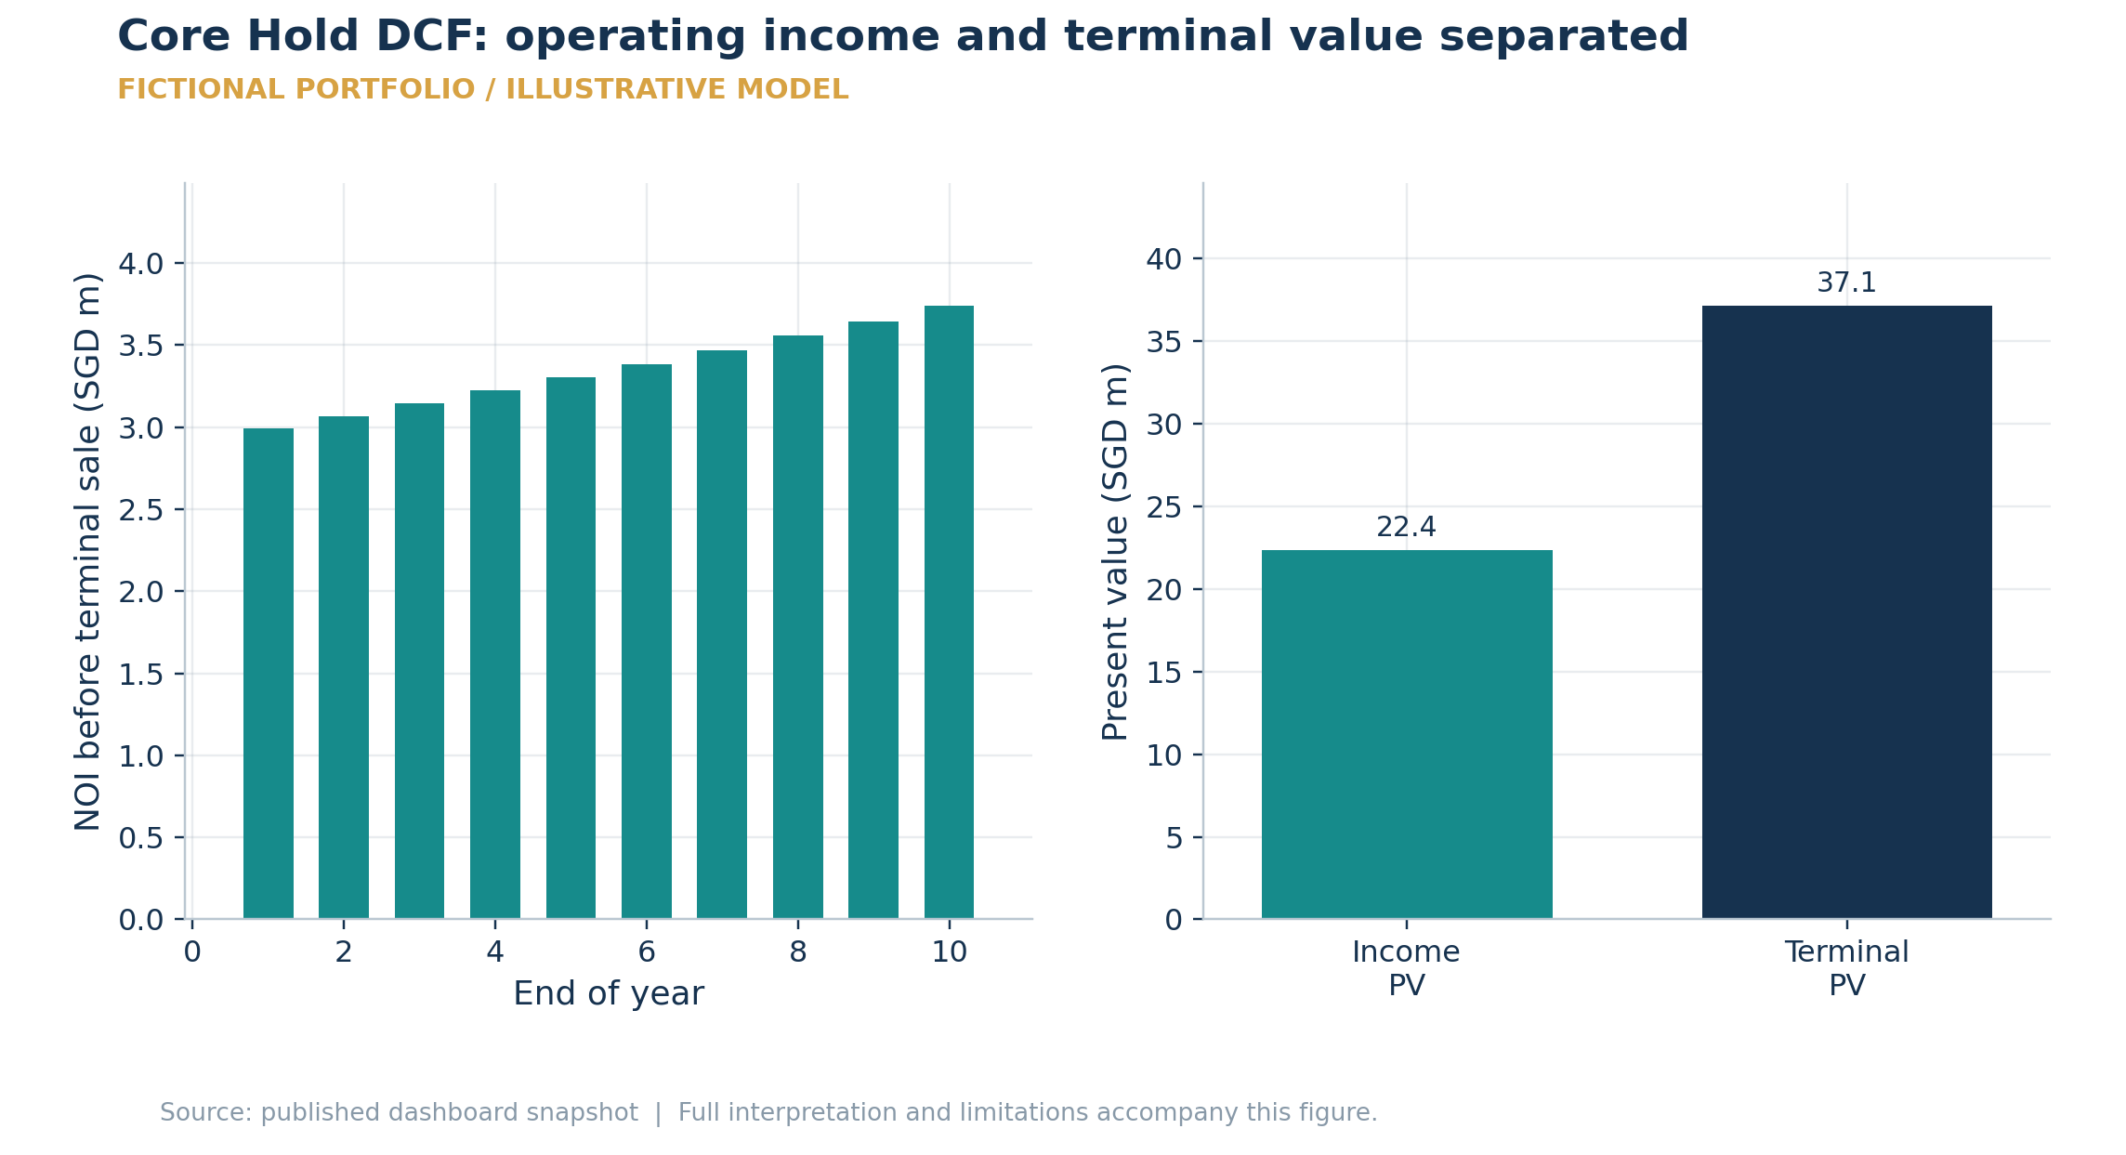
Units: SGD m; year-end periods. Source: /assets/DEMO-001.dcf and economics. Reconstructed from saved data.
DEMO-001 has a Hold DCF of SGD 59.47m: SGD 22.36m from operating income and SGD 37.11m from discounted net terminal value. Terminal PV is 62.4% of total value. That concentration explains sensitivity to exit cap rate and terminal NOI. The SGD 78.64m terminal cash receipt is not recurring annual NOI.
Interpretation boundary NOI growth, cap rate and asset costs remain proxy assumptions; sensitivity to terminal value is a valuation dependency, not evidence of overvaluation.

Figure 20. Core action ranges and loss probability: DEMO-001
  - Actions
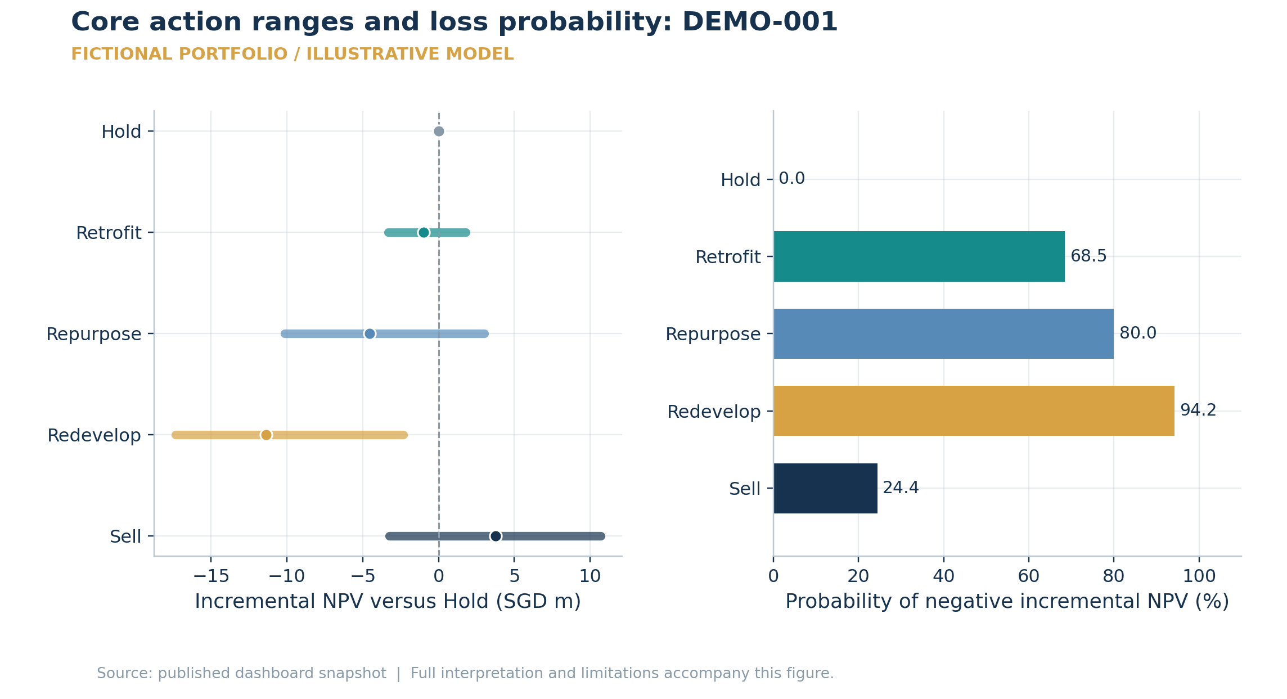
Units: Incremental NPV SGD m; probability %. Source: /assets/DEMO-001.actions. Reconstructed from saved data.
The core screen selects Sell. A P10 below zero indicates lower-tail incremental losses, while the probability panel reports the fraction of all simulated outcomes below zero. Hold has zero incremental risk by construction. P10 is a quantile, not the probability of a 10% loss.
Interpretation boundary These core scenarios use size-scaled factor exposures and approval branches. They differ from the twin environment engine and must not be merged into one distribution.

Figure 21. Stored core simulation draws: DEMO-001
  - Scenario
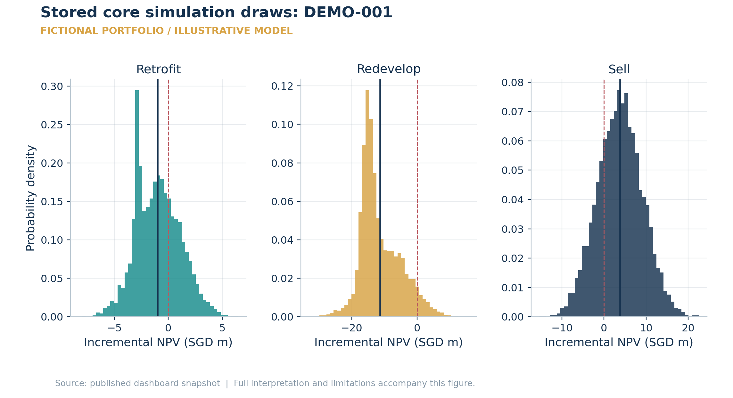
Units: SGD m; probability density integrates to one. Source: /assets/DEMO-001/scenario-samples. Reconstructed from saved data.
Histograms use the same 5,000 stored model draws as the reported core metrics; they are not regenerated chart samples. Retrofit: mean -1.00m, loss frequency 68.5%; Redevelop: mean -11.37m, loss frequency 94.2%; Sell: mean 3.76m, loss frequency 24.4%. The dashed red line is zero incremental NPV, and the solid line marks the sample mean. Multiple modes can reflect success and failed-execution branches.
Interpretation boundary A smooth-looking distribution does not validate its assumed exposures, calibration or tail probabilities. Density heights are not probabilities at individual values.

Figure 22. Input correlation and realised scenario dependence
  - Scenario
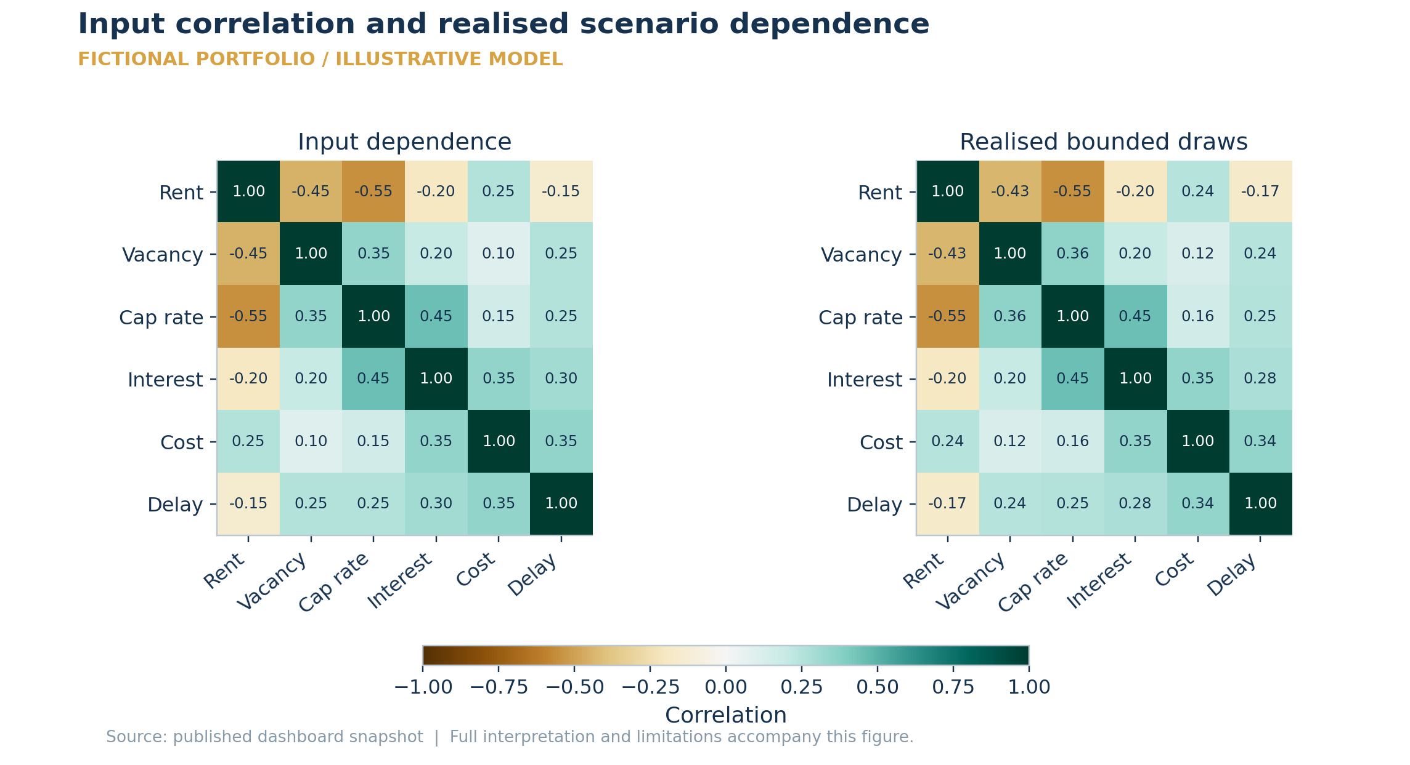
Units: Pearson correlation, -1 to +1. Source: /visualisations/scenario-matrix. Reconstructed from saved data.
The scenario source is assumption fallback. The realised rent-growth/cap-rate correlation is -0.55; a negative value links stronger rent with lower cap rates in this simulation. Clipping and tail mixing can change realised correlations from the input matrix, so both are shown.
Interpretation boundary Fallback correlations are modelling assumptions, not measured market relationships; even a calibrated factor matrix does not validate action-level sensitivities.

Figure 23. Capital scheduling and retained income in the core allocation
  - Optimiser
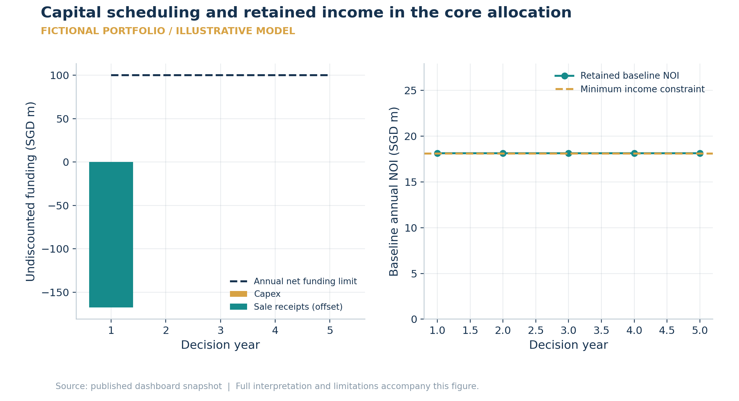
Units: SGD m; decision year. Source: /snapshots/optimise.annual_plan and constraints. Reconstructed from saved data.
The selected plan spends SGD 0.00m and releases SGD 167.70m. Lowest retained baseline NOI is SGD 18.11m, versus the SGD 18.09m minimum. Sale cash offsets funding only at its scheduled settlement; sold assets stop contributing baseline income. The independent constraint audit reports 0 violations.
Interpretation boundary Income continuity is a baseline loss screen, not a full future operating statement; budgeted liquidity is not a bank-account forecast.

Figure 24. Joint portfolio risk must use aligned scenario outcomes
  - Optimiser
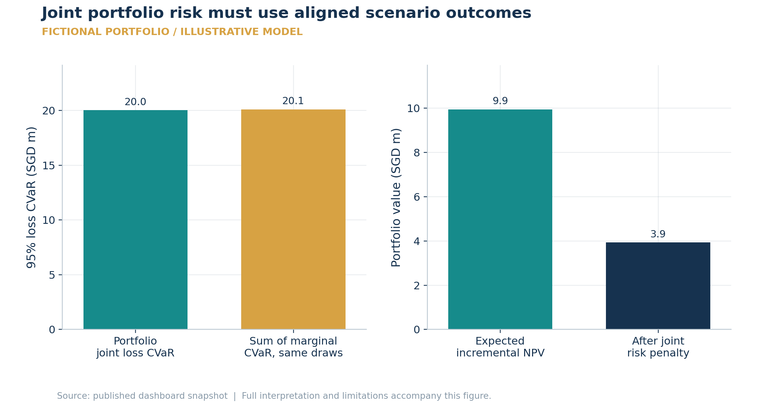
Units: SGD m; 95% CVaR of positive-part loss. Source: /snapshots/optimise plus selected /assets/{id}.actions.scenario_npvs_m. Reconstructed from saved data.
The core allocation has expected incremental NPV SGD 9.95m and joint positive-part-loss CVaR SGD 20.03m. On the same scenario grid, the sum of selected marginal CVaRs is SGD 20.11m. Correlations and offsetting outcomes determine the difference. The risk-adjusted objective is SGD 3.94m after the configured penalty.
Interpretation boundary Compare joint and marginal CVaR on the same draw grid. The optimiser uses a reduced scenario grid and does not prove empirical diversification or safe tails.

Figure 25. Two-stage scenarios connect commitments with funded recourse
  - Optimiser
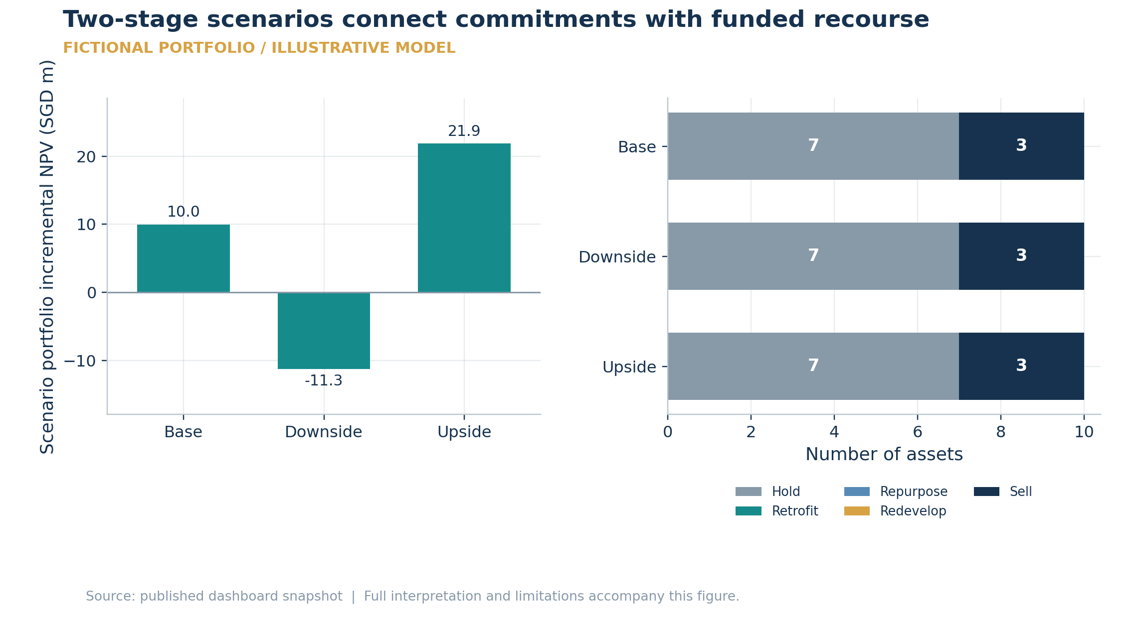
Units: SGD m by scenario; executed/fallback asset counts. Source: /snapshots/two-stage. Reconstructed from saved data.
Probability-weighted portfolio incremental NPV is SGD 7.63m and positive-part-loss CVaR is SGD 11.28m. Base: SGD 9.98m with 0 cancellations; Downside: SGD -11.28m with 0 cancellations; Upside: SGD 21.86m with 0 cancellations. Cancelling retains Hold economics and pays a decision-year fee; delayed projects must still finish inside the horizon.
Interpretation boundary Scenario probabilities and multipliers are assumptions. This is not a continuously rebalanced policy or a calibrated multi-year macro forecast.

Figure 26. Optimiser stability is sensitivity, not prediction accuracy
  - Optimiser
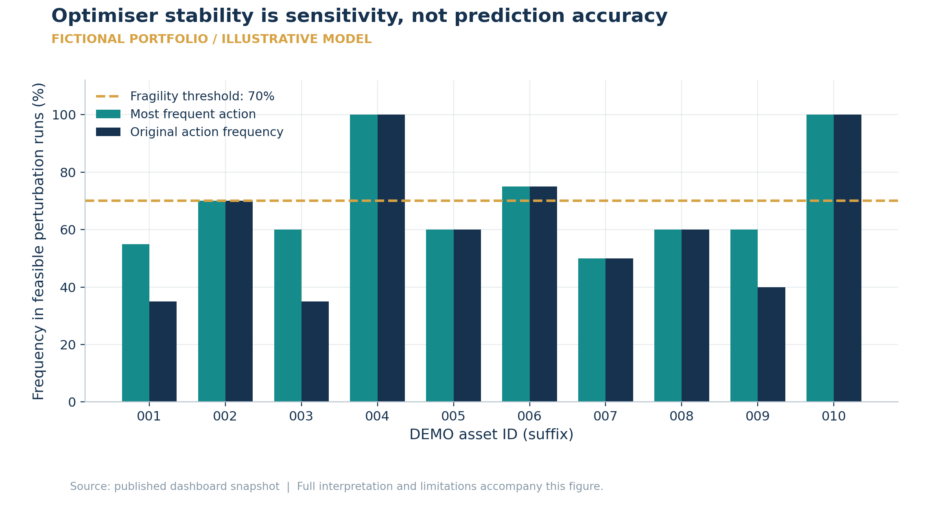
Units: Action frequency %; feasible-run denominator. Source: /snapshots/stability. Reconstructed from saved data.
20/20 perturbation runs were feasible; 6 assets have a modal action frequency below 70%. The most frequent action can differ from the original allocation. The arithmetic mean expected NPV across these perturbation solutions is SGD 20.13m; it is not an out-of-sample return.
Interpretation boundary Asset-by-asset modal actions need not form one jointly feasible portfolio. Perturbation stability and three-environment twin stability have different denominators.

Figure 27. Forecast display examples reconcile; they are not a trained-model backtest
  - Models
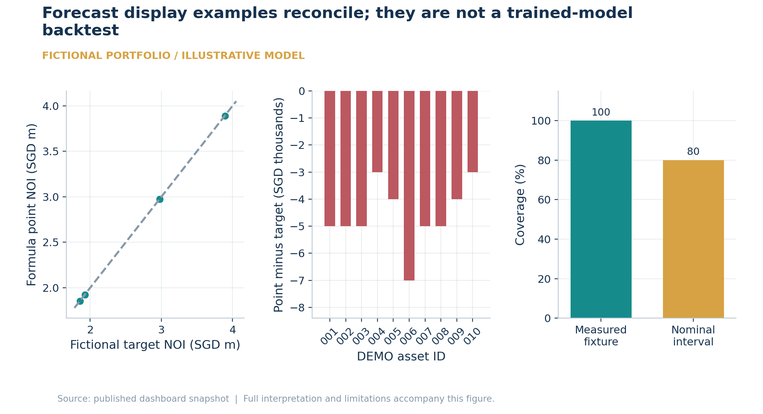
Units: SGD m; residual SGD thousands; coverage %. Source: /models/backtest.predictions and noi_forecast. Reconstructed from saved data.
Recomputing the 10 fictional formula rows gives MAE SGD 4,600, mean bias SGD -4,600 and interval coverage 100.0%. The tight scatter is a consequence of the example formula, not evidence of forecasting skill. No learned production artifact or independent historical investment outcome is used by these cards.
Interpretation boundary The strengthened forecasting pipeline supports chronological train/calibration/holdout evaluation separately; these public fixture cards do not show a fitted model evaluation.

Figure 28. Model pathways, evidence gates and publication boundaries
  - Architecture and Audit
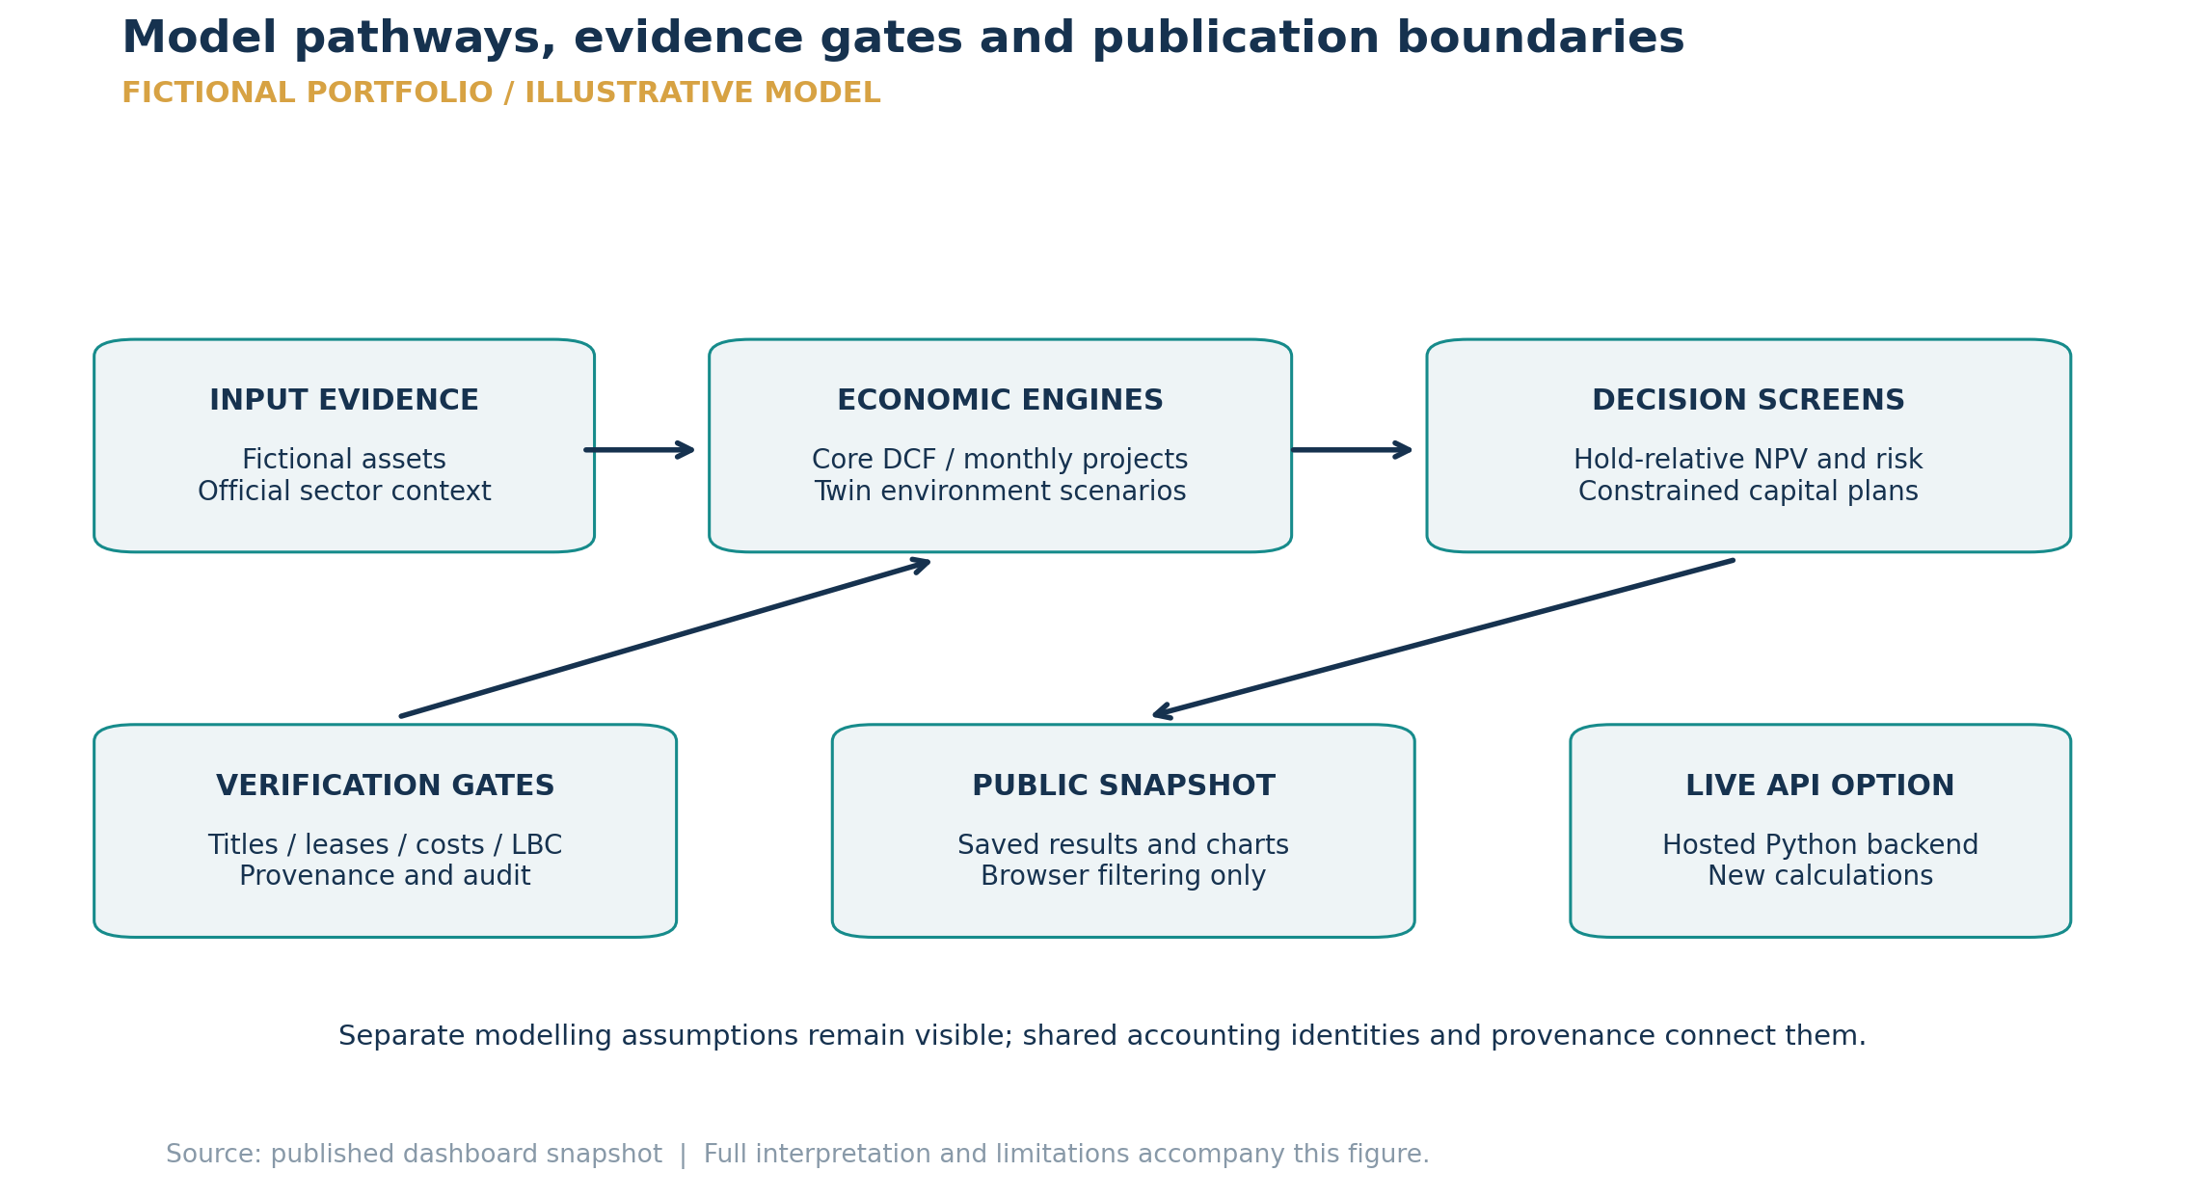
Units: Workflow diagram; no quantitative scale. Source: Repository architecture; API snapshot metadata; model provenance. Reconstructed from saved data.
Official sector indices enrich context; they do not replace missing asset underwriting. Core valuation, detailed projects and digital twins retain distinct assumptions and units. Scenario outcomes feed constrained optimisation, while evidence gates determine whether a recommendation can be used. The public snapshot serves saved results; a connected Python backend is required for new calculations.
Interpretation boundary This diagram describes implemented capabilities and dependencies, not confirmation that a cloud backend is deployed, calibrated or using private company data.

4. Financial method: a common Hold counterfactual
The annual model values unlevered asset cashflows. NOI in future year t grows from current NOI at the assumed annual growth rate. Terminal value capitalises the following year's NOI at the exit cap rate, less selling costs. All future income is discounted at the end of its year; committed action capex is a time-zero outflow.
Quantity | Definition
Annual NOI | NOI(t) = NOI(0) × (1 + growth)^t
Terminal value | TV(T) = NOI(T + 1) ÷ exit cap rate × (1 − selling-cost rate)
Retained-asset PV | Σ NOI(t)/(1 + discount rate)^t + TV(T)/(1 + discount rate)^T
Action incremental NPV | Expected action project PV − retained-asset PV
Branch expectation | Approval probability × success NPV + failure probability × failure NPV
Sell | Immediate net sale proceeds − retained-asset PV
Hold | Exactly zero incremental NPV and capex; absolute retained-asset PV remains positive

NOI uplift starts after execution; construction reduces income during execution, including partial years. A failed development retains Hold income and loses 55% of planned capex in the annual screening engine. That recovery assumption is explicit and uncalibrated. It is a different, simplified failure mechanism from the advanced monthly engine's predevelopment sunk fees.
Full committed costs remain in the capital budget even when probability-weighted expected expenditure is smaller. Funding a successful project requires its actual committed cash. Financing interest is excluded from unlevered action NPV; equity cashflows require a separate financing ledger and equity discount rate.
Default terminal uplift is zero because NOI uplift is already capitalised. Residual planning capacity and legacy Wait/Phase/Abandon/Expand scores do not receive an unsupported additional option premium. Zero credited premium means not valued, not an estimate of zero market optionality.

5. Core risk: common scenarios and exact loss tails
The core engine generates 5,000 aligned factor scenarios for rent growth, vacancy, cap rates, interest rates, construction costs and approval delay. The factor hierarchy uses a calibrated regime artifact if available, calibrated covariance next, then explicit fallback assumptions. In the public run, missing calibration is visible; downloading price/rent indices alone does not create a fully calibrated six-factor process.
Fallback draws combine correlated Gaussian and variance-standardised correlated heavy-tail shocks. The mixture is variance-normalised before rate/delay bounds. The displayed heatmap is the realised correlation of the bounded model sample, with the input correlation matrix retained separately. Neither matrix demonstrates an observed economic relationship in the present fallback run.
Action shocks scale with asset value, capex, annual NOI and execution duration. Sell reverses exposure to the income forgone by sale. Approval samples select explicit success/failure cashflows; failed approval retains Hold economics and only cost uncertainty remains. The direct borrowing-rate penalty has been removed from unlevered NPV. These local sensitivity coefficients remain assumptions.
Risk statistic | Meaning
Expected NPV | Mean of the generated incremental outcomes
P10 / P50 / P90 | 10th, 50th and 90th outcome quantiles; a central 80% range
Probability of loss | Fraction of incremental NPV draws below zero
Positive-part loss | L = max(0, −incremental NPV)
VaR95 | 95th percentile of positive-part loss
CVaR95 | Average loss in the worst 5% probability mass, splitting a boundary observation where needed

A rare loss cannot be offset by profits merely because the 5% tail also contains profitable observations. For example, a 2% probability of losing S$100m and otherwise gaining S$100m gives positive-loss CVaR95 of S$40m. Signed tail statistics are stored separately. Exact saved samples feed the distribution chart and the cards, so those displays now reconcile.

6. Digital Twins: conditional environments and independent evaluation
The twin generator produces its own underwriting and twelve years of financial history. These histories are synthetic, including apparent cycles, tenant diversification and expense trends. Predictions use observable generated fields, not hidden simulation truth. Small bounded score adjustments remain screening assumptions: maximum absolute valuation adjustments are 1.5% for Retrofit and 2% for Repurpose/Redevelop, applied only after success.
Assumption | Base | Stress | Structural
Headline rent-level change | 1.5% | -12.0% | 0.5%
Cap-rate shift, percentage points | 0.00 | 1.20 | 0.30
Construction-cost multiplier | 1.00 | 1.18 | 1.08
Approval multiplier | 1.00 | 0.72 | 0.86

Segment demand adds to the headline rent-level change. Both Hold and action cashflows use that revised NOI. Annual growth is separately bounded at −3% to 8%; exit cap rates at 2% to 15%; sale-price multipliers at 0.35 to 1.75. Construction inflation changes both funding and NPV, and sale-price stress changes both sale proceeds and incremental value. NOI-continuity constraints use the environment-specific baseline.
Each action has 2,048 predictive draws with shared Student-t(6) economic/construction factors and idiosyncratic shocks. A separate seed generates one synthetic evaluation outcome, with hidden effects available only to that evaluation. The hindsight oracle observes those outcomes; the predictive rule does not. Oracle agreement and regret therefore assess a closed simulation, not actual management skill.
Nominal 80% interval coverage is ['74.0%', '78.0%', '76.0%'] across the three cases, each using 50 asset/action evaluation observations. The shortfall is visible evidence that these assumed predictive ranges are not calibrated to every hidden evaluation effect. Recommendation stability across three cases is different from the optimiser's twenty-run perturbation stability.

7. Portfolio optimisation: timing, cash and joint downside
The multi-period mixed-integer model selects exactly one action/start option per asset. It maximises expected incremental NPV minus a chosen penalty times aggregate positive-loss CVaR. When aligned action scenarios are supplied, they retain the same scenario index across the portfolio; the optimiser aggregates them before calculating risk. Without aligned scenarios it explicitly falls back to summed marginal risk penalties.
The solver uses 128 aligned scenarios for computational tractability; core risk cards use 5,000 and twin cards 2,048. A joint-versus-marginal diversification comparison must use the same 128 observations and weights. The optimiser now reports that comparable marginal sum separately from the larger-sample input-card sum.
Constraint or convention | Interpretation
Annual and cumulative capital | Nominal spending minus receipts; the reserve must survive every year
NOI retention | Retained baseline NOI at or above the selected minimum each year
Concurrency and development share | Active projects and exact floor(asset count × share) limits; zero means zero
Complete project horizon | All construction/funding must fit; unfinished costs cannot be truncated
Delayed execution | NPV at start is discounted to the decision date; passive pre-start carry contributes zero incremental NPV
Sale settlement | Receipts fund spending only after settlement; income is retained before settlement
Independent audit | Recompute every selected-schedule constraint; tolerance 0.000001; failed audit prevents feasible status

Budget and liquidity numbers are not additional investment profits. Negative net funding is a receipt surplus. The annual cash convention does not resolve the timing of receipts and payments within the same year. Delaying an aggregate NPV is also an approximation: it does not re-underwrite future market rents, lease expiries, cost inflation or terminal dates.
A feasible optimal plan is best under the encoded objective and assumptions. It does not certify legal capacity, affordability for a specific company, lender covenants or real forecast accuracy. The retained financing constraint based on a percentage of capex is a financing proxy, not balance-sheet loan-to-value.

8. Two-stage recourse and stability
The two-stage model commits to an initial plan and permits specified actions to execute or cancel after one of three illustrative scenarios resolves. Probabilities describe those assumed scenarios; they are not market-implied or empirically estimated frequencies. The default scenario system is coarser than the 128-draw joint-risk optimiser, so their CVaR values are not interchangeable.
Cancellation uses the asset's actual Hold economics and Hold funding plus a default 8% cancellation fee. Without a feasible Hold alternative, cancellation is unavailable. This prevents a fictitious cheap cancellation from replacing an expensive baseline. Scenarios are assumed known before construction: the model does not learn continuously through the life of a project.
Scenario delays move capex, disruption, contractor workload and completion. Each scenario and year enforces income continuity, concurrency, annual funding and cumulative liquidity. Future sales cannot fund earlier spending. Dependency checks require prerequisite completion before dependent execution. Sale-price multipliers affect cash receipts and economic NPV together; the downside default is 0.90 and the upside default 1.05.
For negative-NPV actions, a downside multiplier worsens the loss rather than making it smaller. Increased construction spending also reduces NPV rather than only making the budget harder to satisfy. The top-level annual plan is probability-weighted recourse; each scenario retains its actual plan and audit.
The saved stability calculation has 20 successful and 0 failed perturbation runs, with 6 fragile assets under its threshold. It perturbs model assumptions around the baseline and reports modal-action frequencies only among feasible audited runs. Failure frequency is reported separately.
A collection of per-asset modal actions need not be jointly feasible. A 60% frequency is not a 60% probability that an investment is correct. Perturbation objective quantiles are sensitivity summaries, not prediction intervals or out-of-sample investment returns. The stability report separates risk-adjusted objective from unpenalised expected NPV.

9. Planning, capacity and evidence limits
Statutory screening GFA equals assumed site area multiplied by assumed plot ratio. Physical capacity is the lesser of statutory GFA and the geometric envelope implied by footprint, coverage, setbacks and height. De-facto capacity applies a further practical factor; expected-approved capacity applies an assumed approval probability. These are successive definitions, not quantities to sum.
Economic capacity depends on development value less all-in construction allowances. Unused economic GFA and residual value are screening diagnostics. Economic GFA may exceed probability-weighted expected-approved GFA because one represents an economic feasibility calculation and the other weights physical space by approval assumptions. Neither proves a legally available entitlement.
Sensitivity bars show the absolute response to the stated finite changes in GPR, coverage, height, setbacks or approval probability. They are not unit-free elasticities. Zero height sensitivity can mean that plot ratio is already binding, rather than that height regulations never matter. Capacity P10/P90 values reflect generated uncertainty, not surveyed boundaries.
The approval path contains conditional stages. Overall pass probability multiplies conditional probabilities; percentages cannot be added. Simulated durations can include paths that stop early on failure, so unconditional timing percentiles should not be presented as completion time conditional on approval.
The current map polygons, zoning labels and site rectangles are fictional. Radius controls change the displayed area, not confidence in title boundaries or planning controls. A detailed-looking envelope remains a screening geometry. If no feasible envelope exists, redevelopment value is unavailable rather than calculated using current floor area as a substitute entitlement.
Missing surrounding-building geometry now produces unavailable view metrics. An empty obstruction chart does not establish an unobstructed view or absence of future supply. Fixture legal/predicted labels may agree by construction; the challenger abstains and identifies those numbers as hand-authored display examples, without trained-model or statutory authority.

10. Advanced monthly development and financing
The advanced redevelopment model uses monthly construction and financing cashflows. Construction costs apply to all rebuilt GFA, including replacement of the existing building. Additional GFA is retained only for separate capacity/LBC screening. Charging only incremental area would omit the cost of rebuilding existing floors.
The project includes the current asset's opportunity value at time zero. Its Hold comparison includes the same owned asset and horizon. For owned-property development, incremental NPV equals project NPV minus Hold NPV, so the common opportunity cost cancels in the comparison while remaining in total project returns. Acquire is a distinct comparison with making no acquisition and includes applicable buyer duty.
Monthly identity | Treatment
Unlevered project cashflow | Operating/terminal cash minus development spending and relevant transaction costs
Equity cashflow | Project cashflow + debt draws − cash interest − principal repayment
Debt balance | Prior debt + draws − repayments; development debt repaid at disposal
Incremental NPV | Expected project NPV − Hold NPV on the same timing basis
Equity NPV | Unavailable unless an explicit equity discount rate is supplied
Equity IRR | Includes asset opportunity cost; unavailable for nonconventional/ambiguous cashflows

Predevelopment professional fees are at risk before approval. A failed branch retains the asset's Hold income and value while losing those fees; a successful branch proceeds through construction, lease-up and sale. Probabilities weight complete branches. Higher leverage cannot improve unlevered project NPV merely by adding debt cash to asset proceeds.
The current public advanced outputs remain incomplete: LBC is unassessed, tax-use allocation and development costs are proxies, and existing debt, acquisition financing, corporate income tax, ABSD and tenure top-up are not fully provided. Numeric compatibility fields explicitly exclude missing costs. They are conditional screening values, not executable transaction appraisals.

11. En-bloc residual and decision readiness
The en-bloc screen starts with completed-development value and deducts construction, professional/finance allowances, marketing, demolition, tenant costs, known charges and developer margin. The offered land value must also bear buyer duty calculated on that offer. The solver reconciles offer plus duty to the residual available before duty.
A missing LBC remains null and a decision blocker. A supplied rate is still a screening input rather than a verified statutory assessment. An externally assessed zero is different from a missing charge. Actual chargeable uplift, sector, use, tenure and applicable schedules require verification.
The consent screen can use supplied observed support, or an explicitly uncalibrated independent equal-owner binomial approximation when real voting shares are missing. Raising the required consent threshold cannot increase success probability. This is not a legal voting determination; actual ownership shares and relevant legal thresholds remain external evidence requirements.
The old success-weighted sale value is now identified as only one component. If a sale attempt fails, the existing asset is retained. The incremental comparison includes this retained-asset fallback and compares it with Hold at the same future transaction date. Common intervening income cancels only under the stated assumption that the attempt does not disrupt it.
Residual value is not a cash receipt guaranteed to the owner, an annual return, or an asset appraisal. A negative premium versus the current assumed value can make an en-bloc attempt unattractive even when the gross completed-development value is large. The waterfall is informative only if every cost category and missing charge is visible.
Selection now ranks the common risk-adjusted incremental action comparison. Unsupported transformation, view, capacity and en-bloc premiums remain diagnostics rather than arbitrary additions to alpha. Readiness checks for finite, verified financials, current planning evidence and model inputs govern whether a decision is supported. Public fictional assets remain blocked from transaction-ready status.

12. Forecast validation, possible alpha and what is not established
The forecasting implementation now constructs adjacent fiscal-year samples for the same asset, rejects duplicate years and invalid features, and keeps features and labels aligned. Missing covariates are not silently set to zero. A minimum amount of temporal data is required before training proceeds.
Earlier years train the standardised Ridge, gradient-boosted point and quantile models; the penultimate target year calibrates intervals; the latest target year remains a final holdout. Scaling and fitting see training rows only. The fitted artifact is not subsequently refitted on test outcomes, and its training/calibration/test cutoffs are stored.
The held-out report compares MAE and RMSE with a no-change prior-NOI forecast, records relative forecast skill and evaluates interval width/coverage/score. Negative skill means the fitted ensemble underperformed the simple baseline. Calibration on time-dependent panel data does not inherit an unconditional independent-observation coverage guarantee, and fiscal-year order does not establish publication availability at an investment date.
The public dashboard does not contain that trained-model evaluation. Its 10 displayed fictional formula rows have MAE S$0.0046m, bias S$-0.0046m and 100.0% interval coverage, all recomputed from those exact rows. Their apparent fit is an arithmetic demonstration, not market forecasting evidence.
Action hit rates remain unavailable when independent action outcomes and valid counterfactual labels do not exist. An observed management action is not necessarily the economically optimal action; measuring returns only when model and management agree introduces selection bias and leaves alternatives unobserved.
Potential research improvements include verified lease-level NOI, contemporaneous capex/approval data, better timing of expenditure and sale receipts, explicit opportunity costs, and out-of-time performance measurement against simple alternatives. Establishing investment alpha additionally requires point-in-time information, transaction costs, implementability, risk exposures and a defensible counterfactual. The current work improves the measurement system but does not supply that missing evidence.

13. Architecture, hosting and governance
The architecture follows evidence ingestion → validated asset context → zoning/financial assumptions → cashflow and uncertainty models → action ranking → constrained allocation → review. The dashboard presents those layers; it does not convert unverified source fields into facts. Separate core, twin and advanced paths remain explicitly identified because their underwriting and counterfactuals differ.
The separate lease engine can use tenant-level area, passing/market rent, collection and expiry dates to build monthly income. It prorates the original tenancy, applies renewal or one reletting gap at the supplied expiry, and avoids repeating that gap in every later year. Subsequent expiries, incentives, breaks and re-letting costs still require explicit schedules. The current public dashboard has no verified company leases; this capability is not evidence that its proxy values were derived from a real rent roll.
GitHub Pages serves the compiled React application and saved JSON. This release includes a public API-shaped snapshot for all tabs, allowing asset navigation, graph exploration, search and saved optimiser results on any computer without running Python. The public snapshot excludes review/decision records and hidden latent simulation truth.
New calculations require the Python backend. Build-time preparation generates fictional model data before service startup, and the hosted calculation endpoints validate bounded numeric inputs. A configured frontend API URL connects that service to the same interface. A deployment configuration is not evidence that an authenticated external hosting account has completed its deployment.
The Audit tab communicates source, model, recommendation and human-review gates. A coloured gate is a categorical status; it is not a percentage complete or probability of success. The source code hash and market-snapshot hash identify the captured calculation. Any subsequent package/data change should regenerate the results and the report before making a comparison.
Solver audit verifies the encoded schedule; data gates verify whether required evidence is present; human review determines whether the evidence and assumptions are acceptable. These are separate responsibilities. Missing underwriting, title evidence, LBC or forecast calibration remains visible rather than being replaced by optimistic zeroes or apparently precise certainty scores.

14. Revision summary and verification evidence
Earlier problem | Revised behaviour | Why it matters
Year-one cash discounted at time zero | Common year-end DCF and exact zero incremental Hold | Stops timing and baseline differences manufacturing value
Duplicate capacity/terminal premiums | Capacity unpriced unless justified; no unsupported option credit | Avoids overlapping benefits counted twice
Only extra rebuilt area charged | Construction charged on full replacement GFA | Represents the economic cost of rebuilding
Latent simulation truth in prediction | Observable predictor and disjoint synthetic evaluation | Separates decision information from hindsight
Fixed currency risk and resampled chart | Size-scaled, shared scenarios and exact stored chart samples | Improves exposure consistency and reconciliation
Marginal risk called portfolio risk | Joint positive-loss CVaR on aligned scenarios | Reflects modeled dependence and coherent tail penalties
Truncated projects and loose recourse | Whole schedules, per-year constraints and independent audits | Prevents unfinanced or temporally impossible selections
Fixed metrics and fictional real anchors | Recomputed metrics, explicit no-training status and provenance | Prevents unsupported accuracy and data-quality claims

Verification | Recorded result
backend | passed: 154; skipped: 3; command: PUBLIC_DEMO_MODE=1 python -m pytest -q
frontend | passed: 7; command: npm test
typescript | status: passed; command: npm run typecheck
production build | status: passed; mode: GitHub Pages saved snapshot

Passing tests demonstrates the specified software invariants and exercised paths. It does not verify real asset inputs, legal entitlement, economic calibration or future investment performance. The new tests include rare-loss CVaR, failed-approval exposure, exact forecast-summary reconciliation and a final-year leakage perturbation.

15. Asset register and current decision outputs
Asset | Source sector | Value S$m | NOI S$m | Core rank | Plan
DEMO-001 | Mixed use | 65.00 | 2.92 | Sell | Sell
DEMO-002 | Office | 65.00 | 2.92 | Sell | Hold
DEMO-003 | Retail | 65.00 | 2.92 | Sell | Sell
DEMO-004 | Logistics | 35.00 | 1.82 | Hold | Hold
DEMO-005 | Residential | 42.00 | 1.89 | Sell | Hold
DEMO-006 | Hospitality | 85.00 | 3.82 | Sell | Hold
DEMO-007 | Office | 65.00 | 2.92 | Sell | Hold
DEMO-008 | Retail | 65.00 | 2.92 | Sell | Hold
DEMO-009 | Residential | 42.00 | 1.89 | Sell | Sell
DEMO-010 | Industrial | 35.00 | 1.82 | Hold | Hold

Value and NOI in this table are the core model's proxy economics. The portfolio plan column is constrained and may differ from the independent core rank. The Digital Twins table uses a different generated underwriting dataset and is intentionally not reconciled to these monetary levels. All ten asset records are fictional and all remain subject to data verification.
A large sale receipt can support liquidity while the incremental gain remains small: retaining the asset already has substantial value. Similarly, high gross development value can coexist with negative redevelopment NPV after the existing asset, replacement construction, downtime and required return are recognised. These distinctions explain much of the revised dashboard behaviour.

16. Sources, model files and reproducibility
Market series | Agency | Source URL | Period end
private residential price | URA via SingStat | https://data.gov.sg/datasets/d_da00b36ca8c831322fa0bb2a3378a476/view | 2026-06-30
private residential rent | URA via SingStat | https://data.gov.sg/datasets/d_647dabde09e726b9eeb75e4d9cd96699/view | 2026-06-30
office price | URA via SingStat | https://data.gov.sg/datasets/d_620ad30cf4aca7c1c25eb2eff9e4bedc/view | 2026-06-30
office rent | URA | https://data.gov.sg/datasets/d_862c74b13138382b9f0c50c68d436b95/view | 2026-06-30
retail price | URA via SingStat | https://data.gov.sg/datasets/d_620ad30cf4aca7c1c25eb2eff9e4bedc/view | 2026-06-30
retail rent | URA | https://data.gov.sg/datasets/d_862c74b13138382b9f0c50c68d436b95/view | 2026-06-30
industrial price | JTC via SingStat | https://data.gov.sg/datasets/d_dce35e6697eadb9884f2e02af764e468/view | 2026-06-30
industrial rent | JTC via SingStat | https://data.gov.sg/datasets/d_37e46b203bb77387328d25882247d000/view | 2026-06-30

Official aggregate indices are downloaded reference observations. Source date, period end and refresh date are separate. History may be revised; this report does not claim point-in-time availability for trading or causally attribute asset performance to a public index movement.
Primary method references: NYU Stern / Aswath Damodaran valuation framework (https://pages.stern.nyu.edu/~adamodar/New_Home_Page/lectures/val.html); Singapore Land Authority Land Betterment Charge (https://www.sla.gov.sg/properties/land-betterment-charge/); scikit-learn chronological evaluation documentation (https://scikit-learn.org/stable/modules/generated/sklearn.model_selection.TimeSeriesSplit.html); Romano, Patterson and Candès, Conformalized Quantile Regression, NeurIPS 2019 (https://proceedings.neurips.cc/paper/2019/hash/5103c3584b063c431bd1268e9b5e76fb-Abstract.html). These references explain methodology and do not verify the fictional assets.

16.1 Reproduction record and remaining limitations
Artifact | Purpose
public/data/api_snapshot.json | Captured all-tab route data, exact chart samples and saved optimiser requests
public/data/digital_twin_dashboard.json | Public twin result snapshot and explicit methodology/provenance
data/examples/demo_full_model_results.json | Canonical core action results and underlying scenario observations
scripts/create_public_demo.py | Reproducible fictional inputs and diagnostic fixtures
scripts/build_public_api_snapshot.py | Allowlisted export; rejects non-demo portfolios and private source inputs
scripts/report/make_charts.py | Recreates every figure from saved data
scripts/report/build_report.py | Recreates this Word report and source/hash manifest
docs/*_revision.md | Detailed valuation, optimisation, simulation and forecasting changes

Captured model version: economic-model-0.9.0. Package code SHA-256: 8bd35bf604997f1c2289e1eea3510418ba190cfd0149d827b99cd4bb310ded06. Market snapshot SHA-256: 2810a2696c55a6b7035a354ad59b1170b0d388394732c095ec1683002ef005c6. The source manifest beside this report hashes the exact data, chart manifest and method documents used for reproduction.
Remaining limits include fictional portfolio economics; uncalibrated action uplifts, approvals and sensitivities; proxy site geometry and tax-use allocation; missing assessed LBC and other project costs; coarse recourse scenarios; 128-scenario portfolio tail sampling; annual cash timing; incomplete borrower/debt covenants; unavailable disclosure vintages and counterfactual policy outcomes. These are evidence and modeling limits, not facts that can be removed by additional chart detail.
The practical use is to inspect assumptions, compare consistent cashflow alternatives, understand risk and funding, and identify what evidence a decision requires. Any real asset decision needs verified underwriting and current professional planning, valuation, tax and transaction input.

