**Data Handling(Data Analysis)**

1. **Percentile**

In statistics, a percentile is a term that describes how a score compares to other scores from the same set.

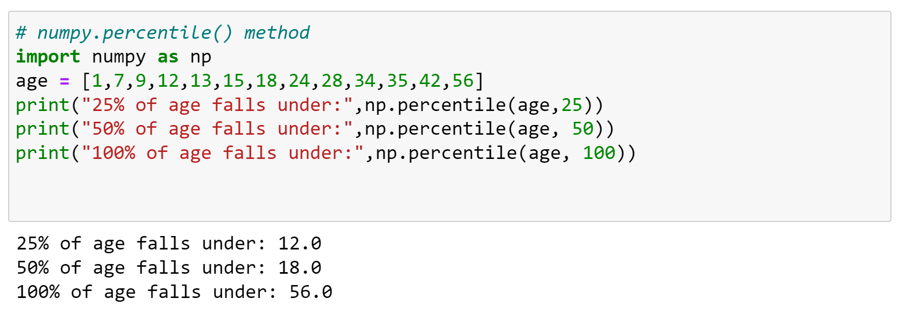

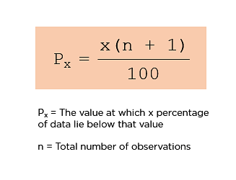

**P50** == 50 (13+1) / 100= 7 (7th position)= **18**

**P25** = 25(14)/100 = 3.5 = 3rd & 4th position

= (9+12)/2 = 10.5 = value near to 10.5 = **12**

1. **Quartile** a quartile is a type of quantile which divides the number of data points into four parts, or quarters, of more-or-less equal size.

**Link :** [**https://towardsdatascience.com/what-are-quartiles-c3e117114cf1**](https://towardsdatascience.com/what-are-quartiles-c3e117114cf1)

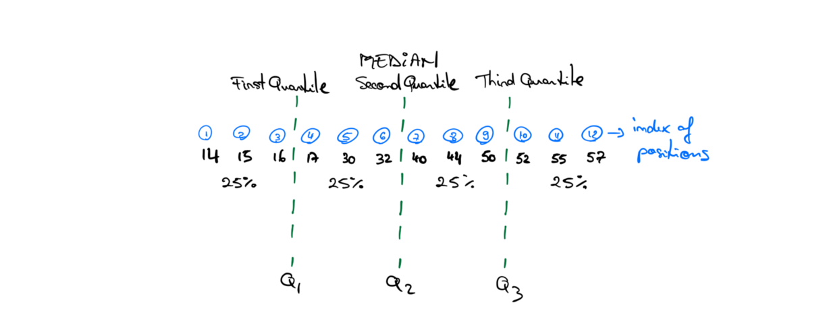

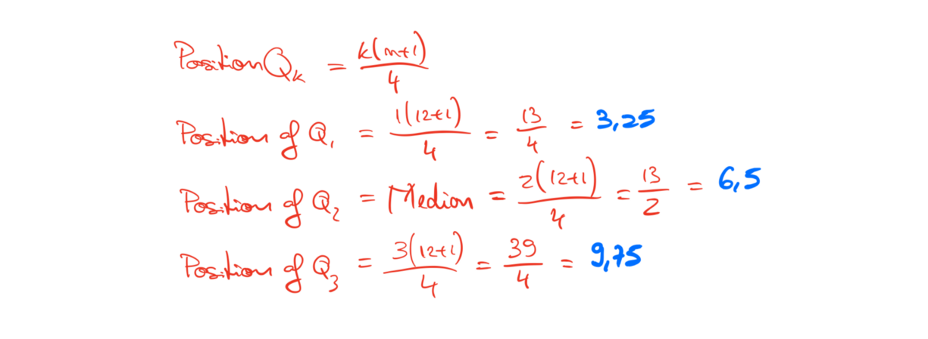

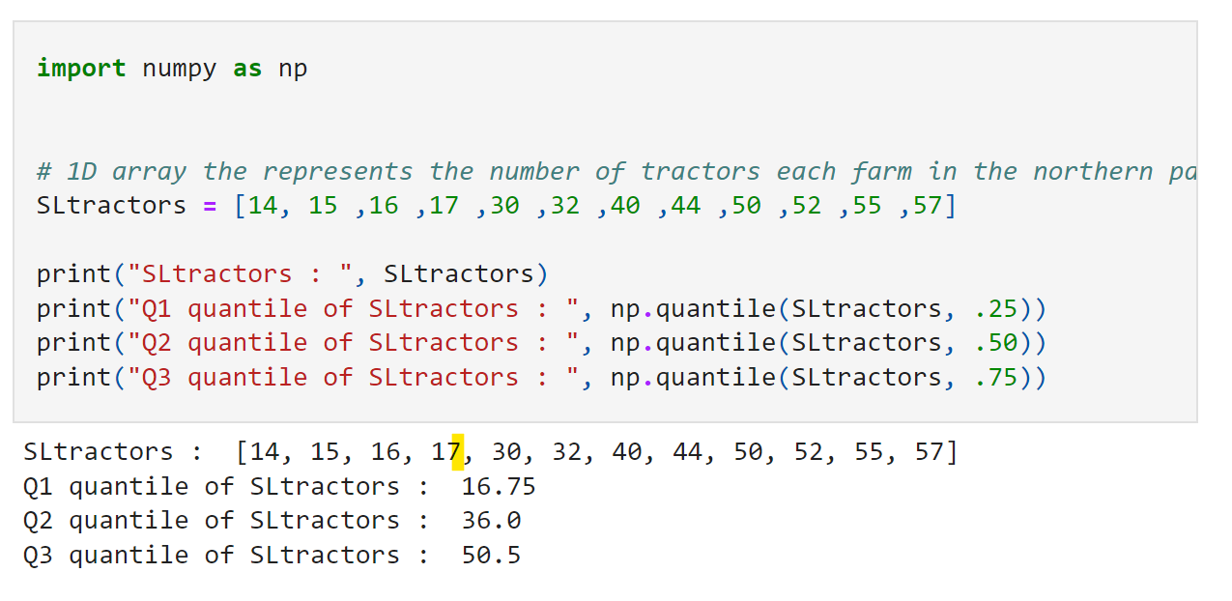

1. **Mean, Variance, SD,Mode, Median,** all the operations included in first lab program
2. **fillna()-** The fillna() method replaces the NULL values with a specified value. The fillna() method returns a new DataFrame object unless the inplace parameter is set to True , in that case the fillna() method does the replacing in the original DataFrame instead.

