TRAINING REPORT

Training Level | P60 ZBX OP Course
Dates of Training | 18th~ 22nd NOV 2022
Instructor | Mohamed Noaman
Project Code* | PRJ-100297-04
System Type | P60 ZBX Cargo scanning
Site of Operation* | Aqaba Main Sea Port- Jordan
Customer | Raven -GID
Course Attendees | Total 13 | Pass:  13 Operator

Document Reference Number | Title
ASE321~1 | Training Manual

- Background

The Contract exits to provide 1 week of P60 ZBX OP Training - on Rapiscan Systems| AS&E Cargo Inspection Systems at Aqaba- Sea port -Jordan

The P60 ZBX inspection system Operator Training Course is essential for personnel assigned to work with a scanner system, so that they can effectively operate the system, acquire scanned images and use knowledge and image interpretation skills to identify contraband and anomalies in inspection targets.
Rapiscan ASE Systems operator Training programs aim to ensure that personnel are capable to safely integrate the Scanning system operation into the Cargo Inspection process.
System capable of finding organic and nonorganic material using BX& TX Technology

- Instructor

The course was delivered by Mohamed Noaman of the Rapiscan Systems| AS&E Training department.

- Training Delivery Language

Training delivered in Arabic Language

Documentation to support training, including System Manuals, Job Aids and Students’ course notes as appropriate in were provided as E-Copy in Arabic Language.

- Training Location

Classroom training was presented at Rapiscan Office _Abu Dhabi_ UAE [Classroom with Projector and white Board]
Practical Training was given at Rapiscan Office.

- Students

A total of 13 students of GID attended the training

Trainees had previous experience
Trainees had Good Computer Skills
Trainees don’t Speak English, only Arabic

- Schedule of Training

P60ZBX OP Course was delivered according to the schedule as supplied prior to training, over a period of 5 consecutive days commencing on 18th Nov and finishing on 22nd Nov ‘22

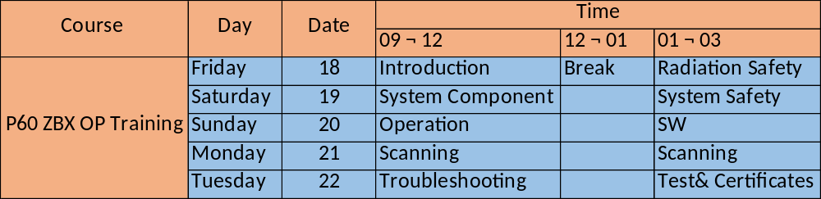

The training plan was for [1] Lesson of each of [1] day duration to a maximum audience of [13] trainees per course.
Maximum attendance limit is set to maintain safety and provide optimum practice time per individual student.

The training course as delivered consisted [1] weeks,[5] classroom days with [5] days of on-site practical exercises on the Scanner System.
Total time for the instructor including in Jordan was [7] days

- Course Completion and Certification

Certificates are awarded to students who attend all sessions of training, or sufficient sessions, and have demonstrated to the instructor that satisfactory levels of learning have been achieved to be knowledgeable, competent and confident in operating on the P60 ZBX system.

Students’ assessments by observation and verbal questioning were carried out by the instructor continuously during the training. A formal written/Practical examination was set at on the final day of the course.

Operator competence was evaluated by the students’ ability, working in groups replicating operational teams, to combine all the required tasks on the system for Operation on scanning cargo traffic, including pre-operational systems checks, start-up, shutdown, troubleshooting and emergence stops. Tasks were set to individuals during scanning operations to verify knowledge and abilities.

Certificates were awarded to 13 students. A list of all attendees and the serial number of certificates, if awarded, is shown in the table below

Summary: 13 Operator Certified :
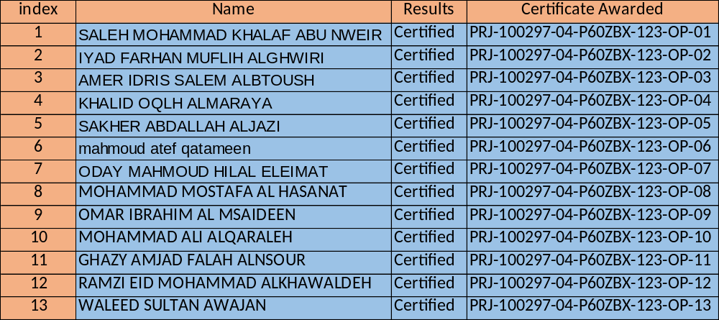

- Additional Notes and QA Issues

Notes:

E Stop Mechanical issue:
P60 Estop showing mechanical issue , reported to FSE

