**CHATBOT DEPLOYMENT WITH IBM CLOUD WATSON ASSISTANT**

PHASE 4: DEVELOPMENT PART 2

Creating the Watson Assistant chatbot with IBM Cloud.

**Img1:** Updated image of 1st page of Watson bot website.

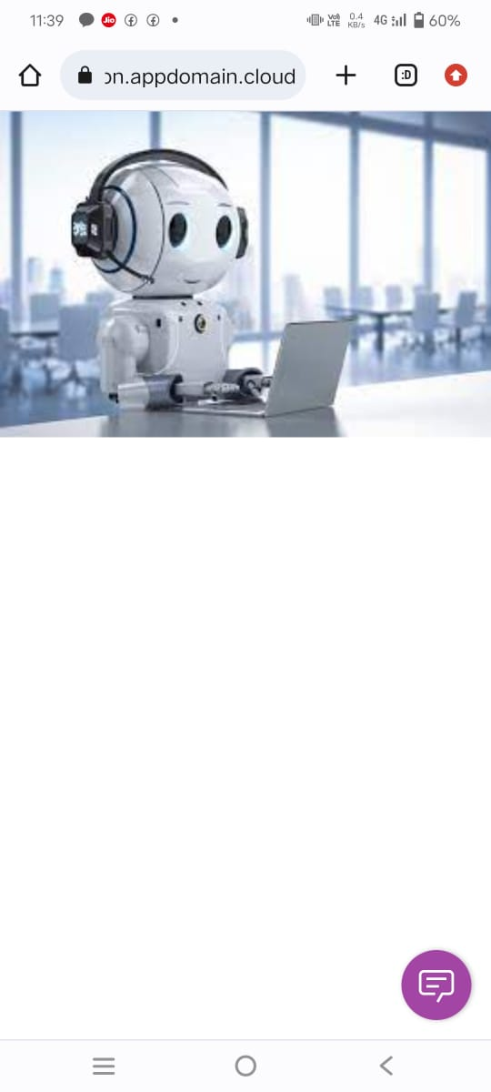

**Img2:** Trail with chatbot

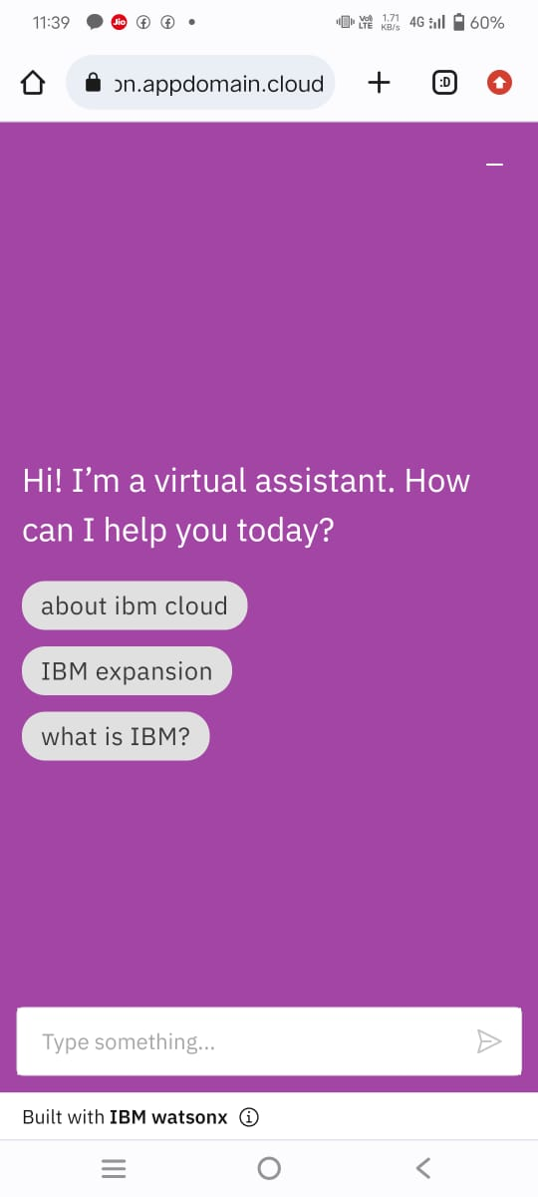

Sample questions which is trained to the Watson chatbot is mentioned in the screenshot.

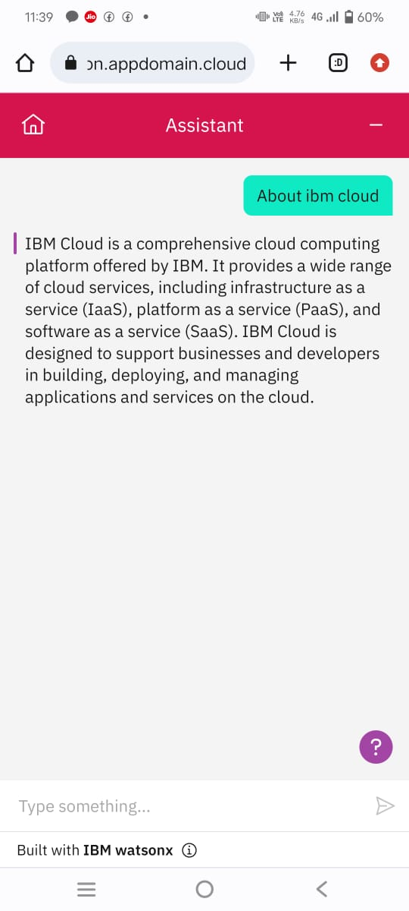

**Img3 & 4 :** Conversation with Watson bot

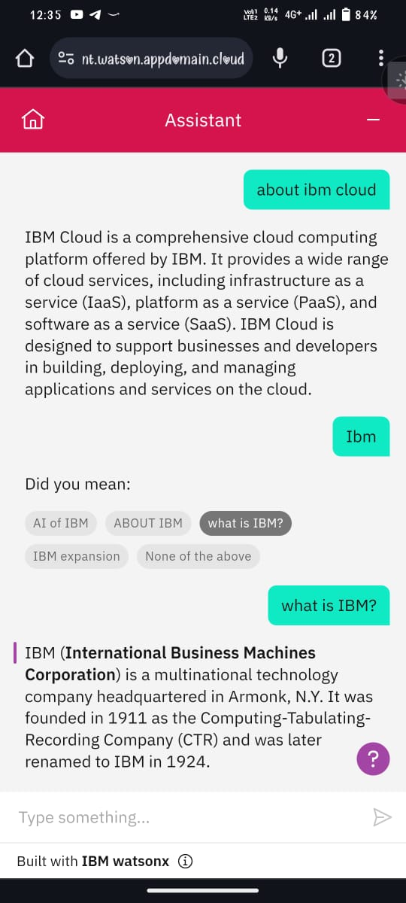

These are the samples of watson assistant chatbot by using IBM cloud.