**CHATBOT DEPLOYMENT WITH IBM CLOUD WATSON ASSISTANT**

PHASE 3: DEVELOPMENT PART 1

Creating the Watson Assistant chatbot with IBM Cloud.

**Img1:** Sample image of 1st page of Watson bot website.

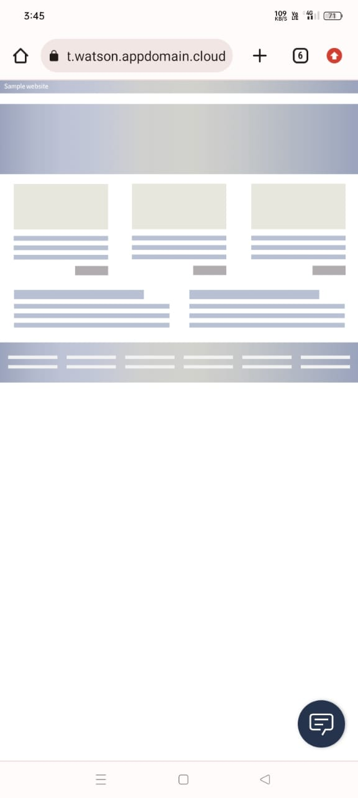

**Img2:** Trail with chatbot

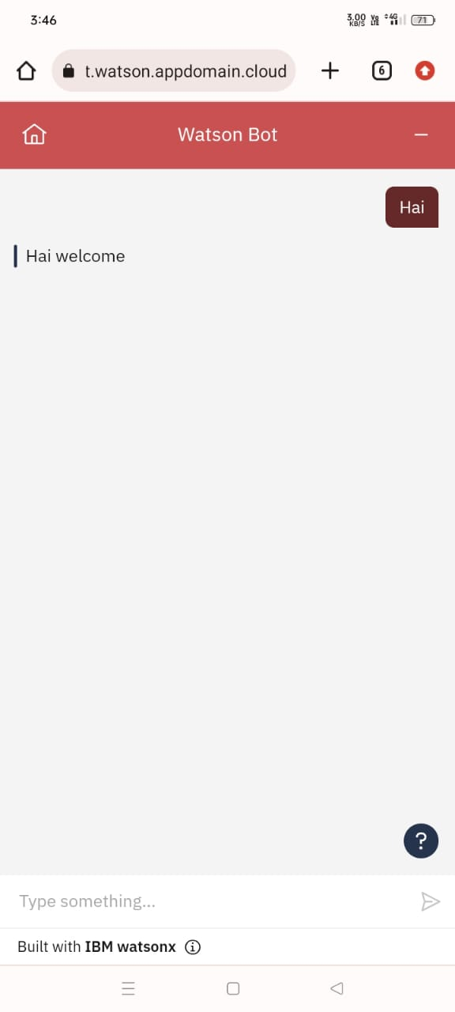

Img3 & 4 : Conversation with Watson bot

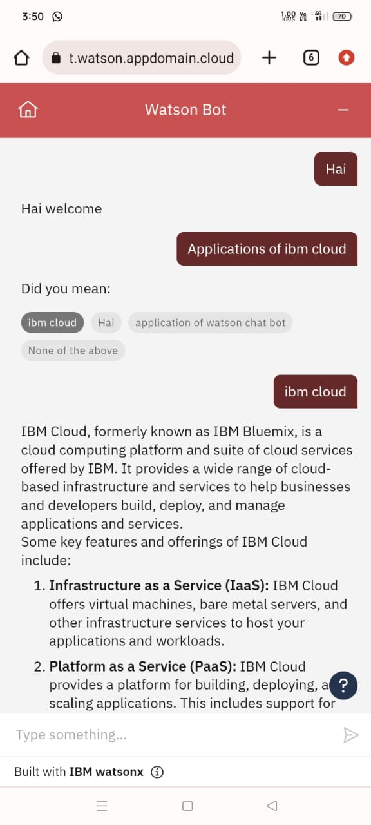

These are the samples of watson assistan chatbot .