Abstract:

This document outlines the implementation of a Salesforce-based solution for HandsMen Threads, a growing fashion brand. The aim of the project is to enhance the company’s business operations by building a robust and scalable CRM system using Salesforce. The project involves creating custom objects, automating workflows, managing data security, and developing features like loyalty programs, inventory tracking, and order confirmations. The work is performed within a Salesforce Developer Org to simulate a real-world enterprise environment.

Objective:

The primary objective of this project is to:

* Create a structured CRM solution tailored to the business needs of HandsMen Threads.
* Improve customer engagement and operational efficiency.
* Integrate automation in order processing and stock management.
* Implement data integrity mechanisms using validation rules and flows.

Technology Description:

The solution is developed using the Salesforce Lightning Platform, employing the following technologies:

* **Custom Objects & Fields** for business data modeling
* **Validation Rules** to enforce data integrity
* **Lightning App Builder** for intuitive UI creation
* **Flows & Process Builder** for automation
* **Apex & Triggers** for advanced logic
* **Permission Sets, Roles, and Profiles** for data security
* **Email Templates** for customer communication
* **Batch Apex** for scheduled bulk data processing

Detailed Execution:

1. **Developer Org Creation**

* Created a Salesforce Developer Org using <https://developer.salesforce.com/signup>
* Verified the email and set up security questions.
* Selected role: Developer | Country: India
* Username in the format: username@organization.com

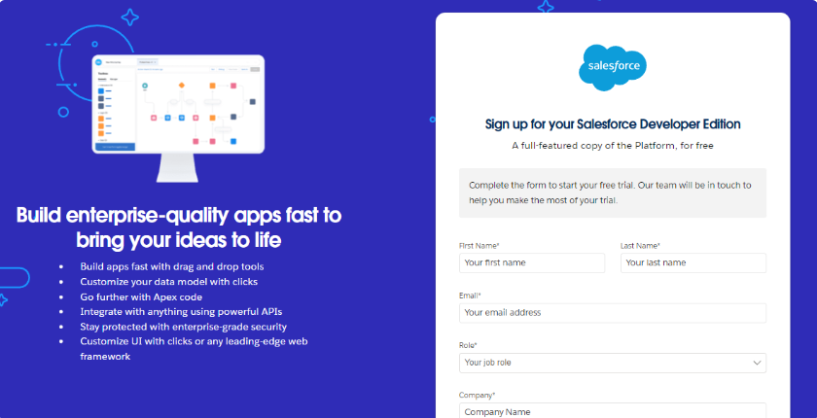

**2. Custom Object Creation**

The following custom objects were created using **Object Manager**: Custom objects were created to reflect the unique business entities of HandsMen Threads such as HandsMen Order, Inventory, Marketing Campaign, HandsMen Customer, and HandsMen Product. Each object was configured with auto-number or text-type primary fields and enabled for reporting and global search. These objects form the foundation of the data model in the application.

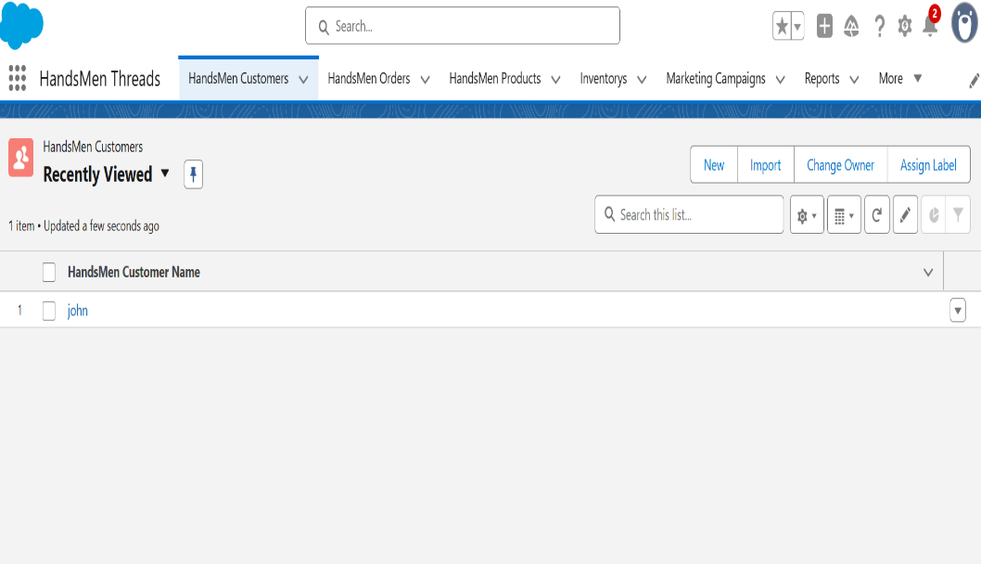

**3. Custom Tabs Creation**

* Created custom tabs for easy navigation:
  + HandsMen Customer
  + HandsMen Order
* Tab styles selected and assigned to default profiles.

**4. Lightning App Creation**

* Created a **Lightning App** using the **App Manager**
* Added relevant objects and tabs to the app layout.
* Set object visibility and default landing tab

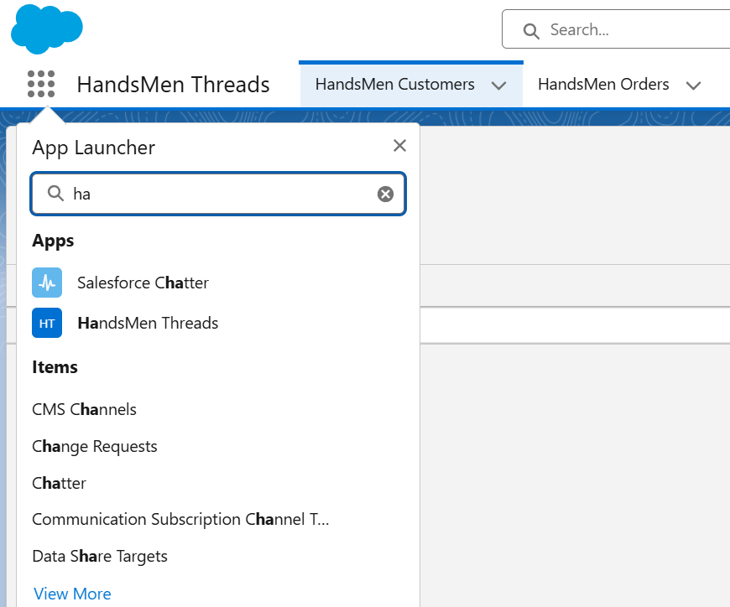

**5. Data Validation Rules**

* Applied field-level validation (e.g., customer name must not be blank).
* Used formula-based validation to ensure correct data formatting.

**6. Flows (Record-Triggered Automation)**

* Created **Record-Triggered Flows** to automate business processes:
  + Send confirmation email on new order creation.
  + Update loyalty points after each purchase.
  + Alert warehouse when inventory < 5 units.

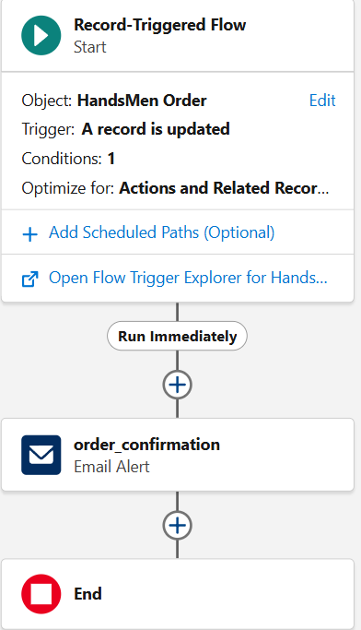

**7. Email Template Configuration**

* **Designed email templates for:**
  + **Order confirmation**
  + **Stock alert**
  + **Loyalty program updates**

**8. Apex & Automation**

* Created simple **Apex triggers** to update related fields.
* Developed scheduled **Batch Jobs** to process bulk orders at midnight.

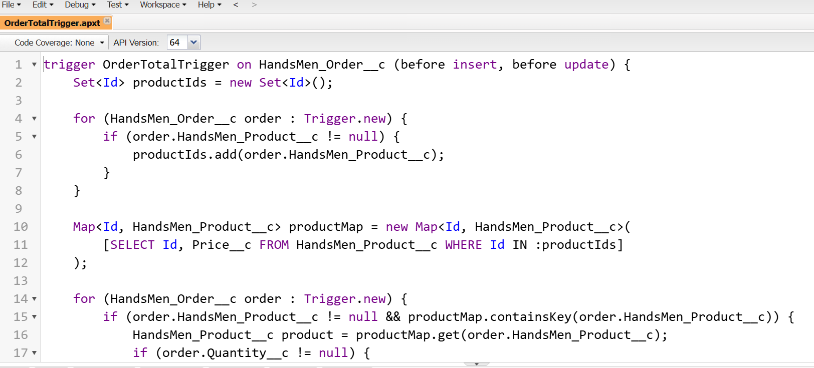

**9. Data Security Configuration**

* Configured **Profiles, Roles, Users, and Permission Sets**
* Controlled access to records and fields as per role hierarchy.

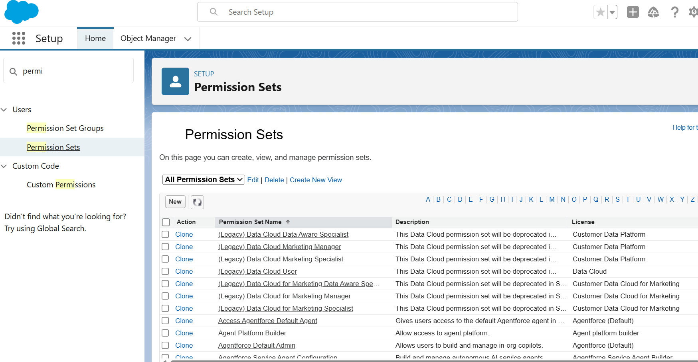

**Conclusion:**

This Salesforce project provides HandsMen Threads with a centralized, automated, and scalable system for managing customers, products, inventory, and marketing campaigns. All modules were built with a focus on usability, data accuracy, and efficiency. The platform enables the business to make informed decisions and deliver better customer service through real-time automation.

**Future Scope:**

* Integration with **third-party payment gateways** for seamless transactions
* Implementation of **Einstein Analytics** for smart customer insights
* **Mobile App development** using Salesforce Mobile SDK
* Use of **Communities** to build customer self-service portals
* Expand loyalty programs with AI-driven recommendations

**Submitted by:**  
**Peddinti Rohini**  
**B.Tech – Electronics and Communication Engineering (ECE)**  
**Srinivasa Ramanujan Institute of Technology (SRIT)**  
**Date:** 27/07/2025