Jenkins Migration Factory
Architecture & Design Document
Platform Engineering | Internal Developer Platform
June 2026 | Status: Design Complete — Build Not Started
Author | Platform Engineering
Date | June 16, 2026
Status | Design complete — build not started
Audience | Platform Engineering team, Architecture Review
ROI Target | $40M saved (100K pipelines × 4 hrs × $100/hr) + Jenkins license elimination

1. Executive Summary

The Jenkins Migration Factory (JMF) is a self-service platform built on Harness IDP and Harness Solutions Factory (HSF) that enables every application team to migrate their Jenkins pipelines to Harness — without requiring platform team involvement for each migration.

At 100,000 pipelines across the organisation, manual migration is not feasible. JMF shifts the migration work to the teams who own the pipelines, with AI-assisted conversion handling the heavy lifting and a built-in validation loop ensuring quality before a pipeline is marked as migrated.

Metric | Value
Pipeline count | ~100,000 Jenkins pipelines
Manual effort avoided | 400,000 hours (4 hrs × 100K)
Financial ROI | $40M at $100/hr blended rate
Additional saving | Full Jenkins license elimination
Migration model | Self-service with AI assist; no platform team per-migration

2. Architecture Overview

JMF comprises four logical layers: data sources, the IDP catalog, self-service workflows, and HSF-managed Harness project provisioning. Teams interact exclusively through IDP; all infrastructure runs on the existing Harness delegate.

Layer summary
Layer | Description
Data sources | Jenkins REST API + GitHub repos (Jenkinsfiles). Discovery pipeline scans both and seeds the catalog.
IDP catalog | One Component entity per Jenkins pipeline. Status lifecycle: pending → converted → validated → migrated. System entities accumulate SYSID-level counters.
IDP workflows | Three self-service workflows: Discover, Convert, Validate. Teams never leave the IDP portal.
HSF | Provisions one Harness project per SYSID via IaCM/Terraform. Runs once per SYSID on first migration.

3. Component Detail

3.1 Catalog Schema

Every Jenkins pipeline is represented as a Component entity in the IDP catalog. A SYSID-level System entity aggregates migration progress counters for that application system.

Component annotations:
- migration/status — pipeline state: pending | converted | validated | migrated
- migration/jenkins-url — direct URL to the Jenkins job
- migration/jenkinsfile-path — path to Jenkinsfile in the GitHub repo
- migration/github-repo — owner/repo reference
- migration/harness-pipeline-id — populated after successful conversion
- migration/attempts — count of validation runs
- migration/migrated-date and migration/migrated-by — set automatically on pass

3.2 Pipelines
Pipeline | Trigger | What it does
jenkins_discovery.yaml | Workflow 01 | Scans Jenkins API + GitHub. Seeds catalog entities with status=pending.
jenkins_conversion.yaml | Workflow 02 | Fetches Jenkinsfile. Runs rule engine → AI pass. Creates draft Harness pipeline YAML.
jenkins_validation.yaml | Workflow 03 | Triggers converted pipeline. Polls result. Updates catalog status to validated or surfaces failure details for fine-tune loop.

3.3 AI Conversion Stack

Conversion is a two-stage process. A deterministic rule engine handles the 80% of patterns that are predictable; the AI handles the remaining complex cases.

- Stage 1 — rules_converter.py: handles checkout, build, test, Docker, and deploy stages via pattern matching. Zero API cost, millisecond latency.
- Stage 2 — ai_converter.py: handles complex Groovy scripting, shared library calls, and custom DSL. Uses Anthropic Claude API (interim) with a planned migration to AWS Bedrock Claude once licensed.
- Merge: outputs from both stages are merged into a single Harness pipeline YAML.
- Fine-tune: if validation fails, the AI receives the original Jenkinsfile + previous YAML + failed step + error message + team notes. Each iteration converges on a more accurate result.
- Secrets: Anthropic API key stored at vault://secret/migration/anthropic_api_key via HashiCorp Vault.

Recommendation: implement ai_client.py as an abstraction layer with a provider interface from day one. This eliminates a refactor when switching from Anthropic API to AWS Bedrock.

3.4 Validation Fine-Tune Loop

No manual "mark migrated" step exists. A pipeline pass triggers an automatic status promotion to migrated. The loop is:
- Team triggers validation via Workflow 03.
- On failure: IDP surfaces the failed step, error message, and link to full logs.
- Team enters notes describing what needs to change.
- Re-conversion runs with original Jenkinsfile + prior YAML + failure context + notes as AI input.
- New YAML is validated. Loop repeats until pass.
- On 3+ consecutive failures: auto-escalation email sent to platform team.

3.5 Scorecard (per SYSID)
Check | Pass condition
Discovery run | ≥1 pipeline entity exists for this SYSID
Conversion started | ≥1 pipeline has status=converted
Validation passed | ≥1 pipeline has status=validated
Migration 25% | % migrated ≥ 25
Migration 50% | % migrated ≥ 50
Migration 100% | All pipelines migrated

4. Delivery Phases

Phase | Deliverable | Outcome
1 | jenkins_scan.py + discovery pipeline | Full pipeline inventory seeded into IDP catalog
2 | rules_converter.py | 80% of pipelines converted automatically, zero AI cost
3 | ai_converter.py + conversion pipeline | Remaining 20% complex cases handled by AI
4 | Validation pipeline + fine-tune loop | End-to-end migration loop working. Pass = auto-migrated.
5 | All 3 IDP workflows | Teams fully self-serve. No platform team involvement per migration.
6 | Scorecard + CIO dashboard | Executive visibility across 100K pipelines with SYSID-level progress.

5. Key Constraints & Decisions

Constraint | Detail
Delegate | act-delegate-k8s-ephub-p2r1 — confirmed reachable to Jenkins API and GitHub
Jenkinsfile source | GitHub repos (canonical). Jenkins API used for job metadata and live execution status.
Project scoping | One Harness project per SYSID. HSF provisions via IaCM if project does not already exist.
Secrets | All secrets via HashiCorp Vault. Anthropic API key at vault://secret/migration/anthropic_api_key
Notifications | Email API only. Auto-escalation to platform team triggered after 3 consecutive validation failures.
AI provider | Anthropic Claude API (interim). Migrate to AWS Bedrock Claude when licensed. Implement via abstraction layer from Phase 3.

6. Open Questions

- Jenkins API pagination: Does the Jenkins instance expose a bulk job list endpoint, or is paginated crawling required? Plan for rate limits and checkpoint/resume in jenkins_scan.py.
- Source of truth conflict: What happens when a Jenkinsfile exists in GitHub but is not registered in Jenkins (or vice versa)? Recommend: GitHub as canonical source, Jenkins as live execution record.
- Harness project pipeline limits: With some SYSIDs having hundreds of pipelines, confirm Harness project-level pipeline limits will not create bottlenecks.
- Decommission workflow: When does the Jenkins job get disabled post-migration? Recommend adding migration/decommission-date annotation and a Phase 7 stub so the CIO dashboard can report true completion (migrated AND Jenkins job retired).

7. Architecture Diagram

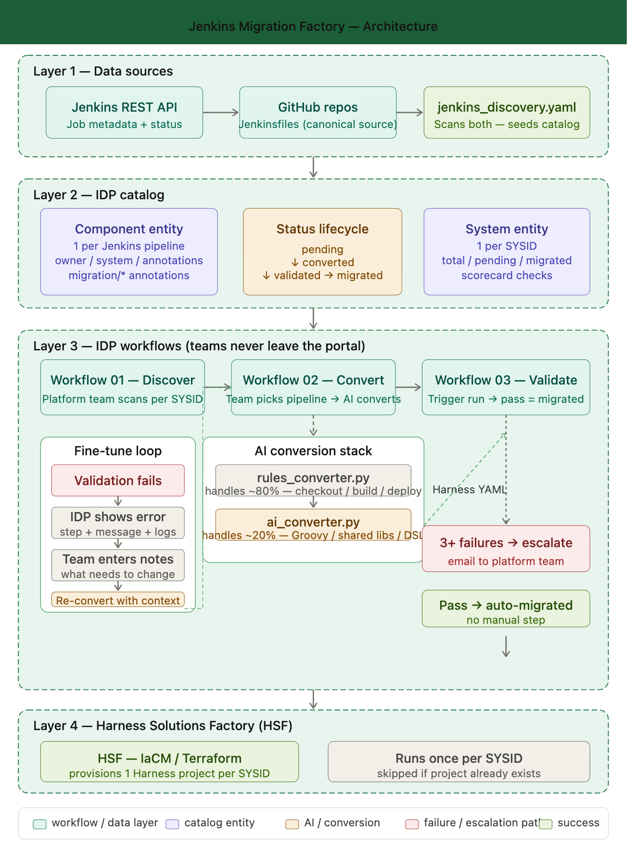
See attached SVG diagram: Jenkins-Migration-Factory-Architecture.svg

The diagram shows the four-layer architecture and the three-workflow lifecycle (Discover → Convert → Validate) with the fine-tune feedback loop and auto-escalation path.

