Access & Authorization Flow
IDP Catalog — Design Document, Section 12
Author: Rohid | Program: RTB — Internal Developer Platform (Harness IDP)
Status: Draft for review | Version: 0.1
Everyone authenticates through Okta. Both Workflows and Catalog are account-level surfaces — visible to every authenticated user with no per-user gating at that stage. Access control happens further down each path, and differently for each.

System overview
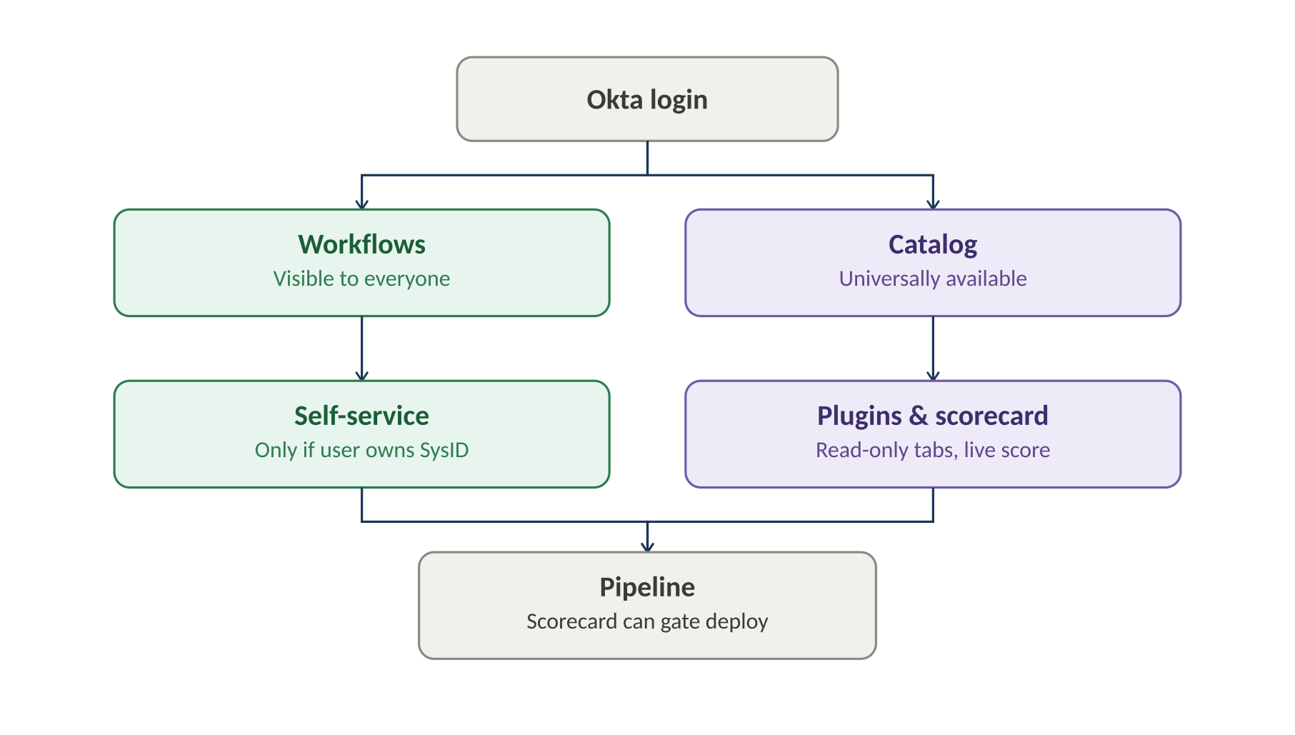
Okta login splits into the two account-level surfaces. Workflows require SysID ownership before self-service unlocks; Catalog is open to browse via plugins, including the live scorecard. Both paths converge on pipeline execution, where the scorecard can act as a governance gate.

Workflow path — SysID authorization and pipeline trigger
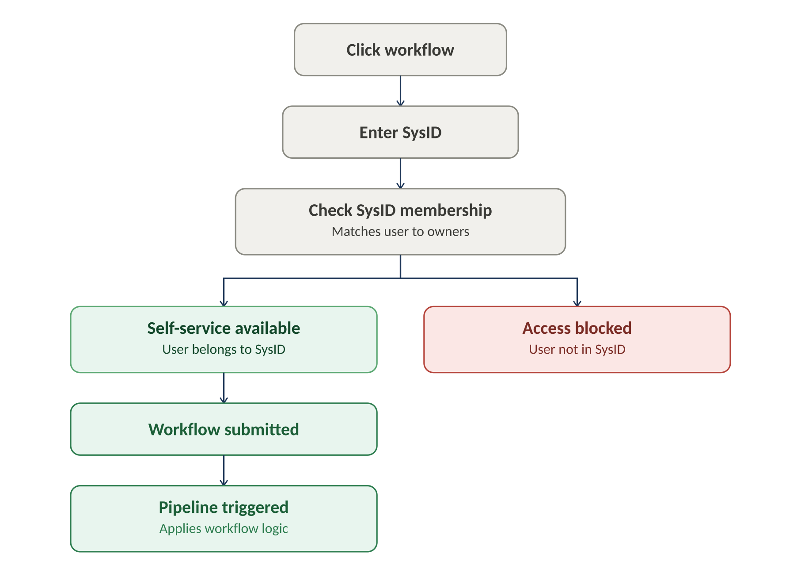
- A user clicks a workflow and enters a SysID.
- The system checks whether the user belongs to that SysID.
- If they do, self-service is available; if not, access is blocked.
- Submitting the workflow triggers a Harness pipeline that applies the workflow's logic (e.g. AD group provisioning, K8s namespace onboarding).

Catalog path — plugin tabs and scorecard governance gate
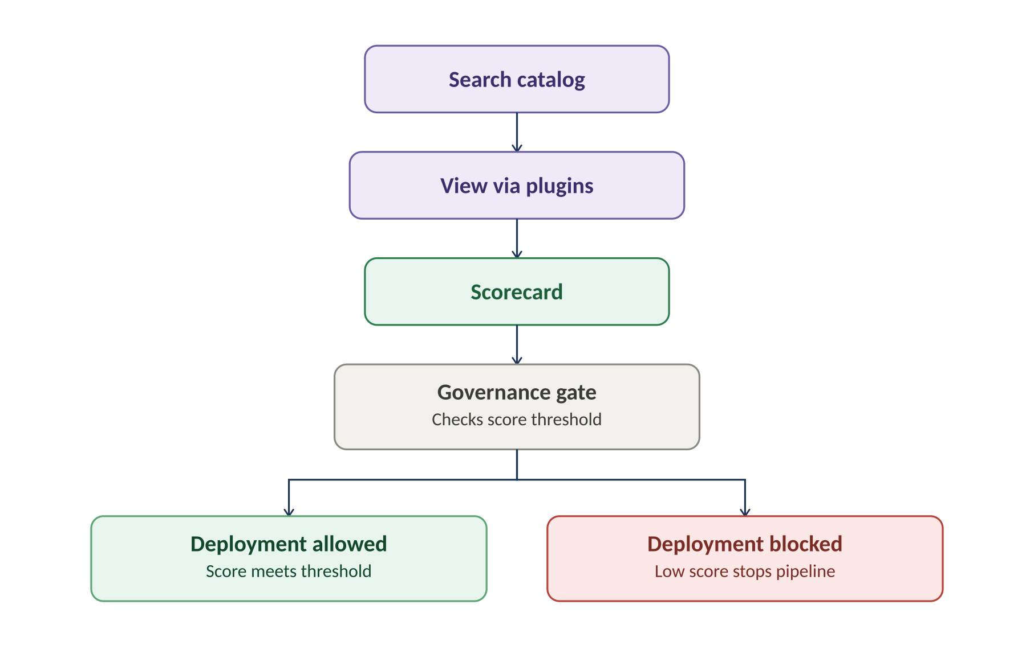
- Any user can search or browse the catalog — no SysID membership required to view.
- Entities are viewed through the read-only plugin tabs.
- Each entity's scorecard is visible directly inside the catalog.
- The scorecard doubles as a governance gate: a pipeline can check the score before allowing deployment, blocking it if the score is too low.

