

|  |  |  |  |
| --- | --- | --- | --- |
| Academic Year | 2021 | | |
| Semester | Fall | Winter | Summer |
| Course Code - Name | BAN130 | | |
| Instructor | Dr. Jemisa Sadiku | | |
| Assessment | Projects |  | |
| Date | Friday, December 03, 2021 | | |

|  |  |  |
| --- | --- | --- |
| **Student ID** | **Student Name** | **Role** |
| 111062212 | Rohil saluja | Group Lead |
|  |  | Member |
|  |  | Member |
|  |  | Member |
|  |  | Member |

1. Data Import
   * This phase requires you to import the data from the provided excel file into SAS using Proc Import.
     + Product sheet in excel file should be imported as Product dataset in SAS.
     + SalesOrderDetail sheet in excel file should be imported as SalesOrderDetail dataset in SAS

Code:

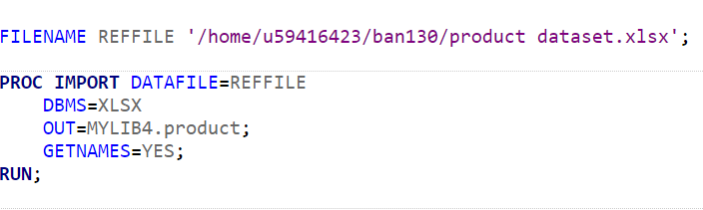

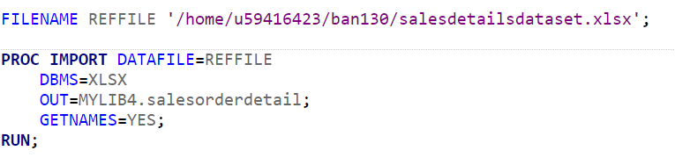

1. Data Cleaning
   * This phase requires you to clean your data before data analysis phase.
     + Product_Clean:
       - Create a Product_Clean dataset from Product dataset by bringing in only ProductID, Name, ProductNumber, Color and ListPrice
       - All the missing values in Color column should be replaced by ‘NA’
       - ListPrice column should be numeric (final column name should be ListPrice) and format should have a dollar sign with 2 decimal places

No un-necessary columns should be part of the Product_Clean dataset.

CODE:

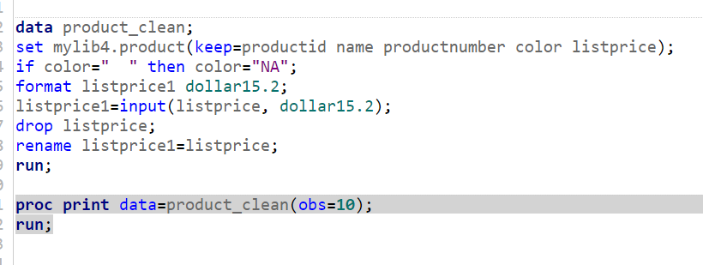

OUTPUT:

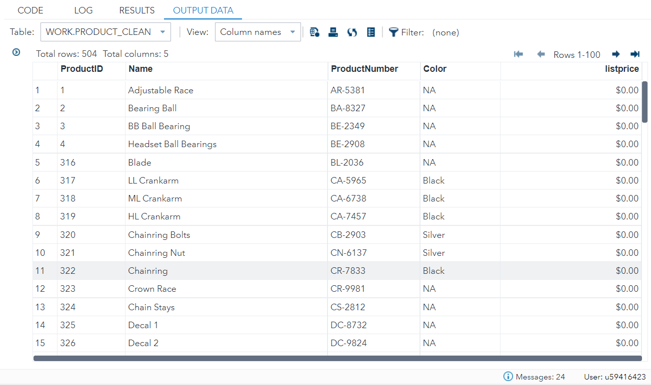

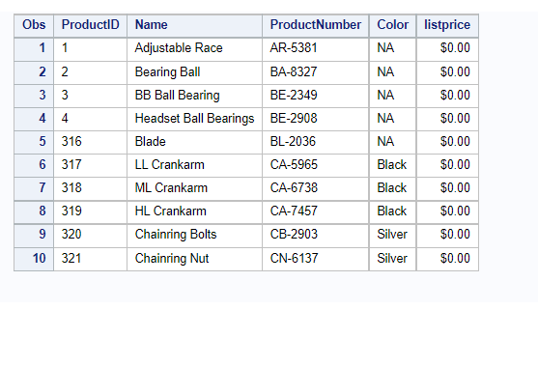

* + - SalesOrderDetail_Clean:
      * Create SalesOrderDetail_Clean dataset from SalesOrderDetail dataset by bringing in only SalesOrderID SalesOrderDetailID OrderQty ProductID UnitPrice LineTotal and ModifiedDate
      * ModifiedDate should be numeric with column name ModifiedDate
      * UnitPrice should be numeric with column name UnitPrice
      * LineTotal should be numeric with column name LineTotal
      * OrderQty should be numeric with column name OrderQty
      * Include date for year 2013 and 2014 in ModifiedDate only
      * ModifiedDate should be mmddyy10. Format
      * UnitPrice and LineTotal should have a dollar with 2 decimal places

No un-necessary columns should be part of the SalesOrderDetail_Clean dataset.

CODE:

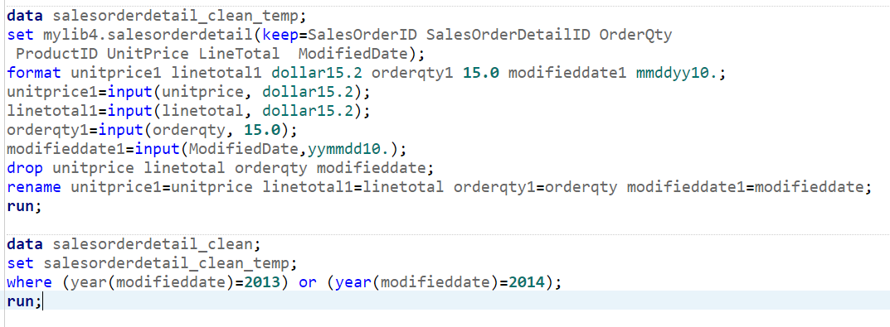

OUTPUT:

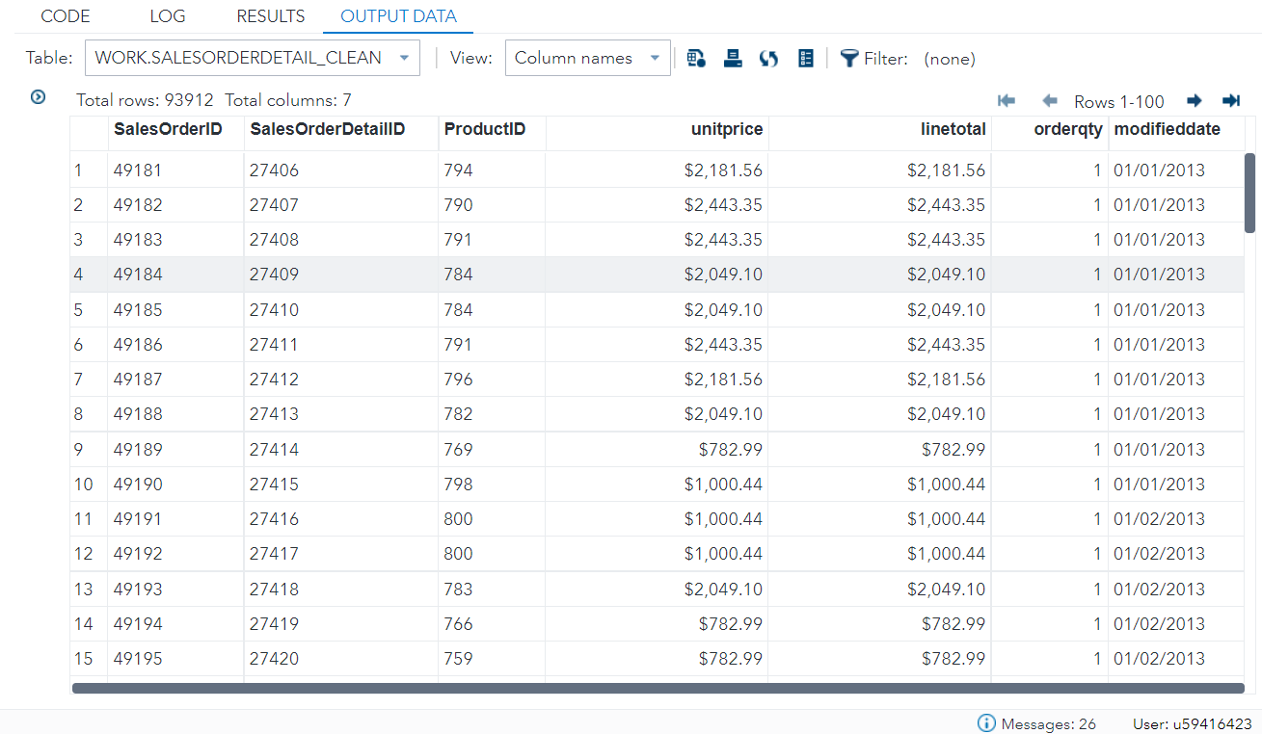

1. Joining and Merging
   * This phase requires you to join / merge your datasets to create a dataset for analysis.
     + SalesDetails:
       - Create a SalesDetails dataset by joining SalesOrderDetail_Clean and Product_Clean datasets
       - Use ProductID column for joining the tables
       - SalesDetails table should contain all the observations from SalesOrderDetail_Clean table along with columns from Product_Clean

Drop SalesOrderID SalesOrderDetailID ProductNumber and ListPrice from the result dataset.

CODE:

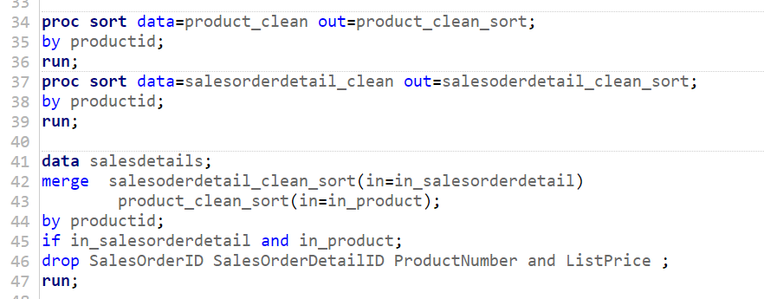

OUTPUT:

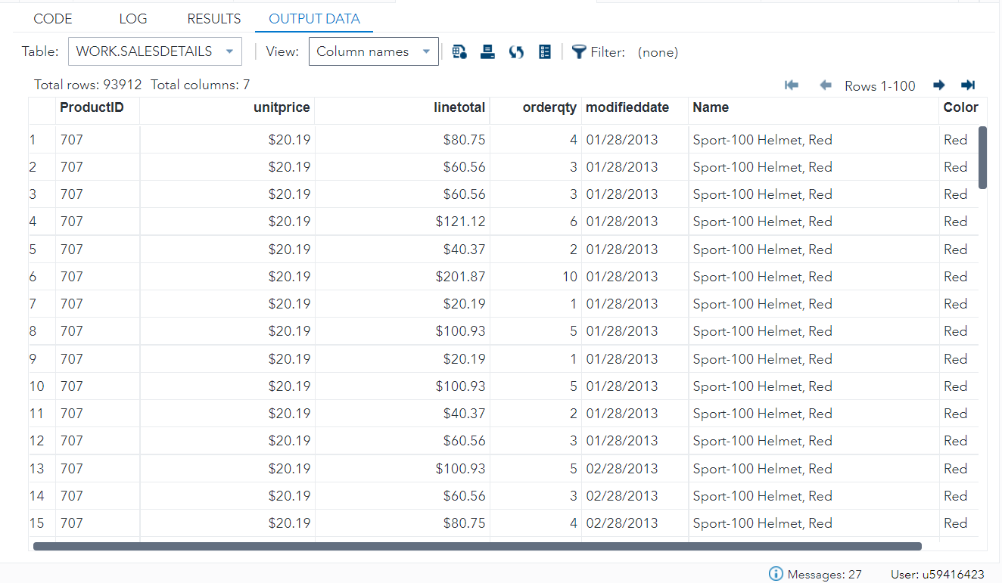

* + - SalesAnalysis:
      * Create a SalesAnalysis dataset from SalesDetails dataset that groups all the products by ProductID (hint: research on obtaining a total for each by group in SAS)
      * Create a SubTotal column in SalesAnalysis that provides an aggregate sum of each product by its ProductID.
      * SubTotal column should have a dollar and 2 decimal places.

CODE:

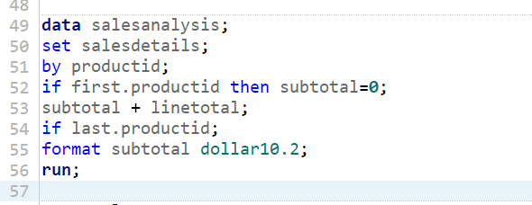

OUTPUT:

H 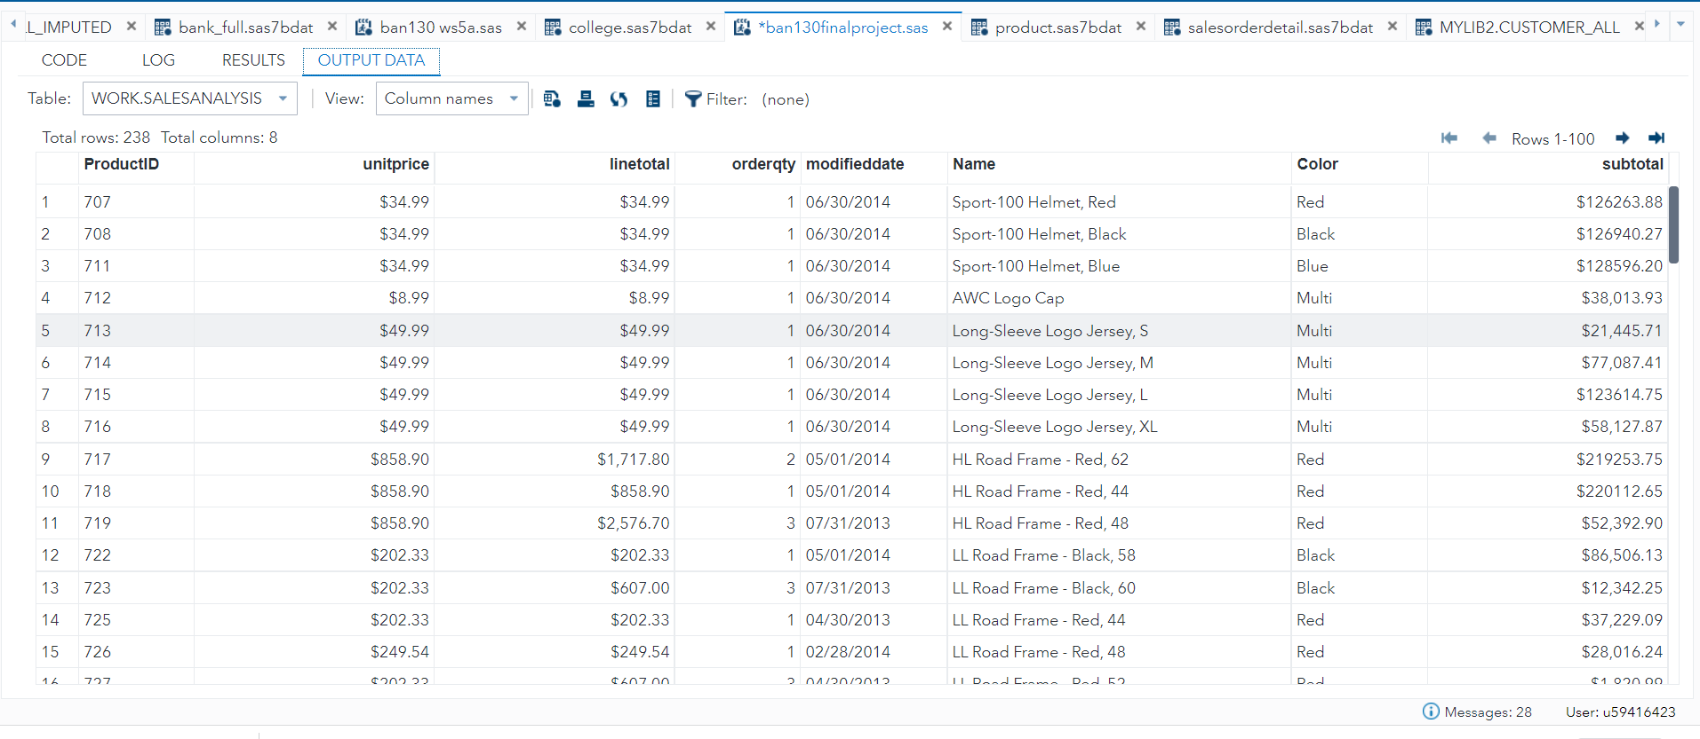

1. Data Analysis
   * This phase requires you to analyze the SalesAnalysis for Adventure Works and answer the following 5 questions by generating reports using Proc Print for each of the 5 questions:
     + How many Red color Helmets are sold in 2013 and 2014?
     + How many items sold in 2013 and 2014 have a Multi color?
     + What is the combined Sales total for all the helmets sold in 2013 and 2014?
     + How many Yellow Color Touring-1000 where sold in 2013 and 2014?
     + What was the total sales in 2013 and 2014?

Create at least one chart in SAS for any analysis of your choice from SalesAnalysis dataset

Q1 CODE:

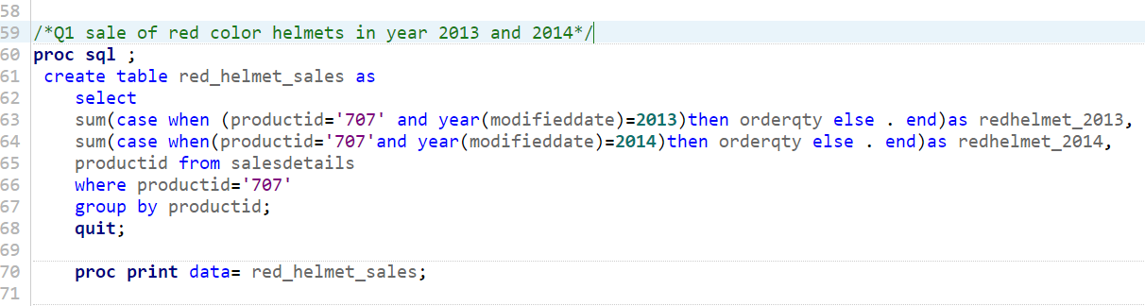

OUTPUT:

: 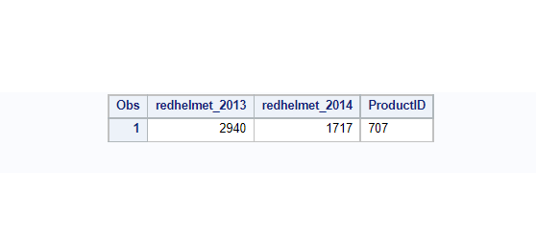

CODE: 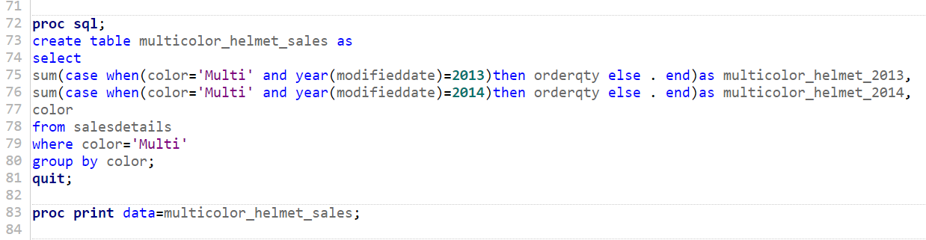

Q2

Code:

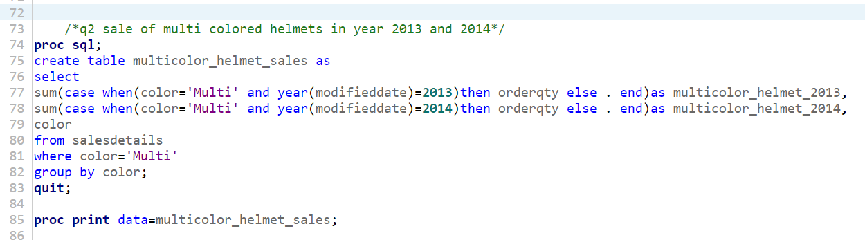

OUTPUT:

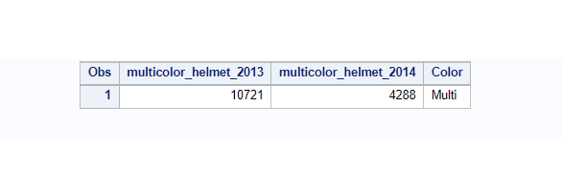

Q3

CODE:

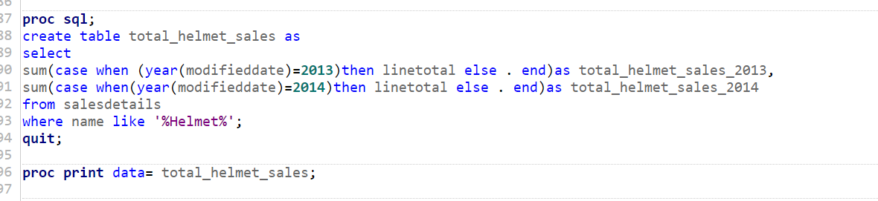

OUTPUT:

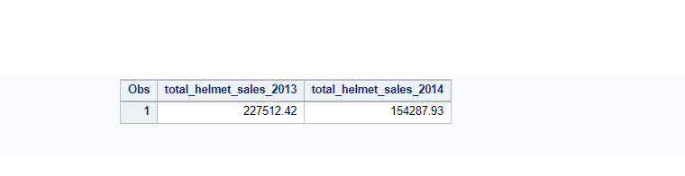

Q4

CODE: 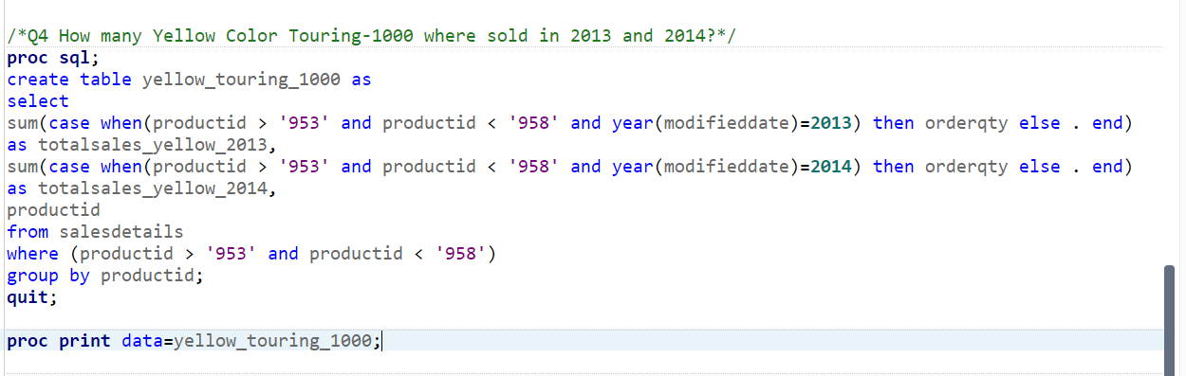

OUTPUT:

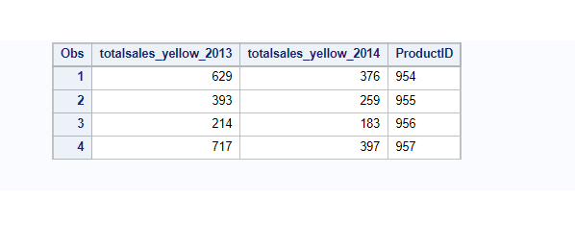

Q5 CODE: 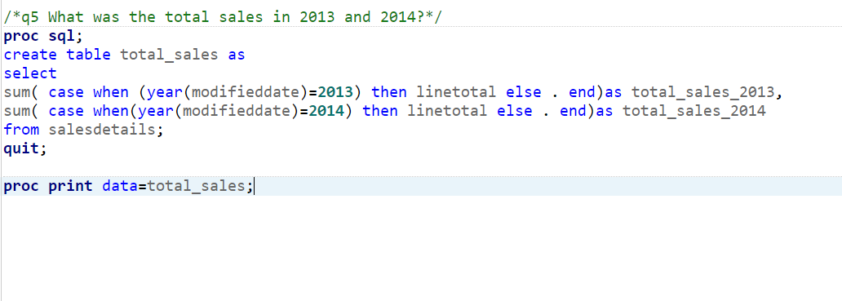

OUTPUT:

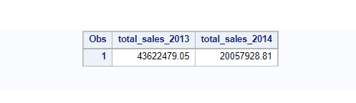

CHART for analysis

Code:

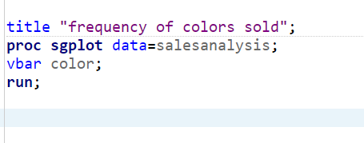

Output:

