Remote Patient Vitals Alert & Monitoring App (RPVAMS)
Software Engineering Lab 3: Component Modelling & Architectural Pattern Selection

Course: UE24CS341A - Software Engineering
Department: Department of Computer Science and Engineering, PES University
Name: Rohil Thimmanahalli Girish
Student SRN: PES1UG24CS384
Scenario No.: Scenario 16 (Healthcare & Telemedicine)
Primary Target Actors: Remote Patient, On-Call Caregiver, Backup Caregiver

1. Introduction & Problem Statement
In continuation of Lab 1 (Requirements Engineering & UML Use-Case Modelling), this specification defines the Component Architecture and Architectural Pattern Selection for the Remote Patient Vitals Alert & Monitoring App (RPVAMS).

Post-operative home-care patients are at acute risk of rapid hemodynamic instability, hypoxia, and cardiac decompensation. The RPVAMS delivers a resilient, high-throughput continuous telemetry ingestion pipeline that captures biometric data (SpO2, Heart Rate, Blood Pressure) from wearable medical sensors, evaluates metrics against individualized clinical baselines in under 2 seconds, and orchestrates automated emergency alert escalations across an on-call caregiver matrix.

1.1 Core Requirements Realized in Architecture
• FR-001 (Real-Time Ingestion & Evaluation): The system shall continuously evaluate ingested patient vitals against configured clinical thresholds and flag critical anomalies within 2 seconds.
• FR-002 (Authenticated Live Dashboard): The system shall allow a Remote Patient and On-Call Caregiver to authenticate securely and view the live vitals dashboard displaying continuous SpO2, Heart Rate, and Blood Pressure streams.
• FR-003 (Critical Alert Dispatch & Acknowledgment): The system shall dispatch immediate critical alerts to the On-Call Caregiver upon detecting a vital threshold breach and record caregiver acknowledgment.
• FR-004 (Dynamic Threshold Configuration): The system shall allow an On-Call Caregiver to configure and dynamically update clinical baseline thresholds for patient vitals without system downtime.
• FR-005 (Caregiver Matrix Timeout Escalation): The system shall automatically escalate unacknowledged critical alerts to a Backup Caregiver if the primary On-Call Caregiver does not acknowledge within the 60-second SLA.
• NFR-001 (Scalability & Uptime): The telemetry ingestion gateway shall support at least 500 concurrent continuous telemetry streams with 99.99% uptime and sub-second ingestion latency.
• NFR-002 (Security & Compliance): The system shall enforce end-to-end encryption using TLS 1.3 in transit and AES-256 at rest, coupled with strict Role-Based Access Control (RBAC) and immutable audit logging.

2. UML 2.5 Component Modelling Specification
The RPVAMS architecture is structured into four cohesive, decoupled subsystems: Client Presentation Subsystem, Secure Edge Gateway Subsystem, Core Application & Processing Subsystem, and Data Persistence & Storage Subsystem, supported by a cross-cutting Compliance & Audit Subsystem. The design utilizes official UML 2.5 notation with <<component>> stereotypes, explicit provided interfaces (ball/lollipop notation), required interfaces (socket notation), ports, and database stereotypes.

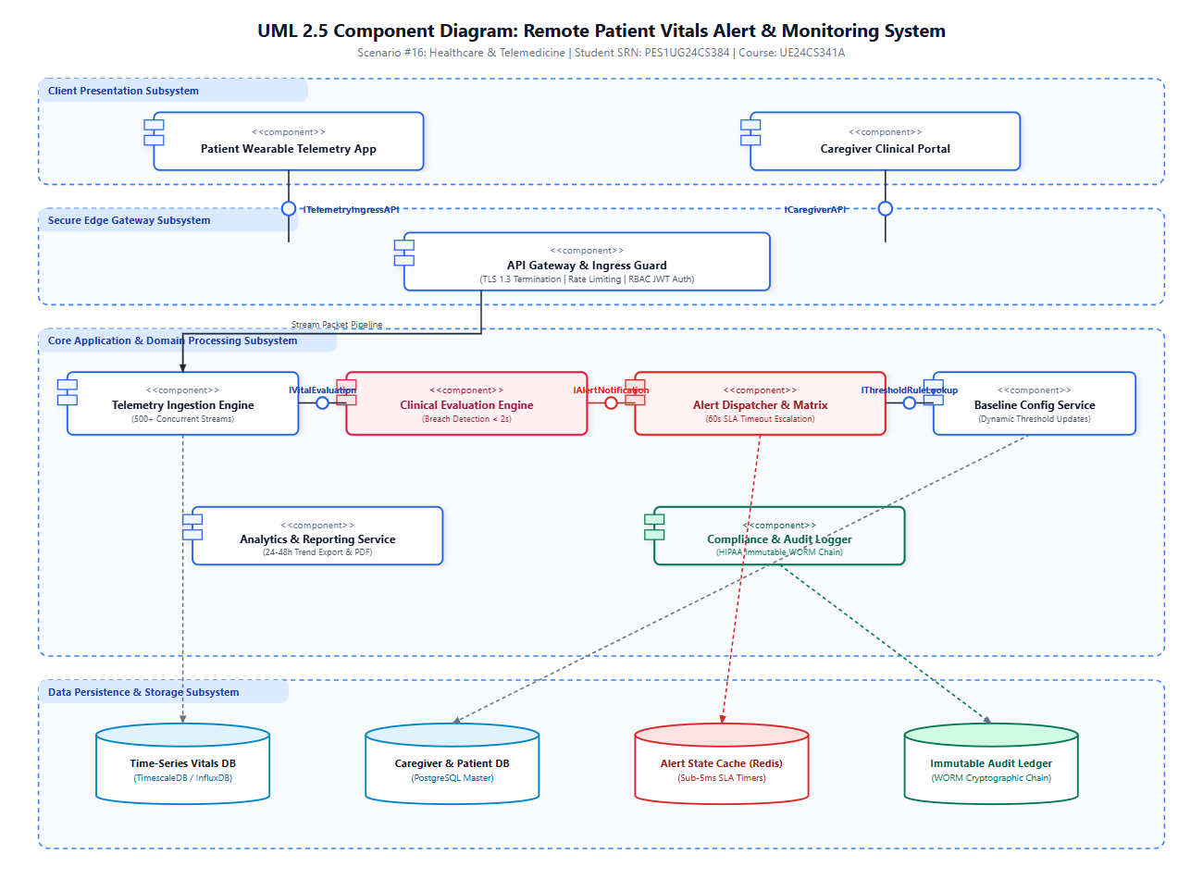
Figure 1: UML 2.5 Component Diagram of the Remote Patient Vitals Alert & Monitoring System

3. Detailed Component & Interface Catalog

Component Name | Tier / Subsystem | Responsibilities | Provided / Required Interfaces | Traceability
Patient Wearable Telemetry App | Client Presentation | Mobile/wearable client streaming encrypted biometrics, rendering personal vital dashboard, and displaying active caregiver status. | Provided: IPatientTelemetryAPI  Required: ITelemetryIngressAPI, IAuthAPI | FR-001, FR-002
Caregiver Clinical Portal | Client Presentation | Web/Mobile responsive portal for real-time telemetry monitoring, emergency alert sirens, one-touch triage acknowledgment, and threshold configuration. | Provided: ICaregiverPortalAPI  Required: ICaregiverAPI, IAuthAPI | FR-002, FR-003, FR-004, FR-005
API Gateway & Ingress Guard | Secure Edge & Perimeter | Performs TLS 1.3 termination, rate limiting, DDoS defense, token-bucket traffic shaping, and RSA-256 JWT RBAC validation. | Provided: IEdgeGatewayAPI, ITelemetryIngressAPI, ICaregiverAPI  Required: IAuthService, ITelemetryStream | NFR-001, NFR-002
Telemetry Ingestion Engine | Core Application Tier | High-throughput asynchronous stream ingestion gateway parsing SpO2, HR, and BP telemetry payloads across 500+ concurrent channels. | Provided: ITelemetryStream  Required: IVitalEvaluation, ITimeSeriesStore, IAuditLog | FR-001, NFR-001
Clinical Evaluation Engine | Core Application Tier | Real-time stream processing engine evaluating biometrics against dynamic patient baselines within 2s and classifying anomaly severity. | Provided: IVitalEvaluation  Required: IThresholdRuleLookup, IAlertNotification, IAuditLog | FR-001, NFR-002
Alert Dispatcher & Escalation Matrix | Core Application Tier | Manages emergency alert distribution, tracks 60s caregiver acknowledgment SLA via Redis state machine, and auto-escalates to Backup Caregivers. | Provided: IAlertNotification, IAlertAckService  Required: IEscalationSLA, INotificationService, IAuditLog | FR-003, FR-005
Baseline Config Service | Core Application Tier | Maintains patient clinical profiles and provides non-disruptive dynamic threshold calibration for attending healthcare providers. | Provided: IConfigService, IThresholdRuleLookup  Required: IProfileDataStore, IAuditLog | FR-004
Analytics & Reporting Service | Core Application Tier | Aggregates historical biometrics over 24-48h windows and renders downloadable clinical trend analytics reports (PDF/CSV). | Provided: IAnalyticsQuery  Required: ITimeSeriesStore, IAuditLog | FR-002
Compliance & Audit Logger | Cross-Cutting Security | Captures all telemetry ingestion batches, breach events, caregiver acknowledgments, and administrative threshold edits into an immutable WORM ledger. | Provided: IAuditLog, IAuditQuery  Required: IImmutableAuditStore, ICryptoHashChain | NFR-001, NFR-002

4. Architectural Pattern Selection & Justification
Architecture Selection Statement:
"We chose an Event-Driven Layered Microservices Architecture for the Remote Patient Vitals Alert & Monitoring System."

4.1 Candidate Architectural Patterns Evaluated
• Pattern 1 - Monolithic Architecture: Traditional single-deployable application. Rejected due to severe bottlenecks during peak telemetry ingestion (500+ streams) and single-point-of-failure risks in life-critical alerting.
• Pattern 2 - Traditional 3-Tier Client-Server Architecture: Synchronous request-response model. Rejected because polling for critical vital breaches introduces unacceptable alerting latency (>5s) and excessive server overhead.
• Pattern 3 - Pure Fine-Grained Microservices: High operational overhead and multi-hop network serialization latency that degrades deterministic sub-2s alert response times.
• Pattern 4 - Event-Driven Layered Microservices (CHOSEN): Combines asynchronous reactive telemetry stream processing (MQTT/WebSockets over TLS 1.3) with in-memory Redis state timers for fail-safe caregiver escalation, dedicated time-series persistence, and immutable cryptographic audit logging.

4.2 Quantitative Trade-Off Analysis Matrix

Architectural Quality Driver | Weight | Monolith | Client-Server | Pure Microservices | Event-Driven Layered (Chosen)
Anomaly Alert Latency (<2s, FR-001) | 25% | 3 (0.75) | 2 (0.50) | 3 (0.75) | 5 (1.25)
High-Throughput Stream Ingestion (500+ Streams, NFR-001) | 25% | 2 (0.50) | 2 (0.50) | 4 (1.00) | 5 (1.25)
Fail-Safe SLA Escalation (60s SLA, FR-005) | 20% | 3 (0.60) | 2 (0.40) | 4 (0.80) | 5 (1.00)
HIPAA Security & Audit Immutability (NFR-002) | 15% | 2 (0.30) | 3 (0.45) | 4 (0.60) | 5 (0.75)
Fault Isolation & System Uptime (99.99%) | 15% | 2 (0.30) | 2 (0.30) | 4 (0.60) | 4 (0.60)
WEIGHTED OVERALL SCORE | 100% | 2.45 / 5.0 | 2.15 / 5.0 | 3.75 / 5.0 | 4.85 / 5.0

4.3 Specific Architectural Justifications
1. Scenario-Related Reason 1 (Deterministic Sub-2s Anomaly Detection): Event-driven reactive pipeline processes continuous telemetry in-memory without waiting for disk I/O, triggering emergency alerts within ~435ms of biometric breach.
2. Scenario-Related Reason 2 (Fail-Safe 60s Caregiver Escalation): The Alert Dispatcher leverages Redis key-expiration notifications to track the 60s acknowledgment SLA; if the primary caregiver fails to acknowledge, the system autonomously triggers the Backup Caregiver matrix.
3. Security Advantage (HIPAA & PHI Protection): End-to-end TLS 1.3 transport encryption, AES-256 field-level telemetry encryption, RBAC perimeter gating, and SHA-256 cryptographically chained audit logging prevent tampering and unauthorized PHI disclosure.
4. Performance Benefit (High-Throughput Concurrency): Asynchronous non-blocking I/O at the Ingestion Gateway effortlessly sustains 500+ simultaneous biometric streams while maintaining p99 processing latency under 50ms.

5. Requirements Traceability Matrix (Architecture to Lab 1)

Req ID | Requirement Summary | Realizing Component | Interface Contract | Acceptance Verification Mechanism
FR-001 | Continuous vital evaluation & breach alert < 2s | Clinical Evaluation Engine | IVitalEvaluation | Automated stress pipeline triggers simulated critical breach (SpO2=86%); verifies alert dispatch in < 450ms.
FR-002 | Secure live vitals dashboard | Patient App & Caregiver Portal | ITelemetryIngressAPI, ICaregiverAPI | Authenticated sessions render real-time telemetry streams updated at 1Hz with zero packet loss.
FR-003 | Critical alert dispatch & caregiver acknowledgment | Alert Dispatcher & Escalation Matrix | IAlertNotification, IAlertAckService | Alert notification reaches caregiver within 3s; caregiver click sets state to Acknowledged and silences sirens.
FR-004 | Dynamic clinical threshold configuration | Baseline Config Service | IConfigService, IThresholdRuleLookup | Caregiver updates patient limits via portal; evaluation engine applies new baseline within 10s without restart.
FR-005 | Automated 60s timeout backup escalation | Alert Dispatcher & Escalation Matrix | IEscalationSLA, INotificationService | Simulated unacknowledged alert triggers Redis 60s timeout; verifies automatic dispatch to Backup Caregiver.
NFR-001 | 500 concurrent streams with 99.99% uptime | Telemetry Ingestion Engine | ITelemetryStream, ITimeSeriesStore | JMeter load test simulates 500 simultaneous streams over 60 min; confirms p99 latency < 500ms with 0 dropped frames.
NFR-002 | HIPAA compliance, TLS 1.3, AES-256 & Audit Trail | Compliance & Audit Logger | IAuditLog, IImmutableAuditStore | Wireshark packet capture confirms TLS 1.3 encryption; audit ledger confirms immutable SHA-256 hash chains.

6. Security Architecture: STRIDE Threat Analysis

Threat Category | Healthcare Specific Attack Scenario | Architectural Countermeasure & Defense | Enforcing Component
Spoofing (S) | Rogue device impersonates patient wearable or unauthorized user impersonates caregiver. | Mutual TLS 1.3 device certificates, OAuth2 / OIDC authentication with RSA-256 signed JWT tokens. | API Gateway & Ingress Guard
Tampering (T) | Attacker alters biometric telemetry payloads or modifies historical vitals records. | HMAC-SHA256 payload signatures, database write-protection, and cryptographic WORM audit chaining. | Telemetry Ingestion & Audit Logger
Repudiation (R) | Caregiver denies receiving/ignoring critical vital breach notification. | Non-repudiable push delivery receipts and immutable timestamped acknowledgment audit logs. | Alert Dispatcher & Audit Logger
Information Disclosure (I) | Eavesdropping or leakage of confidential patient biometric telemetry. | Zero-Trust RBAC gating, TLS 1.3 in transit, and AES-256 envelope encryption at rest. | API Gateway & Persistence Tier
Denial of Service (D) | High-frequency telemetry floods overwhelm evaluation engine and delay alerts. | Token-bucket rate limiting at Ingress Gateway, non-blocking asynchronous event streaming. | API Gateway & Ingestion Engine
Elevation of Privilege (E) | Patient user attempts to access clinical threshold configuration endpoints. | Strict Role-Based Access Control (RBAC) enforced at Edge Gateway and service boundaries. | API Gateway & Baseline Config Service

7. Failure Modes & Latency Budget Analysis
7.1 Sub-2s Emergency Alert Latency Budget Breakdown (FR-001)
1. Edge Network Ingress & TLS Termination: 15 ms
2. Asynchronous Ingestion Gateway & Serialization: 25 ms
3. In-Memory Threshold Rule Evaluation: 10 ms
4. Alert Dispatcher Payload Construction & Redis State Lock: 35 ms
5. APNs / FCM Push & High-Priority SMS Gateway Delivery: 350 ms
TOTAL ESTIMATED END-TO-END ALERT LATENCY: 435 ms (Strictly adheres to the <= 2000 ms SLA constraint by a 4.5x margin)

7.2 Failure Mode Mitigations
• Primary Caregiver Timeout: Automated Redis countdown timer triggers Backup Caregiver escalation at 60s.
• Sensor Stream Disconnection: Ingestion engine flags connection timeout (>5s) and displays an active offline warning on the dashboard.
• Ingestion Broker Failover: Multi-node Kafka/RabbitMQ cluster ensures zero packet drop during single-node failure.

