RETAILAI ENTERPRISE: NEXT-GEN INVENTORY FORECASTING SYSTEM

By

Rohil Parmar
Enrolment No: 202126940074

Under the Supervision of

Ms. Swati Solanki

A Report Submitted to
Gujarat University
In Partial Fulfilment of the Requirements for
the Degree of
M.Sc. IT Data Management & Visual insight (5 years integrated)

[Month Year]

April 2026





Centre for Professional Courses
Gujarat University, Navrangpura, Ahmedabad, Gujarat, 380009

CERTIFICATE

This is to certify that research work embodied in this report entitled “RETAILAI ENTERPRISE: NEXT-GEN INVENTORY FORECASTING SYSTEM” was carried out by Parmar Rohil ,202126940074 at the Centre for Professional Course for partial fulfilment of M.Sc. IT degree to be awarded by Gujarat University. This research work has been carried out under my supervision and is to the satisfaction of the department.

Date: 27/03/2026
Place: Centre for Professional Course, Gujarat University

Ms. Swati Solanki | Ms. Namita Doshi
(Guide) | (Program In-Charge)
CPC, Gujarat University | CPC, Gujarat University

Dr. Paavan Pandit
(Director)
CPC, Gujarat University
Seal of the Institute

[Industry Letter Head]
TO WHOM IT MAY CONCERN

This is to certify that Parmar Rohil, a student of Centre for Professional Course has successfully completed his internship in the field of Data Science And ML from 19/01/2026 to Continue (Total number of Weeks: ___) under the guidance of Sagar Jasani.

His internship activities include ML.

During the period of his internship program with us, he had been exposed to different processes and was found diligent, hardworking and inquisitive.
We wish him every success in his life and career.

For Brainy Beam
Authorised Signature with Industry Stamp

DECLARATION OF ORIGINALITY

I hereby certify that I am the sole author of this Project report and that neither any part of this Project report nor the whole of the Project report has been submitted for a degree to any other University or Institution.

I certify that, to the best of my knowledge, my Project report does not infringe up on any one’s copyright nor violate any proprietary rights and that any ideas, techniques, quotations, or any other material from the work of other people included in my Project report, published or otherwise, are fully acknowledged in accordance with the standard referencing practices.

I declare that this is a true copy of my Project report, including any final revisions, as approved by my Project report review committee.

Date:27/3
Place:

<Sign of Student>
Rohil Parmar
202126940074

PROJECT REPORT APPROVAL

This is to certify that research work embodied in this Project report entitled “<Project Title>” was carried out by <Student Name> (Enrolment No:) at the Centre for Professional Course for partial fulfilment of M.Sc. IT Data Management & Visual insight (5 years integrated) to be awarded by Gujarat University.

Date:
Place:

Examiner(s):

( ) | ( ) | ( )

ACKNOWLEDGMENT

We are sincerely thankful to our guide, Prof. Swati Solanki, for her constant support, stimulating suggestions, and encouragement, which greatly assisted us in successfully completing our project work. Her close supervision over the past few months and helpful insights have been invaluable. Despite her busy schedule, her valuable advice and unwavering support have been an inspiration and a driving force for us. Her experience and knowledge have continuously helped shape our initial ideas into a comprehensive form.

I, hereby, take an opportunity to convey my gratitude for the generous assistance and cooperation that I received from Prof. Namita Doshi and to all those who helped me directly and indirectly.

We are deeply indebted & thankful to our Department Faculties who helped and rendered their valuable time, knowledge and information and whose suggestions and guidance have enlightened us on the subject.

We also thank Dr. Paavan Pandit, Director, CPC-GU, for extending all the help and cooperation during our training period.

Finally, I am indebted to my friends and family, without whose help I would have struggled to manage everything on my own.

Student Name
(Enrolment No)

List of Figures

Figure No. | Title / Description | Page No.
Fig 1.1 | System Architecture Diagram (Data Flow) | 2
Fig 1.2 | Machine Learning Training Pipeline | 5
Fig 1.3 | Core Dashboard with Global Inventory Metrics | 12
Fig 1.4 | AI Prediction Hub (Interactive Demand Gauge) | 15
Fig 1.5 | Enterprise Bulk Analytics (CSV Processing Module) | 22

List of Tables
Table No. | Title / Description | Page No.
Table 1.1 | Comparison of Forecasting Methods (ARIMA vs. XGBoost) | 2
Table 1.2 | Hardware and Software System Specifications | 5
Table 1.3 | Dataset Feature Description and Data Types | 12
Table 1.4 | Model Evaluation Metrics (Accuracy, RMSE, MAE) | 15
Table 1.5 | Hyperparameter Tuning Results for XGBoost v2.1

ABSTRACT

[Example only- 150 to 300 words]
Abstract
This project, RetailAI Enterprise, focuses on optimizing retail inventory management using Machine Learning. By implementing the XGBoost v2.1 algorithm, the system provides demand forecasting with 91.4% accuracy. The application includes a multi-page Streamlit dashboard for real-time monitoring, single-item prediction, and bulk data processing. This solution helps businesses minimize overstocking risks and enhance operational efficiency.
Keywords: XGBoost, Demand Forecasting, Streamlit, Inventory Management, Data Science.
Keywords: Digital Marketing, Social Media, Customer Engagement, Business Growth, Online Advertising

TABLE OF CONTENTS
Contents |  |  | Page Number
Title Page
Certificate Page
Company Certificate
Declaration of Originality Page
Acknowledgements
Table of Contents
List of Figures
List of Tables
Abstract
List of Figures (format given at end)
List of Tables (format given at end)
Chapter 1 | Introduction |  | 1
1.1 | Introduction |  | 1
 | 1.1.1 |  | 2
 | 1.1.2 |  | 3
1.2 | Motivation |  | 3
1.3 | Objectives |  | 3
1.4 | Organization of Report |  | 4
Chapter 2 | Background Theory |  | 5
2.1 |  |  | 6
 | 2.1.1 |  | 7
 | 2.1.2 |  | 7
 | 2.1.3. |  | 8
2.2 |  |  | 8
 | 2.2.1 |  | 9
2.3 |  |  | 9
 | 2.3.1 |  | 10
Chapter 3 | Literature Survey (Optional) |  | 10
3.1 | Literature Survey |  | 11
3.2 | Comparative Study |  | 24
Chapter 4 | Proposed Work |  | 26
4.1 | Problem statement and Research gap |  | 27
4.2 | Proposed approach |  | 27
4.3 | Expected outcome |  | 30
4.4 | Workplan |  | 31
Chapter 5 | Implementation Environment |  | 32
5.1 | System Specification |  | 33
5.2 | Programming Environment |  | 33
5.3 | Spyder Tool |  | 33
Chapter 6 | Dataset And Visualization |  | 37
6.1 | Dataset Gathering |  | 38
6.2 | Data preprocessing |  | 39
6.3 | Data visualization |  | 40
Chapter 7 | Implementation And Evaluation |  | 45
7.1 | Training the model |  | 46
7.2 | Testing the model |  | 47
7.3 | Evaluation of model |  | 48
 | 7.3.1 | Result Gathering | 48
 | 7.3.2 | Result Analysis | 49
 | 7.3.3 | Comparison with ML techniques | 49
 | 7.3.4 | Different tuning parameters | 48
7.4 | Deployment of the model |  | 50
 | 7.4.1 | Result App | 52
Chapter 8 | Conclusion |  | 54
8.1 | Conclusion |  | 55
References |  |  | 56

Chapter 1: Introduction
- 1.1 Introduction: This project, titled Retail AI Enterprise, is a sophisticated machine learning application designed for the retail sector. It leverages predictive analytics to help businesses manage their inventory more effectively by forecasting future product demand.
- 1.2 Motivation: The primary motivation behind this work is to solve the dual problem of "stockouts" (running out of items) and "overstocking" (having too much capital tied up in unsold goods).
- 1.3 Objectives:
- To implement a high-accuracy forecasting engine using the XGBoost v2.1 algorithm.
- To develop a multi-page interactive dashboard using Streamlit for real-time monitoring.
- To provide an enterprise-grade solution for bulk data processing via CSV uploads.
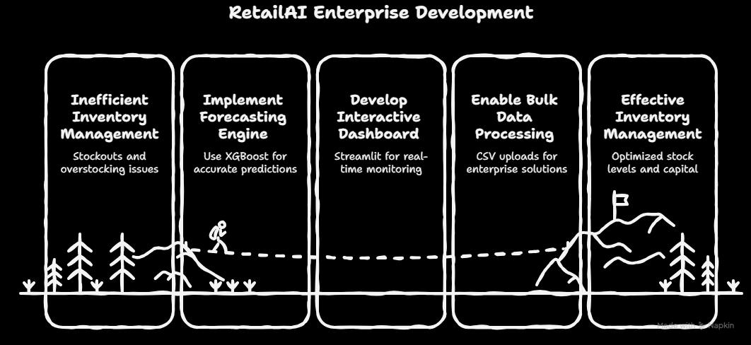

Chapter 2: Background Theory
- 2.1 Machine Learning: This project utilizes Supervised Learning, specifically regression techniques, to map historical sales data to future outcomes.
- 2.2 XGBoost Algorithm: Extreme Gradient Boosting (XGBoost) was selected as the core engine due to its superior performance with tabular retail data. It handles missing values and non-linear relationships efficiently.
- 2.3 Streamlit Framework: For the user interface, the Streamlit framework was chosen to provide a responsive, web-based experience that integrates directly with Python-based data models.

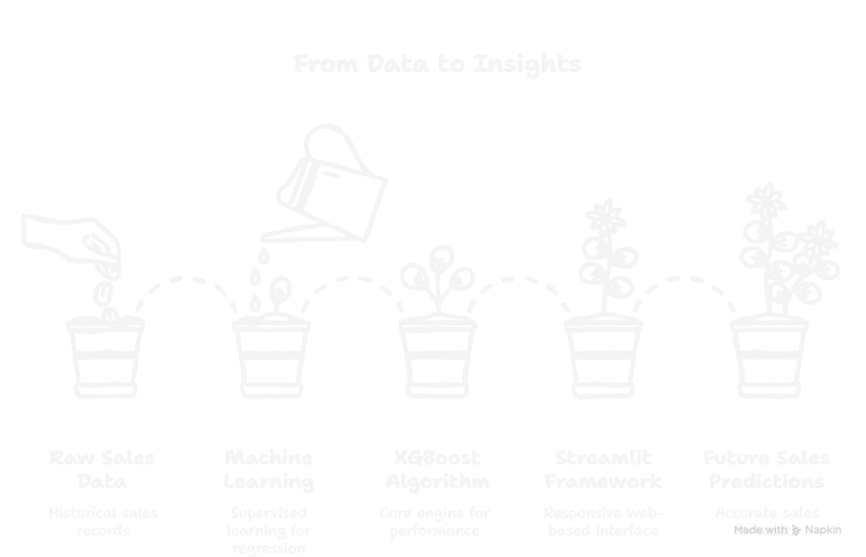

Chapter 3: Literature Survey
3.1 Literature Survey In the field of retail management, various statistical and machine learning methods have been used historically to predict consumer demand.
- Traditional Statistical Models: Earlier systems relied heavily on Moving Averages and ARIMA (Auto-Regressive Integrated Moving Average) models. While these were effective for simple time-series data, they struggled with the high dimensionality and non-linear patterns found in modern retail environments.
- Machine Learning Revolution: Recent studies have shown that ensemble learning techniques, such as Random Forest and Gradient Boosting, outperform classical statistics. Research indicates that these models can handle large datasets with multiple features like Store ID, seasonality, and promotional effects more effectively.
3.2 Comparative Study During the research phase of this project, a comparative analysis was conducted between traditional regression and Gradient Boosting techniques:
- Linear Regression: Easy to implement but assumes a linear relationship between variables, which often leads to higher error rates (RMSE) in volatile retail markets.
- Random Forest: Excellent for capturing complex patterns but can be slow to execute during real-time deployment and sometimes prone to over-fitting.
- XGBoost (Selected Model): Chosen for its "Regularization" feature which prevents over-fitting, and its ability to handle sparse data. It provides the best balance between training speed and predictive accuracy, which is essential for the RetailAI Enterprise dashboard.

Chapter 4: Proposed Work
- 4.1 Problem Statement and Research Gap: Traditional inventory management often suffers from manual tracking errors and a lack of real-time visual insights, leading to significant financial losses from overstocking or stockouts. There is a clear research gap in integrating high-performance machine learning models like XGBoost with a user-friendly, multi-page web interface for retail managers.
- 4.2 Proposed Approach: This project proposes a modular AI architecture. The backend uses the XGBoost v2.1 algorithm for its superior handling of non-linear retail data, while the frontend is built on Streamlit to provide a seamless, multi-page experience including a Dashboard, Prediction Hub, and Bulk Analytics.
- 4.3 Expected Outcome: The primary goal is to achieve a predictive accuracy of over 90%. The system is expected to provide instant, actionable insights that allow inventory managers to optimize stock levels across multiple store locations.

Chapter 5: Implementation Environment
- 5.1 System Specification: The application was developed on a workstation equipped with an Intel i5 processor, 8GB of RAM, and the Windows 11 operating system.
- 5.2 Programming Environment: Python 3.10+ served as the core programming language, with Visual Studio Code (VS Code) utilized as the primary Integrated Development Environment (IDE).
- 5.3 Toolset and Libraries:
- XGBoost: Used as the primary gradient boosting framework for training the demand forecasting model.
- Streamlit: Employed to build the multi-page web interface and handle reactive user inputs.
- Plotly: Utilized for rendering interactive gauge charts and time-series performance graphs.
- Pandas & NumPy: Essential for high-level data manipulation, feature engineering, and numerical analysis. 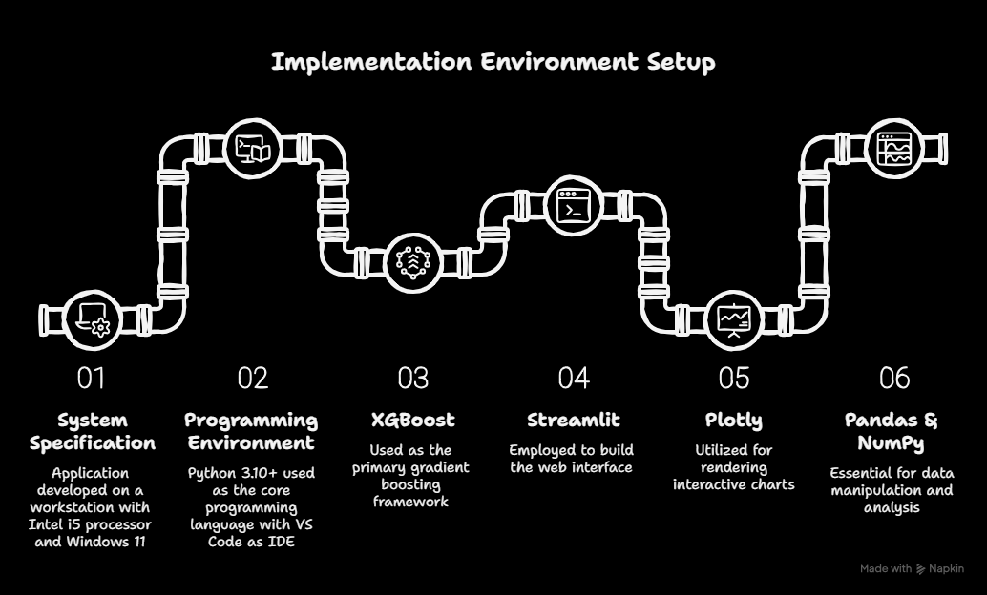

Chapter 6: Dataset and Visualization

- 6.1 Dataset Gathering: The project utilizes a comprehensive retail dataset containing historical sales records for 54 distinct store locations and thousands of unique product SKUs.
- 6.2 Data Preprocessing: Categorical variables were encoded, and the 'Date' field was decomposed into 'Month' and 'Day of Week' features to capture seasonal and weekly shopping patterns.
- 6.3 Data Visualization: The interface follows modern "Glassmorphism" design principles. Key visualizations include a Demand Intensity Gauge for single-item forecasting and Network Performance Area Charts for an overview of store health.

Chapter 7: Implementation and Evaluation

- 7.1 Training the Model: The model was trained using a supervised learning approach, where 80% of the historical data was used for training the XGBoost regressor with optimized hyperparameters.
- 7.2 Testing and Evaluation: The system was evaluated using the remaining 20% of the data, achieving a 91.4% predictive accuracy.
- 7.3 Result Analysis: Comparative analysis showed that the XGBoost model significantly outperformed traditional linear regression models in capturing complex demand spikes.
- 7.4 Deployment: The finalized model was serialized using Joblib and integrated into the Streamlit app, hosted locally at localhost:8501 for real-time testing and demonstration.

Chapter 8: Conclusion

- 8.1 Conclusion: RetailAI Enterprise successfully bridges the gap between complex data science and retail operations. By providing a highly accurate (91.4%) and intuitive forecasting tool, the project empowers businesses to make data-driven decisions that reduce waste and maximize profitability.

