**DBW624 Assignment 2 – Rohil Khakhar – 109270173**

1. **STORE DIMENSION TABLE – 5 stores**

create table store\_dimension(

store\_key number not null primary key,

store\_number number not null,

store\_name varchar(30) not null,

store\_lifespan number not null,

store\_address varchar(30) not null,

store\_occupancy number not null,

store\_city varchar(20) not null,

store\_manager varchar(30) not null,

store\_opening\_date date not null,

store\_province varchar(20) not null

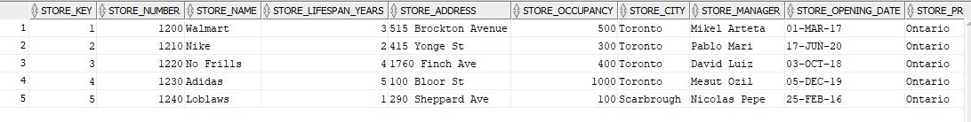);

1. **EMPLOYEE DIMENSION TABLE – 10 employees**

create table employee\_dimension(

employee\_key number not null primary key,

employee\_name varchar(30) not null,

employee\_title varchar(30) not null,

employee\_address varchar(30) not null,

employee\_years\_worked number not null,

employee\_manager varchar(30) not null

);

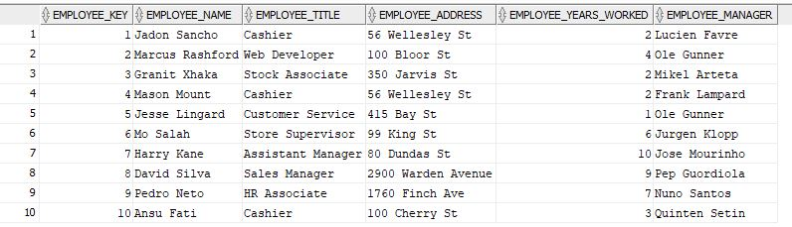

1. 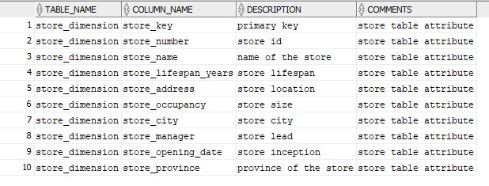**DEFINITION TABLE – 10 records**

create table definition(

table\_name varchar(30) not null,

column\_name varchar(30) not null,

description varchar(30) not null,

comments varchar(100)

);

1. **PAYMENT\_TYPE DIMENSION – 2 records**

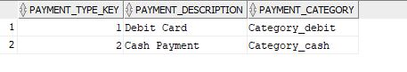

create table payment\_type\_dimension(

payment\_type\_key number not null primary key,

payment\_description varchar(20) not null,

payment\_category varchar(20) not null

);

1. 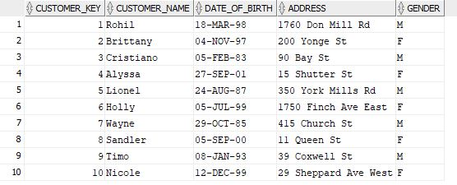**CUSTOMER DIMENSION – 10 records**

create table customer\_dimension(

customer\_key number not null primary key,

customer\_name varchar(30) not null,

date\_of\_birth date not null,

address varchar(30) not null,

gender varchar(1) not null

);

1. **PROMOTION DIMENSION – 1 record**

create table promotion\_dimension(

promotion\_key number not null primary key,

promotion\_name varchar(30) not null,

promotion\_category varchar(20) not null,

description varchar(30) not null,

start\_date date not null,

end\_date date not null,

amount decimal(3,1) not null,

constraint check\_amount

check(amount >0)

F:\Seneca College\SEMESTER6\DBW624\Assignment_solutions\A2\promotion_dimension.JPG);

1. 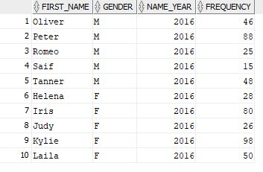**NAMES TABLE – 10 records**

create table names(

first\_name varchar(30) not null,

gender varchar(1)not null,

name\_year number(4) not null,

frequency number(3) not null

);

1. 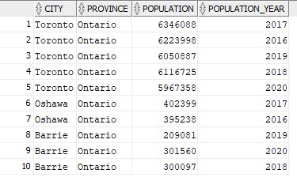**CITY\_POPULATION TABLE – 10 records**

create table city\_population(

city varchar(30) not null,

province varchar(40) not null,

population number(10) not null,

population\_year number(4) not null,

constraint population\_check

check(population > 0)

);

1. 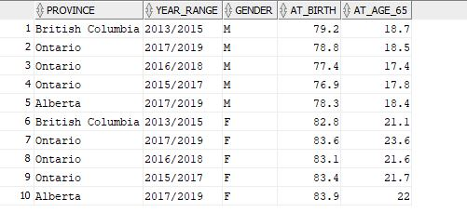**LIFE SPAN TABLE – 10 records**

create table life\_span(

province varchar(25) not null,

year\_range varchar(15) not null,

gender varchar(1) not null,

at\_birth number(3,1) not null,

at\_age\_65 number(3,1) not null

);

1. **PRODUCT GROUP DIMENSION- 4 possible records (1 for each range)**

create table product\_group\_dimension(

product\_group\_key number not null primary key,

age\_range varchar(10) not null,

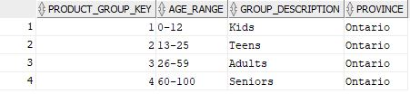 group\_description varchar(20) not null,

province varchar(15) not null

);

1. **DATE DIMENSION – 10 records**

create table date\_dimension(

date\_key number not null primary key,

the\_date date not null,

date\_description varchar(20) not null,

day\_of\_week number(1) not null,

calendar\_month varchar(15) not null,

calendar\_quarter number(1) not null,

holiday\_indicator number(1) not null

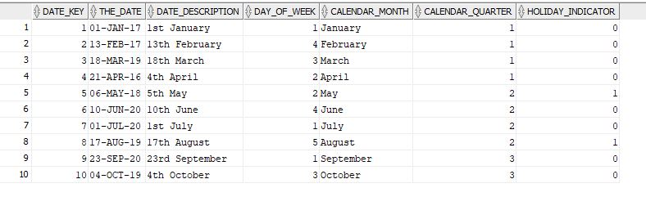);

1. **PRODUCT DIMENSION TABLE – 20 rows (only 10 shown below)**

create table product\_dimension(

product\_key number not null primary key,

description varchar(30) not null,

product\_lifespan\_months number(2) not null,

sku varchar(6) not null,

brand varchar(20) not null,

product\_category varchar(20) not null,

department\_description varchar(20) not null,

package\_type varchar(20) not null,

product\_cost number(3) not null,

list\_price number(3) not null

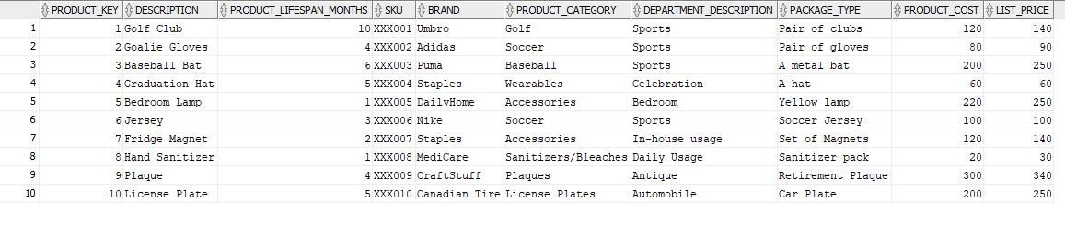);

1. **FACT TABLE – 10 rows shown**

create table sales\_fact(

sales\_id number generated by default as identity primary key not null,

product\_key number not null,

date\_key number not null,

promotion\_key number not null,

payment\_type\_key number not null,

store\_key number not null,

employee\_key number not null,

purchases\_transaction\_id number not null,

item\_scan\_timestamp number not null,

sales\_dollar\_amount number not null,

quantity number not null,

tax\_dollar\_amount number not null,

promotion\_dollar\_amount number not null,

profit number not null,

customer\_key number not null,

product\_group\_key number not null,

product\_name varchar(30) not null,

customer\_name varchar(30) not null,

customer\_gender char(1) not null,

customer\_address varchar(30) not null,

store\_address varchar(30) not null,

**constraint fk\_product\_key foreign key(product\_key)**

**references product\_dimension(product\_key),**

**constraint fk\_date\_key foreign key(date\_key)**

**references date\_dimension(date\_key),**

**constraint fk\_promotion\_key foreign key(promotion\_key)**

**references promotion\_dimension(promotion\_key),**

**constraint fk\_payment\_type\_key foreign key(payment\_type\_key)**

**references payment\_type\_dimension(payment\_type\_key),**

**constraint fk\_store\_key foreign key(store\_key)**

**references store\_dimension(store\_key),**

**constraint fk\_employee\_key foreign key(employee\_key)**

**references employee\_dimension(employee\_key),**

**constraint fk\_customer\_key foreign key(customer\_key)**

**references customer\_dimension(customer\_key),**

**constraint fk\_product\_group\_key foreign key(product\_group\_key)**

**references product\_group\_dimension(product\_group\_key)**

);

**Rows shown on the next page**

**