**DBW624 Assignment 4 – Rohil Khakhar – 109270173**

**\*\*Showing the first 20 rows for Queries having a significant number of rows**

1. **Sales Volumes Analysis by fiscal quarter**
   1. **By Store**
   2. **By Product**
   3. **By Product Group (Age Group)**
2. **By store**

select sales\_fact.quantity,

date\_dimension.calendar\_quarter,

store\_dimension.store\_name

from sales\_fact,date\_dimension,

store\_dimension

where sales\_fact.date\_key = date\_dimension.date\_key

and sales\_fact.store\_key = store\_dimension.store\_key;

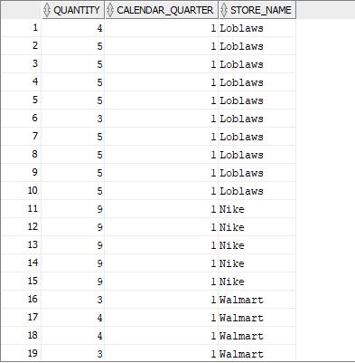

1. **By Product**

select sales\_fact.quantity,

date\_dimension.calendar\_quarter,

product\_dimension.description

from sales\_fact,date\_dimension,

product\_dimension

where sales\_fact.date\_key = date\_dimension.date\_key

and sales\_fact.product\_key = product\_dimension.product\_key;

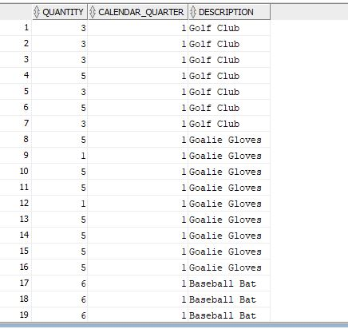

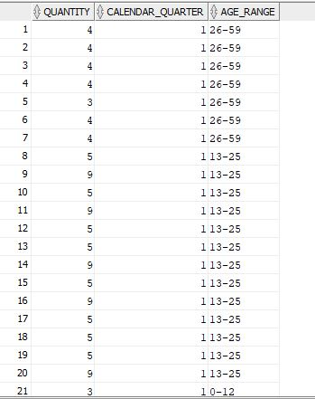

1. **By Product Group (Age Range)**

select sales\_fact.quantity,

date\_dimension.calendar\_quarter,

product\_group\_dimension.age\_range

from sales\_fact,date\_dimension,

product\_group\_dimension

where sales\_fact.date\_key = date\_dimension.date\_key

and sales\_fact.product\_group\_key = product\_group\_dimension.product\_group\_key;

1. **Sales Revenue Analysis by fiscal quarter**
   1. **By Store**
   2. **By Product**
   3. **By Product Group (Age Group)**
2. **By Store**

select sales\_fact.revenue,

date\_dimension.calendar\_quarter,

store\_dimension.store\_name

from sales\_fact,date\_dimension,

store\_dimension

where sales\_fact.date\_key = date\_dimension.date\_key

and sales\_fact.store\_key = store\_dimension.store\_key;

**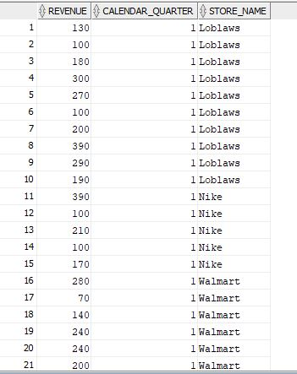**

1. **By Product**

select sales\_fact.revenue,

date\_dimension.calendar\_quarter,

product\_dimension.description

from sales\_fact,date\_dimension,

product\_dimension

where sales\_fact.date\_key = date\_dimension.date\_key

and sales\_fact.product\_key = product\_dimension.product\_key;

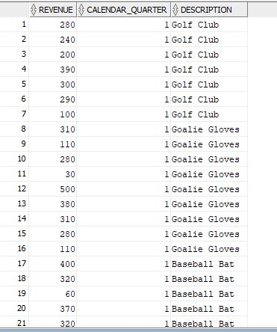

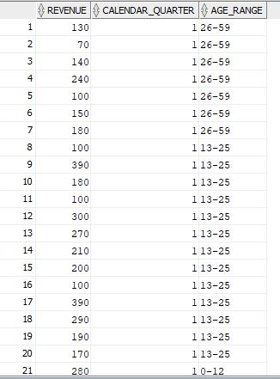

1. **By Product Group (Age Group)**

select sales\_fact.revenue,

date\_dimension.calendar\_quarter,

product\_group\_dimension.age\_range

from sales\_fact,date\_dimension,

product\_group\_dimension

where sales\_fact.date\_key = date\_dimension.date\_key

and sales\_fact.product\_group\_key = product\_group\_dimension.product\_group\_key;

1. **Sales Profit Analysis by fiscal quarter**
   1. **By Store**

select sales\_fact.profit,

date\_dimension.calendar\_quarter,

store\_dimension.store\_name

from sales\_fact,date\_dimension,

store\_dimension

where sales\_fact.date\_key = date\_dimension.date\_key

and sales\_fact.store\_key = store\_dimension.store\_key;

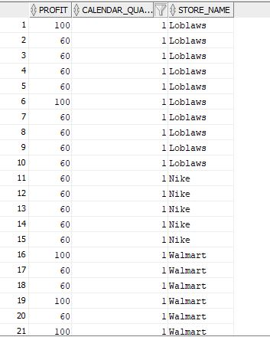

* 1. **By Product**

select sales\_fact.profit,

date\_dimension.calendar\_quarter,

product\_dimension.description

from sales\_fact,date\_dimension,

product\_dimension

where sales\_fact.date\_key = date\_dimension.date\_key

and sales\_fact.product\_key = product\_dimension.product\_key;

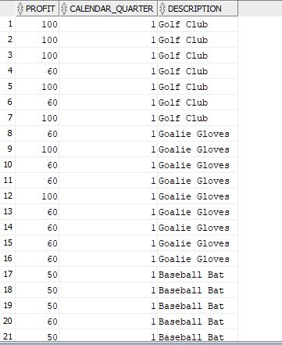

* 1. **By Product Group (Age Group)**

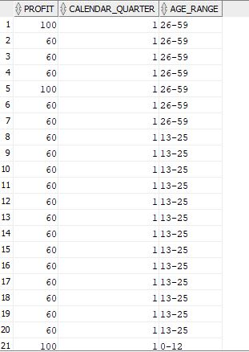select sales\_fact.profit,

date\_dimension.calendar\_quarter,

product\_group\_dimension.age\_range

from sales\_fact,date\_dimension,

product\_group\_dimension

where sales\_fact.date\_key = date\_dimension.date\_key

and sales\_fact.product\_group\_key = product\_group\_dimension.product\_group\_key;

1. **Product Line Analysis by fiscal quarter, measured by revenue and profit**
   1. **Which products have been the most/least successful?**

select product\_dimension.description, date\_dimension.calendar\_quarter, max(sales\_fact.revenue) as "Max Revenue",

max(sales\_fact.profit) as "Max Profit", min(sales\_fact.revenue) as "Min Revenue",

min(sales\_fact.profit) as "Min Profit"

from sales\_fact, date\_dimension, product\_dimension

where sales\_fact.date\_key = date\_dimension.date\_key

and sales\_fact.product\_key = product\_dimension.product\_key

group by product\_dimension.description, date\_dimension.calendar\_quarter

order by 1;

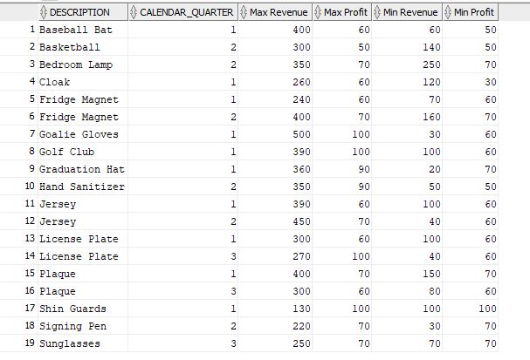

* 1. **Which product groups have been the most / least successful?**

select product\_group\_dimension.age\_range, product\_group\_dimension.group\_description,

date\_dimension.calendar\_quarter, max(sales\_fact.revenue) as "Max Revenue",

max(sales\_fact.profit) as "Max Profit", min(sales\_fact.revenue) as "Min Revenue",

min(sales\_fact.profit) as "Min Profit"

from sales\_fact, date\_dimension, product\_group\_dimension

where sales\_fact.date\_key = date\_dimension.date\_key

and sales\_fact.product\_group\_key = product\_group\_dimension.product\_group\_key

group by product\_group\_dimension.age\_range, product\_group\_dimension.group\_description,

date\_dimension.calendar\_quarter

order by 1;

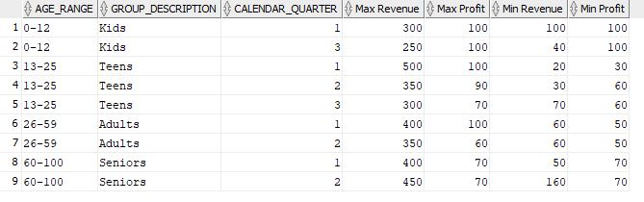

* 1. **What is the product trends (growth or declining)?**

select product\_dimension.description, date\_dimension.calendar\_quarter, sales\_fact.quantity, sum(sales\_fact.revenue) as "Total Revenue",

sum(sales\_fact.profit) as "Total Profit"

from sales\_fact, date\_dimension, product\_dimension

where sales\_fact.date\_key = date\_dimension.date\_key

and sales\_fact.product\_key = product\_dimension.product\_key

group by product\_dimension.description, date\_dimension.calendar\_quarter, sales\_fact.quantity

order by 1;

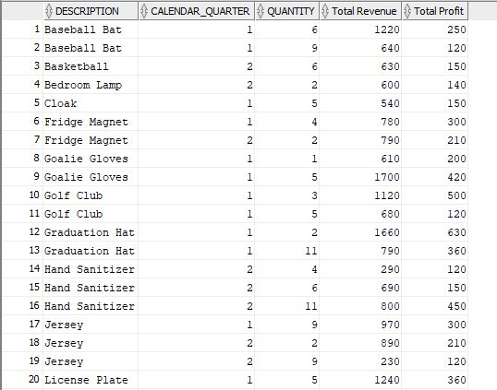

1. **Store Analysis by fiscal quarter, measured by revenue and profit**
   1. **Which stores are the most / least successful?**

select store\_dimension.store\_name, date\_dimension.calendar\_quarter, max(sales\_fact.revenue) as "Max Revenue",

max(sales\_fact.profit) as "Max Profit", min(sales\_fact.revenue) as "Min Revenue",

min(sales\_fact.profit) as "Min Profit"

from sales\_fact, date\_dimension, store\_dimension

where sales\_fact.date\_key = date\_dimension.date\_key

and sales\_fact.store\_key = store\_dimension.store\_key

group by store\_dimension.store\_name, date\_dimension.calendar\_quarter

order by 1;

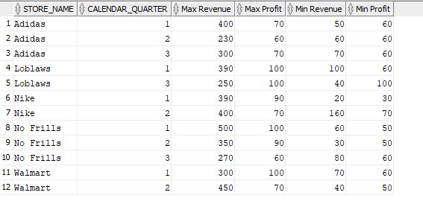

* 1. **What is the growth trends for each store (growth or declining)?**

select store\_dimension.store\_name, date\_dimension.calendar\_quarter, sum(sales\_fact.revenue) as "Total Revenue",

**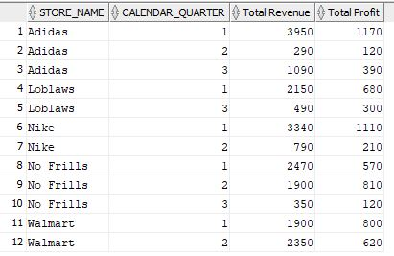**sum(sales\_fact.profit) as "Total Profit"

from sales\_fact, date\_dimension, store\_dimension

where sales\_fact.date\_key = date\_dimension.date\_key

and sales\_fact.store\_key = store\_dimension.store\_key

group by store\_dimension.store\_name, date\_dimension.calendar\_quarter

order by 1;

1. 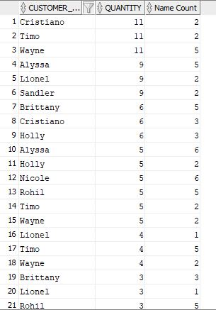**Additional Analysis**
   1. **Which names have been most successful by volume?**

select sales\_fact.customer\_name, sales\_fact.quantity, count(sales\_fact.customer\_name) as "Name Count"

from sales\_fact

group by sales\_fact.customer\_name, sales\_fact.quantity

order by 2 desc;

* 1. **Which gender has been most successful by volume?**

select sales\_fact.customer\_gender, sales\_fact.quantity, count(sales\_fact.customer\_gender) as "Gender Count"

from sales\_fact

group by sales\_fact.customer\_gender, sales\_fact.quantity

order by 2 desc;

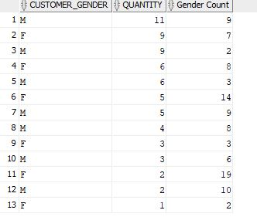

* 1. **Who was the top sales person for the quarter?**

select date\_dimension.calendar\_quarter, employee\_dimension.employee\_name,

count(employee\_dimension.employee\_name) as "Employee Count",

sum(sales\_fact.profit) as "Profit"

from date\_dimension, employee\_dimension, sales\_fact

where sales\_fact.date\_key = date\_dimension.date\_key

and sales\_fact.employee\_key = employee\_dimension.employee\_key

group by date\_dimension.calendar\_quarter, employee\_dimension.employee\_name

order by 3 desc, 4 desc;

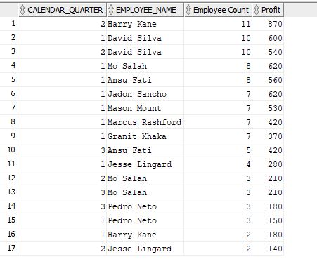

* 1. **What percentage of sales are cash versus credit card?**

select (count(sales\_fact.payment\_type\_key)\*100 /(select sum(count(\*)) over() from sales\_fact)) as "percentage",

payment\_type\_dimension.payment\_description

from sales\_fact, payment\_type\_dimension

where sales\_fact.payment\_type\_key = payment\_type\_dimension.payment\_type\_key

group by payment\_type\_dimension.payment\_description;

**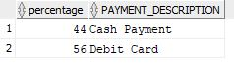**

* 1. **What percentage of sales were using a marketing campaign?**

select (count(sales\_fact.promotion\_key)\*100 /(select sum(count(\*)) over() from sales\_fact)) as "percentage",

F:\Seneca College\SEMESTER6\DBW624\Assignment_solutions\A4\6e.JPGpromotion\_dimension.promotion\_name

from sales\_fact, promotion\_dimension

where sales\_fact.promotion\_key = promotion\_dimension.promotion\_key

group by promotion\_dimension.promotion\_name;

1. **Analytics Against Reference Tables**
   1. **Which 10 cities should we open stores in, based on population?**

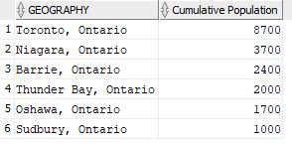**SPECIFIC TO ONTARIO**

select geography, sum(population) as "Cumulative Population" from city\_population

where geography like '%Ontario%'

group by geography

order by 2 desc;

**ALL OF CANADA**

select geography, sum(population) as "Cumulative Population" from city\_population

group by geography

order by 2 desc;

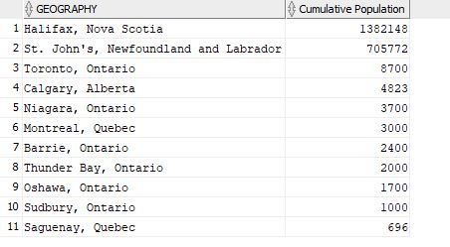

* 1. **Which names should we expect will be the most popular for our personalized products?**

select first\_name, frequency from names

order by 2 desc;

