SMART FORKLIFT SAFETY AND MONITORING SYSTEM

ABSTRACT
This project introduces a comprehensive IoT-driven forklift safety and monitoring system aimed at reducing accidents and improving operational visibility in industrial environments. The system is built around the ESP8266 microcontroller, which serves as the primary data acquisition and communication unit. A Hall Effect sensor mounted near the forklift wheel measures real-time rotational pulses, enabling accurate calculation of vehicle speed. An IR presence sensor detects when a driver approaches or enters the vehicle area, triggering the system to initiate identity verification and logging processes.
Additional safety-critical inputs are captured through dedicated pushbuttons for load confirmation and emergency (panic) events. These user-initiated inputs allow the system to differentiate between normal operation, unsecured cargo movement, and emergency conditions. All sensor readings and events are transmitted wirelessly through MQTT to a laptop-based control system, which acts as the central processing hub.
On the laptop, an AI analytics module continuously evaluates the incoming log data. This module uses both rule-based safety thresholds and anomaly-detection algorithms to identify unsafe driving patterns such as overspeeding, inconsistent behavior, or repeated panic triggers. The laptop also handles face detection for driver authentication using its webcam, ensuring that only authorized personnel operate the vehicle.
By combining real-time sensing, wireless communication, AI-driven risk analysis, and driver authentication, the system provides a low-cost yet highly effective approach to forklift safety. The overall solution enhances situational awareness for supervisors, logs critical events for later analysis, and offers immediate alerts to the operator, thereby reducing the likelihood of accidents and operational misuse.

1. INTRODUCTION
Forklifts are essential machines in manufacturing plants, warehouses, and logistics centers, where they are used extensively for lifting, carrying, and transporting materials. Despite their importance, forklifts are also responsible for a significant number of workplace accidents each year. Common causes include overspeeding in narrow aisles, operating the vehicle without proper authorization, poor load handling practices, and the absence of continuous operator supervision. These risks are further amplified in environments with high worker density, limited visibility, or strict operational timelines.
To address these challenges, this project proposes an intelligent, IoT-based forklift safety module designed to enhance operational awareness and reduce the likelihood of accidents. The system incorporates multiple sensors—such as a Hall Effect speed sensor for real-time speed tracking, an IR presence sensor to detect driver proximity, and dedicated buttons for load confirmation and emergency alerts. These sensors continuously monitor the forklift’s operational behavior and communicate their readings wirelessly to a central dashboard using MQTT.
Beyond basic monitoring, the solution integrates laptop-based artificial intelligence to assess risk patterns that may not be obvious through simple threshold checks. By analyzing historical logs, the AI module can detect anomalies such as irregular driving, rapid acceleration, repeated panic button usage, or movement without proper load confirmation. The system can then produce proactive alerts, giving supervisors and operators early warnings before unsafe conditions escalate. Through the combination of sensing technology, wireless communication, and AI-based analytics, this project delivers a low-cost yet powerful method for improving forklift safety and ensuring disciplined, authorized operation within industrial environments.

2. PROBLEM STATEMENT

Industrial forklifts often operate without real-time monitoring, leading to overspeeding, unauthorized usage, and delayed emergency responses. This lack of visibility increases the risk of avoidable accidents on the factory floor

3. OBJECTIVES
• Prevent unauthorized forklift usage using face detection.
• Monitor and display real-time vehicle speed using a Hall Effect sensor.
• Detect driver presence via IR sensor.
• Record load confirmation and emergency (panic) events.
• Send all data wirelessly to a laptop dashboard using MQTT.
• Use AI to analyze logs and detect unusual or unsafe patterns.

4. SYSTEM OVERVIEW
The system uses ESP8266 to read sensors (speed, presence, buttons) and publish data to an MQTT broker running on a laptop. The laptop handles real-time dashboard display, AI anomaly detection, and face recognition. Alerts are pushed back to the ESP8266 to trigger local warnings using buzzers and LEDs.

5. HARDWARE COMPONENTS
• ESP8266 NodeMCU – Main controller & WiFi communication.
• Hall Effect Sensor (A3144 module) – Speed measurement.
• Magnet – Mounted on forklift wheel for RPM sensing.
• IR Presence Sensor – Detects driver presence.
• Panic Button – Emergency alert.
• Load Confirmation Button – Driver confirms goods secured.
• Active Buzzer (LOW-trigger) – Safety alarm.
• LED Indicator – Authentication/alert display.
• Laptop Webcam – Face detection.
• Laptop/PC – MQTT, Dashboard, AI processing.

6. BLOCK DIAGRAM
Below is an ASCII-based block diagram representing the system architecture:

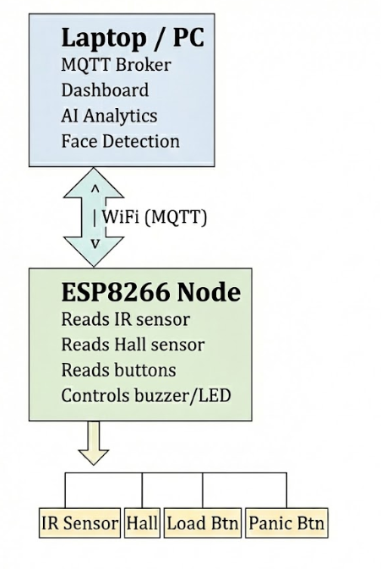

7. HARDWARE CONNECTIONS

Hall Sensor:
• VCC → 3.3V
• GND → GND
• D0 → D7 (interrupt pin)
IR Sensor:
• VCC → 3.3V
• GND → GND
• OUT → D2
Panic Button:
• One side → D3
• Other side → GND
Load Button:
• One side → D6
• Other side → GND
Buzzer (LOW Trigger):
• SIG → D5
• VCC → 3.3V/5V
• GND → GND
LED Indicator:
• Anode → 220Ω → D1
• Cathode → GND

8. SOFTWARE FLOW
1. IR detects presence → ESP sends 'enter' event.
2. Laptop face detection system authenticates driver.
3. If authorized → laptop sends MQTT message → ESP turns LED ON.
4. Hall sensor pulses are counted to calculate speed.
5. Panic or load button events are published immediately.
6. Laptop dashboard displays live data.
7. AI reads log file and detects anomalies.
8. AI sends warnings back to ESP for buzzer alerts.
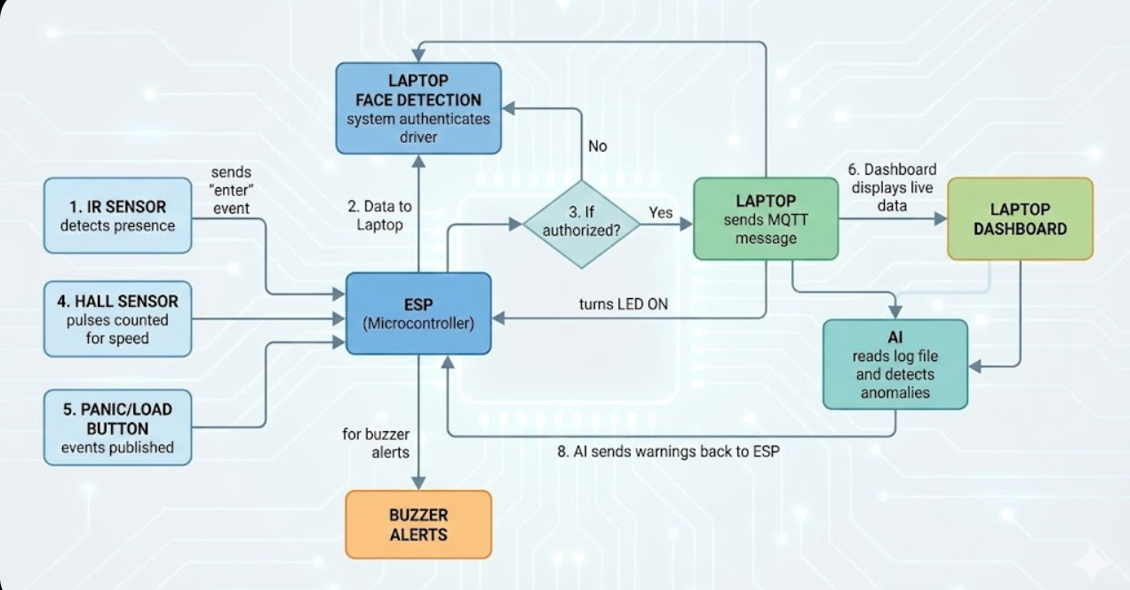

9. RESULTS
MQTT
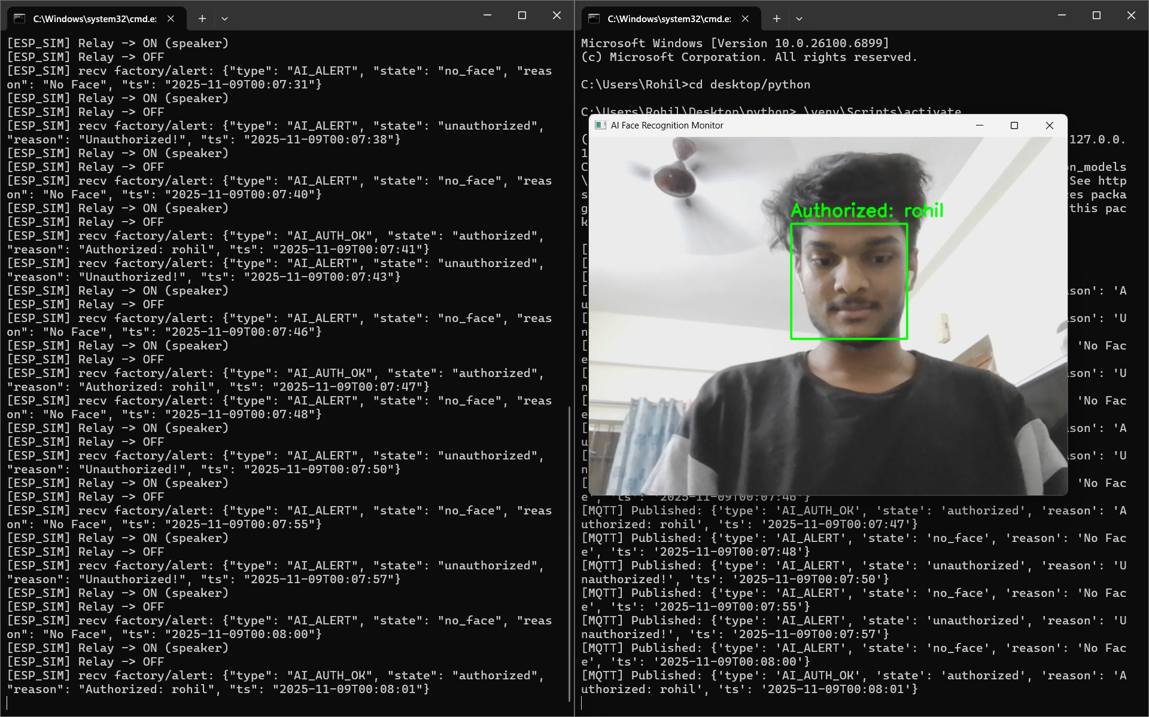
Fig 1: Face detection identifies the driver as authorized and marks the face in green. MQTT logs show AI_AUTH_OK, allowing the forklift to operate.

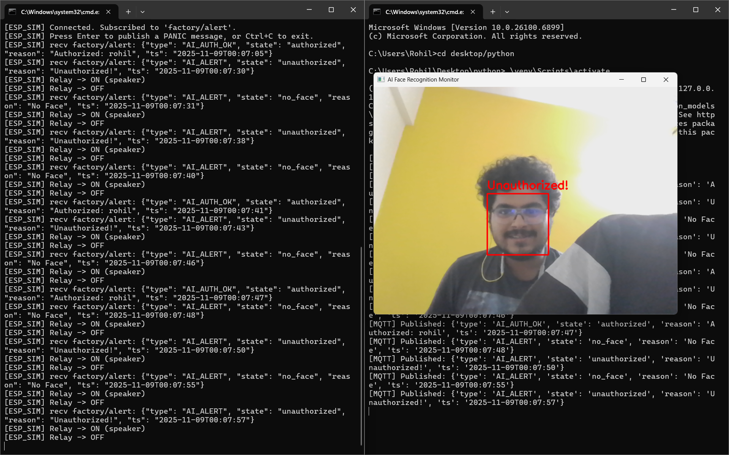

Fig 2: Face detection flags the user as unauthorized and marks the face in red. MQTT logs show AI_ALERT, and the system blocks operation and triggers an alert.

DASHBOARD
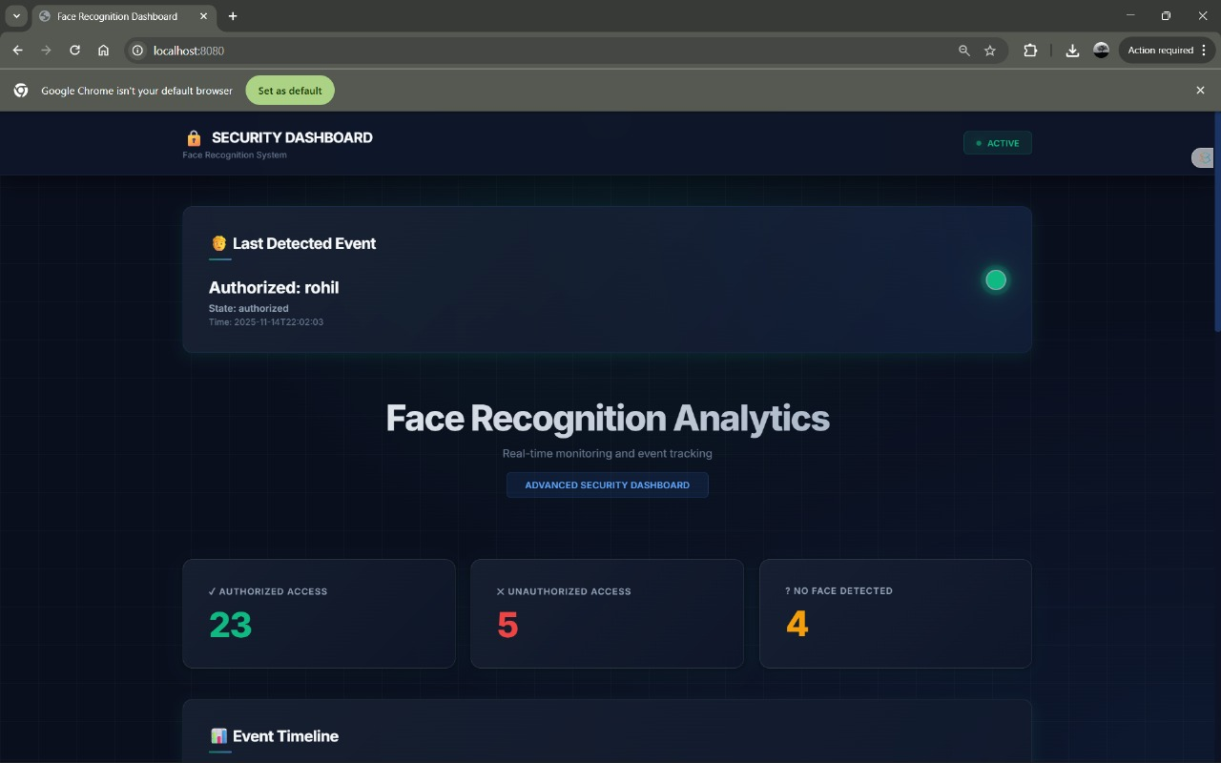
Fig 3: This dashboard displays the latest face-authentication result along with counts of authorized, unauthorized, and unknown detections. It provides a quick overview of system activity and driver verification status.
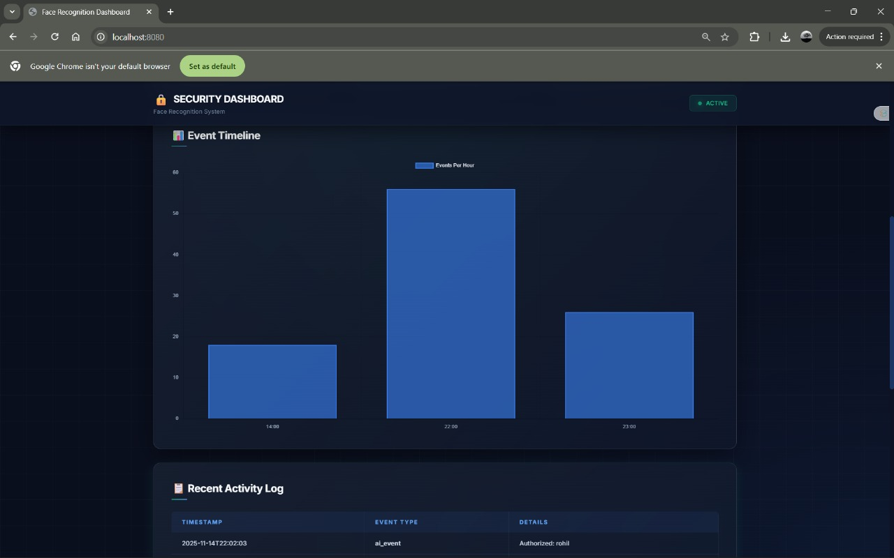
Fig 4: This section visualizes recent events such as detections, alerts, and access attempts using charts and a chronological activity log, helping supervisors track forklift usage patterns at a glance.

LOG FILE
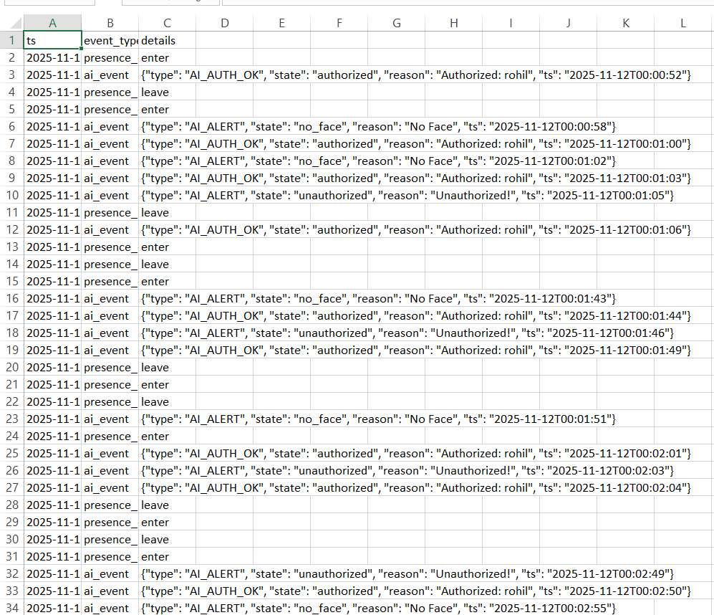
Fig 5: This log file stores every system event with a timestamp, event type, and detailed JSON data. It captures presence entries and exits, face-authentication results, and AI-generated alerts.

10. AI MODEL DESCRIPTION
The AI component of the system employs a hybrid analytical approach that combines traditional rule-based evaluation with an advanced machine learning model known as the Isolation Forest. Rule-based thresholds provide immediate, deterministic checks for conditions such as overspeeding, missing load confirmation, or repeated panic button presses. These rules allow the system to generate instant alerts for clearly unsafe situations without requiring complex computation.
Beyond simple rules, the Isolation Forest model is used to perform deeper anomaly detection on historical log data. The logs include key operational variables such as real-time speed values captured through the Hall Effect sensor, timestamps of driver presence, load confirmation status, and emergency (panic) events. By learning the normal patterns of forklift behavior over time, the Isolation Forest identifies data points and sequences that deviate significantly from standard operation.
This dual approach enables the AI system to recognize subtle and developing risks that may not trigger immediate rule-based alarms. The model can detect overspeeding trends, abrupt acceleration patterns, inconsistent load confirmation behavior, frequent panic activations, and other irregular activities that may indicate unsafe driving habits, operator fatigue, or potential misuse of the forklift. By continuously evaluating incoming and historical data, the AI provides a proactive layer of safety analytics that enhances situational awareness and supports data-driven decision-making for supervisors and safety managers.

11. CONCLUSION
The proposed system offers a low-cost, effective forklift safety solution. It provides real-time monitoring, unauthorized usage prevention, and AI-driven risk detection. The architecture is suitable for expansion with future features like obstacle detection or tilt sensing.

