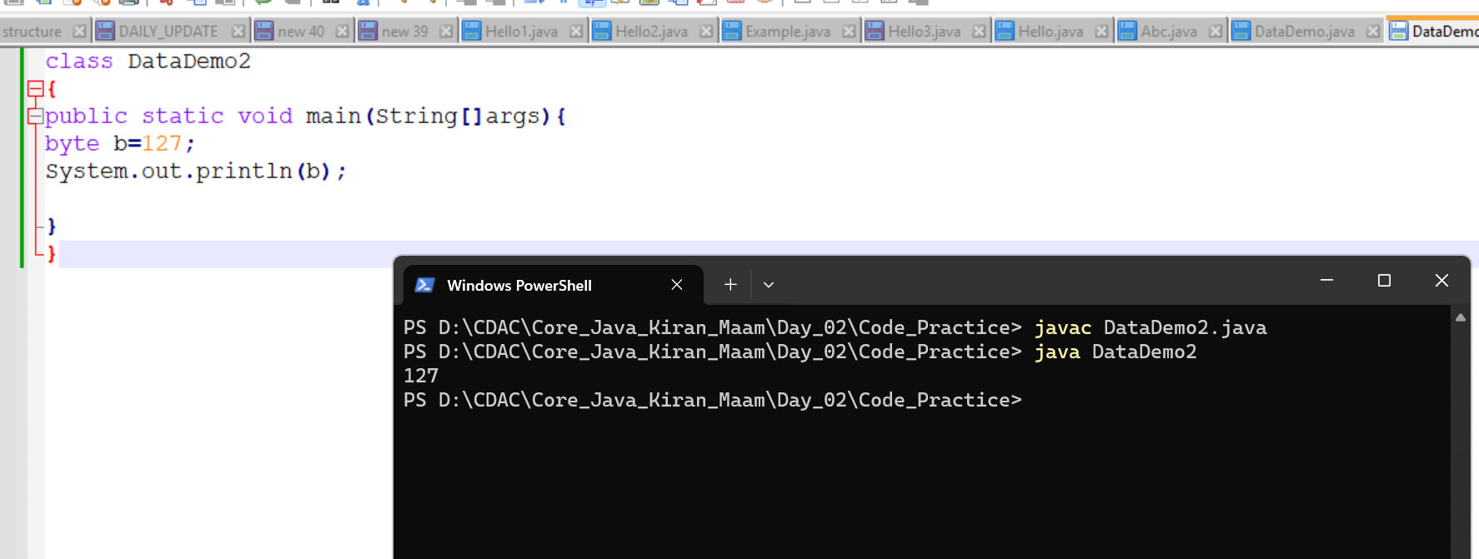

It is within range

