Name: Mayuresh Gorantiwar

Roll No: 2205075

Enrollment No: MITU20BTIT0038

**Output:**

Signup page

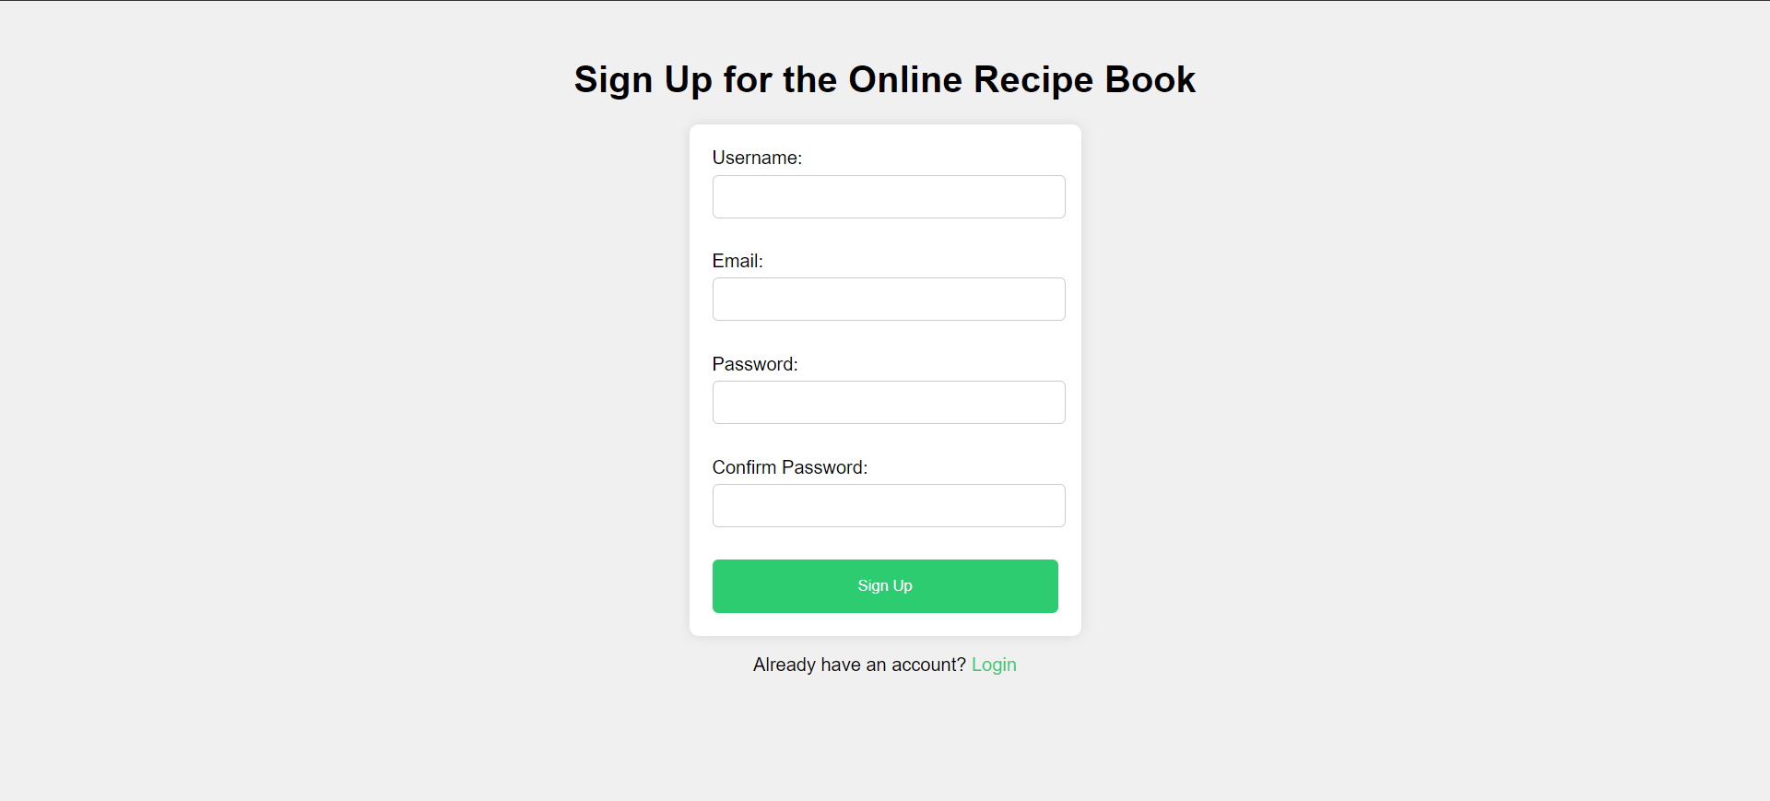

Login page



Navigation page



Recipe page



Contact page



About page

