

MIT Art, Design and Technology University
MIT School of Computing, Pune

Department of Information Technology

Lab Manual

Practical - Web Programming

Class - S.Y. (SEM-IV), DA

Batch - DA-I

Name of the Student

Mr. Aditya Manoj Shinde

A.Y. 2025 – 2026 (SEM-II)
Web Programming
SEMESTER – IV
Course Code: |  | 23IT2008 | Course Credits: | 02
Teaching Hours / Week (L:T:P): |  | 0:0:4 | CA Marks: | 25
Total Number of Teaching Hours: |  |  | END-SEM Marks: | 25
Course Pre-requisites:
Course Description:
This course provides a comprehensive introduction to web technology, designed to help students develop a strong foundation in building and managing websites and web applications. The curriculum covers key topics such as HTML, CSS, and JavaScript,PHP, MySQL, which are essential for creating interactive, well-designed web pages. Students will also explore the principles of responsive design, ensuring that web applications are optimized for different devices and screen sizes.
The course dives deeper into server-side technologies, including HTTP, web servers, and databases, allowing students to understand how websites function behind the scenes. Emphasis is placed on practical learning, and students will gain hands-on experience by working on projects that showcase their ability to design, develop, and deploy websites.
By the end of the course, students will be proficient in using modern web technologies to create web applications. They will understand how to handle client-server interactions, manage user data, and implement various web technologies to enhance the functionality of their applications.
Course Learning Objectives: This course will enable the students to:
- Understand fundamental concepts of front-end web development.
- Enable students to create basic web pages incorporating essential elements such as images, hyperlinks, lists, tables, and forms.
- Teach students how to use CSS to manage fonts, lists, colors, text alignment, and background images for a cohesive and aesthetically pleasing web design.
- Develop an understanding of JavaScript scopes to manage the visibility and lifetime of variables and functions effectively.
- Equip students with the skills to implement and handle JavaScript events, enabling enhanced user interactions through event-driven programming.
- Apply comprehensive knowledge of HTML, CSS, and JavaScript to develop a complete front-end application. Utilize project-based learning to showcase problem-solving skills and creativity in web development projects.
- Configure server environments with Apache/TOMCAT.
- Set up a PHP development environment and write basic PHP scripts.
- Master PHP programming constructs for web development tasks.
- Create and process HTML forms, and manage MySQL database operations.
- Develop comprehensive back-end applications using PHP and MySQL.
Course Outcome: After taking this course, Students will be able to :
- Apply knowledge of HTML to create the structure of the webpage and CSS to style and layout the elements, making the application visually appealing.
- Apply comprehensive knowledge of HTML, CSS, and JavaScript to develop a complete front-end application and utilize project-based learning to showcase problem-solving skills and creativity in web development projects.
- Set up and configure a server environment using tools like Apache or TOMCAT and set up a PHP development environment. Write & execute simple PHP scripts, understanding PHP syntax and basic features, create HTML forms to collect user data and integrate with PHP for processing.
- Design and develop a back-end application using PHP and MySQL, implementing CRUD operations to manage data effectively.
UNIT – I | Introduction to HTML and Cascading Style Sheet |  |  |  | 09 Hours
Module 1 - Markup Language (HTML): Introduction to HTML, Formatting and Fonts, Commenting Code, Anchors, Backgrounds, Images, Hyperlinks, Lists, Tables, Frames, HTML Forms
Module 2 - CSS: Need for CSS, introduction to CSS, basic syntax and structure, Levels of style sheets, Style specification formats, BOX Model, Selector forms, Property value forms, Font properties, List properties, Color, Alignment of text, Background images
Pedagogy | ICT Teaching / PowerPoint Presentation and Videos:  Use tools like Visual Studio Code (free).  Videos:  https://www.coursera.org/learn/html-css-javascript-for-web-developers
Self-study / Do it yourself /:
Practice creating basic HTML pages and enhancing them using CSS.
Experiential Learning Topics:
Design a simple webpage for coffee shop website
PBL - Project Based Learning:
Create a multi-page website (e.g., coffee shop website) using HTML and CSS.
UNIT – II | Front-End Development |  |  |  | 09 Hours
Module 3 - Overview of JavaScript, including JS in an HTML (Embedded, External), Basic JS syntax, basic interaction with HTML
Module 4 - Core features of JavaScript: Data types, Control Structures, Arrays, Functions and Scopes
Pedagogy | ICT Teaching / PowerPoint Presentation and Videos:  Use tools like Visual Studio Code (free).  Videos:  https://www.coursera.org/learn/javascript-basics
Self-study / Do it yourself /:
Solve exercises on JavaScript syntax, control structures, and functions
Experiential Learning Topics:
Build a web page with interactive elements (e.g., a simple calculator).
PBL - Project Based Learning:
Develop an interactive webpage that uses JavaScript to validate form inputs or perform basic calculations.
UNIT – III | Advanced Front-End Development |  |  |  | 09 Hours
Module 5 - DOM: DOM levels, DOM Objects and their properties and methods, Manipulating DOM
Module 6 - JavaScript Events: JavaScript Events, Types of JavaScript Events, Objects in JS, Event Handling
Pedagogy | ICT Teaching / PowerPoint Presentation and Videos:  https://www.coursera.org/learn/building-interactive-web-pages-using-javascript  Use tools like Visual Studio Code (free).
Self-study / Do it yourself /:
Practice exercises on DOM traversal and event handling.
Experiential Learning Topics:
Add dynamic behavior to a webpage using DOM and events (e.g., a to-do list app).
PBL - Project Based Learning:
Develop a web page with dynamic content (e.g., a task manager or interactive quiz) using DOM manipulation and event handling.
UNIT – IV | Server Side Scripting |  |  |  | 09 Hours
Module 7 - Set up and configure a server environment using tools like Apache or TOMCAT, set up a PHP development environment.
Module 8 -Introduction to PHP: : Introduction to PHP, Server side scripting Vs Client side scripting, Basic Development Concepts (Mixing PHP with HTML), Creating, Writing & Running First PHP Script, PHP syntax, conditions & Loops, Functions, String manipulation, Arrays & Functions,
Module 9 - Form handling with HTML and PHP: Designing of Forms using HTML, Form Handling using GET and POST methods of Form
Pedagogy | ICT Teaching / PowerPoint Presentation and Videos:  https://www.coursera.org/learn/web-applications-php  Use tools like Visual Studio Code (free), XAMPP/WAMP for PHP server setup, and MySQL Workbench for database management
Self-study / Do it yourself /:
Practice exercises on form handling and server-side scripting with PHP.
Experiential Learning Topics:
Create a basic form for data submission and handle it using PHP (e.g., feedback form).
PBL - Project Based Learning:
Develop a small server-side application (e.g., a contact form with email validation and submission).
UNIT – V | Working with Databases and Web Application Development |  |  |  | 09 Hours
Module 10 - Working with databases using MySQL with PHP: MySQL database, create database, create table, primary key with AUTO_INCREMENT setting, Insert Data Into a Database Table, Select Data From a Database Table, Open or close a Connection to the MySQL Server.
Module 11 - Web Application Development (Project): Develop the web application to handle client-server interactions, manage user data, and implement various web technologies to enhance the functionality of their applications. Example: Website for a Coffee Shop
Pedagogy | ICT Teaching / PowerPoint Presentation and Videos:  Use tools like Visual Studio Code (free), XAMPP/WAMP for PHP server setup, and MySQL Workbench for database management  Videos:  https://www.coursera.org/learn/web-app
Self-study / Do it yourself /:
Exercises on creating and manipulating databases using PHP and MySQL.
Experiential Learning Topics:
Create a database and design a webpage to display its data dynamically.
PBL - Project Based Learning:
Develop a fully functional web application (e.g., a Coffee Shop website or e-commerce platform) that integrates database functionality for data management.

Project Overview – Shoefy E-Commerce Website

Problem Statement
Design and develop a fully functional e-commerce website for a premium shoe store using HTML, CSS, JavaScript, PHP, and MySQL. This website will serve as the digital storefront for the brand, effectively communicating brand identity, showcasing the product catalog, managing user authentication, and allowing customers to easily add items to their cart and complete a seamless checkout process.

About the Project
Shoefy is a modern, responsive, and dynamically database-driven e-commerce platform for curated footwear. It is built entirely without any frontend framework using only Vanilla JavaScript on the client side demonstrating how a production-grade shopping experience can be delivered with core web technologies. The PHP backend exposes a RESTful API that the frontend consumes via the fetch() wrapper in api.js, keeping the frontend and backend cleanly decoupled.

Tech Stack
Layer | Technology | Purpose
Frontend | HTML5 | Page structure and semantic markup
Frontend | CSS3 (Custom) | Premium styles, Flexbox, Grid, glassmorphism
Frontend | Vanilla JavaScript | DOM manipulation, fetch API, localStorage
Backend | PHP 8+ (PDO) | RESTful API, server-side logic, form handling
Database | MySQL | Persistent product, user, and cart data storage
Dev Tools | XAMPP / PHP CLI | Local Apache + MySQL server environment

Key Features
Feature | Description
Dynamic Product Catalog | Products fetched and rendered directly from MySQL database
Real-Time Search | Frontend search bar filters products instantly without page reload
User Authentication | Secure Sign Up and Login using PHP password_hash (BCRYPT)
Database-Driven Cart | Cart items stored per-user in MySQL; supports add, update, remove
Fully Functional Checkout | Calculates totals dynamically; empties cart on successful payment
Responsive Design | CSS Flexbox + Grid layouts optimised for desktop and mobile

Local Setup & Running the Project
Follow these steps to run Shoefy locally using XAMPP:

Code
1. Install XAMPP – ensure Apache and MySQL modules are running.
2. Place project folder inside: C:\xampp\htdocs\practice
3. Open phpMyAdmin at: http://localhost/phpmyadmin
4. Create database named: shoefy_ecommerce_site
5. Import: backend/schema.sql (creates tables + seeds product data)
6. Verify db_connection.php credentials (User: aditya, Password: 8767)
OR update to: username=root, password='' for default XAMPP config
Option A – Apache: http://localhost/practice/index.html
Option B – PHP CLI: php -S localhost:8000 (in project root)

Project Directory Structure
Code
shoefy-website/
├── backend/
│ ├── api.php
│ ├── db_connection.php
│ └── schema.sql
├── css/
│ ├── checkout.css
│ ├── index.css
│ ├── login.css
│ └── product.css
├── images/
├── js/
│ ├── api.js
│ ├── cart.js
│ ├── checkout.js
│ ├── index.js
│ └── product_grid.js
├── pages/
│ ├── about.html
│ ├── cart.html
│ ├── checkout.html
│ ├── contact.html
│ ├── login.html
│ ├── product_detail.html
│ └── product.html
└── index.html

Index of Experiments
Practical: Web Programming | Shoefy E-Commerce Project
Exp. No. | Title | Problem Statement
Experiment 1 | Project Planning & Website Design | Create the basic structure of the Shoefy e-commerce website. Plan layout, goals, deliverables, audience, visual direction, and site structure.
Experiment 2 | HTML Structure – Home, Shop & Product Detail Pages | Create detailed structural pages using semantic HTML: home page, shop/catalog page, and product detail page with proper layout sections.
Experiment 3 | CSS Grid & Advanced Layouts | Enhance the website layout using CSS Grid for the home page and product catalog. Style product items with headings, spacing, images, descriptions, and prices.
Experiment 4 | Styling Complex UI Components | Style the cart page, about page, contact page, registration form, and login form with premium UI padding, border-radius, shadows, and focus states.
Experiment 5 | JavaScript – User Authentication & Form Handling | Implement registration and login forms with client-side validation. Redirect successful logins to the homepage and provide real-time feedback.
Experiment 6 | JavaScript – Cart State Management | Develop cart functionality to add items, update quantities, and remove items. Persist state via localStorage and dynamically render cart totals.
Experiment 7 | PHP Backend – User Registration | Develop a PHP script to handle user registration with server-side validation, error handling, and BCRYPT password hashing before storing in MySQL.
Experiment 8 | PHP Backend – User Login & Authentication | Develop a PHP login script that verifies submitted passwords against stored hashes and returns clear success or failure feedback responses.
Experiment 9 | PHP & MySQL Cart Management | Develop a PHP script using MySQL to manage the shopping cart add items, view contents, update quantities, and remove items with session persistence.
Experiment 10 | PHP Products Endpoint & Checkout Process | Develop a PHP endpoint to fetch products from MySQL and implement checkout: validate form, calculate totals, clear cart, and redirect on success.

Experiment 1
Project Planning & Website Design

Problem Statement

- Create the basic structure of the Shoefy e-commerce website, including the home page layout with a header, main content area, and footer.
- Prepare a common project website design and plan document.
- Brief information about the project.
- Set the goals & deliverables.
- Finalize the modules of the project.
- Define the audience.
- Describe pain points & the ideal experience (based on existing systems).
- Set the visual direction.
- Map out the project structure.
- Plan the content for each page.
- Add ideas for content, images & layout.
- Determine site structure or create content for core website pages.
- Create and collect design elements defining brand personality through colors, typography, logos, and images.

Objective

To design the basic structure of an e-commerce shoe store (Shoefy) by planning its layout, content, and visual elements, ensuring it meets user needs, provides a seamless shopping experience, and effectively represents a premium, modern brand.

Theory

1. Brief Information about the Project:
The project is to create a user-friendly, highly polished, and visually appealing e-commerce website for a shoe store named Shoefy. It aims to attract shoe shoppers, highlight premium products, and offer features such as seamless online ordering, cart management, and order history tracking. The website will support robust login and registration to personalize user experiences and securely manage customer data via a PHP and MySQL backend.

2. Goals and Deliverables:
Goals:
- Develop an engaging, functional, and modern e-commerce website.
- Showcase the store's catalog of sneakers, running shoes, formal shoes, and casual shoes.
- Enable users to register, log in, manage their cart, and track orders.
- Create a responsive website that works across all devices with premium UI aesthetics like glassmorphism and micro-animations.

Deliverables:
- Website Pages: Home Page, Shop/Catalog Page, Product Details Page, Shopping Cart Page, Checkout Page, Login & Registration Pages.
- Core Features: Header and footer with consistent navigation, functional authentication, responsive grid designs, and dynamic database-driven product fetching.

3. Modules of the Project:
- Home Page Module: Welcomes users and highlights trending categories and products.
- Shop/Catalog Module: Displays the full inventory of shoes in a user-friendly grid.
- Product Details Module: Provides comprehensive information, sizing, and Add to Cart functionality.
- Cart & Checkout Module: Handles the pre-purchase view and payment form logic.
- User Auth Module: Provides authentication and secure account management.

4. Target Audience:
- Sneakerheads & Trendsetters: Need high-quality imagery and easy navigation.
- Professionals: Need dedicated sections for formal shoes and reliable functionality.
- Online Shoppers: Need a seamless e-commerce experience and fast checkout.

5. Pain Points & Ideal Experience:
Pain Points: Cluttered Interfaces, Lack of Mobile Optimization, Complicated Checkout steps, and Bland Visuals.
Ideal Experience: Intuitive Navigation, Mobile-Responsive CSS Grid Design, Premium Visuals using soft shadows, and a Seamless Checkout process.

6. Visual Direction:
- Color Palette: Premium Blacks/Whites, Slate Grays, and crisp accents.
- Typography: Poppins (Google Fonts) for sleek, modern professionalism.
- Imagery: High-resolution shoe images with transparent backgrounds resting on soft aesthetics.

7. Content Plan Per Page:
- Home Page: Hero banner, featured products grid, and footer.
- Shop Page: Grid of product cards showing image, name, and price.
- Product Details Page: 2-column layout. Left: Large shoe image. Right: Title, price, description, and 'Add to Cart' button.
- Cart & Checkout: Modern table layouts and side-by-side payment forms.
- About Page: Brand story, core values, and imagery.
- Contact Page: Contact form and Google Maps embed for store location.

8. Database Schema:
The MySQL database shoefy_ecommerce_site contains three core tables:
- users stores id, full_name, email, password_hash, created_at.
- products stores id, name, description, price, image_url, category.
- cart_items junction table linking user_id and product_id with a quantity field.

9. API Routing Strategy:
All backend communication is handled through a single entry point: backend/api.php. Requests are routed using the ?action= query parameter (e.g., ?action=login, ?action=cart). This simulates a RESTful API using PHP, with HTTP methods (GET, POST, PUT, DELETE) determining the operation performed.

10. Security Considerations:
- Passwords are never stored in plain text BCRYPT hashing is applied via password_hash().
- All database queries use PDO prepared statements to prevent SQL injection.
- User session is managed client-side via localStorage the server never issues cookies or sessions.

Conclusion

This plan outlines a comprehensive, user-centric approach to building Shoefy. By focusing on modern web aesthetics, a mobile-first responsive grid, and a robust PHP/MySQL backend, the project ensures a seamless and professional digital shopping experience. The clean separation of frontend (HTML/CSS/JS) and backend (PHP/MySQL) layers provides a scalable and maintainable architecture suitable for real-world deployment.

Experiment 2
HTML Structure – Home, Shop & Product Detail Pages

Problem Statement

Create the detailed structural pages for the Shoefy e-commerce website using semantic HTML and custom CSS:
- A. Create a detailed home page for the Shoefy website.
- B. Create a detailed shop/catalog page for listing all available shoes.
- C. Create a detailed product details page for single-item views.

Objective

To create the structural foundation of the Shoefy e-commerce platform using semantic HTML and CSS grids, ensuring accessibility, search engine optimization, and a clear DOM tree for JavaScript interactivity.

Theory

HTML (HyperText Markup Language) is the standard markup language used to create the structure of web pages. Semantic tags such as <header>, <main>, <section>, and <footer> are heavily utilised to group related content in a meaningful, machine-readable way that benefits search engines and screen readers alike.

For layout, CSS Grid and Flexbox are applied to these elements to create responsive, multi-column designs such as the product catalog grid and the two-column checkout form that seamlessly adapt to any screen width from mobile to desktop.

In Shoefy, the navbar is injected dynamically by JavaScript (index.js) into a <div id='navbar'> placeholder, and product cards are rendered by product_grid.js into a <div class='products-grid'> container. This separation of structure (HTML) from behaviour (JS) keeps the codebase clean and maintainable.

HTML Tag | Purpose in Shoefy
<header> | Contains the navbar div injected dynamically by JS
<main id='content'> | Primary scrollable content area for each page
<section id='hero'> | Home page hero banner with CTA and product image
<section id='featured-products'> | Dynamically populated product grid on home page
<footer id='footer'> | Site-wide footer with brand logo and copyright
<div id='product-detail-container'> | Single-product detail view populated via JS API call

Implementation

A. Home Page (index.html)

Code
<!DOCTYPE html>
<html lang="en">
<head>
<meta charset="UTF-8">
<meta name="viewport" content="width=device-width, initial-scale=1.0">
<title>Shoefy - Home</title>
<link rel="stylesheet" href="./css/index.css">
<link rel="stylesheet" href="./css/product.css">
</head>
<body>
<header>
<div id="navbar"></div>
</header>
<main id="content">
<section id="hero">
<div class="hero-content">
<h1>Welcome to Shoefy</h1>
<p>Step into style with our premium collection.</p>
<button class="cta-btn">Shop Now</button>
</div>
<div class="hero-image">
<img src="./images/hero_shoe_splash.png" alt="Hero Image">
</div>
</section>
<section id="featured-products">
<h2>Featured Products</h2>
<div class="products-grid">
<!-- Products dynamically rendered here -->
</div>
</section>
</main>
<footer id="footer">
<div id="logo">Shoefy</div>
<div>All rights reserved</div>
</footer>
<script src="./js/api.js"></script>
<script src="./js/index.js"></script>
<script src="./js/product_grid.js"></script>
</body>
</html>

Output: Home Page
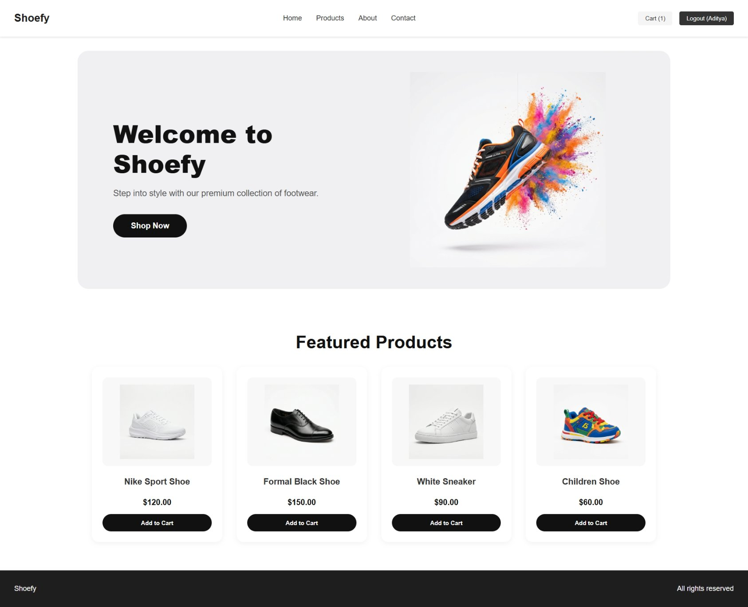

B. Shop / Catalog Page (pages/product.html)

Code
<!DOCTYPE html>
<html lang="en">
<head>
<meta charset="UTF-8">
<title>Shoefy - Products</title>
<link rel="stylesheet" href="../css/index.css">
<link rel="stylesheet" href="../css/product.css">
</head>
<body>
<header><div id="navbar"></div></header>
<main id="content">
<section id="all-products">
<h2 style="text-align:center; margin-bottom:2rem;">Our Full Collection</h2>
<div class="products-grid">
<!-- Products rendered dynamically by product_grid.js -->
</div>
</section>
</main>
<footer id="footer">
<div id="logo">Shoefy</div>
<div>All rights reserved</div>
</footer>
<script src="../js/api.js"></script>
<script src="../js/index.js"></script>
<script src="../js/product_grid.js"></script>
</body>
</html>

Output: Shop / Catalog Page
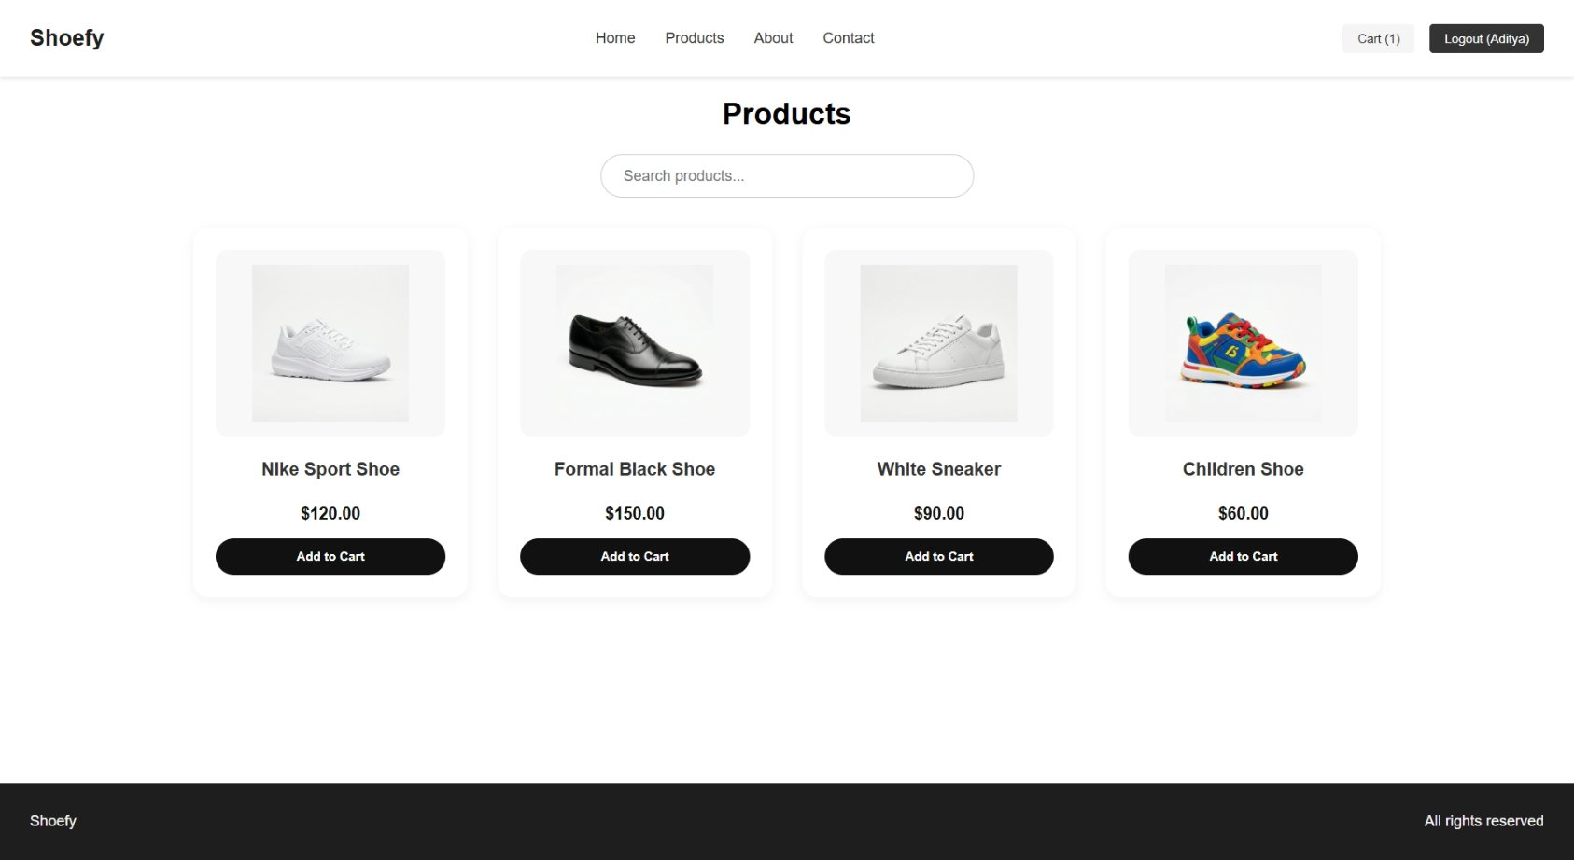

C. Product Details Page (pages/product_detail.html)

Code
<!DOCTYPE html>
<html lang="en">
<head>
<meta charset="UTF-8">
<title>Shoefy - Product Detail</title>
<link rel="stylesheet" href="../css/index.css">
<link rel="stylesheet" href="../css/product.css">
</head>
<body>
<header><div id="navbar"></div></header>
<main id="content">
<div id="product-detail-container" class="product-detail-layout">
<!-- Rendered dynamically via JS API Call -->
</div>
</main>
<footer id="footer">
<div id="logo">Shoefy</div>
<div>All rights reserved</div>
</footer>
<script src="../js/api.js"></script>
<script src="../js/index.js"></script>
<script src="../js/product_grid.js"></script>
</body>
</html>

Output: Product Details Page
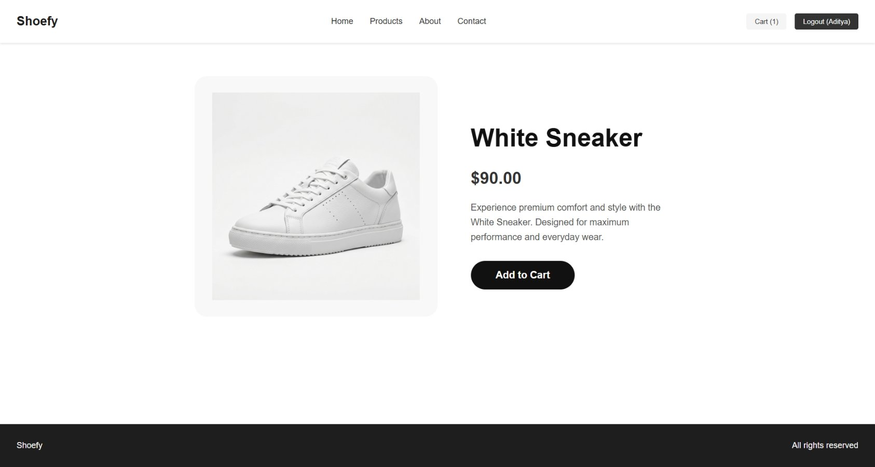

Conclusion

By meticulously crafting the HTML pages for the Shoefy platform, we successfully established a robust, accessible, and SEO-friendly structural layer. The use of semantic HTML5 tags ensures that the content is logically organized, while custom CSS provides a premium aesthetic. This clean DOM tree serves as the perfect foundation for our PHP API integration and dynamic JavaScript rendering.

Experiment 3
CSS Grid & Advanced Layouts

Problem Statement

- A. Enhance the layout of the Shoefy website using CSS Grid for the home page.
- B. Use CSS Grid to layout the product items in a structured manner and style the categories with appropriate headings, spacing, separators, images, descriptions, and prices.

Objective

To implement modern CSS layouts using CSS Grid and Flexbox to create a responsive, visually appealing, and structured presentation for the Shoefy home page and product catalog.

Theory

CSS Grid Layout is a two-dimensional grid-based layout system. Unlike Flexbox (which is one-dimensional), Grid allows precise control over both rows and columns simultaneously. By using grid-template-columns: repeat(auto-fit, minmax(280px, 1fr)), the product grid automatically creates as many columns as will fit the container, each at least 280px wide delivering a fully responsive layout without any media queries.

Flexbox complements Grid by handling alignment within individual components. For example, the hero section uses Flexbox to horizontally split the text content and the shoe image into a two-column layout.

CSS Property | Value Used | Effect
display | grid | Activates CSS Grid on the container
grid-template-columns | repeat(auto-fit, minmax(280px,1fr)) | Responsive multi-column card layout
gap | 2.5rem | Consistent spacing between product cards
border-radius | 16px | Rounded corners for modern card aesthetic
box-shadow | 0 4px 20px rgba(0,0,0,0.05) | Soft elevation shadow for depth
transition | transform 0.3s ease | Smooth hover lift animation

Implementation

Home Page & Product Grid CSS (css/product.css)

/* ===== css/product.css – Product Grid & Card Styles ===== */
/* CSS for product page */
#featured-products {
padding: 4rem 0;
}
#featured-products h2 {
text-align: center;
font-size: 2.5rem;
margin-bottom: 2rem;
color: #111;
}
.products-grid {
display: grid;
grid-template-columns: repeat(auto-fit, minmax(250px, 1fr));
gap: 2rem;
padding: 0 2rem;
}
.product-card {
background-color: #fff;
border-radius: 16px;
padding: 1.5rem;
box-shadow: 0 4px 12px rgba(0,0,0,0.05);
text-align: center;
transition: transform 0.3s ease, box-shadow 0.3s ease;
display: flex;
flex-direction: column;
justify-content: space-between;
}
.product-card:hover {
transform: translateY(-5px);
box-shadow: 0 8px 24px rgba(0,0,0,0.1);
}
.product-image-container {
background-color: #f8f8f8;
border-radius: 12px;
padding: 1rem;
margin-bottom: 1rem;
display: flex;
justify-content: center;
align-items: center;
height: 200px;
}
.product-card img {
max-width: 100%;
max-height: 100%;
object-fit: contain;
}
.product-card h3 {
font-size: 1.2rem;
margin: 0.5rem 0;
color: #333;
}
.product-card p {
font-size: 1.1rem;
font-weight: 700;
color: #111;
margin-bottom: 1rem;
}
.product-card .add-to-cart-btn {
background-color: #111;
color: #fff;
border: none;
padding: 0.75rem 1.5rem;
border-radius: 50px;
cursor: pointer;
font-weight: 600;
transition: background-color 0.3s ease;
}
.product-card .add-to-cart-btn:hover {
background-color: #333;
}
/* Product Detail Layout */
.product-detail-layout {
display: flex;
gap: 4rem;
padding: 4rem 2rem;
align-items: center;
max-width: 1000px;
margin: 0 auto;
}
.detail-image {
flex: 1;
background-color: #f8f8f8;
border-radius: 24px;
padding: 2rem;
display: flex;
justify-content: center;
align-items: center;
}
.detail-image img {
width: 100%;
max-width: 400px;
object-fit: contain;
}
.detail-info {
flex: 1;
}
.detail-info h2 {
font-size: 3rem;
color: #111;
margin-bottom: 1rem;
}
.detail-info .price {
font-size: 2rem;
font-weight: 700;
color: #333;
margin-bottom: 1.5rem;
}
.detail-info .description {
font-size: 1.1rem;
color: #555;
line-height: 1.6;
margin-bottom: 2rem;
}
.detail-add-to-cart-btn {
background-color: #111;
color: #fff;
border: none;
padding: 1rem 3rem;
font-size: 1.2rem;
font-weight: 600;
border-radius: 50px;
cursor: pointer;
transition: all 0.3s ease;
}
.detail-add-to-cart-btn:hover {
background-color: #333;
transform: translateY(-2px);
box-shadow: 0 4px 15px rgba(0,0,0,0.2);
}
@media (max-width: 768px) {
.product-detail-layout {
flex-direction: column;
text-align: center;
}
}
/* ===== css/index.css – Home Page & Navigation ===== */
* {
box-sizing: border-box;
}
body {
margin: 0;
padding: 0;
font-family: "Poppins", sans-serif;
overflow-x: hidden;
}
/* Navbar */
.navbar {
display: flex;
justify-content: space-between;
align-items: center;
padding: 1rem 2rem;
background-color: #fff;
box-shadow: 0 2px 4px rgba(0, 0, 0, 0.1);
}
.logo {
font-size: 1.5rem;
font-weight: 700;
color: #1e1e1e;
}
.nav-links {
display: flex;
list-style: none;
}
.nav-links li {
margin: 0 1rem;
}
.nav-links a {
text-decoration: none;
color: #333;
}
.nav-links a:hover {
color: #007bff;
}
.cta-btns {
display: flex;
}
.cta-btns button {
padding: 0.5rem 1rem;
margin-left: 1rem;
border: none;
border-radius: 4px;
cursor: pointer;
}
.cart-btn {
background-color: #f5f5f5;
color: #333;
}
.login-btn {
background-color: #333;
color: #fff;
}
footer {
padding: 2rem;
background-color: #1e1e1e;
color: #f5f5f5;
display: flex;
justify-content: space-between;
}
/* main content */
#content {
min-height: 100vh;
max-width: 1400px;
margin: 0 auto;
padding: 0 2rem;
}
#hero {
display: flex;
justify-content: space-between;
align-items: center;
background-color: #f0f0f3;
border-radius: 24px;
padding: 3rem 5rem;
margin-top: 2rem;
}
.hero-content {
flex: 1;
padding-right: 2rem;
}
.hero-content h1 {
font-size: 3.5rem;
font-weight: 800;
color: #111;
margin-bottom: 1rem;
line-height: 1.2;
}
.hero-content p {
font-size: 1.2rem;
color: #555;
margin-bottom: 2rem;
line-height: 1.6;
}
.hero-content .cta-btn {
padding: 1rem 2.5rem;
font-size: 1.1rem;
font-weight: 600;
background-color: #111;
color: #fff;
border: none;
border-radius: 50px;
cursor: pointer;
transition: all 0.3s ease;
}
.hero-content .cta-btn:hover {
background-color: #333;
transform: translateY(-2px);
box-shadow: 0 4px 15px rgba(0, 0, 0, 0.2);
}
.hero-image {
flex: 1;
display: flex;
justify-content: center;
align-items: center;
}
.hero-image img {
height: 60vh;
width: auto;
object-fit: contain;
}

Output: CSS Grid Layout – Home Page


Conclusion

The CSS Grid implementation ensures the Shoefy product catalog is fully responsive and adapts seamlessly from mobile to desktop viewports. The hover animations on product cards enhance user interactivity and overall premium feel.

Experiment 4
Styling Complex UI Components

Problem Statement

- A. Enhance the cart page to make it user-friendly and visually appealing with appropriate margins, paddings, and inputs.
- B. Enhance and style the about us page.
- C. Enhance and style the contact page.
- D. Enhance and style the user registration form.
- E. Enhance and style the user login form.

Objective

To apply premium styling to functional components such as tables, forms, and informational pages to ensure a seamless and high-end shopping experience.

Theory

Forms and data tables are historically rigid HTML elements. By applying padding, border-radius, soft shadows, and focus states, we transform generic browser inputs into branded, accessible, and user-friendly interfaces. The CSS :focus pseudo-class is especially important for accessibility it provides a visible ring around the active field so keyboard users can track their position.

The glassmorphism aesthetic used in Shoefy's auth cards is achieved with background: rgba(255,255,255,0.8) combined with backdrop-filter: blur(10px), giving the card a frosted-glass appearance that layers beautifully over background imagery.

Component | CSS Technique | Visual Outcome
Auth card (login/signup) | border-radius: 16px + box-shadow | Floating card with soft shadow
Form inputs | padding: 1rem + border-radius: 8px | Pill-shaped, spacious input fields
Input :focus state | border-color + box-shadow: 0 0 0 3px | Visible focus ring for accessibility
Cart table header | border-bottom: 2px solid #eee + color: #666 | Clean column separator lines
About page hero | background: #f5f5f5 + border-radius: 16px | Soft grey rounded hero banner
Contact store card | background: #1a1a1a + color: #fff | Dark card for address & contact info
CTA Buttons | border-radius: 50px + background: #000 | Bold pill-shaped action buttons

Implementation

Form and Cart Styling (css/index.css & css/login.css)

/* ===== css/about.css – About Page ===== */
/* CSS for about page */
.about-page-wrapper {
max-width: 1200px;
margin: 0 auto;
padding: 2rem 0;
}
.about-hero {
background: #f0f0f3;
border-radius: 24px;
padding: 6rem 2rem;
text-align: center;
margin-bottom: 4rem;
}
.page-title {
font-size: 3.5rem;
font-weight: 800;
color: #111;
margin: 0 0 1rem 0;
}
.page-subtitle {
font-size: 1.5rem;
color: #555;
margin: 0;
font-weight: 500;
}
.about-story {
display: flex;
align-items: center;
gap: 4rem;
margin-bottom: 5rem;
}
.story-content {
flex: 1;
}
.story-content h2 {
font-size: 2.5rem;
color: #111;
margin-bottom: 1.5rem;
}
.story-content p {
font-size: 1.1rem;
color: #555;
line-height: 1.8;
margin-bottom: 1.5rem;
}
.story-image {
flex: 1;
background: #f8f8f8;
border-radius: 24px;
padding: 3rem;
display: flex;
justify-content: center;
align-items: center;
}
.story-image img {
max-width: 100%;
height: auto;
border-radius: 12px;
}
.about-values h2 {
text-align: center;
font-size: 2.5rem;
color: #111;
margin-bottom: 3rem;
}
.values-grid {
display: grid;
grid-template-columns: repeat(auto-fit, minmax(300px, 1fr));
gap: 2rem;
}
.value-card {
background: #fff;
padding: 2.5rem;
border-radius: 16px;
box-shadow: 0 4px 15px rgba(0,0,0,0.05);
text-align: center;
transition: transform 0.3s ease;
}
.value-card:hover {
transform: translateY(-5px);
box-shadow: 0 8px 24px rgba(0,0,0,0.1);
}
.value-card h3 {
font-size: 1.5rem;
color: #111;
margin-top: 0;
margin-bottom: 1rem;
}
.value-card p {
color: #666;
line-height: 1.6;
margin: 0;
}
@media (max-width: 768px) {
.about-story {
flex-direction: column;
}
}
/* ===== css/cart.css – Cart Page ===== */
/* CSS for cart page */
.cart-page-wrapper {
max-width: 1200px;
margin: 0 auto;
padding: 2rem 0;
}
.cart-title {
font-size: 2.5rem;
font-weight: 800;
margin-bottom: 2rem;
color: #111;
}
.cart-layout {
display: flex;
gap: 2rem;
align-items: flex-start;
}
/* Left side table container */
.cart-items {
flex: 2;
background: #fff;
border-radius: 16px;
box-shadow: 0 4px 15px rgba(0,0,0,0.05);
padding: 1.5rem;
overflow-x: auto;
}
.cart-table {
width: 100%;
border-collapse: collapse;
}
.cart-table th {
text-align: left;
padding-bottom: 1rem;
border-bottom: 2px solid #eaeaea;
color: #555;
font-weight: 600;
}
.cart-table td {
padding: 1.5rem 0;
border-bottom: 1px solid #f0f0f3;
vertical-align: middle;
}
.cart-item-row:last-child td {
border-bottom: none;
}
.cart-td-image {
width: 70px;
}
.cart-td-image img {
width: 50px;
height: 50px;
object-fit: contain;
background-color: #f8f8f8;
border-radius: 8px;
padding: 0.5rem;
display: block;
}
.cart-td-name h3 {
font-size: 1.1rem;
margin: 0;
color: #111;
}
.cart-td-price {
color: #555;
font-weight: 600;
}
.quantity-controls {
display: inline-flex;
align-items: center;
gap: 0.8rem;
background: #f0f0f3;
padding: 0.3rem 0.5rem;
border-radius: 50px;
}
.qty-btn {
background: #fff;
border: none;
width: 24px;
height: 24px;
border-radius: 50%;
font-weight: bold;
cursor: pointer;
box-shadow: 0 2px 5px rgba(0,0,0,0.1);
display: flex;
align-items: center;
justify-content: center;
transition: transform 0.2s;
}
.qty-btn:active {
transform: scale(0.95);
}
.cart-td-total strong {
font-size: 1.1rem;
color: #111;
}
.remove-btn {
background: none;
border: none;
color: #ff4757;
font-weight: 600;
cursor: pointer;
text-decoration: underline;
padding: 0;
}
/* Right side summary */
.cart-summary {
flex: 1;
background: #f8f8f8;
padding: 2rem;
border-radius: 24px;
position: sticky;
top: 2rem;
}
.cart-summary h2 {
margin-top: 0;
margin-bottom: 1.5rem;
font-size: 1.5rem;
}
.summary-row {
display: flex;
justify-content: space-between;
font-size: 1.2rem;
font-weight: 700;
margin-bottom: 2rem;
padding-bottom: 1rem;
border-bottom: 2px solid #eaeaea;
}
.summary-total {
font-size: 1.8rem;
}
.checkout-btn {
width: 100%;
padding: 1rem;
background: #111;
color: #fff;
border: none;
border-radius: 50px;
font-size: 1.1rem;
font-weight: bold;
cursor: pointer;
transition: all 0.3s ease;
}
.checkout-btn:hover {
background: #333;
transform: translateY(-2px);
box-shadow: 0 4px 15px rgba(0,0,0,0.2);
}
.empty-cart-msg {
font-size: 1.2rem;
color: #555;
text-align: center;
padding: 3rem;
background: transparent;
}
@media (max-width: 768px) {
.cart-layout {
flex-direction: column;
}
.cart-summary {
width: 100%;
}
}
/* ===== css/checkout.css – Checkout Page ===== */
.checkout-container {
max-width: 1200px;
margin: 4rem auto;
padding: 0 2rem;
display: grid;
grid-template-columns: 1fr 1fr;
gap: 3rem;
}
@media (max-width: 800px) {
.checkout-container {
grid-template-columns: 1fr;
}
}
.checkout-section {
background: rgba(255, 255, 255, 0.9);
backdrop-filter: blur(10px);
border-radius: 16px;
padding: 3rem;
box-shadow: 0 12px 40px rgba(0, 0, 0, 0.08);
}
.checkout-section h2 {
margin-top: 0;
margin-bottom: 2rem;
font-size: 1.8rem;
color: #1a1a1a;
border-bottom: 2px solid #f0f0f0;
padding-bottom: 1rem;
}
.form-group {
margin-bottom: 1.5rem;
}
.form-group label {
display: block;
margin-bottom: 0.5rem;
font-weight: 600;
color: #444;
font-size: 0.95rem;
}
.form-group input {
width: 100%;
padding: 1rem;
border: 1px solid #e1e1e1;
border-radius: 8px;
font-size: 1rem;
background: #fafafa;
transition: all 0.3s ease;
}
.form-group input:focus {
outline: none;
border-color: #000;
background: #fff;
box-shadow: 0 0 0 4px rgba(0, 0, 0, 0.05);
}
.form-row {
display: grid;
grid-template-columns: 1fr 1fr;
gap: 1.5rem;
}
.order-summary {
background: #f8f9fa;
padding: 1.5rem;
border-radius: 12px;
margin-top: 2rem;
border: 1px solid #eee;
}
.order-summary h3 {
margin: 0;
display: flex;
justify-content: space-between;
align-items: center;
font-size: 1.2rem;
color: #555;
font-weight: 500;
}
.total-amount {
font-size: 2rem;
font-weight: 700;
color: #000;
}
.pay-btn {
width: 100%;
padding: 1.2rem;
background: #000;
color: #fff;
border: none;
border-radius: 50px;
font-size: 1.2rem;
font-weight: 600;
cursor: pointer;
transition: all 0.3s ease;
margin-top: 2rem;
letter-spacing: 0.5px;
}
.pay-btn:hover {
background: #222;
transform: translateY(-3px);
box-shadow: 0 10px 25px rgba(0, 0, 0, 0.2);
}
/* ===== css/contact.css – Contact Page ===== */
/* CSS for contact page */
.contact-page-wrapper {
max-width: 1200px;
margin: 0 auto;
padding: 3rem 0;
}
.page-title {
font-size: 3rem;
font-weight: 800;
text-align: center;
color: #111;
margin-bottom: 0.5rem;
}
.page-subtitle {
text-align: center;
color: #666;
font-size: 1.1rem;
margin-bottom: 3rem;
}
.contact-layout {
display: flex;
gap: 3rem;
align-items: flex-start;
}
.contact-form-container {
flex: 1;
background: #fff;
padding: 3rem;
border-radius: 24px;
box-shadow: 0 10px 30px rgba(0, 0, 0, 0.05);
}
.contact-form {
display: flex;
flex-direction: column;
gap: 1.5rem;
}
.input-group {
display: flex;
flex-direction: column;
text-align: left;
}
.input-group label {
font-size: 0.95rem;
font-weight: 600;
color: #333;
margin-bottom: 0.5rem;
}
.input-group input,
.input-group textarea {
width: 100%;
padding: 1rem;
border: 1px solid #ddd;
border-radius: 12px;
font-size: 1rem;
font-family: inherit;
background: #fafafa;
transition: all 0.3s ease;
}
.input-group input:focus,
.input-group textarea:focus {
outline: none;
border-color: #111;
box-shadow: 0 0 0 3px rgba(17, 17, 17, 0.1);
background: #fff;
}
.submit-btn {
background: #111;
color: #fff;
border: none;
padding: 1rem;
border-radius: 50px;
font-size: 1.1rem;
font-weight: bold;
cursor: pointer;
transition: all 0.3s ease;
margin-top: 1rem;
}
.submit-btn:hover {
background: #333;
transform: translateY(-2px);
box-shadow: 0 4px 15px rgba(0,0,0,0.2);
}
.contact-map-container {
flex: 1;
display: flex;
flex-direction: column;
gap: 2rem;
}
.contact-info {
background: #111;
color: #fff;
padding: 2.5rem;
border-radius: 24px;
box-shadow: 0 10px 30px rgba(0, 0, 0, 0.1);
}
.contact-info h3 {
font-size: 1.5rem;
margin-top: 0;
margin-bottom: 1rem;
}
.contact-info p {
font-size: 1.1rem;
line-height: 1.8;
margin: 0;
color: #ddd;
}
.map-wrapper {
border-radius: 24px;
overflow: hidden;
box-shadow: 0 10px 30px rgba(0, 0, 0, 0.05);
height: 300px;
}
.map-wrapper iframe {
width: 100%;
height: 100%;
border: none;
}
@media (max-width: 768px) {
.contact-layout {
flex-direction: column;
}
}
/* ===== css/login.css – Login & Auth Pages ===== */
/* CSS for login page */
.auth-container {
display: flex;
justify-content: center;
align-items: center;
min-height: 80vh;
padding: 2rem;
}
.auth-box {
background: #fff;
width: 100%;
max-width: 450px;
padding: 3rem;
border-radius: 24px;
box-shadow: 0 10px 30px rgba(0, 0, 0, 0.08);
text-align: center;
animation: fadeIn 0.4s ease-in-out;
}
@keyframes fadeIn {
from { opacity: 0; transform: translateY(10px); }
to { opacity: 1; transform: translateY(0); }
}
.auth-box h2 {
font-size: 2rem;
font-weight: 800;
color: #111;
margin-top: 0;
margin-bottom: 0.5rem;
}
.auth-box p {
color: #666;
margin-bottom: 2rem;
}
.auth-form {
display: flex;
flex-direction: column;
gap: 1.5rem;
}
.input-group {
text-align: left;
}
.input-group label {
display: block;
font-size: 0.9rem;
font-weight: 600;
color: #333;
margin-bottom: 0.5rem;
}
.input-group input {
width: 100%;
padding: 1rem;
border: 1px solid #ddd;
border-radius: 12px;
font-size: 1rem;
font-family: inherit;
transition: border-color 0.3s, box-shadow 0.3s;
background: #fafafa;
}
.input-group input:focus {
outline: none;
border-color: #111;
box-shadow: 0 0 0 3px rgba(17, 17, 17, 0.1);
background: #fff;
}
.auth-btn {
background: #111;
color: #fff;
border: none;
padding: 1rem;
border-radius: 50px;
font-size: 1.1rem;
font-weight: bold;
cursor: pointer;
transition: background 0.3s, transform 0.2s;
margin-top: 1rem;
}
.auth-btn:hover {
background: #333;
transform: translateY(-2px);
box-shadow: 0 4px 15px rgba(0,0,0,0.2);
}
.auth-btn:active {
transform: translateY(0);
}
.auth-switch {
margin-top: 2rem;
font-size: 0.9rem;
color: #555;
}
.auth-switch button {
background: none;
border: none;
color: #111;
font-weight: 700;
cursor: pointer;
padding: 0;
text-decoration: underline;
font-size: 0.9rem;
transition: color 0.3s;
}
.auth-switch button:hover {
color: #555;
}

Output: Styled Forms & Cart UI
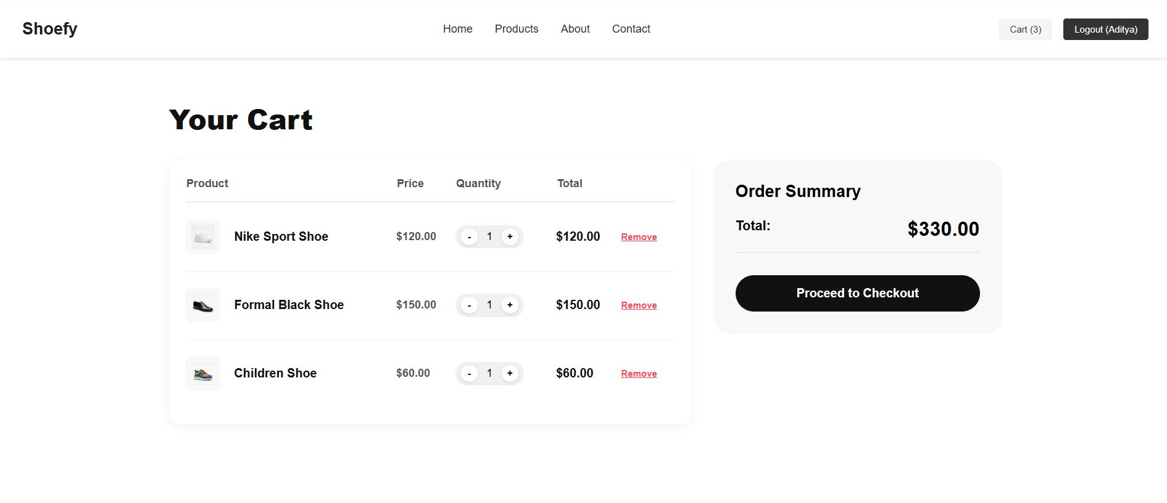

Output: About Page


Output: Contact Page
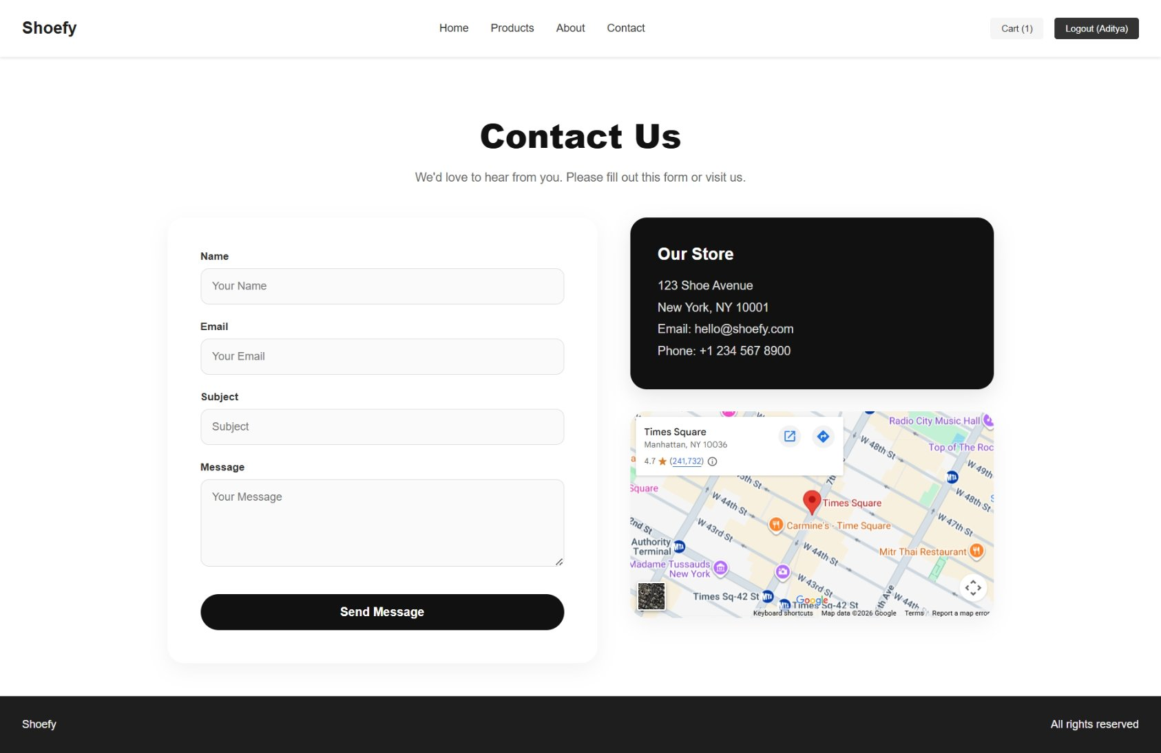

Conclusion

By applying consistent, premium CSS styles to all form elements and the cart table, the Shoefy website achieves a cohesive, branded, and user-friendly interface across all its complex UI components.

Experiment 5
JavaScript – User Authentication & Form Handling

Problem Statement

- A. Implement user registration and login forms to capture basic user details.
- B. Provide validations for forms.
- C. Redirect successful logins to the homepage.
- D. Use localStorage to store authentication data.

Objective

To use vanilla JavaScript to intercept form submissions, validate user input, communicate with the backend API, and manage client-side session state using the browser's localStorage.

Theory

JavaScript transforms static HTML into a dynamic application. By attaching event listeners to form submit events and calling preventDefault(), we intercept the browser's default form submission and handle it entirely in JavaScript, enabling validation and asynchronous communication with the server.

The Fetch API (fetch()) is a modern, Promise-based replacement for XMLHttpRequest. It sends HTTP requests with a JSON body to the PHP backend and awaits the response asynchronously, keeping the UI responsive throughout.

localStorage is a key-value store built into every browser that persists data beyond the current page session. Shoefy stores the authenticated user object (id and full_name) as a JSON string under the key shoefy_user. Every page checks for this key on load to determine the user's login state and update the navbar accordingly.

Concept | Shoefy Usage | File
DOMContentLoaded event | Initialize navbar & load cart count on every page | index.js
submit event listener | Intercept login and signup form submissions | index.js
fetch() with POST + JSON body | Send credentials to backend/api.php | api.js
localStorage.setItem() | Save user object after successful login | index.js
localStorage.getItem() | Read user session on page load to update navbar | index.js
window.location.href | Redirect user to home page after successful login | index.js

Implementation

Authentication and LocalStorage (js/api.js & js/index.js)

Code
// api.js - Generic Fetch Wrapper
async function apiRequest(action, method = "GET", data = null) {
let url = `${API_BASE_URL}?action=${action}`;
const options = { method, headers: { "Content-Type": "application/json" } };
if (data && method !== "GET") options.body = JSON.stringify(data);
const response = await fetch(url, options);
const result = await response.json();
if (!response.ok || !result.success) throw new Error(result.message);
return result;
}
// Login with Redirect
async function handleLogin() {
const email = document.getElementById("login-email").value;
const password = document.getElementById("login-password").value;
try {
const res = await apiRequest("login", "POST", { email, password });
localStorage.setItem("shoefy_user", JSON.stringify(res.user));
window.location.href = "../index.html"; // Redirect on success
} catch (e) {
alert(e.message);
}
}

Output: Login Form
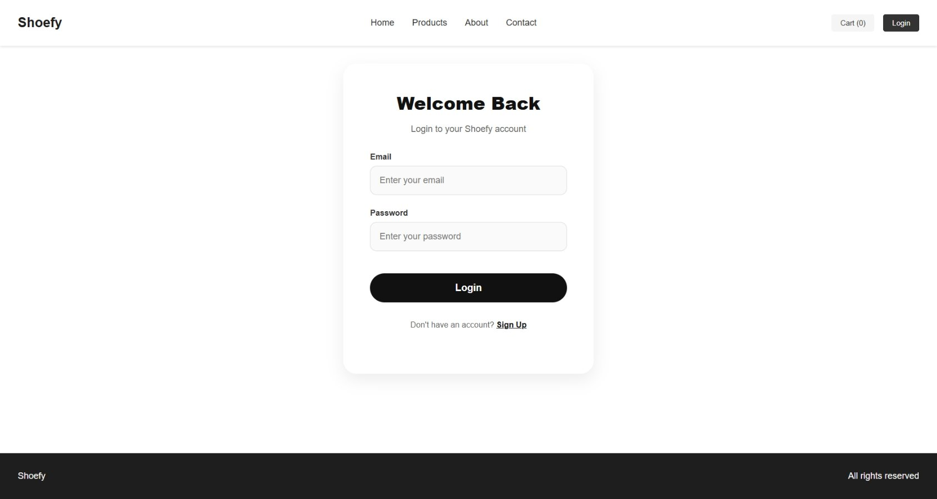

Conclusion

By combining the fetch() API with localStorage, the Shoefy frontend achieves a smooth, session-aware authentication flow without requiring page reloads. Form validation ensures data integrity before any server communication occurs.

Experiment 6
JavaScript – Cart State Management

Problem Statement

- A. Develop cart functionality to add items to the cart.
- B. Develop functionality to update item quantities in the cart.
- C. Develop functionality to remove items from the cart.
- D. Persist and retrieve cart state across page navigation.

Objective

To implement client-side cart management using JavaScript and the fetch() API, allowing users to add, update, and remove items from their cart with real-time synchronization to the server-side MySQL database.

Theory

Cart state management involves synchronizing the client-side UI with server-side data stored in MySQL. A clean REST-style API is used where the HTTP method determines the operation type. After every mutation (add, update, remove), the entire cart is re-fetched from the server and the UI is re-rendered, ensuring the displayed totals and quantities always reflect the true database state.

The smart duplicate-check logic in the backend prevents a product from being inserted twice. If the user adds an item already in their cart, the quantity is incremented with an UPDATE rather than creating a duplicate row, enforcing the UNIQUE(user_id, product_id) constraint defined in schema.sql.

HTTP Method | Action | SQL Operation | Shoefy Behaviour
GET | cart?user_id=X | SELECT + JOIN | Fetch all cart items with product details
POST | cart | INSERT / UPDATE | Add item; increment qty if already exists
PUT | cart | UPDATE / DELETE | Update quantity; remove if qty set to 0
DELETE | cart?cart_id=X | DELETE | Remove a specific item completely

Implementation

Cart Add & Remove Logic (js/cart.js)

Code
// cart.js - Add to Cart
async function addToCart(productId) {
const user = JSON.parse(localStorage.getItem("shoefy_user"));
if (!user) {
alert("Please log in to add items to your cart.");
window.location.href = "../pages/login.html";
return;
}
try {
await apiRequest("cart", "POST", {
user_id: user.id,
product_id: productId
});
alert("Item added to cart!");
} catch (e) {
alert(e.message);
}
}
// cart.js - Remove from Cart
async function removeFromCart(cartId) {
const user = JSON.parse(localStorage.getItem("shoefy_user"));
try {
await apiRequest("cart", "DELETE", {
cart_id: cartId,
user_id: user.id
});
loadCart(); // Refresh cart display
} catch (e) {
alert(e.message);
}
}

Output: Cart Page


Conclusion

The cart management module successfully bridges the client-side UI and the server-side MySQL database. By checking localStorage for a valid session before every operation, the module enforces authentication and prevents unauthorized cart manipulation.

Experiment 7
PHP Backend – User Registration

Problem Statement

- A. Develop a PHP script to handle user registration (accept name, email, password).
- B. Implement server-side validation and error handling for registration.
- C. Hash passwords securely before storing in the database.

Objective

To build a secure server-side registration endpoint using PHP that validates user input, hashes passwords using PASSWORD_BCRYPT, and stores user records in the MySQL database via PDO prepared statements.

Theory

PHP acts as the server-side language bridging the client browser and the MySQL database. The api.php file routes all requests using the ?action= query parameter combined with the HTTP method, forming a lightweight RESTful API pattern without a dedicated framework.

PDO (PHP Data Objects) is a database abstraction layer that supports prepared statements. A prepared statement separates the SQL query structure from user-supplied data: the query template is sent to MySQL first, and the user values are bound to placeholders (?) separately. This completely prevents SQL injection because user input is never concatenated directly into the query string.

password_hash() uses the BCRYPT algorithm by default, which automatically generates and embeds a random salt and applies thousands of computational rounds. This means even if the database is breached, the passwords cannot be reversed to plain text without an infeasible brute-force effort.

PHP Concept | Role in Registration
$_SERVER['REQUEST_METHOD'] | Detect GET/POST/PUT/DELETE to route the action
json_decode(file_get_contents('php://input')) | Read raw JSON body from JavaScript fetch() call
filter_var($email, FILTER_VALIDATE_EMAIL) | Server-side email format validation
password_hash($password, PASSWORD_BCRYPT) | Hash password before storing in database
$pdo->prepare(SQL) | Create a prepared statement to prevent SQL injection
$stmt->execute([$val1, $val2]) | Bind values to placeholders and execute safely
json_encode($response) | Return structured JSON response to client

Implementation

A. Database Connection (backend/db_connection.php)

All database access flows through a single file: db_connection.php. It creates a PDO instance with ERRMODE_EXCEPTION so every query failure throws a catchable exception rather than silently failing.

Code
<?php
$host = "localhost"; // XAMPP default
$db_name = "shoefy_ecommerce_site";
$username = "aditya";
$password = "8767";
try {
$pdo = new PDO(
"mysql:host=$host;dbname=$db_name;charset=utf8",
$username,
$password
);
// Throw exceptions on DB errors (easier debugging)
$pdo->setAttribute(PDO::ATTR_ERRMODE, PDO::ERRMODE_EXCEPTION);
// Always return rows as associative arrays
$pdo->setAttribute(PDO::ATTR_DEFAULT_FETCH_MODE, PDO::FETCH_ASSOC);
} catch(PDOException $e) {
die("Connection failed: " . $e->getMessage());
}
?>

B. User Registration Handler (backend/api.php – signup case)

The full api.php sets CORS headers, reads the HTTP method and action, then dispatches to the appropriate switch case. The signup case validates input, checks for duplicate emails, hashes the password with BCRYPT, and inserts the new user into MySQL.

Code
<?php
// --- API Headers (CORS + JSON) ---
header("Access-Control-Allow-Origin: *");
header("Content-Type: application/json; charset=UTF-8");
header("Access-Control-Allow-Methods: POST, GET, PUT, DELETE");
require_once "db_connection.php";
$method = $_SERVER["REQUEST_METHOD"];
$action = isset($_GET["action"]) ? $_GET["action"] : "";
$input = json_decode(file_get_contents("php://input"), true);
$response = ["success" => false, "message" => "Invalid Request"];
try {
switch ($action) {
// ---- SIGNUP ----
case "signup":
if ($method === "POST") {
$name = $input["full_name"] ?? "";
$email = $input["email"] ?? "";
$password = $input["password"] ?? "";
if (empty($name) || empty($email) || empty($password))
throw new Exception("All fields are required");
// Check if email already registered
$stmt = $pdo->prepare("SELECT id FROM users WHERE email = ?");
$stmt->execute([$email]);
if ($stmt->rowCount() > 0)
throw new Exception("Email already exists");
$hash = password_hash($password, PASSWORD_BCRYPT);
$stmt = $pdo->prepare(
"INSERT INTO users (full_name, email, password_hash)
VALUES (?, ?, ?)"
);
if ($stmt->execute([$name, $email, $hash])) {
$response = [
"success" => true,
"message" => "User created successfully",
"user_id" => $pdo->lastInsertId()
];
}
}
break;
}
} catch (Exception $e) {
http_response_code(400);
$response = ["success" => false, "message" => $e->getMessage()];
}
echo json_encode($response);
?>

Output: Registration / Sign Up Page
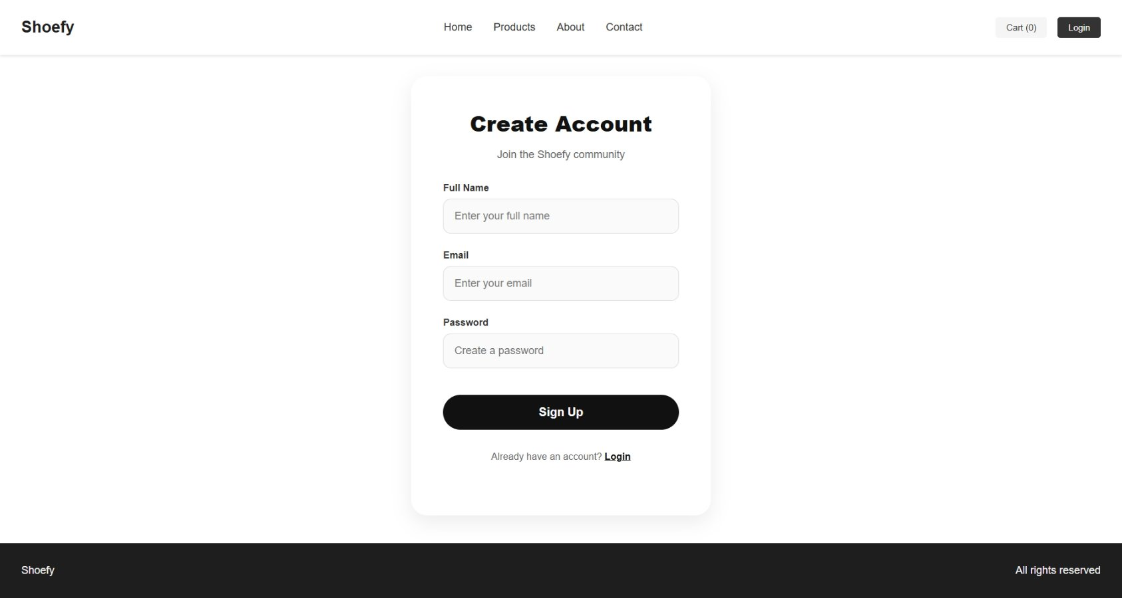

Conclusion

The PHP registration module provides a secure, server-side validation layer. Using PDO with prepared statements prevents SQL injection, while password_hash() with BCRYPT ensures that user passwords are stored as one-way cryptographic hashes, protecting user data even in the event of a database breach.

Experiment 8
PHP Backend – User Login & Authentication

Problem Statement

- A. Develop a PHP script to handle user login.
- B. Verify the submitted password against the stored hash.
- C. Provide clear feedback responses upon successful or failed authentication.

Objective

To implement a secure login endpoint in PHP that fetches a user record from MySQL, uses password_verify() to check credentials against the stored BCRYPT hash, and returns a structured JSON response to the client.

Theory

Authentication requires comparing the user-supplied password against a stored hash without ever decrypting it, because BCRYPT is a one-way function. PHP's password_verify($plain, $hash) handles this automatically, applying the same algorithm and embedded salt to the input and checking if the result matches.

The login query fetches the user by email only. The password comparison happens in PHP, not in SQL this is intentional. A SQL query like WHERE password = '$hash' would be vulnerable to timing attacks, while PHP's password_verify() uses constant-time comparison.

Security Principle | Implementation in Shoefy
One-way password storage | BCRYPT hash stored; original password never saved
No plain-text comparison | password_verify() used; never compare raw strings
User enumeration prevention | Same error msg for wrong email OR wrong password
SQL injection prevention | PDO prepared statement: SELECT ... WHERE email = ?
Minimal data exposure | Only id and full_name returned to client, not password_hash
HTTP error codes | http_response_code(400) returned on all auth failures

Implementation

User Login Handler (backend/api.php – login case)

Code
// ---- LOGIN ----
case "login":
if ($method === "POST") {
$email = $input["email"] ?? "";
$password = $input["password"] ?? "";
if (empty($email) || empty($password))
throw new Exception("Email and password are required");
// Fetch user record by email only (not password)
$stmt = $pdo->prepare(
"SELECT id, full_name, password_hash FROM users WHERE email = ?"
);
$stmt->execute([$email]);
$user = $stmt->fetch();
// password_verify() compares plain text against BCRYPT hash
if ($user && password_verify($password, $user["password_hash"])) {
$response = [
"success" => true,
"message" => "Login successful",
"user" => [
"id" => $user["id"],
"full_name" => $user["full_name"],
"email" => $email
]
];
} else {
// Generic message prevents user enumeration attacks
throw new Exception("Invalid email or password");
}
}
break;

Output: Login Authentication Page


Conclusion

The login module correctly implements credential verification using password_verify() against the BCRYPT hash stored during registration. The use of a generic error message prevents user enumeration, and PDO prepared statements guard against SQL injection throughout.

Experiment 9
PHP & MySQL Cart Management

Problem Statement

Develop a PHP script to manage the shopping cart using MySQL. The script should allow users to add items, view contents, and remove items, ensuring persistence across sessions.

Objective

To transition from volatile client-side cart storage to secure, persistent server-side storage using a relational database.

Theory

A robust e-commerce cart is implemented as a junction table (cart_items) in the relational database, linking a user_id to a product_id with a quantity column. This server-side persistence means the cart survives page refreshes, browser restarts, and even multiple devices logging into the same account.

The UNIQUE(user_id, product_id) constraint in schema.sql enforces that each product can appear at most once per user in the cart. Instead of failing on a duplicate insert, the PHP backend implements a smart 'upsert' it checks if the row exists, then either UPDATEs the quantity or INSERTs a new row. The GET endpoint uses a JOIN to fetch product name, price, and image alongside the cart quantity in a single SQL call.

Table | Key Columns | Relationships
users | id, full_name, email, password_hash | Referenced by cart_items.user_id
products | id, name, description, price, image_url | Referenced by cart_items.product_id
cart_items | id, user_id, product_id, quantity | FK → users + FK → products, UNIQUE(user_id, product_id)
orders | id, user_id, total_amount, status | FK → users (future order tracking)
order_items | id, order_id, product_id, price_at_time | FK → orders + FK → products

Implementation

A. Database Schema (backend/schema.sql)

The schema.sql file creates all five tables and seeds the initial four product records. It must be imported into MySQL (via phpMyAdmin or CLI) before the application can run.

Code
-- Shoefy E-Commerce Database Schema
CREATE TABLE IF NOT EXISTS users (
id INT AUTO_INCREMENT PRIMARY KEY,
full_name VARCHAR(255) NOT NULL,
email VARCHAR(255) UNIQUE NOT NULL,
password_hash VARCHAR(255) NOT NULL,
created_at TIMESTAMP DEFAULT CURRENT_TIMESTAMP
);
CREATE TABLE IF NOT EXISTS products (
id INT AUTO_INCREMENT PRIMARY KEY,
name VARCHAR(255) NOT NULL,
description TEXT,
price DECIMAL(10, 2) NOT NULL,
image_url VARCHAR(255),
created_at TIMESTAMP DEFAULT CURRENT_TIMESTAMP
);
CREATE TABLE IF NOT EXISTS cart_items (
id INT AUTO_INCREMENT PRIMARY KEY,
user_id INT,
product_id INT,
quantity INT NOT NULL DEFAULT 1,
created_at TIMESTAMP DEFAULT CURRENT_TIMESTAMP,
FOREIGN KEY (user_id) REFERENCES users(id) ON DELETE CASCADE,
FOREIGN KEY (product_id) REFERENCES products(id) ON DELETE CASCADE,
UNIQUE(user_id, product_id)
);
CREATE TABLE IF NOT EXISTS orders (
id INT AUTO_INCREMENT PRIMARY KEY,
user_id INT,
total_amount DECIMAL(10, 2) NOT NULL,
status VARCHAR(50) DEFAULT 'pending',
created_at TIMESTAMP DEFAULT CURRENT_TIMESTAMP,
FOREIGN KEY (user_id) REFERENCES users(id) ON DELETE SET NULL
);
INSERT INTO products (name, description, price, image_url) VALUES
("Nike Sport Shoe", "Premium comfort for max performance.", 120.00, "images/nike_sport_shoe.png"),
("Formal Black Shoe", "Premium comfort for max performance.", 150.00, "images/formal_black_shoe.png"),
("White Sneaker", "Premium comfort for max performance.", 90.00, "images/white_sneaker.png"),
("Children Shoe", "Premium comfort for max performance.", 60.00, "images/children_shoe.png");

B. Full Cart Handler (backend/api.php – cart case)

Code
case "cart":
$user_id = isset($_GET["user_id"])
? intval($_GET["user_id"])
: (isset($input["user_id"]) ? intval($input["user_id"]) : null);
if (!$user_id)
throw new Exception("User ID is required for cart operations");
if ($method === "GET") {
// JOIN fetches product info alongside cart quantity in one query
$stmt = $pdo->prepare(
"SELECT c.id as cart_id, c.quantity, p.*
FROM cart_items c
JOIN products p ON c.product_id = p.id
WHERE c.user_id = ?"
);
$stmt->execute([$user_id]);
$response = ["success" => true, "cart" => $stmt->fetchAll()];
} elseif ($method === "POST") {
$product_id = $input["product_id"] ?? null;
$quantity = $input["quantity"] ?? 1;
if (!$product_id) throw new Exception("Product ID required");
// Smart upsert: increment qty if item exists, else insert new row
$stmt = $pdo->prepare(
"SELECT id, quantity FROM cart_items
WHERE user_id = ? AND product_id = ?"
);
$stmt->execute([$user_id, $product_id]);
$existing = $stmt->fetch();
if ($existing) {
$stmt = $pdo->prepare(
"UPDATE cart_items SET quantity = ? WHERE id = ?"
);
$stmt->execute([$existing["quantity"] + $quantity, $existing["id"]]);
} else {
$stmt = $pdo->prepare(
"INSERT INTO cart_items (user_id, product_id, quantity)
VALUES (?, ?, ?)"
);
$stmt->execute([$user_id, $product_id, $quantity]);
}
$response = ["success" => true, "message" => "Item added to cart"];
} elseif ($method === "PUT") {
$cart_id = $input["cart_id"] ?? null;
$quantity = $input["quantity"] ?? null;
if (!$cart_id || $quantity === null)
throw new Exception("Cart ID and quantity required");
if ($quantity <= 0) {
$stmt = $pdo->prepare(
"DELETE FROM cart_items WHERE id = ? AND user_id = ?"
);
$stmt->execute([$cart_id, $user_id]);
} else {
$stmt = $pdo->prepare(
"UPDATE cart_items SET quantity = ? WHERE id = ? AND user_id = ?"
);
$stmt->execute([$quantity, $cart_id, $user_id]);
}
$response = ["success" => true, "message" => "Cart updated"];
} elseif ($method === "DELETE") {
$cart_id = isset($_GET["cart_id"]) ? intval($_GET["cart_id"]) : null;
if (!$cart_id) throw new Exception("Cart ID required");
$stmt = $pdo->prepare(
"DELETE FROM cart_items WHERE id = ? AND user_id = ?"
);
$stmt->execute([$cart_id, $user_id]);
$response = ["success" => true, "message" => "Item removed from cart"];
}
break;

Output: Cart Management


Conclusion

By implementing server-side cart management with MySQL, the Shoefy platform ensures that cart data persists reliably across sessions. The JOIN query efficiently fetches cart items along with their product details in a single database call.

Experiment 10
PHP Products Endpoint & Checkout Process

Problem Statement

- A. Develop a PHP endpoint to fetch all products and individual product details from MySQL.
- B. Implement the checkout process: validate the form, calculate the cart total dynamically.
- C. Upon simulated successful payment, clear the user's cart from the database.
- D. Redirect the user to the homepage after a successful order.

Objective

To complete the full e-commerce lifecycle from displaying products fetched dynamically from MySQL, through cart management, to a final checkout that atomically clears the cart and confirms the order to the user.

Theory

The products endpoint handles two cases: fetching all products (for the catalog page) or fetching a single product by ID (for the detail page). This is controlled by an optional ?id= query parameter. Both responses return JSON consumed by the frontend's product_grid.js renderer.

The checkout process is entirely client-side orchestrated. JavaScript reads the cart from the API, sums the totals, and on form submit iterates through each cart item issuing a DELETE request. This loop approach clears each row individually, working within the existing REST API without requiring a dedicated 'clear cart' endpoint.

Checkout Step | Technology Used | What Happens
1. Page Load | JS + fetch() GET cart | Fetch cart items, render totals dynamically
2. Auth Check | localStorage.getItem() | Redirect to login if no session found
3. Form Submit | addEventListener('submit') | Prevent default; validate cart not empty
4. Cart Clearing | fetch() DELETE loop | Each cart item deleted via REST API one by one
5. Success Redirect | window.location.href | User sent to homepage after confirmation alert

Implementation

A. Products PHP Endpoint (backend/api.php – products case)

The products case serves both the catalog page (all products) and the detail page (single product by ?id=). A conditional branch checks for the optional id parameter.

Code
// ---- PRODUCTS ----
case "products":
if ($method === "GET") {
$id = isset($_GET["id"]) ? intval($_GET["id"]) : null;
if ($id) {
// Single product by ID
$stmt = $pdo->prepare("SELECT * FROM products WHERE id = ?");
$stmt->execute([$id]);
$product = $stmt->fetch();
if ($product) {
$response = ["success" => true, "product" => $product];
} else {
throw new Exception("Product not found");
}
} else {
// All products
$stmt = $pdo->query("SELECT * FROM products");
$products = $stmt->fetchAll();
$response = ["success" => true, "products" => $products];
}
}
break;

B. Checkout JavaScript (js/checkout.js)

On page load, the cart is fetched and totals are rendered. On form submit, every cart item is deleted via the API, then the user is redirected to the home page.

Code
// checkout.js – load cart then handle form submission
let cartItems = [];
let currentUser = JSON.parse(localStorage.getItem("shoefy_user"));
async function loadCheckoutCart() {
if (!currentUser) {
window.location.href = "../pages/login.html";
return;
}
const res = await apiRequest(`cart?user_id=${currentUser.id}`, "GET");
cartItems = res.cart;
const total = cartItems.reduce((sum, i) => sum + i.price * i.quantity, 0);
document.getElementById("checkout-total").textContent = `$${total.toFixed(2)}`;
}
// On form submit: validate → clear cart → redirect
document.getElementById("checkout-form").addEventListener("submit", async (e) => {
e.preventDefault();
if (cartItems.length === 0) {
alert("Your cart is empty!");
return;
}
try {
// Delete every cart item via the REST API
for (const item of cartItems) {
await apiRequest(
`cart?cart_id=${item.cart_id}&user_id=${currentUser.id}`,
"DELETE"
);
}
alert("Payment successful! Your order is on the way.");
window.location.href = "../index.html";
} catch (err) {
alert("An error occurred: " + err.message);
}
});
document.addEventListener("DOMContentLoaded", loadCheckoutCart);

Output: Checkout Process
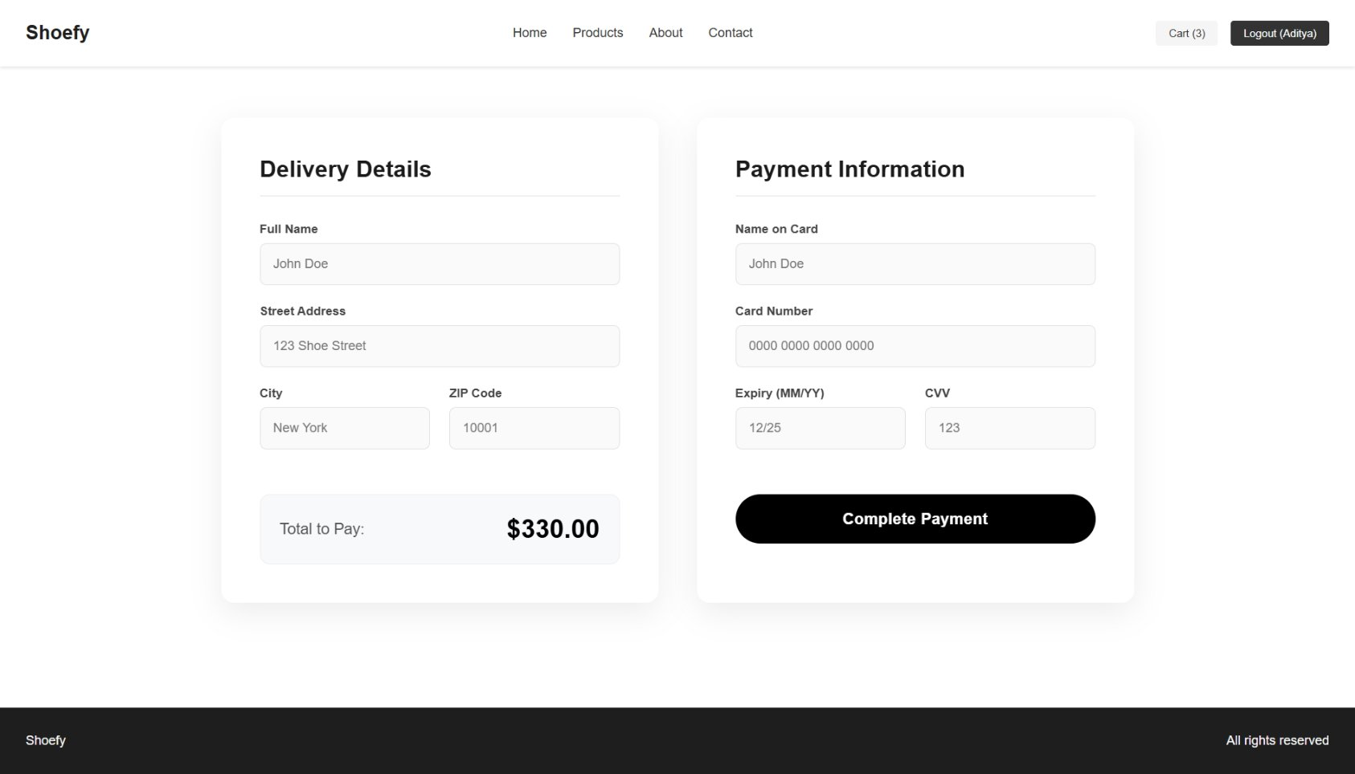

Conclusion

The products endpoint and checkout module together complete the full e-commerce lifecycle for Shoefy. Products are served dynamically from MySQL, ensuring the catalog always reflects the latest database state. The checkout process atomically clears the user's cart via the existing REST API, maintaining database consistency without requiring a dedicated transaction endpoint. The project successfully demonstrates a complete, full-stack web application built with vanilla HTML, CSS, JavaScript, PHP, and MySQL.

