**📝Test Estimation Report**

## **1. Introduction**

This document provides an estimation of testing effort, resources, and timelines for the upcoming release of the web application. The estimation covers both **Functional** and **Non-Functional Testing** activities. It also highlights assumptions, risks, and dependencies considered during estimation.

## **2. Objectives**

* Provide effort and resource estimates for Functional and Non-Functional testing.
* Define the scope and assumptions for estimation.
* Identify risks and mitigation plans related to testing effort.
* Establish a baseline for test planning and execution.

## **3. Scope of Testing**

### **3.1 Functional Testing**

* Requirement Validation
* Test Case Design & Review
* Functional Test Execution
* Regression Testing
* Defect Reporting & Retesting

### **3.2 Non-Functional Testing**

* Performance & Load Testing
* Security Testing
* Compatibility (Cross-Browser & Device) Testing
* Usability Testing
* Accessibility Testing

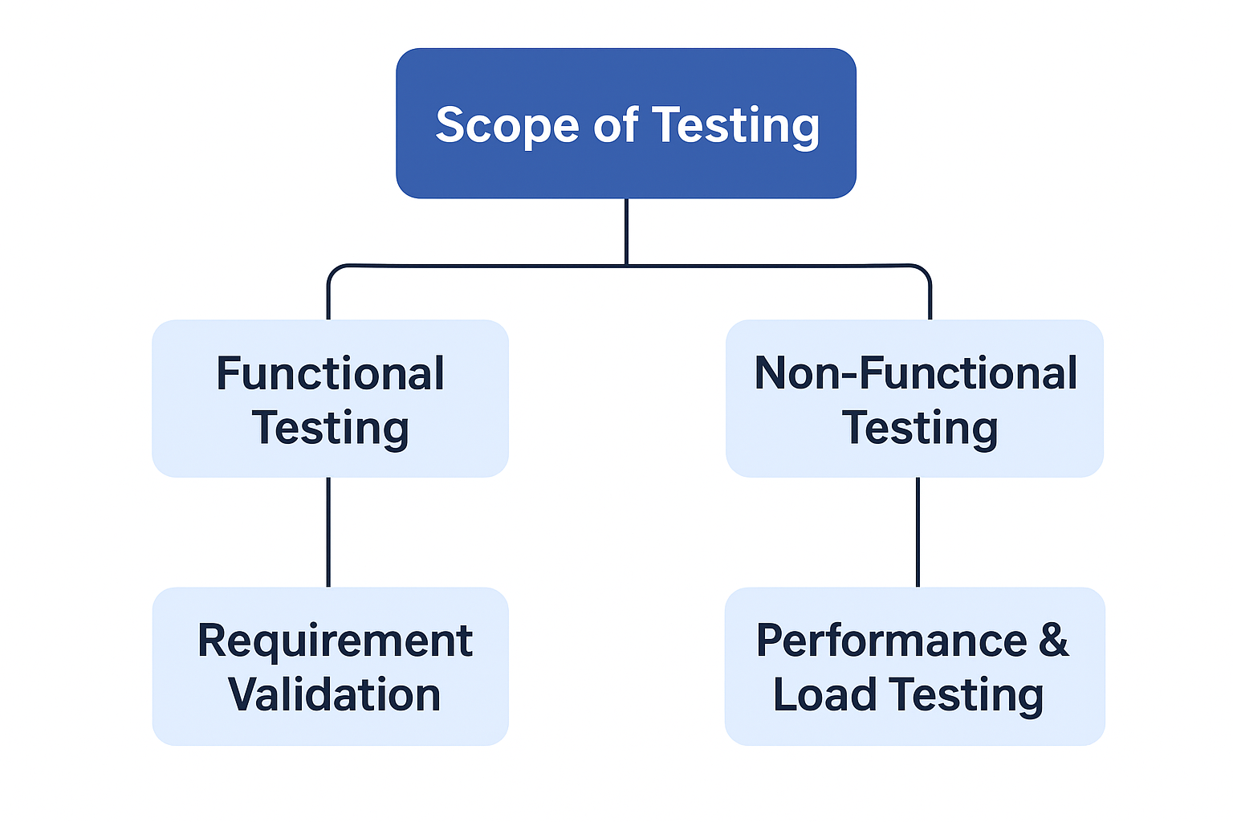

## **4. Estimation Approach**

The following methods were used:

* **Work Breakdown Structure (WBS)** – breaking down into granular tasks.
* **Historical Data** – based on past project velocity & defect density.
* **Three-Point Estimation (PERT Formula)** – for uncertain activities.
* **Expert Judgment** – input from QA leads and SMEs.

## **5. Estimation Breakdown**

### **5.1 Functional Testing Estimation**

|  |  |  |
| --- | --- | --- |
| **Activity** | **Effort (Person-Days)** | **Assumptions** |
| Requirement Analysis | 5 | All requirements are documented & reviewed. |
| Test Case Preparation | 10 | ~200 test cases to be written. |
| Test Case Review | 3 | Peer review for coverage & quality. |
| Test Execution | 15 | Includes multiple cycles & retesting. |
| Defect Reporting & Closure | 5 | Avg. 30 defects expected. |
| Regression Testing | 7 | Regression pack ~150 test cases. |
| **Total** | **45 Person-Days** |  |

### **5.2 Non-Functional Testing Estimation**

|  |  |  |
| --- | --- | --- |
| **Activity** | **Effort (Person-Days)** | **Assumptions** |
| Performance & Load Testing | 10 | Using JMeter; 1,000 concurrent users. |
| Security Testing | 8 | Includes vulnerability scanning + manual pen tests. |
| Compatibility Testing | 5 | Across 3 browsers & 2 devices. |
| Usability Testing | 3 | Involves 5 business users for feedback. |
| Accessibility Testing | 4 | WCAG 2.1 compliance checks. |
| **Total** | **30 Person-Days** |  |

## **6. Resource Plan**

|  |  |  |  |
| --- | --- | --- | --- |
| **Role** | **Count** | **Duration** | **Effort Allocation** |
| QA Manager | 1 | Full cycle | Oversight, reporting, sign-off |
| Test Leads | 1 | Full cycle | Planning, reviews, defect triage |
| Test Engineers | 3 | Full cycle | Execution of functional test cases |
| Performance Tester | 1 | 2 weeks | Performance & load testing |
| Security Engineer | 1 | 1.5 weeks | Security assessment |

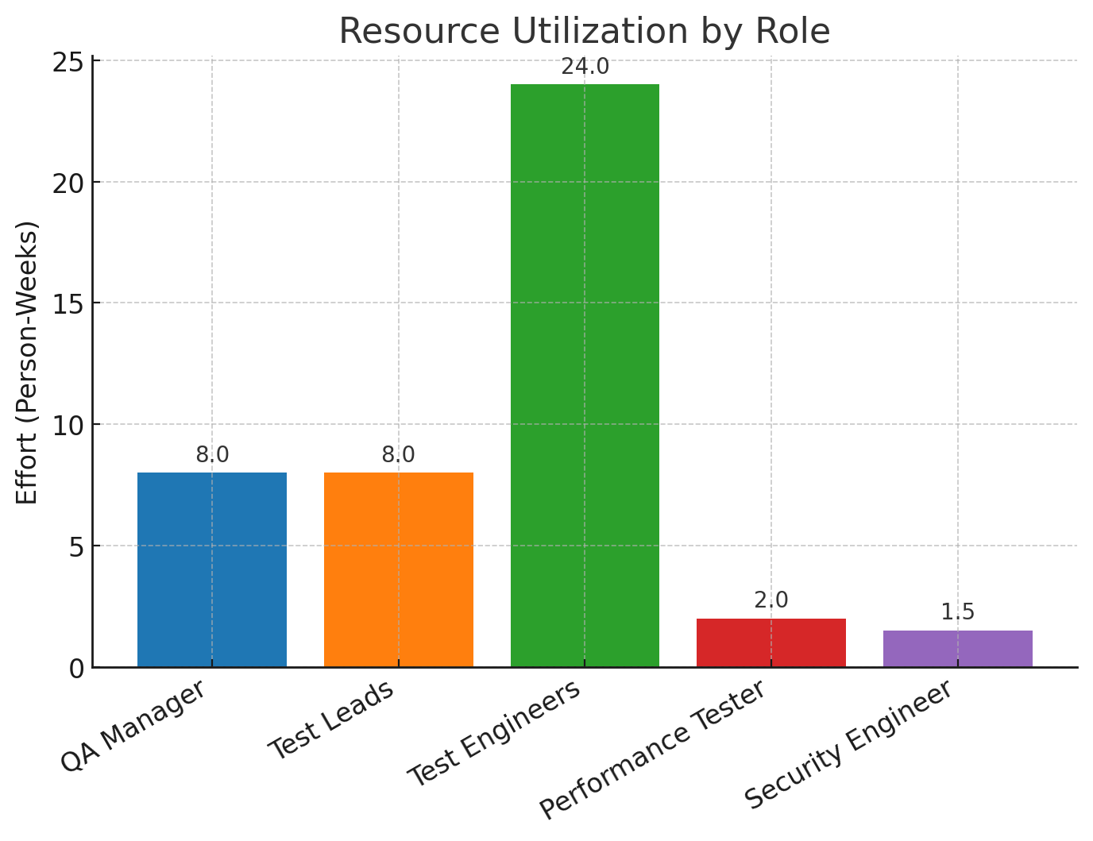

## **7. Effort Summary**

* **Functional Testing Effort:** 45 Person-Days
* **Non-Functional Testing Effort:** 30 Person-Days
* **Total QA Effort:** 75 Person-Days

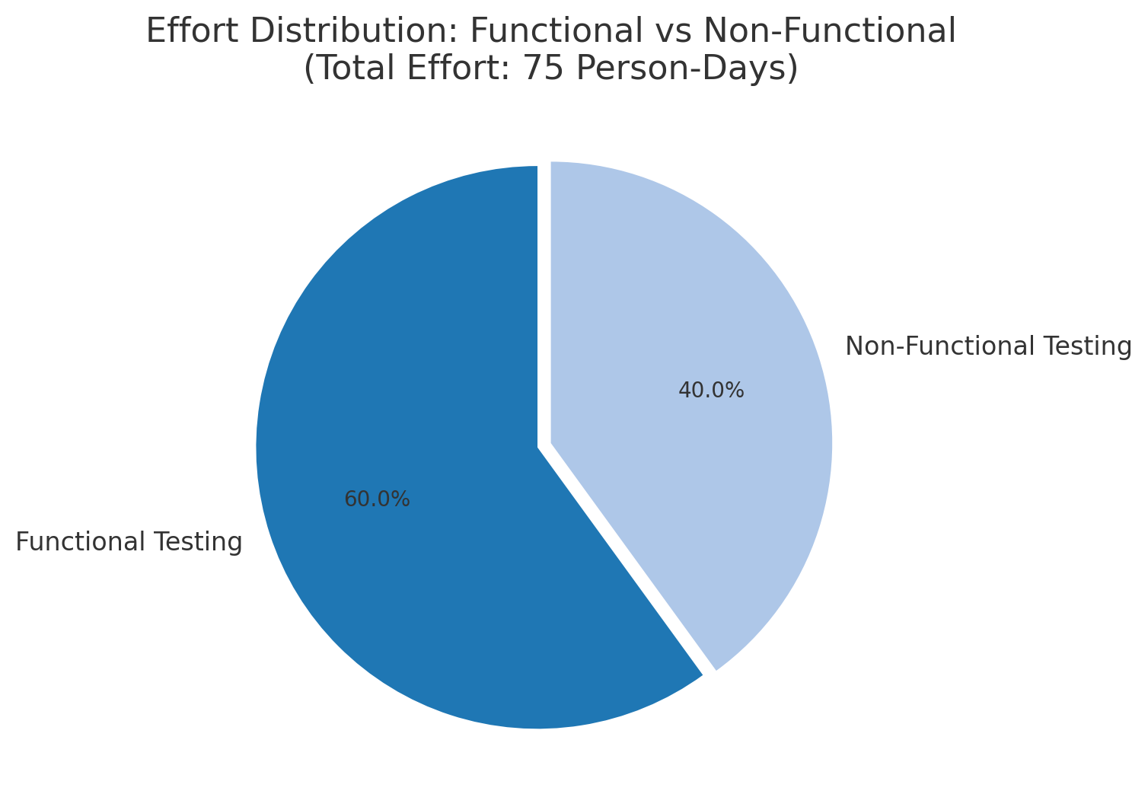

## **8. Assumptions**

* Requirements are signed off and stable.
* Test environments will be available as per schedule.
* Test data will be prepared by the development/business team.
* All third-party integrations are stable.
* No major scope changes post-estimation.

## **9. Risks & Mitigation**

|  |  |  |
| --- | --- | --- |
| **Risk** | **Impact** | **Mitigation** |
| Delayed environment readiness | High | Request early provisioning; fallback to lower env. |
| Scope creep in requirements | Medium | Re-baseline estimation after CR approval. |
| Limited performance testing window | High | Early performance testing cycles; monitoring post go-live. |
| Test data unavailability | Medium | Use synthetic data generation tools. |

## **10. Conclusion & Recommendation**

Based on the estimation approach and breakdown, a total of **75 Person-Days** effort is required to complete both Functional and Non-Functional testing activities. Adequate resource allocation, stable environments, and timely data availability are critical for meeting this estimation.

**Prepared By:**  
QA Manager – _____________________  
Date – _____________________