Test Plan

UK Banking & Financial Application

# 1. Introduction

This Test Plan describes the QA approach for the UK Banking & Financial Solution Application. The testing scope covers key areas such as **functional, regression, security, performance, accessibility, and compliance**. All testing activities will ensure the application meets UK regulatory standards including FCA, PSD2, and GDPR.

# 2. Test Objectives

* Ensure system performance under load conditions.
* Validate data integrity across transactions.
* Verify user interface responsiveness.
* Test compatibility with various devices and browsers.
* Assess security vulnerabilities and risks.
* Validate compliance with UK banking regulations (FCA, PSD2, GDPR).
* Ensure functional and non-functional quality.
* Deliver defect-free, stable application to end-users.

# 3. Test Approach

Risk-based testing approach, Agile methodology, automation for regression and smoke testing, and continuous reporting via dashboards.

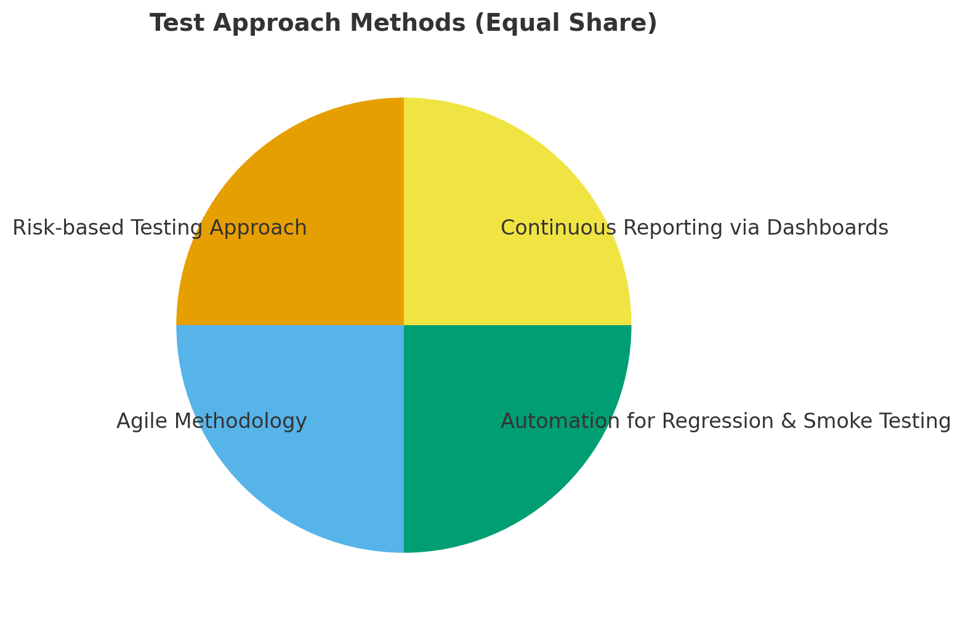

# 4. Test Levels

The **testing lifecycle** progresses through multiple levels to ensure complete application quality. It begins with **Unit Testing**, where individual components are validated in isolation. Next, **SIT (System Integration Testing)** checks interactions between modules, followed by **System Testing** to verify the application. **Regression Testing** ensures that new changes don’t break existing functionality. **UAT (User Acceptance Testing)** validates the solution against business requirements. **Non-functional testing** includes **Performance** to measure speed and scalability, **Security** to safeguard data, **Accessibility** to ensure usability for all users, and **Compliance Testing** to confirm adherence to industry and regulatory standards.



# 5. Entry & Exit Criteria

#### **Entry Criteria**

Testing activities will commence only when the following prerequisites are met:

1. **Business Requirement Document (BRD) / Functional Specifications Approved**
   1. All requirements are baselined, reviewed, and formally signed off by the Business and Product Owner.
   2. Any open clarifications are tracked via the requirement management tool and resolved before test design begins.
2. **Environment Readiness**
   1. The designated test environments (SIT, UAT, Performance) are provisioned and validated for stability.
   2. Required configurations, integrations with dependent systems (e.g., payment gateways, CRM, third-party APIs), and access permissions are in place.
   3. Build deployment has been verified as successful and is aligned with the release package.
3. **Test Data Prepared & Validated**
   1. Sufficient and representative test data sets are created, covering both positive and negative scenarios, and are refreshed or masked to comply with data privacy guidelines.
   2. Test data has been validated for completeness, ensuring that boundary values, regulatory conditions, and financial/accounting scenarios (specific to the Banking & Financial domain) are covered.
4. **Test Plan & Test Cases Reviewed and Approved**
   1. Test plan is finalized and signed off by stakeholders.
   2. Test cases are peer-reviewed, mapped to requirements (RTM in place), and uploaded into the Test Management Tool.
5. **Defect Management Process in Place**
   1. Defect triage schedule and severity/priority definitions are agreed upon by QA, Dev, and Business stakeholders.
   2. Access to the defect tracking tool is confirmed for all stakeholders.

#### **Exit Criteria**

Testing will be considered complete only when the following conditions are fulfilled:

1. **Defect Resolution**
   1. All High and Critical severity defects are closed and successfully retested.
   2. No open Medium/Low severity defects that can block business processes or regulatory compliance.
   3. Defect leakage analysis is completed for defects identified in later stages.
2. **Regression Testing Passed**
   1. Full regression suite executed successfully across impacted areas.
   2. No regression failures in critical business workflows (e.g., payments, customer onboarding, account closure, compliance reporting).
3. **Coverage Achieved**
   1. All planned test cases executed, and requirement coverage (via RTM) is 100%.
   2. Automation suite execution results are reviewed (if applicable).
4. **Test Closure Activities Completed**
   1. Test Summary Report prepared, highlighting execution statistics, defect trends, and quality metrics.
   2. Test closure meeting conducted with stakeholders, and formal sign-off obtained from Business and Product Owner.
   3. All QA deliverables (test cases, logs, defect reports, metrics) stored in the project repository for audit and compliance.
5. **No Major Risks Outstanding**
   1. Any known risks or open issues are documented, communicated, and accepted by stakeholders before sign-off.

# 6. Environment

Environments: Dev, SIT, UAT, Pre-Prod, Prod.  
Data management with GDPR compliance.

# 7. Roles & Responsibilities

|  |  |  |  |  |
| --- | --- | --- | --- | --- |
| **Role** | **Responsible (R)** | **Accountable (A)** | **Consulted (C)** | **Informed (I)** |
| QA Manager |  | X | X | X |
| Test Leads | X |  | X | X |
| Testers | X |  |  | X |
| Automation Engineers | X |  |  | X |
| Security Testers | X |  |  | X |
| Business Analysts |  |  | X | X |

# 8. Deliverables

The deliverables for this project will include a comprehensive set of documents and materials that meet the specified requirements and objectives. These materials include the **Project Plan, Requirements Specification, Design Document, Test Plan, and User Manual**. Each deliverable will be **reviewed** and **approved** to ensure quality and alignment with project goals. Detailed timelines and responsibilities will be outlined to facilitate efficient completion and delivery.

# 9. Schedule

The project schedule is divided into several key phases, each critical to the successful completion of the project. Below is a chart illustrating these phases: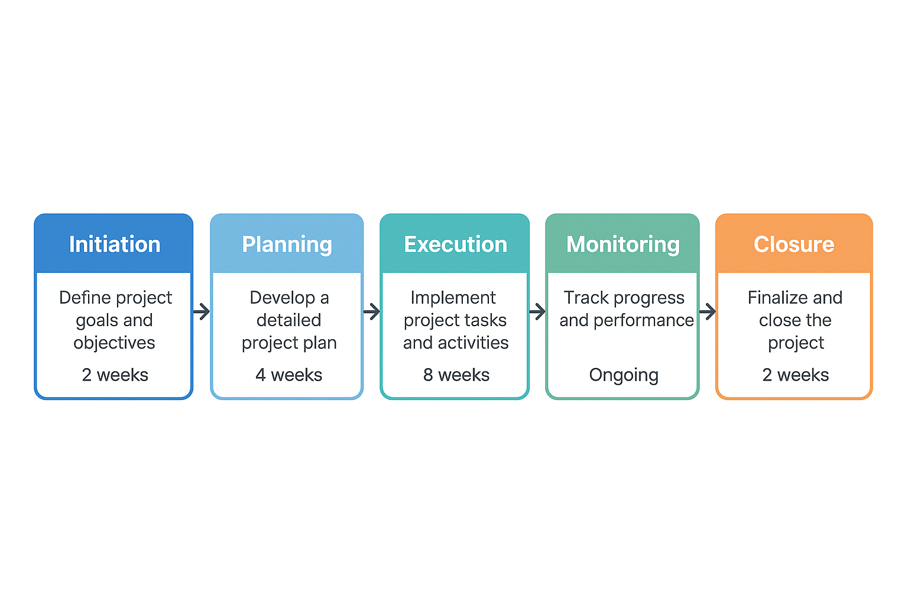End of document.