# **Test Sign-Off Report**

## **1. Introduction**

This Test Sign-Off Report provides a summary of the testing activities carried out for the web application go-live. It highlights the scope of testing, results, defect status, risks, and overall QA recommendation for release.

## **2. Scope of Testing**

The following testing types were executed as part of this release:

* Unit Testing
* System & System Integration Testing
* Functional Testing
* Regression Testing
* User Acceptance Testing (UAT)
* Performance Testing
* Security Testing
* Non-Functional Testing (Accessibility, Look & Feel (UI/UX) validation, Lighthouse, Wave & Cross-Browser)



## **3. Test Execution Summary**

|  |  |  |  |  |  |
| --- | --- | --- | --- | --- | --- |
| **Test Type** | **Executed** | **Passed** | **Failed** | **Blocked** | **Pass %** |
| Functional | 120 | 115 | 5 | 0 | 95.8% |
| Regression | 80 | 78 | 2 | 0 | 97.5% |
| Integration | 50 | 47 | 3 | 0 | 94.0% |
| UAT | 40 | 38 | 2 | 0 | 95.0% |
| Performance | 20 | 18 | 2 | 0 | 90.0% |
| Security | 15 | 14 | 1 | 0 | 93.3% |

**Overall Pass %:** 95%

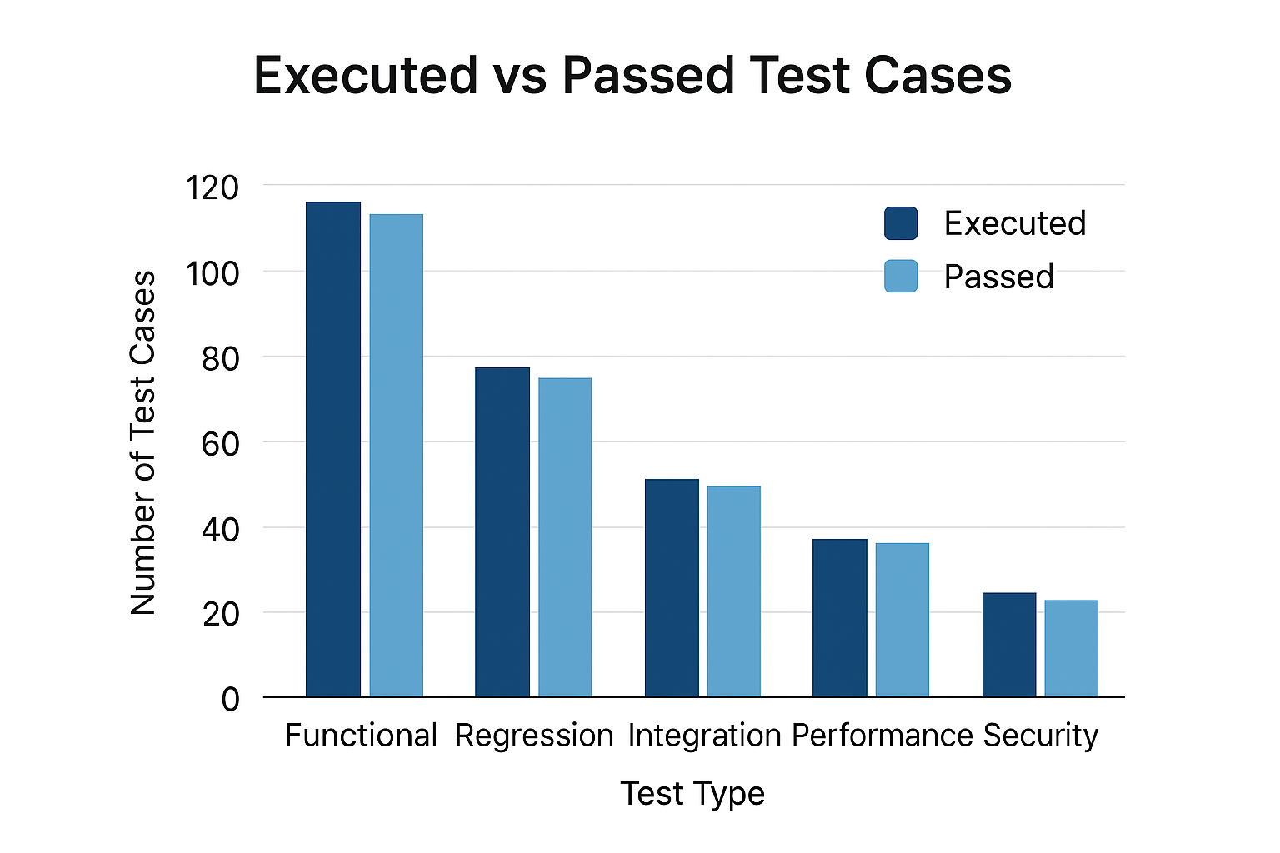

## **4. Defect Summary**

|  |  |  |  |
| --- | --- | --- | --- |
| **Severity** | **Raised** | **Closed** | **Open/Deferred** |
| Critical | 10 | 10 | 0 |
| High | 15 | 15 | 0 |
| Medium | 20 | 18 | 2 |
| Low | 25 | 20 | 5 |

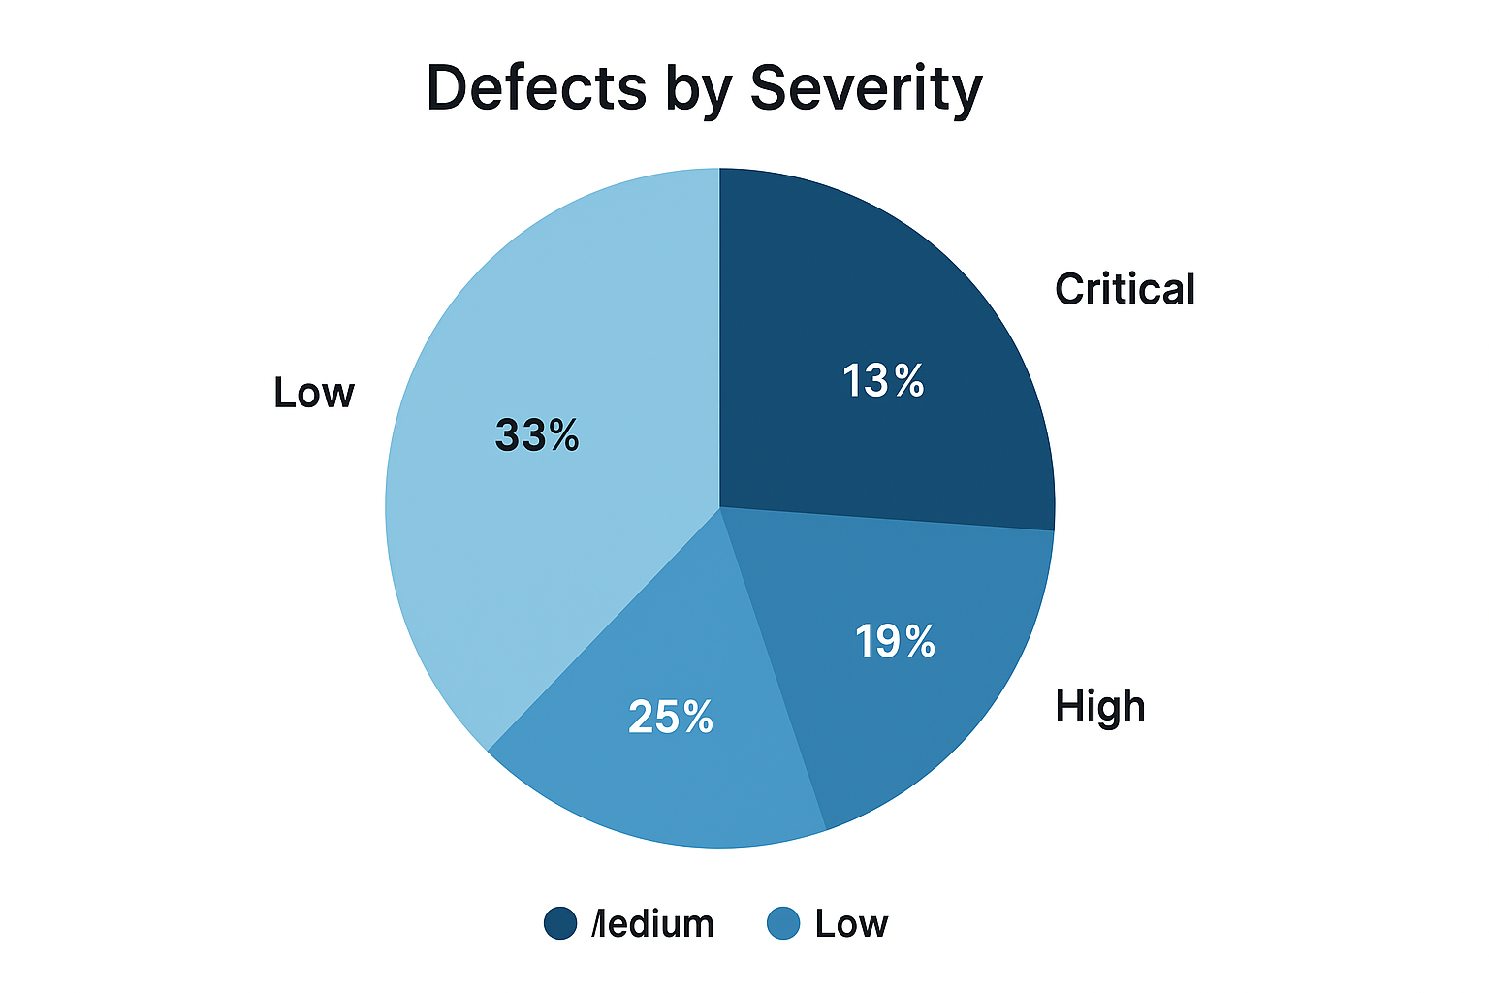

**Observation:** All critical and high-severity defects have been closed. Medium and low-severity issues are either fixed or deferred to the next release.

## **5. Risks & Mitigation**

* **Risk:** Limited time for performance testing.
  + *Mitigation:* Continuous monitoring planned post go-live.
* **Risk:** Minor UI defects deferred.
  + *Mitigation:* Fixes scheduled in the next release patch.
* **Risk:** Dependency on third-party API response times.
  + *Mitigation:* SLA agreement and fallback mechanism implemented.

## **6. Lessons Learnt**

### **What Went Well ✅**

* Strong collaboration between QA, Dev, and Business teams.
* Early involvement of QA in requirement reviews.
* Stable test environment availability.

### **Challenges Faced ⚠️**

* Delays in receiving stable builds.
* Limited test data for edge-case scenarios.
* Performance testing window was shortened.

### **Improvements for Future 🔧**

* Automate smoke/regression packs for faster cycles.
* Strengthen Test Data Management process.
* Start performance/security testing earlier in the lifecycle.

## **7. QA Sign-Off**

Based on the testing performed, defect resolution, and UAT approval, the QA team recommends sign-off for the web application go-live.

**Approved By:**  
QA Manager: _________________________  
Date: _________________________