SRI CHANDRASEKHARENDRA SARASWATHI VISWA MAHAVIDYALAYA

(UNIVERSITY ESTABLISHED under section 3 of UGC Act 1956)

ENATHUR, KANCHIPURAM – 631 561



OBJECT ORIENTED PROGRAMMING IN JAVA
LABORATORY RECORD

Name : G.ROHINI

Reg. No : 112534040

Class : I YEAR BCA

Subject : UCAF252T50 – OOP in Java Lab

SRI CHANDRASEKHARENDRA SARASWATHI

VISWA MAHAVIDYALAYA
(University Established under section 3 of UGC Act 1956)



BONAFIDE CERTIFICATE

This is to Certify that this is the bonafide record of work done by Ms.G.ROHINI with Reg. No 112534040 of I Year BCA in the Object Oriented Programming in Java Lab during the year 2026.

Staff-in-charge Head of the Department

Submitted for the Practical Examination held on ________________________

Internal Examiner External Examiner.

INDEX

S.No. | Date | Title | Page No. | Signature
1 | 05 Feb 2026 | PROGRAM USING CLASS, OBJECT, OVERLOADED METHODS, COMMAND LINE ARGUMENTS | 01
2 | 12 Feb 2026 | PROGRAM TO EXPLORE JAVA.LANG.MATH CLASS METHODS AND CUSTOM PACKAGE | 05
3 | 12 Feb 2026 | PROGRAM TO EXPLORE STRING AND STRINGBUFFER METHODS | 09
4 | 19 Feb 2026 | PROGRAM TO DEMONSTRATE INHERITANCE, DYNAMIC DISPATCH CONCEPTS | 13
5 | 26 Feb 2026 | PROGRAM TO EXPLORE BUILT IN EXCEPTIONS AND STATIC METHODS | 21
6 | 05 Mar 2026 | PROGRAM TO EXPLORE USER-DEFINED (CUSTOM) EXCEPTIONS | 24
7 | 26 Mar 2026 | PROGRAM TO EXPLORE MULTI THREADING | 27
8 | 26 Mar 2026 | PROGRAM TO EXPLORE FILE OPERATIONS | 31
9 | 02 Apr 2026 | PROGRAM TO EXPLOREL COLLECTIONS FRAMEWORK (DATASTRUCTURES) AND JAVADOC | 34
10 | 09 Apr 2026 | SAMPLE GUI WITH EVENT HANDLING USING JAVA SWINGS | 41
11 | 16 Apr 2026 | DATABASE PROGRAMMING WITH JAVA.SQL | 44

1 | PROGRAM USING CLASS, OBJECT, OVERLOADED METHODS, COMMAND LINE ARGUMENTS | 05 Feb 2026

AIM:
To demonstrate the use of classes, packages, method overloading, and command-line arguments in Java.

UML DIAGRAMS:
Package Diagram:
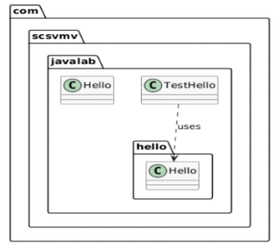

Class Diagram:
com.scsvmv.javalab.hello.Hello
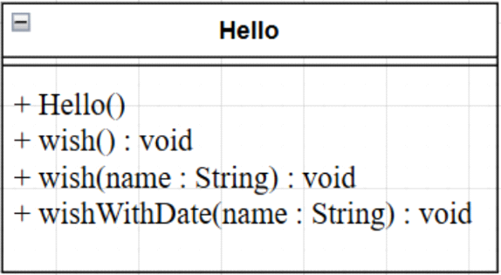

com.scsvmv.javalab.Hello
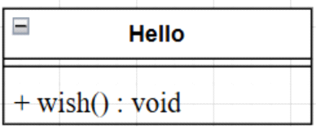

com.scsvmv.javalab.TestHello
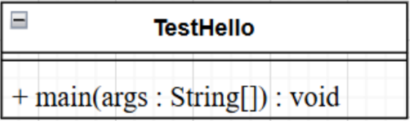
SOURCE CODE:
https://github.com/rohiniclab/java-lab/tree/main/pgm1/src/com/scsvmv/javalab/hello

PROGRAM PATH:

com/scsvmv/javalab/Hello.java

package com.scsvmv.javalab;
/*
*Simple Hello class
*Always wishes Hello World
*/

public class Hello{
public void wish(){
System.out.println("Hello World");
}
}

com/scsvmv/javalab/TestHello.java
package com.scsvmv.javalab;
import com.scsvmv.javalab.hello.Hello;
/*
*TestHello class
*Demonstrates passing command-line arguments
*/
public class TestHello{
public static void main(String[] args){
Hello simpleHello = new Hello();
simpleHello.wish();

com.scsvmv.javalab.hello.Hello h =
new com.scsvmv.javalab.hello.Hello();

if(args.length>0){
h.wish(args[0]);
h.wishWithDate(args[0]);
}else{
System.out.println("Usage:");
System.out.println("java com.scsvmv.javalab.TestHello<name>");
System.out.println("Example:");
System.out.println("java com.scsvmv.javalab.TestHello Student");
}
}
}

com/scsvmv/javalab/hello/Hello.java

package com.scsvmv.javalab.hello;
import java.util.Date;
/*
*Hello class
*Demonstartes method overloading and command-line arguments
*/
public class Hello{
public Hello(){
}
public void wish(){
System.out.println("Hello World");
}
public void wish(String name){
System.out.println("Hello" + name);
}
public void wishWithDate(String name){
Date today = new Date();
System.out.println("Hello"+name+"Date:"+today);
}
}

OUTPUT:
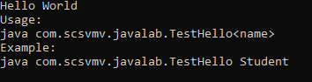

2 | PROGRAM TO EXPLORE JAVA.LANG.MATH CLASS METHODS AND CUSTOM PACKAGE | 12 Feb 2026

AIM:
To demonstrate the use of important methods in java.lang.Math class and to experiment custom packages in Java.

UML DIAGRAMS:
Class Diagram:
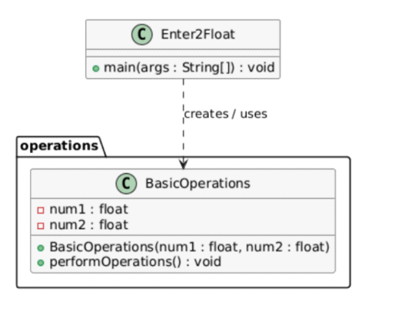
Sequence Diagram:
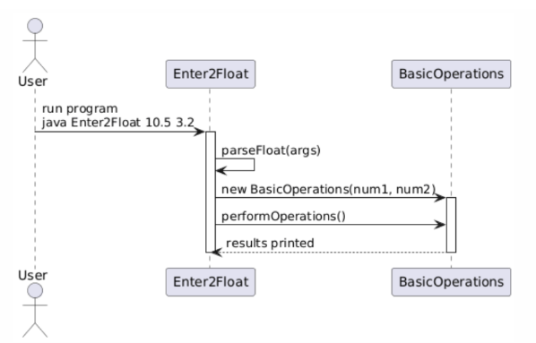

Package Diagram:

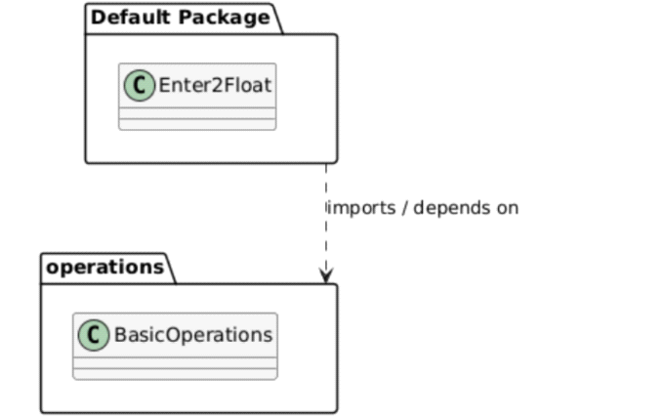
SOURCE CODE:

https://github.com/rohiniclab/java-lab/tree/main/pgm2/operations

PROGRAM PATH:

Enter2Float.java
import operations.BasicOperations;
public class Enter2Float {
public static void main(String[] args) {
if (args.length != 2) {
System.out.println("Usage: java Enter2Float <num1> <num2>");
return;
}
try {
float num1 = Float.parseFloat(args[0]);
float num2 = Float.parseFloat(args[1]);

BasicOperations obj1 = new BasicOperations(num1, num2);
obj1.performOperations();

BasicOperations obj2 = new BasicOperations(10, 3);
obj2.performOperations();
} catch (NumberFormatException e) {
System.out.println("Please enter valid float numbers.");
}
}
}

operations/BasicOperations.java
package operations;
public class BasicOperations {

private float num1;
private float num2;
// Constructor for float values
public BasicOperations(float num1, float num2) {
this.num1 = num1;
this.num2 = num2;
}
// Overloaded constructor for int values
public BasicOperations(int num1, int num2) {
// Convert ints to float
this.num1 = (float) num1;
this.num2 = (float) num2;
}
public void performOperations() {
System.out.println("--- Basic Arithmetic ---");
System.out.println("Addition: " + (num1 + num2));
System.out.println("Subtraction: " + (num1 - num2));
System.out.println("Multiplication: " + (num1 * num2));
if (num2 != 0) {
System.out.println("Division: " + (num1 / num2));
System.out.println("Modulus: " + (num1 % num2));
} else {
System.out.println("Division and Modulus: Cannot divide by zero");
}
System.out.println("\n--- Math Class Methods ---");
System.out.println("Absolute value of num1: " + Math.abs(num1));
System.out.println("Maximum: " + Math.max(num1, num2));
System.out.println("Minimum: " + Math.min(num1, num2));
System.out.println("Power (num1^num2): " + Math.pow(num1, num2));
System.out.println("Square root of num1: " + Math.sqrt(num1));
System.out.println("Rounded num1: " + Math.round(num1));
System.out.println("Floor of num1: " + Math.floor(num1));
System.out.println("Ceil of num1: " + Math.ceil(num1));
System.out.println("Random number (0-1): " + Math.random());
}
}

OUTPUT:

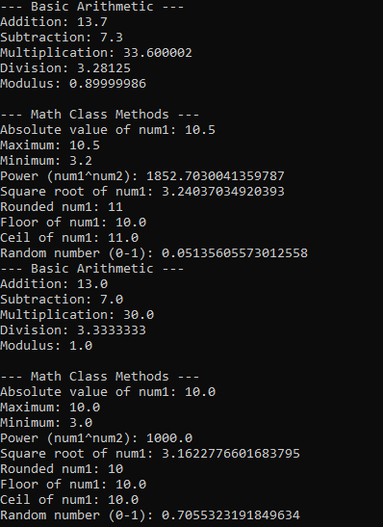

3 | PROGRAM TO EXPLORE STRING AND STRINGBUFFER METHODS | 12 Feb 2026

AIM:
To demonstrate the use of String and StringBuffer methods in Java using command-line arguments.

UML DIAGRAMS:
Class Diagram
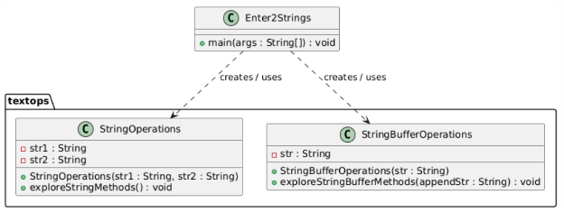

Package Diagram

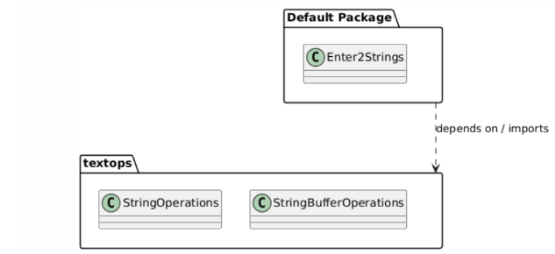

Sequence diagram
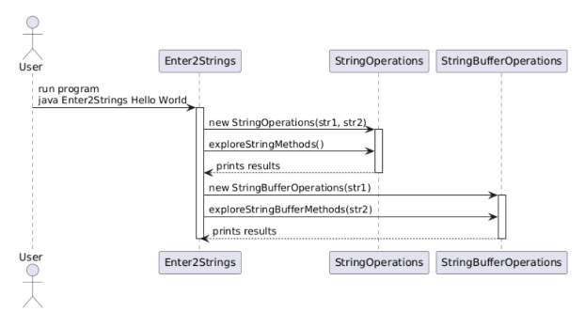

SOURCE CODE :

https://github.com/rohiniclab/java-lab/tree/main/pgm3/textops

PROGRAM PATH:

textops/StringOperations.java
package textops;
public class StringOperations {
private String str1;
private String str2;
public StringOperations(String str1, String str2) {
this.str1 = str1;
this.str2 = str2;
}
public void exploreStringMethods() {
System.out.println("----- String Methods -----");

System.out.println("Length of str1: " + str1.length());
System.out.println("Uppercase str1: " + str1.toUpperCase());
System.out.println("Lowercase str1: " + str1.toLowerCase());
System.out.println("Concatenation: " + str1.concat(str2));
System.out.println("Equals: " + str1.equals(str2));
System.out.println("Equals Ignore Case: " + str1.equalsIgnoreCase(str2));
System.out.println("Contains str2 in str1: " + str1.contains(str2));
System.out.println("Substring of str1 (0,3): " +
(str1.length() >= 3 ? str1.substring(0, 3) : "Too short"));
System.out.println("Replace 'a' with 'x' in str1: " + str1.replace('a', 'x'));
System.out.println("Index of str2 in str1: " + str1.indexOf(str2));
System.out.println("Trim str1: '" + str1.trim() + "'");
}
}

textops/StringBufferOperations.java

package textops;
public class StringBufferOperations {
private String str;
public StringBufferOperations(String str) {
this.str = str;
}
public void exploreStringBufferMethods(String appendStr) {
System.out.println("\n----- StringBuffer Methods -----");
// Create a StringBuffer object from str
StringBuffer sb = new StringBuffer(str);
System.out.println("Original StringBuffer: " + sb);
// append() adds text to the end of the buffer (mutable)
sb.append(appendStr);
System.out.println("After append: " + sb);
// insert() inserts text at a specified index (mutable)
sb.insert(0, "Start-");
System.out.println("After insert: " + sb);
// replace() replaces characters between start and end index (mutable)
sb.replace(0, 5, "Begin");
System.out.println("After replace: " + sb);

// delete() removes characters between start and end index (mutable)
sb.delete(0, 6);
System.out.println("After delete: " + sb);
// reverse() reverses the buffer content (mutable)
sb.reverse();
System.out.println("After reverse: " + sb);
// capacity() shows current buffer size; it automatically increases as needed
System.out.println("Capacity: " + sb.capacity());
// length() shows the number of characters currently in the buffer
System.out.println("Length: " + sb.length());
// NOTE: Unlike String, these operations modify the same object
// String operations (concat, replace, etc.) return new String objects
}
}

Enter2Strings.java

import textops.StringOperations;
import textops.StringBufferOperations;
public class Enter2Strings {
public static void main(String[] args) {
if (args.length != 2) {
System.out.println("Usage: java Enter2Strings <str1> <str2>");
return;
}
String str1 = args[0];
String str2 = args[1];
// Instantiate and call StringOperations
StringOperations stringOps = new StringOperations(str1, str2);
stringOps.exploreStringMethods();
// Instantiate and call StringBufferOperations
StringBufferOperations sbOps = new StringBufferOperations(str1);
sbOps.exploreStringBufferMethods(str2);
}
}

OUTPUT:
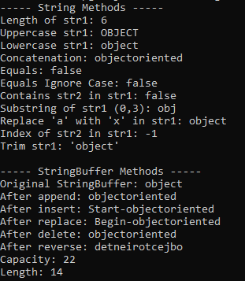

4 | PROGRAM TO DEMONSTRATE INHERITANCE, DYNAMIC DISPATCH CONCEPTS | 19 Feb 2026

AIM:
To demonstrate interfaces, inheritance, polymorphism (static & dynamic), and use of super keyword in Java.
UML DIAGRAMS:
Package and Class Diagram:
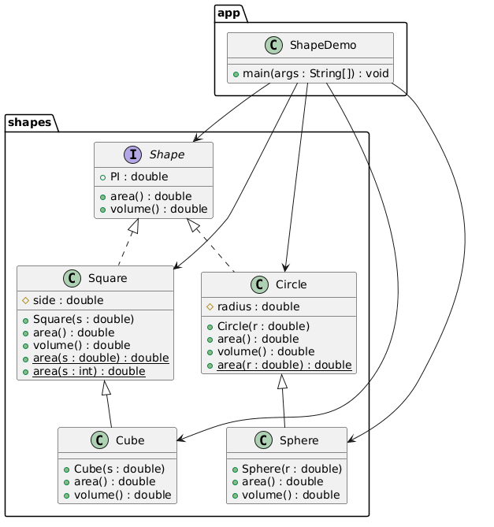

Sequence Diagram:
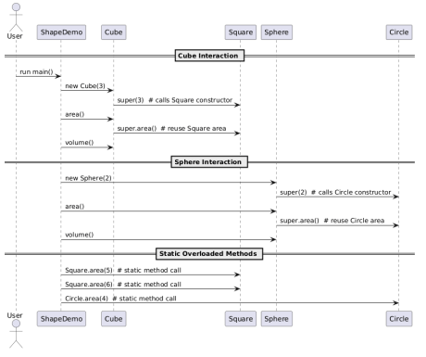

SOURCE CODE:
github.com/rohiniclab/java-lab/tree/main/pgm4/app/Shapes

PROGRAM PATH:
shapes/Shape.java
package shapes;

/**
* Interface representing geometric shapes.
* All shapes must implement methods to calculate area and volume.
*/
public interface Shape {
/** Constant value of PI */
double PI = 3.14159;
/**
* Calculate the area of the shape.
* @return area as double
*/
double area();
/**
* Calculate the volume of the shape.
* @return volume as double
*/
double volume();
}
Square Class
File: shapes/Square.java
package shapes;
/**
* Class representing a square.
* Implements the Shape interface.
*/
public class Square implements Shape {
/** Side length of the square */
protected double side;
/**

* Constructor to initialize square side
* @param s side length
*/
public Square(double s) {
side = s;
}
/**
* Calculate area of the square
* @return side^2
*/
public double area() {
return side * side;
}
// ----------------------------
// Static overloaded methods
// ----------------------------
/**
* Calculate area for a given side (double)
* @param s side length
* @return area
*/
public static double area(double s) {
return s * s;
}
/**
* Calculate area for a given side (int)
* @param s side length
* @return area
*/
public static double area(int s) {
return s * s;
}
/**
* Square does not have volume
* @return 0
*/
public double volume() {
return 0;
}
}

Cube Class
File: shapes/Cube.java
package shapes;
/**
* Cube class extends Square
* Demonstrates use of super() and super.area()
*/
public class Cube extends Square {
/**
* Constructor calls Square constructor
* @param s side length
*/
public Cube(double s) {
super(s); // super() calls parent constructor
}
/**
* Calculate surface area of cube
* Uses one face area from Square
* @return surface area
*/
public double area() {
double tmp = super.area(); // reuse Square area
return 6 * tmp;
}
/**
* Calculate cube volume
* @return volume
*/
public double volume() {
return side * side * side;
}
}
Circle Class
File: shapes/Circle.java
package shapes;
/**
* Circle class implements Shape interface
*/
public class Circle implements Shape {

/** Radius of the circle */
protected double radius;
/**
* Constructor
* @param r radius
*/
public Circle(double r) {
radius = r;
}
/**
* Calculate area of the circle
* @return PI * r^2
*/
public double area() {
return PI * radius * radius;
}
// ----------------------------
// Static overloaded method
// ----------------------------
/**
* Calculate area for a given radius
* @param r radius
* @return area
*/
public static double area(double r) {
return PI * r * r;
}
/**
* Circle has no volume
* @return 0
*/
public double volume() {
return 0;
}
}
Sphere Class
File: shapes/Sphere.java
package shapes;
/**

* Sphere class extends Circle
* Demonstrates reuse of Circle area using super.area()
*/
public class Sphere extends Circle {
/**
* Constructor calls Circle constructor
* @param r radius
*/
public Sphere(double r) {
super(r); // super() call
}
/**
* Calculate surface area of sphere
* Reuses Circle's area method
* @return surface area
*/
public double area() {
double tmp = super.area(); // circle area
return 4 * tmp;
}
/**
* Calculate volume of sphere
* @return volume
*/
public double volume() {
return (4.0 / 3.0) * PI * radius * radius * radius;
}
}
app/ShapeDemo.java
package app;
// Import all classes from shapes package
import shapes.*;
/**
* Main class to demonstrate shapes
* Shows dynamic polymorphism and static overloading
*/
public class ShapeDemo {
public static void main(String[] args) {

Shape s;
// ----------------------------
// Dynamic polymorphism examples
// ----------------------------
s = new Cube(3);
System.out.println("Cube Area = " + s.area());
System.out.println("Cube Volume = " + s.volume());
s = new Sphere(2);
System.out.println("Sphere Area = " + s.area());
System.out.println("Sphere Volume = " + s.volume());
// ----------------------------
// Static polymorphism examples
// ----------------------------
System.out.println("Square Area (static) = " + Square.area(5));
System.out.println("Square Area (static int) = " + Square.area(6));
System.out.println("Circle Area (static) = " + Circle.area(4));
}
}

OUTPUT:

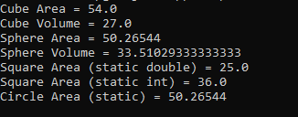

5 | PROGRAM TO EXPLORE BUILT IN EXCEPTIONS AND STATIC METHODS | 26 Feb 2026

AIM:
To demonstrate built-in exception handling and the use of static methods in Java.

UML DIAGRAM:

Class Diagram:
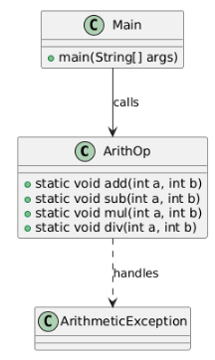
Sequence Diagram:

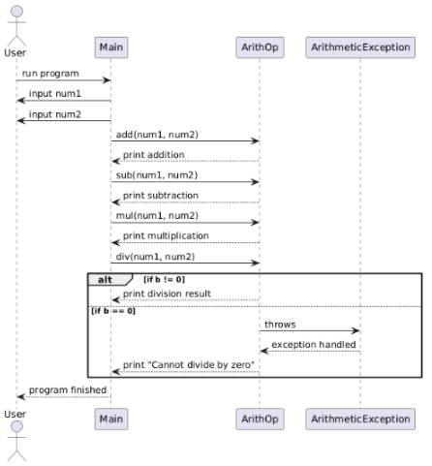

SOURCE CODE:

https://github.com/rohiniclab/java-lab/tree/main/pgm5

PROGRAM PATH:

ArithOp.java
public class ArithOp {
public static void add(int a, int b) {
int result = a + b;
System.out.println("Addition = " + result);
}
public static void sub(int a, int b) {
int result = a - b;
System.out.println("Subtraction = " + result);
}
public static void mul(int a, int b) {
int result = a * b;
System.out.println("Multiplication = " + result);
}
/**
* Performs division of two integers.
* Handles division by zero using try-catch.
*
* @param a Dividend
* @param b Divisor
*/
public static void div(int a, int b) {
try {
// Attempt to divide a by b
int result = a / b;
System.out.println("Division = " + result);
}
catch (ArithmeticException e) {
// This block executes if b is zero
System.out.println("Error: Cannot divide by zero.");

}
finally {
// This block always executes regardless of exception
System.out.println("Division operation finished.");
}
}
}
import java.util.Scanner;
public class Main {
public static void main(String[] args) {
Scanner sc = new Scanner(System.in);
System.out.print("Enter first number: ");
int num1 = sc.nextInt();
System.out.print("Enter second number: ");
int num2 = sc.nextInt();
// Call static methods directly using class name
ArithOp.add(num1, num2);
ArithOp.sub(num1, num2);
ArithOp.mul(num1, num2);
ArithOp.div(num1, num2);
sc.close();
}
}

OUTPUT:

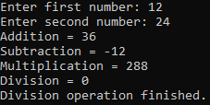

6 | PROGRAM TO EXPLORE USER-DEFINED (CUSTOM) EXCEPTIONS | 05 March 2026

AIM:
To demonstrate custom exception in Java.

UML DIAGRAM:

Class Diagram:

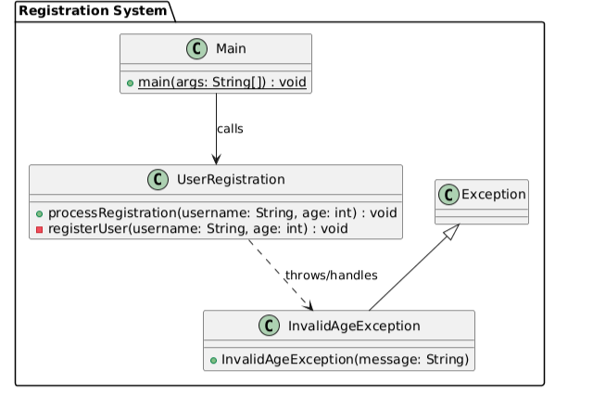

Sequence Diagram:
Failure scenario

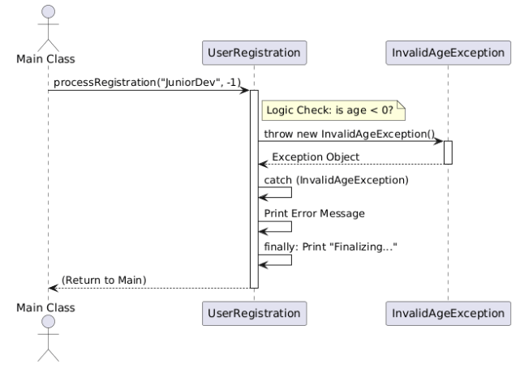

Sequence Diagram: Success Flow

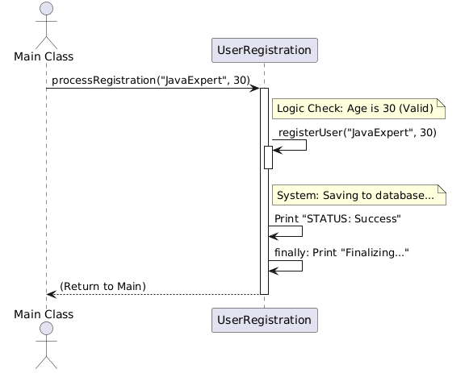

SOURCE CODE:

https://github.com/rohiniclab/java-lab/tree/main/pgm6

InvalidAgeException.java
public class InvalidAgeException extends Exception {
public InvalidAgeException(String message) {
super(message);
}
}

// File: UserRegistration.java
public class UserRegistration {
/**
* Logic and Validation moved here (The Calling Method)
*/
public void processRegistration(String username, int age) {

System.out.println(">>> Processing registration for: " + username);
try {
// Validation Logic (Moved here per request)
if (age < 0) {
throw new InvalidAgeException("Age cannot be negative (" + age + ").");
}
if (username == null || username.trim().isEmpty()) {
throw new InvalidAgeException("Username is required.");
}
// If validation passes, call the registration/save action
registerUser(username, age);
System.out.println("STATUS: Success.");
} catch (InvalidAgeException e) {
// Handle Failure Scenario
System.err.println("STATUS: Failed - " + e.getMessage());
} finally {
System.out.println("Finalizing request...\n");
}
}
/**
* The simple action method
*/
private void registerUser(String username, int age) {
System.out.println("System: Saving " + username + " (Age: " + age + ") to database.");
}
}
// File: Main.java
public class Main {
public static void main(String[] args) {
UserRegistration app = new UserRegistration();
// Scenario 1: Valid
app.processRegistration("JavaExpert", 30);
// Scenario 2: Invalid Age
app.processRegistration("JuniorDev", -1);
// Scenario 3: Invalid Username
app.processRegistration("", 20);

}
}

OUTPUT:

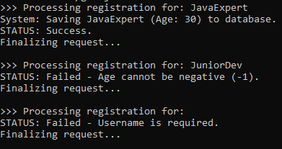

7 | PROGRAM TO EXPLORE MULTI THREADING | 26 March 2026

AIM:
To demonstrate Multithreading in Java.

UML DIAGRAM:

Class Diagram:

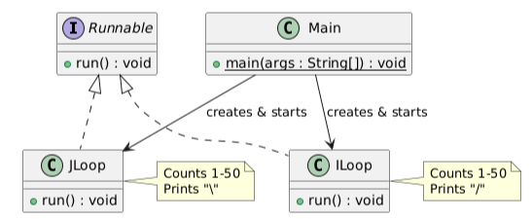
Sequence Diagram:
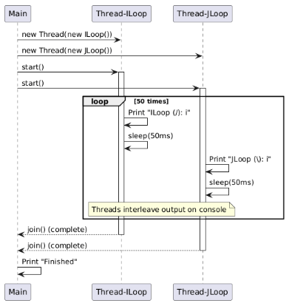
SOURCE CODE:

https://github.com/rohiniclab/java-lab/tree/main/pgm7

CountThreads.java
class ILoop implements Runnable {
@Override
public void run() {
for (int i = 1; i <= 50; i++) {
System.out.println("ILoop (/): " + i);
try {
// Short sleep to allow the other thread to take turns
Thread.sleep(50);
} catch (InterruptedException e) {
Thread.currentThread().interrupt();
}
}
}
}
// JLoop: Prints 1 to 50 with a '\' symbol
class JLoop implements Runnable {

@Override
public void run() {
for (int i = 1; i <= 50; i++) {
System.out.println("JLoop (\\): " + i);
try {
Thread.sleep(50);
} catch (InterruptedException e) {
Thread.currentThread().interrupt();
}
}
}
}
public class CountThreads {
public static void main(String[] args) {
System.out.println("--- Starting Concurrent Count ---\n");
Thread t1 = new Thread(new ILoop());
Thread t2 = new Thread(new JLoop());
t1.start();
t2.start();
try {
t1.join();
t2.join();
} catch (InterruptedException e) {
e.printStackTrace();
}
System.out.println("\n--- Both threads finished counting! ---");
}
}

OUTPUT:

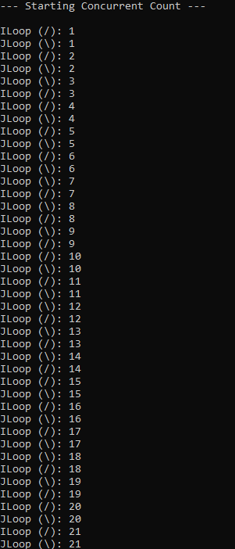

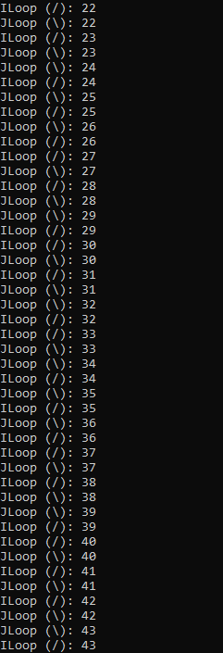
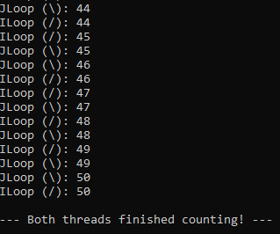
8 | PROGRAM TO EXPLORE FILE OPERATIONS | 26 March 2026

AIM:
To demonstrate File Operations using java.io package classes in Java.

UML DIAGRAM:

Class Diagram:
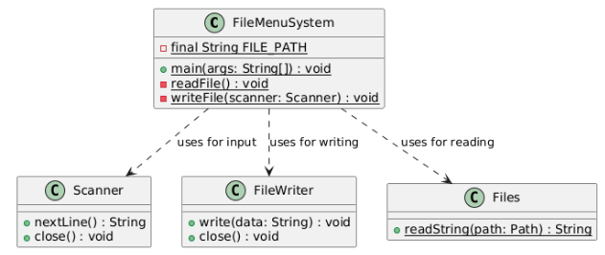
Activity Diagram:
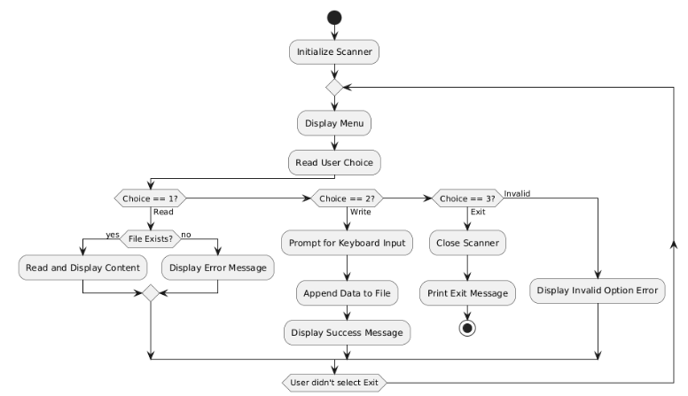SOURCE CODE:

https://github.com/rohiniclab/java-lab/tree/main/pgm8

FileMenuSystem.java
import java.util.Scanner;
import java.io.*;
import java.nio.file.*;
public class FileMenuSystem {
private static final String FILE_PATH = "userdata.txt";
public static void main(String[] args) {
Scanner scanner = new Scanner(System.in);
boolean running = true;
while (running) {
System.out.println("\n--- FILE MANAGER MENU ---");

System.out.println("1. Read File");
System.out.println("2. Write to File");
System.out.println("3. Exit");
System.out.print("Select an option: ");
String choice = scanner.nextLine();
switch (choice) {
case "1":
readFile();
break;
case "2":
writeFile(scanner);
break;
case "3":
System.out.println("Exiting program...");
running = false;
break;
default:
System.out.println("Invalid option. Please try again.");
}
}
scanner.close();
}
private static void readFile() {
try {
File file = new File(FILE_PATH);
if (!file.exists()) {
System.out.println("Error: File does not exist yet. Write something first!");
return;
}
String content = Files.readString(Path.of(FILE_PATH));
System.out.println("\n--- FILE CONTENT ---");
System.out.println(content);
System.out.println("---------------------");
} catch (IOException e) {
System.err.println("Failed to read: " + e.getMessage());
}
}
private static void writeFile(Scanner scanner) {
System.out.print("Enter text to save to file: ");
String data = scanner.nextLine();
try (FileWriter writer = new FileWriter(FILE_PATH, true)) { // 'true' enables appending

writer.write(data + System.lineSeparator());
System.out.println("Success: Data saved to " + FILE_PATH);
} catch (IOException e) {
System.err.println("Failed to write: " + e.getMessage());
}
}
}
OUTPUT:

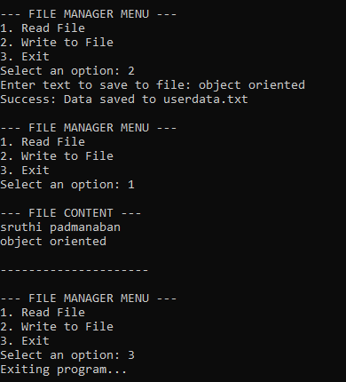

9 | PROGRAM TO EXPLOREL COLLECTIONS FRAMEWORK (DATA STRUCTURES) AND JAVADOC | 02 Apr 2026

AIM:
To demonstrate Data Structure Operations using java.util collections framework and to experiment Javadoc feature.

UML DIAGRAM:

CLASS DIAGRAM:
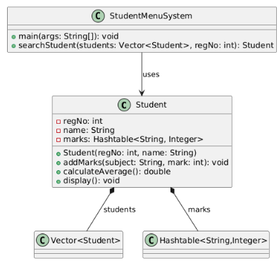
USE CASE DIAGRAM:
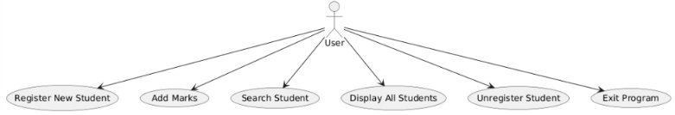
ACTIVITY DIAGRAM:
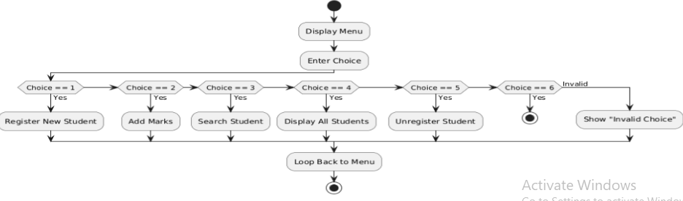

SEQUENCE DIAGRAM:
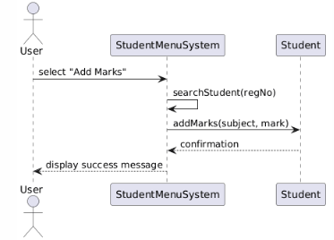
SOURCE CODE:

github.com/rohiniclab/java-lab/tree/main/pgm9

StudentMenuSystem.java
import java.util.Scanner;
import java.util.Vector;
import java.util.Hashtable;
import java.util.Iterator;
/**
* Represents a Student with registration number, name, and marks.
* Demonstrates OOP concepts and uses Hashtable for subject → marks mapping.
*/
class Student {
int regNo;
String name;
Hashtable<String, Integer> marks;
/**
* Constructs a Student object with registration number and name.
* Initializes the marks Hashtable.
*
* @param regNo registration number of the student
* @param name name of the student
*/
Student(int regNo, String name) {
this.regNo = regNo;
this.name = name;
marks = new Hashtable<>();
}
/**
* Adds a subject and its marks to the student's record.
*
* @param subject name of the subject
* @param mark marks obtained in the subject
* @throws IllegalArgumentException if mark is negative or greater than 100
*/
void addMarks(String subject, int mark) throws IllegalArgumentException {
if (mark < 0 || mark > 100) {
throw new IllegalArgumentException("Mark must be between 0 and 100.");
}
marks.put(subject, mark);

}
/**
* Calculates the average marks of the student.
*
* @return average of all marks as double
*/
double calculateAverage() {
int sum = 0;
for (int m : marks.values()) {
sum += m;
}
return marks.size() == 0 ? 0.0 : (double) sum / marks.size();
}
/**
* Displays student details including registration number, name, subjects, and average marks.
*/
void display() {
System.out.println("RegNo: " + regNo);
System.out.println("Name: " + name);
System.out.println("Marks: " + marks);
System.out.println("Average: " + calculateAverage());
System.out.println("----------------------");
}
}
/**
* Menu-driven Student Management System.
* Features:
* - Register new student
* - Add marks
* - Search student by registration number
* - Display all students
* - Unregister student
*/
public class StudentMenuSystem {
/**
* Searches for a student in the Vector by registration number.
*
* @param students Vector of Student objects
* @param regNo registration number to search
* @return the Student object if found; null otherwise
*/
public static Student searchStudent(Vector<Student> students, int regNo) {

for (Student s : students) {
if (s.regNo == regNo) {
return s;
}
}
return null;
}
/**
* Main method for the menu-driven Student Management System.
* Provides a looped menu to perform operations like register, add marks, search, display,
unregister, and exit.
*
* @param args command-line arguments
* @throws IllegalArgumentException if marks entered are invalid
*/
public static void main(String[] args) throws IllegalArgumentException {
Scanner sc = new Scanner(System.in);
Vector<Student> students = new Vector<>();
int choice;
do {
System.out.println("\n--- Student Management System ---");
System.out.println("1. Register New Student");
System.out.println("2. Add Marks");
System.out.println("3. Search Student");
System.out.println("4. Display All Students");
System.out.println("5. Unregister Student");
System.out.println("6. Exit");
System.out.print("Enter your choice: ");
choice = sc.nextInt();
sc.nextLine(); // consume newline
switch (choice) {
case 1:
// Register new student
System.out.print("Enter RegNo: ");
int regNo = sc.nextInt();
sc.nextLine();
System.out.print("Enter Name: ");
String name = sc.nextLine();
if (searchStudent(students, regNo) != null) {
System.out.println("Student with this RegNo already exists!");
} else {
students.add(new Student(regNo, name));

System.out.println("Student registered successfully.");
}
break;
case 2:
// Add marks
System.out.print("Enter RegNo to add marks: ");
int regSearch = sc.nextInt();
sc.nextLine();
Student s = searchStudent(students, regSearch);
if (s != null) {
System.out.print("Enter subject name: ");
String subject = sc.nextLine();
System.out.print("Enter marks: ");
int mark = sc.nextInt();
sc.nextLine();
try {
s.addMarks(subject, mark);
System.out.println("Marks added successfully.");
} catch (IllegalArgumentException e) {
System.out.println("Error: " + e.getMessage());
}
} else {
System.out.println("Student not found!");
}
break;
case 3:
// Search student
System.out.print("Enter RegNo to search: ");
int searchReg = sc.nextInt();
sc.nextLine();
Student found = searchStudent(students, searchReg);
if (found != null) {
System.out.println("\nStudent Found:");
found.display();
} else {
System.out.println("Student not found!");
}
break;
case 4:
// Display all students
if (students.isEmpty()) {
System.out.println("No students registered.");
} else {

System.out.println("\n--- All Students ---");
Iterator<Student> it = students.iterator();
while (it.hasNext()) {
Student st = it.next();
st.display();
}
}
break;
case 5:
// Unregister student
System.out.print("Enter RegNo to unregister: ");
int delReg = sc.nextInt();
sc.nextLine();
Student removeStu = searchStudent(students, delReg);
if (removeStu != null) {
students.remove(removeStu);
System.out.println("Student unregistered successfully.");
} else {
System.out.println("Student not found!");
}
break;
case 6:
System.out.println("Exiting program...");
break;
default:
System.out.println("Invalid choice! Try again.");
}
} while (choice != 6);
sc.close();
}
}

OUTPUT:

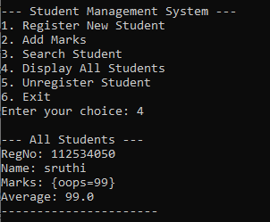
10 | SAMPLE GUI WITH EVENT HANDLING USING JAVA SWINGS | 09 Apr 2026

AIM:
To demonstrate java Graphical User Interface and Event handling features using javax.swing components.

UML DIAGRAM:

PACKAGE AND CLASS DIAGRAM:
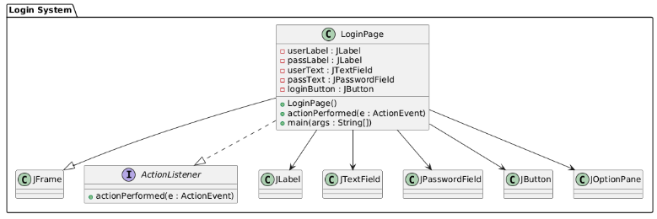
SEQUENCE DIAGRAM:

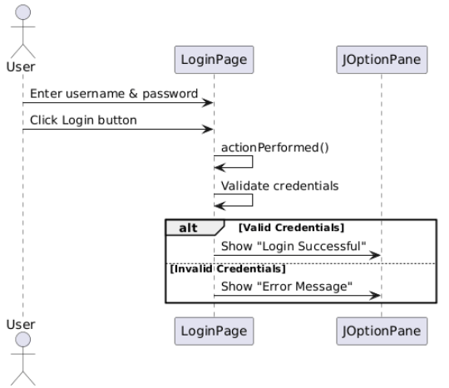

SOURCE CODE:

https://github.com/rohiniclab/java-lab/tree/main/pgm10

LoginPage.java

import javax.swing.*;
import java.awt.*;
import java.awt.event.*;
// Creating a class that extends JFrame (window)
// and implements ActionListener (for button click handling)
public class LoginPage extends JFrame implements ActionListener {
// Declaring GUI components
JLabel userLabel, passLabel; // Labels for username and password
JTextField userText; // Text field for username input
JPasswordField passText; // Password field (hides input)
JButton loginButton; // Login button
// Constructor to set up the GUI
LoginPage() {
setTitle("Login Page"); // Set window title
setSize(350, 200); // Set window size
setLayout(null); // Use absolute positioning
setDefaultCloseOperation(JFrame.EXIT_ON_CLOSE); // Close app on exit
// Username Label

userLabel = new JLabel("Username:");
userLabel.setBounds(30, 30, 80, 25); // Set position and size
add(userLabel); // Add to frame
// Username Text Field
userText = new JTextField();
userText.setBounds(120, 30, 150, 25);
add(userText);
// Password Label
passLabel = new JLabel("Password:");
passLabel.setBounds(30, 70, 80, 25);
add(passLabel);
// Password Field
passText = new JPasswordField();
passText.setBounds(120, 70, 150, 25);
add(passText);
// Login Button
loginButton = new JButton("Login");
loginButton.setBounds(120, 110, 100, 30);
loginButton.addActionListener(this); // Register button click event
add(loginButton);
setVisible(true); // Make the frame visible
}
// This method is called when the button is clicked
public void actionPerformed(ActionEvent e) {
// Get entered username
String username = userText.getText();
// Get entered password (converted from char array to String)
String password = new String(passText.getPassword());
// Simple validation (hardcoded values)
if (username.equals("admin") && password.equals("1234")) {
// Show success message
JOptionPane.showMessageDialog(this, "Login Successful!");
} else {
// Show error message
JOptionPane.showMessageDialog(this, "Invalid Username or Password");
}
}

// Main method - entry point of the program
public static void main(String[] args) {
new LoginPage(); // Create and display the login page
}
}

OUTPUT:

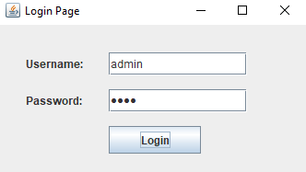

11 | DATABASE PROGRAMMING WITH JAVA.SQL | 16 Apr 2026

AIM:
To demonstrate data base connectivity capabilities with java.sql and mysql

UML DIAGRAM:

CLASS DIAGRAM:
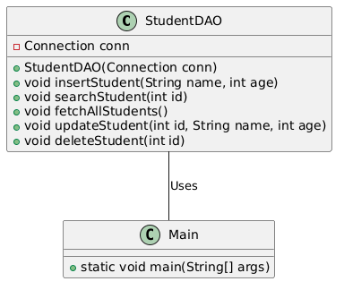
COMPONENT DIAGRAM:
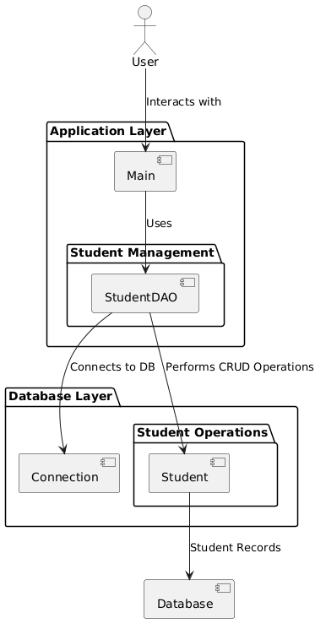

SEQUENCE DIAGRAM:
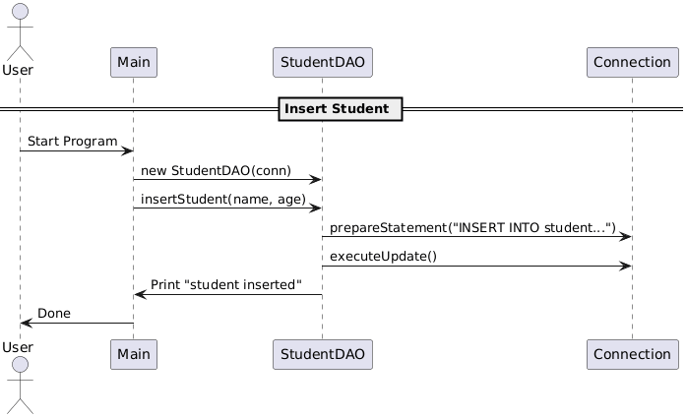

SOURCE CODE:

https://github.com/rohiniclab/java-lab/tree/main/pgm11/src

PROGRAM PATH:

StudentApp/src/StudentDAO.java

import java.sql.*;
// Data Access Object (DAO) for Student table
public class StudentDAO {
private Connection conn;
// Constructor receives DB connection
public StudentDAO(Connection conn) {
this.conn = conn;
}
// Insert a student
public void insertStudent(String name, int age) throws SQLException {
String sql = "INSERT INTO student (name, age) VALUES (?, ?)";
try (PreparedStatement ps = conn.prepareStatement(sql)) {
ps.setString(1, name);
ps.setInt(2, age);
int rows = ps.executeUpdate();
System.out.println(rows + " student inserted.");
}
}
// Search student by ID
public void searchStudent(int id) throws SQLException {

String sql = "SELECT * FROM student WHERE id=?";
try (PreparedStatement ps = conn.prepareStatement(sql)) {
ps.setInt(1, id);
try (ResultSet rs = ps.executeQuery()) {
if (rs.next()) {
System.out.println("ID: " + rs.getInt("id"));
System.out.println("Name: " + rs.getString("name"));
System.out.println("Age: " + rs.getInt("age"));
} else {
System.out.println("Student not found.");
}
}
}
}
// Fetch all students
public void fetchAllStudents() throws SQLException {
String sql = "SELECT * FROM student";
try (Statement stmt = conn.createStatement();
ResultSet rs = stmt.executeQuery(sql)) {
System.out.println("\n--- All Students ---");
while (rs.next()) {
System.out.println("ID: " + rs.getInt("id") +
", Name: " + rs.getString("name") +
", Age: " + rs.getInt("age"));
}
}
}
// Update student details by ID
public void updateStudent(int id, String name, int age) throws SQLException {
String sql = "UPDATE student SET name=?, age=? WHERE id=?";
try (PreparedStatement ps = conn.prepareStatement(sql)) {
ps.setString(1, name);
ps.setInt(2, age);
ps.setInt(3, id);
int rows = ps.executeUpdate();
System.out.println(rows + " student updated.");
}
}
// Delete student by ID
public void deleteStudent(int id) throws SQLException {
String sql = "DELETE FROM student WHERE id=?";
try (PreparedStatement ps = conn.prepareStatement(sql)) {

ps.setInt(1, id);
int rows = ps.executeUpdate();
System.out.println(rows + " student deleted.");
}
}
}

StudentApp/src/Main.java

import java.sql.*;
import java.util.Properties;
import java.io.FileInputStream;
import java.io.IOException;
import java.util.Scanner;
public class Main {
public static void main(String[] args) {
Properties props = new Properties();
// Load DB properties
try (FileInputStream fis = new FileInputStream("db.properties")) {
props.load(fis);
} catch (IOException e) {
e.printStackTrace();
return;
}
String url = props.getProperty("db.url");
String user = props.getProperty("db.user");
String pass = props.getProperty("db.pass");
// DB connection
try (Connection conn = DriverManager.getConnection(url, user, pass);
Scanner sc = new Scanner(System.in)) {
System.out.println("Connected to database successfully.");
StudentDAO dao = new StudentDAO(conn); // Create DAO object
while (true) {
System.out.println("\n1. Insert Student\n2. Search Student\n3. Fetch All Students\n4.
Update Student\n5. Delete Student\n6. Exit");
System.out.print("Choose option: ");
int choice = sc.nextInt();
sc.nextLine(); // Consume newline
switch (choice) {

case 1:
System.out.print("Enter name: ");
String name = sc.nextLine();
System.out.print("Enter age: ");
int age = sc.nextInt();
dao.insertStudent(name, age);
break;
case 2:
System.out.print("Enter ID to search: ");
int id = sc.nextInt();
dao.searchStudent(id);
break;
case 3:
dao.fetchAllStudents();
break;
case 4:
System.out.print("Enter ID to update: ");
int updateId = sc.nextInt();
sc.nextLine();
System.out.print("Enter new name: ");
String newName = sc.nextLine();
System.out.print("Enter new age: ");
int newAge = sc.nextInt();
dao.updateStudent(updateId, newName, newAge);
break;
case 5:
System.out.print("Enter ID to delete: ");
int deleteId = sc.nextInt();
dao.deleteStudent(deleteId);
break;
case 6:
System.out.println("Exiting...");
return;
default:
System.out.println("Invalid option!");
}
}
} catch (SQLException e) {
e.printStackTrace();
}
}
}

StudentApp/db.properties

db.url=jdbc:mysql://localhost:3306/school
db.user=root
db.pass=password

StudentApp/lib/ mysql-connector-java-8.x.x.jar

