PRACTICAL2
<!DOCTYPE html>
<html>
<head>
<title>Web technology Assignment2</title>
<link rel="stylesheet" type="text/css" href="style.css">
</head>

<body>
<div class="container-fluid">
<div class="navbar">
<h1>Eat n Smile</h1>
<ul>
<li>Home</li>
<li><a href="menu.html">Menu</a></li>
<li>Contact</li>
</ul>
</div>

<div class="content">
<div>
<h3>Welcome to,</h3>
<h1><span>Eat n Smile</span></h1>
<input type="search" name="" placeholder="What do you want??">
<button>Search</button>
</div>
</div>
</div>
</body>
</html>

<!DOCTYPE html>
<html lang="en">
<head>
<meta charset="UTF-8">
<meta http-equiv="X-UA-Compatible" content="IE=edge">
<meta name="viewport" content="width=device-width, initial-scale=1.0">
<title>Document</title>
<link rel="stylesheet" href="style.css">
</head>
<body>
<section class="food-menu">
<div class="container">
<h2 class="text-center">Today's Menu</h2>
<div class="food-menu-box">
<div class="food-menu-img">
<img src="images/menu-chessepizza.png" alt="Chesse pizza" class="img-responsive img-curve">
</div>
<div class="food-menu-desc">
<h4>Cheese Pizza</h4>
<p class="food-price">₹ 200</p>
<p class="food-detail">
Italian Sauce, Mozzarella chesse and Cheddar chesse
</p>
<br>
<a href="#" class="btn btn-primary">Order Now</a>
</div>
</div>
<div class="food-menu-box">
<div class="food-menu-img">
<img src="images/menu-chesseburger.jpg" alt="Chesse Burger" class="img-responsive img-curve">
</div>
<div class="food-menu-desc">
<h4>Chesse Burger</h4>
<p class="food-price">₹ 200</p>
<p class="food-detail">
Mozzarella chesse and fresh vegetables
</p>
<br>
<a href="#" class="btn btn-primary">Order Now</a>
</div>
</div>
<div class="food-menu-box">
<div class="food-menu-img">
<img src="images/menu-butterchicken.jpg" alt="Butter Chicken" class="img-responsive img-curve">
</div>
<div class="food-menu-desc">
<h4>Butter Chicken</h4>
<p class="food-price">₹ 300</p>
<p class="food-detail">
Chicken
</p>
<br>
<a href="#" class="btn btn-primary">Order Now</a>
</div>
</div>
<div class="food-menu-box">
<div class="food-menu-img">
<img src="images/menu-whitepasta.jpg" alt="White Pasta" class="img-responsive img-curve">
</div>
<div class="food-menu-desc">
<h4>White Pasta</h4>
<p class="food-price">₹ 150</p>
<p class="food-detail">
Italian Sauce and chesse.
</p>
<br>
<a href="#" class="btn btn-primary">Order Now</a>
</div>
</div>
<div class="food-menu-box">
<div class="food-menu-img">
<img src="images/menu-redpasta.jpg" alt="Red Pasta" class="img-responsive img-curve">
</div>
<div class="food-menu-desc">
<h4>Red Pasta</h4>
<p class="food-price">₹ 150</p>
<p class="food-detail">
Italian Sauce, tomatoes and chesse
</p>
<br>
<a href="#" class="btn btn-primary">Order Now</a>
</div>
</div>
<div class="food-menu-box">
<div class="food-menu-img">
<img src="images/menu-frenchfries.jpg" alt="French fries" class="img-responsive img-curve">
</div>
<div class="food-menu-desc">
<h4>French fries</h4>
<p class="food-price">₹ 100</p>
<p class="food-detail">
Potatoes
</p>
<br>
<a href="#" class="btn btn-primary">Order Now</a>
</div>
</div>
</div>
</section>
</body>
</html>

*{
margin: 0 0;
padding: 0 0;
font-family: Arial, Helvetica, sans-serif;
}
.container{
width: 80%;
margin: 0 auto;
padding: 1%;
}
.img-responsive{
width: 100%;
}
.img-curve{
border-radius: 15px;
}

.text-right{
text-align: right;
}
.text-center{
text-align: center;
}
.text-left{
text-align: left;
}
.text-white{
color: white;
}

a{
color: #f7c717;
text-decoration: none;
}
a:hover{
color: #eaff47;
}
.btn{
padding: 1%;
border: none;
font-size: 1rem;
border-radius: 5px;
}
.btn-primary{
background-color: #ff6b81;
color: white;
cursor: pointer;
}
.btn-primary:hover{
color: white;
background-color: #ff4757;
}
.float-text{
position: absolute;
bottom: 50px;
left: 40%;
}

/*Navbar Section */
.logo{
width: 12%;
float: left;
}
.menu{
line-height: 60px;
}
.menu ul{
list-style-type: none;
}
.menu ul li{
display: inline;
padding: 2%;
font-weight: bold;
}

/* Food Search*/
.food-search{
background-image: url(../images/bg.jpg);
background-size: cover;
background-repeat: no-repeat;
background-position: center;
padding: 7% 0;
}
.food-search input[type="search"]{
width: 50%;
padding: 1%;
font-size: 1rem;
border: none;
border-radius: 5px;
}

/* Menu */
.food-menu{
background-color: #bcb8b8;
padding: 4% 0;
}
.food-menu-box{
width: 38%;
margin: 1%;
padding: 2%;
float: left;
background-color: rgb(27, 22, 22);
border-radius: 15px;
}
.food-menu-img{
width: 20%;
float: left;
}
.food-menu-desc{
width: 70%;
float: left;
margin-left: 8%;
color: beige;
}
.food-price{
font-size: 1.2rem;
margin: 2% 0;
}
.food-detail{
font-size: 1rem;
color: #747d8c;
}
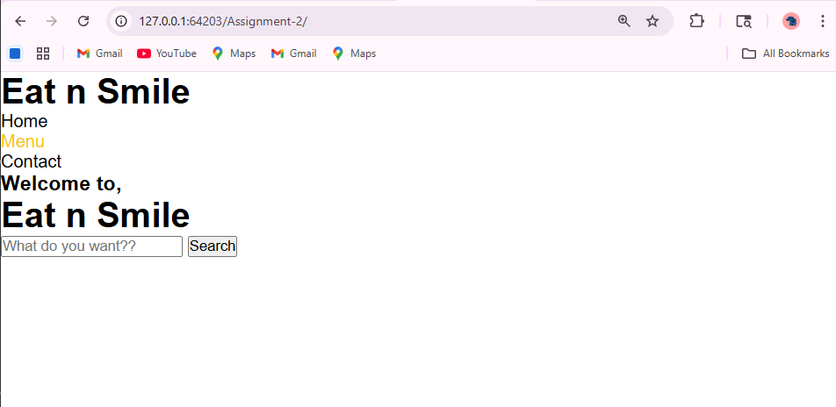

PRACTICAL3
<?xml version="1.0" encoding="UTF-8"?>
<?xml-stylesheet href="employee.xsl" type="text/xsl"?>
<employees>
<employee>
<name>someone pandey</name>
<age>20</age>
<salary>$100000</salary>
<address>Pune</address>
</employee>
<employee>
<name>Emilie Kennedy</name>
<age>21</age>
<salary>$100000</salary>
<address>Annapolis</address>
</employee>
<employee>
<name>Jeffrey Bush</name>
<age>22</age>
<salary>$100000</salary>
<address>Beaudesert</address>
</employee>
<employee>
<name>Angelica Bean</name>
<age>23</age>
<salary>$100000</salary>
<address>Passaic</address>
</employee>
<employee>
<name>Diwakar Jain</name>
<age>24</age>
<salary>$100000</salary>
<address>Thirsk</address>
</employee>
<employee>
<name>Jordan Hester</name>
<age>25</age>
<salary>$100000</salary>
<address>Beatrice</address>
</employee>
</employees>

<!ELEMENT employees (employee)*>
<!ELEMENT employee (name, age, salary, address)>
<!ELEMENT name (#PCDATA)>
<!ELEMENT age (#PCDATA)>
<!ELEMENT salary (#PCDATA)>
<!ELEMENT address (#PCDATA)>

<?xml version="1.0" encoding="UTF-8"?>
<xsl:stylesheet version="1.0"
xmlns:xsl="http://www.w3.org/1999/XSL/Transform">
<xsl:template match="/">
<html >
<body style="text-align:center">
<h1 style="color:black">Employee's Data</h1>
<table style="width: 100% ; height:80%" border='2'>
<thead style="background-color:teal;color:white;padding:4px;height:20% ;font-size:25px">
<tr style="width: 25% ; height:50%">
<th >Name </th>
<th >Age</th>
<th >Salary</th>
<th >Address</th>
</tr>
</thead>
<tbody>
<xsl:for-each select="employees/employee">
<tr >
<td style="background-color:gray;color:white;padding:4px">
<span style="font-weight:bold ;font-size:25px "><xsl:value-of select="name"/> </span>
</td>
<td style="background-color:gray;color:white;padding:4px">
<span style="font-weight:bold ;font-size:25px"><xsl:value-of select="age"/> </span>
</td>
<td style="background-color:gray;color:white;padding:4px">
<span style="font-weight:bold ;font-size:25px"><xsl:value-of select="salary"/> </span>
</td>
<td style="background-color:gray;color:white;padding:4px">
<span style="font-weight:bold ;font-size:25px"><xsl:value-of select="address"/> </span>
</td>
</tr>
</xsl:for-each>
</tbody>
</table>
</body>
</html>
</xsl:template>
</xsl:stylesheet>

<!DOCTYPE html>
<html>
<head>
<title>Employee XML Data</title>
</head>
<body>

<h2>Employee Details</h2>

<button onclick="loadXML()">Load Data</button>

<table border="1" id="dataTable">
<tr>
<th>Name</th>
<th>Age</th>
<th>Salary</th>
<th>Address</th>
</tr>
</table>

<script>
function loadXML() {
var xhttp = new XMLHttpRequest();

xhttp.onreadystatechange = function() {
if (this.readyState == 4 && this.status == 200) {
displayData(this);
}
};

xhttp.open("GET", "employe.xml", true);
xhttp.send();
}

function displayData(xml) {
var xmlDoc = xml.responseXML;
var table = document.getElementById("dataTable");

var employees = xmlDoc.getElementsByTagName("employee");

for (var i = 0; i < employees.length; i++) {
var row = table.insertRow();

var name = employees[i].getElementsByTagName("name")[0].childNodes[0].nodeValue;
var age = employees[i].getElementsByTagName("age")[0].childNodes[0].nodeValue;
var salary = employees[i].getElementsByTagName("salary")[0].childNodes[0].nodeValue;
var address = employees[i].getElementsByTagName("address")[0].childNodes[0].nodeValue;

row.insertCell(0).innerHTML = name;
row.insertCell(1).innerHTML = age;
row.insertCell(2).innerHTML = salary;
row.insertCell(3).innerHTML = address;
}
}
</script>

</body>
</html>

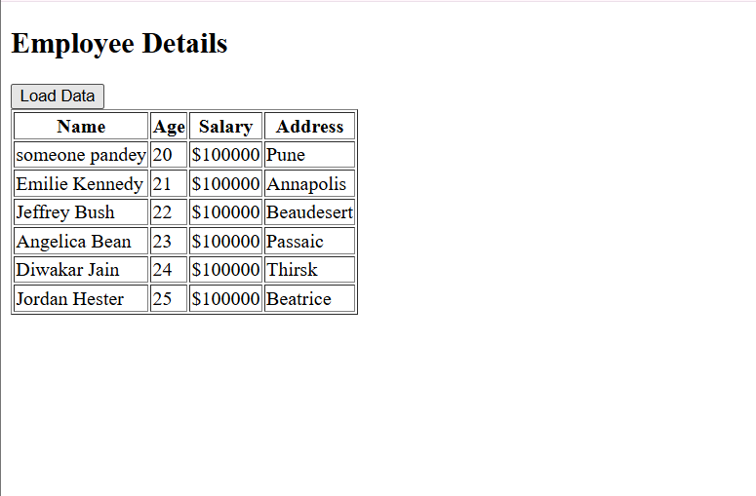

PRACTICAL4
<!DOCTYPE html>
<html lang="en">

<head>
<meta charset="UTF-8">
<meta name="viewport" content="width=device-width, initial-scale=1.0">
<meta http-equiv="X-UA-Compatible" content="ie=edge">
<link rel="stylesheet" href="style.css">
<title>Assignment 4</title>
</head>

<body>
<div class="container">
<h1>Calculator</h1>

<div class="calculator">
<input type="text" name="screen" id="screen">
<table>
<tr>
<td><button>(</button></td>
<td><button>)</button></td>
<td><button>C</button></td>
<td><button>%</button></td>
</tr>
<tr>
<td><button>7</button></td>
<td><button>8</button></td>
<td><button>9</button></td>
<td><button>X</button></td>
</tr>
<tr>
<td><button>4</button></td>
<td><button>5</button></td>
<td><button>6</button></td>
<td><button>-</button></td>
</tr>
<tr>
<td><button>1</button></td>
<td><button>2</button></td>
<td><button>3</button></td>
<td><button>+</button></td>
</tr>
<tr>
<td><button>0</button></td>
<td><button>.</button></td>
<td><button>/</button></td>
<td><button>=</button></td>
</tr>
</table>
</div>
</div>

</body>
<script src="index.js"></script>

</html>

let screen = document.getElementById('screen');
buttons = document.querySelectorAll('button');
let screenValue = '';
for (item of buttons) {
item.addEventListener('click', (e) => {
buttonText = e.target.innerText;
console.log('Button text is ', buttonText);
if (buttonText == 'X') {
buttonText = '*';
screenValue += buttonText;
screen.value = screenValue;
}
else if (buttonText == 'C') {
screenValue = "";
screen.value = screenValue;
}
else if (buttonText == '=') {
screen.value = eval(screenValue);
}
else {
screenValue += buttonText;
screen.value = screenValue;
}

})
}

.container{
text-align: center;
margin-top:23px
}
table{
margin: auto;
}
input{
border-radius: 21px;
border: 5px solid #dce0dc;
font-size:34px;
height: 65px;
width: 456px;
}
button{
border-radius: 10px;
font-size: 30px;
background: #978fa0;
width: 102px;
height: 90px;
margin: 6px;
}
.calculator{
border: 4px solid #000000;
background-color: #beb8be;
padding: 23px;
border-radius: 40px;
display: inline-block;
}
h1{
font-size: 28px;
font-family: Cambria, Cochin, Georgia, Times, 'Times New Roman', serif;
}

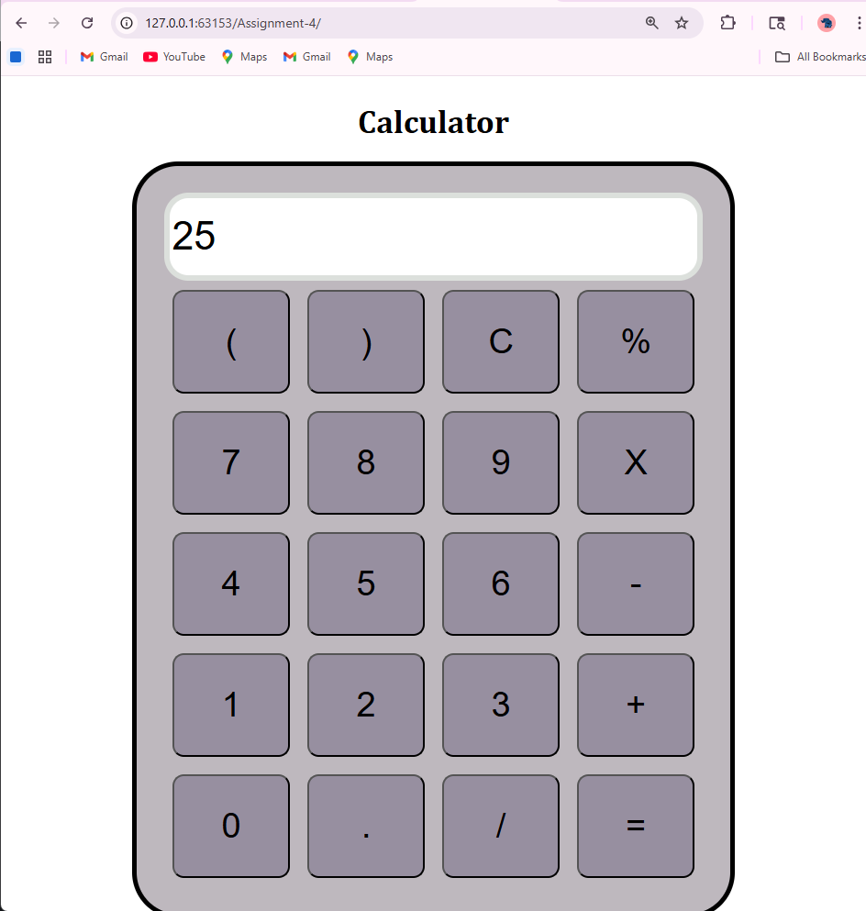

PRACTICAL5
import java.io.IOException;
import java.io.PrintWriter;
import java.sql.Connection;
import java.sql.DriverManager;
import java.sql.ResultSet;
import java.sql.Statement;
import javax.servlet.ServletException;
import javax.servlet.annotation.WebServlet;
import javax.servlet.http.HttpServlet;
import javax.servlet.http.HttpServletRequest;
import javax.servlet.http.HttpServletResponse;

// Servlet implementation class Details
@WebServlet("/Book")
public class Book extends HttpServlet {
private static final long serialVersionUID = 1L;
//Default constructor.
public Book(){
// TODO Auto-generated constructor stub
}
//@see HttpServlet#doGet(HttpServletRequest request, HttpServletResponse response)
protected void doGet(HttpServletRequest request, HttpServletResponse response) throws ServletException, IOException{
// TODO Auto-generated method stub
PrintWriter out=response.getWriter();
try{
Class.forName("com.mysql.jdbc.Driver");
Connection con = DriverManager.getConnection("jdbc:mysql://localhost:3306/assignment_5","root","root");
Statement stmt=con.createStatement();
ResultSet rs=stmt.executeQuery("select * from book");

out.println("<h1 style=\"text-align:center; color:#FFFFFF;\">Book Details</h1>");

out.println("<div style=\"margin-left:25%; font-size:40px;\"><table border=\"1\" style=\"width:70%;\"><tr style=\"background-color:#78c2be; color:#fff;\"><td><strong>Book ID</strong></td><td><strong>Book Title</strong></td><td><strong>Author</strong></td><td><strong>Price</strong></td><td><strong>Quantity</strong></td></tr>");

while(rs.next()){
out.println("<tr style=\"color:#fff;\"><td>"+rs.getString(1)+"</td><td>"+rs.getString(2)+"</td><td>"+rs.getString(3)+"</td><td>"+rs.getString(4)+"</td><td>"+rs.getString(5)+"</td></tr>");
out.println("</table></body>");
con.close();
}
}
catch(Exception e){
out.println(e);
}
}
// @see HttpServlet#doPost(HttpServletRequest request, HttpServletResponse response)
protected void doPost(HttpServletRequest request, HttpServletResponse response) throws ServletException, IOException {
// TODO Auto-generated method stub
doGet(request, response);
}
}

PRACTICAL6
<%@ page language="java" contentType="text/html; charset=UTF-8"
pageEncoding="UTF-8"%>
<%@ page import="java.sql.*" %>
<%@ page import="javax.sql.*" %>

<!DOCTYPE html>
<html>
<head>
<meta charset="UTF-8">
<title>Student Data</title>
</head>
<body>

<%
try {
// Updated driver (new versions use this)
Class.forName("com.mysql.cj.jdbc.Driver");

Connection con = DriverManager.getConnection(
"jdbc:mysql://localhost:3306/db_1", "root", "App1e$$$"
);

Statement st = con.createStatement();
ResultSet rs = st.executeQuery("SELECT * FROM stud");

while (rs.next()) {
out.print(rs.getInt(1) + " ");
out.print(rs.getString(2) + "<br>");
}

// Close resources
rs.close();
st.close();
con.close();

} catch (Exception e) {
out.print("Error: " + e.getMessage());
}
%>

</body>
</html>

OUTPUT
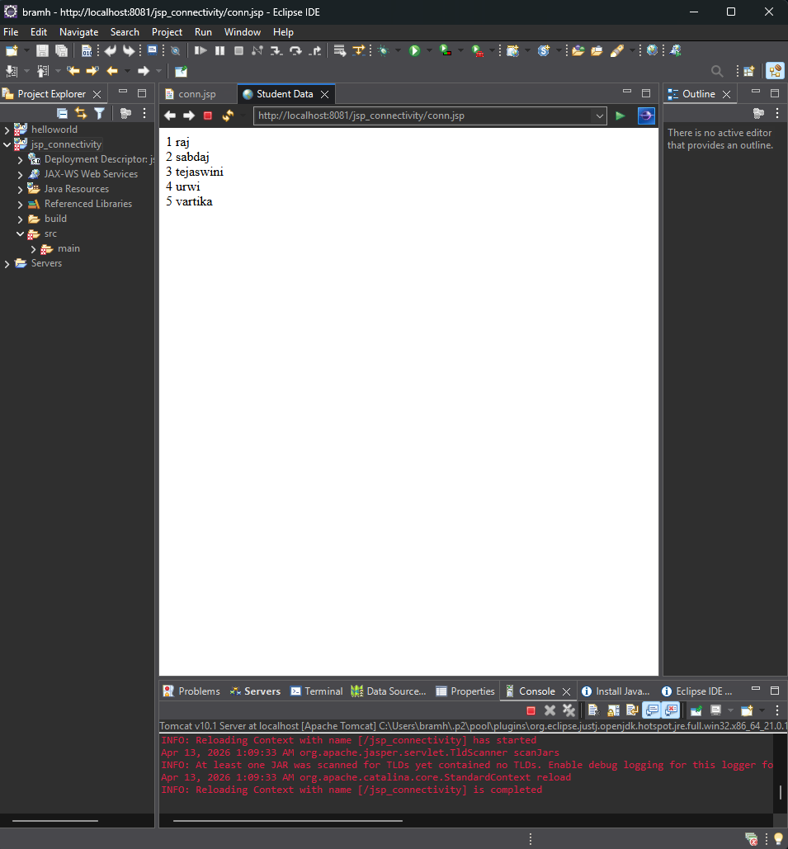

Practical 7
HTML
<!DOCTYPE html>
<html>
<head>
<meta charset="utf-8">
<title>Register</title>
<link rel="stylesheet" href="https://cdnjs.cloudflare.com/ajax/libs/font-awesome/6.2.0/css/all.min.css" integrity="sha512-xh6O/CkQoPOWDdYTDqeRdPCVd1SpvCA9XXcUnZS2FmJNp1coAFzvtCN9BmamE+4aHK8yyUHUSCcJHgXloTyT2A==" crossorigin="anonymous" referrerpolicy="no-referrer">
<link href="style.css" rel="stylesheet" type="text/css">
</head>
<body>
<div class="register">
<h1>Register</h1>
<form action="register.php" method="post" autocomplete="off">
<label for="username">
<i class="fas fa-user"></i>
</label>
<input type="text" name="username" placeholder="Username" id="username" required>
<label for="password">
<i class="fas fa-lock"></i>
</label>
<input type="password" name="password" placeholder="Password" id="password" required>
<label for="email">
<i class="fas fa-envelope"></i>
</label>
<input type="email" name="email" placeholder="Email" id="email" required>
<input type="submit" value="Register">
</form>
</div>
</body>
</html>

CSS FILE

* {
box-sizing: border-box;
font-family: -apple-system, BlinkMacSystemFont, "segoe ui", roboto, oxygen, ubuntu, cantarell, "fira sans", "droid sans", "helvetica neue", Arial, sans-serif;
font-size: 16px;
}
body {
background-color: #776483;;
margin: 0;
}
.register {
width: 400px;
background-color: #ffffff;
box-shadow: 0 0 9px 0 rgba(0, 0, 0, 0.3);
margin: 100px auto;
}
.register h1 {
text-align: center;
color: #8c69a0;
font-size: 24px;
padding: 20px 0 20px 0;
border-bottom: 1px solid #dee0e4;
}
.register form {
display: flex;
flex-wrap: wrap;
justify-content: center;
padding-top: 20px;
}
.register form label {
display: flex;
justify-content: center;
align-items: center;
width: 50px;
height: 50px;
background-color: #9a32d6;
color: #ffffff;
}
.register form input[type="password"], .register form input[type="text"], .register form input[type="email"] {
width: 310px;
height: 50px;
border: 1px solid #dee0e4;
margin-bottom: 20px;
padding: 0 15px;
}
.register form input[type="submit"] {
width: 100%;
padding: 15px;
margin-top: 20px;
background-color: #9a32d6;
border: 0;
cursor: pointer;
font-weight: bold;
color: #ffffff;
transition: background-color 0.2s;
}
.register form input[type="submit"]:hover {
background-color: #9a32d6;
transition: background-color 0.2s;
}

PHP(REGISTER)
<?php
require_once 'connection.php';

if (!isset($_POST['username'], $_POST['password'], $_POST['email'])) {
exit('Please complete the registration form!');
}
// Make sure the submitted registration values are not empty.
if (empty($_POST['username']) || empty($_POST['password']) || empty($_POST['email'])) {
// One or more values are empty.
exit('Please complete the registration form');
}

// Username doesn't exists, insert new account
if ($stmt = $con->prepare('INSERT INTO accounts (username, password, email) VALUES (?, ?, ?)')) {
// We do not want to expose passwords in our database, so hash the password and use password_verify when a user logs in.
// $password = password_hash($_POST['password'], PASSWORD_DEFAULT);
$stmt->bind_param('sss', $_POST['username'], $_POST['password'], $_POST['email']);
$stmt->execute();
echo 'You have successfully registered! You can now login!';
} else {
// Something is wrong with the SQL statement, so you must check to make sure your accounts table exists with all 3 fields.
echo 'Could not prepare statement!';
}

CONNECTION.PHP

<?php
$DATABASE_HOST = 'localhost';
$DATABASE_USER = 'root';
$DATABASE_PASS = '';
$DATABASE_NAME = 'phplogin';
// Try and connect using the info above.
$con = mysqli_connect($DATABASE_HOST, $DATABASE_USER, $DATABASE_PASS, $DATABASE_NAME);
if (mysqli_connect_errno()) {
// If there is an error with the connection, stop the script and display the error.
exit('Failed to connect to MySQL: ' . mysqli_connect_error());
}

OUTPUT
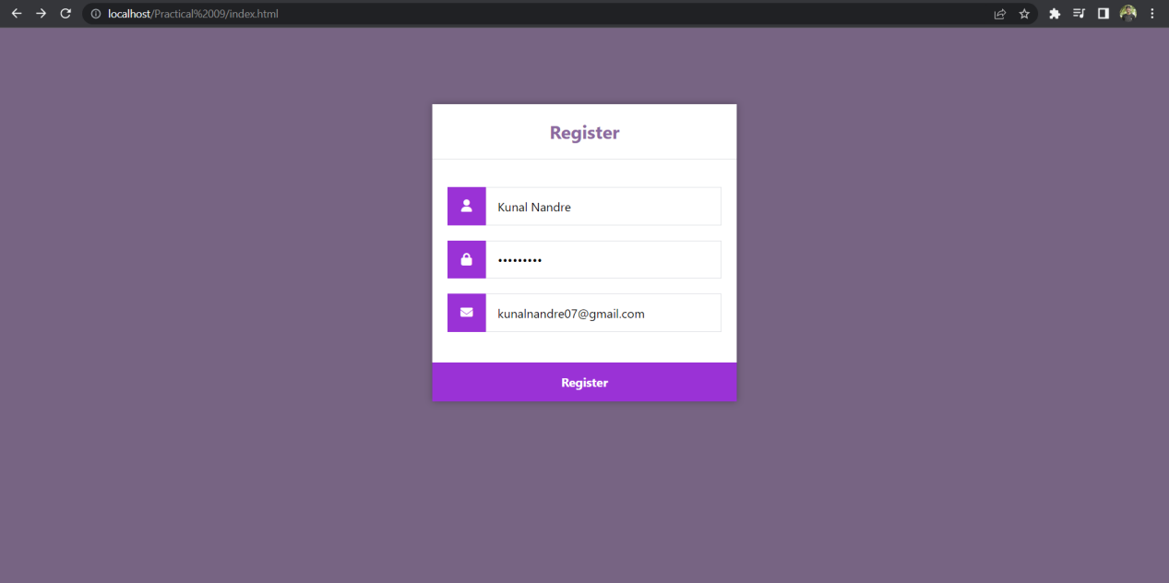
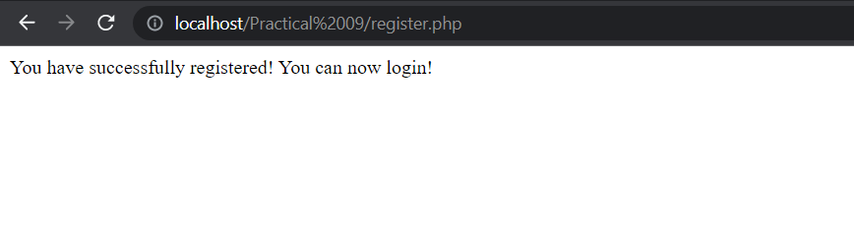

PRACTICAL 8
<?xml version="1.0" encoding="UTF-8"?>
<web-app id="WebApp_9" version="2.4" xmlns="http://xmlns.jcp.org/xml/ns/javaee" xmlns:xsi="http://www.w3.org/2001/XMLSchema-instance"
xsi:schemaLocation="http://java.sun.com/xml/ns/j2ee http://java.sun.com/xml/ns/j2ee/web-app_2_4.xsd">

<display-name>LoginAppInStruts2</display-name>
<filter>
<filter-name>
struts2
</filter-name>
<filter-class>
org.apache.struts2.dispatcher.ng.filter.StrutsPrepareAndExecuteFilter
</filter-class>
</filter>

<filter-mapping>
<filter-name>struts2</filter-name>
<url-pattern>/*</url-pattern>
</filter-mapping>

<welcome-file-list>
<welcome-file>login.jsp</welcome-file>
</welcome-file-list>
</web-app>

&<%@ page language="java" contentType="text/html; charset=ISO-8859-1" pageEncoding="ISO-8859-1"%>
<%@taglib uri="/struts-tags" prefix="s" %>

<!DOCTYPE html PUBLIC "-//W3C//DTD HTML 4.01 Transitional//EN" "http://www.w3.org/TR/html4/loose.dtd">

<html>

<head>
<meta http-equiv="Content-Type" content="text/html; charset=ISO-8859-1">
<title>Login Page</title>
<s:head />
</head>

<body bgColor="lightBlue">
<s:form action="Login">
<s:textfield name="userName" label="User Name" />
<s:password name="password" label="Password" />
<s:submit value="Login" />
</s:form>
</body>

</html>

<%@ page language="java" contentType="text/html; charset=ISO-8859-1" pageEncoding="ISO-8859-1"%>
<%@taglib uri="/struts-tags" prefix="s"%>
<!DOCTYPE html PUBLIC "-//W3C//DTD HTML 4.01 Transitional//EN" "http://www.w3.org/TR/html4/loose.dtd">

<html>

<head>
<meta http-equiv="Content-Type" content="text/html; charset=ISO-8859-1">
<title>login Successful</title>
</head>
<body>
Welcome <s:property value="userName"/>!!!
</body>

</html>

<?xml version="1.0" encoding="UTF-8"?>
<projectDescription>
<name>LoginAppInStruts2</name>
<comment></comment>
<projects>
</projects>
<buildSpec>
<buildCommand>
<name>org.eclipse.jdt.core.javabuilder</name>
<arguments>
</arguments>
</buildCommand>
<buildCommand>
<name>org.eclipse.wst.common.project.facet.core.builder</name>
<arguments>
</arguments>
</buildCommand>
<buildCommand>
<name>org.eclipse.wst.validation.validationbuilder</name>
<arguments>
</arguments>
</buildCommand>
</buildSpec>
<natures>
<nature>org.eclipse.jem.workbench.JavaEMFNature</nature>
<nature>org.eclipse.wst.common.modulecore.ModuleCoreNature</nature>
<nature>org.eclipse.wst.common.project.facet.core.nature</nature>
<nature>org.eclipse.jdt.core.javanature</nature>
<nature>org.eclipse.wst.jsdt.core.jsNature</nature>
</natures>
<filteredResources>
<filter>
<id>1776199705675</id>
<name></name>
<type>30</type>
<matcher>
<id>org.eclipse.core.resources.regexFilterMatcher</id>
<arguments>node_modules|\.git|__CREATED_BY_JAVA_LANGUAGE_SERVER__</arguments>
</matcher>
</filter>
</filteredResources>
</projectDescription>

OUTPUT
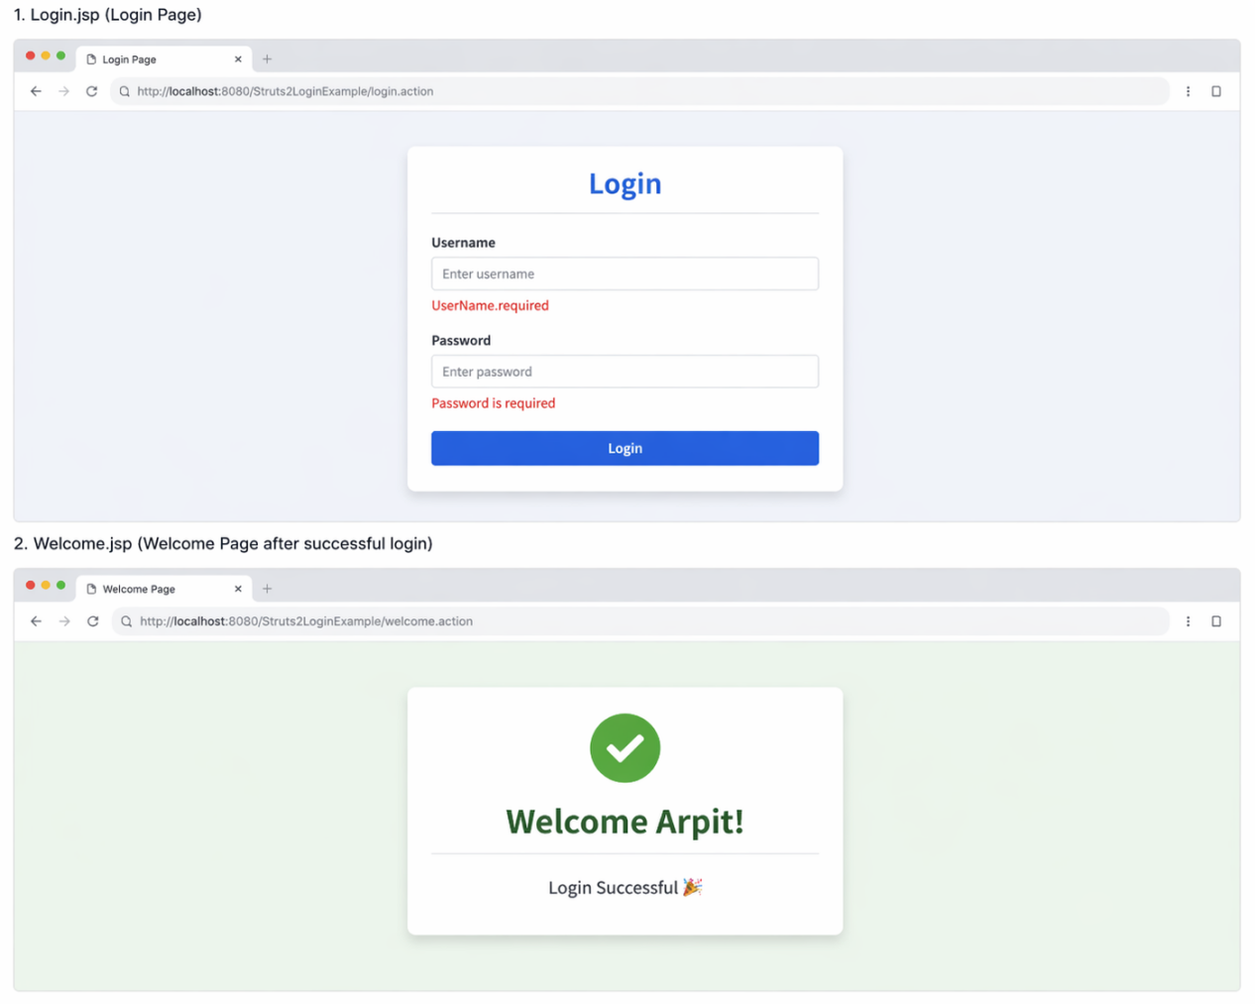

PRACTICAL 9
var myApp = angular.module("myApp", []);
myApp.service("ContactService" , function(){
var uid = 1;
var contacts = [{
'id' : 0,
'name' : 'Sumedha Zaware',
'email' : 'snz@gmail.com',
'password': 'SumedhaZ',
'phone' : '123456789',
'age' : '19'}];

// Save Service for sving new contact and saving existing edited contact.
this.save = function(contact)
{
if(contact.id == null)
{
contact.id = uid++;
contacts.push(contact);
}
else
{
for(var i in contacts)
{
if(contacts[i].id == contact.id)
{
contacts[i] = contact;
}
}
}
};

// serach for a contact

this.get = function(id)
{
for(var i in contacts )
{
if( contacts[i].id == id)
{
return contacts[i];
}
}
};

//Delete a contact
this.delete = function(id)
{
for(var i in contacts)
{
if(contacts[i].id == id)
{
contacts.splice(i,1);
}
}
};
//Show all contacts
this.list = function()
{
return contacts;
};
});

////Controller area .....

myApp.controller("ContactController" , function($scope , ContactService){
console.clear();

$scope.ifSearchUser = false;
$scope.title ="List of Users";

$scope.contacts = ContactService.list();

$scope.saveContact = function()
{
console.log($scope.newcontact);
if($scope.newcontact == null || $scope.newcontact == angular.undefined)
return;
ContactService.save($scope.newcontact);
$scope.newcontact = {};
};
$scope.delete = function(id)
{
ContactService.delete(id);
if($scope.newcontact != angular.undefined && $scope.newcontact.id == id)
{
$scope.newcontact = {};
}
};
$scope.edit = function(id)
{
$scope.newcontact = angular.copy(ContactService.get(id));
};
$scope.searchUser = function(){
if($scope.title == "List of Users"){
$scope.ifSearchUser=true;
$scope.title = "Back";
}
else
{
$scope.ifSearchUser = false;
$scope.title = "List of Users";
}
};
});

<!DOCTYPE html>
<html>
<head>
<meta charset="utf-8">
<title>Assignment-9</title>
<meta name="viewport" content="width=device-width, initial-scale=1">
<script src="https://ajax.googleapis.com/ajax/libs/jquery/1.11.2/jquery.min.js"></script>
<script src="https://ajax.googleapis.com/ajax/libs/angularjs/1.2.26/angular.min.js"></script>
<link rel="stylesheet" href="https://maxcdn.bootstrapcdn.com/bootstrap/3.2.0/css/bootstrap.min.css">
<script src="app.js"></script>
</head>
<body>
<div ng-app = "myApp" class = "container" style="width:550px">
<div style="text-align:center;color:rgb(15, 15, 15);background-color: rgb(202, 226, 248);">
<h3><b>Registraion Form</b></h3>
</div>
<div ng-controller = "ContactController">
<div align="right">
<a href="#" ng-click="searchUser()">{{title}}</a>
</div>
<form role = "form" class="well" ng-hide="ifSearchUser">
<div class = "form-group">
<label for = "name"> Name: </label>
<input type = "text" id = "name" class = "form-control" placeholder = "Enter Name " ng-model = "newcontact.name">
</div>
<div class = "form-group">
<label for = "email"> Email: </label>
<input type = "email" id = "email" class = "form-control" placeholder = "Enter Email " ng-model = "newcontact.email">
</div>
<div class = "form-group">
<label for = "password"> Password: </label>
<input type = "password" id = "password" class = "form-control" placeholder = "Enter Password " ng-model = "newcontact.password">
</div>
<div class = "form-group">
<label for = "phone"> Phone: </label>
<input type = "text" id = "phone" class = "form-control" placeholder = "Enter Phone " ng-model = "newcontact.phone">
</div>
<div class = "form-group">
<label for = "age"> Age: </label>
<input type = "text" id = "age" class = "form-control" placeholder = "Enter Age " ng-model = "newcontact.age">
</div>
<br>
<input type="hidden" ng-model="newcontact.id">
<input type="button" class="btn btn-primary" ng-click="saveContact()" class="btn btn-primary" value = "Submit">
</form>

<div><h4><b>Registered Users</b></h4>
<table ng-if="contacts.length" class = "table table-striped table-bordered table-hover">
<thead>
<tr class = "info">
<th>Name</th>
<th>Email</th>
<th>Phone</th>
<th>Age</th>
<th ng-if="!ifSearchUser">Action</th>
</tr>
</thead>
<tbody>
<tr ng-repeat = "contact in contacts">
<td>{{ contact.name }}</td>
<td>{{ contact.email }}</td>
<td>{{ contact.phone }}</td>
<td>{{ contact.age }}</td>
<td ng-if="!ifSearchUser">
<a href="#" ng-click="edit(contact.id)" role = "button" class = "btn btn-info">edit</a> &nbsp;
<a href="#" ng-click="delete(contact.id)" role = "button" class = "btn btn-danger">delete</a>
</td>
</tr>
</tbody>
</table>
<div ng-hide="contacts.length > 0">No Users Found</div>
</div>
</div>
</div>
</body>
</html>

