**What is ER Diagram in DBMS ?**

An Entity Relationship Diagram in DBMS is a blueprint of the database that can be later implemented as an actual database in the form of tables. It is a "diagrammatic representation of the database".

An ER diagram is used for creating a systematic study of the data requirements and then making a proper database. It is considered to be one of the best practices before implementing an actual database.

the entity-relationship diagram has entities, attributes, and the relationship between the data.

**Note:**

the **entity-relationship diagram might look close to a flowchart**, however, they contain some set of symbols and notations and their meanings are what make them unique.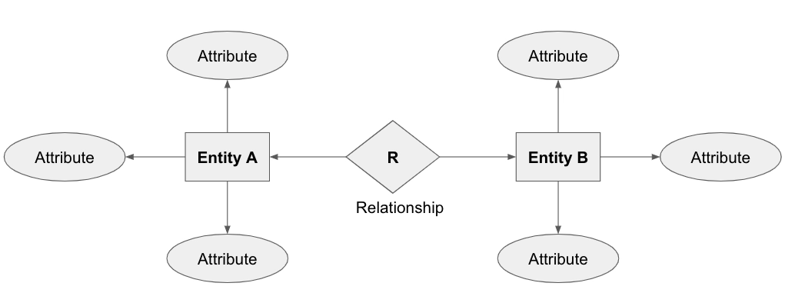

example:

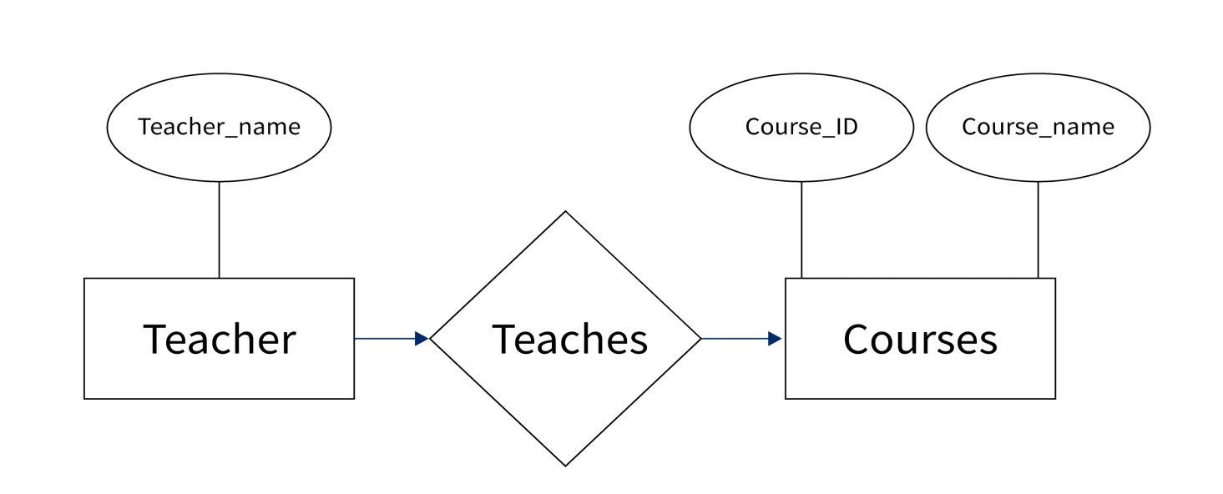

in the above diagram, Teacher and Courses are two entities whereas teacher_Name is the attribute of the entity Teacher. Similarly, the Course_ID and Course_name are the attributes of the entity Courses.

Moreover, the relationship between the two entities will be many to many since many teachers can teach many courses at a University.

**Why Use ER Diagrams?**

The main reasons for using the ER diagram before constructing an actual database are as follows:

* An Entity Relationship Diagram is used for modeling the data that will be stored in a database.
* The database designers get a better understanding of the information that will be contained in the database using the Entity Relationship Diagram.
* An ER diagram is used as a blueprint by the database designers to implement the data in a certain application.
* They define what data will be stored in the databases, that is, the entities and their attributes.
* However, they also specify the relationships between the data.
* It provides a preview of how the tables should be connected and what entities are in which table.
* These ER diagrams can easily be converted into relational tables that help in the designing of the software quickly.

**Symbols and its usage in an ER diagram:**

**Rectangle:**

* It is used to represent the entities in an entity-relationship diagram.

**Ellipses/Oval:**

* This symbol is used to represent the attributes in an entity-relationship diagram.

**Diamond:**

* This symbol is used to represent the type of relationship that exists between the entities such as one-to-one, many-to-one, and many-to-many.

**Lines:**

* It links the entities to the relationship types whereas the attributes to the entity types.

**Double Ellipses:**

* It is used to represent a multivalued attribute.

**Double rectangle:**

* It is used to represent a weak entity.

**Double diamond:**

* It is used to represent a weak relationship between entities.

**Note:**

To represent a primary key in an entity-relationship diagram, the attributes are underlined and to represent the foreign key in an entity-relationship diagram, that attributes are dashed-underlined.

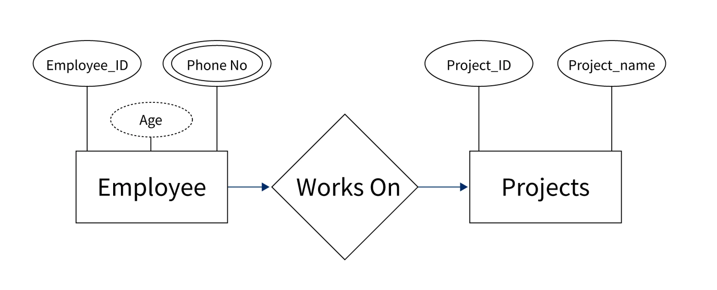

**Components of the ER Diagram:**

The ER diagram is made up of three components:

* Entities
* Attributes
* Relationships

