**What is Relationship in DBMS?**

* Any association between two entities is called a relationship.
* Relationships tell us how two or more datasets/entities are linked.
* It helps in storing the data in separate tables.
* A relationship is represented by a diamond shape in an ER diagram.

**Types of relationships:**

1. One-to-One Relationship
2. One-to-Many or Many-to-One Relationship
3. Many-to-Many Relationship

**One-to-One Relationship**

* According to this relationship, a single record in Table A is related to a single record in Table B, and vice-versa is also true.

Example:

* Only one passport is allowed per person, and each passport belongs to only one person. Therefore it is a one-to-one relationship.

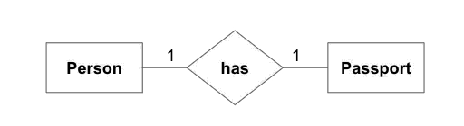

**One-to-Many or Many-to-One Relationship**

* According to this relationship, each record of Table A can be related to one or more-than one record of table B.

Example:

* Each customer can have multiple accounts, so it is a one-to-many relationship and other way, many accounts are held by one customer only. Therefore it is a many-to-one/one-to-many relationship also.

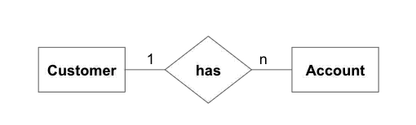

**Many-to-Many Relationship**

* According to this relationship, each record of Table A can be related to one or more than one record of table B and vice versa is also true, i.e., each record of Table B can be connected to one or more than one record of table A.

Example:

* Each customer can buy more than 1 product, and many customers can buy one product. Therefore it is a many-to-many relationship.

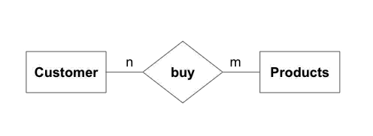

**What is Normalization?**

* Normalization is a process of designing a consistent database by minimizing redundancy and ensuring data integrity through decomposition which is lossless.
* It was developed by E. F. Codd.

**Features of Normalization:**

* Normalization avoids the data redundancy.
* It is a formal process of developing data structures.
* It promotes the data integrity.
* It ensures data dependencies make sense that means data is logically stored.
* It eliminates the undesirable characteristics like Insertion, Updation and Deletion Anomalies.

**Types of Normalization:**

Following are the types of Normalization:

1. First Normal Form (1NF)

2. Second Normal Form (2NF)

3. Third Normal Form (3NF)

4. BCNF (Boyce – Codd Normal Form)

5. Fourth Normal Form (4NF)

6. Fifth Normal Form (5NF)

**how to represent the comments in MySQL?**

Comment on a Single Line:

/* */

Comment on Multiple Lines:

/* comment line _1

Comment line_2

…..

Comment line_n */

Ex1:

mysql> **select * from emp /* retrieve the employee data */;**

Ex2:

mysql> **select * from emp where dno=10/*retrieve the employee data whose**

**/*> employee working under department number 10 */;**

Ex3:

mysql> **select * from emp where dno=10 and ename like 's%' /* to retrieve the employee data**

**/*> whose employee working under department number 10 and**

**/*> which employee name starts with 's' character */;**

**Ex:** **write a SQL Query to print the employee data,whoose employee to get the maximum salary?**

**mysql> select * from workers where sal=(select max(sal) from workers);**

**mysql> select * from workers order by sal desc limit 1;**

**mysql> select * from workers where sal=(select sal from workers order by sal desc limit 1);**

**mysql> select * from workers where sal=(select sal from workers order by sal desc limit 2,1);**

**mysql> select * from workers where sal=(select sal from workers order by sal desc limit 1,1);**

**mysql>select * from workers where sal=(select sal from workers order by sal desc limit 3,1);**