Question 1

Part A: MapReducer procedure:

Step 1: Mapper function

The mapper method implemented in TokenizerMapper reads the file line by line and splits into tokens. This function delivers intermediary records of key-value pairs of the last two columns. Considering this graph data, when passed to map function it generates the key value pairs as:

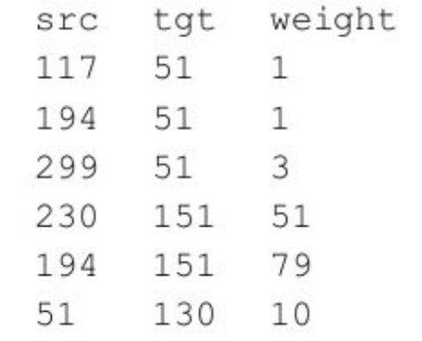

Output:

(51,1)

🡺 (51,1)

(51,3)

(151,51)

(151,79)

(130,10)

Step 2: Reducer function

The reducer procedure is implemented in IntMaxReducer.The generated intermediary records shown above are passed to the reducer function. The reducer function only keeps the key,value pairs with maximum weight value for all the records sharing the same key.

Final Output:

(51,3)

(151,79)

(130,10)