**Test Case Name** : TC001_Login_Logout_Verification

URL : <https://gor-pathology.web.app/>

1. Launch application and will verify page

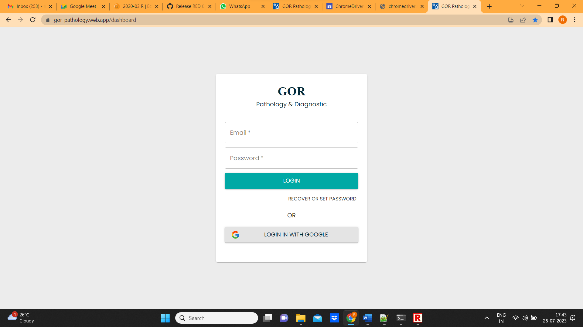

1. Enter username and password and click on login

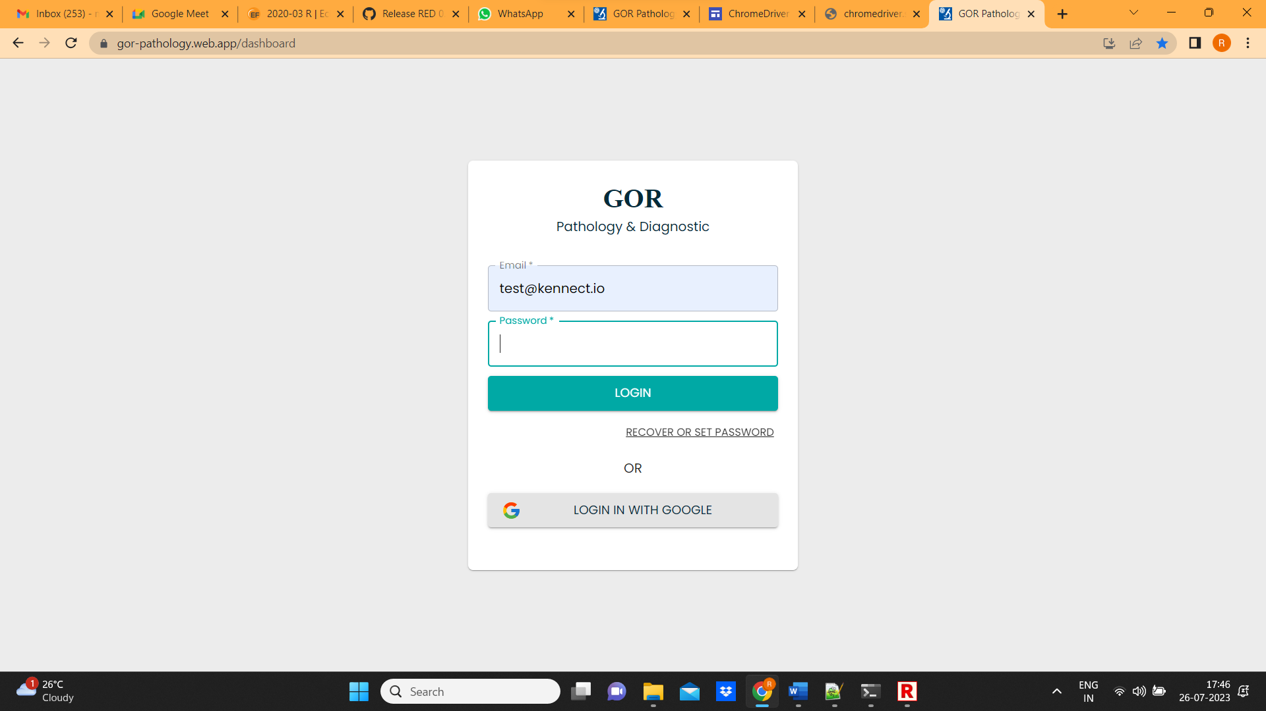

1. Home page will open and verify dashboard

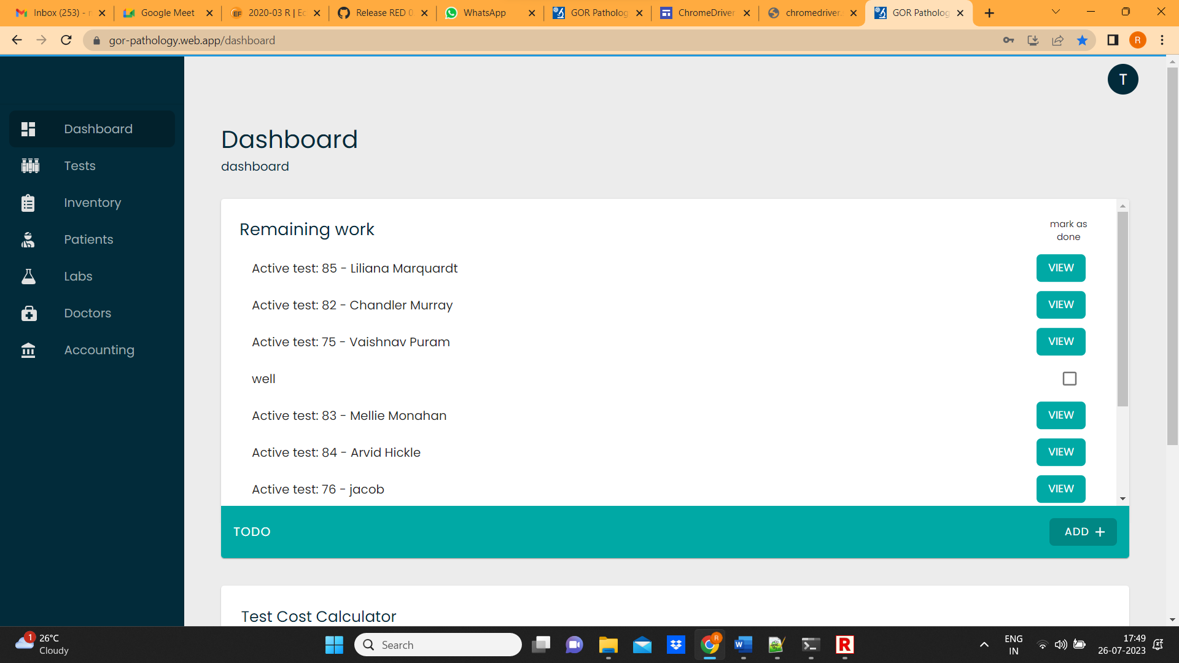

1. After successful verification, Click on profile and click on sign out

