**Test Case Name** : TC002_Home_Page_Navigation

URL : <https://gor-pathology.web.app/>

1. Launch application and will verify page

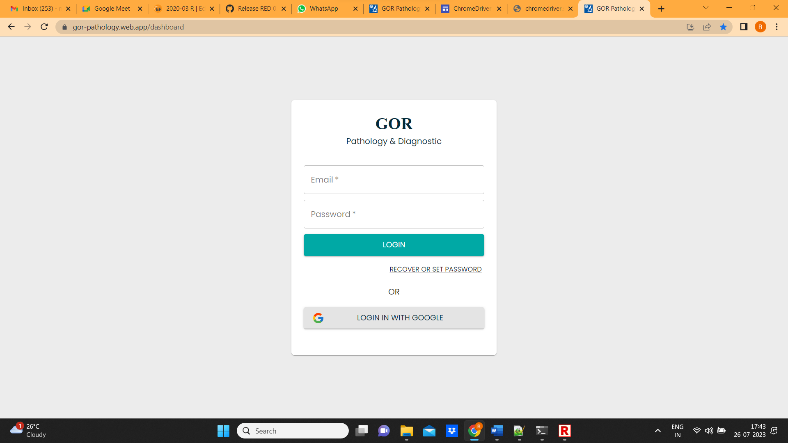

1. Enter username and password and click on login

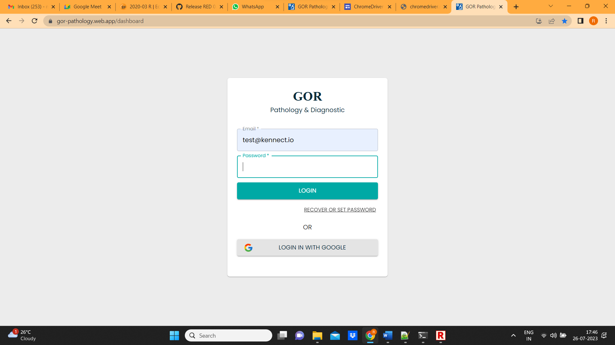

1. Home page will open and verify menu bar and dashboard page

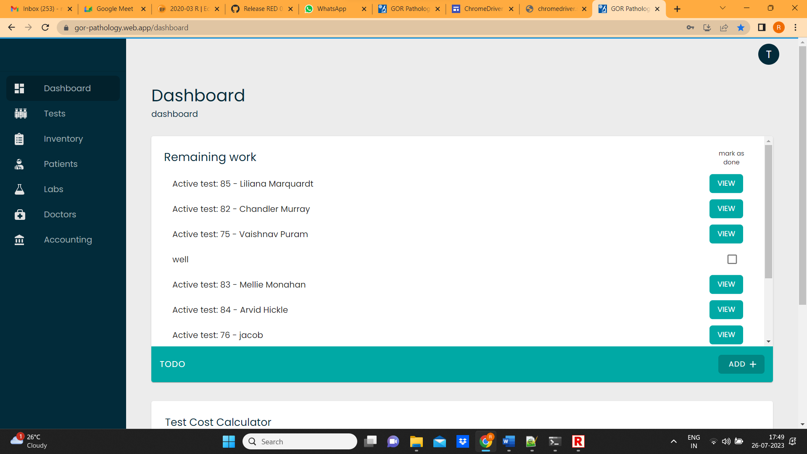

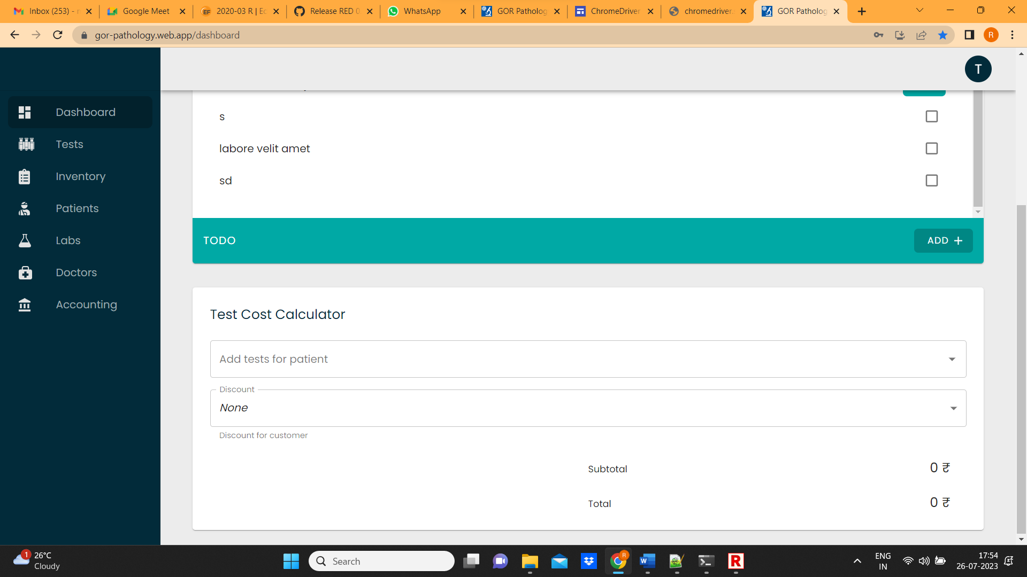

1. After successful verification, Click on profile and click on sign out

