**Test Case Name** : TC003_Test_Case_Calculater_Verification

URL : <https://gor-pathology.web.app/>

1. Launch application and will verify page

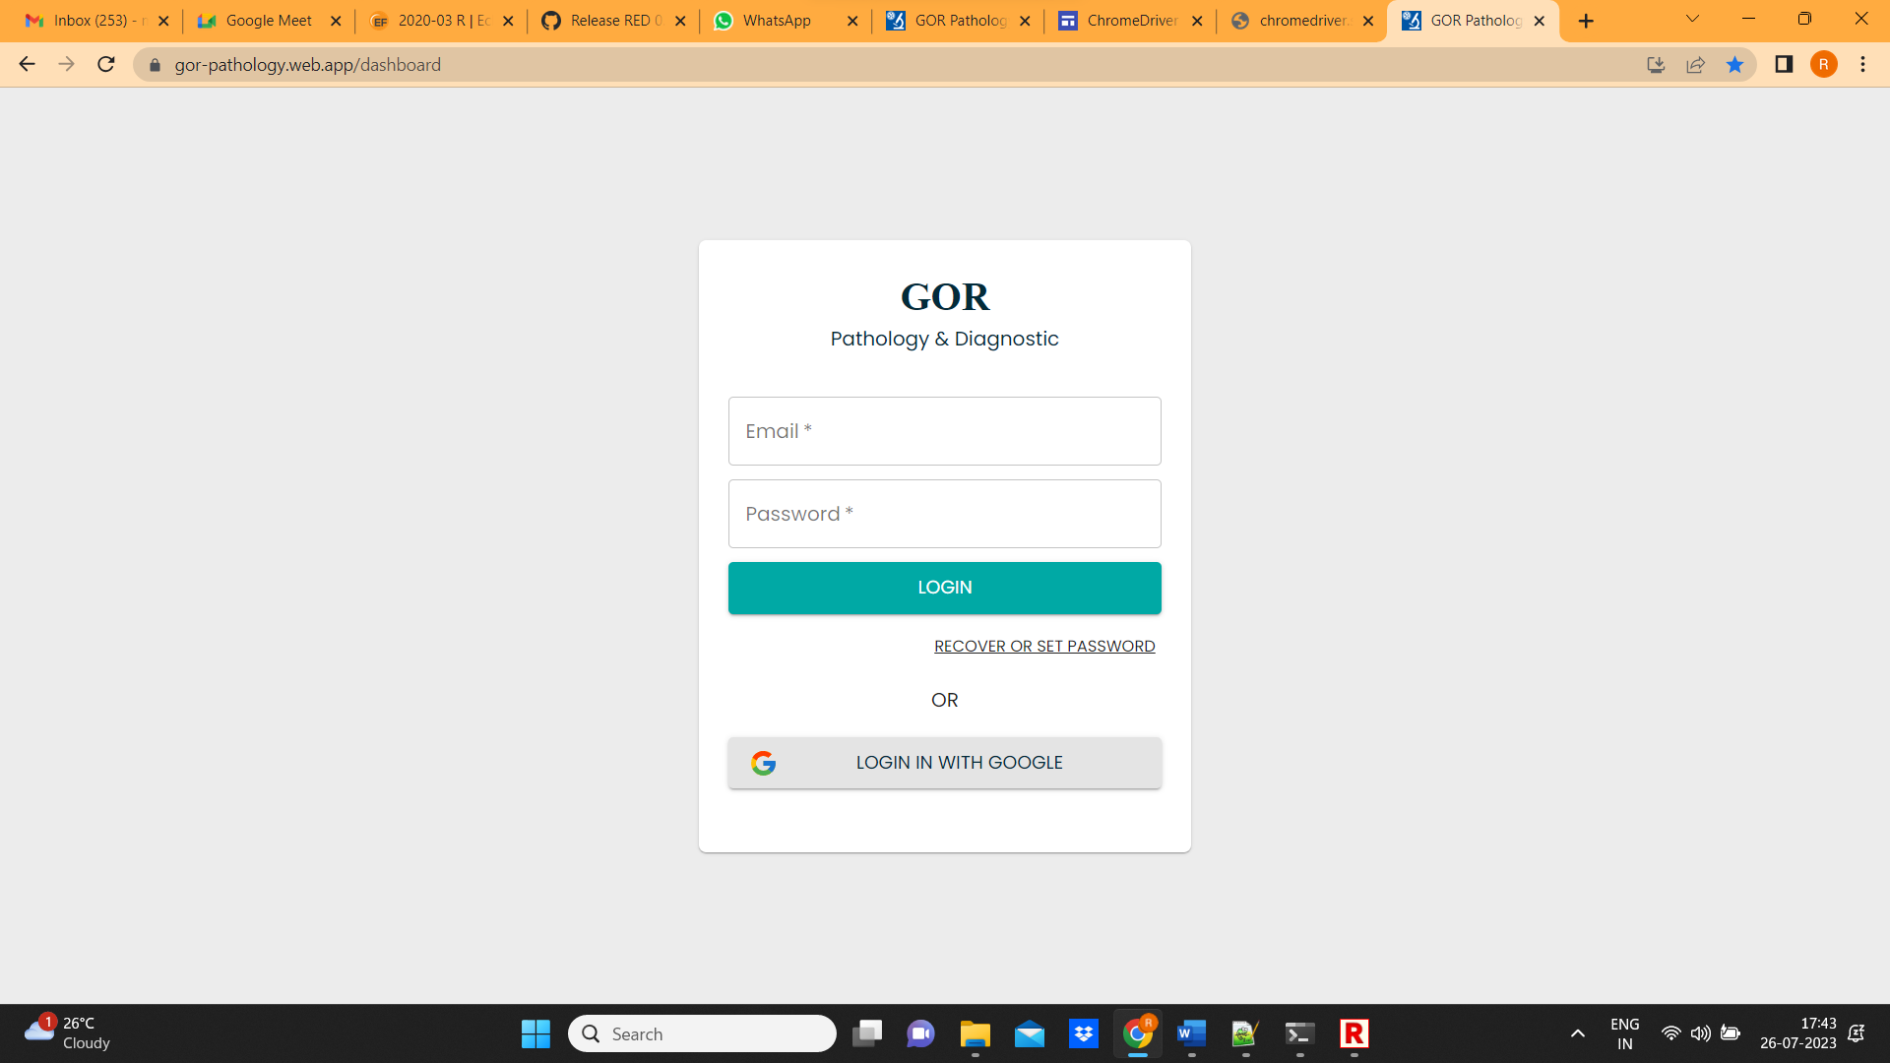

1. Enter username and password and click on login

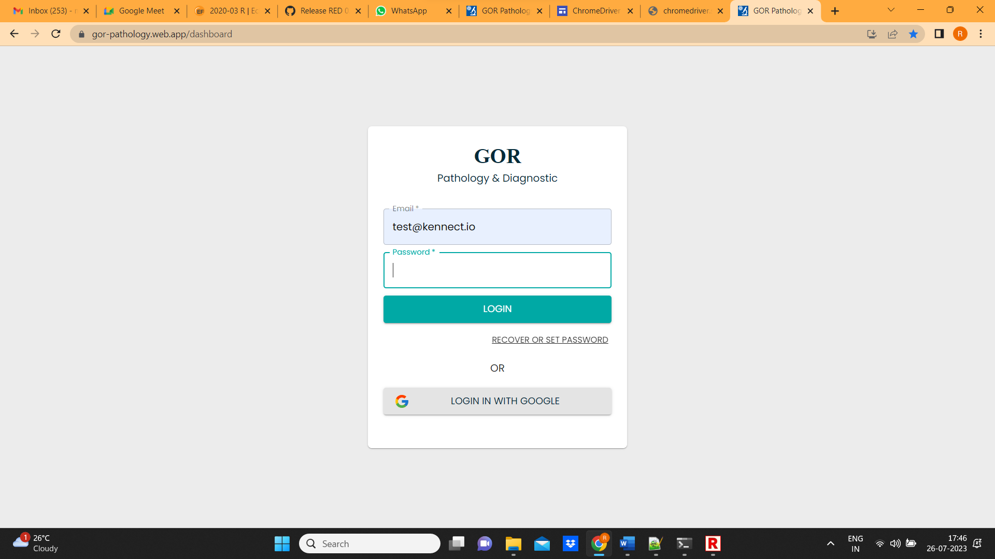

1. Click on add tests for patient

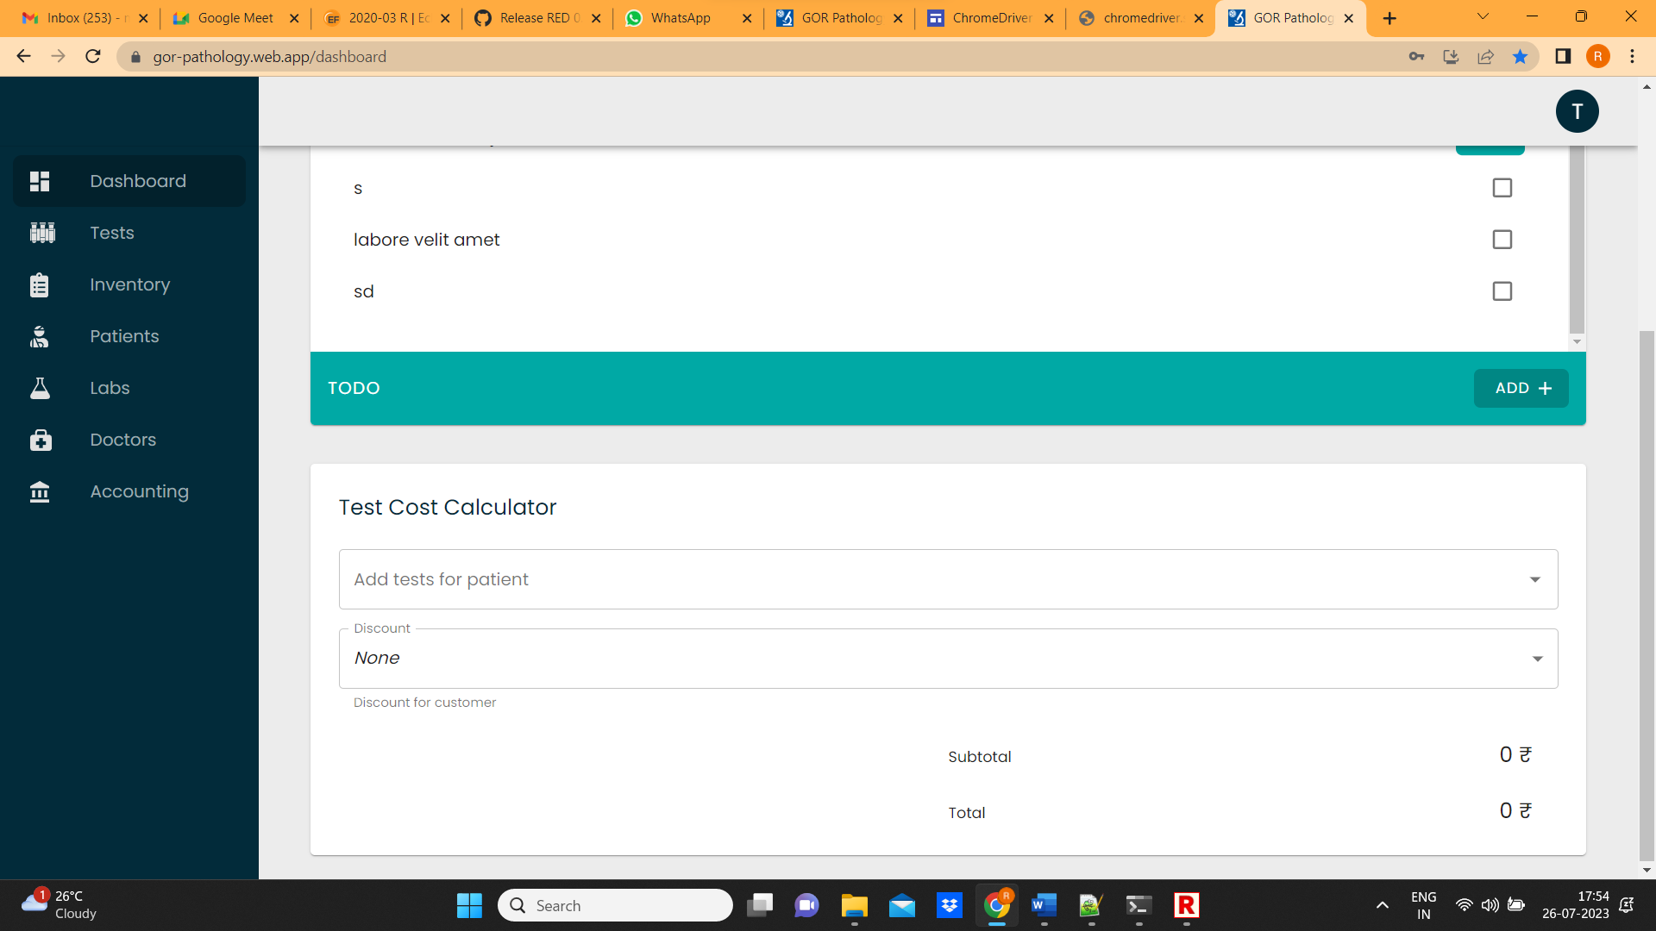

5 . Select any one the test

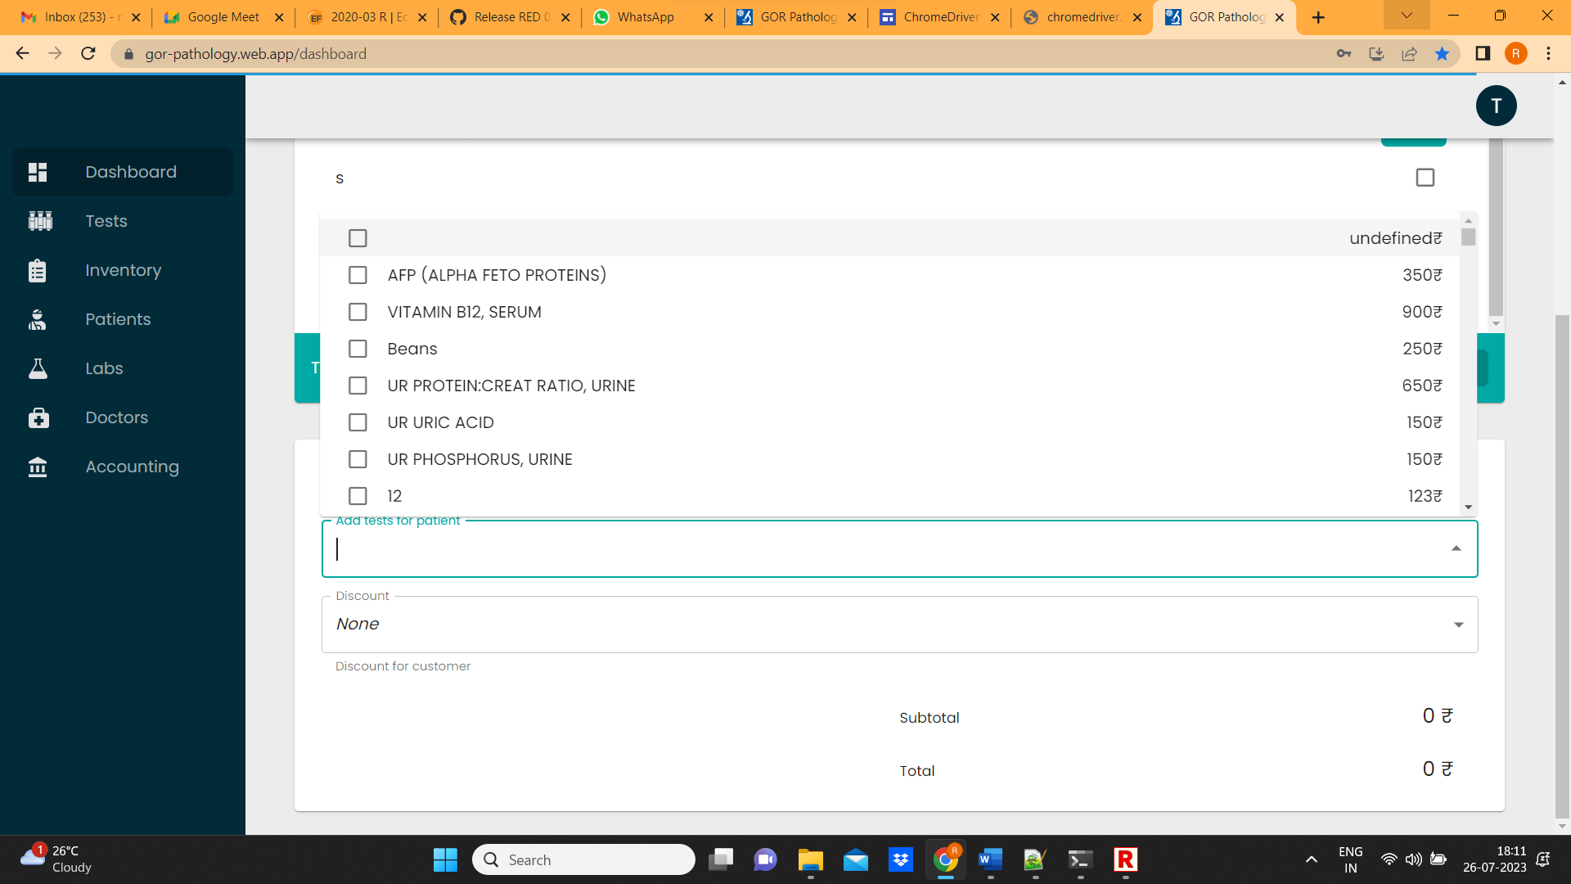

6. Click on discount and select discount

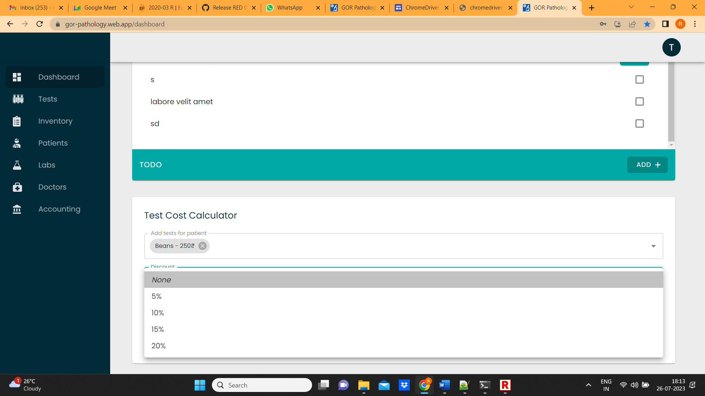

7. After selection , verify subtotal and total amount

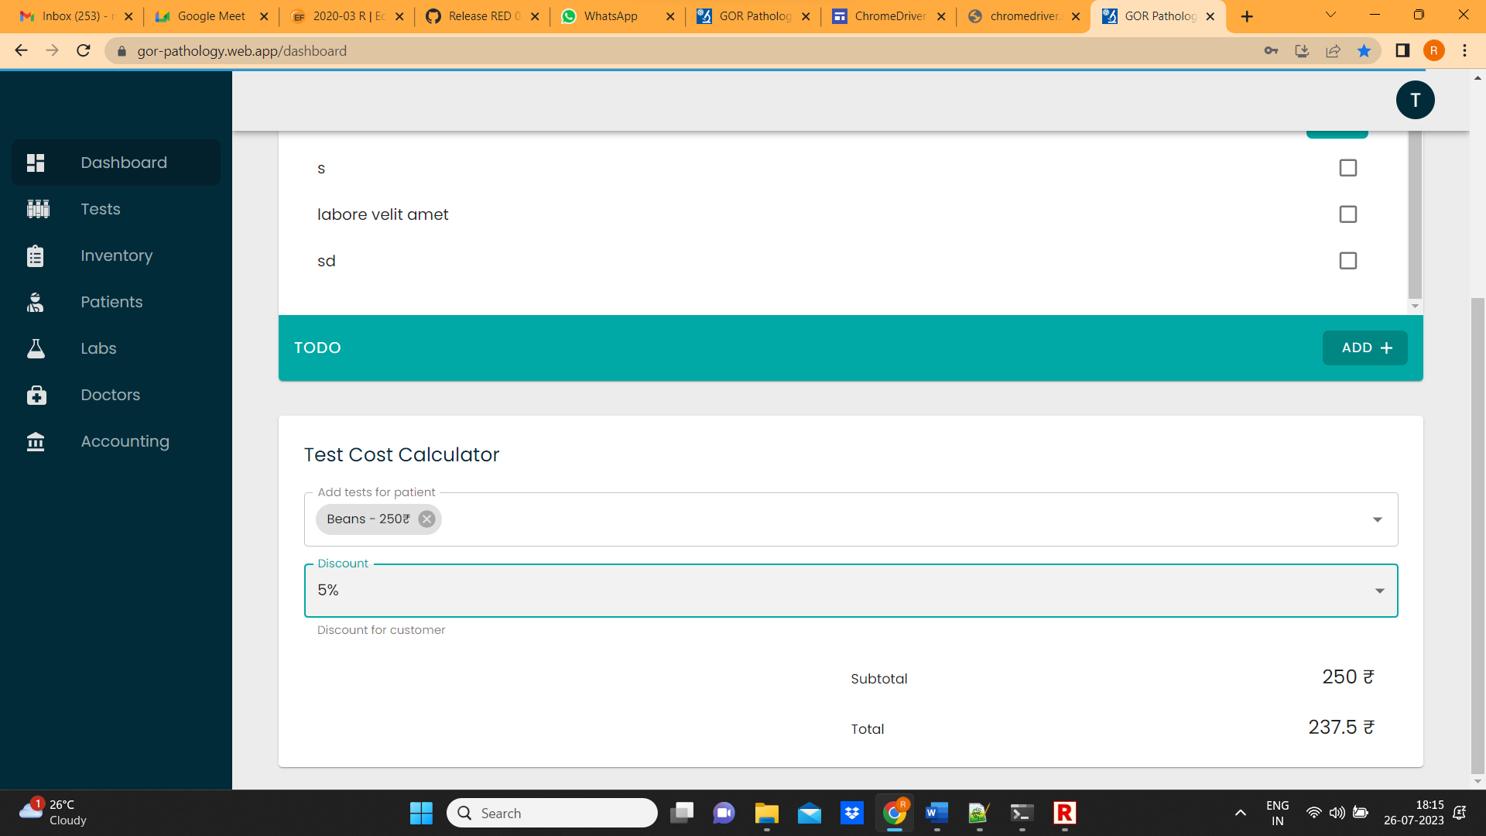

1. After successful verification, Click on profile and click on sign out

