**Test Case Name** : TC004_Create_Test_For_Patient

URL : <https://gor-pathology.web.app/>

1. Launch application and will verify page

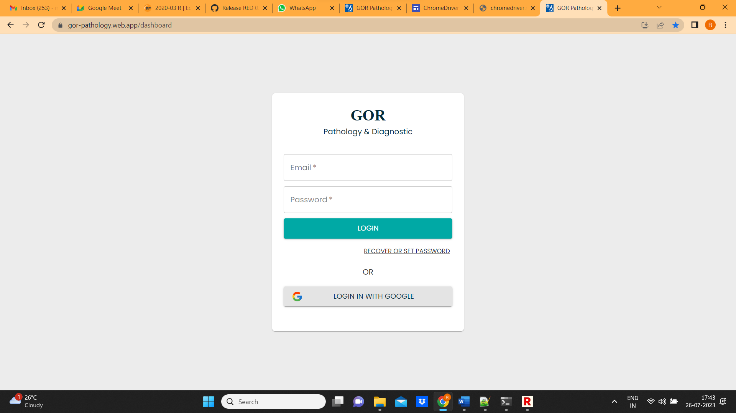

1. Enter username and password and click on login

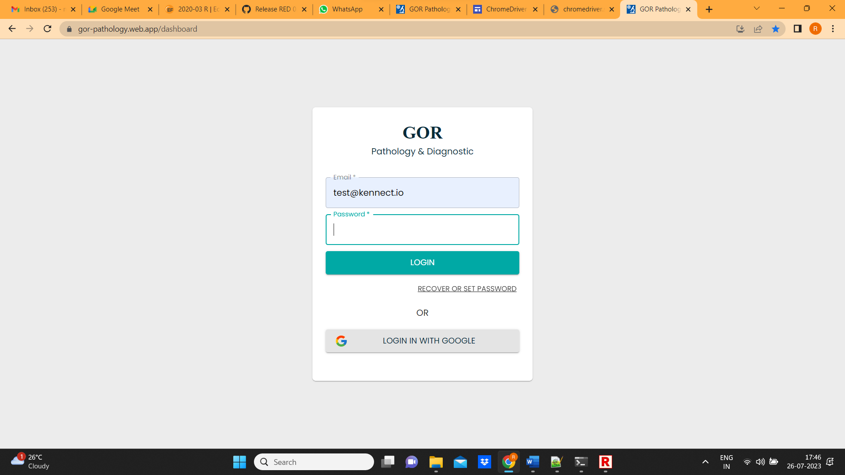

1. Click on patients

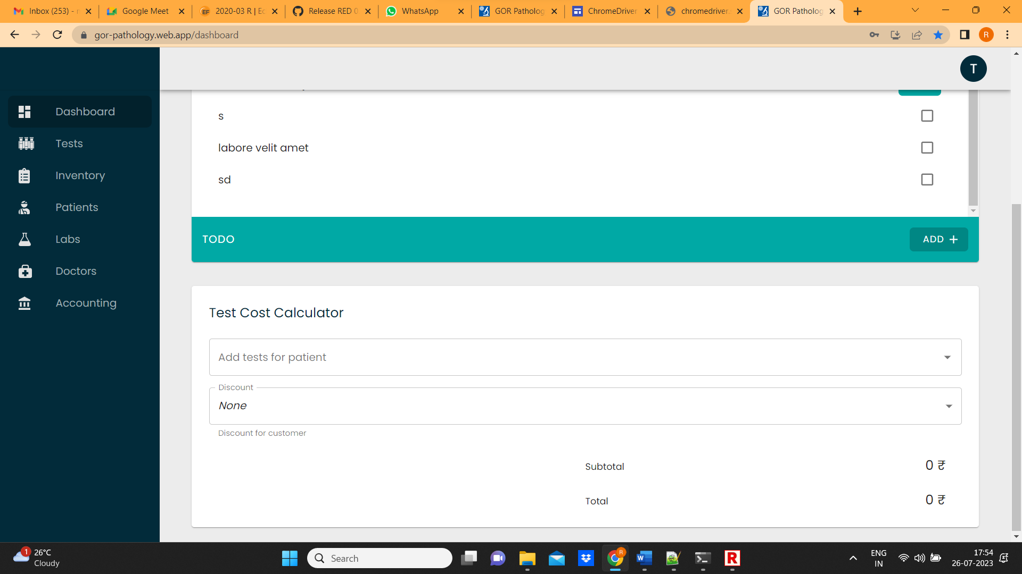

1. Verify patients and click on Add patient

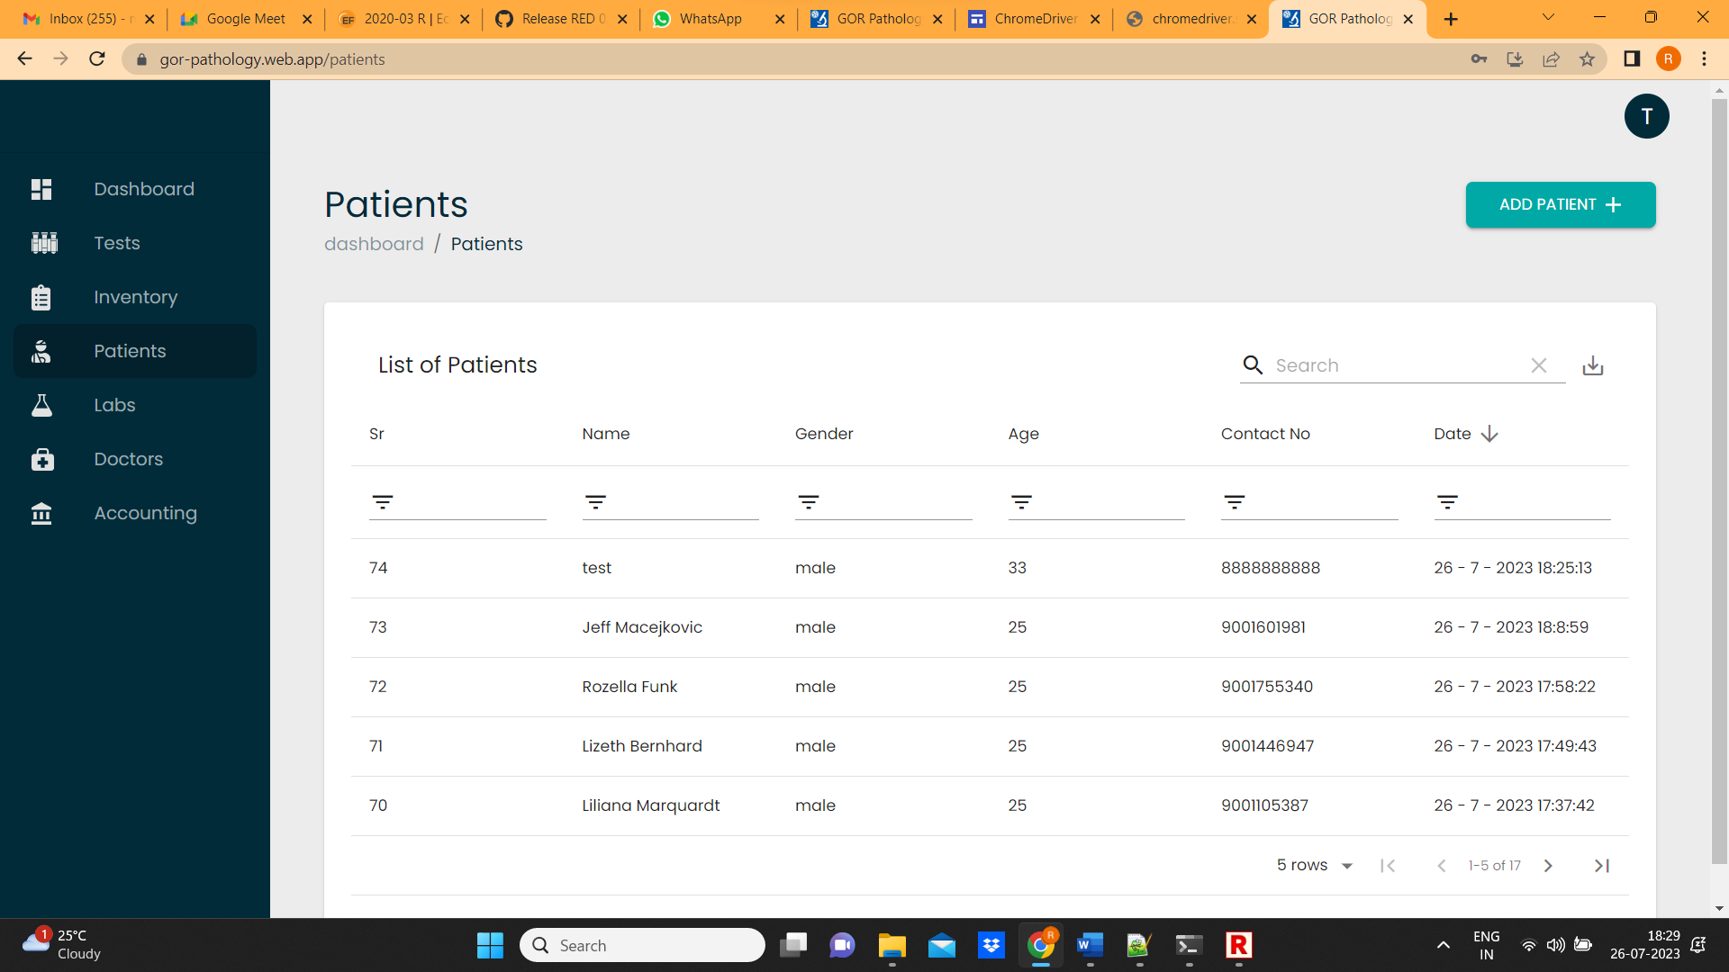

1. Enter name , email, phone and click on General details

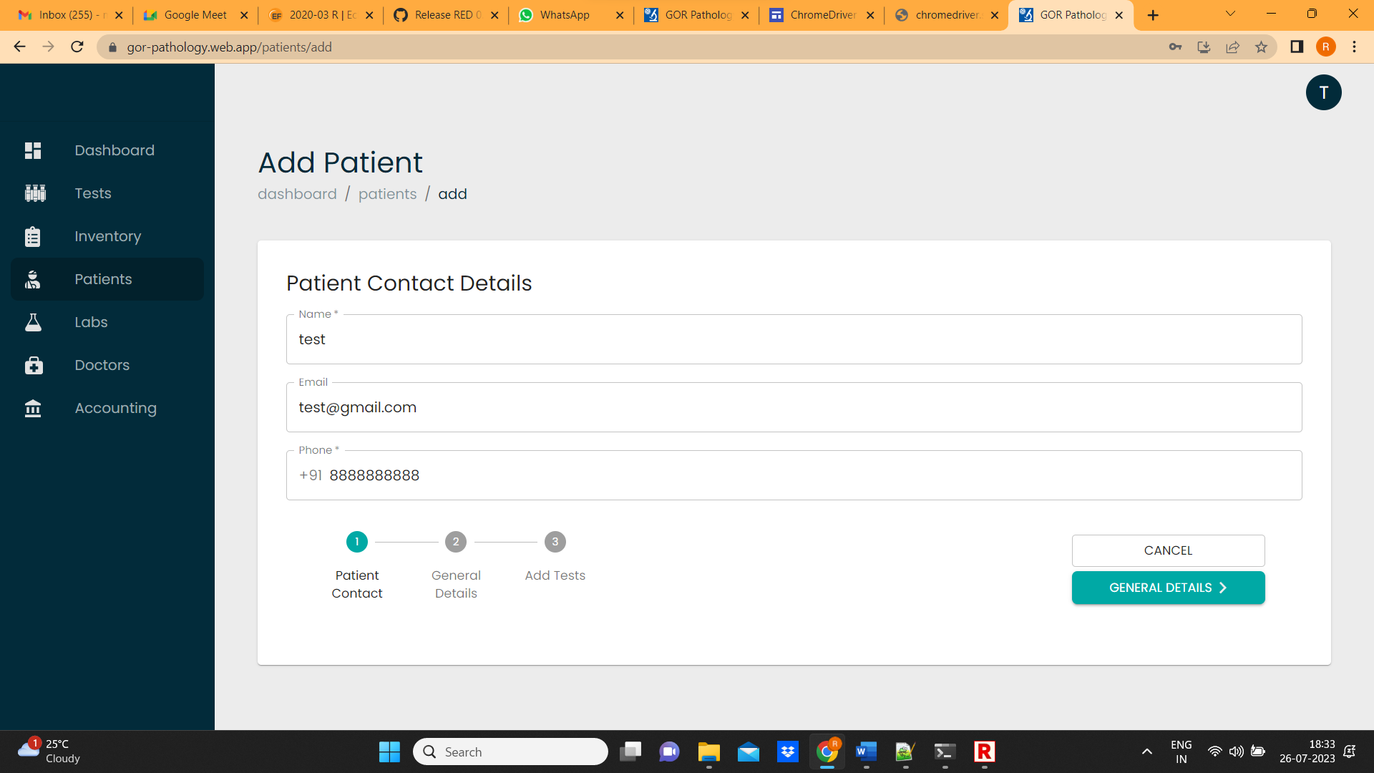

1. Select height, weight, gender, age and blood pressure details and click on Add tests

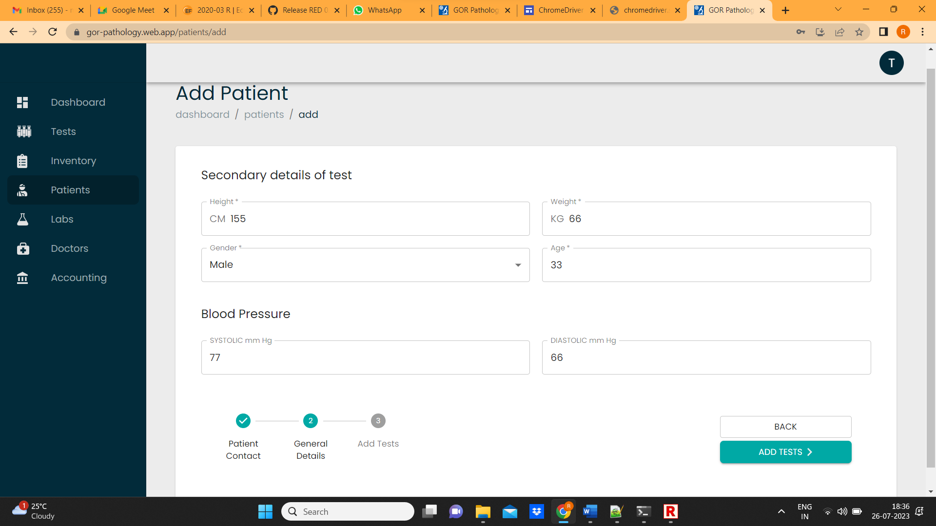

1. Select each field of the form

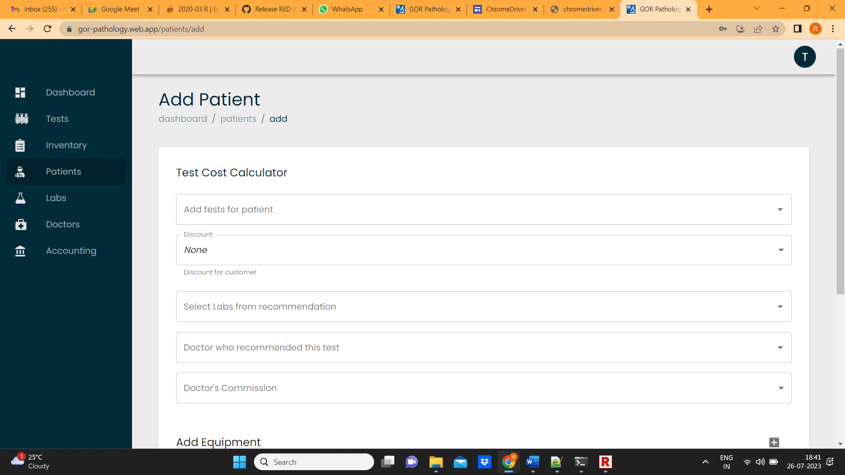

1. Add equipment, select equipment name, select action and click on add patient

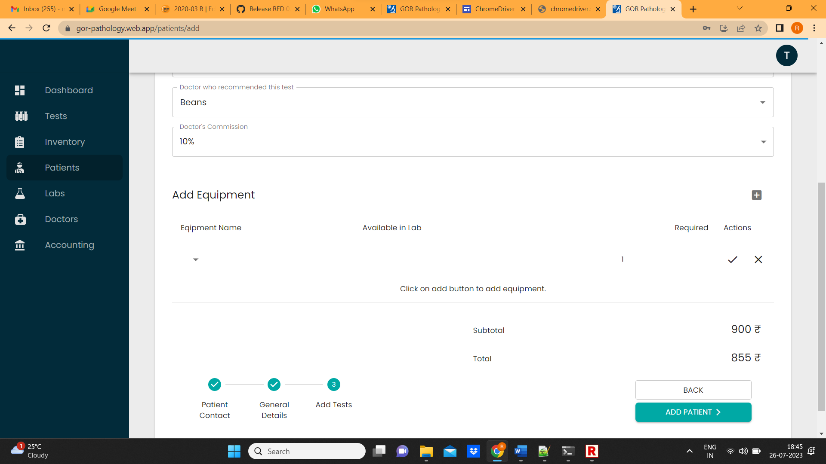

1. Verify on page and click on dashboard

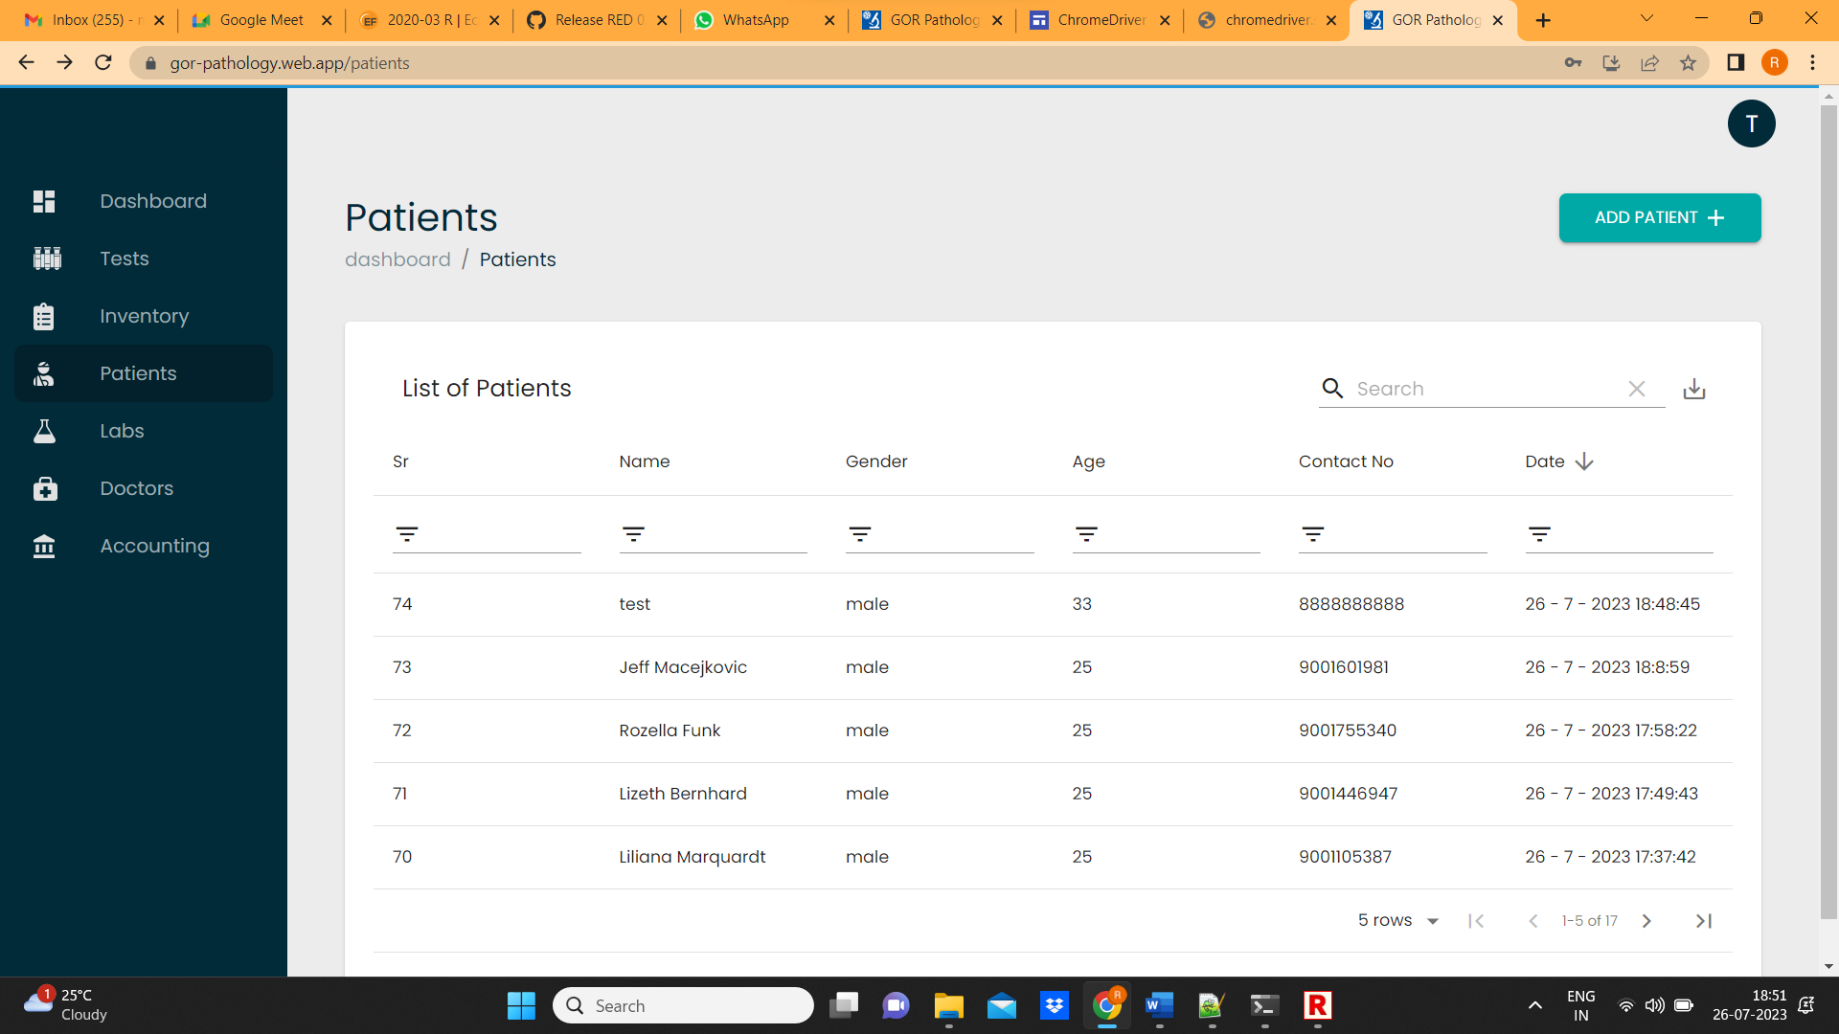

1. . Verify created test in todo list and click on view

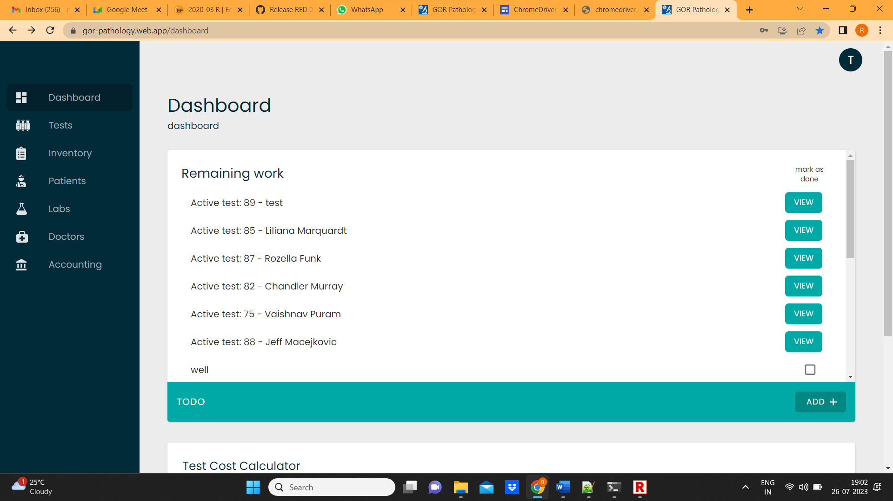

1. Verify name and go back

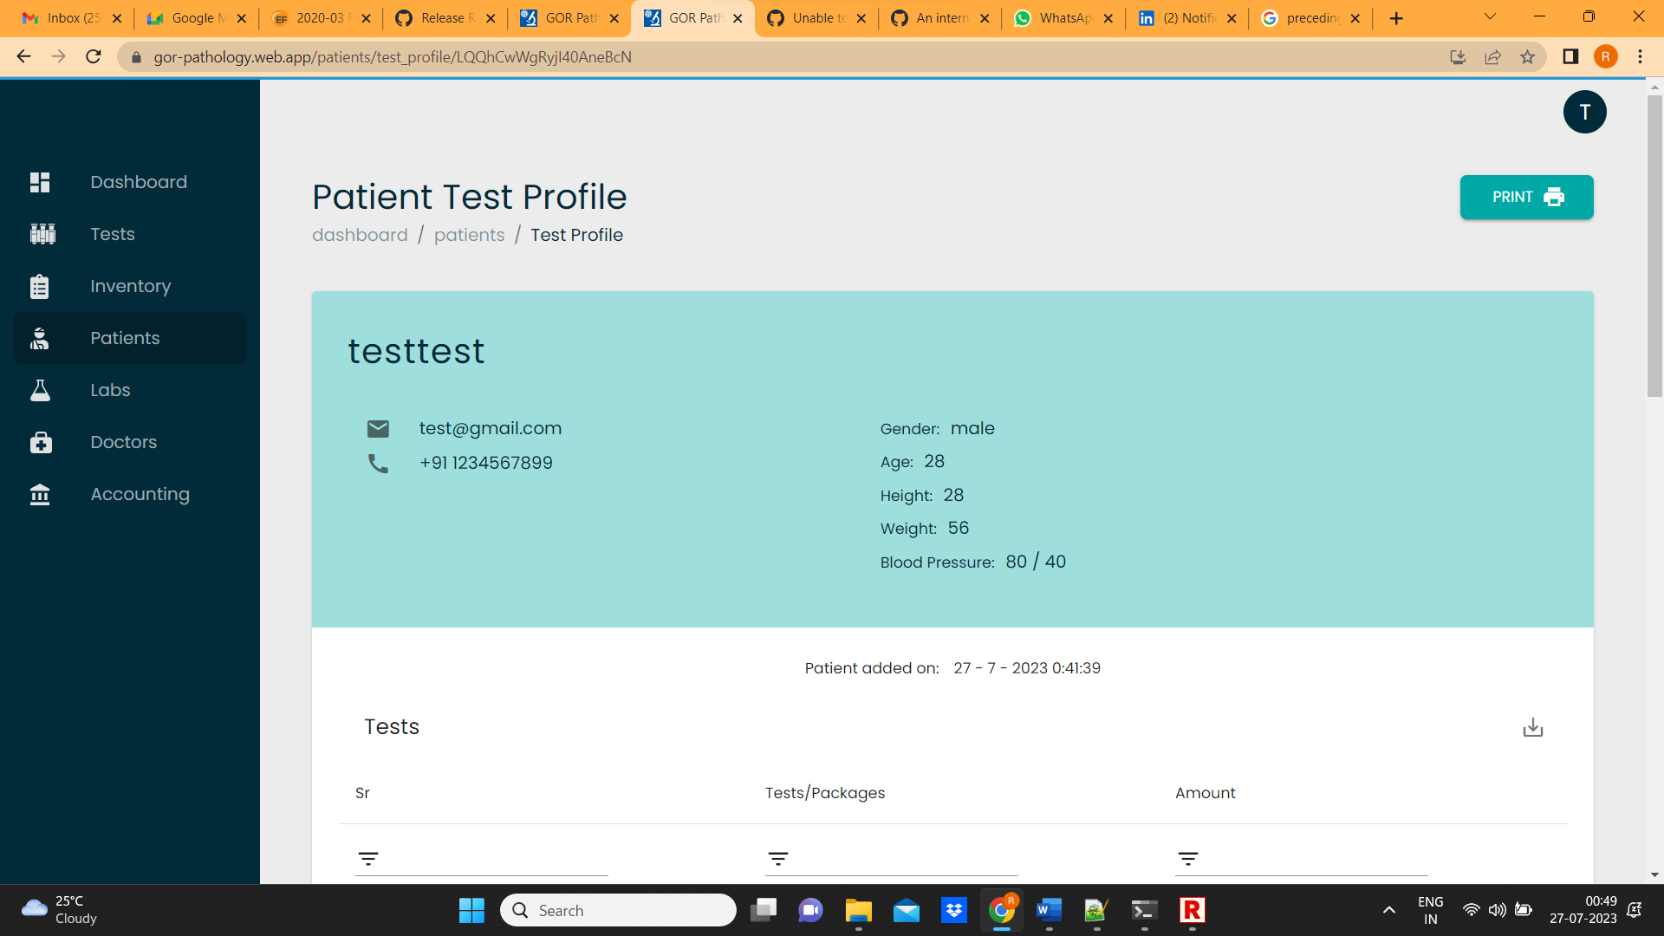

1. After successful verification, Click on profile and click on sign out

