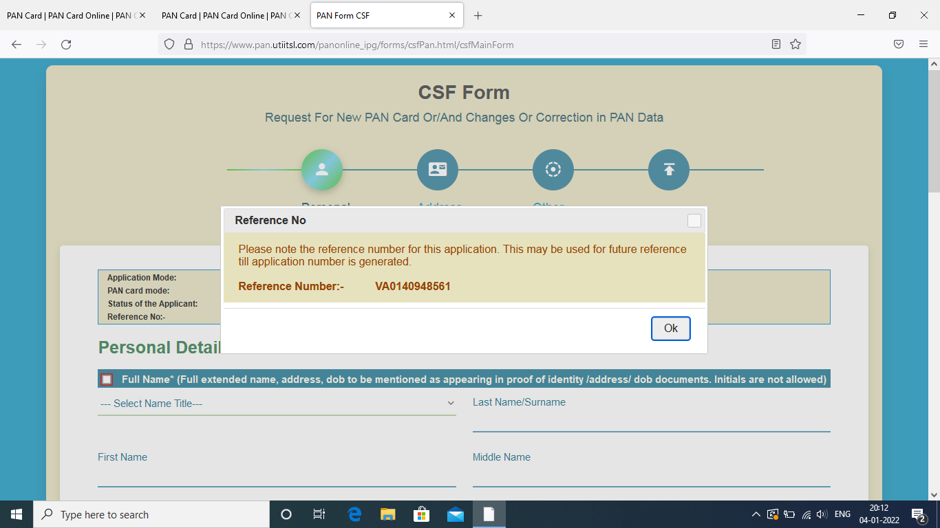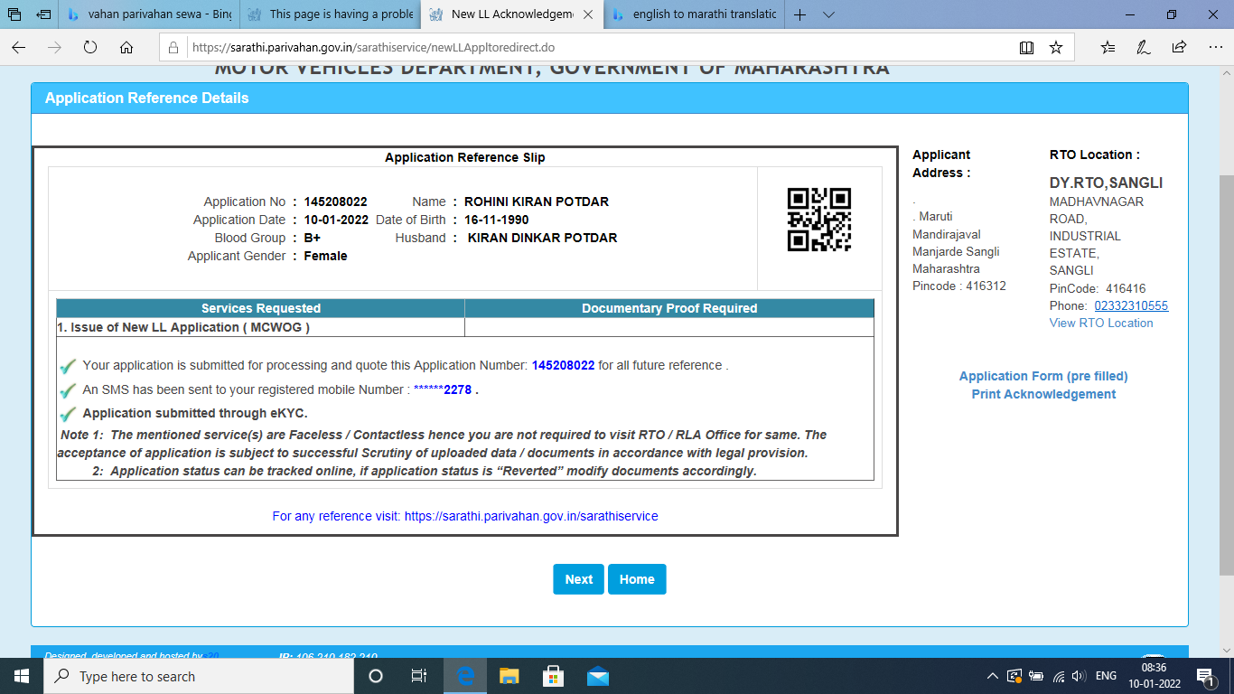

https://www.youtube.com/playlist?list=PLVlQHNRLflP-jc5Fbhfdhzv52AWYq836j