Cloud Computing Lab Project #1:

Open the command prompt in the local machine. Download the etherpad zip folder from git. Extract all files from the folder to a different folder in the local machine. Change the path of the cmd to the folder to which all the files are extracted. Check if all the files are present using dir command.

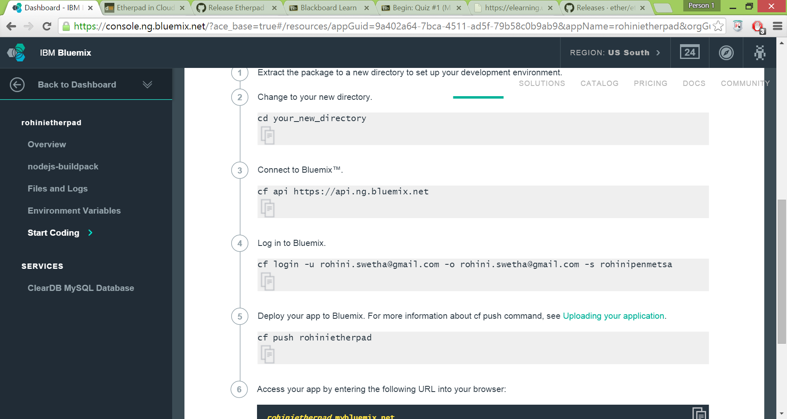

Use cf s to share the space which you have registered.

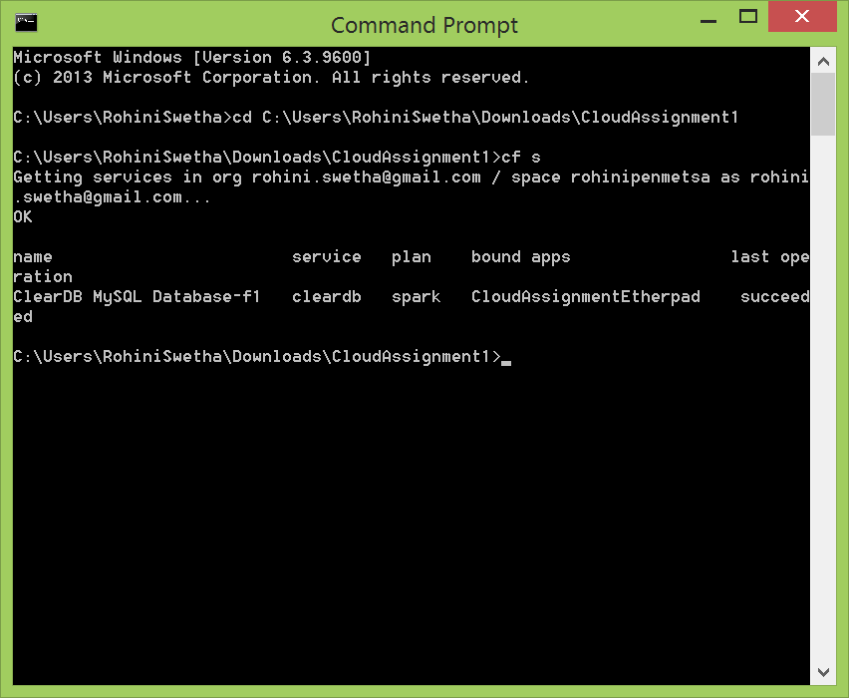

Use the cf domains command to view all the domains under your name. Use the command – cf push rohinietherpad -m 512M -b https://github.com/cloudfoundry/nodejs-buildpack.git

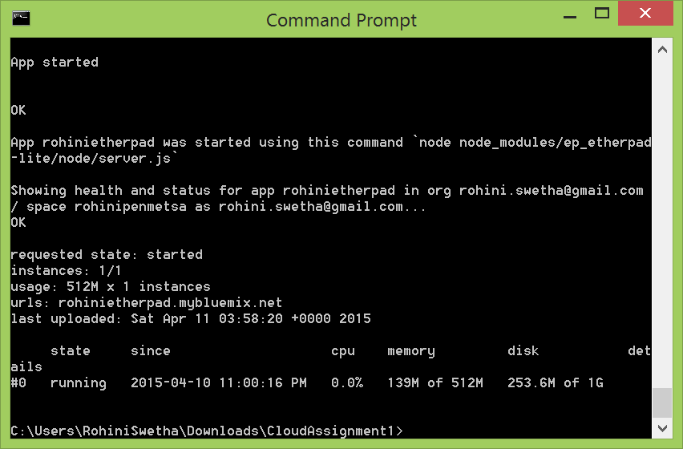

A service is to be added to the application. Click on add a service and scroll down to find the data management area which has the required database for the app which ClearDB MySQL Database. Select it. A dialogue box with auto filled fields is shown. Click create. You will be asked to restage the application. Click yes for it.

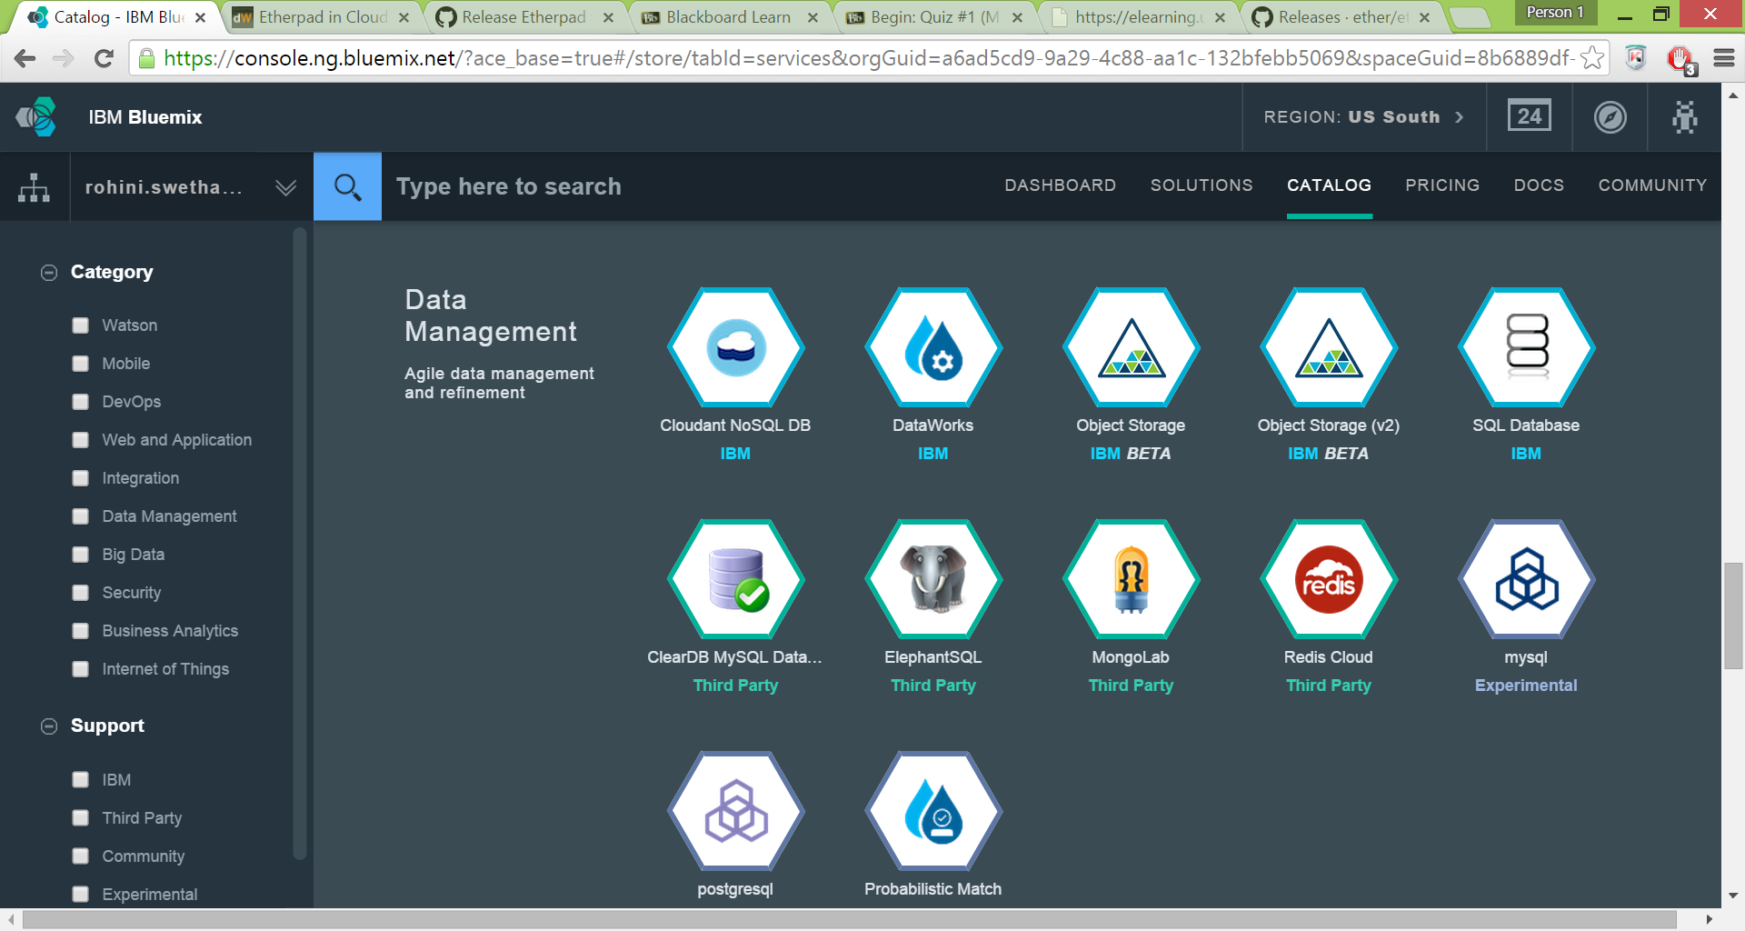

To bind the database with the application, open the settings.json file and change the value as shown below:

The dbservice value needs to be changed to the value which is there in the configurations part of the database in the bluemix UI.

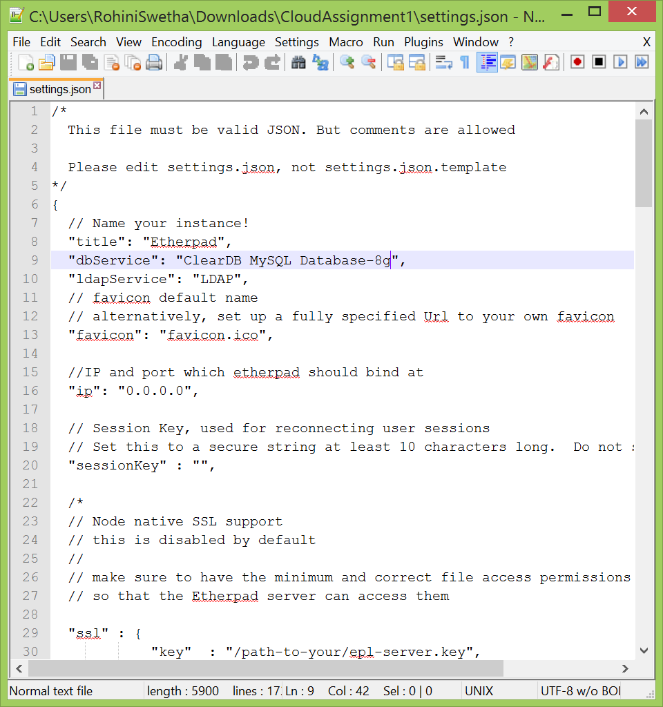

Now, since we made changes, the application package has to staged and deployed. The command specified above has to be used again to do so.

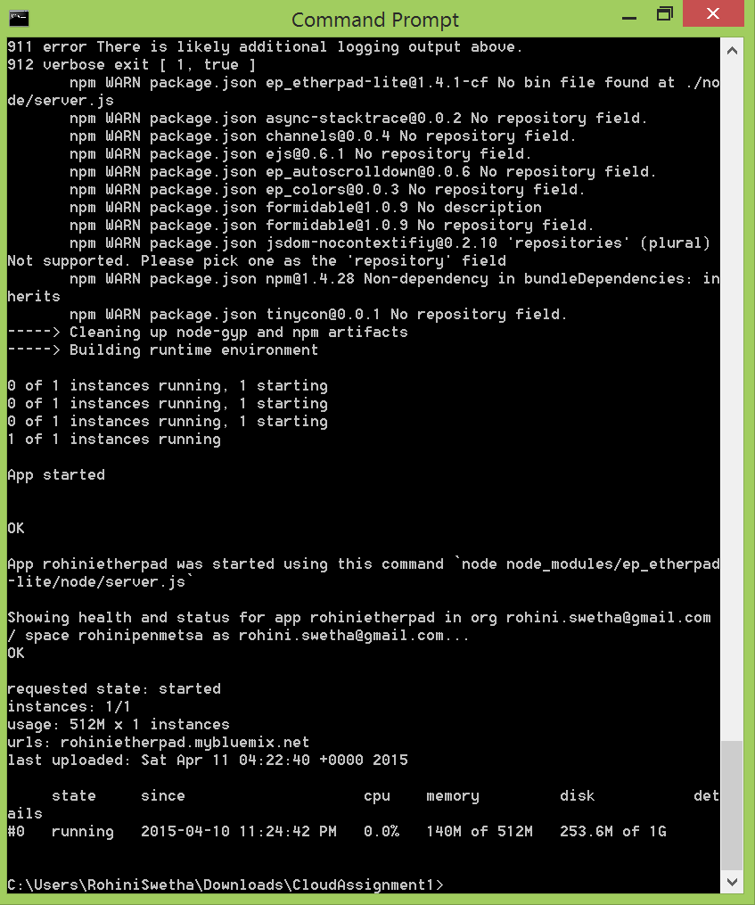

Using the url specified in the bluemix url, we can access the application.

