Lab#3: Openshift

* Launch an instance from the publicly available image in the amazon ec2.
* Launch putty with the public ip and the key.
* First start the openshift service:

openshift start --listenAddr="0.0.0.0:8080" in one terminal.

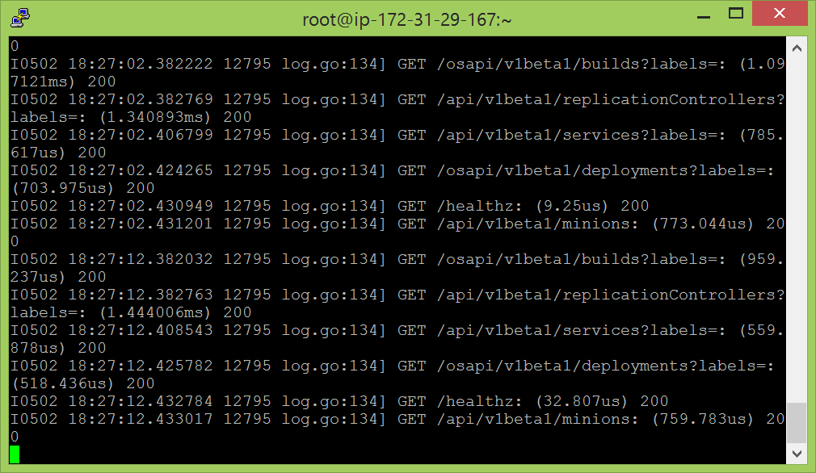

* Open a duplicate session and generate a webhook:

lab_generate_webhook

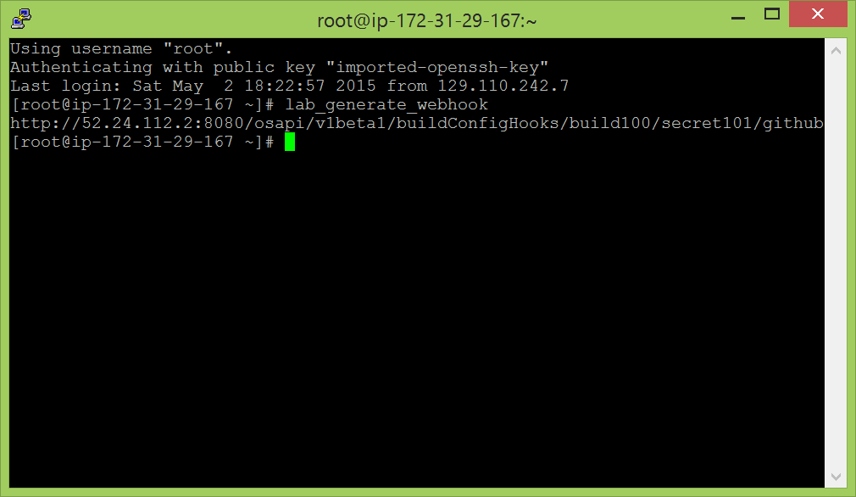

* Now, open the link given in the lab exercise:

<https://github.com/openshift/ruby-hello-world> in a web browser.

Fork the application to your own github accountcreate an account if you do not have one].

Then go into settings, webhooks and add the payload url. This url is from the generate url command from our terminal. Copy it here and generate webhook.

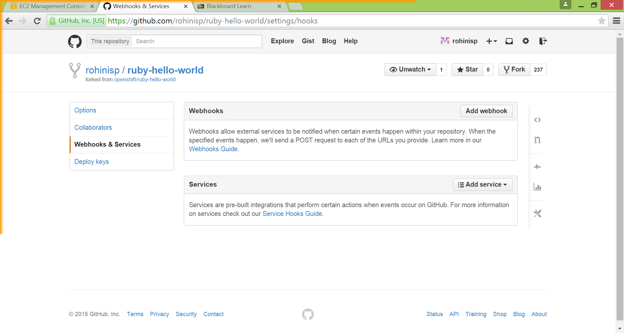

http://52.24.112.2:8080/osapi/v1beta1/buildConfigHooks/build100/secret101/github

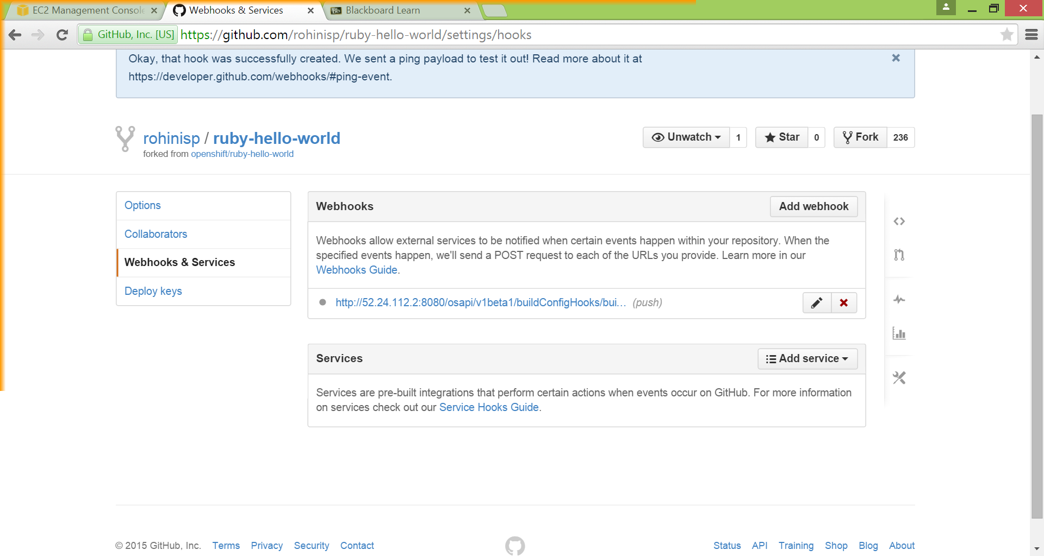

* Openshift is useful to automatically build docker and run the services from the previous labs.
* Run the config which contains the kubernetes service and controllers using:

openshift kube apply -c registry_config/registry_config.json

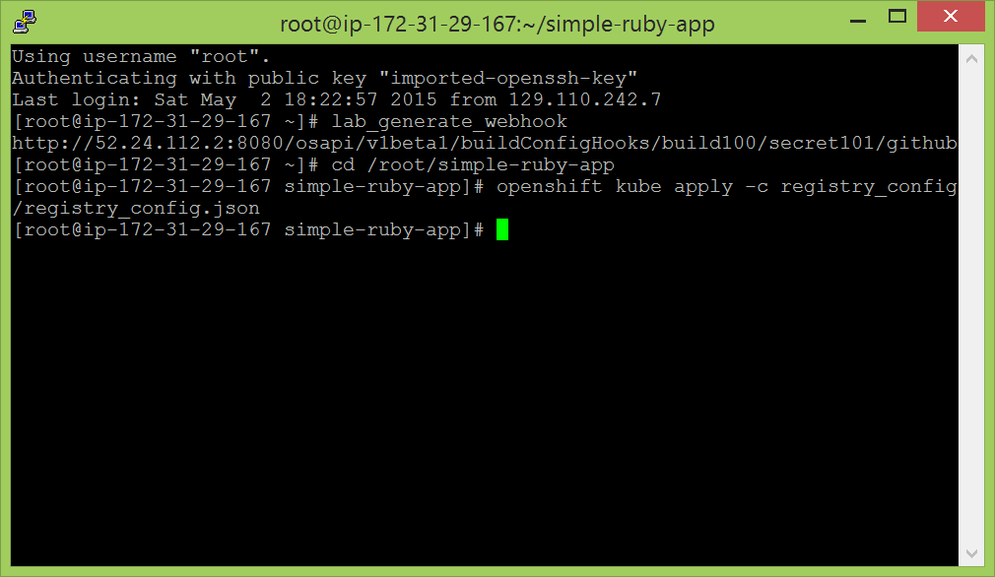

The first terminal still shows the following logs:

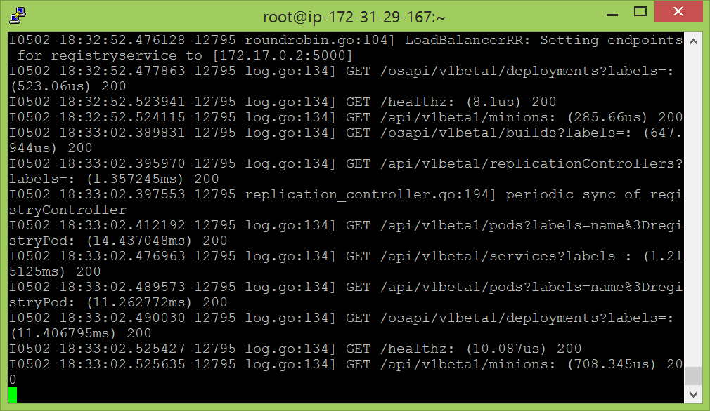

* To check the list of pods:

openshift kube list pods

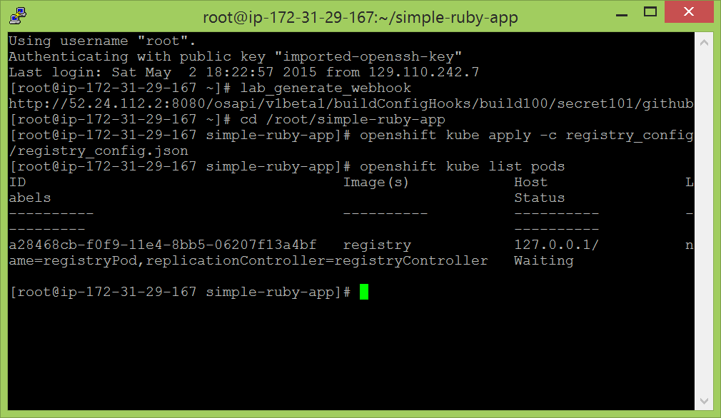

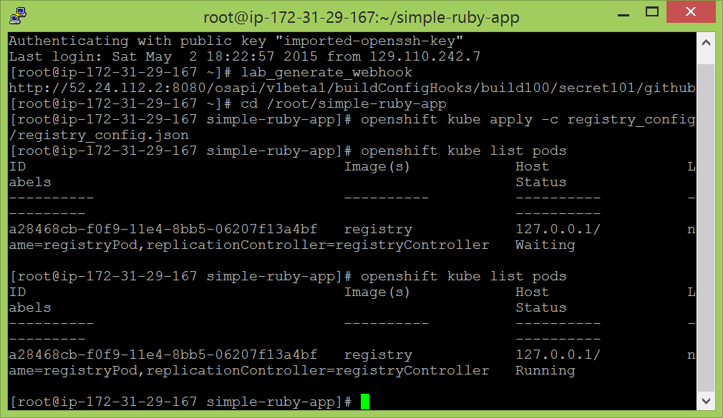

* When the registry is running we move ahead and open the build config file and change the path present in the sourceURI field. The new path should be the path of the application which has been forked to your account:

vi buildcfg/buildcfg.json

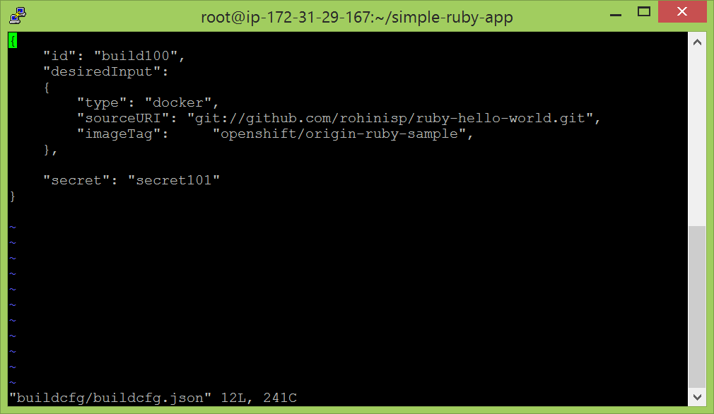

* To create and implement the build config file:

openshift kube create buildConfigs -c buildcfg/buildcfg.json

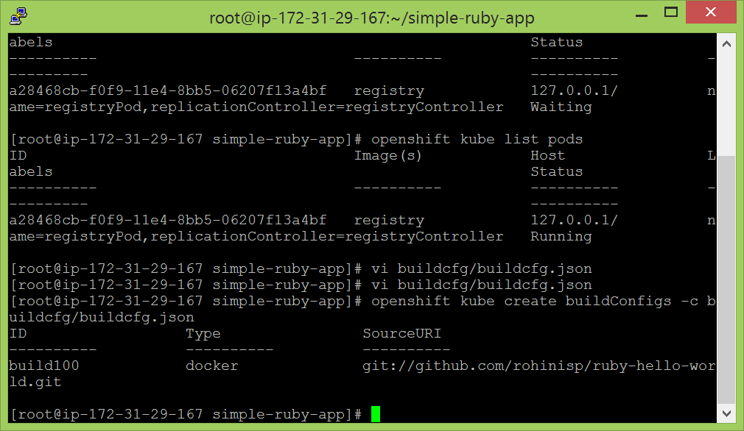

* To list all the buildconifgs that have been created:

openshift kube list buildConfigs

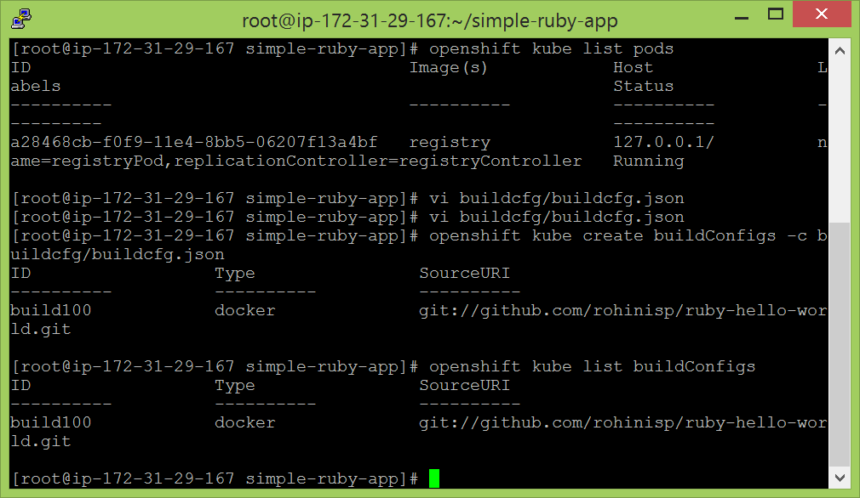

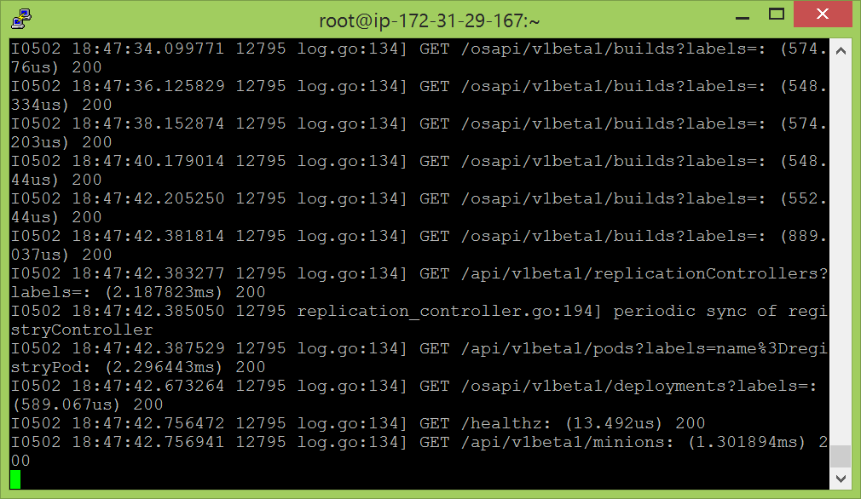

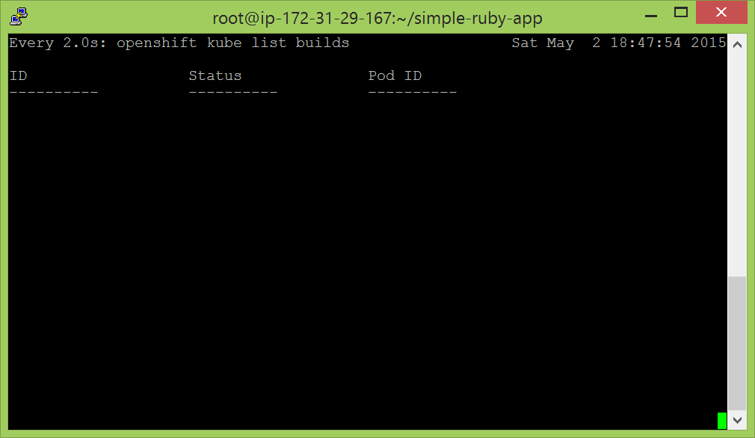

It doesn’t show anything as there haven’t been any created yet. These are created when any modifications have been made. So, I came out of the watch list and made some changes to the app.rb file in github account and committed the changes. Then, we can see in the following screenshots:

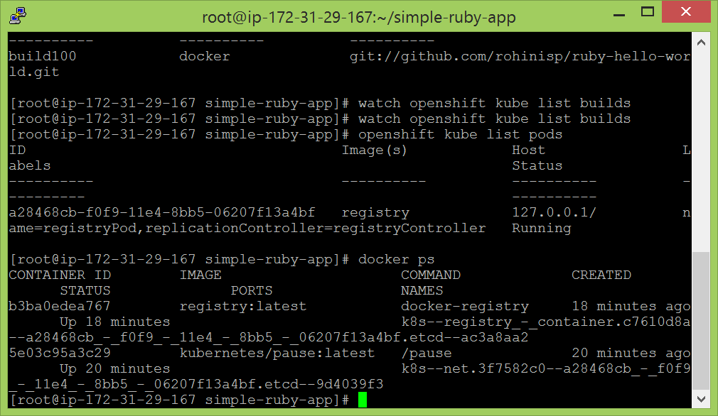

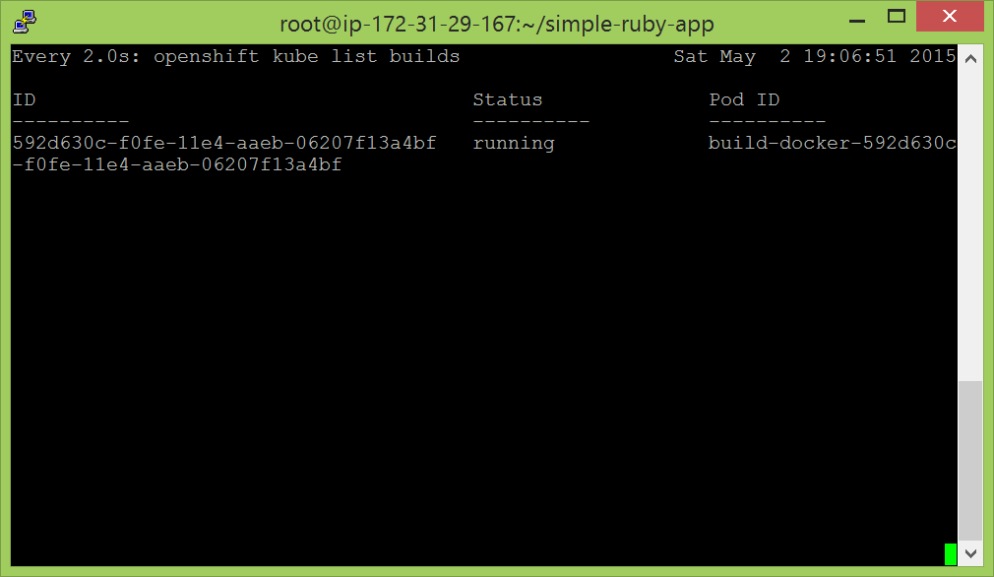

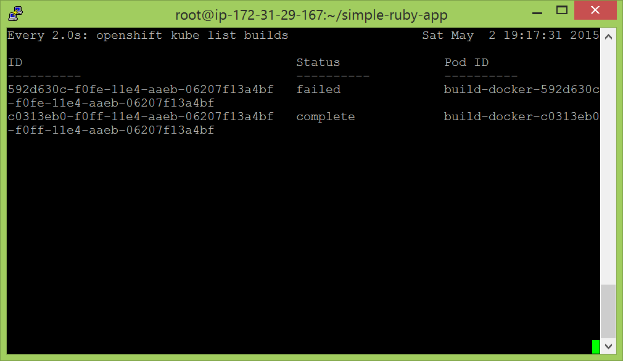

* When the status changes to complete we are supposed to find an image related to our build. I could only find that there is a new container which is created but then there is no image being created.
* curl -XGET http://${DOCKER_REGISTRY}/v1/search

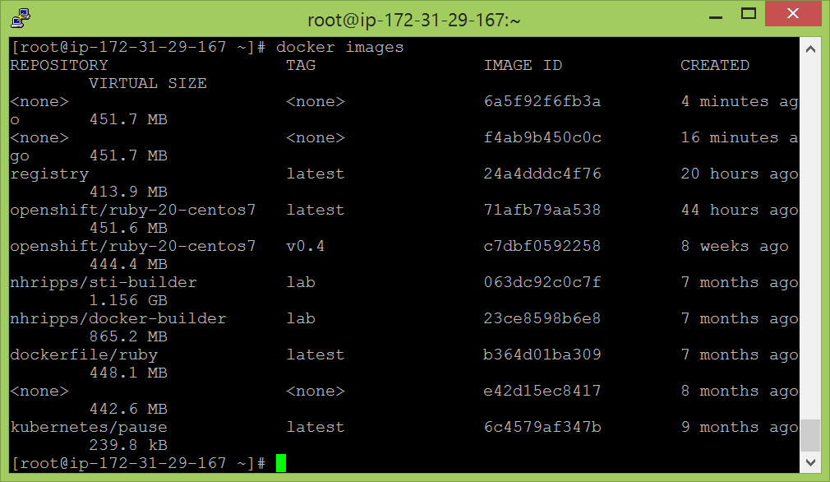

echo $DOCKER_REGISTRY

“172.31.29.167:5000

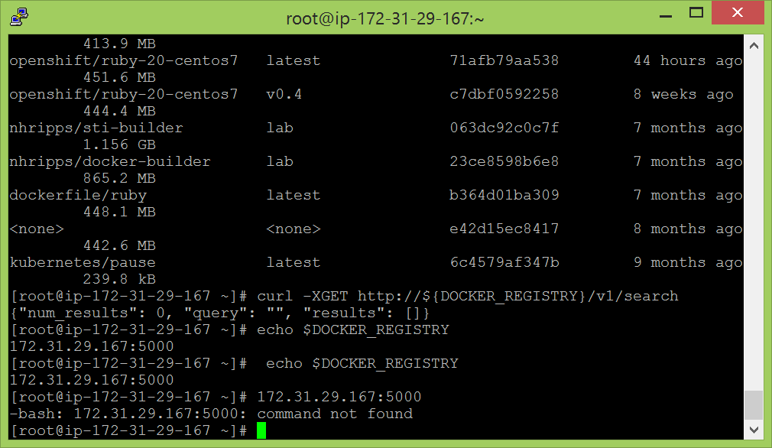

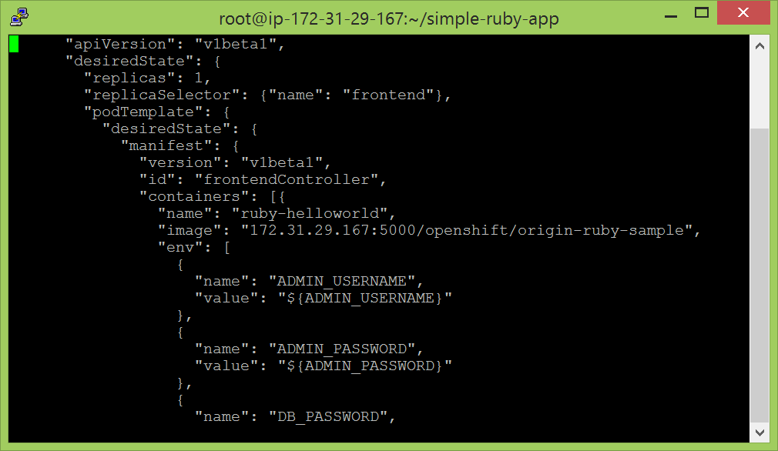

The image is not getting created after trying all the ways which were discussed. I tried creating a new instance. Terminated and restarted again but nothing worked. According to a discussion in the forum, I even tried creating a new application in my github account, it didn’t work either.

So, tried in my team mates laptop and accounts, it worked without any big glitches. The screenshots are attached below:

**Module 1: Set Up Source Code in GitHub**

**1. Launch OpenShift**

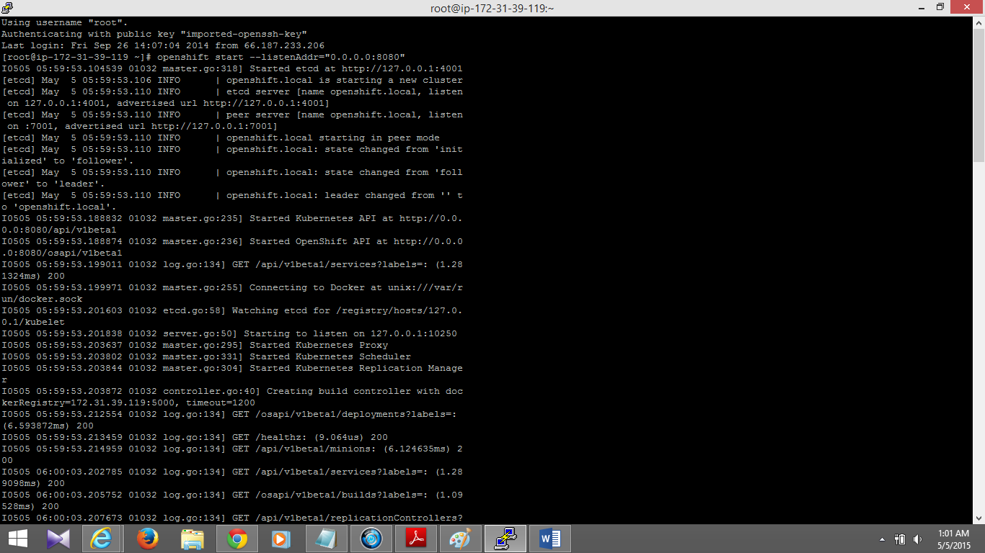

**2. Fork the Application Code**

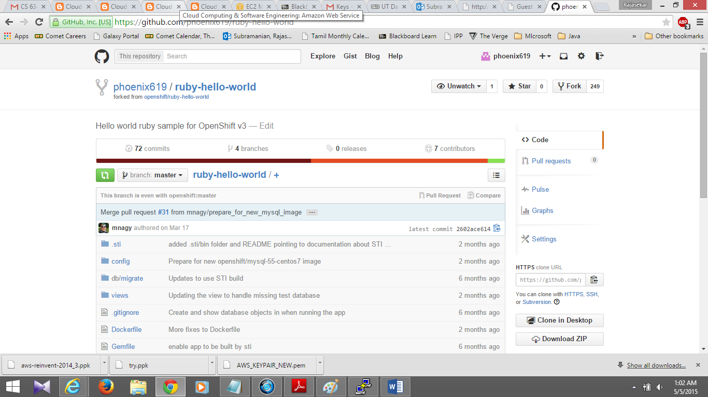

**3. Set up a Webhook for this Source Code**

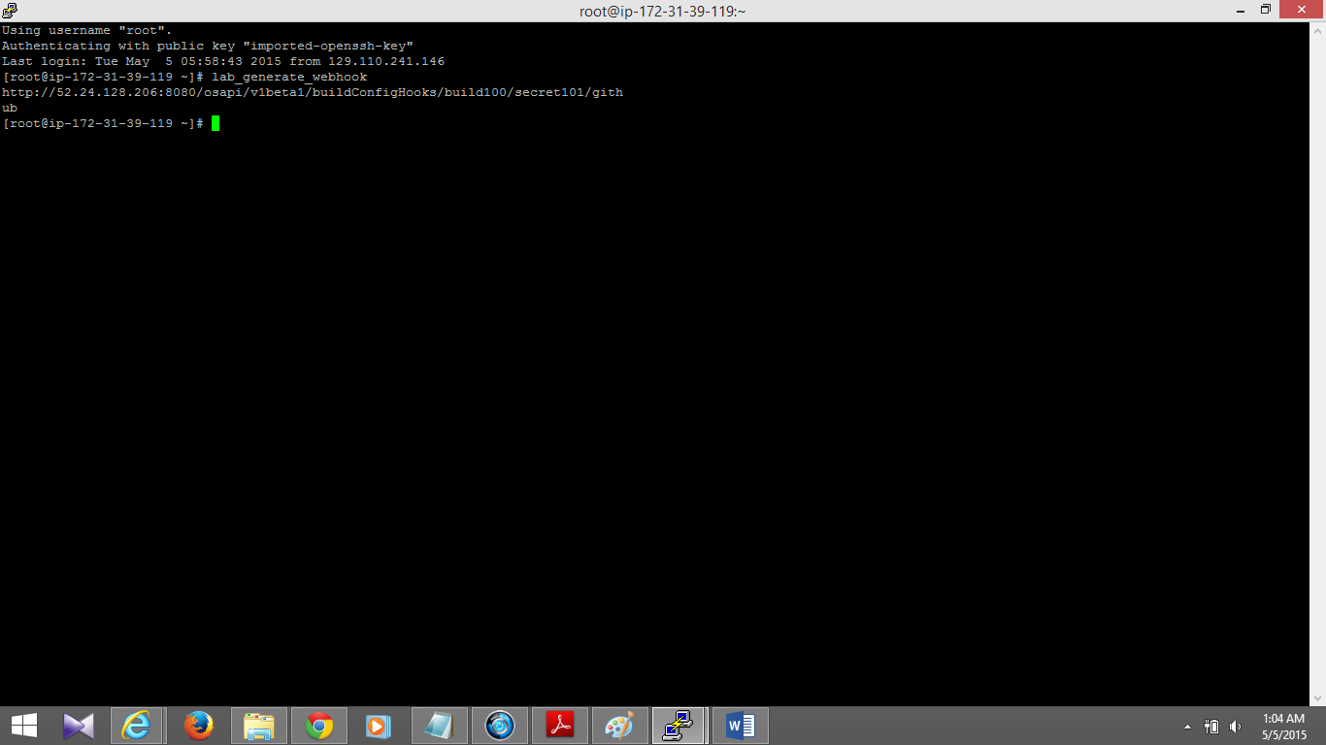

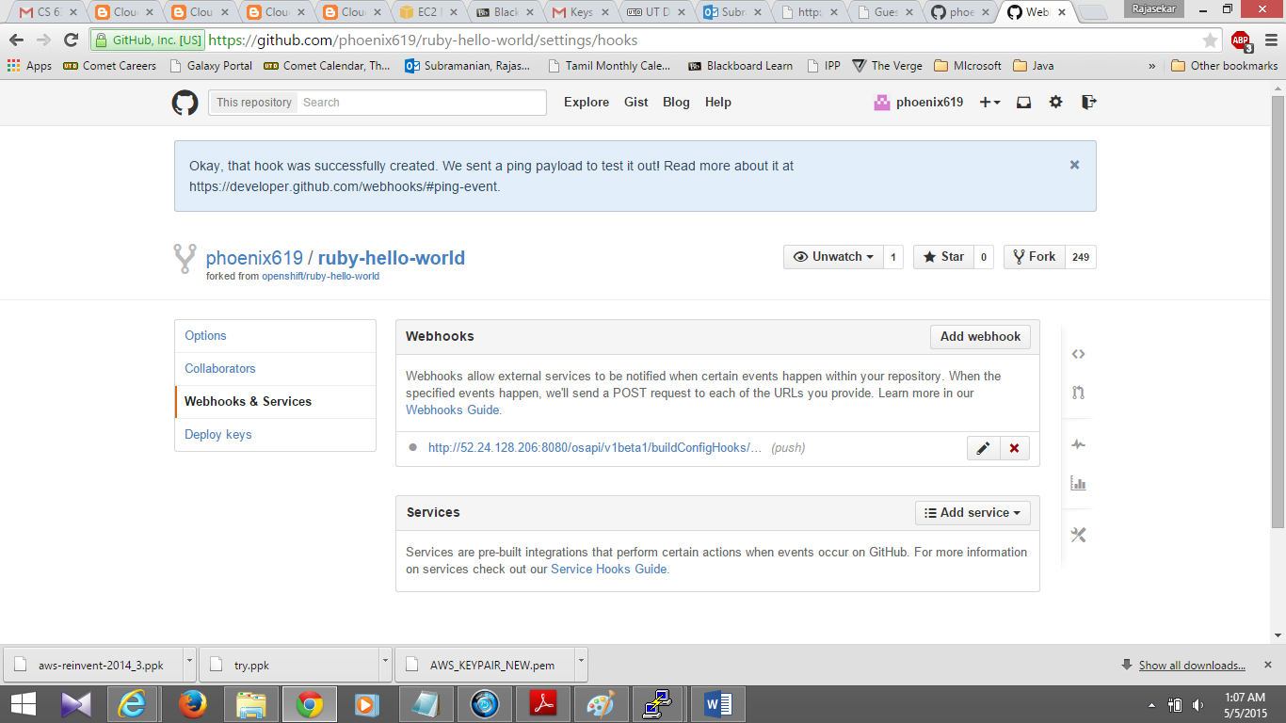

**Module 2: Getting Under the Hood of OpenShift 3**

**1. Start a Private Docker Registry**

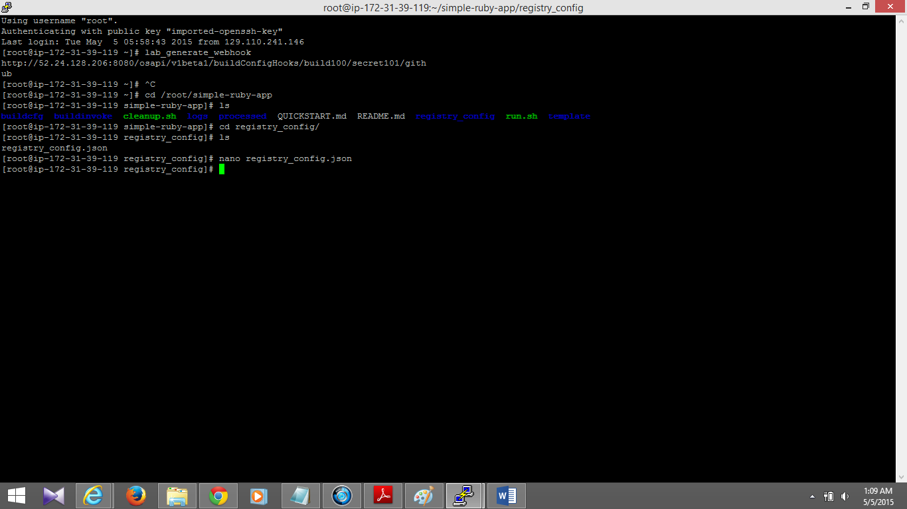

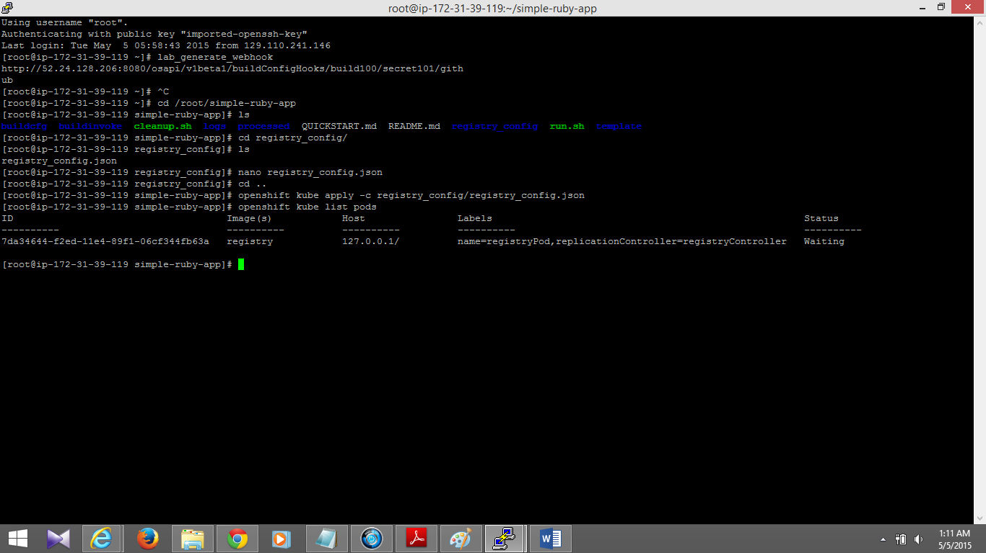

**2. Define a Build Configuration**

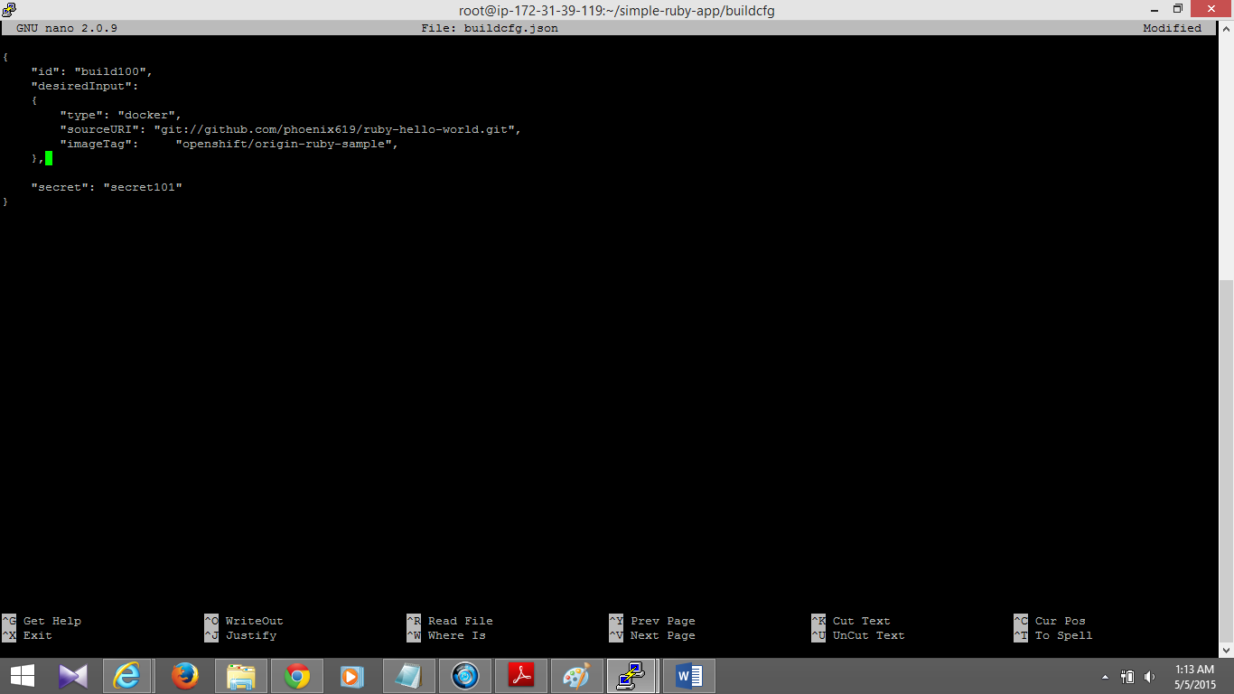

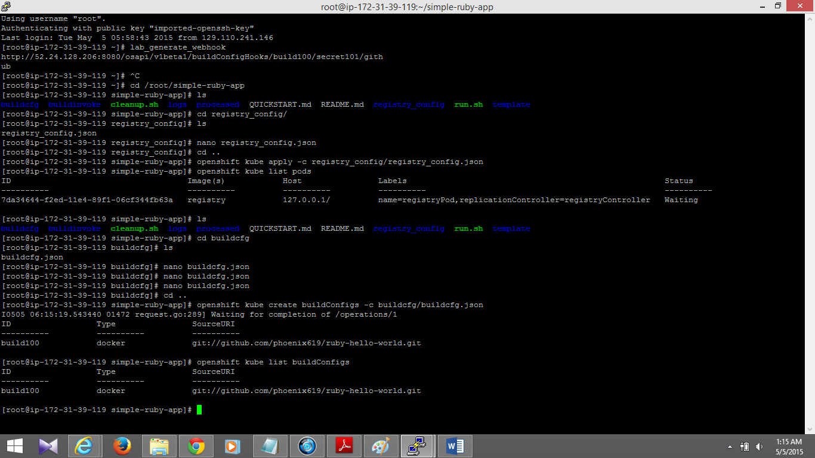

**3. Trigger a Build of Your Application Image**

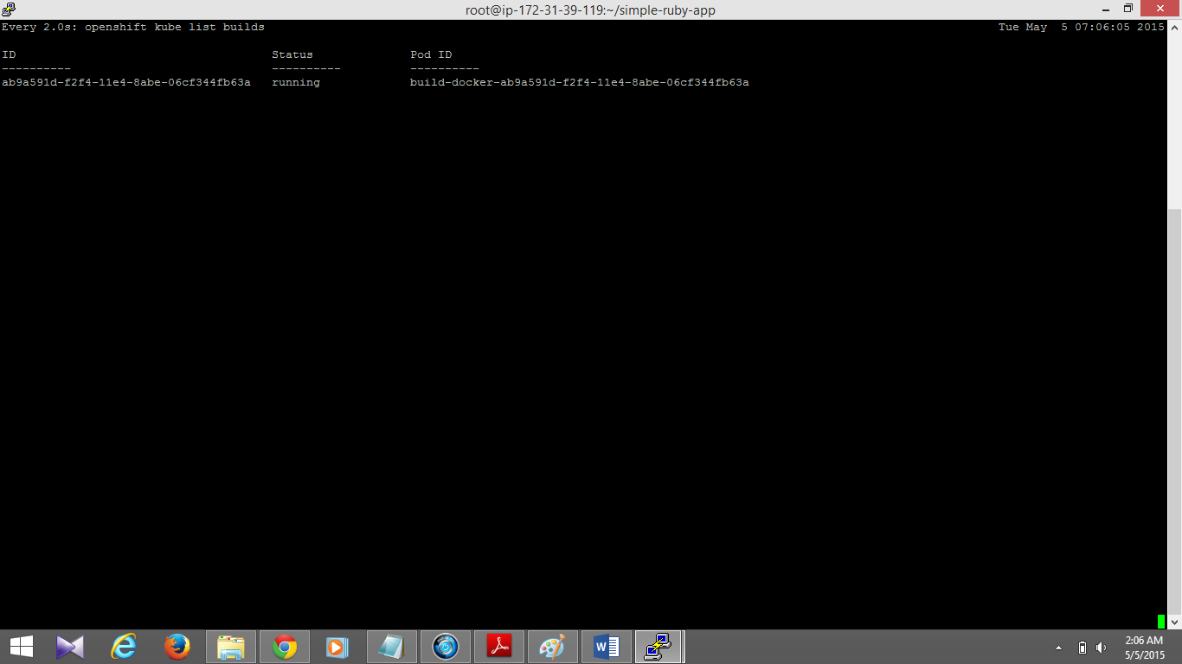

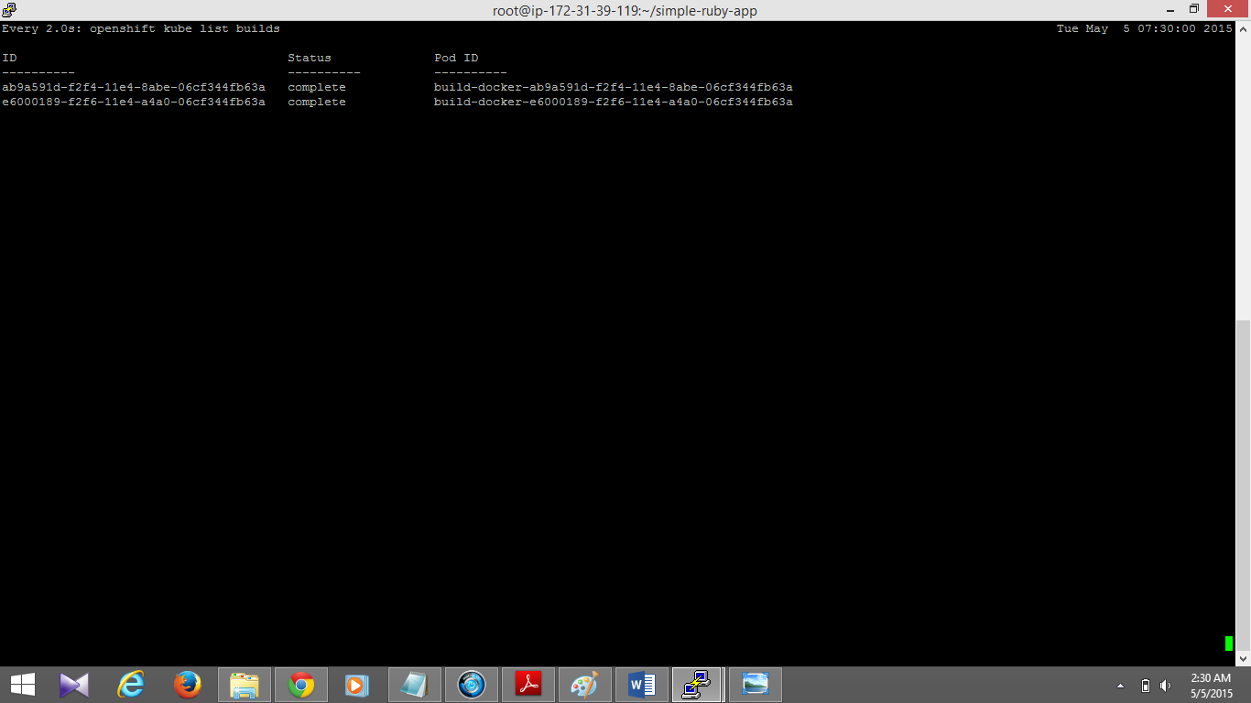

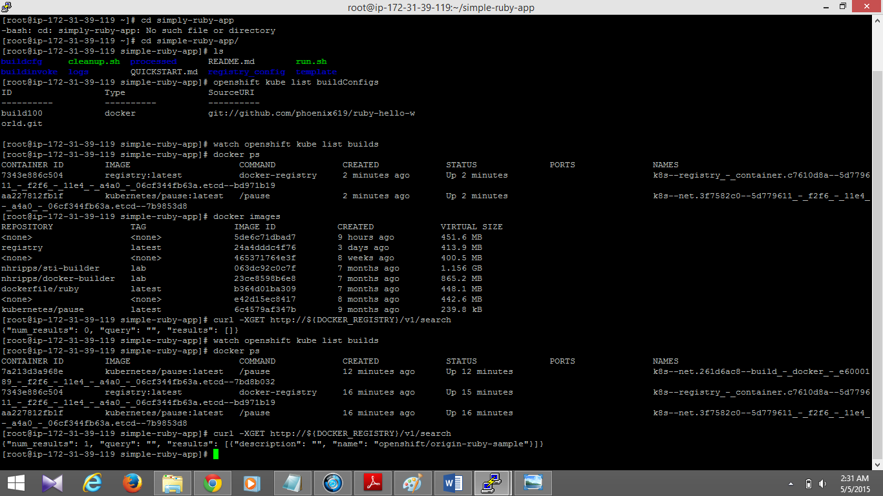

**4. Configure and Launch an Application**

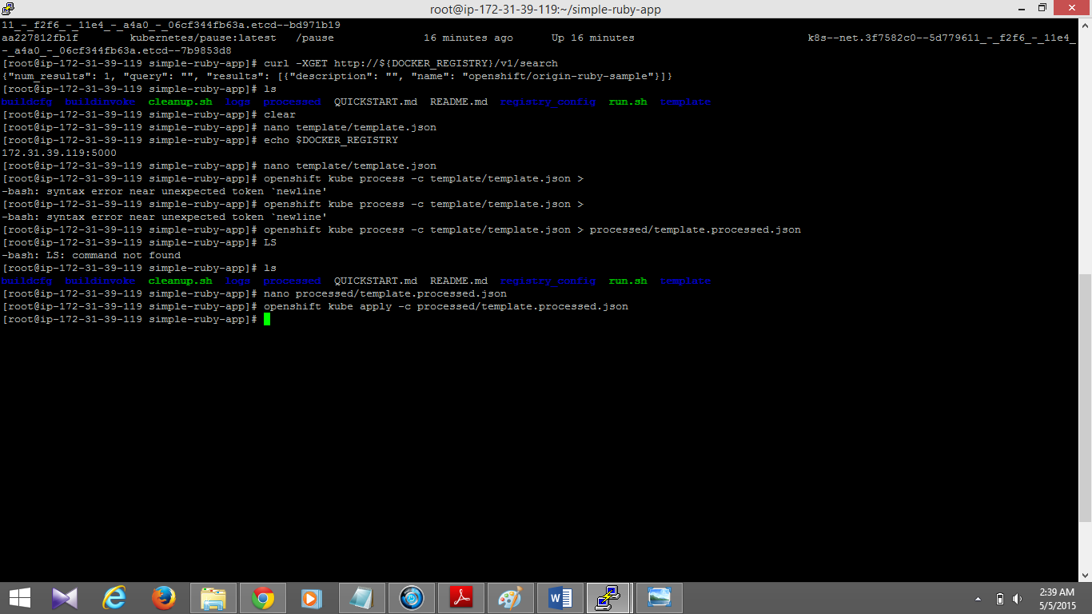

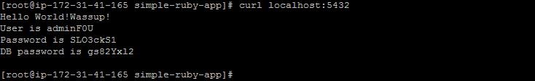

**Module 3: Redeploying with an Updated Image**

**1. Make Another Code Change**

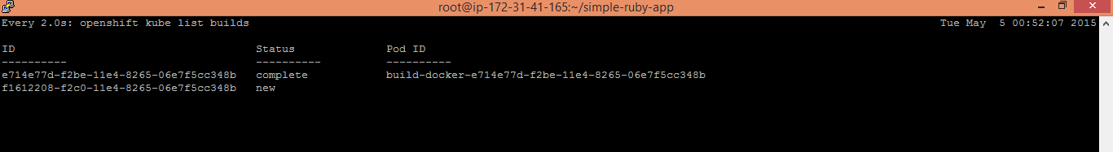

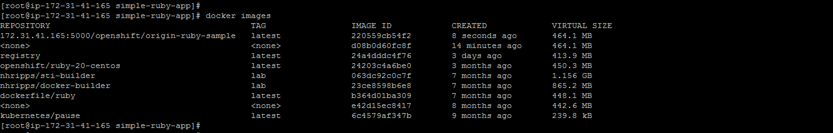

**2. Trigger the App Redeployment**



