Lab #1: Docker

* Install putty. Using the public ip and the key, open a terminal.
* Now, install docker with:

sudo yum –y –q install docker

* Searching for docker images in the hub:

sudo docker search fedora/apache

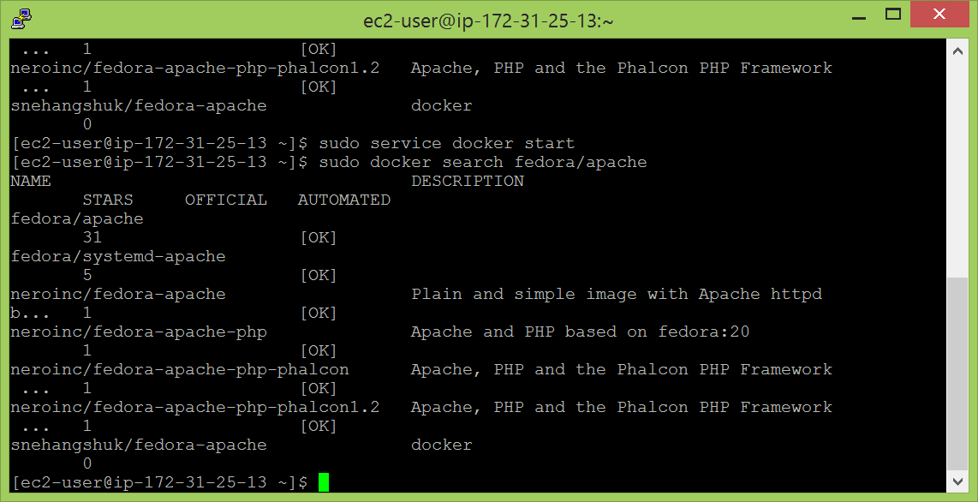

* To download all the required related software for docker:

docker pull fedora/apache:latest

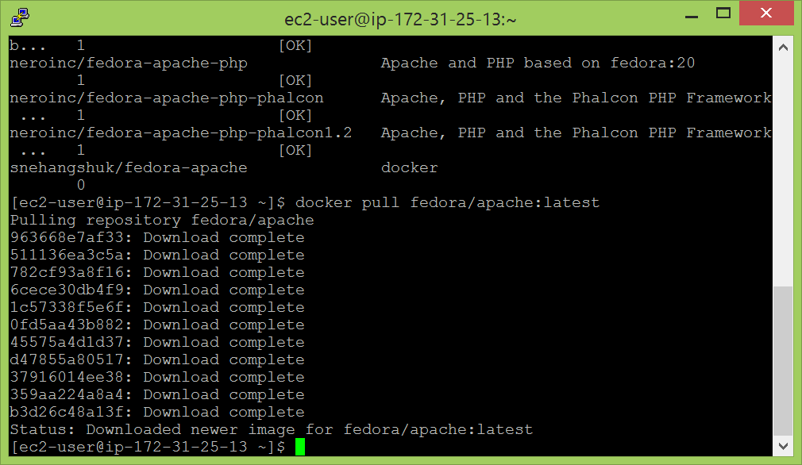

* To check the history of the downloads and the changes made:

docker history fedora/apache

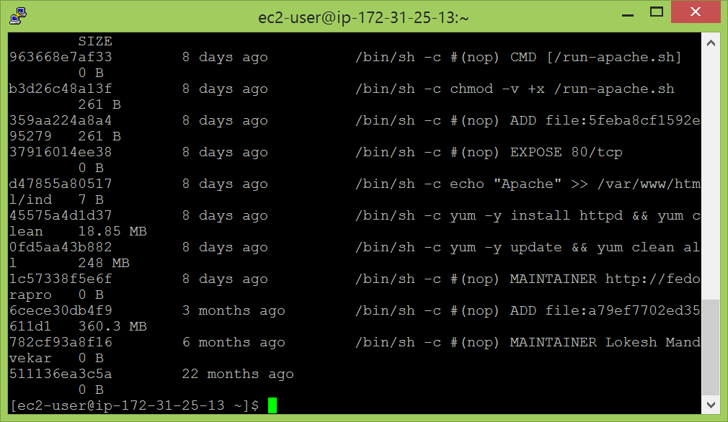

* Locally available docker images can be listed using:

docker images

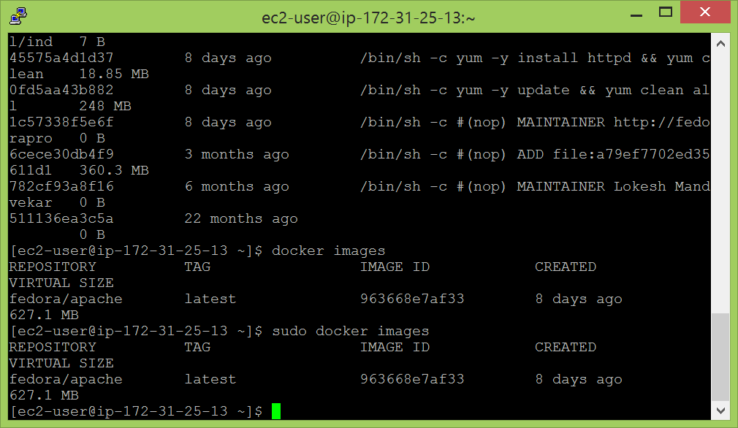

* To check the containers which are running:

docker ps

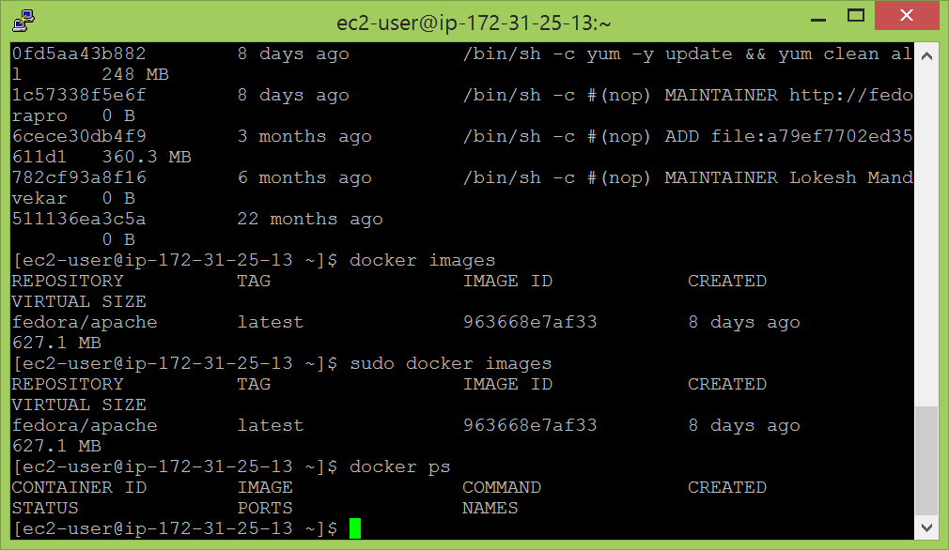

* To run the docker:

docker run -i -t fedora/apache /bin/echo 'hello world'

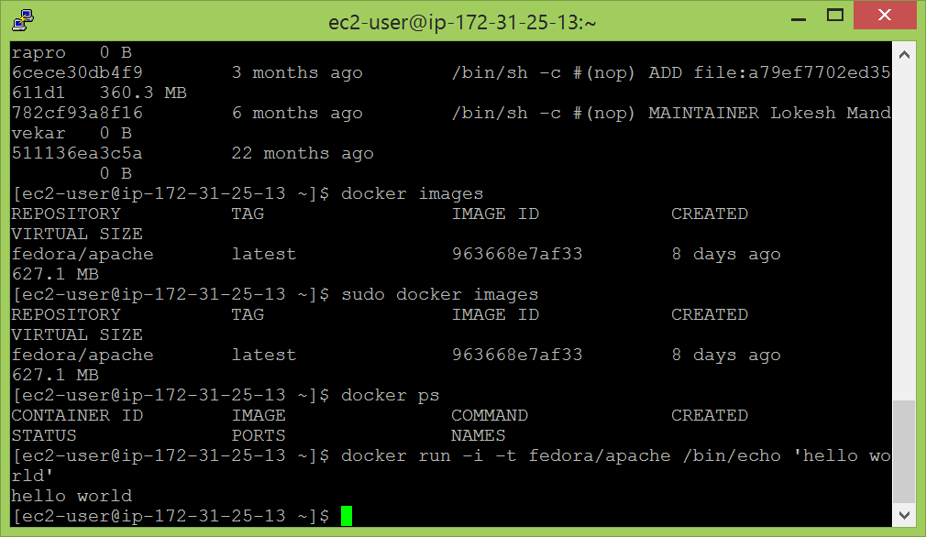

* To list all the containers which have been run last:

docker ps –l

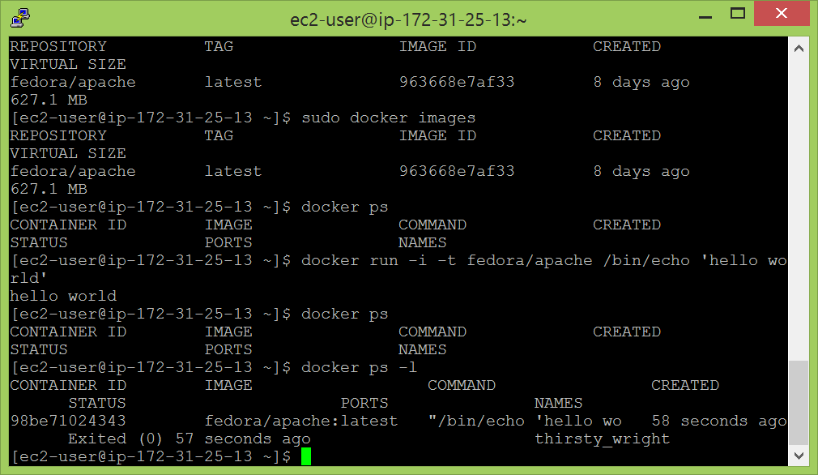

* An image was created by running the previous command. Now, we want to run apache service and start serving web content:

docker run -d -P fedora/apache

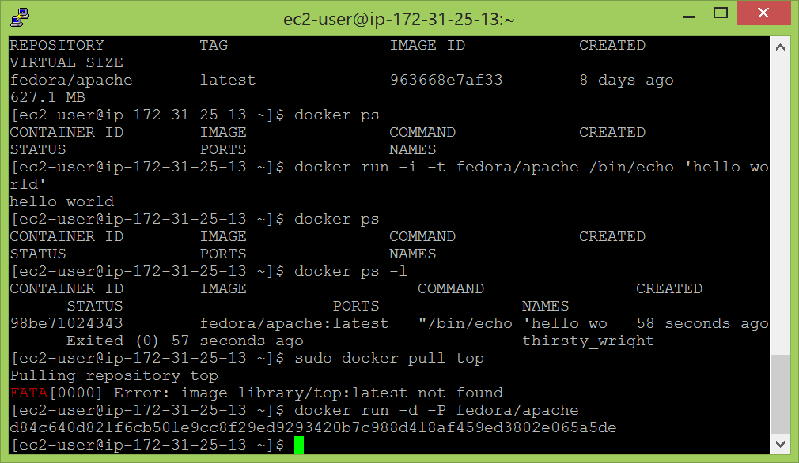

* To make sure that the connection between the input port to apache is intact:

curl -v 0.0.0.0:49153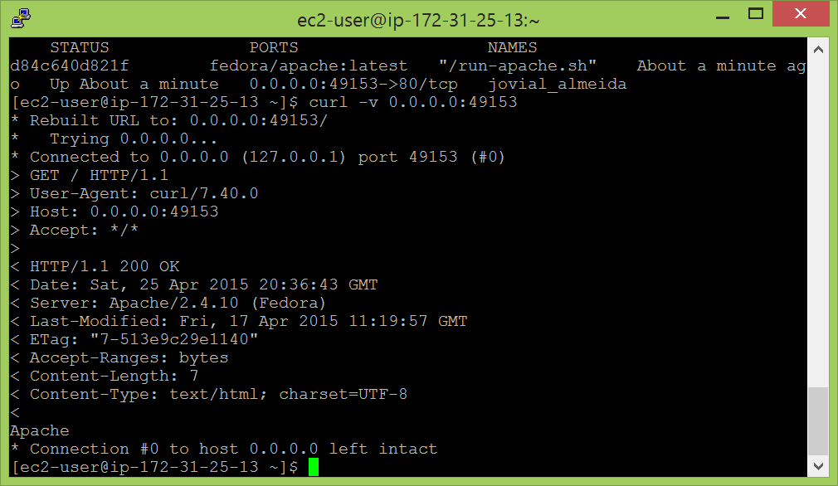

* To kill a docker image which we have started running:

docker kill jovial_almeida

We can also use the container ID to do the same.

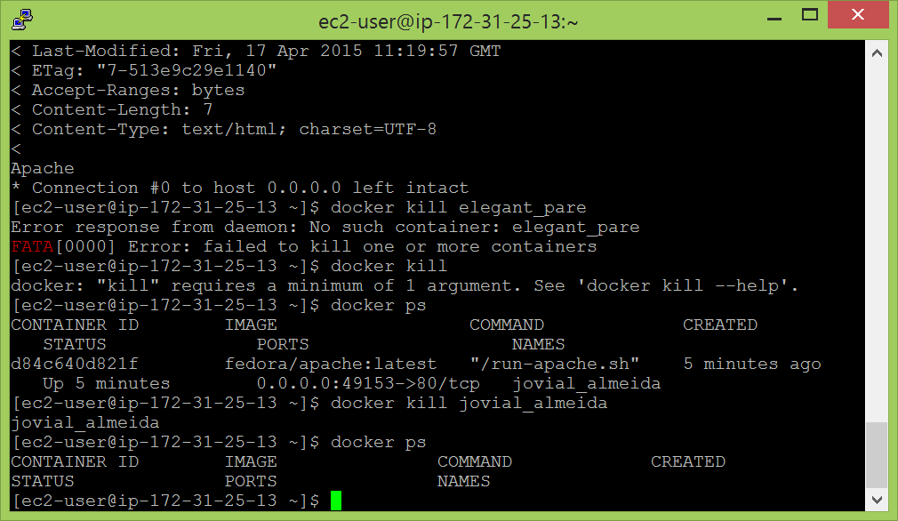

* To make my own image with the docker file:

$ mkdir nano-pg

$ cd nano-pg

$ touch Dockerfile

$ nano Dockerfile

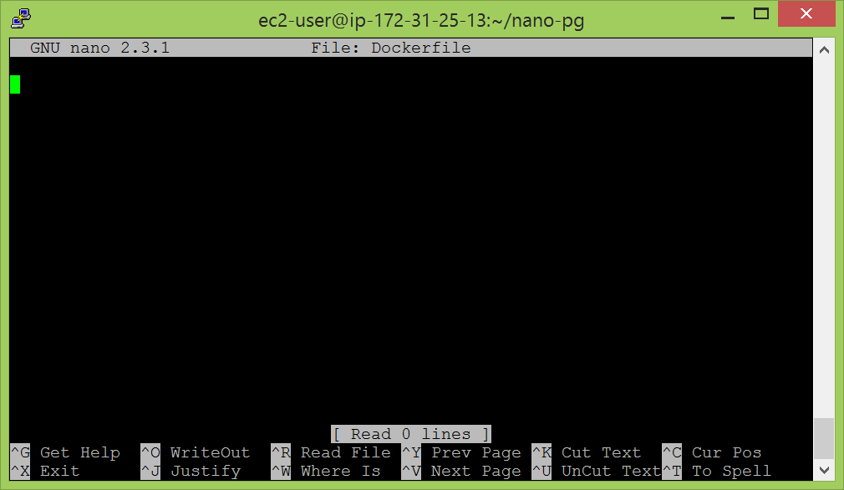

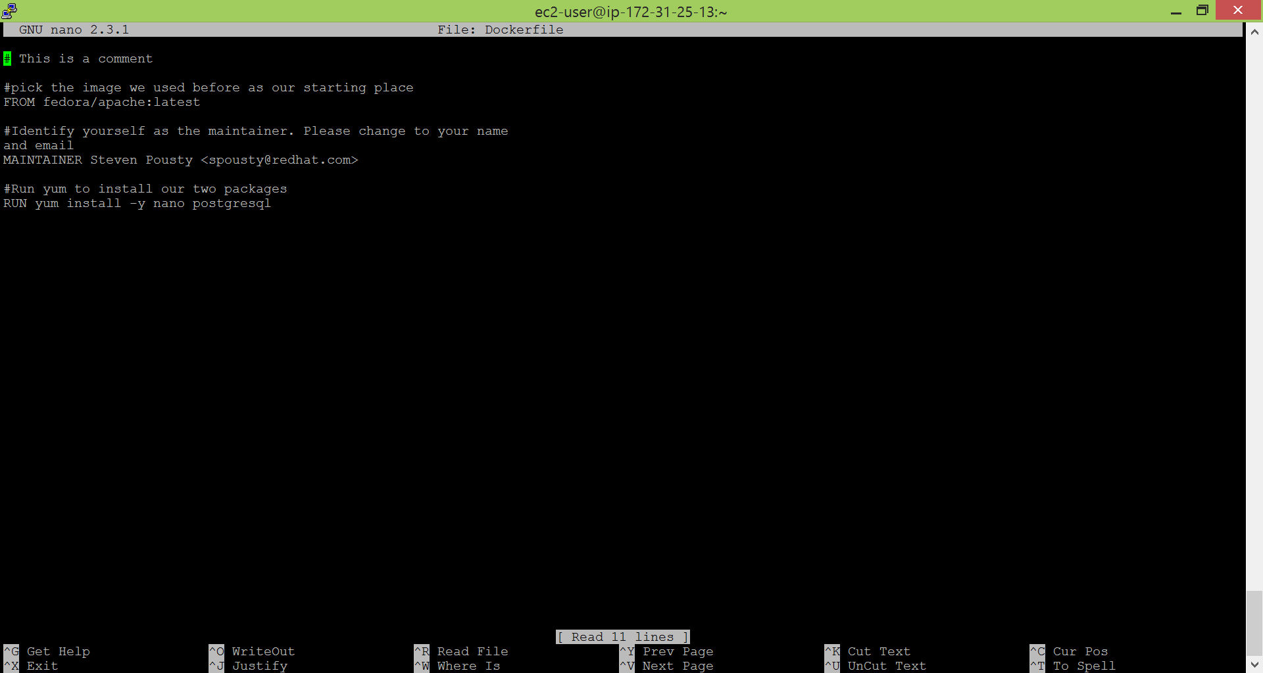

* We can make some changes in the file and customize it to create our own docker image. Then, to build the image from the file, we use:
* Usually to build an image from a file:

docker build -t "spousty/myfedora:1.0" .

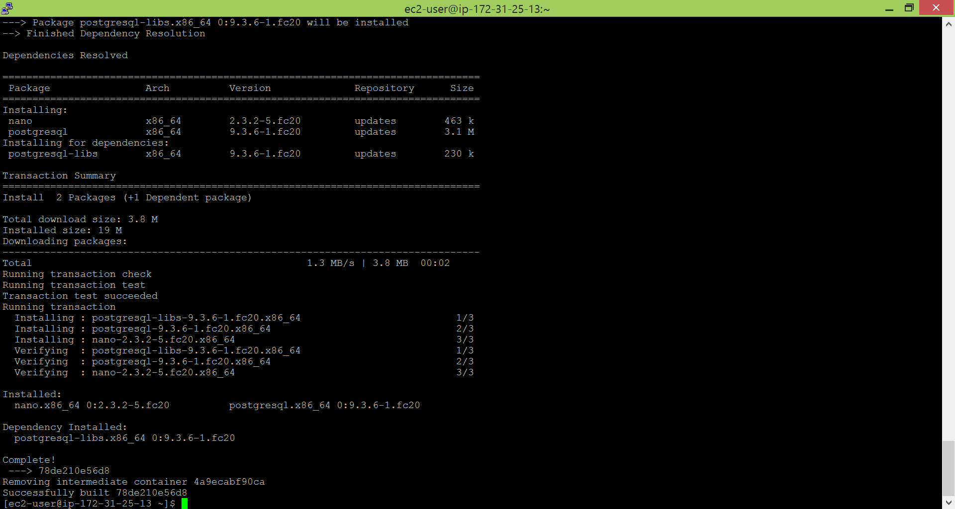

* Image is built. Now, it has to be run. So, we use:

docker run -i -t spousty/myfedora:1.0 /bin/nano

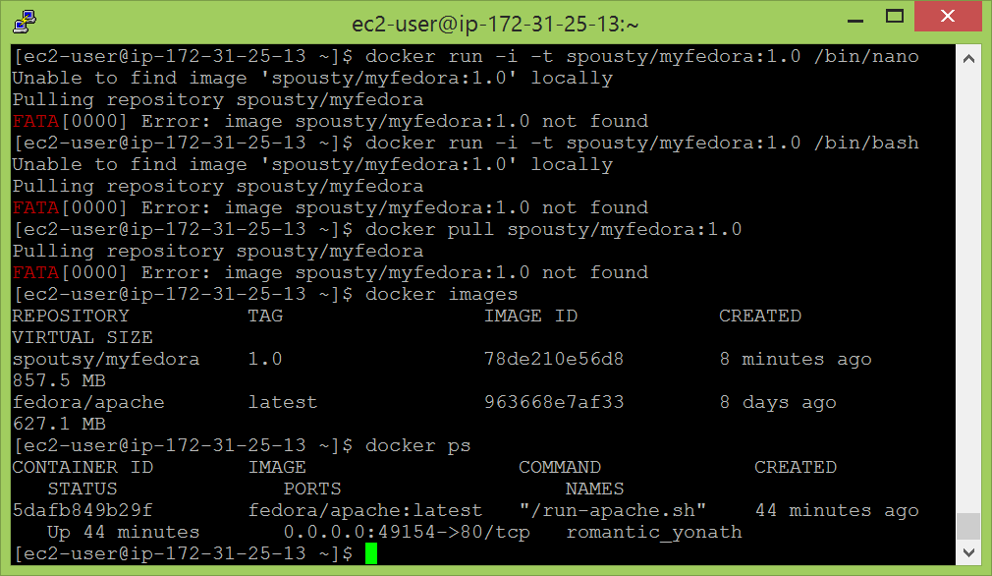

* I used the image ID to run the image than using the name as I encountered issues with using he name of the image which can be seen in the screenshot above.

docker run -i -t spousty/myfedora:1.0 /bin/bash

* Making own docker images by making changes in the container:

docker run -i -t 78de210e56d8 /bin/bash

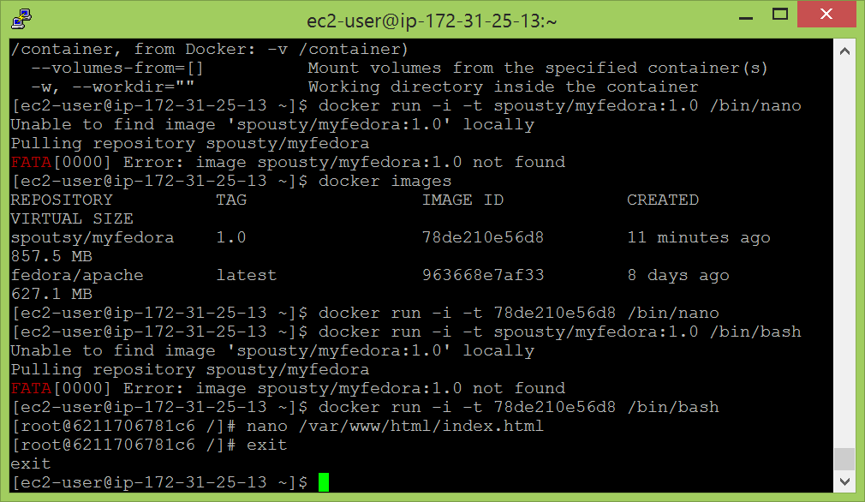

* Using nano we make changes to a file and then follow the above steps to get an image running. The changes are to be then committed.
* To enable inter container communication, the following steps are to be implemented. To spin up an image for the database, we use:

docker run -d -P --name db training/postgres

* To make the connection:

sudo docker run -i -t --name web --link db:postdb

* To check the environment variables:

env |grep POSTDB

* To test the connection:

psql -h postdb -p $POSTDB_PORT_5432_TCP_PORT –V

psql -h postdb -p $POSTDB_PORT_5432_TCP_PORT -U docker

docker=# \db

