POWER BI PROJECT REPORT
(OE-BBA A13)

Prepared for: Dr. Vinay Ch



SCHOOL OF Engineering & Technology
CSE 2nd year
SRM University AP,
Mangalagiri Mandal,
Guntur – 522502

Report By:
U. Rohini || AP23110011253

Submitted on
28-04-2025

TABLE OF CONTENTS

- Introduction………….…………………………………………….3
- Data cleaning………………………………………………………4
- Dashboard Development &
Story Telling ……………………………………..……………....5
- Dashboard-1.………………………………………………..…......6
- Dashboard-2…………………………………………………….....8
- Dashboard-3……………………………………………………....10
- Dashboard-4……………………………………………………….13
- Conclusion…………………………………………………….......15

INTRODUCTION:

The review analysis was performed on a sample of 1 lakh reviews randomly obtained from a database of over 1 crore reviews on Glassdoor(data). Using Power BI, we created interactive dashboards to help identify relevant insights related to company review ratings, employee sentiments, CEO approval ratings, and job satisfaction trends on various companies and years. Glass door data is doing good work it is helping people to find right job at right time.
In todays world like after pandemic it has became difficult to get job unless you are highly skilled. So in this analysis and making of dashboard I tried to visualize as much as I can I think you may like it.

DASHBOARD 1: Consists of “Overview

DASHBOARD 2: Consists of “Culture Scorecard”.

DASHBOARD 3: Consists of “Leadership Insights”.

DASHBOARD 4: Consists of “Sentimental Deep Dive”.

Data Cleaning :

In this data cleaning process I have did some important steps to clean data and make use of it very precisely by using Power Query Editor.
- Removed Duplicates:
- There are some columns which are repeated. So I have removed that.
- Removed Empty Values:
- There are some columns which does not have any meaning. I have removed that columns.
- Filtered Out NULL Values
- Split some columns:
- In this dataset status and experience variable combined so I split it with option split columns by delimeter.
- Extracting:
- Extracted the firm name from column firm link using Extract option in Power Query.
- Conditional Statements:
- Created column Reviews using Conditional Column by if else statements.
- If rating is 1&2 then it is Negative
rating is 3 then it is Neutral
rating is 4&5 then it is Positive
- Extracted pros and cons length

Dashboard Development & Story Telling:

The Power BI dashboard was developed to provide a deep, insightful look into how employees experience their workplaces across a range of companies. Drawing from over 1,000 employee reviews from organizations like Amazon, TCS, HP, McDonald’s, and Walmart, the dashboard captures key metrics such as sentiment scores, average ratings, CEO approval rates, work-life balance, and cultural values. The data showed an average employee rating of 3.64, with positive and negative sentiments fairly evenly split. Using visual tools like bar charts, line graphs, donut charts, tables, and a vibrant word cloud, the dashboard paints a clear picture of employee satisfaction trends, leadership influence, and how workplace culture evolved between 2021 and 2023.
The story the dashboard tells begins by highlighting the overall sentiment among employees — a landscape where positivity and negativity are finely balanced and ratings have remained steady over time. Companies like Amazon and TCS emerge as strong performers with solid ratings and encouraging business outlooks, while firms such as Accenture and Infosys are praised for fostering a healthy work-life balance. A key takeaway is how important leadership is: high CEO approval scores closely align with positive employee sentiment and a bright view of the company's future. Delving deeper, the word cloud analysis reveals that employees often speak highly about opportunities for growth, a supportive environment, and strong management — but they also voice concerns about compensation, workload, and management practices.
In the end, the dashboard doesn't just present numbers — it offers actionable lessons for organizations looking to improve. It emphasizes the need for strong, transparent leadership, fair and competitive compensation, and a continued focus on work-life balance and company culture. Regularly listening to employee sentiment can help companies address issues early and maintain a healthy, productive workplace. By combining data-driven insights with a human understanding of what matters most to employees, the dashboard becomes a powerful tool for any organization serious about its people and its future success.

DASHBOARD – 1:

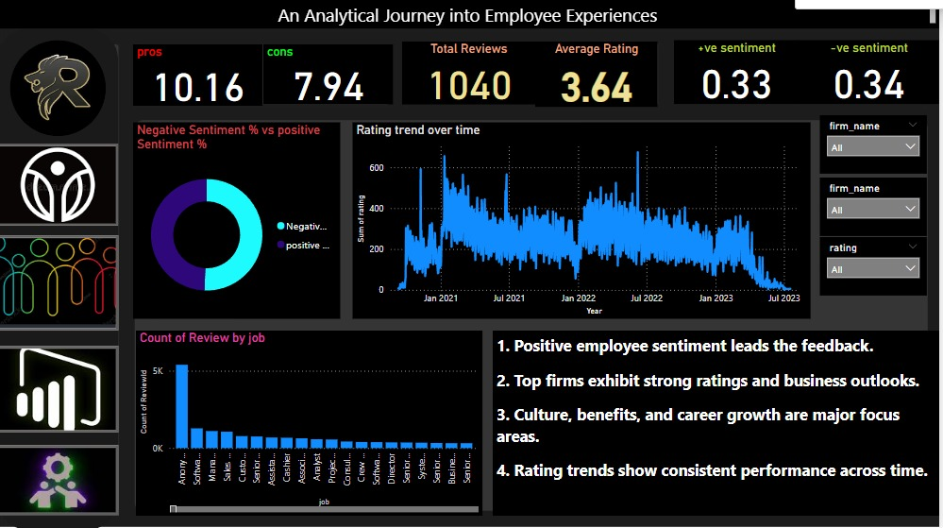
Used Charts and Visuals:
1. Cards / KPI Cards (Top row: Pros, Cons, Total Reviews, Average Rating, Positive Sentiment, Negative Sentiment)
- Type of visual: Card visual
- Function:
➔ Quickly shows important KPIs at a glance:
  - Pros count: 10.16
  - Cons count: 7.94
  - Total Reviews: 1040
  - Average Rating: 3.64
  - Positive sentiment score: 0.33
  - Negative sentiment score: 0.34
- Insight mentioned:
→ Overall employee experience summarized through key metrics.

2. Doughnut Chart (Negative Sentiment % vs Positive Sentiment %)
- Type of visual: Doughnut Chart / Pie Chart
- Function:
➔ Displays the proportion of positive vs negative sentiments from reviews.
- Insight mentioned:
→ Helps users immediately see that positive sentiment leads the feedback (as written in Point 1 at the bottom).

3. Line Chart (Rating trend over time)
- Type of visual: Line Chart
- Function:
➔ Shows how the Sum of Ratings changes across time (from Jan 2021 to July 2023).
- Insight mentioned:
→ Supports the conclusion that rating trends show consistent performance over time (Point 4).

4. Bar Chart (Count of Review by Job)
- Type of visual: Clustered Bar Chart
- Function:
➔ Shows which job roles have the highest number of reviews.
(Example: "Anonymous", "Software Engineer", etc.)
- Insight mentioned:
→ Highlights distribution across different job roles – shows which roles are most vocal.

5. Slicers (Filters on right side: firm_name, firm_name again, rating)
- Type of visual: Slicer
- Function:
➔ Allows the user to filter the entire dashboard by:
  - Firm Name
  - Rating value
- Insight mentioned:
→ Makes the dashboard interactive so users can drill down into a specific company or rating group.

6. Text Boxes (Bottom Right: 4 insights written)
- Type of visual: Text Box
- Function:
➔ Summarizes main findings from the dashboard:
  - Positive employee sentiment leads.
  - Top firms show strong ratings and outlooks.
  - Culture, benefits, and growth are key.

DASHBOARD – 2:

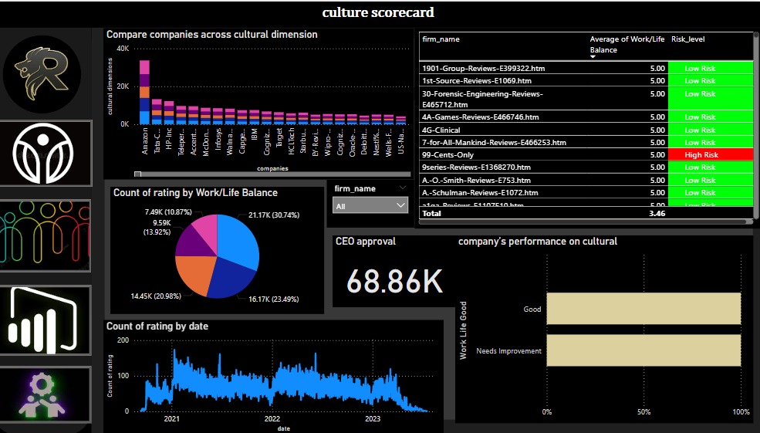

Used Charts and Visuals:

1. Clustered Bar Chart (Compare companies across cultural dimension)
- Type of visual: Clustered Bar Chart
- Function:
➔ Compares companies based on their cultural dimension scores (like Work/Life Balance, etc.).
- Insight mentioned:
→ Identifies top firms like Amazon, TCS, HP with better culture performance.

2. Table with Conditional Formatting (firm_name, Average of Work/Life Balance, Risk_level)
- Type of visual: Table (with conditional formatting for Risk Level)
- Function:
➔ Lists individual companies with their Work/Life Balance scores and Risk Levels (Low Risk/High Risk).
- Insight mentioned:
→ Quickly shows which companies offer better work-life balance and which are risky for employees.

3. Pie Chart (Count of rating by Work/Life Balance)
- Type of visual: Pie Chart
- Function:
➔ Shows the distribution of employee ratings categorized by Work/Life Balance.
- Insight mentioned:
→ Highlights how employees feel about their work-life balance overall across companies.

4. Card / KPI Card (CEO Approval: 68.86K)
- Type of visual: Card
- Function:
➔ Displays the total number of CEO approvals captured in the data (68.86K).
- Insight mentioned:
→ Signifies strong leadership backing in many companies — a leadership sentiment metric.

5. 100% Stacked Bar Chart (company’s performance on cultural - Work Life Good vs Needs Improvement)
- Type of visual: 100% Stacked Bar Chart
- Function:
➔ Splits companies based on how many employees rated them as "Good" versus "Needs Improvement" for work-life balance.
- Insight mentioned:
→ Shows how companies are performing culturally on a broad scale — easily visible Good vs. Improvement comparison.

6. Line Chart (Count of rating by date)
- Type of visual: Line Chart
- Function:
➔ Tracks the number of ratings submitted over time (2021–2023).
- Insight mentioned:
→ Helps observe trends in employee feedback activity over the years.

7. Slicer (firm_name)
- Type of visual: Slicer
- Function:
➔ Allows the user to filter the entire dashboard by specific company name.
- Insight mentioned:
→ Enables interactive exploration — users can focus on one company's culture data.

DASHBOARD – 3:

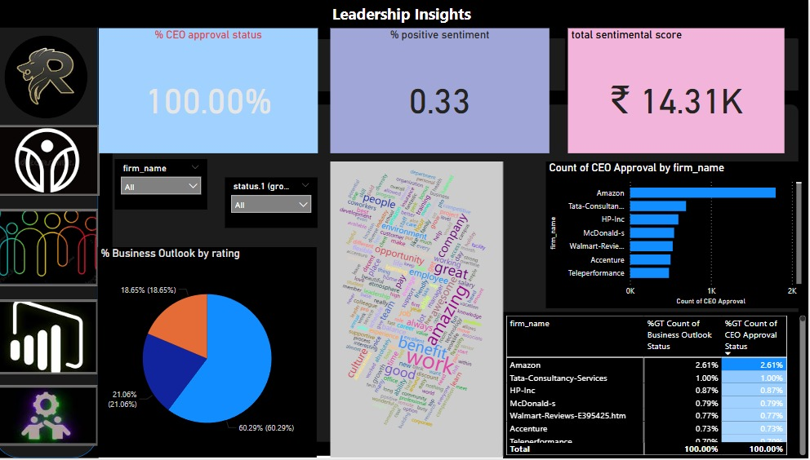

Used Charts and Visuals:
1. Cards / KPI Cards
- Visual Type: Card
- Function:
➔ Displays quick important KPIs:
  - % CEO Approval Status: 100.00%
  - % Positive Sentiment: 0.33
  - Total Sentimental Score: ₹14.31K
- Insight Supported:
→ Shows overall leadership effectiveness and employee sentiment strength.

2. Slicers
- Visual Type: Slicer
- Function:
➔ Allows users to filter by:
  - Firm Name
  - Status (like Business Outlook or CEO Approval)
- Insight Supported:
→ Provides interactivity and focused exploration across companies.

3. Pie Chart (% Business Outlook by Rating)
Visual Type: Pie Chart
- Function:
➔ Shows distribution of employee business outlook ratings:
  - Positive
  - Neutral
  - Negative
- Insight Supported:
→ Highlights that 60.29% of employees have a positive business outlook.

4. Word Cloud (Keywords from reviews)
- Visual Type: Word Cloud
- Function:
➔ Displays frequent positive words from employee feedback, like:
  - "Amazing", "Work", "Opportunity", "Growth", "Benefit", "Good".
- Insight Supported:
→ Gives a visual sense of what employees appreciate most.
5. Bar Chart (Count of CEO Approval by Firm Name)
- Visual Type: Bar Chart
- Function:
➔ Shows number of CEO approval counts by company.
  - Amazon, TCS, HP-Inc, McDonald's, etc.
- Insight Supported:
→ Amazon leads in CEO approvals among surveyed companies.

- Table (Firm Name, Business Outlook %, CEO Approval
Visual Type: Table
- Function:
➔ Lists companies with their % Business Outlook and % CEO Approval contribution.
- Insight Supported:
→ Easy comparison across top firms regarding leadership impact and company optimism.

DASHBOARD – 4:

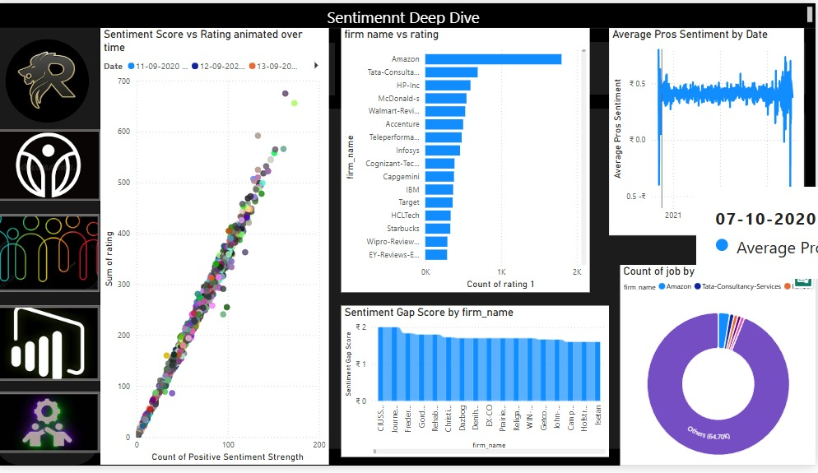

Used Charts and Visuals:
1. Scatter Plot (with Animation)
- Visual Type: Scatter Plot (animated over time)
- Function:
➔ Plots Sentiment Score vs Sum of Rating dynamically over time. ➔ Each dot represents a firm at a given date, colored differently.
- Insight Supported:
→ Shows a strong positive relationship between sentiment strength and employee ratings over time.

2. Bar Chart (firm name vs rating)
- Visual Type: Bar Chart
- Function:
➔ Displays the count of ratings by firm name (e.g., Amazon, TCS, HP, etc.).
- Insight Supported:
→ Identifies which companies have the highest number of reviews and ratings.

3. Line Chart (Average Pros Sentiment by Date)
- Visual Type: Line Chart
- Function:
➔ Tracks the average positive sentiment score over time.
- Insight Supported:
→ Analyse trend of employee positivity across dates — helps detect improvement or decline.

4. Donut Chart (Count of job by firm name)
- Visual Type: Donut Chart
- Function:
➔ Shows the percentage distribution of jobs across major firms. ➔ "Others" category represents the highest share (64.70%).
- Insight Supported:
→ Visualizes job role spread across companies, highlighting dominant or major contributors.

5. Bar Chart (Sentiment Gap Score by firm name))
- Visual Type: Bar Chart
- Function:
➔ Displays the Sentiment Gap Score (the difference between positive and negative sentiment) for each firm.
- Insight Supported:
→ Highlights which companies have the best emotional experience based on feedback gap.

CONCLUSION:
Throughout this analytical journey, the dashboards built using Power BI offer a rich, meaningful view into how employees perceive their workplaces across leading organizations. By carefully tracking key metrics like sentiment scores, CEO approval, cultural dimensions, and work-life balance, we are able to truly listen to the employee voice — not just through isolated feedback, but through broad patterns that emerge over time.
The findings reveal a landscape where positive sentiment often leads, yet clear opportunities for improvement remain. Companies like Amazon, TCS, and HP stand out for maintaining strong ratings and leadership approval, while others are working to close gaps in culture and employee satisfaction. It's clear that leadership strength, healthy work environments, and opportunities for personal growth are critical drivers of employee loyalty and optimism. Tools like the sentiment deep dive, cultural scorecards, and business outlook trackers help businesses not only monitor these trends but act on them proactively.
In the end, the true power of these insights lies in their ability to transform organizations. This is not just about collecting data — it’s about making data work for people. When companies take the time to truly understand their employees, address their concerns, and champion a culture of growth and trust, they don’t just enhance satisfaction; they unlock potential. The organizations that prioritize this human-centred approach will not only see higher engagement and retention but will build teams that are stronger, more innovative, and resilient.

