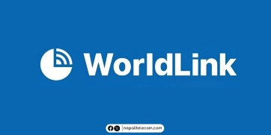
.25 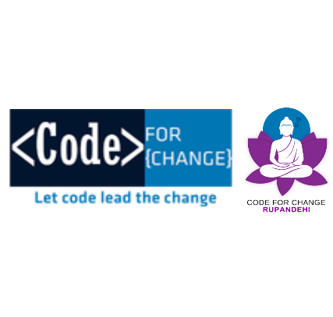

Memorandum of Understanding
Internet Service Provider Partner for whole Tenure
Between Code for Change - Rupandehi and Worldlink Communications Pvt. Ltd.
1. Purpose
This Memorandum of Understanding (MoU) is entered into between Code for Change – Rupandehi (CFC Rupandehi) and WorldLink Communications Pvt. Ltd. to establish a collaborative partnership.

The primary purpose of this agreement is to facilitate reliable internet connectivity during events organized by Code for Change – Rupandehi. WorldLink Communications Pvt. Ltd. agrees to support these events by providing routers and internet access as required.
2. Roles and Responsibilities
Code for Change Rupandehi agrees to:
- Coordinate with WorldLink prior to events regarding internet requirements.
- Ensure proper handling and usage of provided networking equipment.
- Acknowledge and promote WorldLink Communications Pvt. Ltd. as an official Internet Service Partner during events and related communications.
- Provide necessary logistical support during setup and operation at event venues.
WorldLink Communications Pvt. Ltd. agrees to:
- Provide internet connectivity (router and bandwidth) for events organized by Code for Change – Rupandehi, subject to feasibility and prior notice.
- Ensure reasonable technical support for setup and connectivity during events.
- Maintain service quality to the best of their ability during event duration.
3. Mutual Understanding
- Both parties agree to maintain a professional, respectful, and collaborative relationship.
- This MoU does not create any financial obligation or legally binding employment relationship between the parties.
- Use of logos, names, or branding materials must be approved in writing by the respective party.
- This partnership is non-exclusive, and both parties may engage in similar agreements with other organizations.

4. Duration of the MoU
This MoU shall come into effect on the date of signing and shall remain valid for one (1) year
starting from 13th May, 2026 to 13th May, 2027. It may be extended upon mutual written agreement by both parties.

5. Termination
Either party may terminate this MoU by providing at least seven (7) days prior written notice to the other party. Both parties agree to ensure a smooth transition or closure of any ongoing commitments before termination.

6. Signed and Agreed By
On behalf of Code for Change – Rupandehi

Signature: _______________________
Name: Dipesh Pokhrel
Designation: Project Lead
Date: 13 May 2026

On behalf of WorldLink Communications Pvt. Ltd.
Signature: _______________________
Name: _______________________
Designation: _______________________
Date: 13 May 2026

