Scalable News Aggregator
System Design: Architecture, Dedup/Clustering Strategy, and Design Trade-offs

1. Overview
The system ingests news articles continuously from RSS feeds, publisher APIs, webhooks, and crawled sites; normalizes them into a common schema; detects duplicates and near-duplicates across sources; clusters articles that cover the same underlying event into a single “story”; ranks stories by corroboration, recency, source reliability, and relevance; and serves a deduplicated, ranked feed to millions of users through a set of read APIs.
The central challenge is recognizing that independently-written articles from different publishers can describe the same real-world event without sharing text, and merging them into one story while using the number and quality of corroborating sources as a ranking signal.

2. High-Level Architecture
Each stage below is a separate, independently scalable consumer group reading from a durable log (Kafka), so a slow stage produces consumer lag rather than blocking upstream ingestion or dropping data.
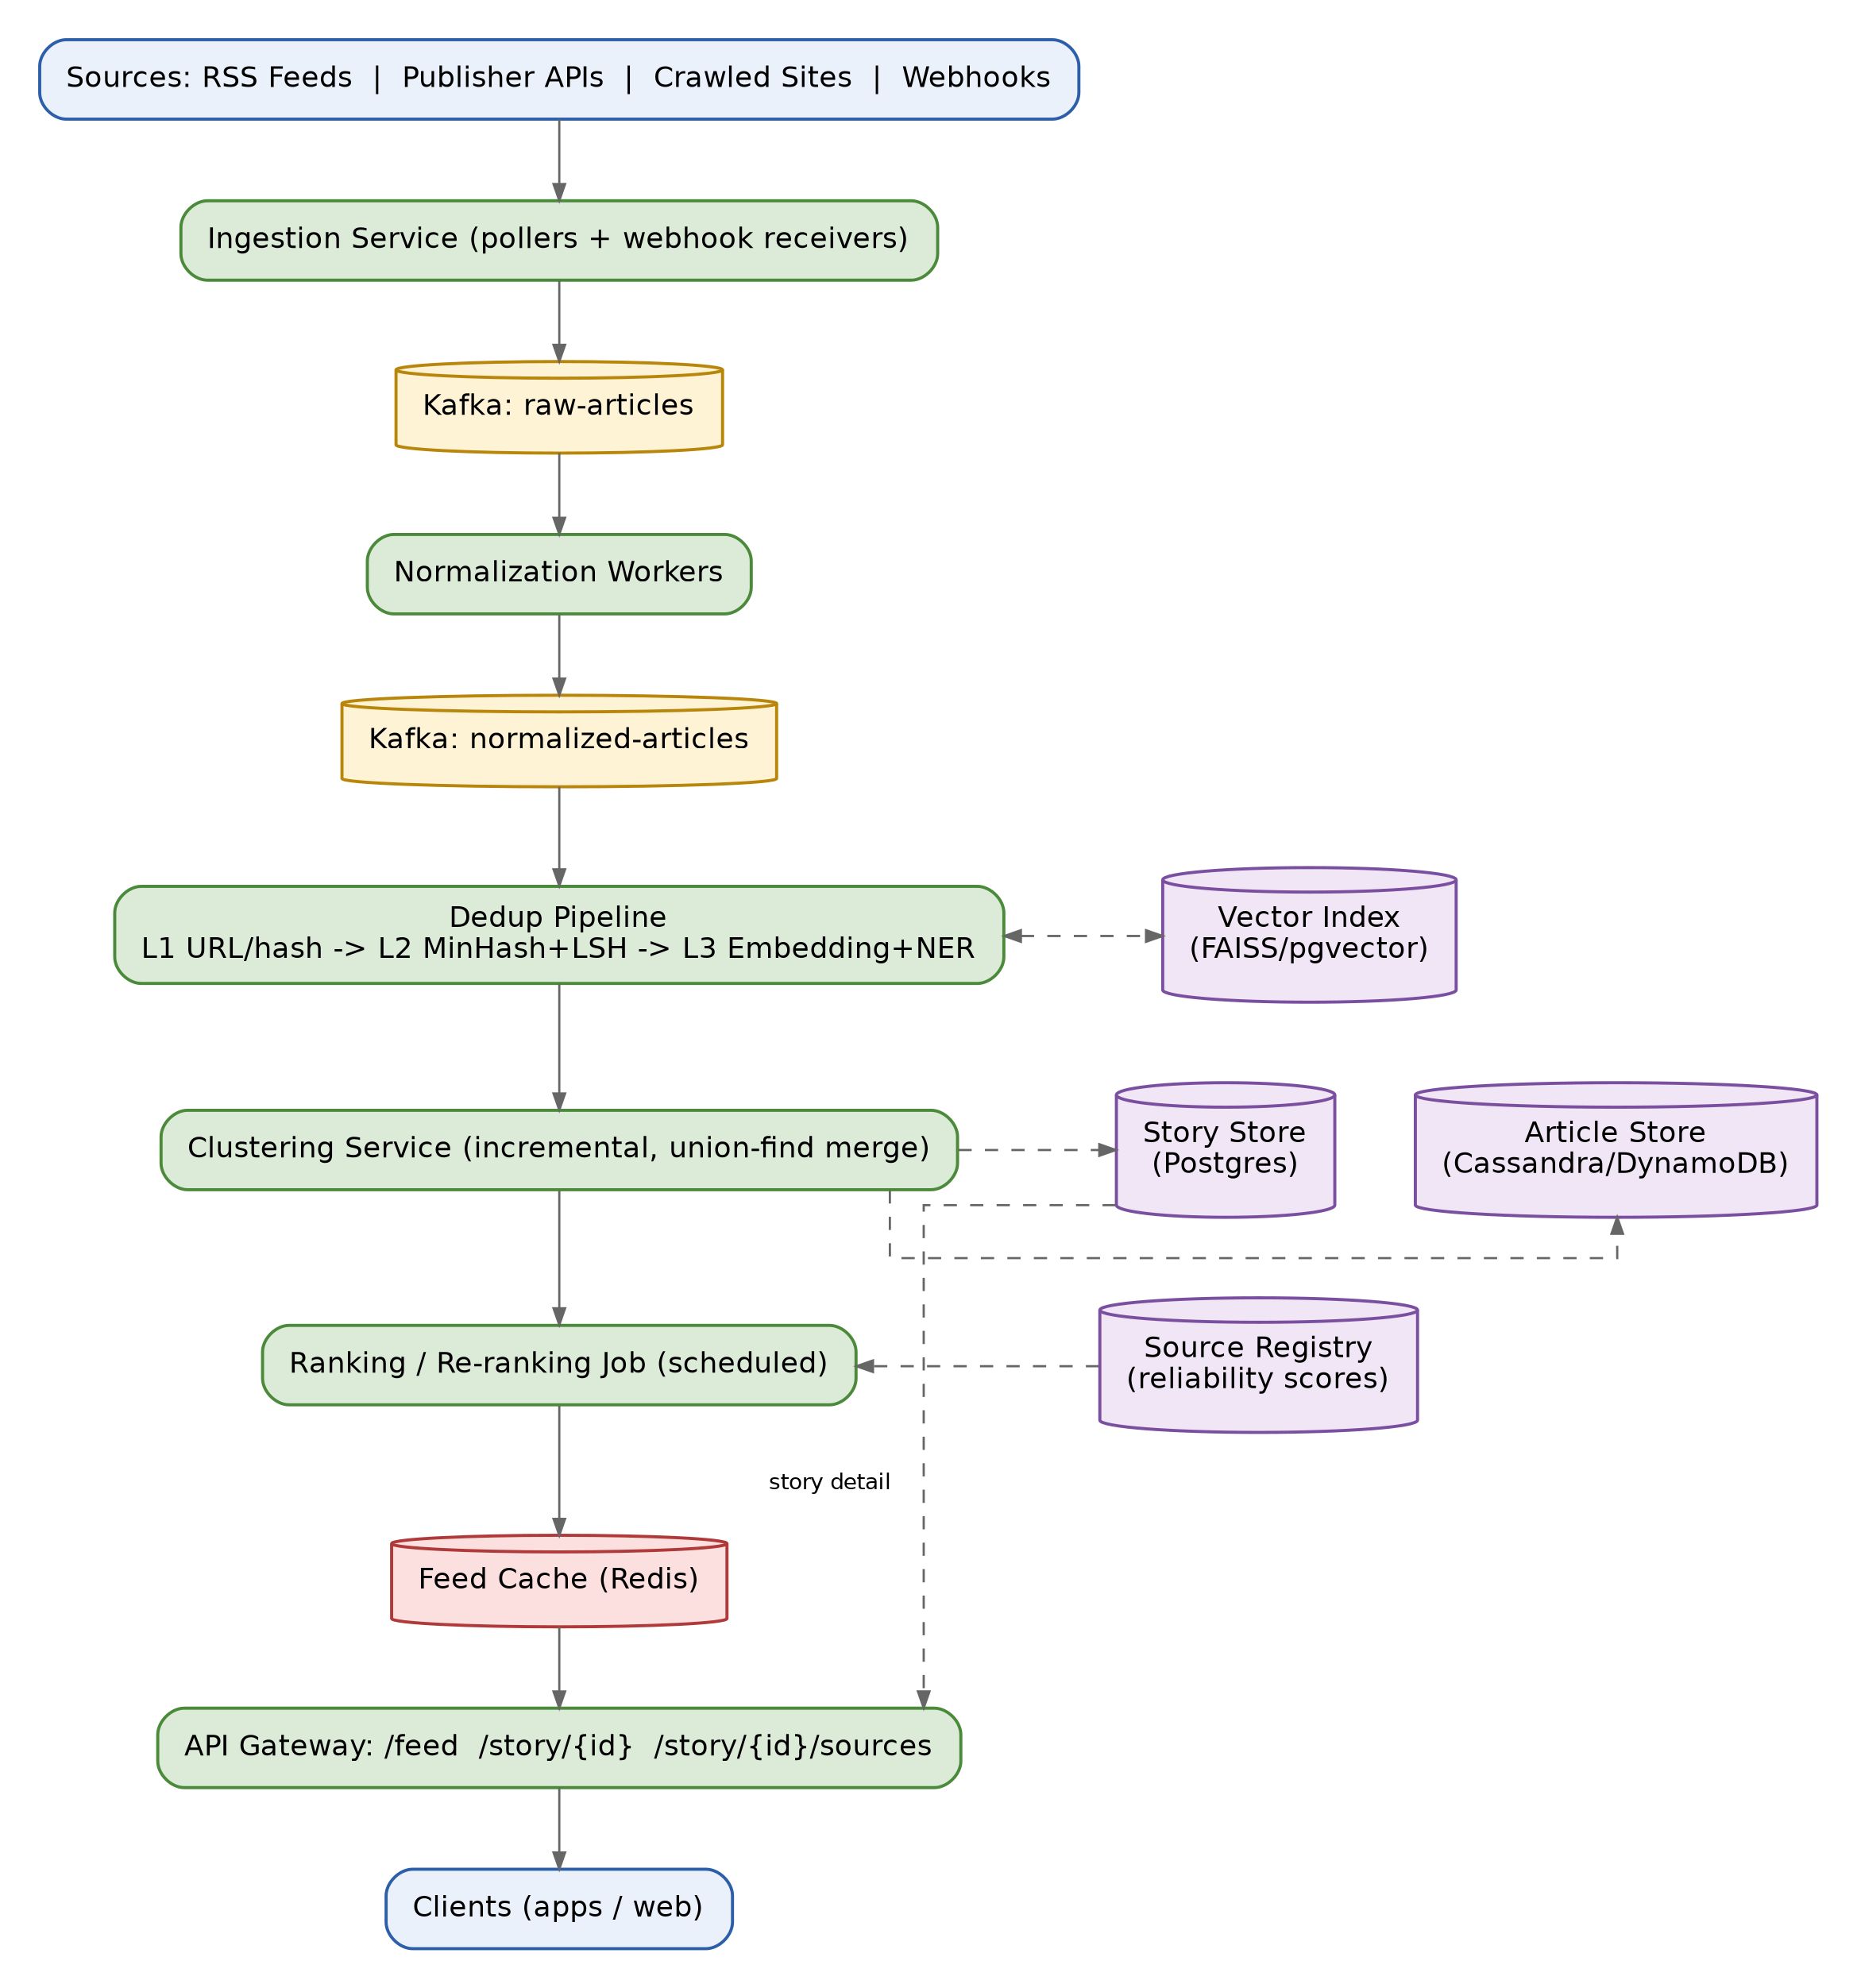
Dashed arrows in the diagram are reads/writes to supporting stores (vector index, article/story stores, source registry); solid arrows are the main streaming pipeline.

3. Data Ingestion & Processing Pipeline
- Pull-based sources (RSS, polling APIs) are polled at a frequency proportional to publish rate — e.g. a wire service every 30s, a low-volume blog every 15 minutes.
- Push-based sources (webhooks, partner feeds) hit an ingestion endpoint and land on the queue immediately, minimizing latency for partners who support push.
- Raw articles are published to a raw-articles topic partitioned by source ID, preserving per-source order and spreading load across consumers.
- Normalization workers extract title, cleaned body text (boilerplate/ad removal), author, canonical URL, publish timestamp, images and language, and emit a normalized-articles topic.

4. Duplicate Detection & Similarity Strategy
Detection runs in three layers, cheapest first, so expensive comparisons only run on genuinely ambiguous cases:
- Layer 1 — URL and content-hash dedup: canonicalize URLs (strip tracking params, resolve redirects) and hash normalized body text (SimHash/MinHash) to catch verbatim wire-copy syndication.
- Layer 2 — Near-duplicate detection: MinHash + LSH over body shingles catches the same source text with light edits or a different headline, without pairwise comparison across the whole corpus.
- Layer 3 — Semantic similarity: sentence embeddings of title + lead paragraph, matched via an ANN index (HNSW/FAISS/pgvector) against recent articles; a candidate is treated as “same story” only when embedding similarity, named-entity overlap, and publish-time proximity all agree — this combination is what correctly merges independently-written coverage of one event while avoiding false merges on merely topically-similar articles.

5. Story Clustering Approach
- A story is the unit shown to users: one or more member articles clustered around one event.
- Clustering is incremental and online: a new article's embedding is compared against centroids of recently-active stories; it attaches to the closest match above threshold or seeds a new story.
- Merges use union-find semantics so two stories later discovered to be the same event can be merged, with the old story ID kept as an alias for any client that cached it.
- The ANN search is restricted to stories updated within a recent time window (e.g. last 48–72 hours), bounding the candidate set since news events are inherently time-bound.

6. Ranking / Re-ranking Algorithm
Each story is scored as a weighted combination, recomputed on a schedule for active stories:
score = w1·log(1 + independent_source_count) + w2·avg_source_reliability + w3·recency_decay + w4·velocity + w5·relevance
- Independent source count is deduplicated at the publisher level so syndication partners of one wire story don't inflate corroboration.
- Source reliability is a maintained per-publisher score (editorial track record), starting as a simple tier list.
- Recency decay lets breaking stories rise quickly and fade over hours/days; velocity (rate of new sources joining) boosts stories that are actively breaking.

7. Database & Data Model
- Articles: source_id, canonical_url, url_hash, content_hash, embedding_ref, title, body, published_at, story_id — stored in a wide-column store (Cassandra/DynamoDB) for high write throughput, time-partitioned so old data ages into cold storage.
- Stories: story_id, canonical_title, centroid_embedding, first_seen_at, last_updated_at, source_count, score, status — stored in Postgres for richer query needs at lower volume.
- A separate vector index (FAISS/pgvector/Milvus) holds embeddings, updated incrementally alongside the primary stores.
- A source registry stores publisher metadata, reliability score and polling frequency.

8. Caching Strategy
- Feed cache (Redis): precomputed ranked stories per category/locale, refreshed by the ranking job — the hot read path never recomputes ranking.
- Dedup index cache: recent-hours article hashes/embeddings held in memory for fast lookups during the active dedup window.
- CDN for article metadata/images served to clients.

9. APIs
- GET /feed?category=&locale=&page_token= — cursor-paginated ranked stories (cursor-based since ranking order shifts continuously).
- GET /story/{story_id} — full story detail with contributing articles.
- GET /story/{story_id}/sources — list of independent sources, for user-facing transparency.

10. Scalability & Fault Tolerance
- Every stage is a stateless, horizontally scalable consumer group; workers scale independently based on which stage is the bottleneck (usually embedding generation).
- At-least-once delivery plus idempotent writes is sufficient given deterministic keys — no exactly-once infrastructure required.
- Multi-region replication for storage and regional feed caches for read latency; a single region owns clustering decisions to avoid split-brain on story IDs.
- Circuit breakers on individual source connectors so one bad feed can't stall the ingestion fleet.

11. Handling Late-Arriving & Updated Articles
- Articles are keyed by (source_id, canonical_url); a publisher edit to an existing URL is a version update — re-normalized and re-checked against clustering, since an edit can change which story it belongs to.
- Late-arriving coverage (a smaller outlet reporting on a multi-day-old story) is a normal case, not an edge case: it enters the same pipeline and, on matching an existing story, bumps its source count and reactivates it for ranking.

12. Idempotency & No-Duplicate Guarantee
- article_id is derived deterministically from hash(source_id + canonical_url) (or content_hash when URLs are unstable), so reprocessing the same payload is always an upsert, never a new row.
- Dedup and clustering decisions are pure functions of content — hashes and embeddings — not of arrival order, so retries are safe regardless of sequencing.
- The feed is served strictly from the Stories table (never raw Articles), and the API returns one row per story_id — duplication is structurally impossible in the response, not just filtered out.

13. Key Design Decisions — Why This vs. Why Not the Alternatives
The table below lays out the main architectural forks in this design, the counter-approaches considered, and the concrete reason each alternative was set aside.
Decision | Why This | Why Not the Alternatives
Message backbone: Kafka (log) vs. SQS/RabbitMQ vs. direct DB writes | Kafka-style log gives ordered, replayable, multi-consumer streams — dedup, clustering and ranking can each consume the same event independently and replay history after a bug fix. | Direct DB writes couple ingestion speed to write throughput and give no replay. SQS/RabbitMQ are simpler but lack cheap long retention and per-partition ordering, which matters for per-source ordering guarantees.
Dedup: layered (hash -> MinHash -> embedding) vs. always run embeddings | Cheap hash/LSH filters remove ~most exact/near-exact syndication before anything touches the expensive embedding + ANN step, keeping compute proportional to genuinely ambiguous cases. | Running embeddings on every article at millions/day is computationally and financially expensive and adds latency for the common case (verbatim wire-copy) that a hash already solves in microseconds.
Cross-source matching: embeddings + entity/time overlap vs. keyword/TF-IDF only | Embeddings capture paraphrased meaning; requiring entity + time-window agreement on top prevents topically-similar-but-unrelated articles from merging. | Keyword/TF-IDF overlap misses independently-written coverage of the same event (different wording, different emphasis) — exactly the case the brief calls out as the core challenge.
Clustering: incremental online vs. periodic batch re-clustering | News is real-time; an incremental online cluster assignment lets a new story appear within seconds and lets sources attach to it as they publish, which batch jobs (hourly/daily) can't do. | Batch clustering is simpler and cheaper per record, but a user could see an unclustered duplicate for up to a batch interval, violating 'never sees duplicate stories.'
Cluster merge logic: union-find over centroids vs. graph community detection (e.g. Louvain) | Union-find with a running centroid is O(near-constant) per new article and merges incrementally — fits a continuous stream. | Community detection algorithms are typically run over a static or periodically-rebuilt graph; recomputing communities on every new article at this volume is not practical in near-real-time.
Ranking: weighted scoring function vs. learned ranking model (e.g. LTR/ML) | A transparent, tunable weighted formula (sources, recency, reliability, velocity) is explainable, fast to compute, and doesn't need labeled training data on day one. | A learned ranking model likely performs better at scale but needs click/engagement data to train and is harder to debug when a story ranks oddly — a natural v2 once labels exist, layered on top of this scoring baseline.
Source counting: independent publishers vs. raw article count | Counting distinct publishers (deduping syndication partners of the same wire copy) reflects genuine corroboration, which is the actual ranking signal the brief asks for. | Counting raw articles double-counts wire-service syndication (50 sites republishing one AP story isn't 50 independent confirmations) and would badly bias ranking toward heavily-syndicated content.
Article storage: wide-column store (Cassandra/DynamoDB) vs. relational (Postgres) for articles | Article writes are high-volume, mostly key-based lookups by ID/URL with no complex joins — a fit for a wide-column store's write throughput and horizontal scaling. | A single relational instance struggles to scale write throughput horizontally at millions of articles/day without heavy sharding work Cassandra/Dynamo give for free.
Feed serving: precomputed cache (Redis) vs. compute ranking on every read | Ranking is expensive relative to a feed read; precomputing and caching means read latency stays low even as read volume (millions of users) dwarfs write volume. | Computing rank on-demand per request would recompute the same score millions of times for the same story and could not meet low-latency read SLAs at this scale.
No-duplicate guarantee: story as the unit of the feed vs. filter duplicates at read-time | Serving the feed strictly from Stories (never Articles) makes duplication structurally impossible in the response, rather than relying on a filter that could have edge-case bugs. | Read-time dedup filtering re-solves the same problem on every request and is a place bugs re-surface a fixed dedup decision; it also costs extra computation on the hot read path.
Idempotency: deterministic ID + upsert vs. distributed lock / dedup-check service | A deterministic ID (hash of source + canonical URL/content) plus upsert makes retries naturally safe with no extra coordination service or lock contention. | A separate locking/dedup-check service adds a network hop and a new point of contention on every write, and still needs the same deterministic key underneath to work correctly.

14. Failure Scenarios & Trade-off Summary
Scenario | Impact if Unhandled | Mitigation
Clustering / embedding service down | Cross-source merging pauses | Fall back to hash-based dedup only; queue affected articles for re-clustering once recovered
Vector index corrupted / rebuilding | New articles can't be matched to existing stories | Serve from last-good snapshot while rebuilding in background
Ranking job delayed | Feed order goes stale | Serve last-known-good cached ranking rather than blocking reads
A source feed floods garbage / duplicate content | Queue backlog, skewed source-count ranking signal | Per-source rate limiting and anomaly detection on ingestion volume
Kafka partition / consumer lag spike | Processing delay, not data loss | Queue absorbs backpressure; autoscale consumer groups on lag metrics

Overall trade-off stance: the design favors precision over recall in matching (fewer false merges, occasionally two stories that should be one stay separate briefly) and favors eventual, self-healing consistency (stale cache, delayed clustering) over blocking correctness checks, since a slightly stale ranked feed is preferable to a feed that is unavailable or slow at millions-of-users scale.

