* What is the average loan amount for borrowers who are more than 5 days past due?
  + SELECT AVG(loan_amount) AS average_loan_amount FROM predixion.borrower WHERE days_left_to_pay_current_emi > 5;
  + 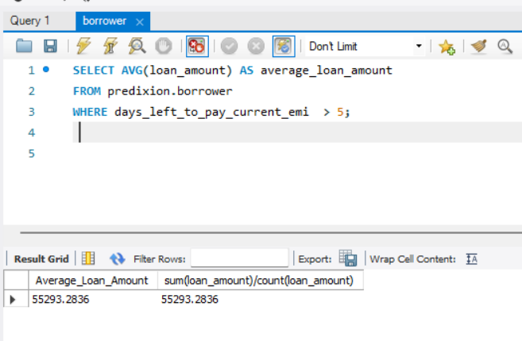
* Who are the top 10 borrowers with the highest outstanding balance?
  + select name, loan_amount-(emi*total_emi_paid_count) as outstanding_balance from predixion.borrower order by 2 desc limit 10;
  + 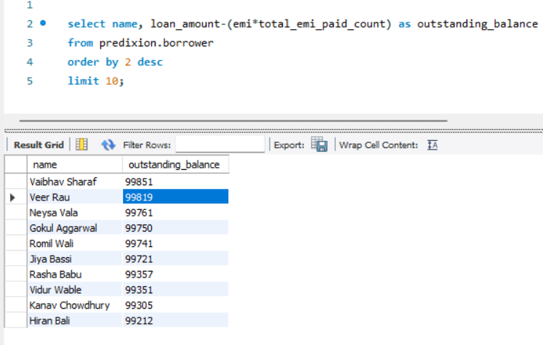
* List of all borrowers with good repayment history
  + select name from predixion.borrower where delayed_payment='No';
  + 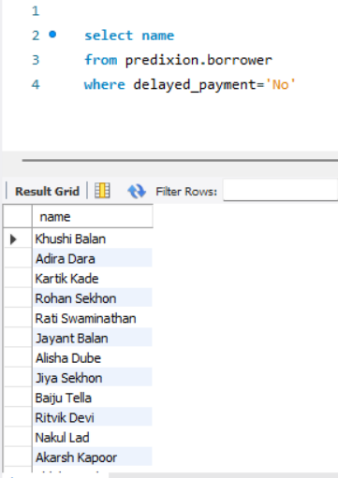

**Brief analysis wrt loan type**

* Count of Borrowers for Each Loan Type
  + **Purpose**: To understand which loan types are most popular among borrowers.
  + **Insight**: The analysis shows how many borrowers have taken each type of loan. This helps identify the most and least common loan types.
  + SELECT loan_type, COUNT(*) AS borrower_count FROM predixion.borrower GROUP BY loan_type;
  + 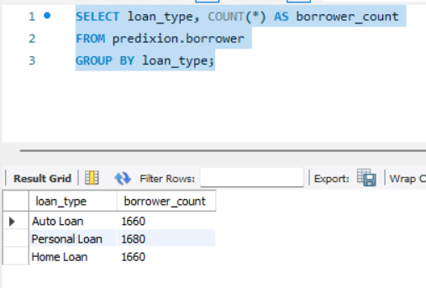
* Average Loan Amount for Each Loan Type
  + **Purpose**: To determine the typical loan size for different loan types.
  + **Insight**: By looking at the average loan amount for each loan type, we can understand the typical borrowing size. For example, home loans might have higher average amounts compared to personal loans.
  + SELECT loan_type, AVG(loan_amount) AS average_loan_amount
  + FROM predixion.borrower GROUP BY loan_type;
  + 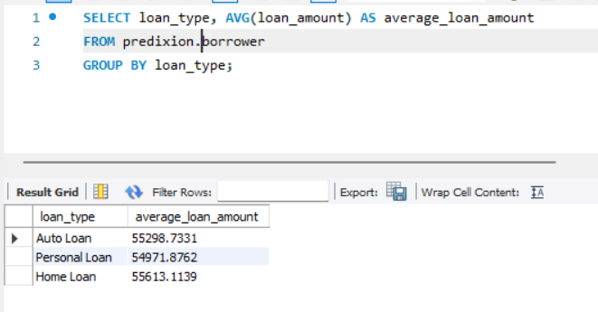
* Detailed Statistics for Each Loan Type
  + **Purpose**: To get a comprehensive overview of borrower distribution, average loan size, and financial exposure by loan type.
  + **Insight**: Combining the count of borrowers, average loan amount, and total outstanding balance provides a detailed picture of each loan type. This helps in understanding the scale and impact of different loan types.
  + SELECT loan_type, COUNT(*) AS borrower_count, AVG(loan_amount) AS average_loan_amount, round(SUM(loan_amount-(emi*total_emi_paid_count)),2) AS total_outstanding_balance FROM predixion.borrower GROUP BY loan_type;
  + 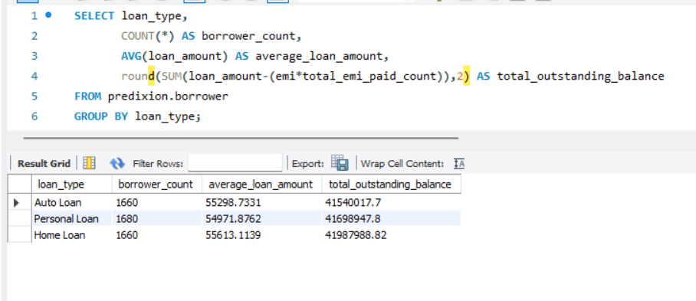
* Top Borrowers by Loan Type
  + **Purpose**: To identify the top borrower for each loan type based on the outstanding balance.
  + **Insight**: This analysis pinpoints the borrower with the highest outstanding balance for each loan type. It helps in identifying key borrowers who may pose higher risks or represent significant value to the lending institution.
  + SELECT loan_type, name, outstanding_amount FROM ( SELECT loan_type, name, loan_amount-(emi*total_emi_paid_count) as outstanding_amount,ROW_NUMBER() OVER (PARTITION BY loan_type ORDER BY loan_amount-(emi*total_emi_paid_count) DESC) AS rn FROM predixion.borrower) AS ranked WHERE rn = 1;
  + 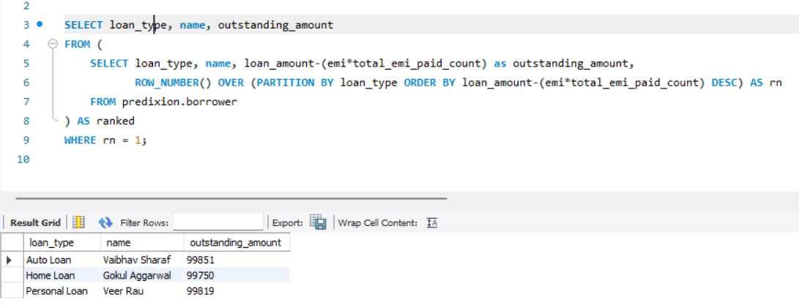

### Summary

* **Popular Loan Types**: By knowing which loan types are most popular, businesses can tailor their products and marketing strategies to meet demand.
* **Typical Loan Sizes**: Understanding average loan sizes helps in setting appropriate loan limits and interest rates.
* **Financial Exposure**: Knowing the total outstanding balance for each loan type aids in risk management and financial planning.
* **Comprehensive Overview**: Detailed statistics provide a holistic view of the loan portfolio, aiding in strategic decision-making.
* **Key Borrowers**: Identifying top borrowers allows businesses to manage high-value clients effectively and mitigate potential risks.

These insights help business users make informed decisions about product offerings, risk management, marketing strategies, and customer relationship management.