Week 4: Exploratory Data Analysis and Feature Engineering
Analyzing Customer Reviews for Personalized Skincare Recommendations
Beauty & Wellness Data Science Internship

Objective and scope
Describe the cleaned review sample using available ratings, review text, self-reported skin-type categories, and product identifiers. The analysis is exploratory: it does not test causal effects, validate skin concerns, or establish that a product is suitable for a particular person.
Input: C:\Users\delld\OneDrive\Desktop\Data-Science-Beauty-Wellness-Internship-main\data\processed\reviews_clean_sample.csv. The file contains 999 rows and 24 columns. These findings apply only to this input file, not to the full Sephora review corpus.

Methodology
- Loaded the actual Week 3 cleaned sample without modifying it.
- Calculated per-column missing-value counts and percentages against all input rows.
- Summarized ratings using valid integer values from 1 through 5; reported count, mean, median, sample standard deviation, minimum, maximum, and frequency counts.
- Recomputed word and character lengths from review_text_clean for consistent descriptive analysis.
- Included unknown/missing profiles in the skin-type count chart; excluded unknown profiles from ratings-by-skin-type summaries.
- Counted product_id values and attached product names for display when available.
- Generated only charts supported by the available input columns. Each analysis records its own usable sample size in the JSON output.

Preprocessing and analysis flow
Week 3 cleaned sample CSV
Schema and missing-value inventory
Rating, review-length, skin-type and product summaries
Descriptive features (length, known-profile flag, rating band)
Charts + machine-readable JSON summary
↓
↓
↓
↓

Actual findings
Ratings were available for n=999 reviews. The mean was 4.098, the median was 5, and observed values ranged from 1 to 5. Counts by rating: {'1': 85, '2': 83, '3': 84, '4': 144, '5': 603}.
Cleaned review length (n=999) averaged 45.89 words (median 36; range 7–297).
Missing values occurred in 6 of 24 columns. The input contained 999 rows.
Column | Missing rows | Missing (%)
helpfulness | 199 | 19.92
review_title | 242 | 24.22
skin_tone | 223 | 22.32
eye_color | 120 | 12.01
hair_color | 258 | 25.83
skin_type_raw | 102 | 10.21
Reported skin-type category counts for n=999: combination: 436, dry: 198, normal: 157, oily: 106, unknown: 102. The unknown group is retained in this distribution.
Among reviews with a known self-reported skin type and usable rating (n=897), descriptive mean ratings were: combination n=436, mean=4.177; dry n=198, mean=3.960; normal n=157, mean=4.140; oily n=106, mean=4.132. These are within-sample descriptions, not evidence of product suitability or statistically validated differences.
Product identifiers were available for n=999 reviews, covering 2 unique products.
Product ID | Product name | Reviews in sample
P420652 | Lip Sleeping Mask Intense Hydration with Vitamin C | 998
P504322 | Gentle Hydra-Gel Face Cleanser | 1

Input schema and data quality
Input column | Pandas dtype
unnamed: 0 | int64
author_id | int64
rating | int64
is_recommended | float64
helpfulness | float64
total_feedback_count | int64
total_neg_feedback_count | int64
total_pos_feedback_count | int64
submission_time | str
review_text | str
review_title | str
skin_tone | str
eye_color | str
skin_type | str
hair_color | str
product_id | str
product_name | str
brand_name | str
price_usd | float64
primary_category | str
skin_type_raw | str
review_text_clean | str
review_length_words | int64
review_length_chars | int64

Charts and captions
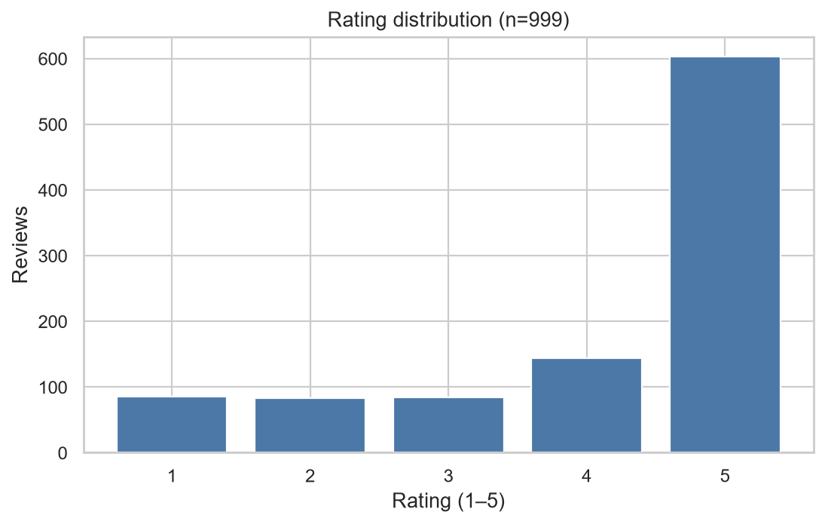
Rating distribution. Bars show observed counts for integer ratings 1–5; n is the number of valid ratings.
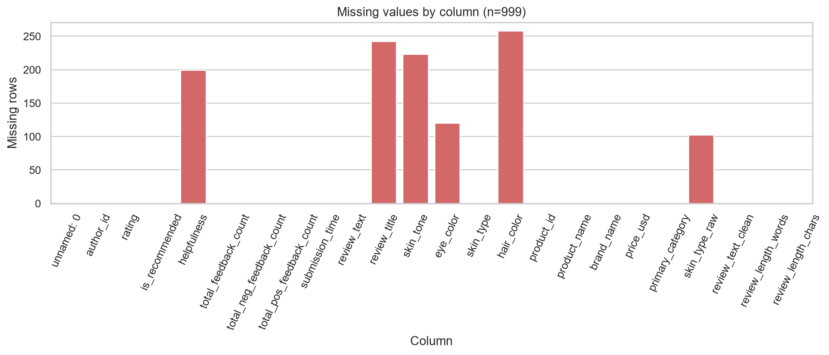
Missing-value count by input column. Counts are shown rather than imputed values; optional missing data were retained.
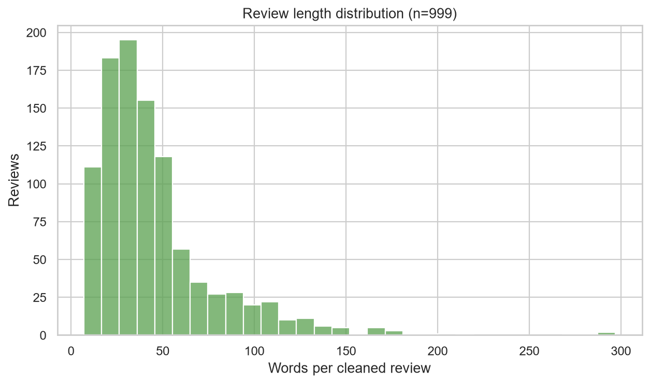
Word count per non-empty cleaned review. Word count is descriptive and does not indicate review quality.
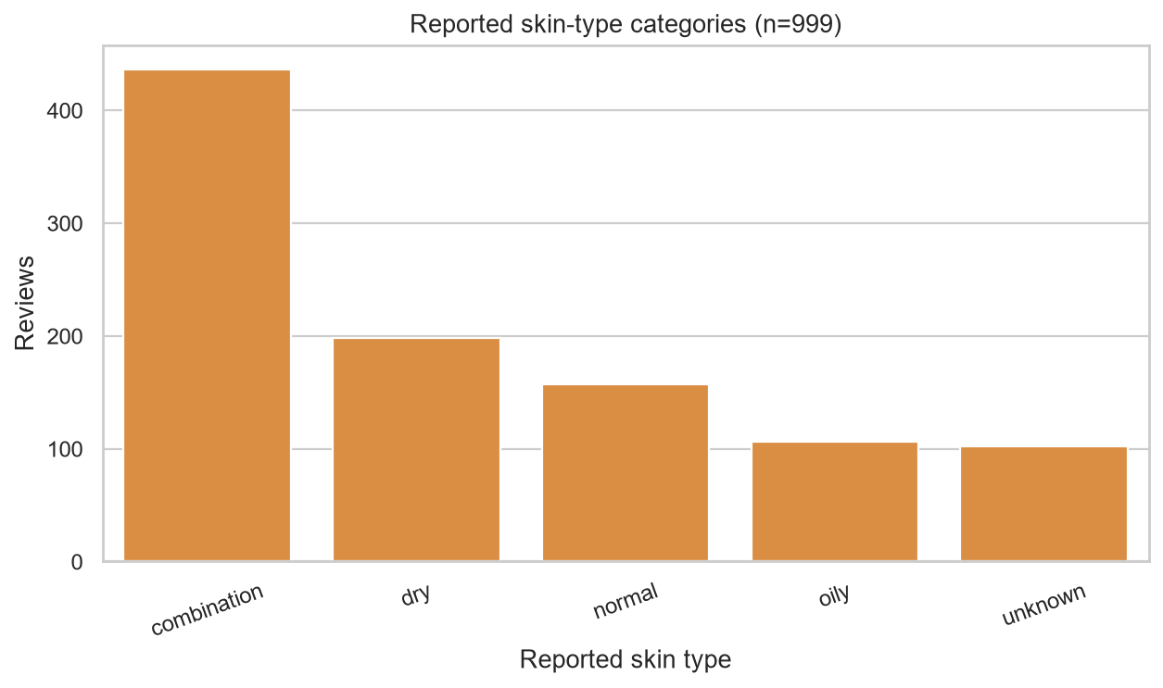
Self-reported skin-type categories. Unknown values remain visible; the categories are not independently verified.
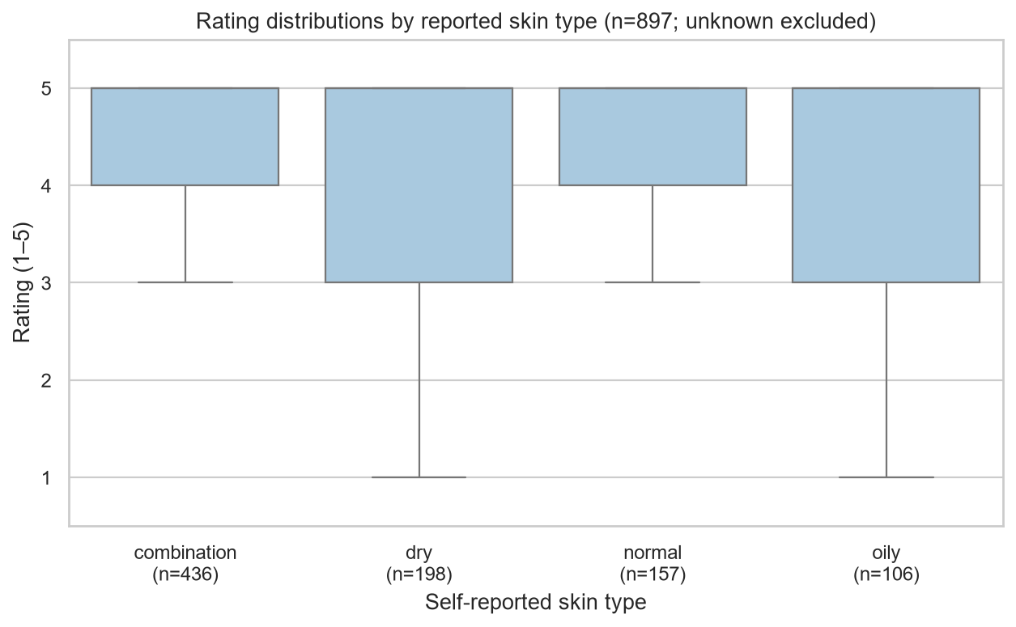
Rating distributions by known self-reported skin type; unknown profiles are excluded. This chart is descriptive and confounded by the sample's product concentration.
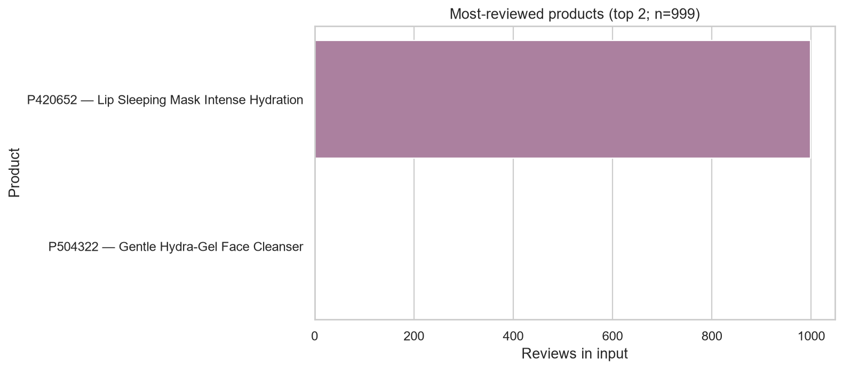
Products with the highest review counts within this input sample; counts do not represent product-wide totals.

Feature definitions and leakage safeguards
- review_length_words: Whitespace-separated token count from review_text_clean. Recomputed for the EDA output; descriptive text metadata.
- review_length_chars: Character count of review_text_clean. Descriptive text metadata.
- skin_type_known: Boolean flag: True when skin_type is non-empty and not 'unknown'; False otherwise. It indicates reported profile availability, not a validated skin characteristic.
- rating_band: low (1–2), middle (3), or high (4–5), derived directly from rating. This is an outcome label for summaries only and must not be used as a predictor when rating or recommendation is the target.
The Week 3 cleaned CSV remains unchanged. Engineered columns are written to a separate EDA feature CSV. No skin-concern keyword, sentiment, medical, or suitability feature was created.

Limitations
- The input is the first 1,000 rows in file order from one review chunk, reduced to 999 by Week 3 duplicate removal. It is not a random or representative sample of all Sephora reviews.
- The sample is extremely concentrated: 998 of 999 rows refer to one product and one row to another. Skin-type rating summaries are therefore dominated by that product and cannot establish general product suitability or independent skin-type effects.
- Skin type is self-reported; 102 rows are categorized as unknown. The unknown value does not identify a true underlying profile.
- Ratings and review text are self-selected and may be biased. Descriptive rating differences are not causal or inferential.
- The full raw review corpus has not yet been cleaned and analyzed. Full-dataset results may differ.
- No evidence in this analysis validates customer skin concerns, product compatibility, or medical outcomes. The work is not dermatological advice.

Conclusion
This EDA pipeline produced sample-specific summaries and 6 charts from the available cleaned fields. It identifies a rating distribution, missing optional data, review lengths, reported skin-type categories, and product concentration. Given the non-representative sample and single-product concentration, these results do not validate personalized recommendations. Run EDA on the full cleaned corpus before drawing broader conclusions.

References
- Sephora Products and Skincare Reviews dataset, Kaggle: https://www.kaggle.com/datasets/nadyinky/sephora-products-and-skincare-reviews (local sample inspected; license not verified).
- pandas documentation: https://pandas.pydata.org/docs/
- NumPy documentation: https://numpy.org/doc/stable/
- Matplotlib documentation: https://matplotlib.org/stable/
- seaborn documentation: https://seaborn.pydata.org/

