Analyzing Customer Reviews for Personalized Skincare Recommendations
Week 6: Final Evaluation and Business Impact
Beauty & Wellness Data Science Internship | Prepared 2026-10-18
Evidence is limited to the local dataset, existing project outputs, and verification runs described in this document. No consumer or business impact experiment was conducted.

Executive finding
The project delivered reproducible cleaning, descriptive EDA, and a review-level classification benchmark. The Week 5 Logistic Regression outperformed a majority-class baseline on a reviewer-held-out sample, but it predicts the recorded review recommendation flag from post-review wording and a self-reported profile. It does not establish that skin-profile personalization improves product selection, nor that products are suitable, safe, or effective for an individual. The original hypothesis remains inconclusive and is not validated by these experiments.

1. Objective and original research questions
The business motivation was that a product-wide average star rating may hide differences in how people with different self-reported skin profiles describe their experience. The initial project asked:
- RQ1: Can specific skin types and skin concerns be extracted from unstructured customer-review text?
- RQ2: Is there a noticeable difference in how different skin profiles rate the exact same product?
- Week 1 hypothesis: grouping review text by skin type would provide a more useful signal than an overall average rating for whether a new customer may benefit from a product.
Assessment: the Week 4 sample shows descriptive rating averages that differ across known skin-profile categories, but its 999 rows are a first-rows sample and 998 belong to one product. No per-product significance test or validation against future customer benefit was performed. Therefore, this is at most a preliminary descriptive hint; the hypothesis is not established. RQ1 is unanswered: no skin-concern extraction system was evaluated against ground truth.

2. Methodology and verification
Week 3 cleaning: the saved audit records 1,094,411 raw review rows and 969,885 cleaned rows. The final audit documents blank-review removal, duplicate removal by author/text, rating validation, skin-type canonicalization, conservative text cleaning, and removal of text empty after cleaning. Raw source files were preserved.
Final verification reran the cleaner on a bounded 1,000-source-row sample using separate temporary output paths; it completed with 999 cleaned rows. The full cleaner was not rerun during final verification because its default outputs already exist and are useful local data.
Week 4 EDA was rerun on the existing 999-row, 24-column cleaned sample using separate temporary outputs. All six chart types were generated. The descriptive summary reports a mean rating of 4.098, with rating-analysis n=999; profile-known ratings used n=897. This sample has only two product IDs (998 and 1 reviews), so the results are not treated as representative.
Table 1. Observed Week 4 sample ratings by reported skin type (profile-known ratings only).
Skin type | n | Mean rating | Median rating
combination | 436 | 4.177 | 5
dry | 198 | 3.960 | 5
normal | 157 | 4.140 | 5
oily | 106 | 4.132 | 5
Week 5 streamed the full 969,885-row cleaned file to calculate target counts and selected a reproducible, class-proportional sample of 30,000 labeled reviews. The full file has 811,974 valid labels: 683,626 recommended and 128,348 not recommended; 157,911 rows have missing/invalid target labels. Predictors were cleaned review text (word TF-IDF unigrams/bigrams) and one-hot encoded skin type. Rating, target-derived fields, feedback counts, product IDs/names, and author IDs were excluded as predictors. Author IDs were used only for reviewer grouping.
Validation used a reviewer-grouped 80/20 holdout (24,022 train; 5,978 test; 0 reviewer overlap) and 3-fold GroupKFold on training data. The feature transformation and vectorization are fitted within each model pipeline and training fold.

3. Held-out model comparison
Positive class is is_recommended=1. Metrics below are from the saved machine-readable summary; the final rerun reproduced its test metrics and split exactly.
Model | Accuracy | Precision + | Recall + | F1 + | Macro F1 | ROC-AUC
Most Frequent Baseline | 0.839 | 0.839 | 1.000 | 0.912 | 0.456 | 0.500
Logistic Regression | 0.908 | 0.977 | 0.912 | 0.943 | 0.851 | 0.962
Decision Tree | 0.737 | 0.931 | 0.742 | 0.826 | 0.647 | 0.789
Model | CV macro F1 mean +/- SD | Train macro F1 | CV ROC-AUC mean +/- SD
Logistic Regression | 0.852 ? 0.009 | 0.908 | 0.961 ? 0.006
Decision Tree | 0.639 ? 0.009 | 0.710 | 0.794 ? 0.005
The majority baseline already reaches high accuracy because the sample is imbalanced (the positive label is common), but its macro-F1 is low and it never identifies the negative class. Logistic Regression has the strongest held-out and grouped-CV macro-F1 and ROC-AUC. The Decision Tree is weaker on both macro-F1 and ROC-AUC. Training macro-F1 exceeds cross-validation macro-F1 for both models, indicating a generalization gap; it is larger for the tree, but neither score establishes suitability.

4. Error patterns and visualizations
Confusion counts below use actual held-out predictions, with rows as true labels (0, 1) and columns as predicted labels (0, 1).
Model | True 0 / predicted 0 | True 0 / predicted 1 | True 1 / predicted 0 | True 1 / predicted 1
Most Frequent Baseline | 0 | 963 | 0 | 5015
Logistic Regression | 856 | 107 | 441 | 4574
Decision Tree | 689 | 274 | 1296 | 3719
For Logistic Regression, 107 of 963 not-recommended reviews were predicted as recommended (false positives), while 441 of 5,015 recommended reviews were predicted as not recommended (false negatives). Its class-0 recall was 0.889; class-0 precision was 0.660. Error costs depend on a future use case; no operational threshold was selected.
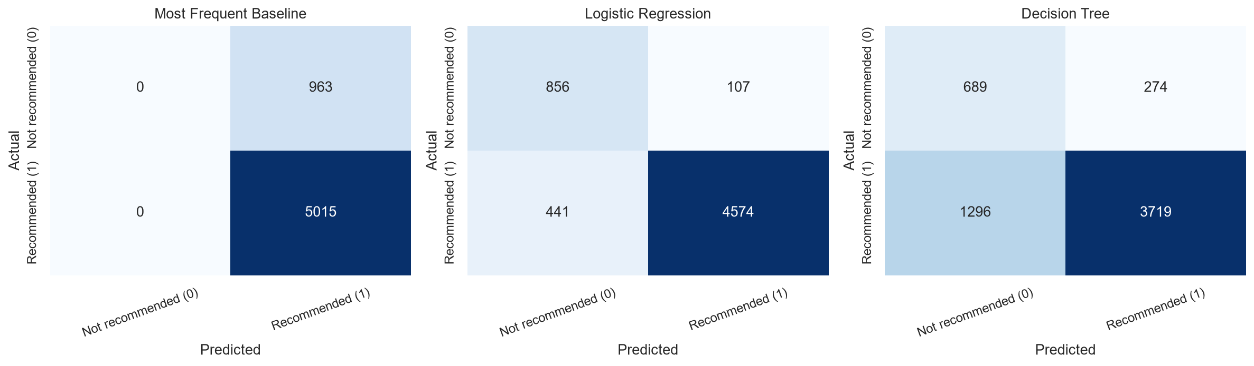
Figure 1. Held-out confusion matrices from the verified Week 5 evaluation.
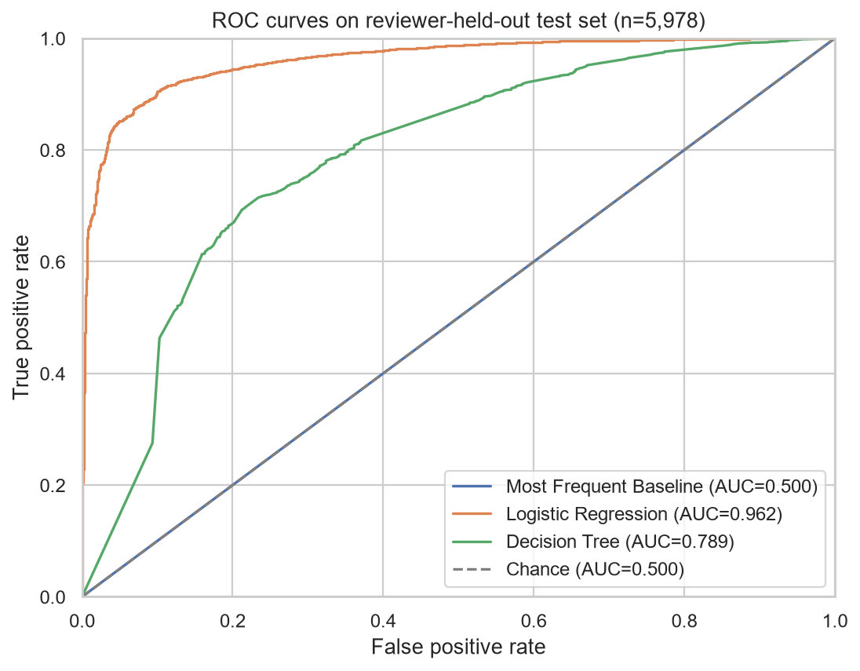
Figure 2. Held-out ROC curves; these evaluate the review-label task, not product suitability.
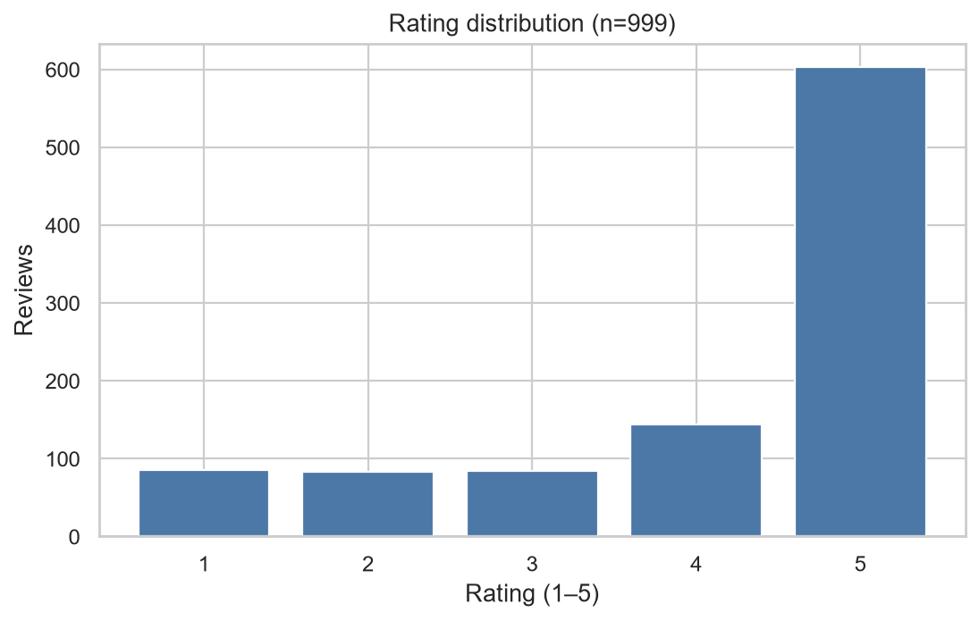
Figure 3. Week 4 rating distribution, n=999; this is the first-rows cleaned sample.
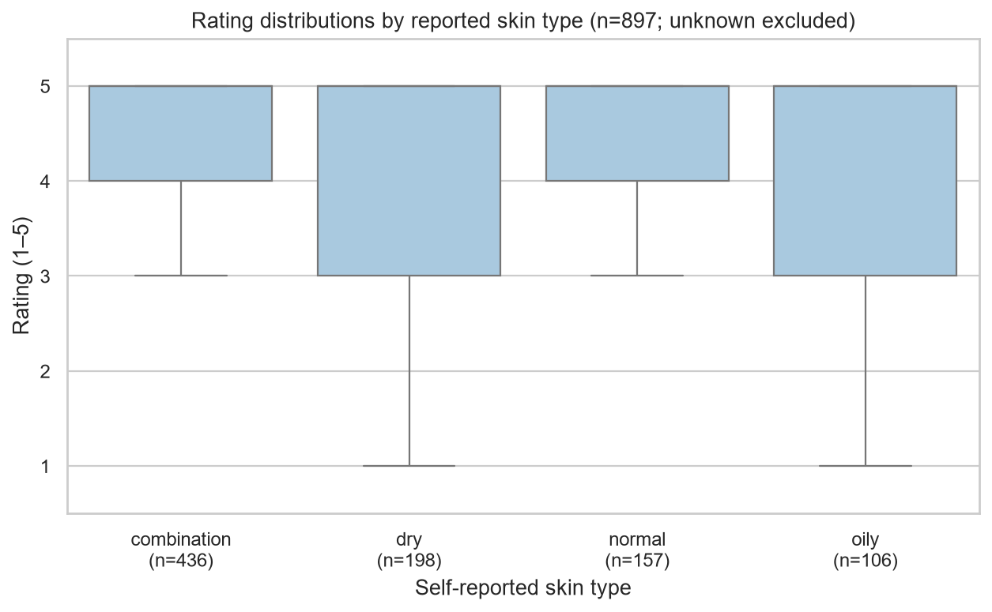
Figure 4. Week 4 ratings by self-reported skin type. The sample is heavily concentrated in one product and is descriptive only.

5. Business implications (potential, not measured)
- A retailer could organize existing review summaries by self-reported profile when there are enough reviews for each product/profile group. Show the review count and a visible uncertainty cue; suppress or clearly label low-count groups using a pre-defined policy.
- Product comparison and discovery could present profile-specific review themes alongside, not instead of, overall rating, with links to the underlying reviews and clear notes that profiles are self-reported.
- Improve data collection by asking optional, purpose-limited profile questions, allowing unknown/prefer-not-to-say, recording timing and product context, and collecting structured post-purchase satisfaction and irritation/return feedback with consent and retention controls.
- Before deployment, test a non-medical review-summary or discovery feature with real users through a controlled pilot. Predefine usefulness, comprehension, safety, subgroup, privacy, and guardrail measures; measure conversion, trust, returns, or sales only if the experiment actually captures them.
- Use human-reviewed language and avoid asserting that a product is suitable for a skin condition or that review sentiment demonstrates efficacy.
No sales lift, conversion gain, increased trust, or reduced returns were measured in this project.

6. Limitations, privacy, and fairness
- The target is a historical review-level recommendation flag, not an outcome for a future shopper. Review text is written after product use and can state sentiment, so this model is not a pre-purchase recommendation system.
- 157,911 cleaned rows have no valid target, and the valid labels are imbalanced. The 30,000-row sample and fixed split do not replace external or temporal validation.
- Skin type is self-reported; "unknown" is retained rather than imputed. Profile coverage and correctness are not independently verified. No subgroup fairness, calibration, or profile-specific error audit was completed.
- Reviewer grouping prevents the same author appearing on both sides of the holdout, but product overlap is permitted. Results may exploit product-specific language and need product-grouped evaluation for new-product claims.
- The EDA is a non-random prefix sample dominated by one product. RQ2 requires full-corpus, per-product comparisons with adequate cell sizes and suitable statistical inference; that analysis was not completed.
- No skin-concern extractor, clinically reviewed labels, dermatologist validation, safety/efficacy outcome, recommendation-feature A/B test, or customer business-impact experiment was performed.
- Raw and processed customer data are local and Git-ignored; keep them out of public commits. Limit access, avoid exposing reviewer identifiers, and verify dataset terms before redistribution or commercial use.
This project is educational analysis only. It is not medical advice and does not provide a medically validated skincare recommendation system.

7. Conclusion and future scope
The verified Logistic Regression benchmark substantially exceeds the majority baseline for predicting the dataset's review-level label on a reviewer-held-out sample. That finding supports using text analytics as a possible aid to organizing or summarizing existing reviews, subject to human review and uncertainty communication. It does not validate personalized product recommendations. The original hypothesis remains inconclusive because the Week 4 profile comparison is a highly product-concentrated prefix sample and Week 5 did not test whether skin profile adds value beyond text or establish product-level benefit.
- Run full-corpus EDA into new output paths, preserve the sample report, and publish complete denominators and missingness.
- Test RQ2 by comparing profile ratings within the same products after predefining minimum counts; use appropriate non-parametric or ordinal methods, uncertainty intervals, and multiple-comparison controls.
- Annotate a consented, representative set of skin-concern mentions and evaluate an extraction method against those labels; do not infer concerns from unvalidated keywords.
- Compare text-only, profile-only, and combined predictors; evaluate by held-out products/time and profile subgroup; calibrate probabilities and assess decision thresholds.
- Verify the Kaggle license/download date, document dataset provenance, inspect both final DOCX files in Word, and keep raw/restricted data out of Git.

References
- Sephora Products and Skincare Reviews dataset, Kaggle: https://www.kaggle.com/datasets/nadyinky/sephora-products-and-skincare-reviews (license and download date not verified).
- scikit-learn documentation: https://scikit-learn.org/stable/; Pipeline and ColumnTransformer: https://scikit-learn.org/stable/modules/compose.html.
- scikit-learn model evaluation: https://scikit-learn.org/stable/modules/model_evaluation.html.
- pandas documentation: https://pandas.pydata.org/docs/.

