Week 5: Predictive Modeling and Algorithm Selection
Analyzing Customer Reviews for Personalized Skincare Recommendations
Beauty & Wellness Data Science Internship

1. Modeling objective and research-question connection
Predict the dataset's observed is_recommended flag (0/1) from the review's cleaned text and the reviewer's self-reported skin_type. This is a secondary predictive task related to whether review content and profile information are associated with a recorded recommendation label. It does not extract or validate skin concerns and does not predict whether a product is suitable for an individual.
The task does not directly answer RQ2 (whether different skin profiles rate the same product differently). It is an exploratory supervised proxy using the dataset's recommendation outcome.

2. Dataset and target variable
Input: C:\Users\delld\OneDrive\Desktop\Data-Science-Beauty-Wellness-Internship-main\data\processed\reviews_clean.csv. The full cleaned file contains 969,885 rows. The binary target is available for 811,974 rows: 128,348 not recommended and 683,626 recommended. 157,911 rows have missing or invalid target values and were excluded from training/evaluation.
The modeling sample contains 30,000 labeled rows ({'0': 4742, '1': 25258}). Sampling: Uniform priority-reservoir sample within each target class, allocated proportionally to full-file class counts.
Input missingness among modeling columns: {'author_id': 0, 'rating': 0, 'is_recommended': 157911, 'skin_type': 0, 'review_text_clean': 0}.

3. Feature selection and preprocessing
Predictors: review_text_clean transformed with word-level TF-IDF (unigrams and bigrams; max_features=12,000; min_df=2) and skin_type transformed with one-hot encoding. Empty/missing profile values are represented as unknown. The preprocessing steps are inside each scikit-learn Pipeline and are fitted only on each training fold.
Leakage controls: rating was excluded because it is strongly associated with is_recommended in the source (rating is part of the outcome generation process). is_recommended itself, rating_band, helpfulness, feedback counts, product IDs/names, author IDs, and other post-outcome or identifier-like columns were not predictors. author_id was used only to keep reviewers in a single split/fold.

4. Models and rationale
Baseline: DummyClassifier(strategy='most_frequent'), which predicts the training-set majority class. Logistic Regression with balanced class weights provides a regularized linear model over sparse TF-IDF/profile features. A depth-limited Decision Tree with a minimum leaf size tests a nonlinear tree-based alternative while controlling complexity.

5. Baseline and validation strategy
A reviewer-grouped holdout used GroupShuffleSplit with 24,022 training and 5,978 test observations. No author appears in both partitions. The test set contains 5,497 reviewers; the training set contains 21,987. Three-fold GroupKFold cross-validation was performed on training data, grouped by reviewer. Sampling and splitting used random_state=42.
Reported metrics: accuracy, positive-class precision/recall/F1, macro F1, and ROC-AUC. Positive class means is_recommended=1. The majority baseline's ROC-AUC is 0.500 because it assigns the same score to all observations.

6. Actual held-out evaluation
Model | Accuracy | Precision | Recall | F1 positive | Macro F1 | ROC-AUC
Most Frequent Baseline | 0.839 | 0.839 | 1.000 | 0.912 | 0.456 | 0.500
Logistic Regression | 0.908 | 0.977 | 0.912 | 0.943 | 0.851 | 0.962
Decision Tree | 0.737 | 0.931 | 0.742 | 0.826 | 0.647 | 0.789
On this held-out sample, Logistic Regression had the highest macro F1 (0.851). The majority baseline accuracy was 0.839; because class 1 is common, accuracy alone is not sufficient.

7. Cross-validation and fit diagnostics
Model | CV macro F1 mean ± SD | Train macro F1 | CV ROC-AUC mean ± SD
Logistic Regression | 0.852 ± 0.009 | 0.908 | 0.961 ± 0.006
Decision Tree | 0.639 ± 0.009 | 0.710 | 0.794 ± 0.005
Training-versus-cross-validation macro F1 provides a limited overfitting diagnostic. A large gap suggests overfitting; low training and validation scores suggest underfitting. These diagnostics apply to the sampled data and selected features only.

8. Evaluation plots
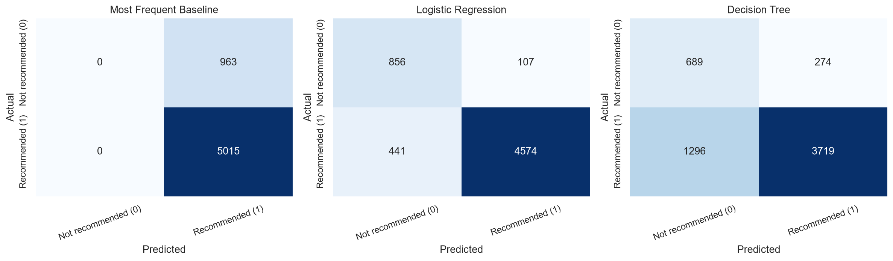
Held-out confusion matrices; rows are actual labels and columns are predicted labels.
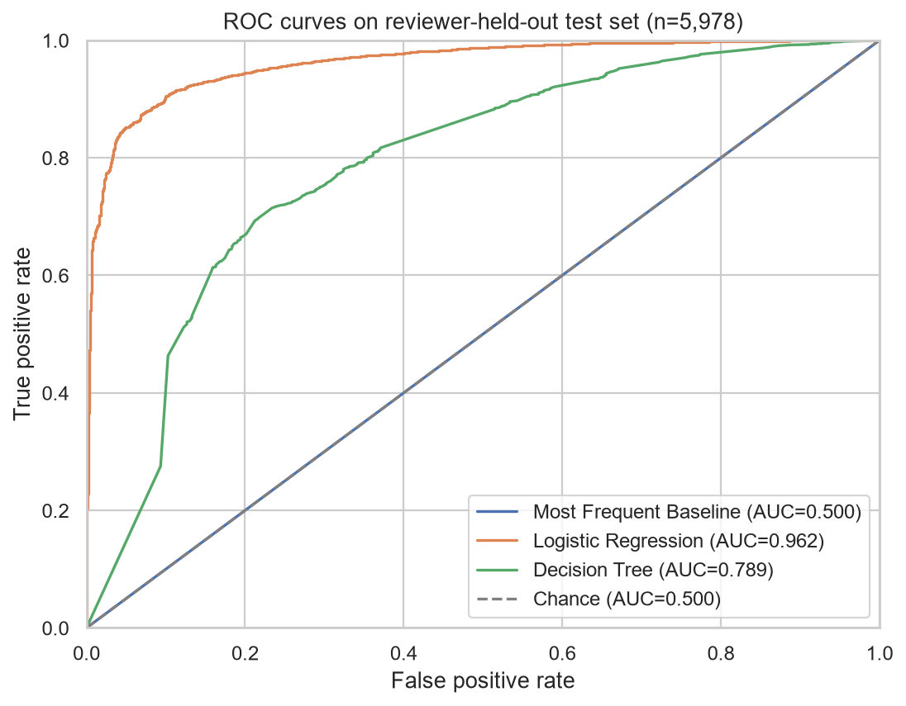
Held-out receiver operating characteristic curves, computed from predicted positive-class probabilities.

9. Business interpretation
The best macro-F1 model (logistic regression) can be interpreted only as predicting the platform's review-level recommendation flag from review wording and a self-reported profile. Text may encode a reviewer's expressed opinion. This is not evidence that skin type causes satisfaction or that the product is clinically or personally suitable. The baseline comparison and minority-class recall/precision should guide any further evaluation, not a direct consumer recommendation.

10. Limitations and Week 6 recommendations
- The evaluation uses a 30,000-row class-proportional sample of the full cleaned dataset, not all 811,974 labeled examples.
- is_recommended is strongly associated with rating; rating was excluded to prevent target leakage. Review text may still express or reveal sentiment closely related to the label.
- Reviewer-grouped splitting prevents the same reviewer from appearing in train and test; product IDs are excluded from predictors, but products may occur in both partitions.
- The target is an observed review-level flag, not an expert assessment of efficacy, skin concerns, safety, or suitability.
- The class distribution is imbalanced; accuracy can overstate useful performance. Compare macro F1, positive precision/recall, ROC-AUC, and the baseline.
- Cross-validation and holdout results depend on the fixed sample/split and may not generalize across time, products, or other platforms.
- Week 6 should audit errors by skin-type availability and product, calibrate scores if needed, test temporal/product-group splits, quantify uncertainty, and evaluate fairness and business utility before any recommendation use.

Conclusion
Actual results show whether review text plus self-reported skin type predict the dataset's recommendation indicator better than the majority baseline on a reviewer-held-out sample. The highest macro-F1 model was logistic regression at 0.851. This is an exploratory benchmark only, not a validated personalized skincare recommender. Expected outcomes were not substituted for measured metrics.

References
- Sephora Products and Skincare Reviews dataset, Kaggle: https://www.kaggle.com/datasets/nadyinky/sephora-products-and-skincare-reviews (local processed file inspected; license not verified).
- scikit-learn documentation: https://scikit-learn.org/stable/
- scikit-learn Pipeline and ColumnTransformer documentation: https://scikit-learn.org/stable/modules/compose.html
- scikit-learn model evaluation documentation: https://scikit-learn.org/stable/modules/model_evaluation.html
- pandas documentation: https://pandas.pydata.org/docs/

