ADV-DEVOPS EXPERIMENT-1
Aim: To create AWS EC2 instance (VMs).
Theory:
An Amazon EC2 instance is a virtual server, or virtual machine, in the Amazon Web Services (AWS) cloud that provides secure and resizable compute capacity. It functions like a computer that users can rent on-demand to run their applications, choosing the desired operating system, software, and specific configurations of CPU, memory, storage, and networking to suit their needs. EC2 instances are "elastic," allowing users to easily scale their resources up or down, pay only for what they use, and avoid the cost and complexity of managing physical hardware.
Procedure :
Task 1: Launching your EC2 instance
1. In the AWS Management Console in the Search, enter EC2 and choose Enter.
2. From the search results, choose EC2.
3. In the Launch instance section, choose Launch instance.
STEP 1: NAME YOUR EC2 INSTANCE
4. In the Name and tags pane, in the Name text box, enter Web-Server
then choose Enter.
5. Choose the Add additional tags link.
6. From the Resource types dropdown list, Instances is selected by default. Leave Instances selected and select Volumes.
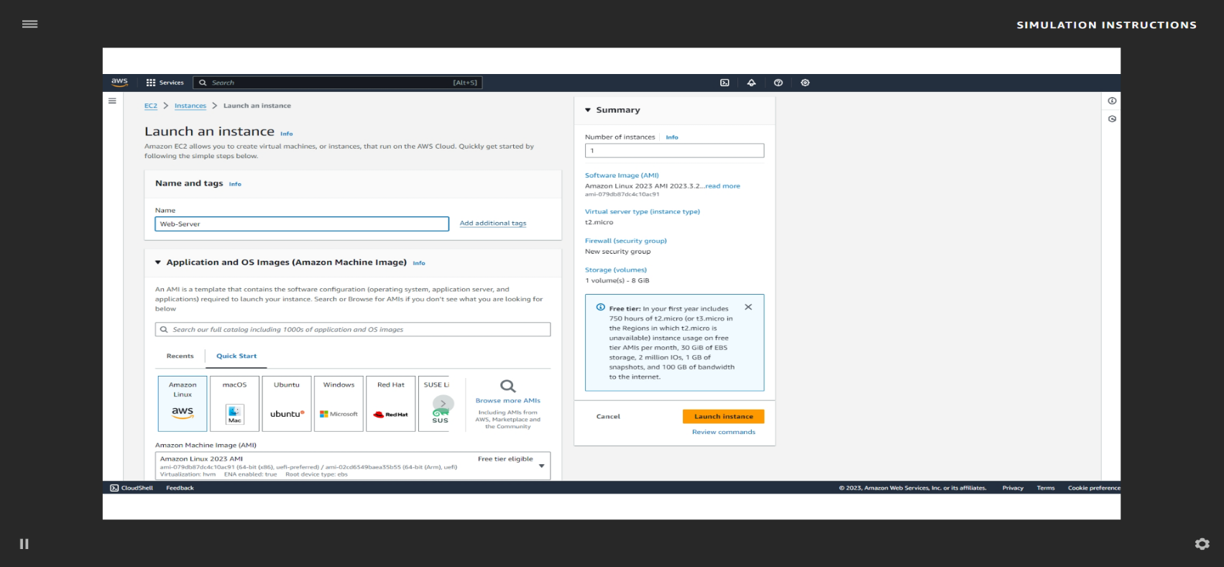
STEP 2: CHOOSE AN AMI
7. Locate the Application and OS Images (Amazon Machine Image) section. It’s below
the Name and tags section. In the search box, enter Windows Server 2019 Base and
choose Enter.
8. Next to Microsoft Windows Server 2019 Base, choose Select.
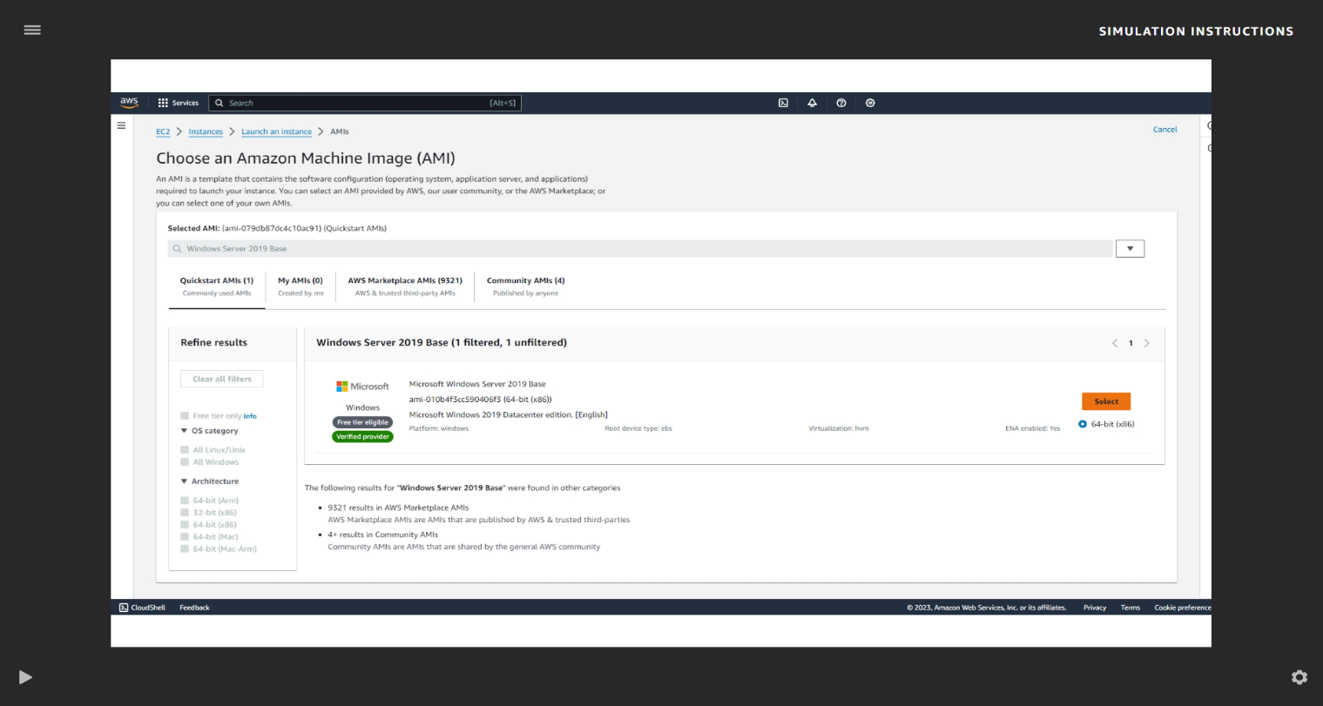
STEP 3: CHOOSE AN INSTANCE TYPE
9. In the Instance type section, keep the default instance type, t2.micro.
STEP 4: CONFIGURE A KEY PAIR
10. In the Key pair (login) section, from the Key pair name - required dropdown list,
choose Proceed without a key pair (not recommended).
STEP 5: CONFIGURE THE NETWORK SETTINGS
11. In the Network settings section, choose Edit.
12. From the VPC - required dropdown list, choose Lab VPC.
13. For Firewall (security groups), choose Select existing security group.
14. From Common security groups, choose Web Server security group.
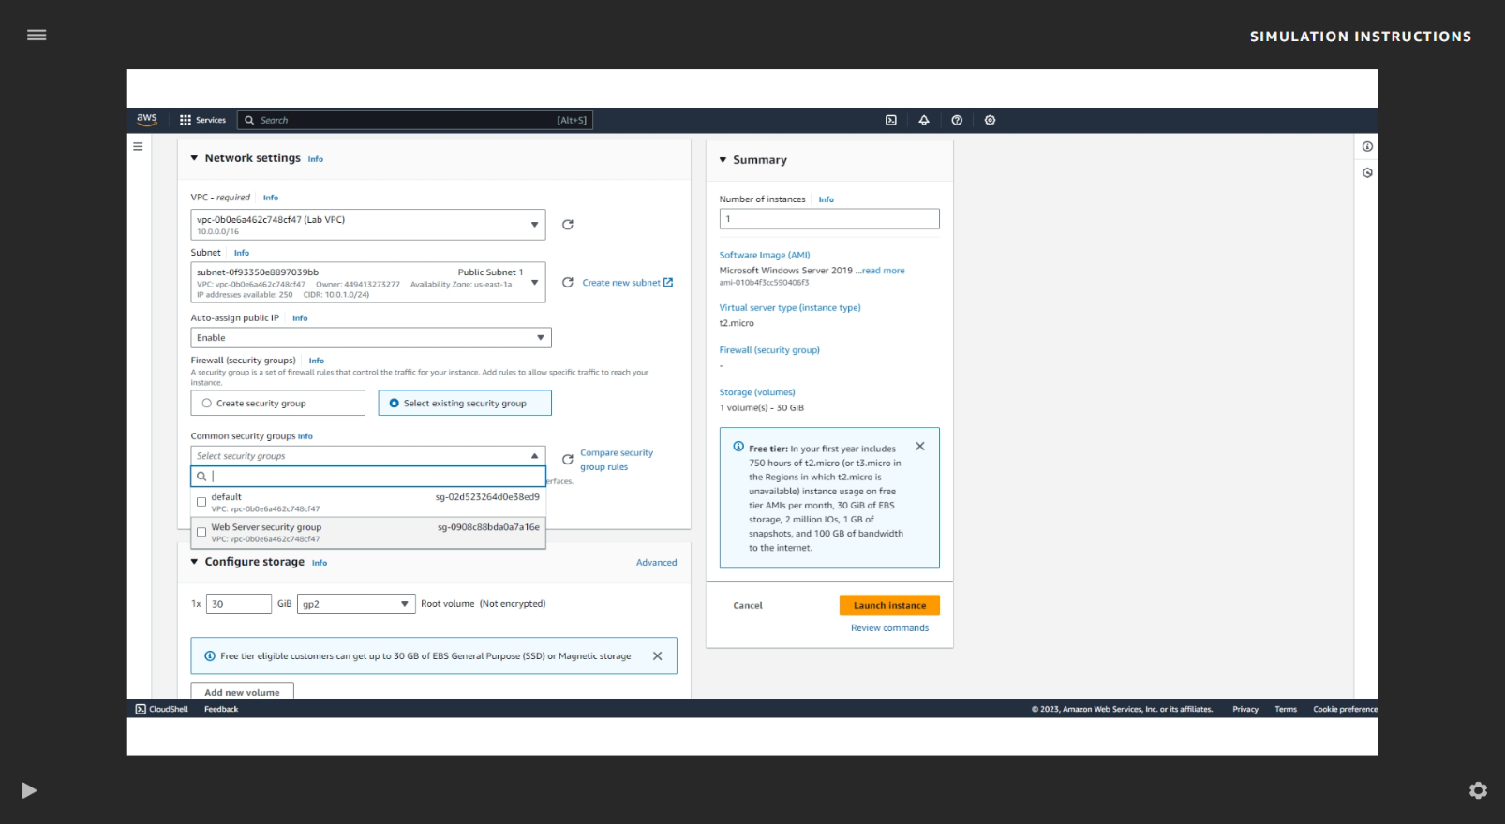
STEP 6: ADD STORAGE
STEP 7: CONFIGURE ADVANCED DETAILS
15. Expand the Advanced details section.
16. For IAM instance profile, choose the role that begins with LabStack in the name.
17. From the Termination protection dropdown list, choose Enable.
18. Copy the following commands, and choose the User data text box. Then, choose Paste.
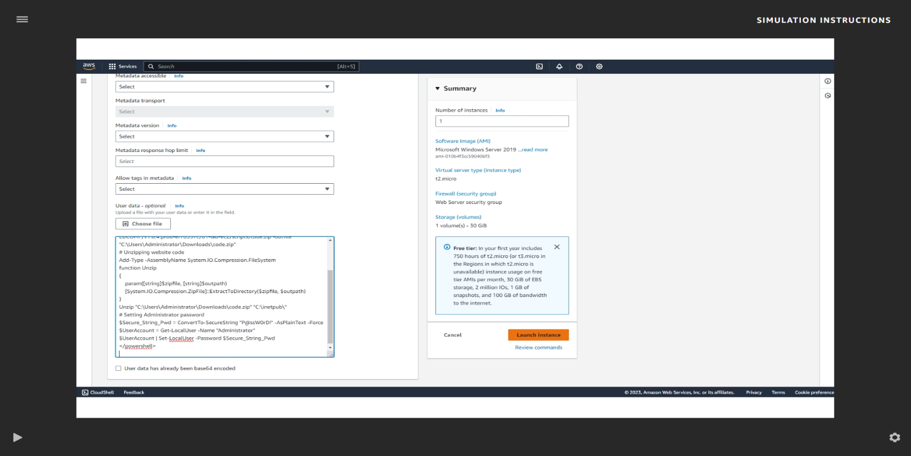
STEP 8: LAUNCH AN EC2 INSTANCE
19. In the Summary section, choose Launch instance.
20. Choose View all instances.
21. Next to your Web-Server, select the check box. This will show the Details tab. Review
the Details tab which displays information about your instance.
22. Choose the Security tab and review the information that’s available to you.
23. Choose the Networking tab and review the information that’s available to you. Next, choose Continue.

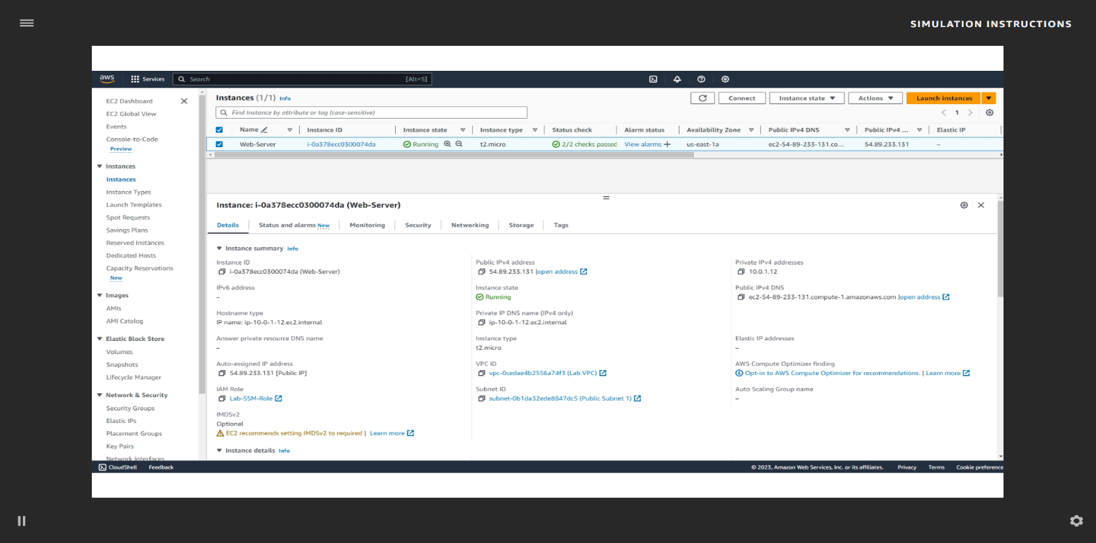
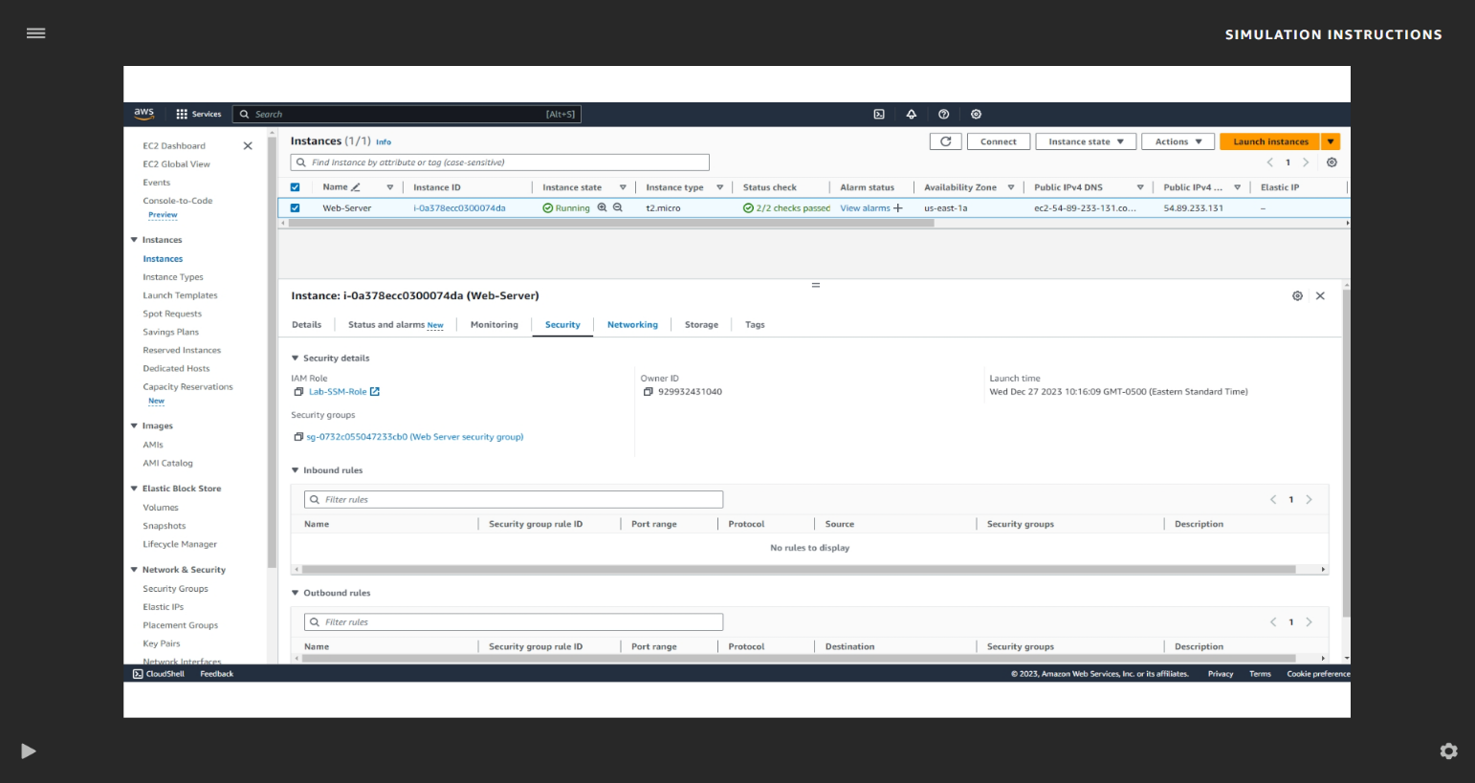
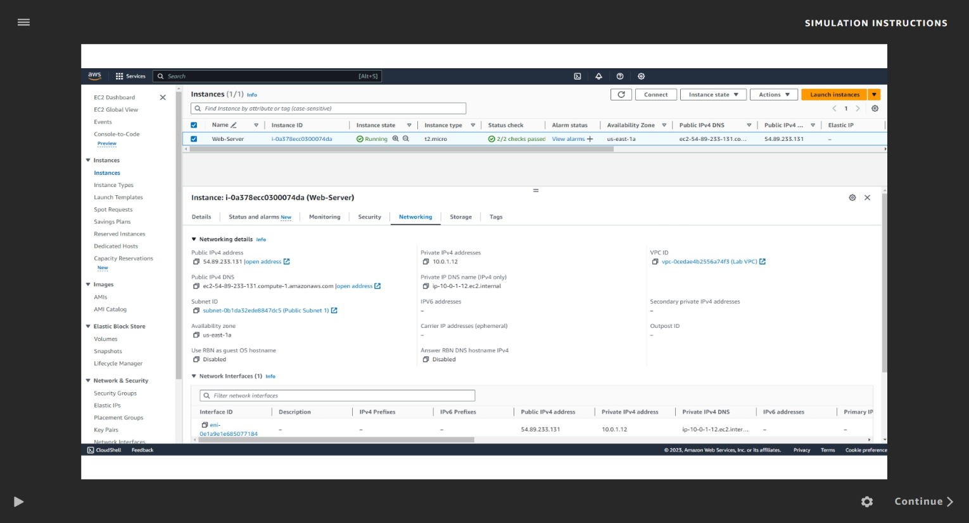
Task 2: Monitor your instance
24. Choose the Status and alarms tab. Review the information that’s available to you.
25. Choose the Monitoring tab.
26. At the top of the page, choose the Actions dropdown list. Choose Monitor and
troubleshoot Get system log.
27. In the System log, review the messages in the output.
28. To return to the Amazon EC2 dashboard, choose Cancel.
29. With your Web-Server selected, choose the Actions dropdown list, and choose Monitor
and troubleshoot Get instance screenshot.
30. At the bottom of the page, choose Cancel.
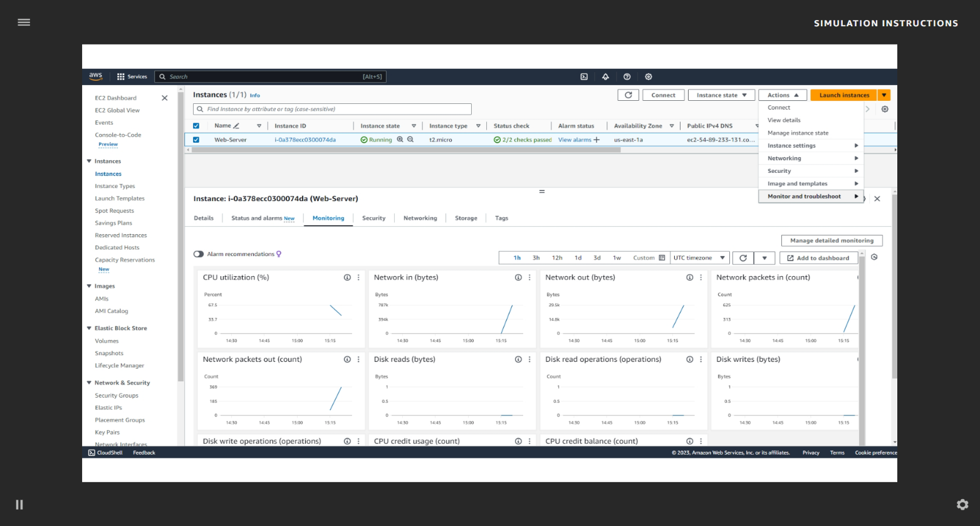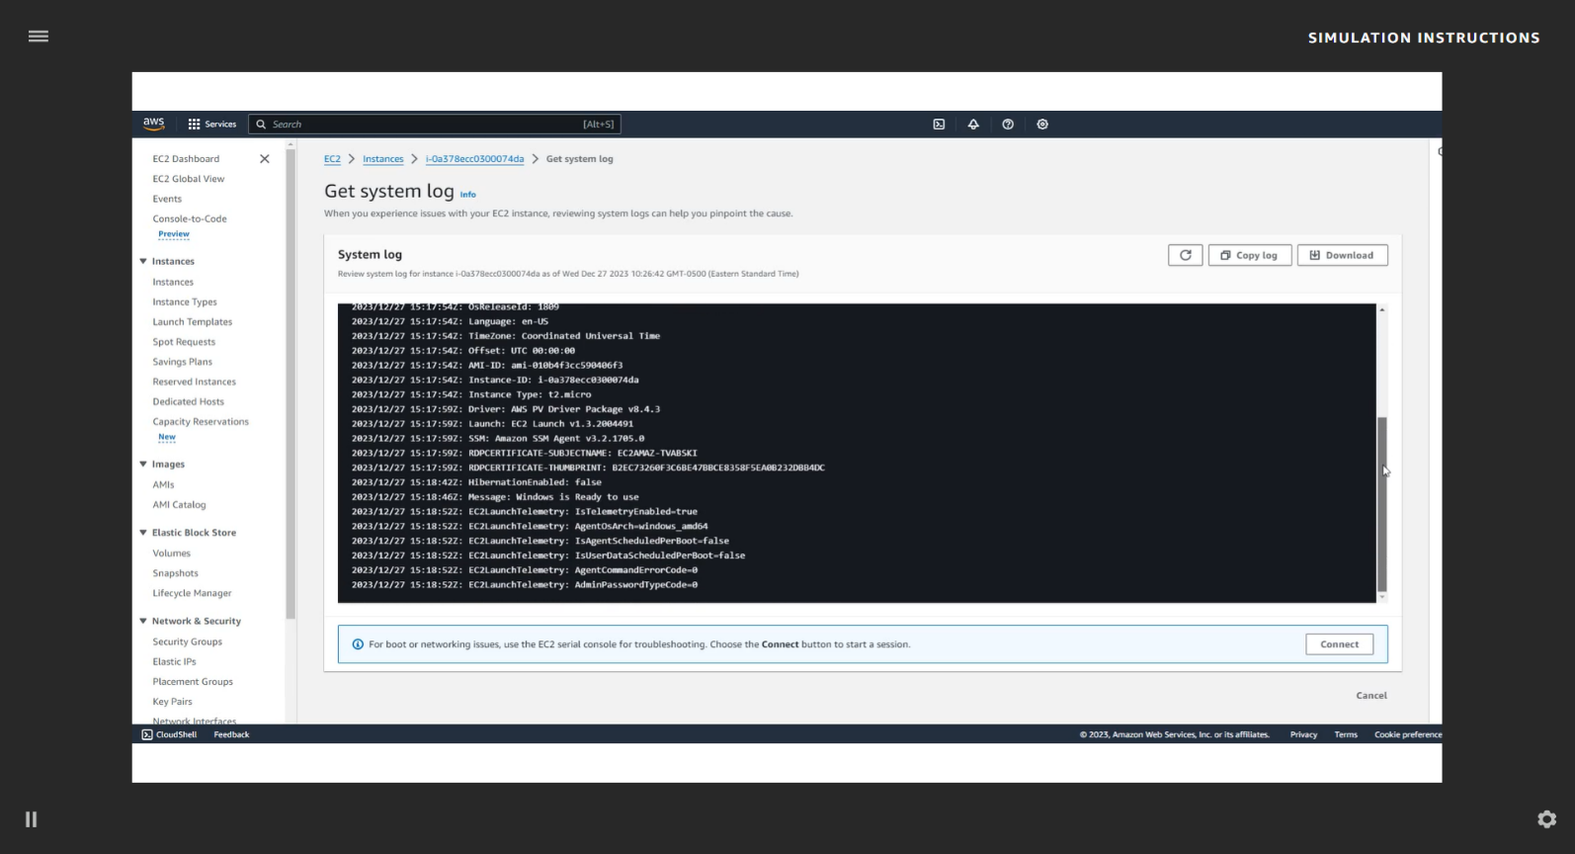

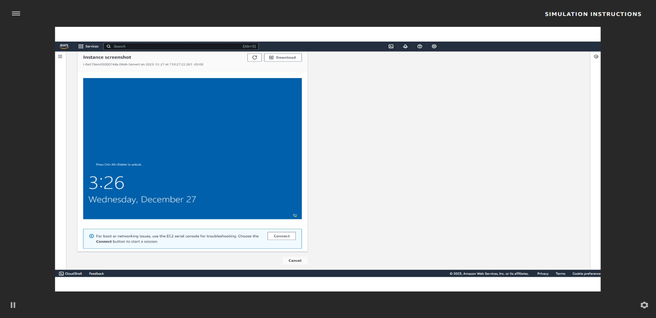
Task 3: Updating your security group and accessing the
31. In the left navigation pane, choose Security Groups.
32. Next to Web Server security group, select the check box.
33. Choose the Inbound rules tab.
34. Choose Edit inbound rules, and then choose Add rule, and configure the following
options:
• Type: Choose HTTP.
• Source: Choose Anywhere-IPv4.
35. Choose Save rules.
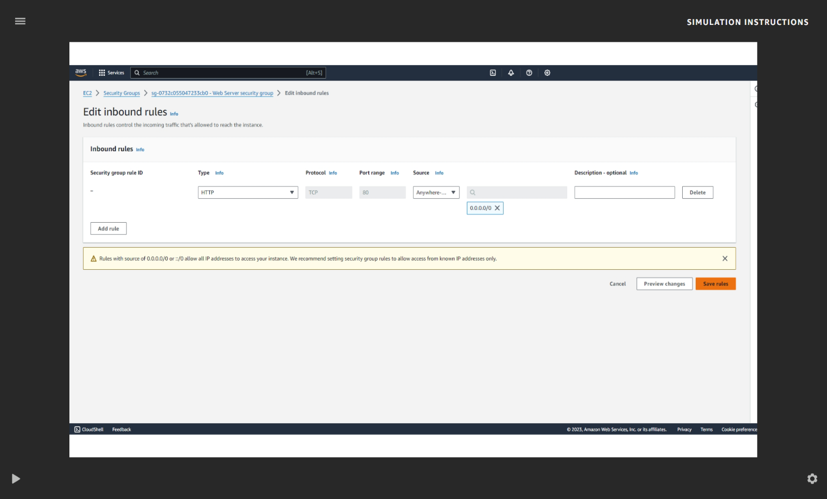
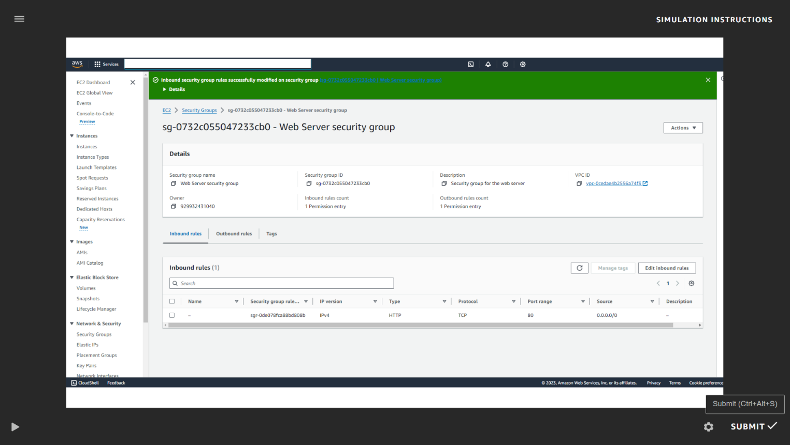
Task 4: Connecting to your instance using AWS
36. Search for Systems Manager and choose Enter.
37. Choose Systems Manager.
38. In the left navigation pane, choose Fleet Manager.
39. Under Managed nodes, select your Web-Server EC2 instance.
40. From the Node actions dropdown list, choose Connect, then Connect with Remote Desktop.
41. Enter the Username: Administrator
42. Enter the Password: P@ssW0rD!
43. Choose Connect.
44. To disconnect from your Web-Server instance, choose Action and then choose End session.
45. In the pop-up window, choose End session again.
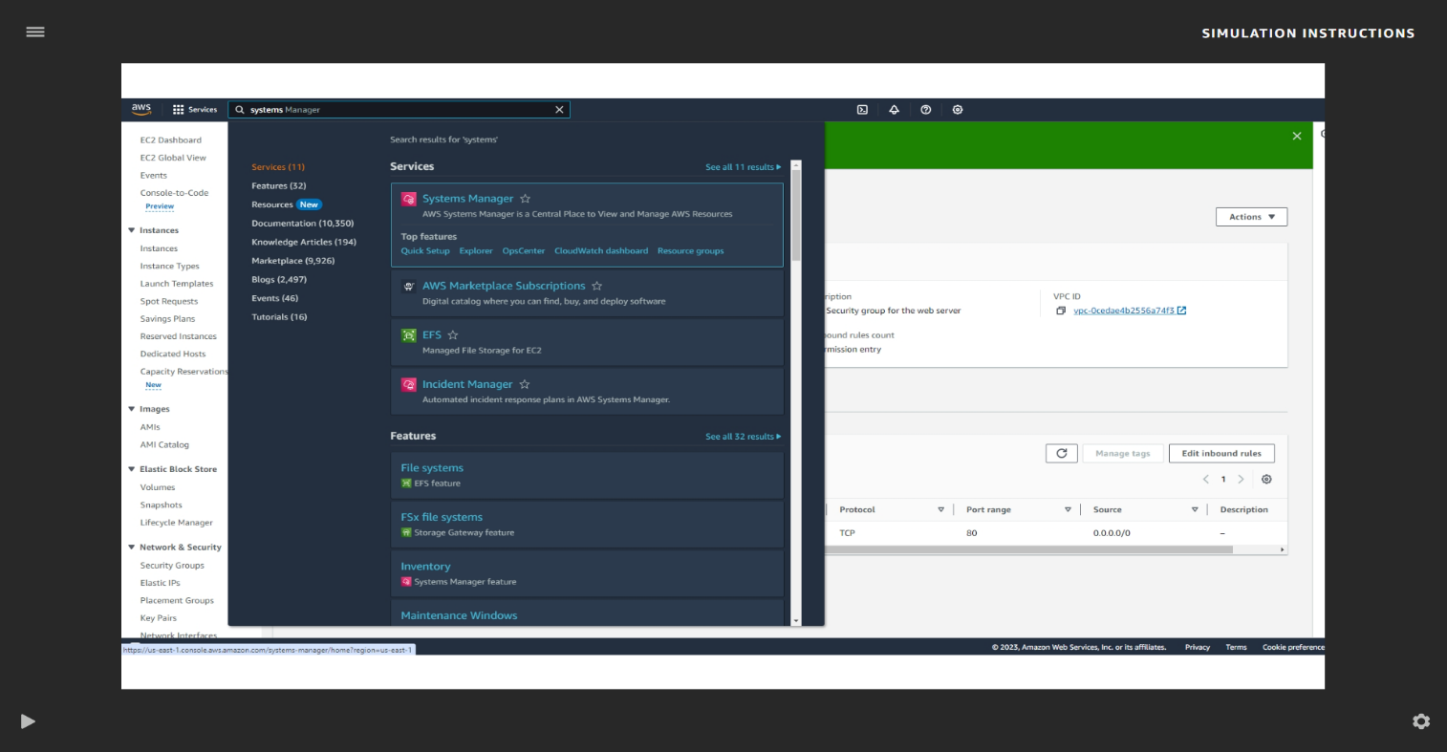
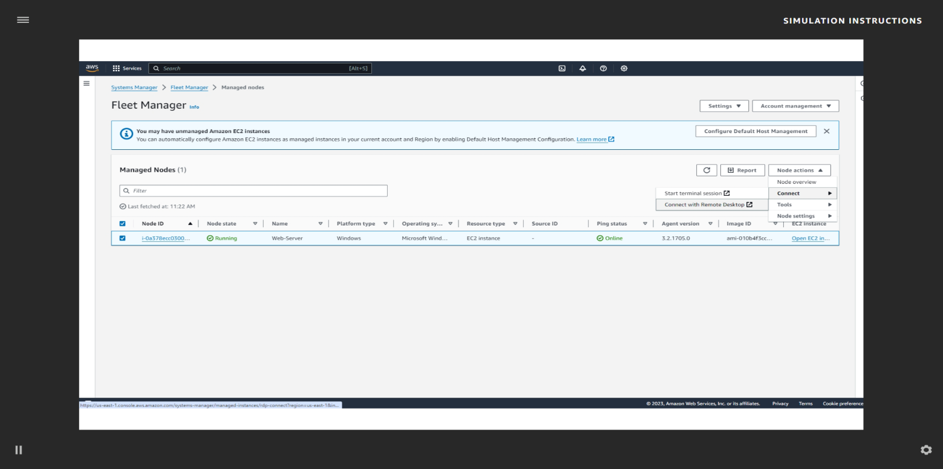
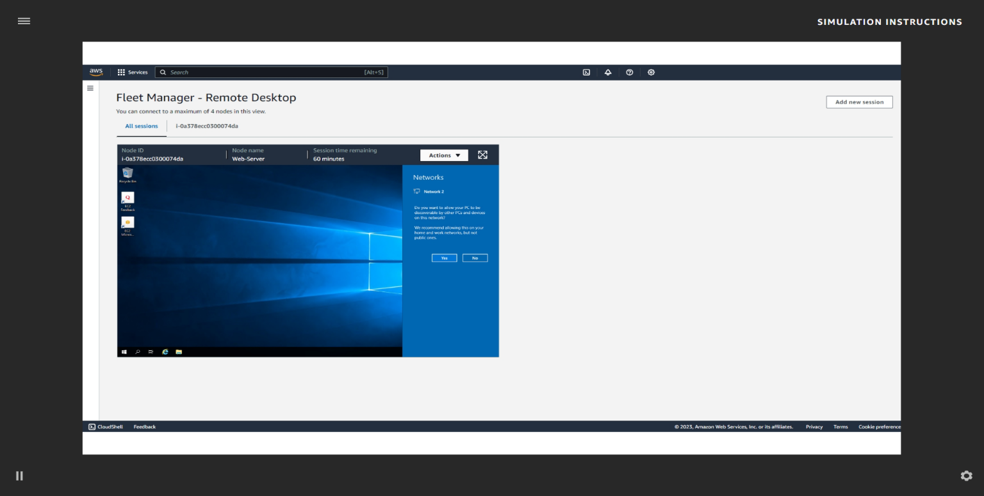
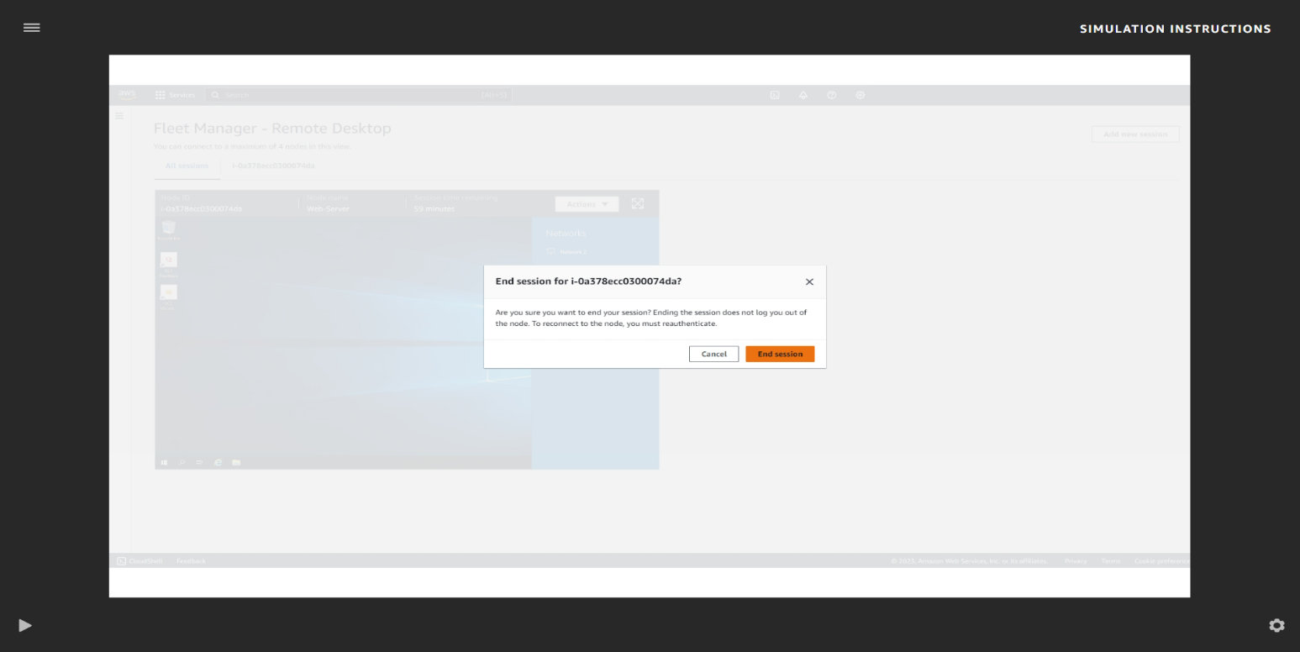
Task 5: Resizing your instance
46. In the AWS Management Console, search for EC2 and choose Enter. Then, choose EC2.
47. On the EC2 Management Console, in the left navigation pane, choose Instances.
48. Select the check box next to your Web-Server instance. At the top of the page, choose the Instance state dropdown list, and choose Stop instance.
49. In the Stop instance? pop-up window, choose Stop.
50. Wait for the Instance state to display Stopped.
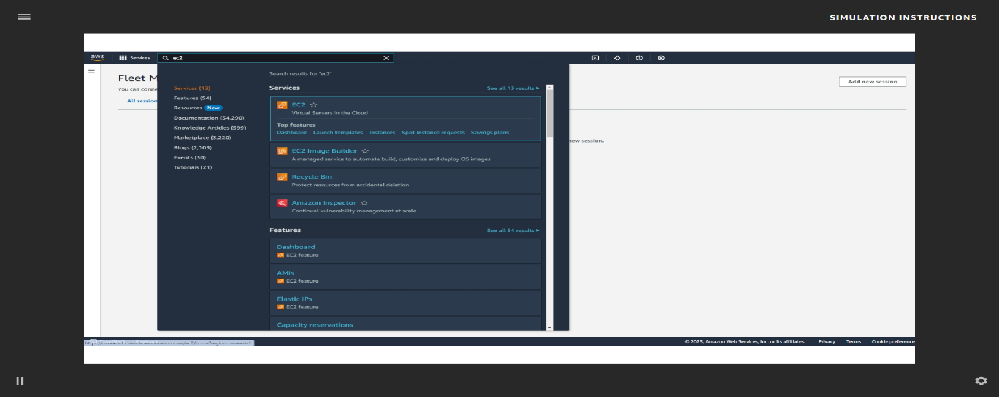
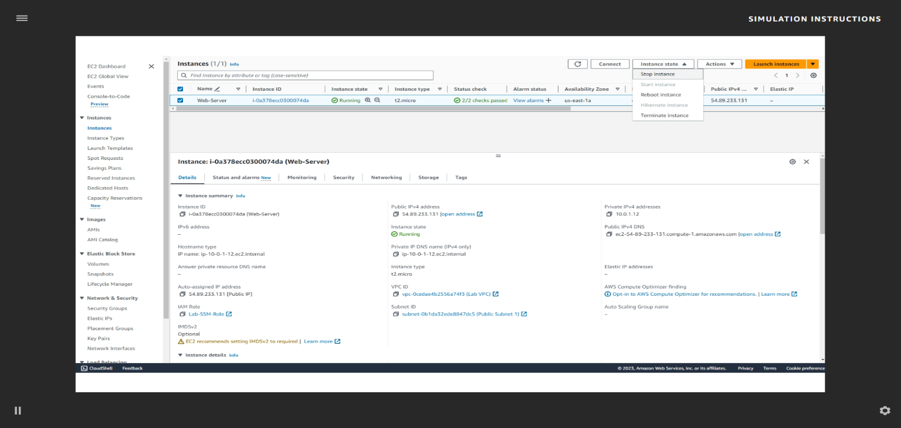
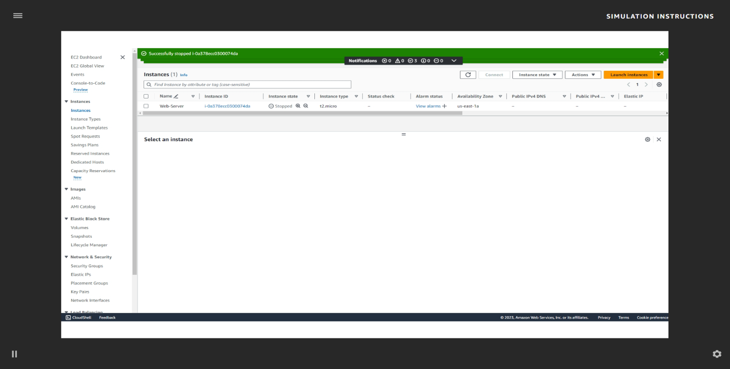
CHANGE THE INSTANCE TYPE
51. Select the check box next to your Web-Server. From the Actions dropdown list,
select Instance settings Change instance type, and then configure the following
option:
• Instance type: Select t2.nano.
52. Choose Apply.
Note: You are restricted from using other instance types in this simulation.
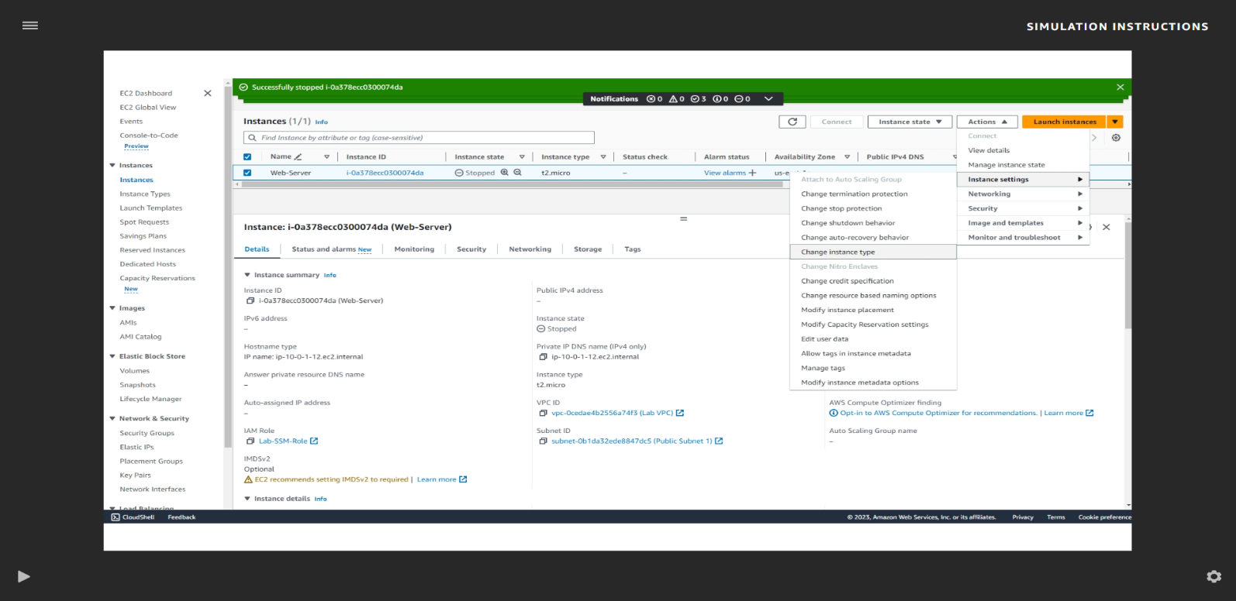
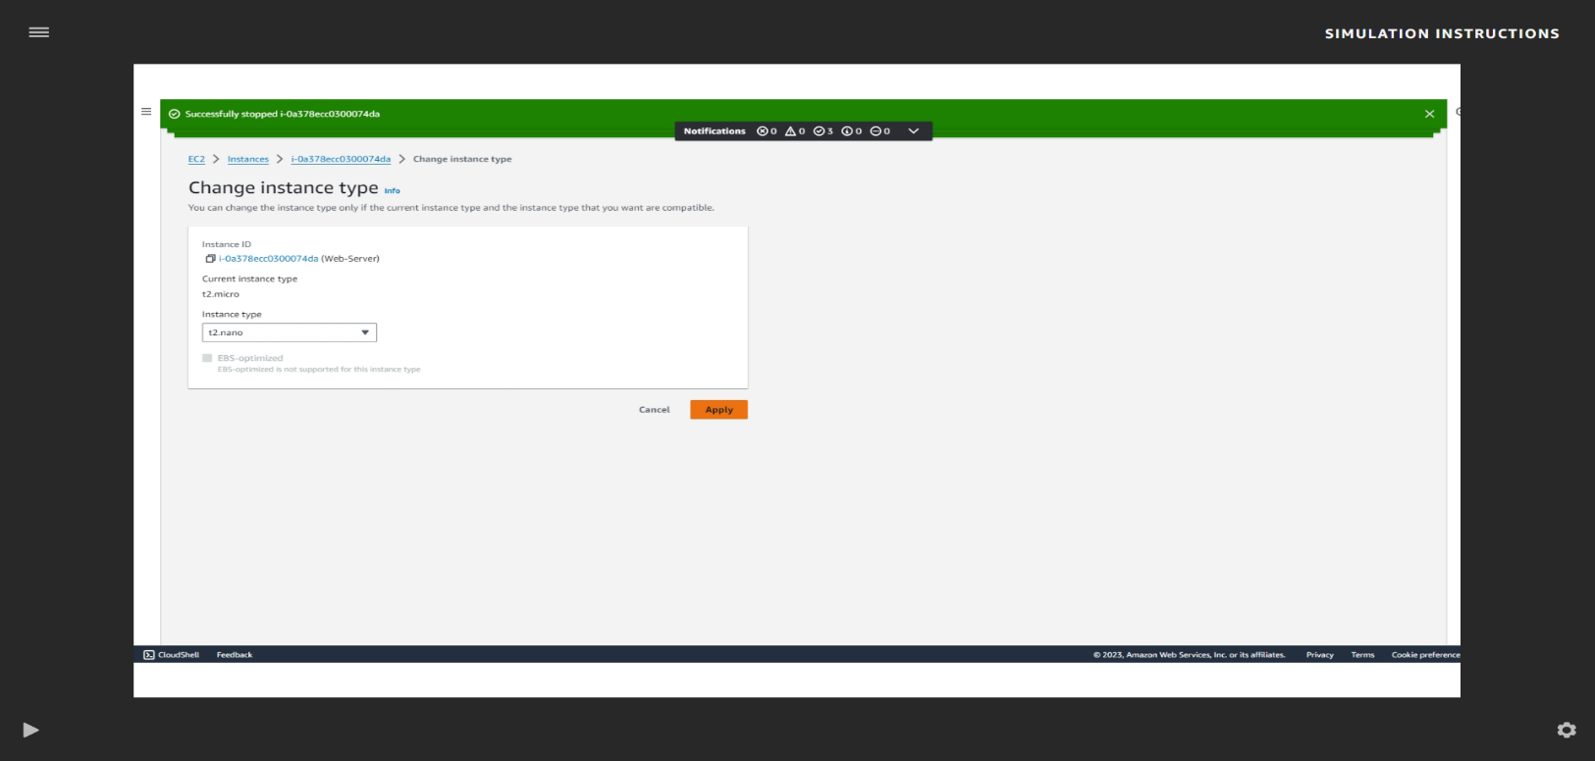
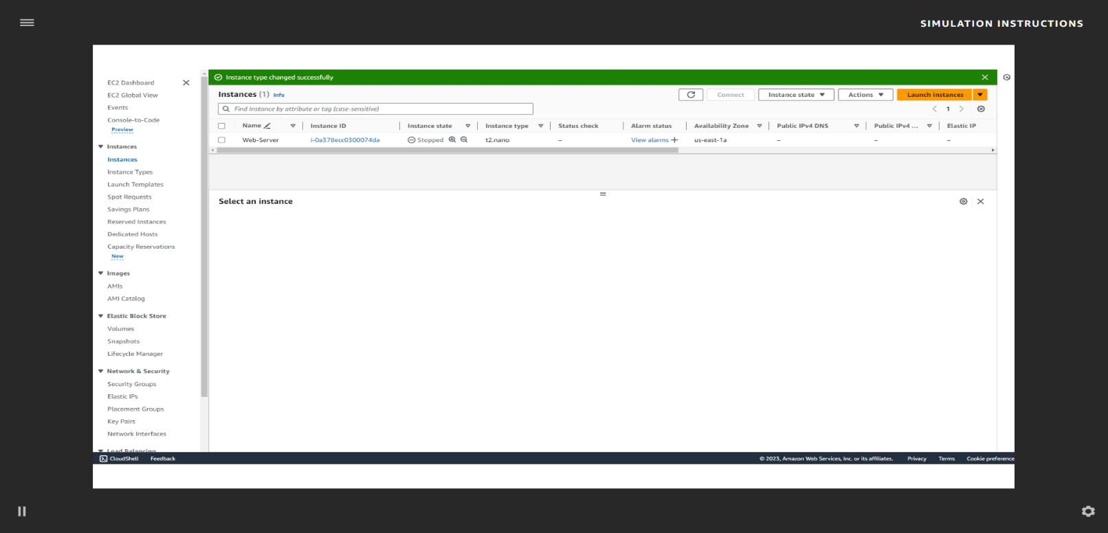
START THE RESIZED INSTANCE
53. Next to your Web-Server, select the check box.
54. From the Instance state dropdown list, choose Start instance.

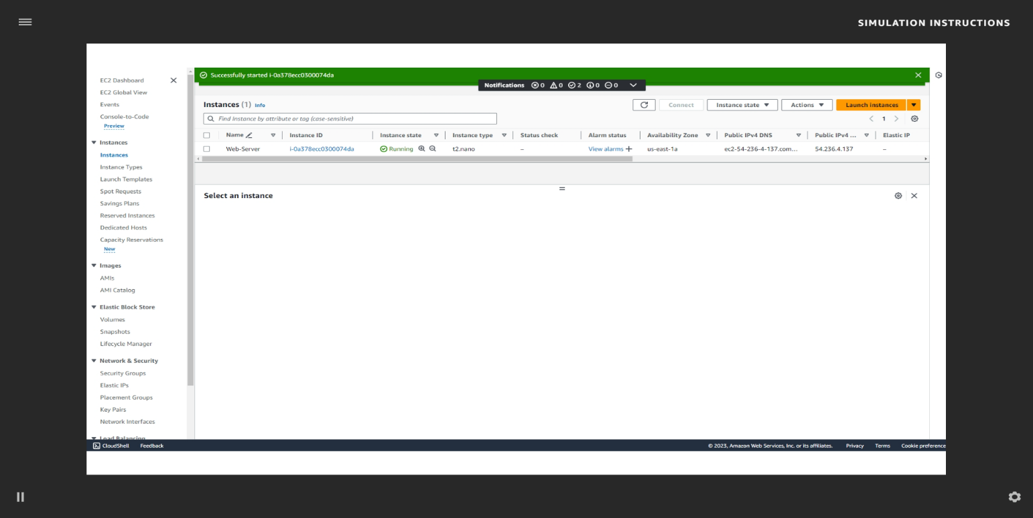
Task 6: Testing termination protection
55. Select the check box next to your Web-Server instance. From the Instance state
dropdown list, choose Terminate instance.
56. Choose Terminate to see what will happen if you try to terminate the instance.
If you really want to terminate the instance, you need to turn off termination protection.
57. From the Actions dropdown list, choose Instance settings, and then choose Change termination protection.
58. The check box for Enable will be selected. Clear the checkbox to disable.
59. Choose Save.
60. Now, try to terminate the instance again. From the Instance state dropdown list,
choose Terminate instance.
61. The instance state will now successfully be terminated. Choose Terminate.
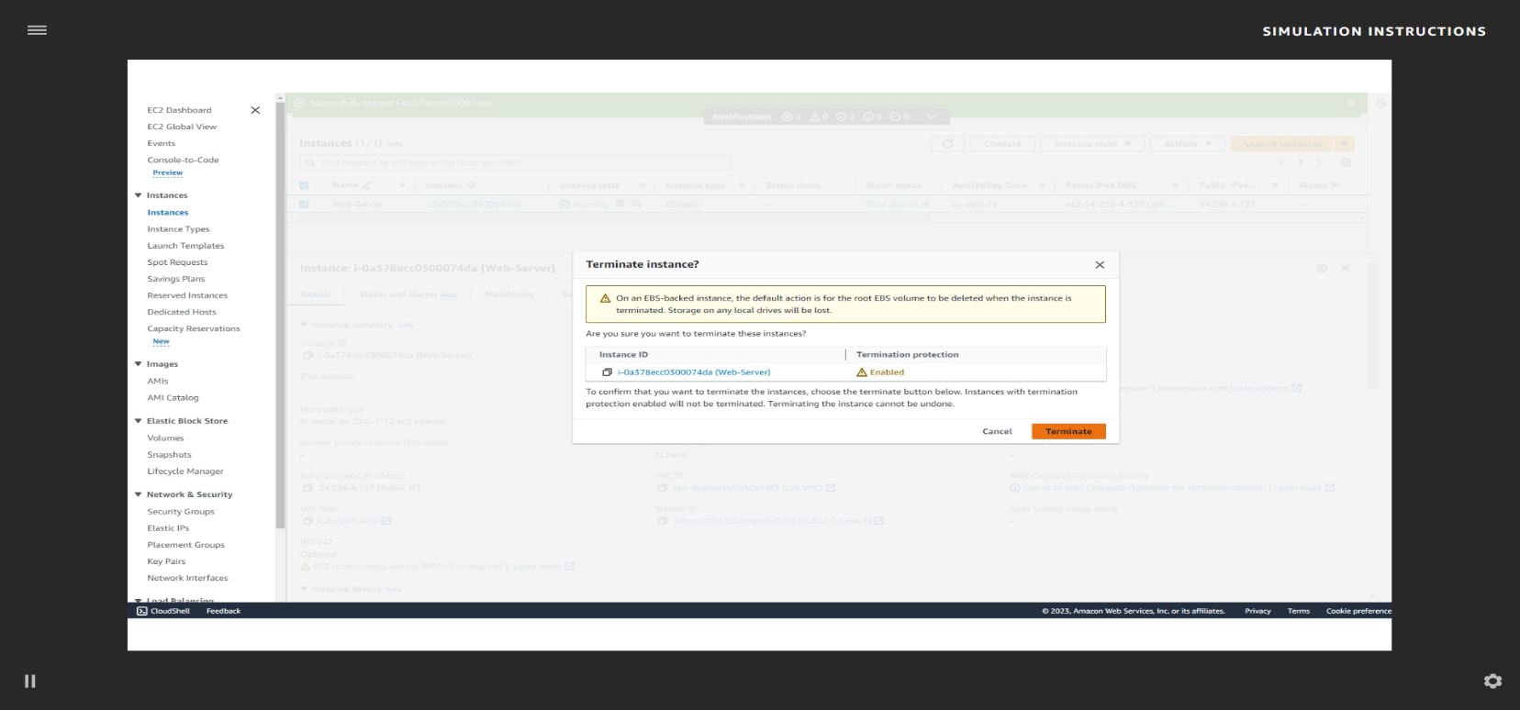

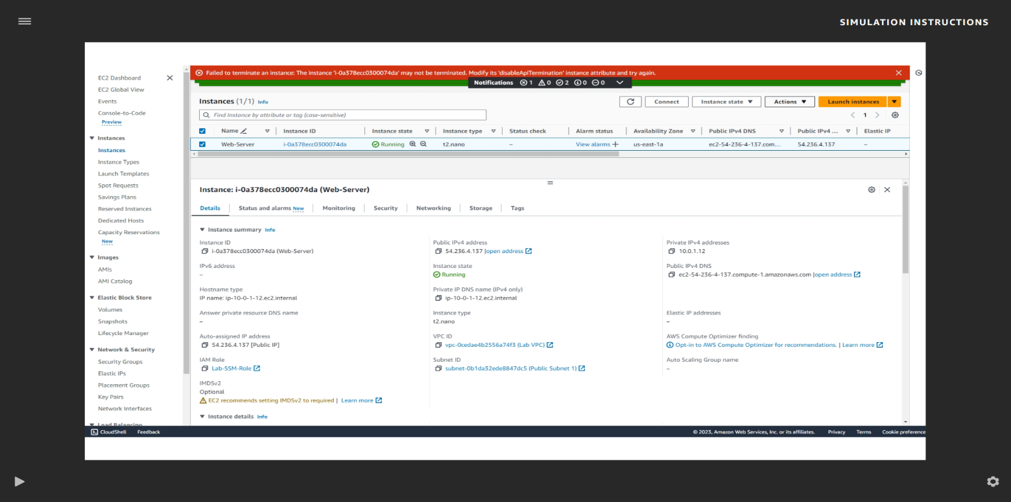
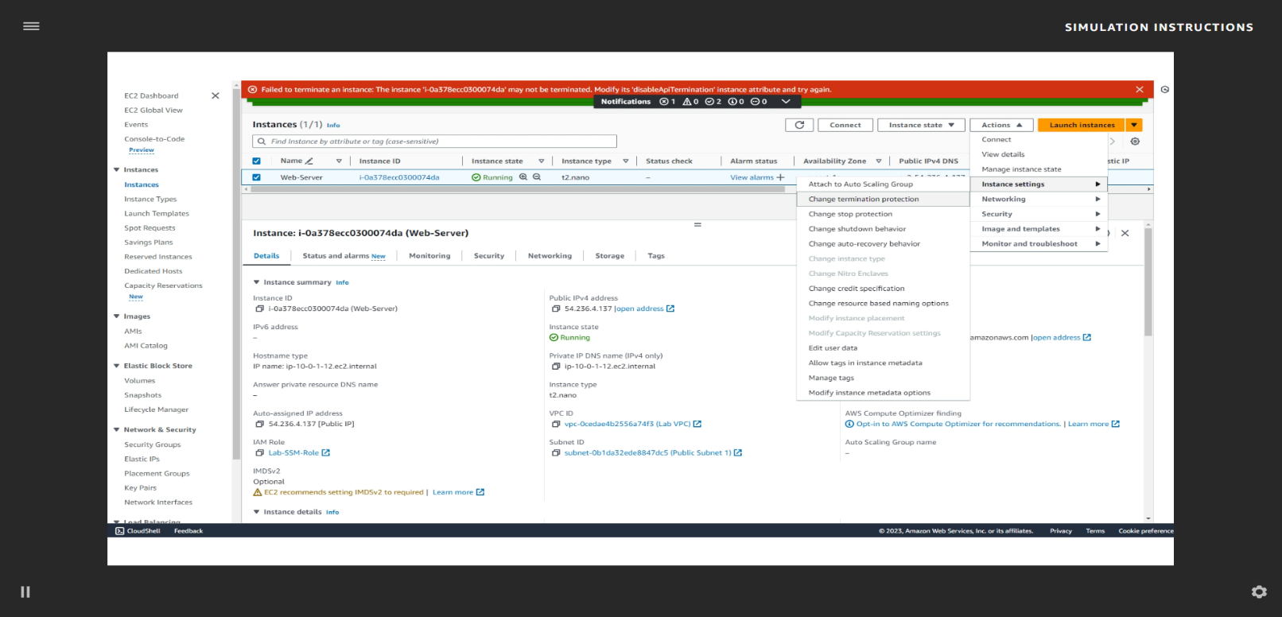
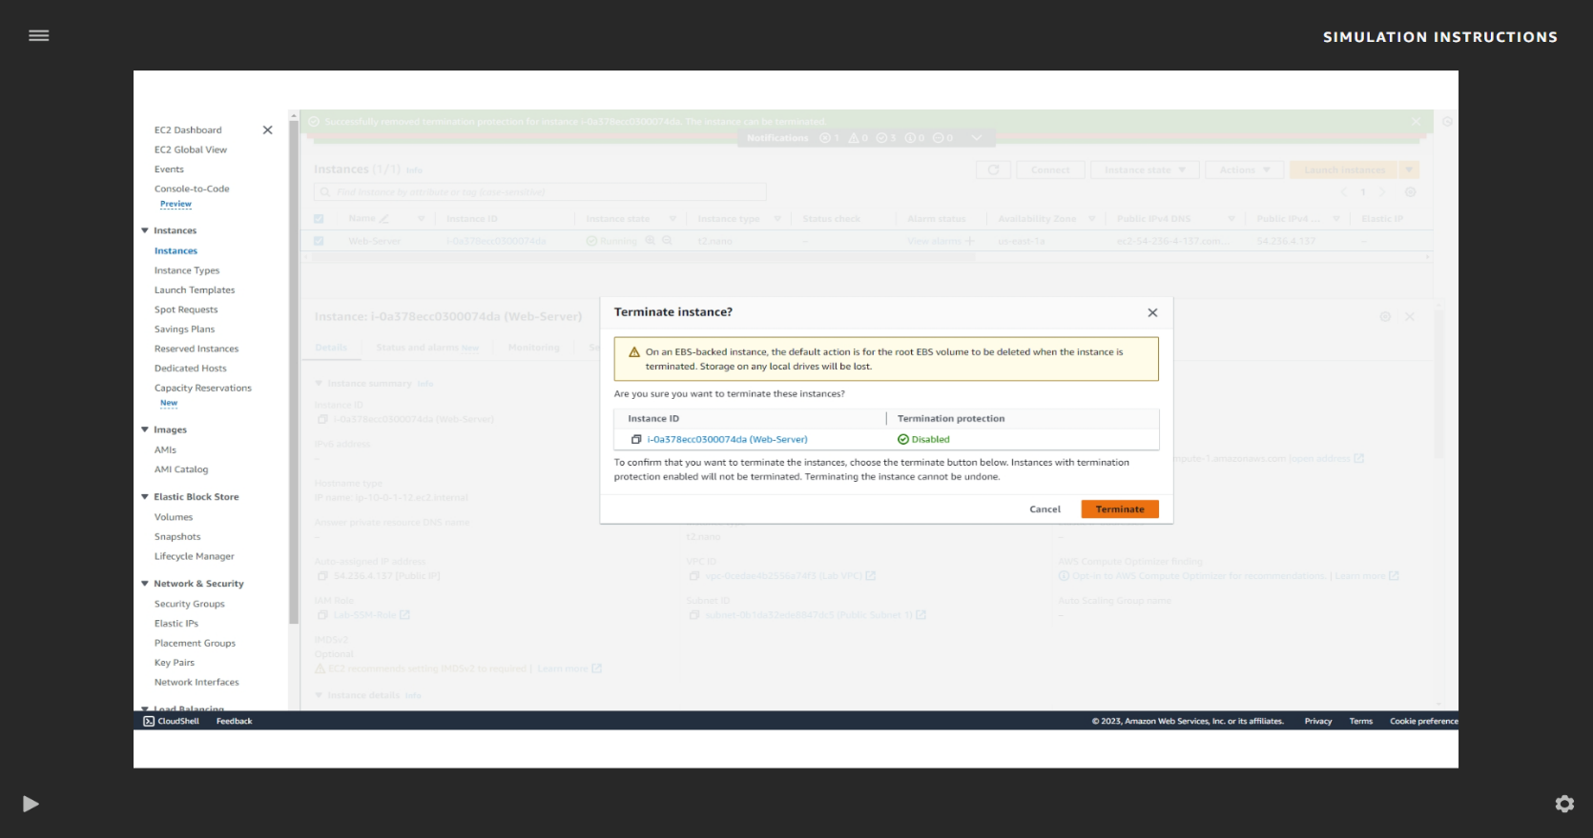
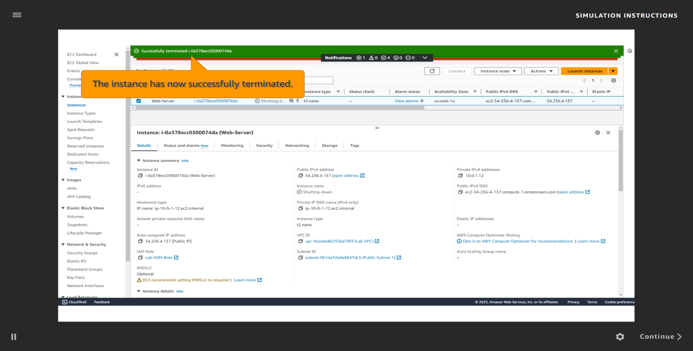
Conclusion:
In this lab, we successfully launched, configured, monitored, resized, and terminated an Amazon EC2 instance. We explored key EC2 features such as AMI selection, key pair setup, security group configuration, IAM roles, and termination protection. This hands-on exercise demonstrated the flexibility and scalability of EC2, reinforcing how AWS allows users to manage virtual servers efficiently and securely.

