ADV-DEVOPS EXPERIMENT-2
Aim : To create bucket using S3.
Theory :
An Amazon S3 bucket is a fundamental component within Amazon Web Services (AWS) Simple Storage Service (S3), which is an object storage service. Essentially, an S3 bucket serves as a container for storing objects (files) in the cloud.
In essence, an S3 bucket is a highly scalable, durable, and secure storage solution within AWS, providing a flexible way to store and manage diverse types of data in the cloud.
Procedure :
Task 1: Creating a bucket in Amazon S3
1. In the AWS Management Console, choose the search bar and enter S3. Then choose S3 from the search results.
2. Choose Create bucket.
3. For Bucket name, enter sim-website.
4. Choose the scroll bar to scroll down to Object Ownership. For Object Ownership, choose ACLs enabled.
5. Choose the scroll bar to scroll down to Block Public Access settings for this bucket.
6. For Block Public Access settings for this bucket, clear the checkbox for Block all public access. Then, select the box that states I acknowledge that the current settings might result in this bucket and the objects within becoming public.
7. Choose the scroll bar to scroll down to Bucket Versioning.
8.For Bucket Versioning, choose Enable.
9.For Tags, choose Add tag, and enter the following:
Key: Department Value: Marketing
10.Choose the scroll bar to scroll down.
11.Choose Create bucket.
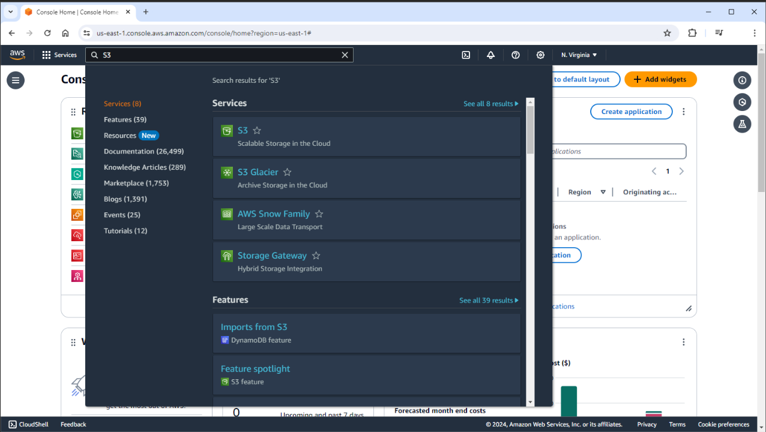
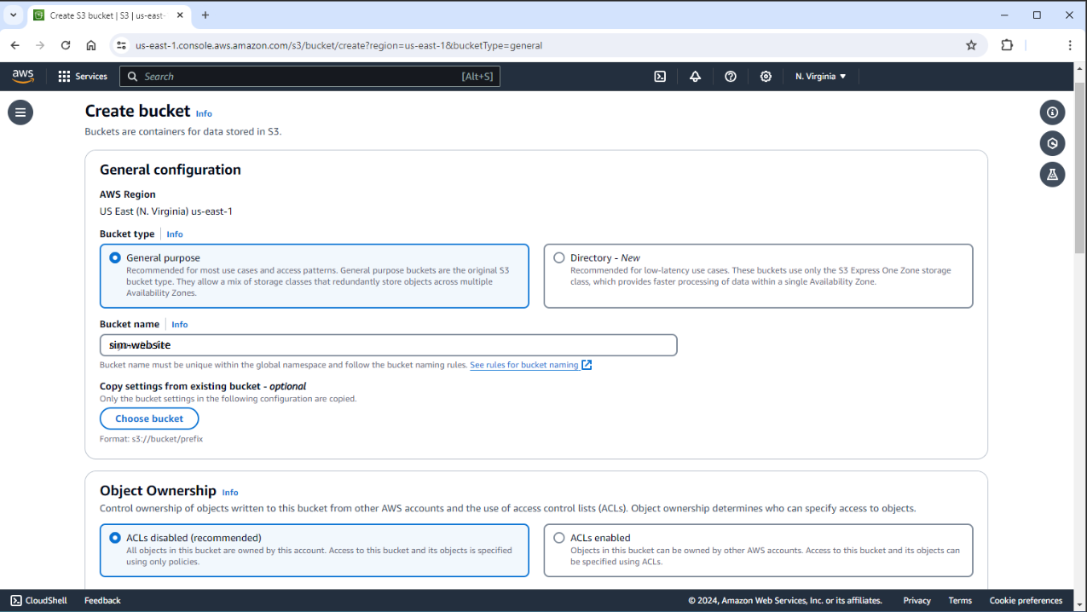
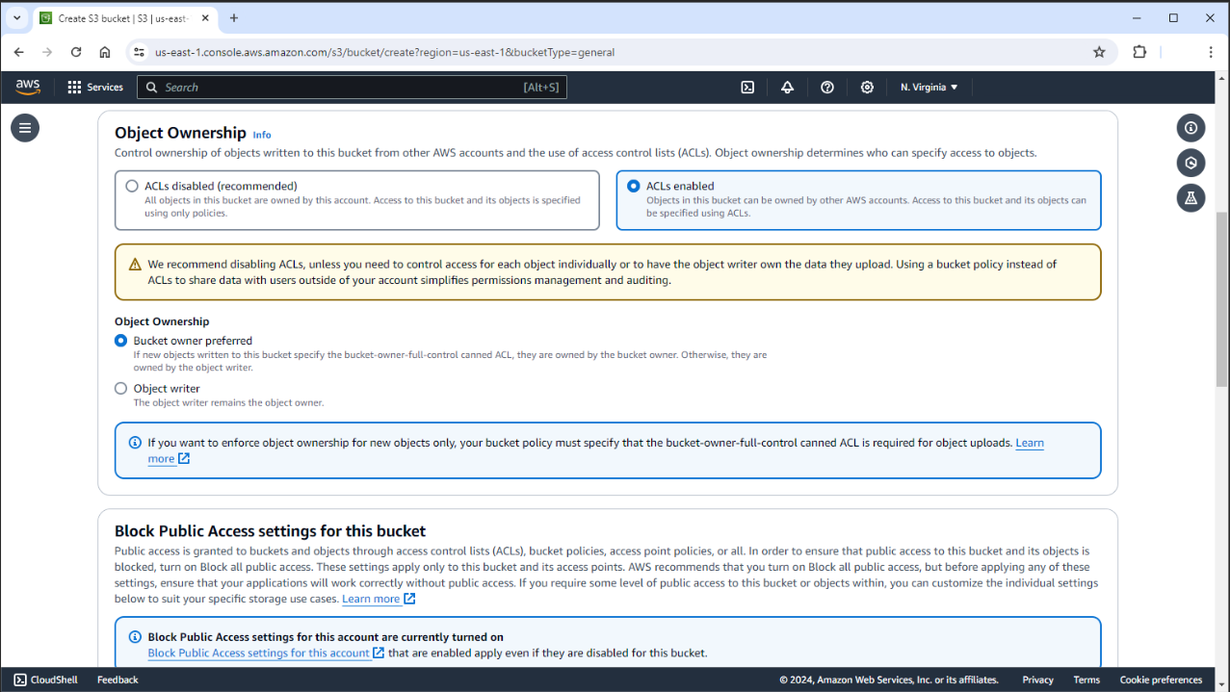
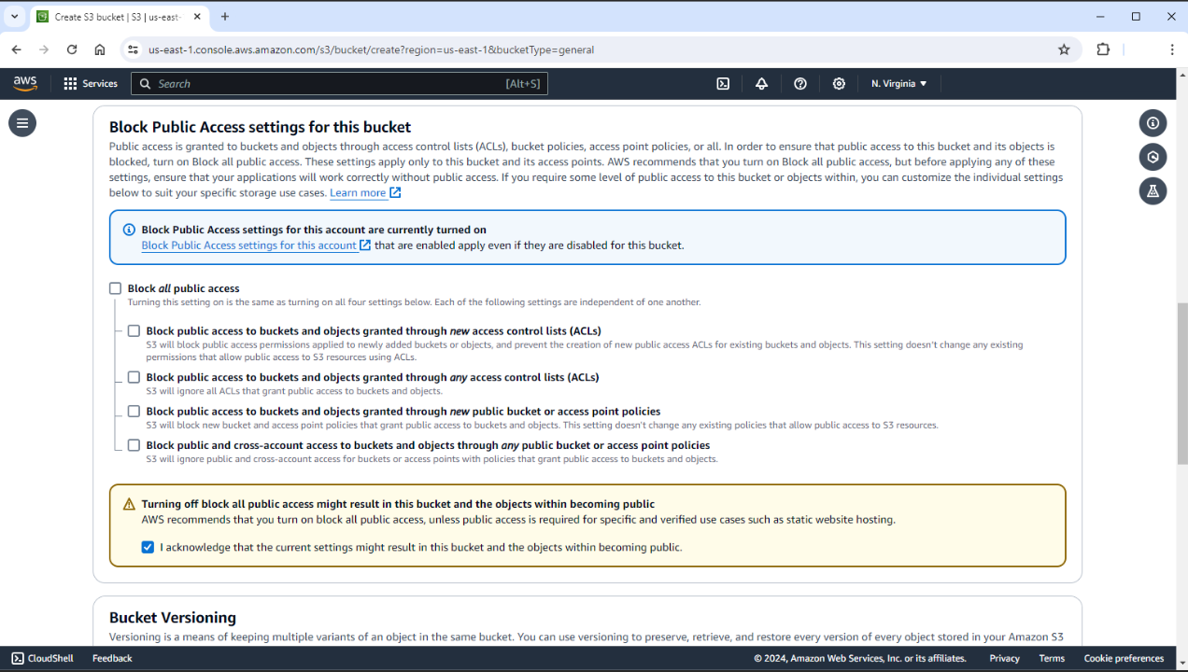
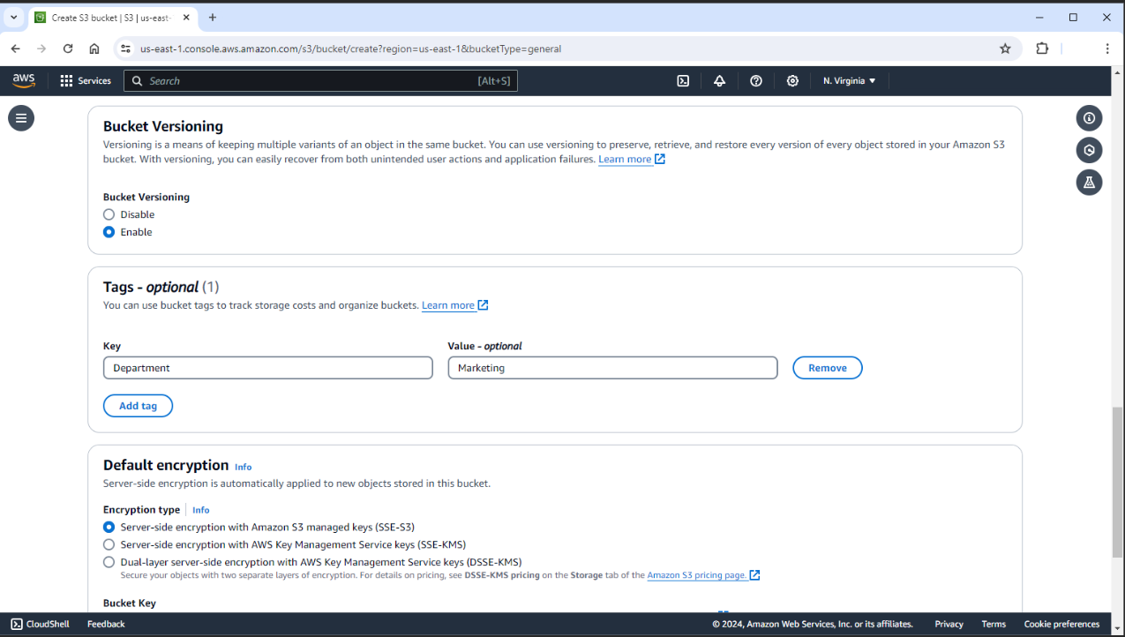
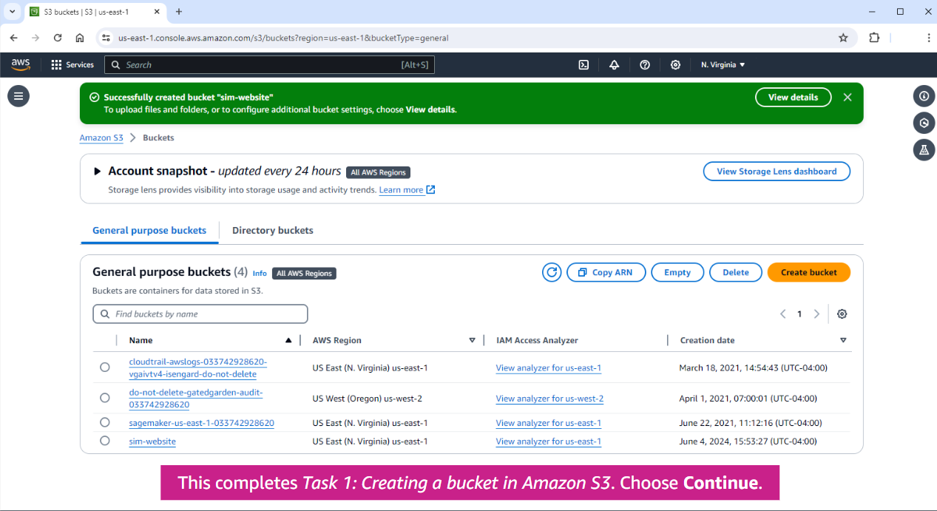
Task 2: Configuring a static website on Amazon S3
12.In the list of your buckets, choose the name of the bucket that you just created, sim-website.
13.Choose the Properties tab.
14.Choose the scroll bar to scroll to the Static website hosting panel.
15.Choose Edit to the Static website hosting panel, Choose Enable.
16.For Hosting type, keep the default setting Host a static website.
17.Configure the following settings:
Index document: Enter index.html Error document: Enter error.html
18.Choose the scroll bar to scroll down, Choose Save changes.
19.Choose the scroll bar to scroll to the Static website hosting panel.
20.In the Static website hosting panel under Bucket website endpoint, choose the link. A new tab opens where you receive a 403 Forbidden message because you have not yet configured the bucket permissions.
21.Choose the AWS Management Console tab on your browser. You have configured your bucket to host a static website.
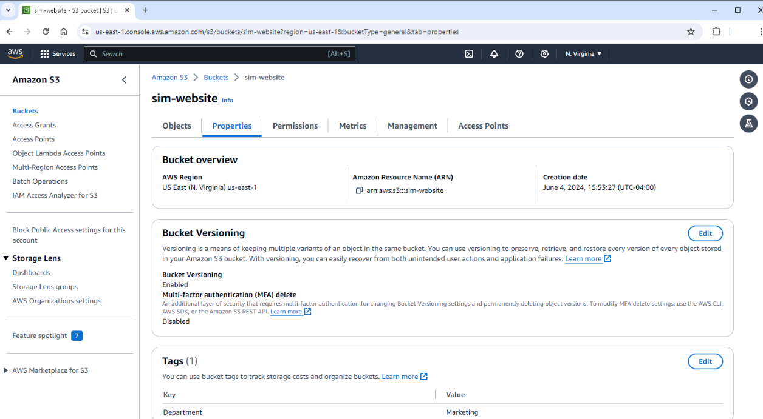
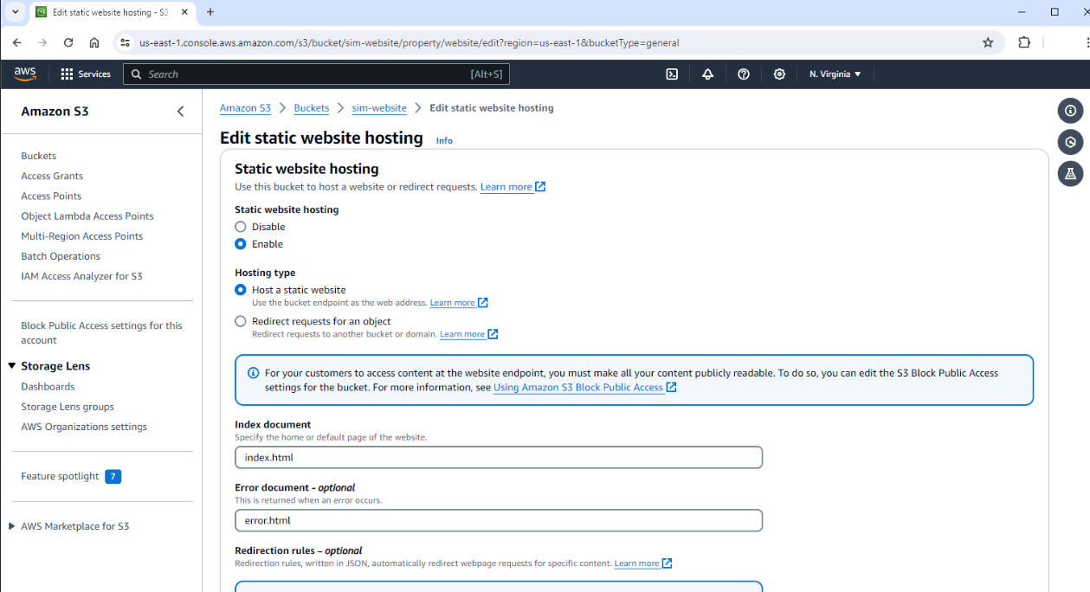
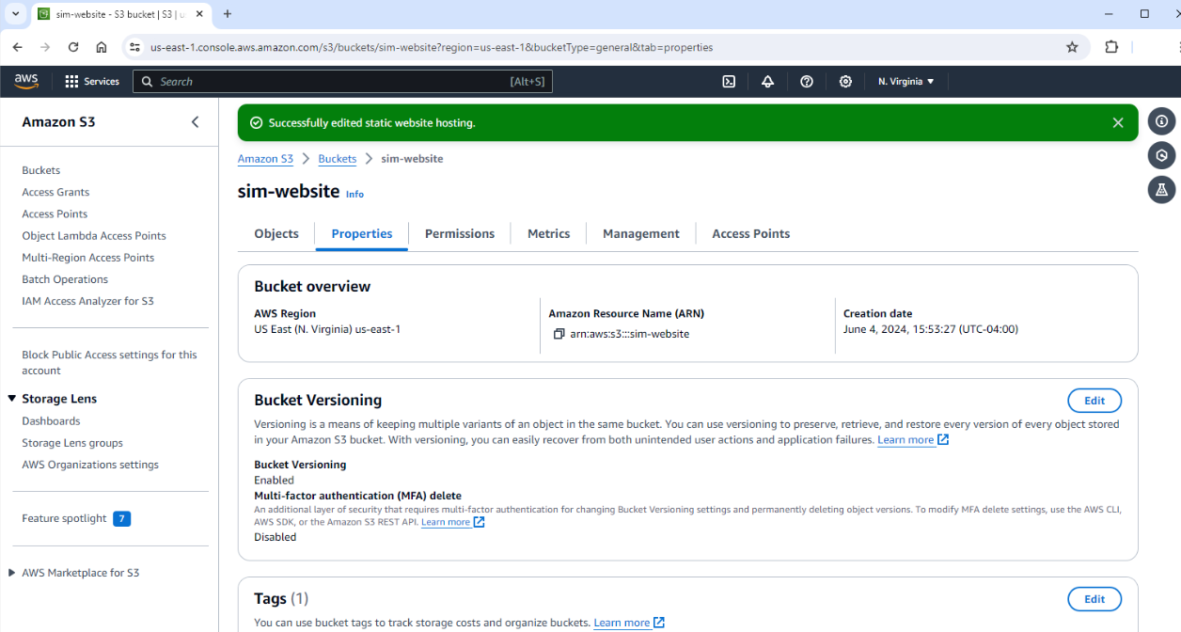
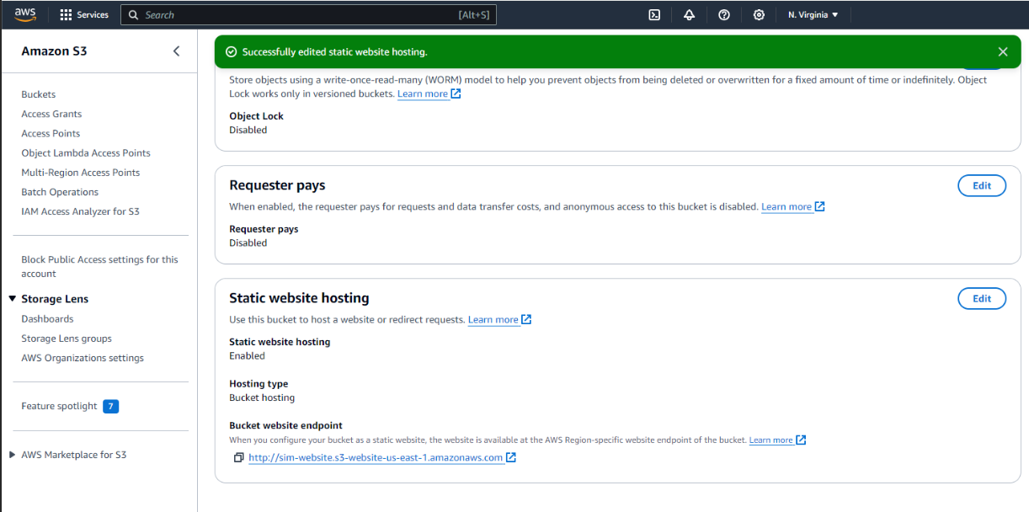
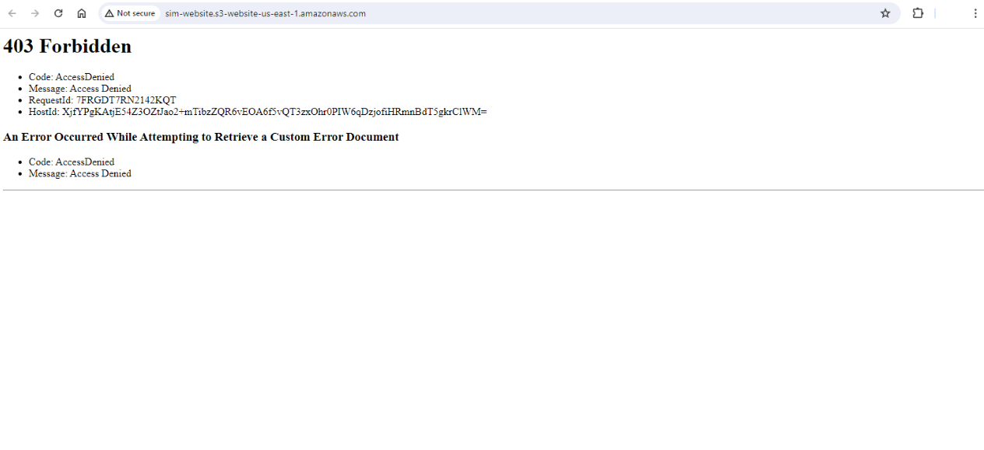
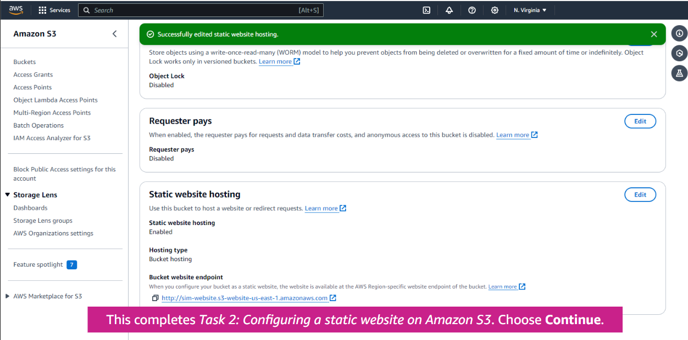
Task 3: Uploading content to your bucket
22.Choose the scroll bar to scroll to the top of the page, and choose the Objects tab. 23.Choose Upload, Choose Add files, Choose the Website files folder, and choose Open to open the folder.
24.Use your mouse to choose each of the following files: index.html, script.js, and style.css (order does not matter). Then choose Open.
25.Choose the scroll bar to scroll down, Choose Upload. Your files are uploaded to the bucket, Choose Close.
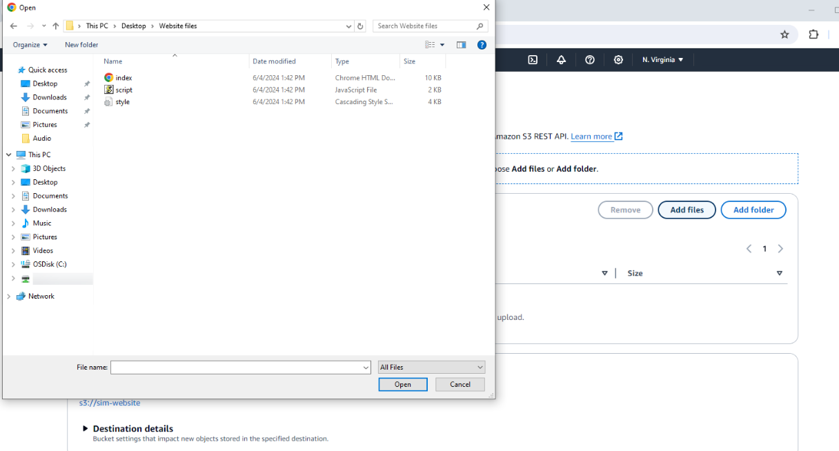
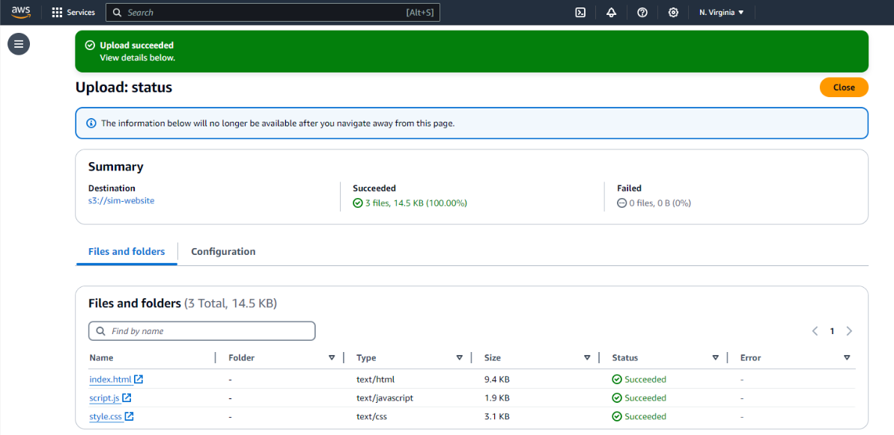
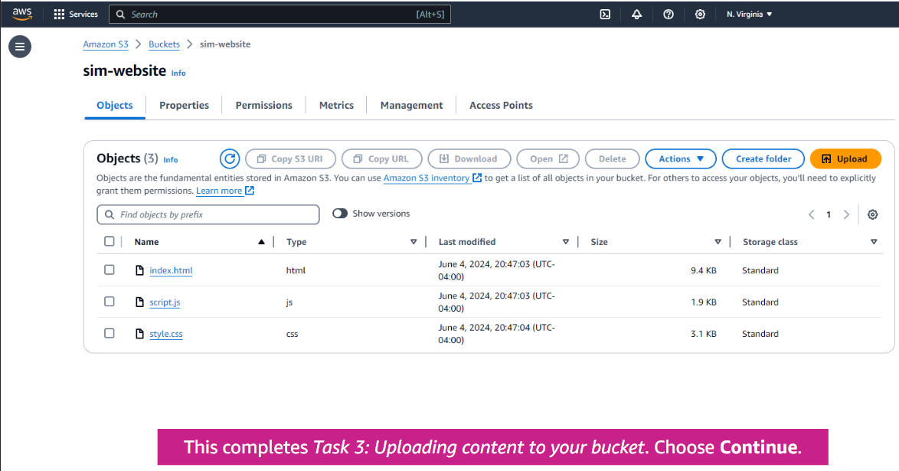
Task 4: Turning on public access to the objects
26.Return to the browser tab that showed the 403 Forbidden message.
27.Choose the Refresh button for the webpage. You should still see a 403 Forbidden message.
28.Keep the website tab open, and return to the web browser tab with the Amazon S3 console.
29.Choose the Name checkbox to select all three objects.
30.In the Actions menu, choose Make public using ACL. A list of the three objects is displayed.
31.Choose Make public. Your static website is now publicly accessible.Choose Close.
32.Return to the web browser tab that has the 403 Forbidden message; Refresh the webpage. You should now see the static website that Amazon S3 is hosting.
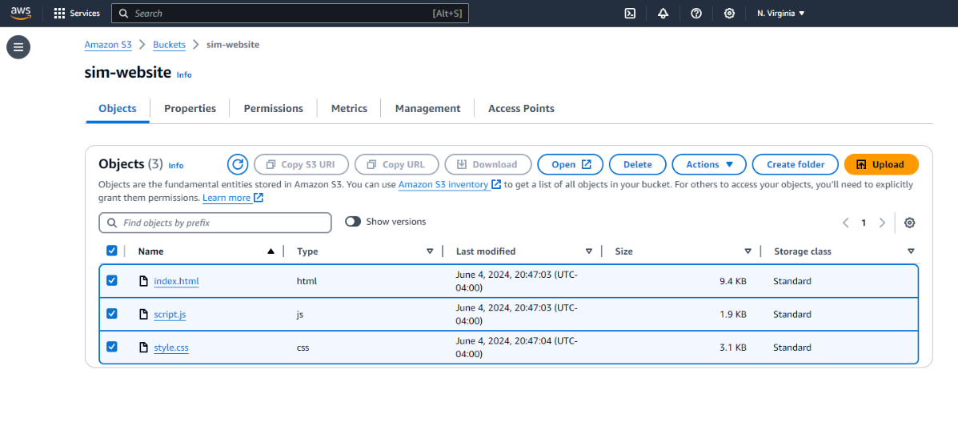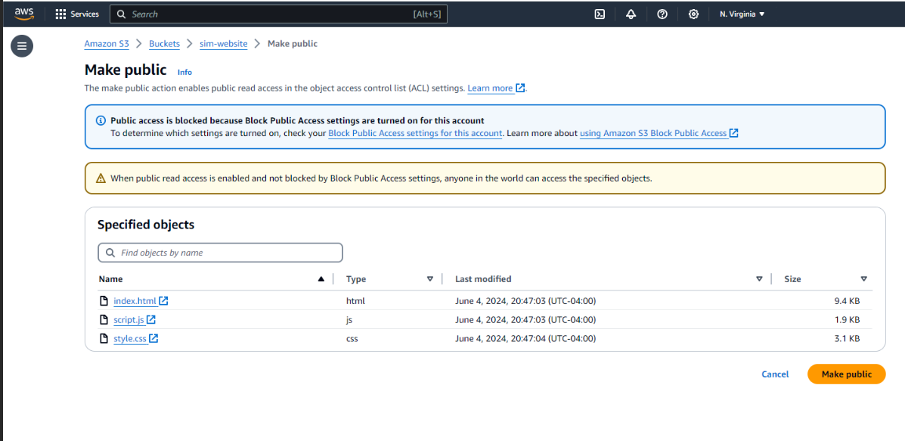
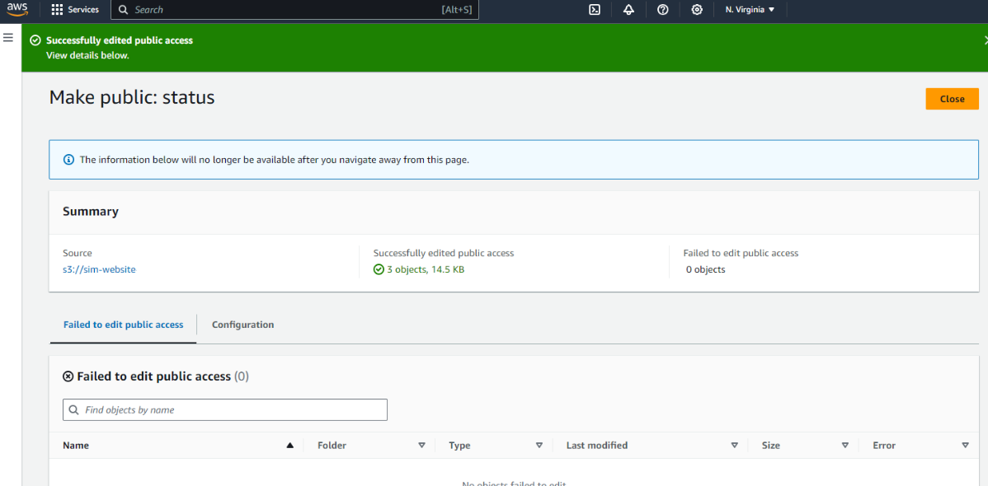
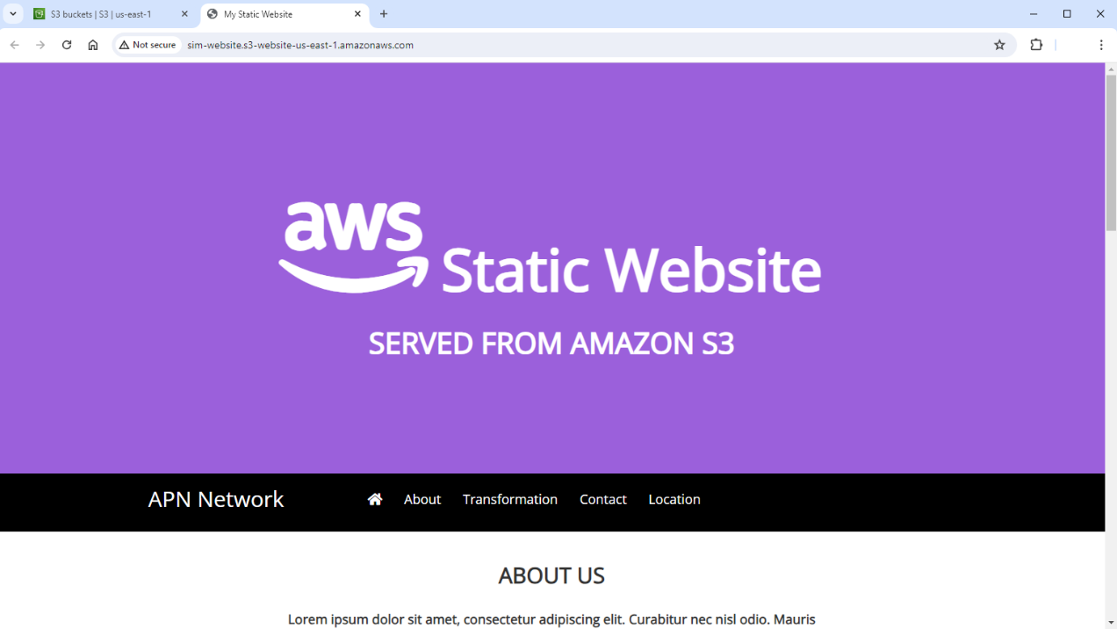
Task 5: Securely sharing an object by using a presigned URL
33.Choose Upload > Choose Add files > Choose the file new-report file and choose Open.
34.Choose the scroll bar to scroll down & Choose Upload then Choose Close.
35.In the Objects tab, choose new-report.png > From the Actions menu, select Share with a presigned URL > In the pop-up window, keep the default Minutes selected for the Time interval until the presigned URL expires. For Number of minutes, enter 2.
36.Choose Create presigned URL > From the banner at the top of the page, choose Copy presigned URL > Open a new browser tab > Paste the URL that you copied into the address bar.
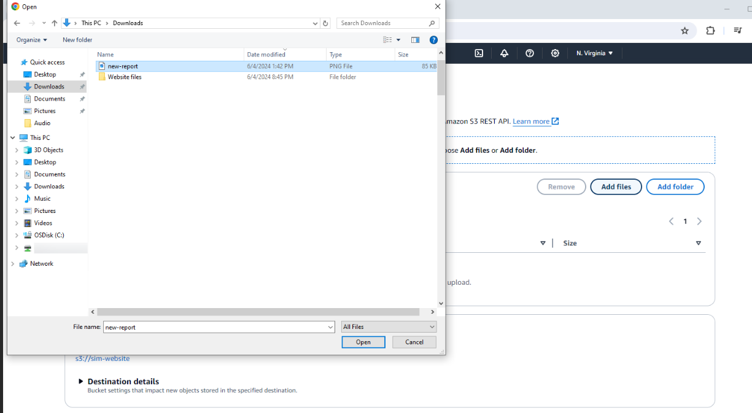
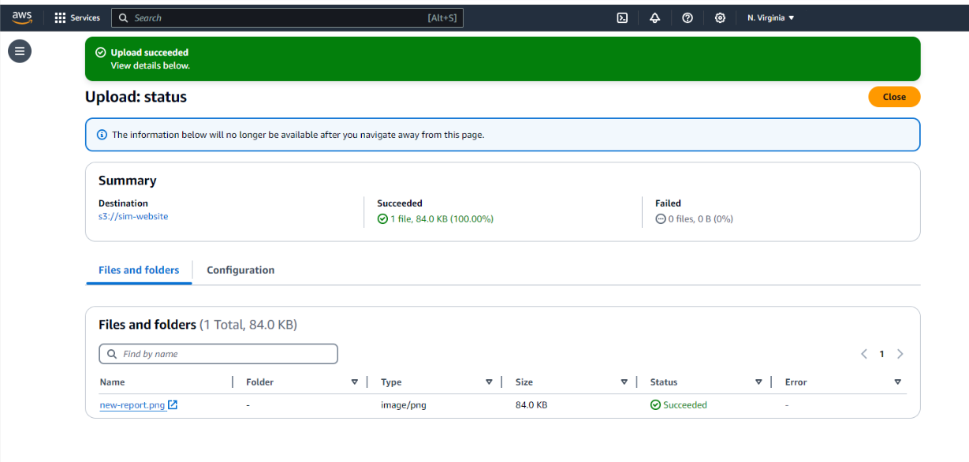
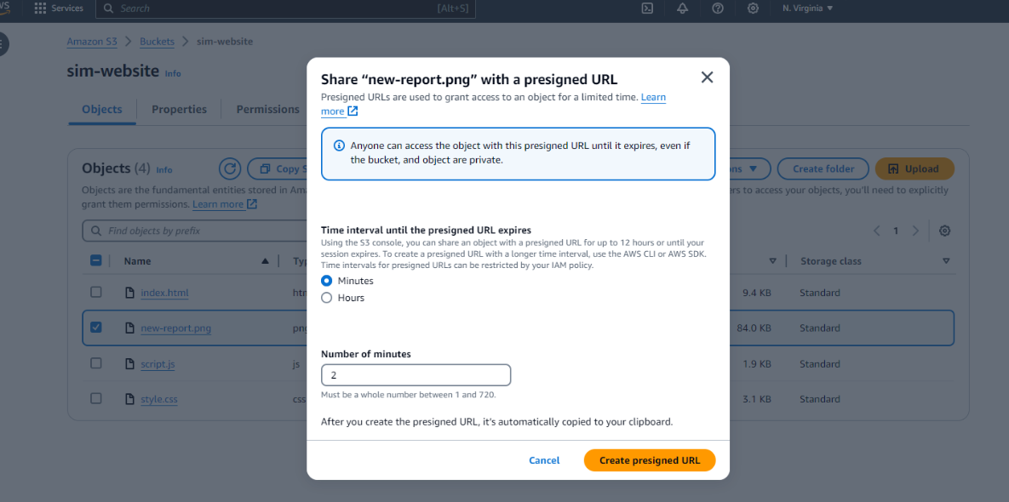
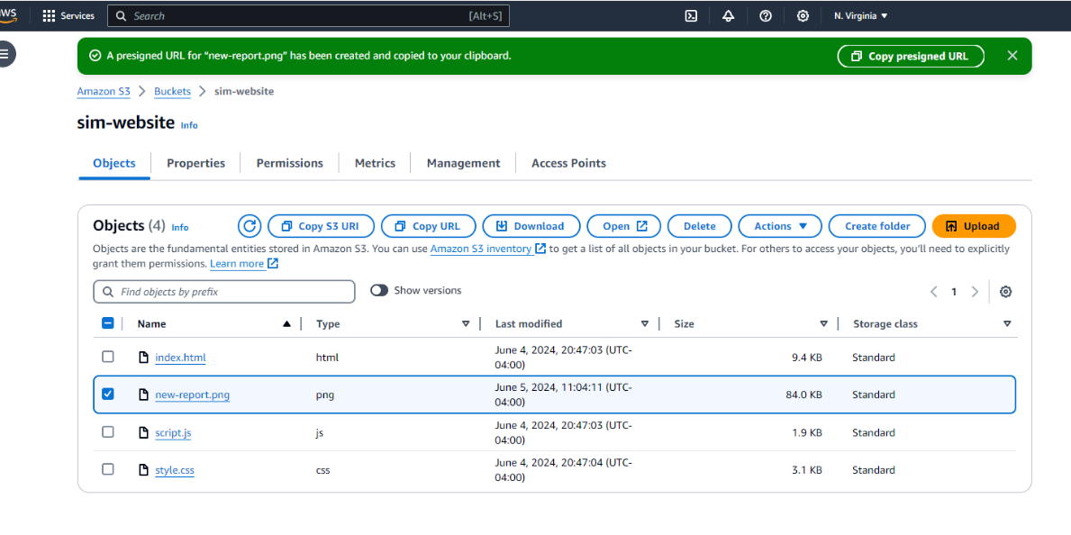
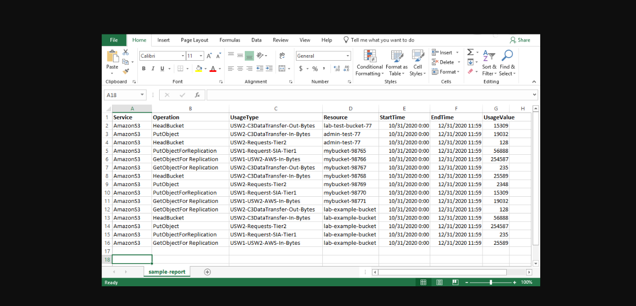
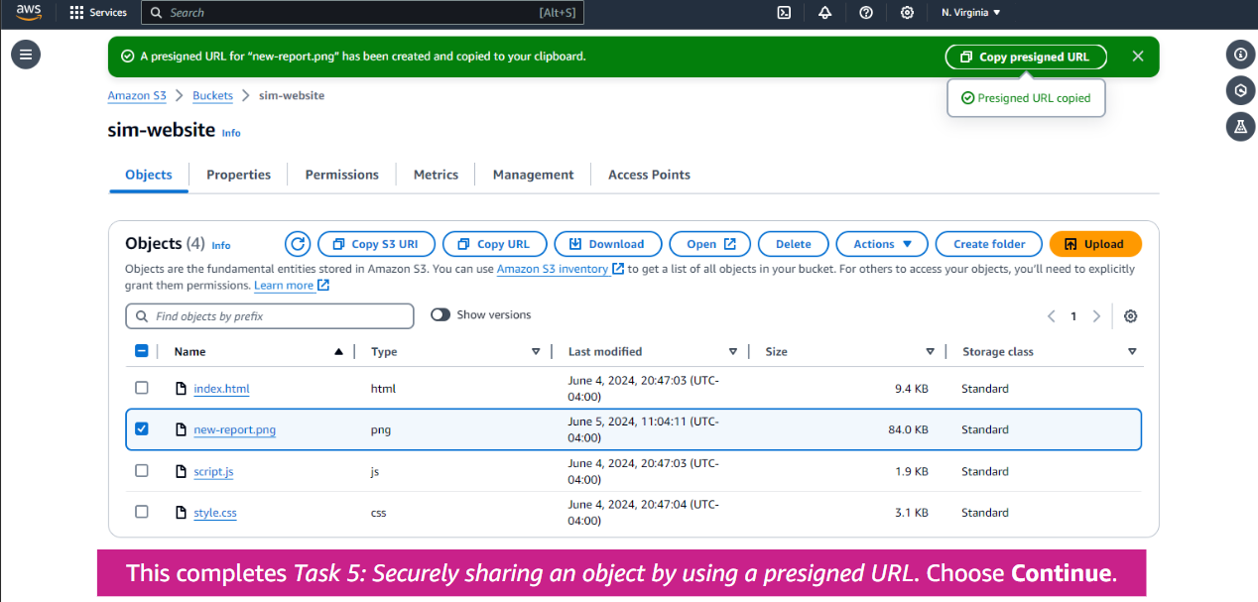
Task 6: Using a bucket policy to secure your bucket
37.Choose the Permissions tab > Choose the scroll bar to scroll down to the Bucket policy panel > In the Bucket policy panel, choose Edit.
38.Copy the following policy text and paste it in the Policy text editor field.
39.Choose the scroll bar to scroll down > Choose Save changes >Return to the Objects tab > Select index.html > Choose Delete > In the Delete objects panel, enter delete to confirm that you want to remove this file.
40.Choose Delete objects. Notice that the index.html file is listed in the Failed to delete pane. This entry confirms that your policy is working and preventing the website's files from being deleted.
41.Choose Close to return to the Objects tab. Your bucket policy is now protecting your website files from being deleted.
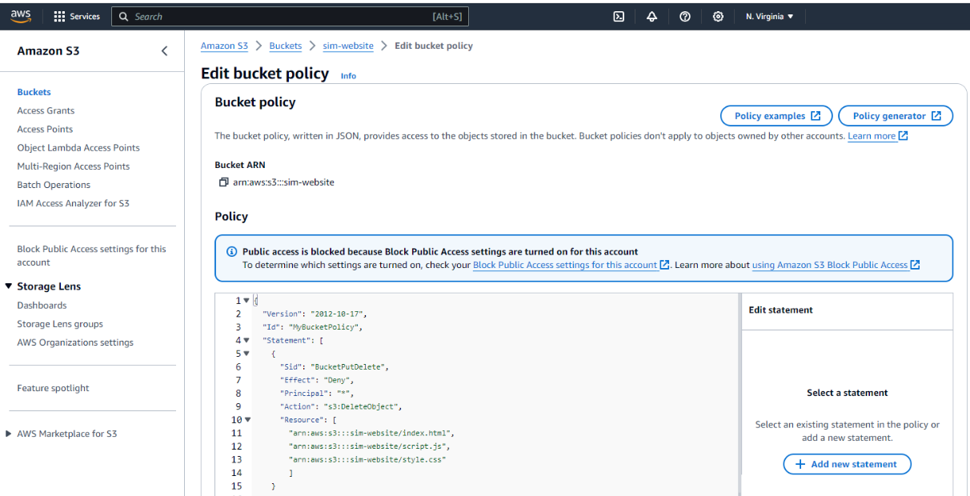
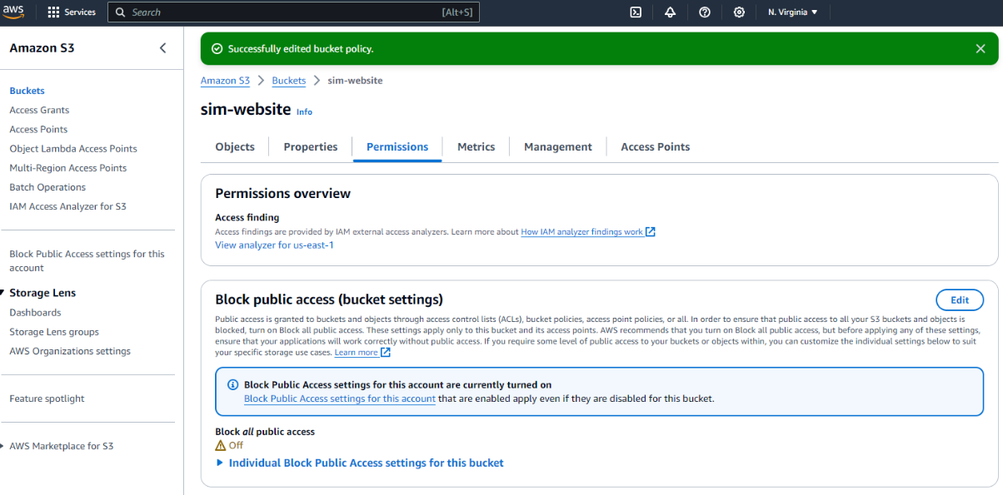
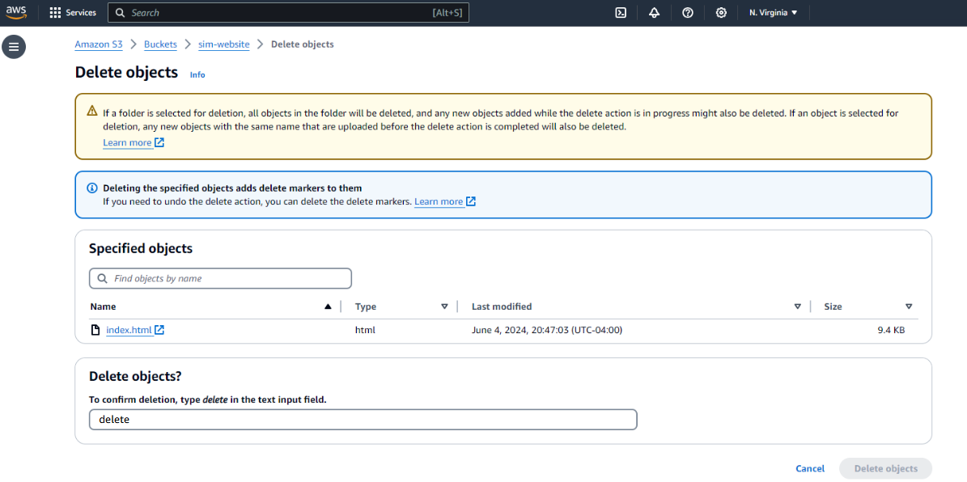
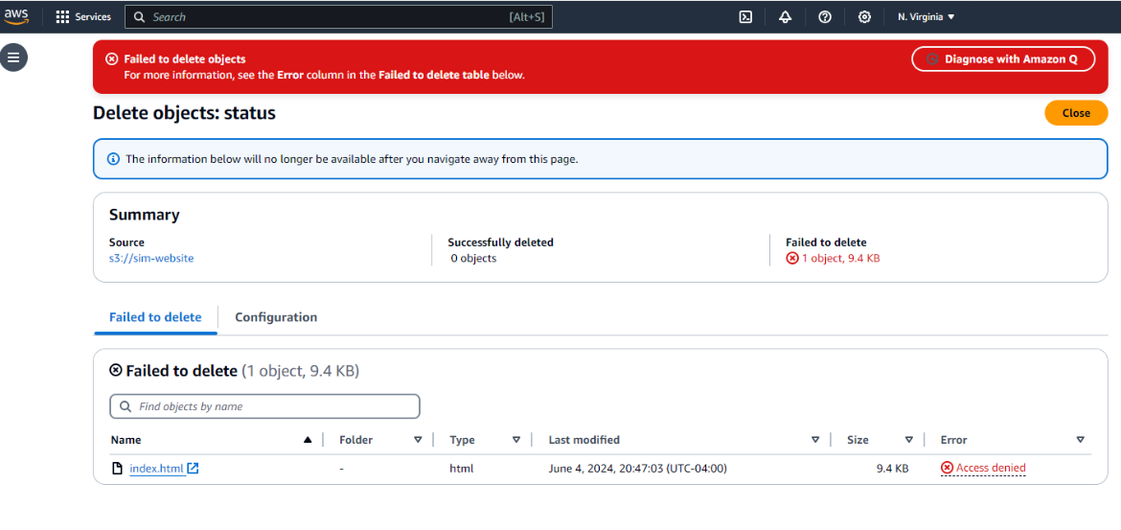
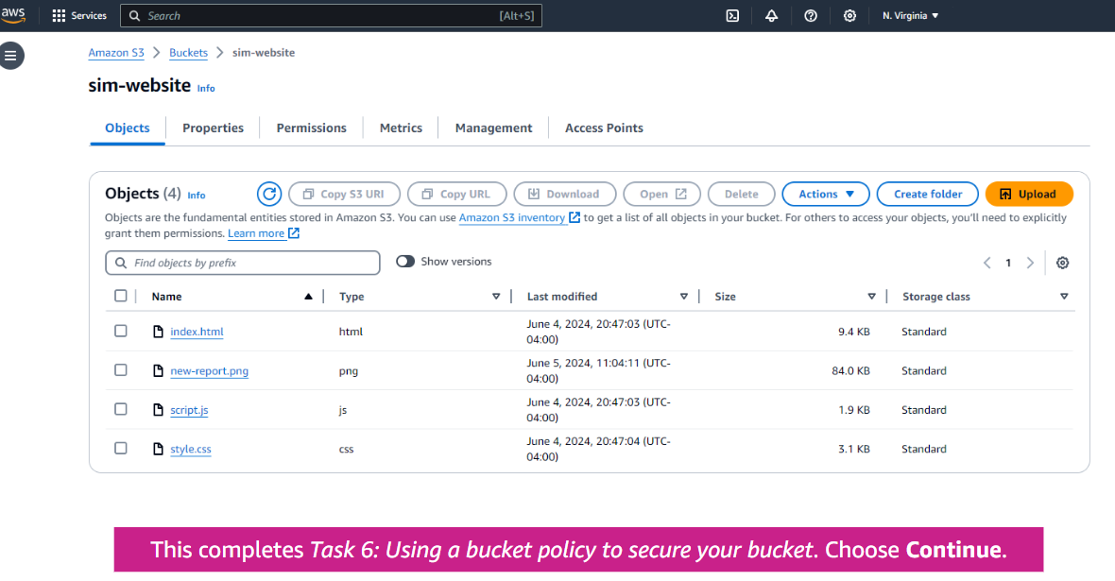
Task 7: Updating the website
42.On your computer, load the index.html file into a text editor (in this simulation, you use Notepad).
43.Find the text Served from Amazon S3, and replace it with Created by Jane.
44.Choose the index.html file name (choose the link, not the checkbox).
45.Choose the Back arrow on your browser to return to the Amazon S3 console. 54.Choose the sim-website link from the navigation at the top of the page.
46.Upload the index.html file that you just edited.
47.Select the index.html checkbox, and in the Actions menu, choose the Make public using ACL option again.
48.Choose Make public, and choose Close.
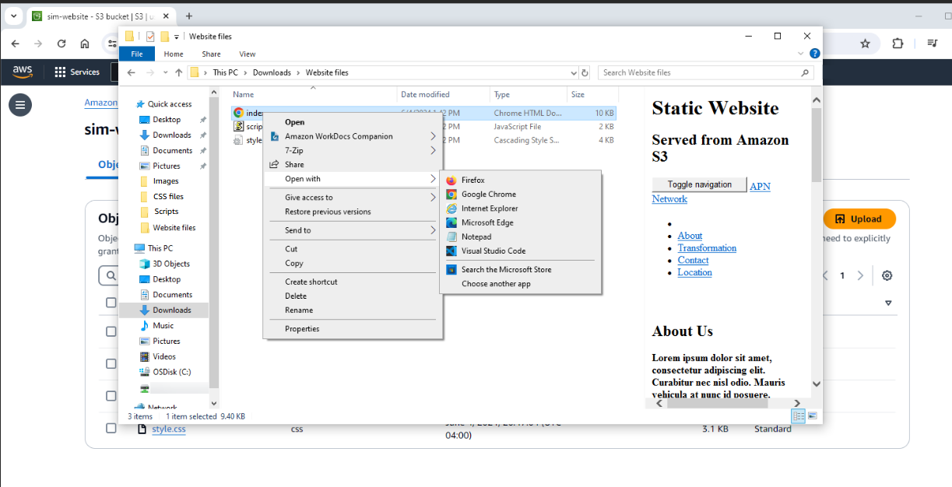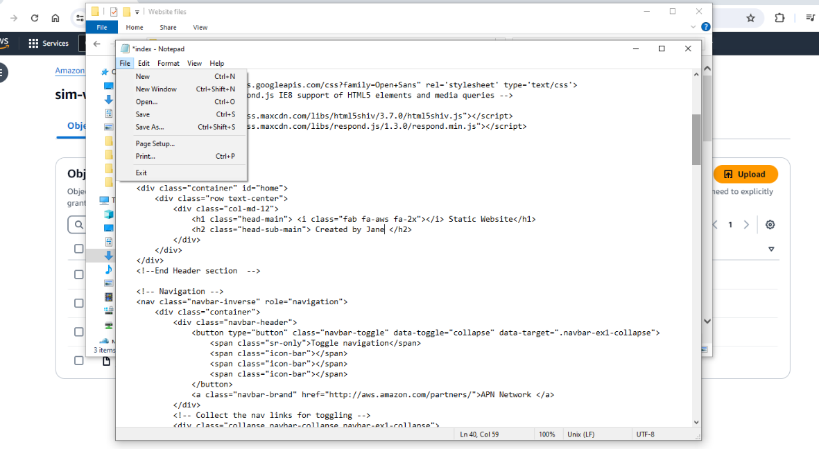
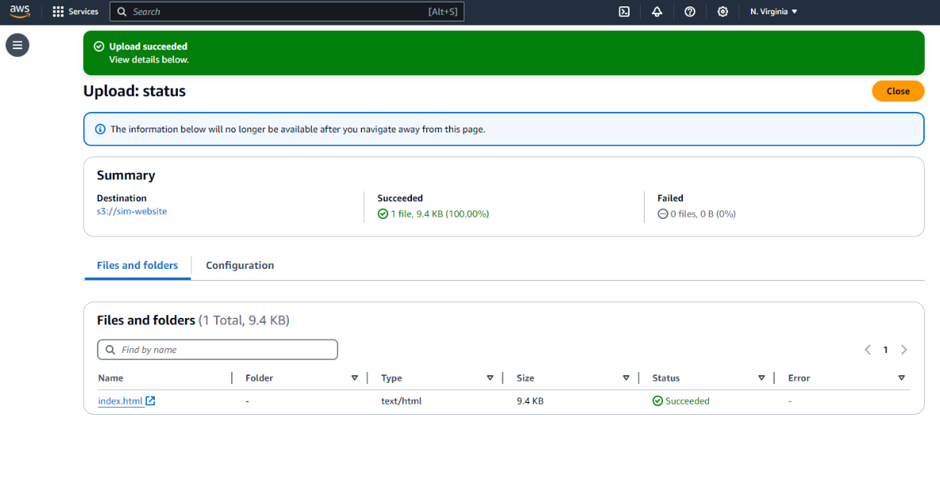
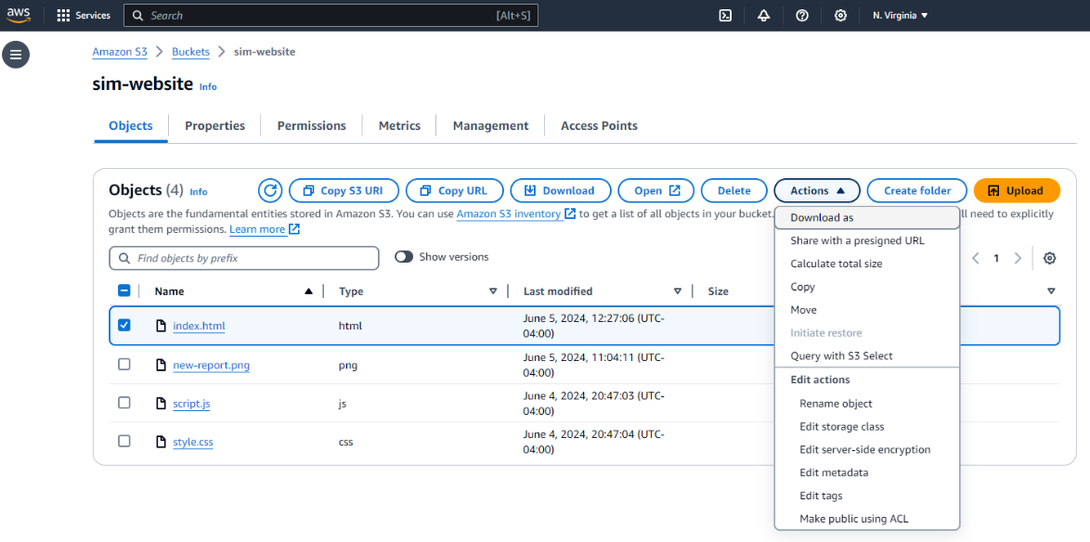
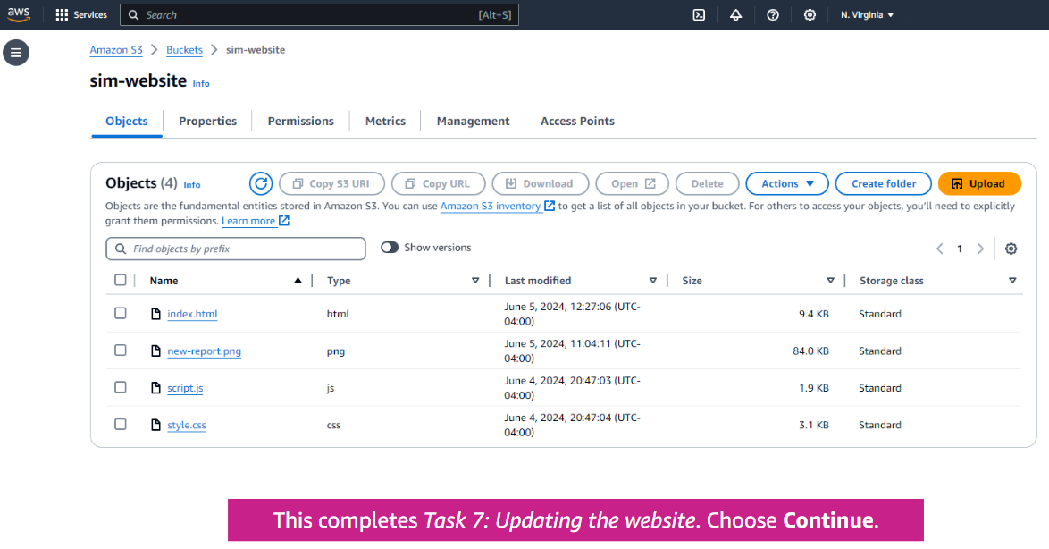
Task 8: Exploring file versions
49.Choose Show versions to see which files have multiple versions > Choose the scroll bar to scroll down.
50.Review the list of objects in the bucket. Notice that each file has a Version ID.
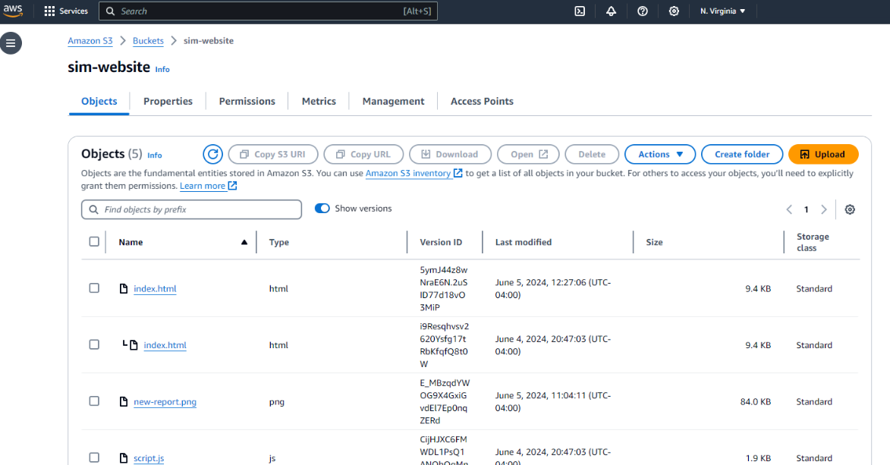
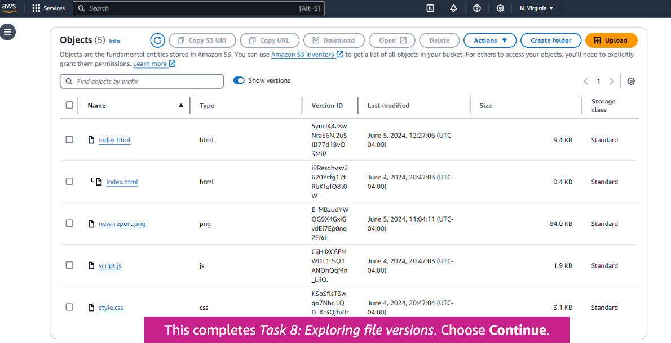
Conclusion :
Through this activity, we successfully created and configured an Amazon S3 bucket for static website hosting. We uploaded website files, enabled public access, and used bucket policies to secure the content. Additionally, we explored features like presigned URLs and versioning for better content management. This exercise demonstrated the scalability, flexibility, and security capabilities of Amazon S3 for hosting and managing web content in the cloud.

