ADV-DEVOPS EXPERIMENT-3

Aim : To understand the benefits of Cloud Infrastructure and Setup AWS Cloud9 IDE.

Theory :
AWS Cloud9 is a cloud-based integrated development environment (IDE) that allows developers to write, run, and debug code directly from a browser. It’s hosted on AWS, with tight integration into AWS services like EC2, Lambda, and S3.
Key Features:
- Cloud-Based IDE: Accessible from any device with an internet connection.
- Real-Time Collaboration: Multiple users can collaborate on the same project.
- Pre-configured Environment: Built-in support for languages like Python, JavaScript, and Ruby.
- Integrated Terminal & Debugger: Run commands and debug code within the IDE.
- AWS Integration: Seamless deployment to AWS services (e.g., EC2, Lambda).
- Git Support: Easy version control integration.
How It Works:
- Workspaces: Cloud9 runs in cloud-based environments called workspaces, often backed by EC2 instances.
- Collaboration: Multiple users can edit code together in real-time.
- Customizable: You can install additional tools and modify your workspace as needed.
Benefits:
- Instant Setup: No local setup required; start coding immediately.
- Cross-Platform: Works on any device with a web browser.
- Scalable: Leverages AWS resources for performance scaling.
- Integrated Debugging: Powerful debugging and testing tools built in.
Limitations:
- Requires Internet: You need a stable connection to use Cloud9.
- Cost: Charges for AWS resources like EC2 instances.
- Performance: Slower with poor internet connection or heavy workloads.
- Customization: Less flexible than local IDEs in terms of plugins and configuration.

AWS Cloud9 Architecture:
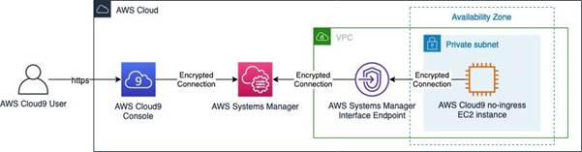Figure 1: Accessing AWS Cloud9 environment via AWS Systems Manager and Interface VPC Endpoints
Procedure :
1. In services, click on “Cloud9
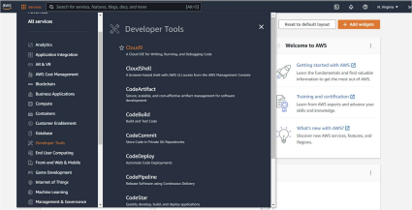

2. You will see the following page. Click on “Create Environment” 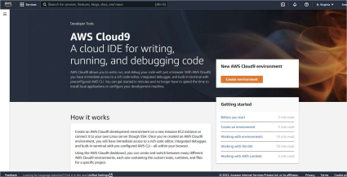

3. Follow the steps and add the details mentioned below.
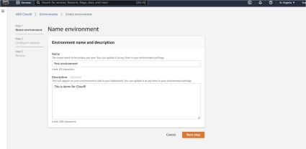
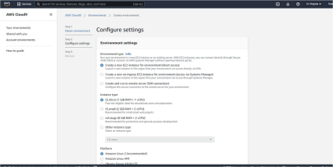
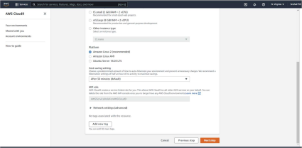

4. Now, Click on “Next Step”. Review the same and click on “Create environment”
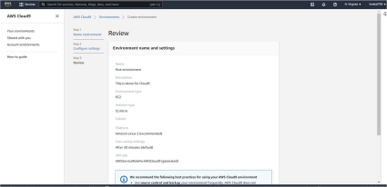
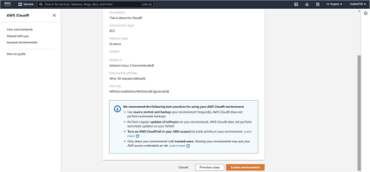

5. Wait for few minutes, the environment is getting created
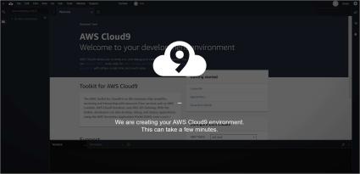

6. We are now ready to code.
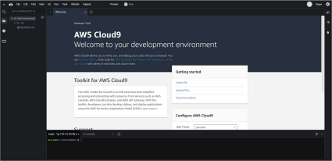

7. Click on File>New file. Inside this write a code
8. After writing complete code, save it and go to “Run” and select desired language.
9. You will get the output in the terminal below.
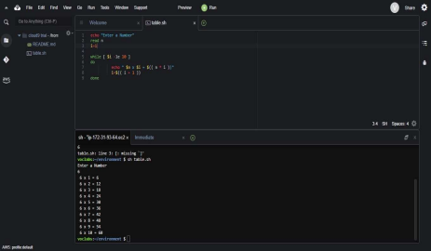

The Created Environments can be seen here

Conclusion :
AWS Cloud9 is perfect for cloud-native development, especially for those using AWS services. It offers real-time collaboration, a pre-configured development environment, and tight AWS integration, but may not be ideal for those with limited internet access or in need of heavy customization.

