ADV-DEVOPS EXPERIMENT-4
Aim: To create repository using AWS CodeCommit.
Theory:
AWS CodeCommit is a source control service that is provided by Amazon Web Service which is fully managed. It is a version code service. It helps to manage and store assets such as codes or documents or any other type of file such as binary file etc. It allows the team to work collaboratively in a secure and highly scalable environment. It eliminates the need for third-party version control and also eliminates the need for your own source control system. You can work easily with your existing git tools by using the CodeCommit service. You can store your source code and other files within a few clicks and can also perform pushing, pulling, or commit of data with ease. It allows you to cross-link the two AWS accounts easily to share repositories in a secure environment but need to remember a few things that do not share SSH key or Aws credential.

Benefits:
- Collaboration
- Encryption
- Access Control
- High Availability and Durability
- The repositories you need, when you need them
- Easy Access and Integration
- Notifications and Custom Scripts
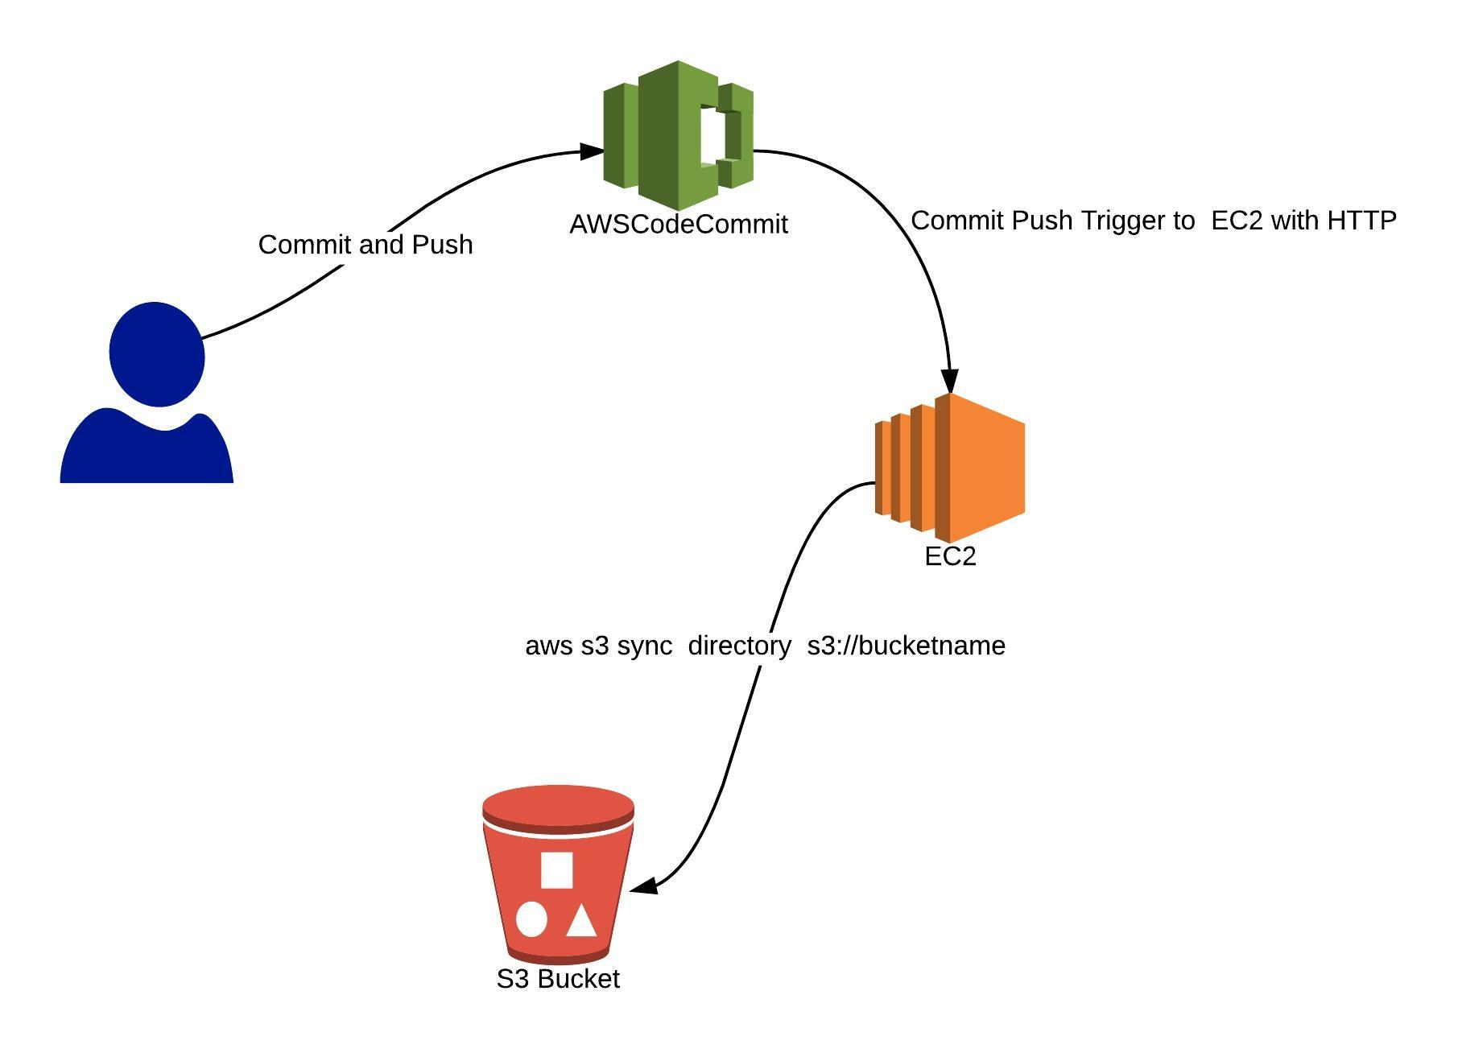

Git Vs AWS CodeCommit
Differences:
- AWS CodeCommit is more secure than the git as AWS uses IAM roles for securing techniques which allows users to share their repositories to the limited person and in highly secure environment.
- Git interface comes out to be more interactive than the AWS CodeCommit .
- Git is basically connected to the github whereas AWS CodeCommit is managed and hosted by the AWS which is more reliable platform.
Similarities:
- Both can integrate with AWS cloudbuild that can import your github and other Google cloud storage to your specifications and produce containers.
- Both uses git repositories.
- Both supports code review.

- Working On AWS Code Commit
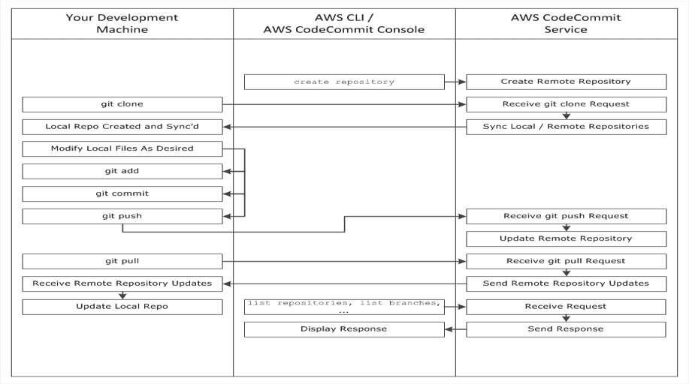

Procedure:
1. In services, click on “CodeCommit”
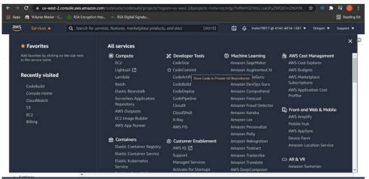

2. You will see the following page
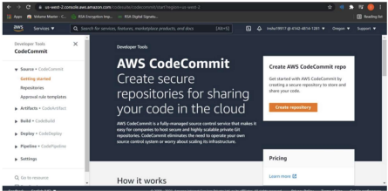

3. Click on create repository and create a new repository. In may case, I have already created that. So, I won’t create that again.
4. Now we’ll commit a code. So, click on “Add a file” or “Upload a file”.
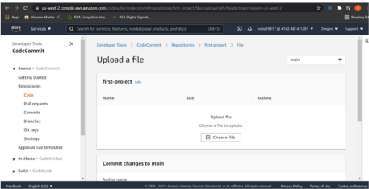

5. Now click on “Choose a file”. Choose your program file and fill the details in the textbox given below. Click on “Commit changes”.
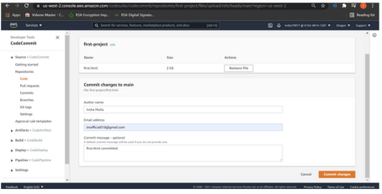

6. You can see that your code has been committed.
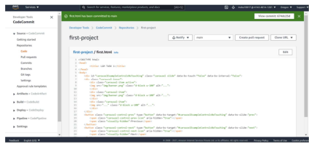

Conclusion:
In this experiment, a repository was successfully created using AWS CodeCommit, showcasing how to set up a cloud-based version control system. The process highlighted the ease of managing code in a secure and scalable environment, along with the ability to collaborate with team members efficiently. This experiment also emphasized the advantages of integrating CodeCommit with other AWS services for streamlined development and deployment workflows.

