Experiment no.5
Aim : To understand the Kubernetes Cluster Architecture, install and deploy Kubernetes on Windows

Theory :
Kubernetes (K8s) is an open-source container orchestration platform developed by Google and now maintained by the Cloud Native Computing Foundation (CNCF).
It automates the deployment, scaling, and management of containerized applications across machines.
Kubernetes is widely used for DevOps, microservices, and cloud-native applications due to its reliability, scalability, and portability.

2. Need for Kubernetes:
Modern applications are built using containers (like Docker) for consistency and isolation.
However, managing multiple containers across many hosts manually is complex.
Kubernetes simplifies this by:
- Automating container deployment and scaling
- Handling load balancing
- Providing self-healing capabilities (restarts failed containers automatically)
- Offering service discovery and networking between containers

3. Kubernetes Cluster Architecture:
A Kubernetes cluster consists of two main types of nodes:
- Master Node (Control Plane)
- Worker Nodes

A. Master Node (Control Plane):
The master node manages and controls the entire cluster. It makes global decisions about scheduling and monitors the cluster’s state.
Key Components:
- API Server:
  - Acts as the front-end for the Kubernetes control plane.
  - All communication (CLI, Dashboard, or REST calls) goes through it.
- etcd:
  - A distributed key-value store that stores all cluster configuration data (like node info, pod states, secrets, etc.).
- Controller Manager:
  - Monitors the cluster and ensures the desired state is maintained (e.g., if a pod crashes, it creates a new one).
- Scheduler:
  - Assigns newly created pods to appropriate worker nodes based on resource availability and constraints.

B. Worker Node:
Worker nodes are the machines where application containers actually run.
Key Components:
- Kubelet:
  - Agent running on each node.
  - Ensures containers are running in a Pod as defined by the control plane.
- Kube Proxy:
  - Handles network communication and load balancing for pods and services.
- Container Runtime:
  - Responsible for running containers (e.g., Docker, containerd).
Each worker node hosts one or more Pods, which are the smallest deployable units in Kubernetes.

4. Kubernetes Objects and Concepts:
- Pod: Smallest deployable unit; can contain one or more containers.
- ReplicaSet: Ensures a specified number of identical pods are running.
- Deployment: Manages rolling updates and rollbacks for applications.
- Service: Exposes a set of pods as a network service.
- Namespace: Logical grouping of cluster resources.

Procedure:

Installing kubectl:

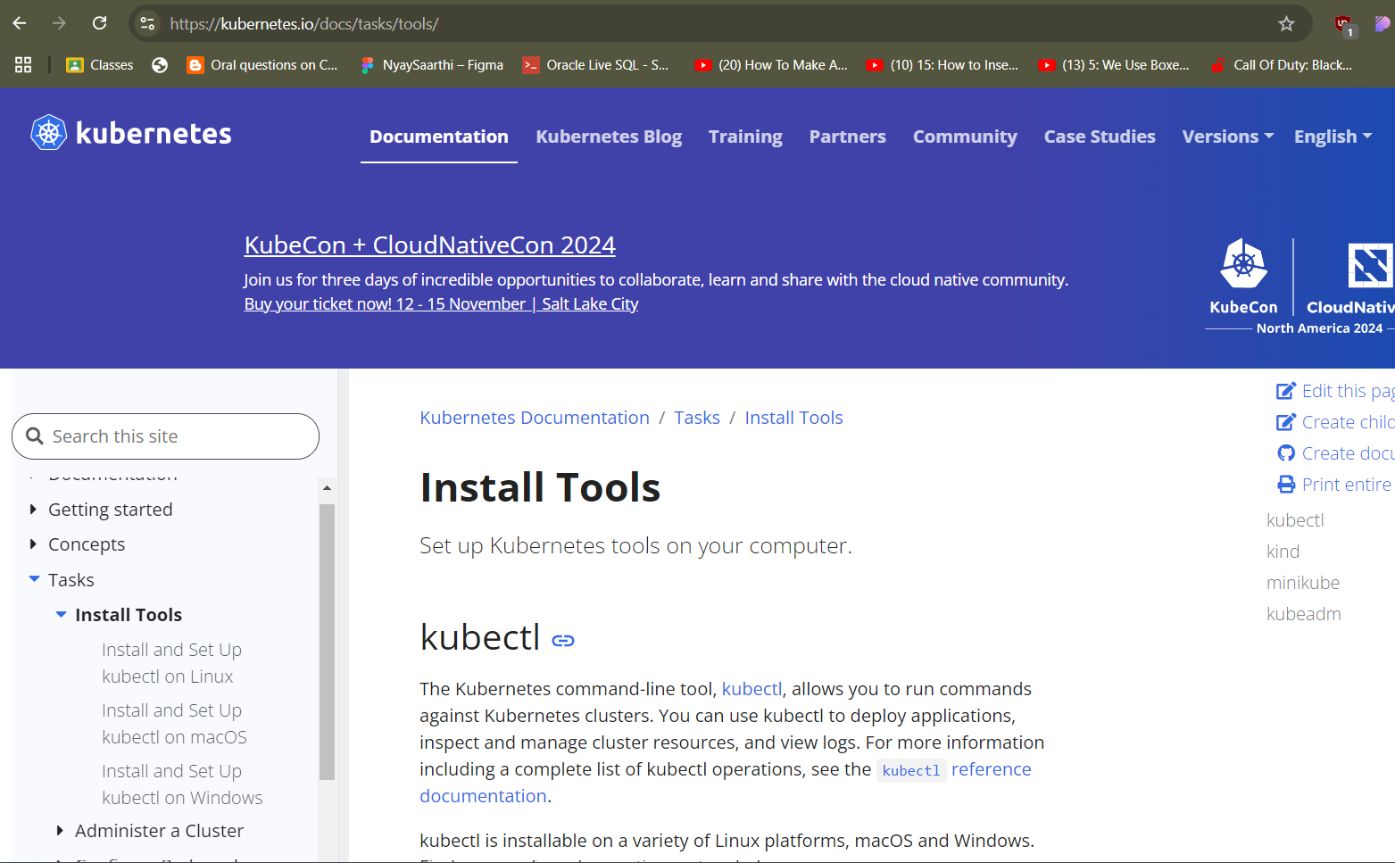
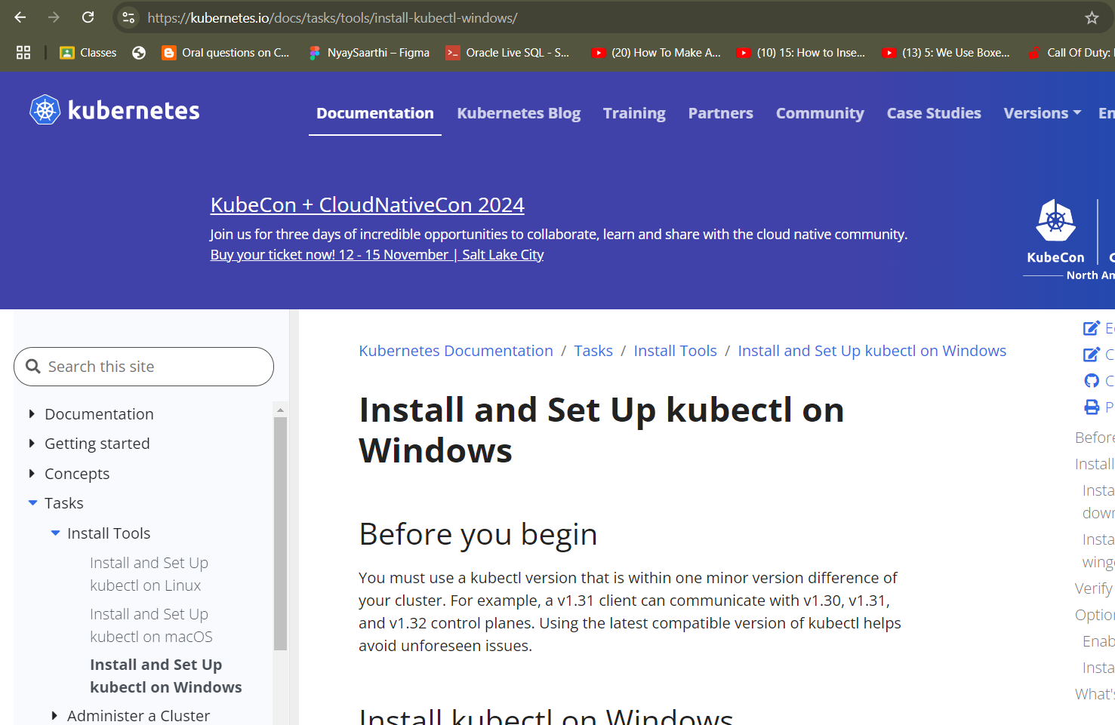

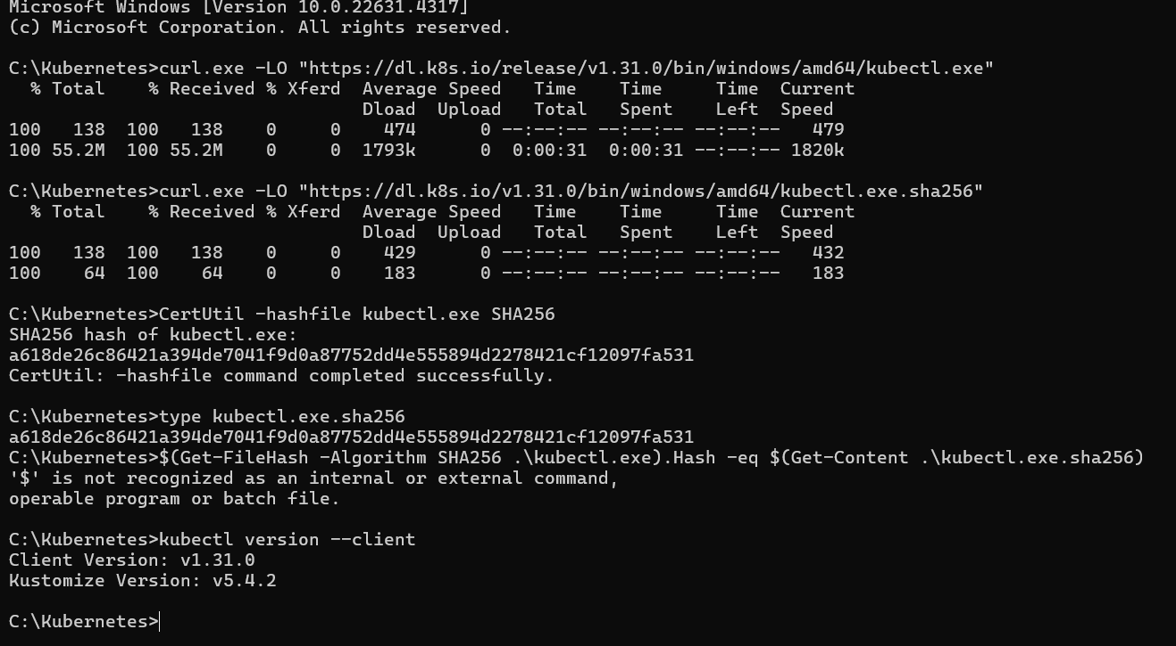

Installing minikube:
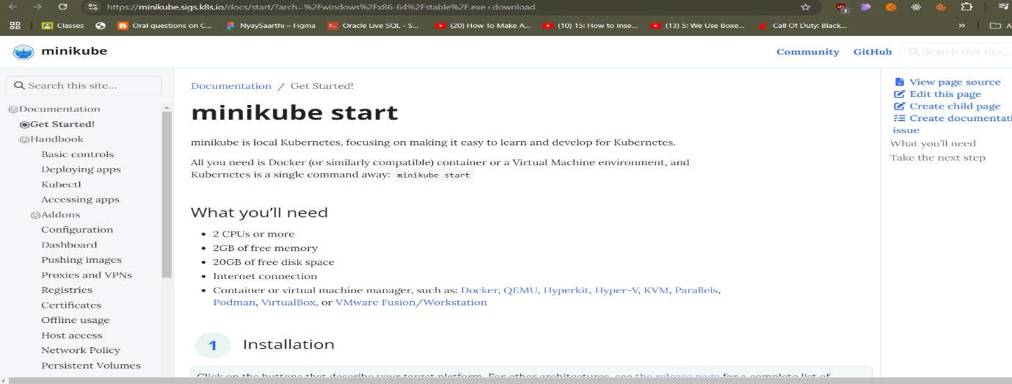

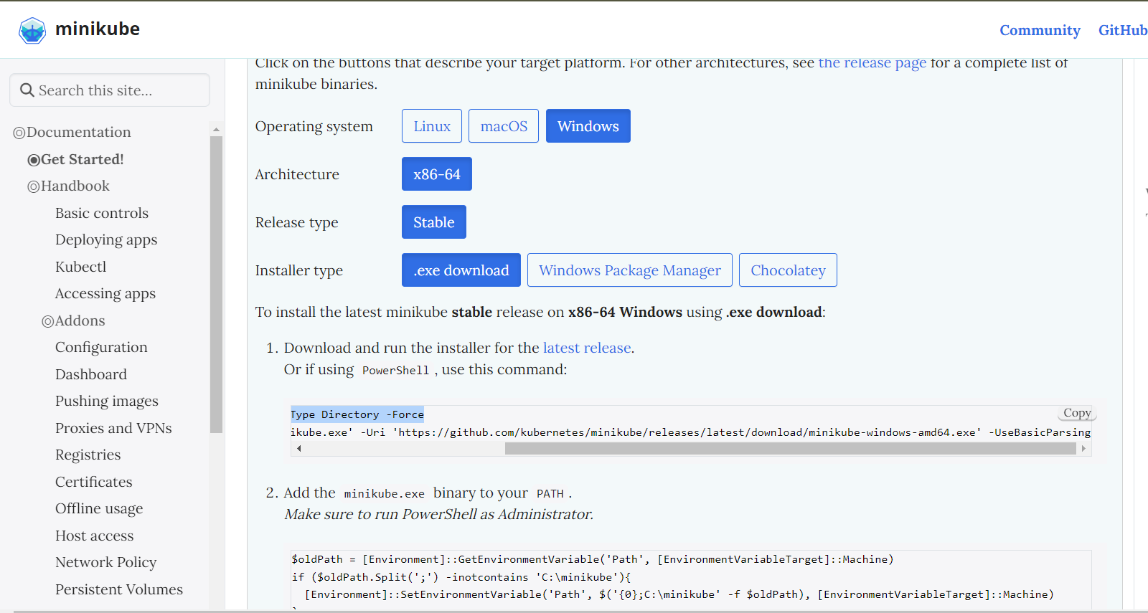

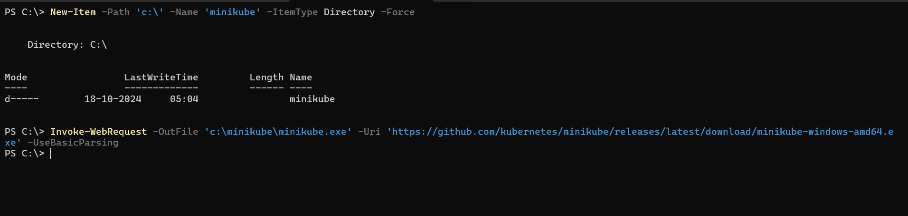

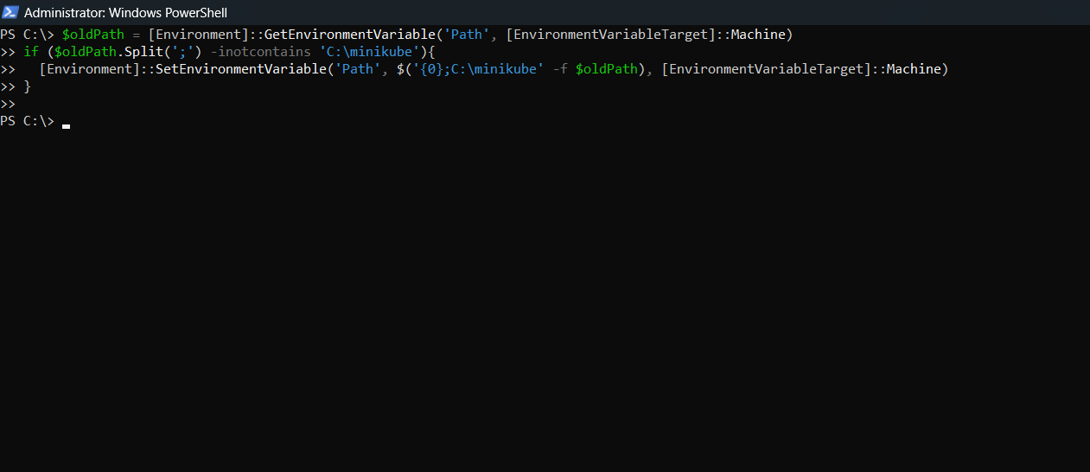

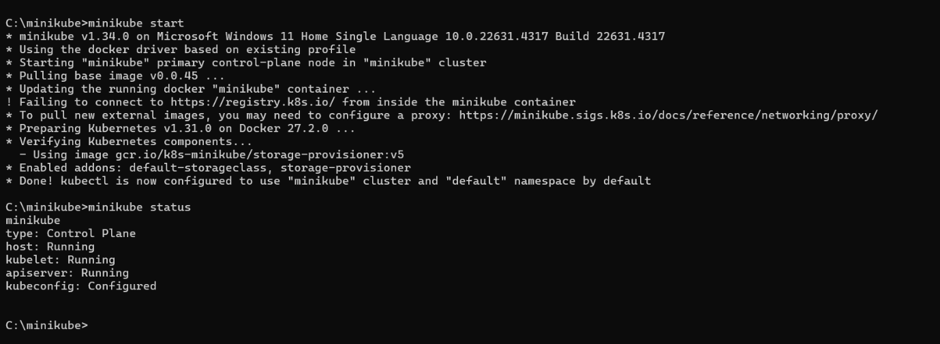

Installing Docker :

Check for System requirements:
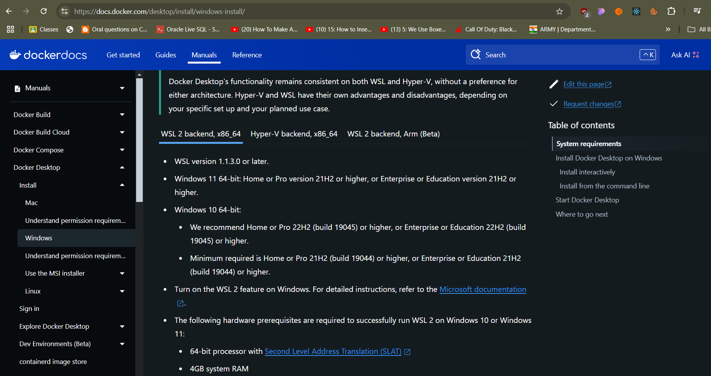

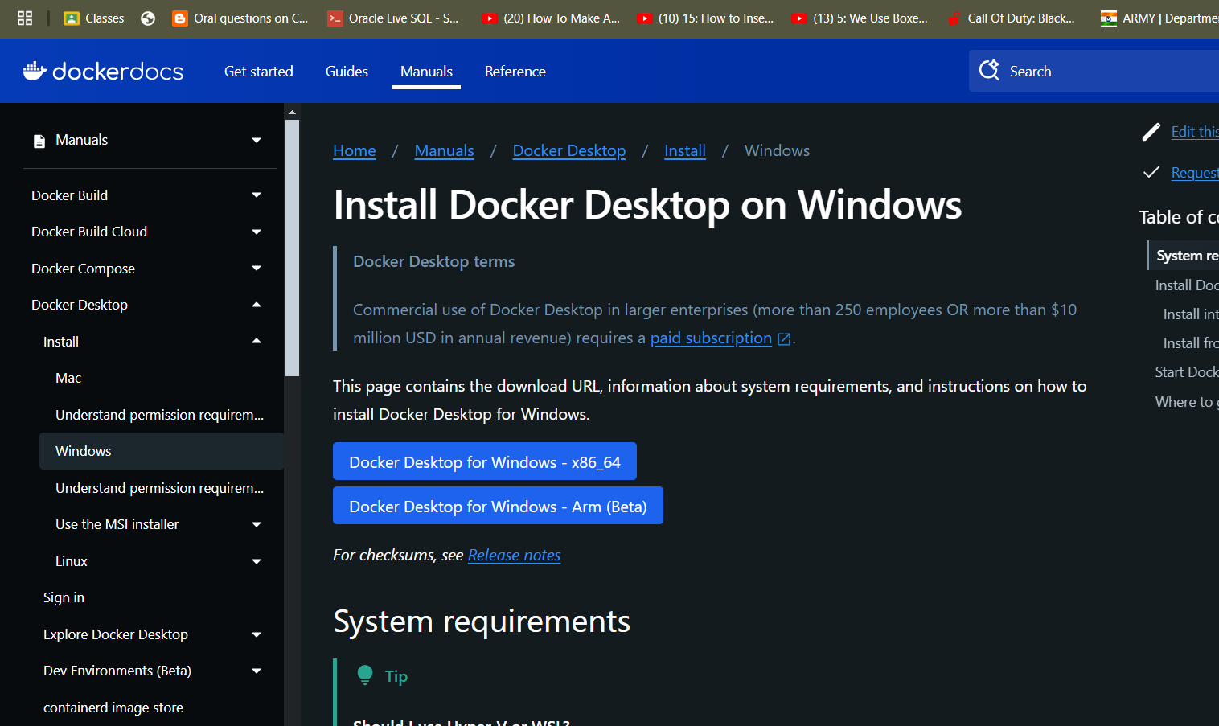
Make sure you have selected :Virtual Machine Platform,Windows Hypervisior Platform and Windows Subsystem for Linux and restart your system once selected to run docker smoothly.

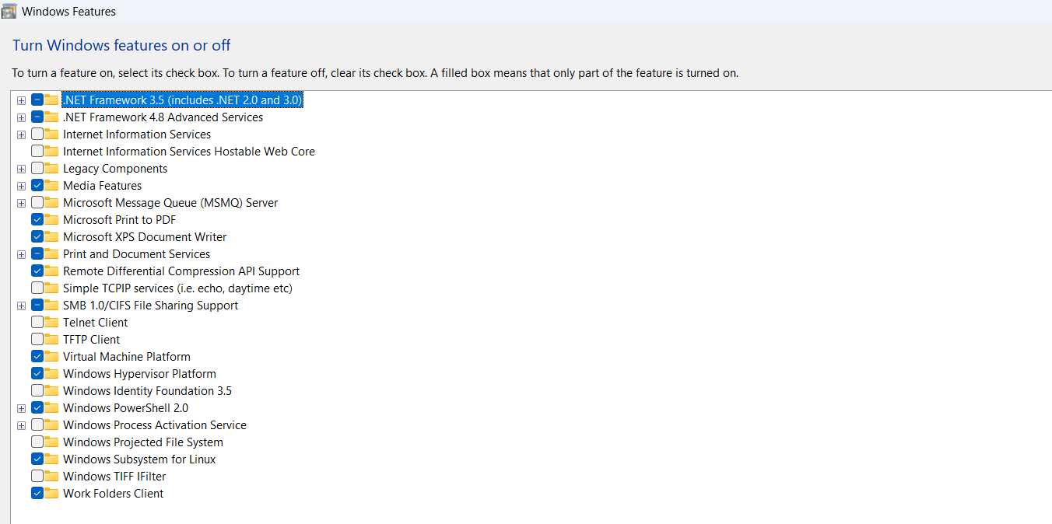

Command to update wsl:

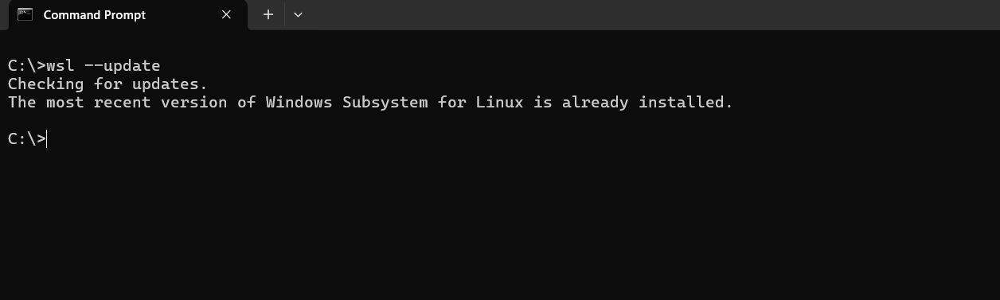

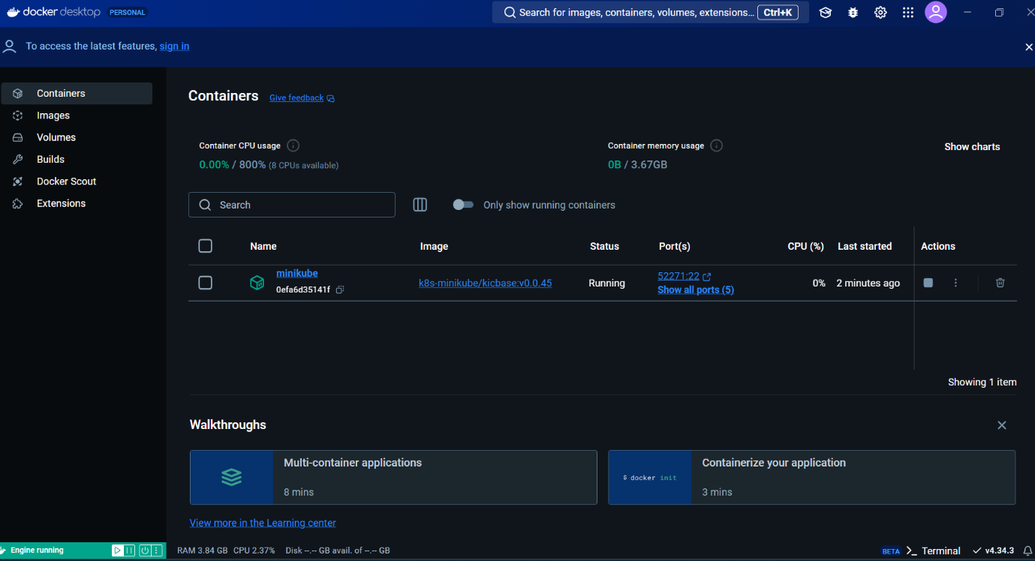

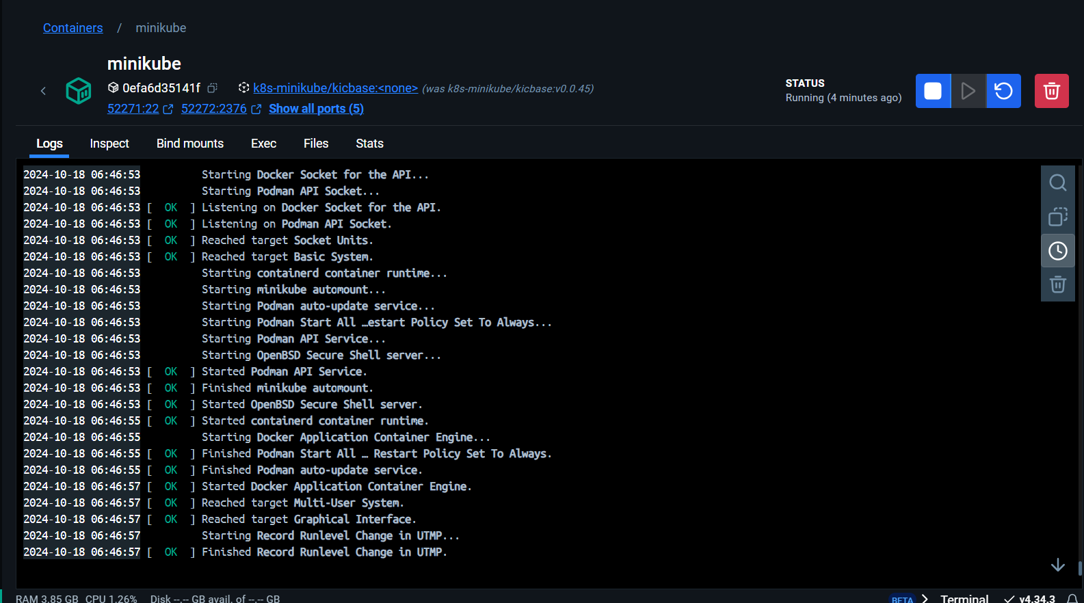

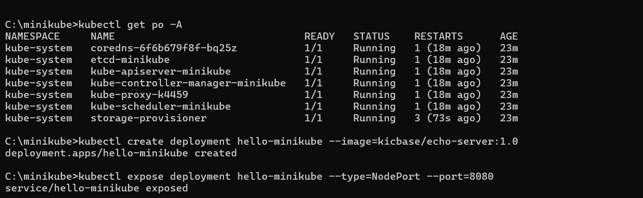

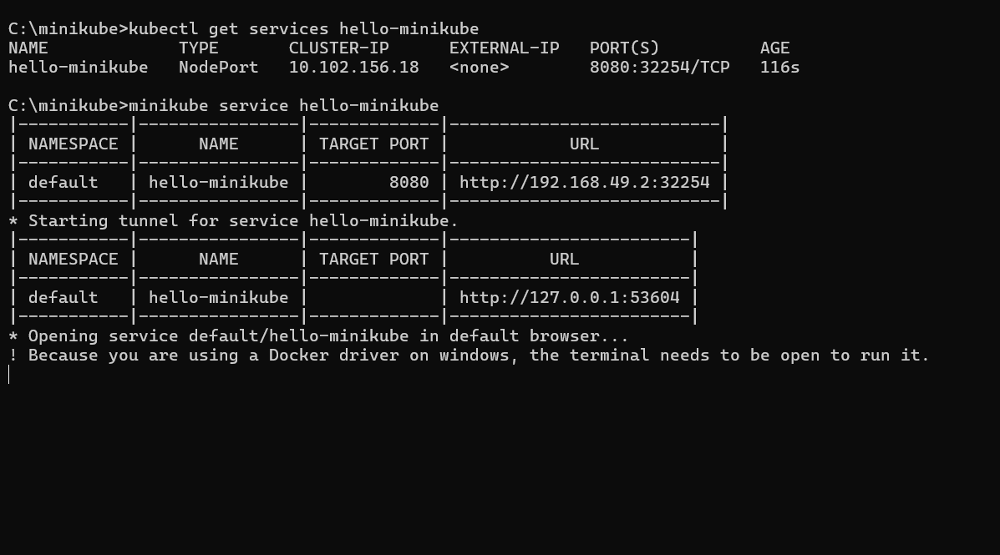
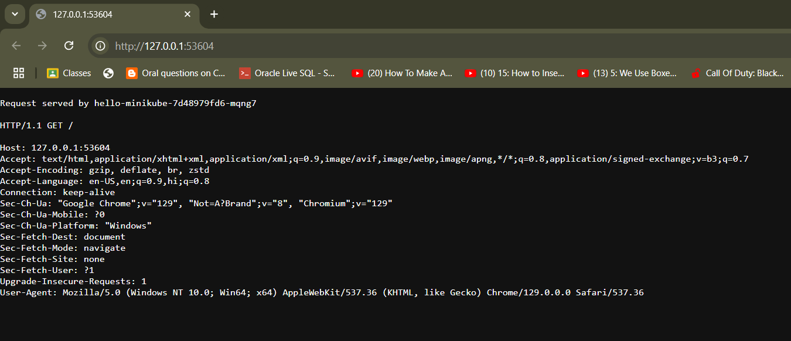

Conclusion :
Kubernetes provides a powerful, automated, and scalable platform for managing containerized applications. By understanding its cluster architecture and deploying it on Windows, developers can experiment with real-world DevOps workflows, microservices management, and cloud-native development in a local environment.

