ADV-DEVOPS EXPERIMENT-6
Aim : To understand terraform lifecycle, core concepts/terminologies, and install it on a windows machine.
Theory :
Terraform Overview:
Terraform is an open-source IaC tool developed by HashiCorp. It allows users to define both cloud and on-prem resources using a declarative configuration language called HashiCorp Configuration Language (HCL). Terraform supports multiple cloud providers, including AWS, Azure, and GCP.
Using Terraform, users can:
- Build infrastructure (e.g., EC2 instances, S3 buckets)
- Change or update existing infrastructure
- Destroy infrastructure when it is no longer needed

Terraform Core Concepts:
- Providers: These are plugins used to interact with APIs of different services (e.g., AWS, Azure). For this experiment, we use the AWS provider.
- Resources: Basic building blocks in Terraform representing infrastructure components (like EC2 instances, VPCs, etc.).
- Variables: Input parameters that make Terraform configurations reusable.
- State: Terraform maintains a state file (terraform.tfstate) to keep track of the current infrastructure.
- Plan & Apply:
  - terraform plan: Shows what changes Terraform will make without applying them.
  - terraform apply: Applies the planned changes to build or modify infrastructure.
- Destroy:
  - terraform destroy: Removes all infrastructure components defined in the Terraform configuration.

Lifecycle of Terraform Usage:
The standard lifecycle in this experiment involves three main phases:
- Build: Write Terraform configuration and apply it to provision AWS resources.
- Change: Modify the configuration to update resources, then apply again to reflect changes.
- Destroy: Tear down the infrastructure using terraform destroy when it’s no longer needed.
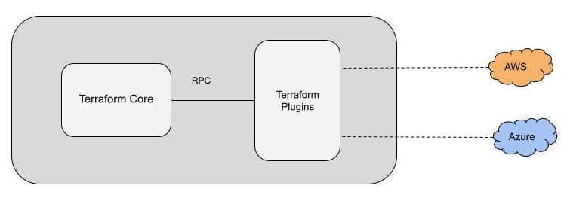
Procedure :
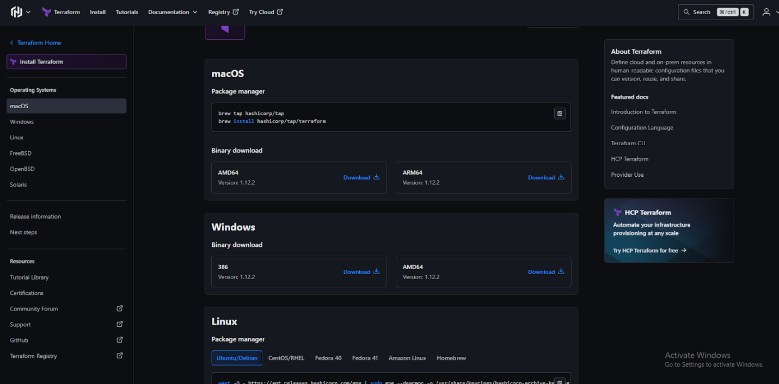
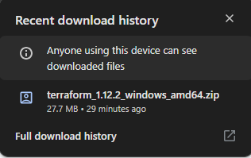
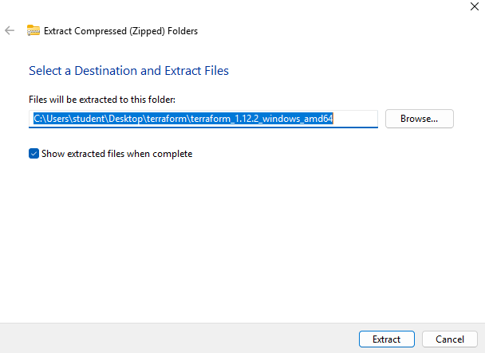
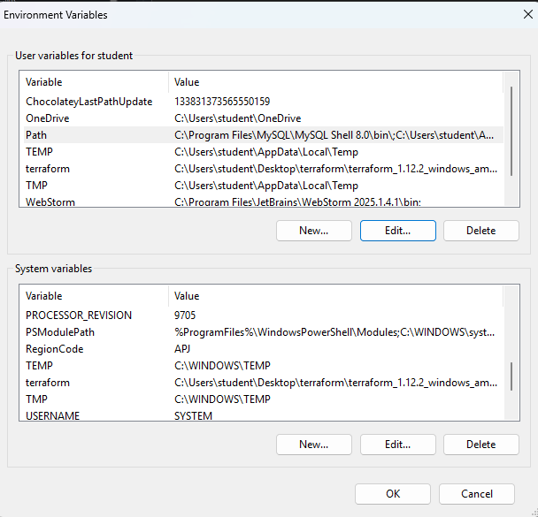

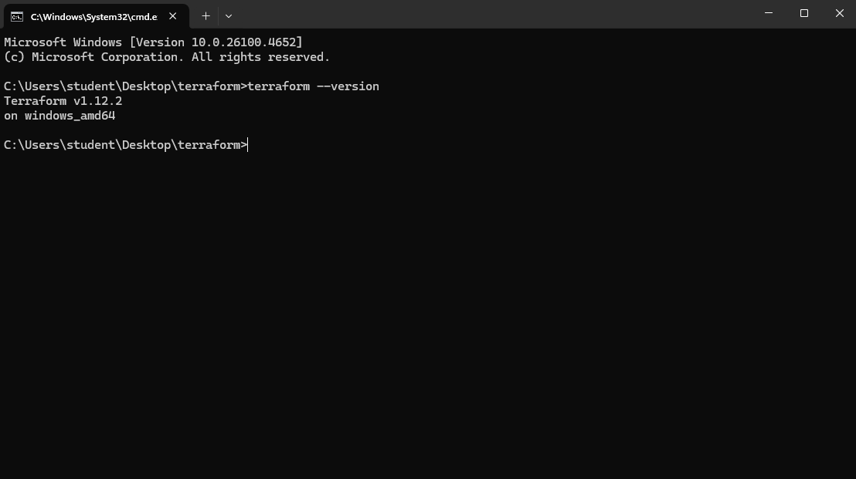
Conclusion :
Terraform enables developers and operations teams to define the desired state of their infrastructure, allowing Terraform to manage the entire lifecycle of resources like virtual machines, storage, and networking across various platforms such as AWS, Azure, and Google Cloud.

