ADV DEVOPS EXPERIMENT-7
Aim : To Build, change, and destroy AWS infrastructure Using Terraform.

Theory :

To Build AWS infrastructure using terraform make sure to have Java installed and running on your machine. For instructions, see Java Development kit. Apache maven Java Lambdas are build using mvn packages and are deployed using Terraform into AWS set up terraform. For steps, see Terraform downloads an AWS account.

To change AWS infrastructure using terraform you created your first infrastructure with terraform: A single EC2 Instance on AWS. Infrastructure is continuously evolving, and
terraform helps you manage that charge. As you change terraform configurations. Terraform builds an execution plan that only modifies what is necessary to reach you desired state.
To Destroy AWS infrastructure using terraform once you no longer need infrastructure, you may want to destroy it to reduce your security exposure & costs. For example, you may remove a production environment from service, or manage short-lived environments like build or testing systems.
In addition to build and modifying infrastructure, terraform can destroy or recreate the infrastructure it manages.
Hashicrop terraform is an open source infrastructure. As code software tool that allows DevOps engineers to programmatically provision the physical resources an application requires to run.

Lifecycle of terraform is given below.
- Terraform init
- Terraform validate
- Terraform plan.
- Terraform apply.
- Terraform destroy.

Procedure :

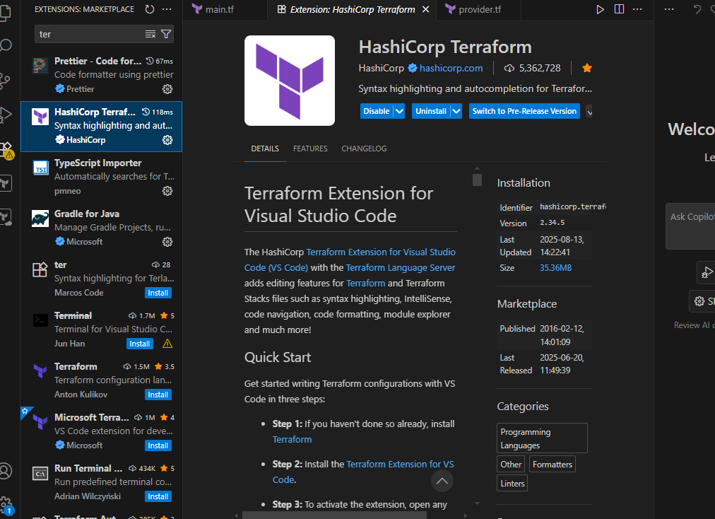

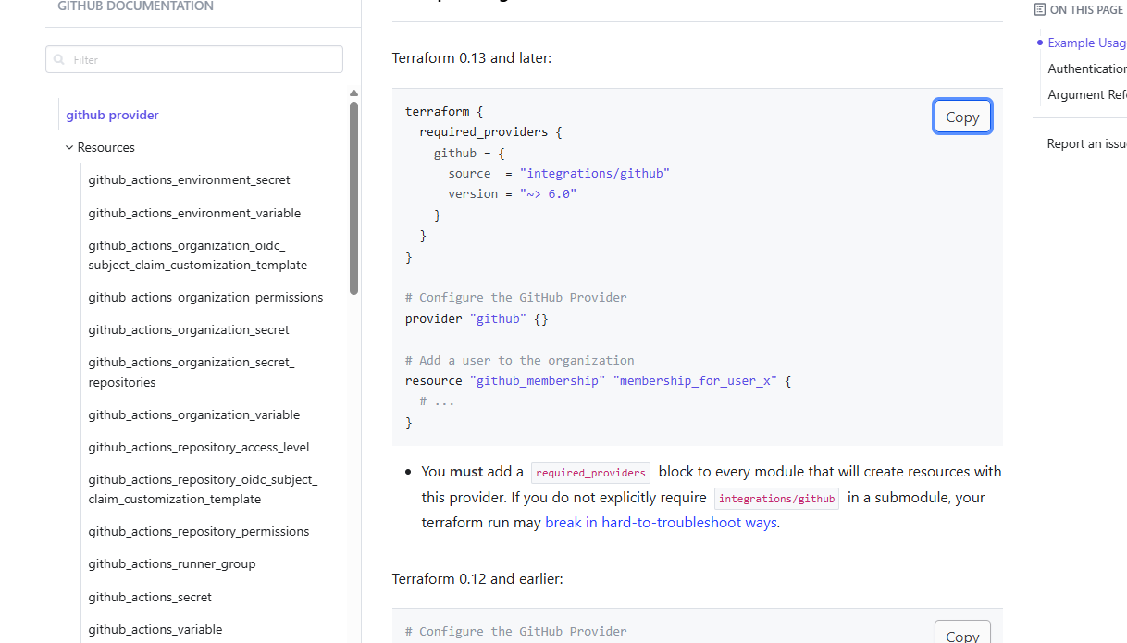

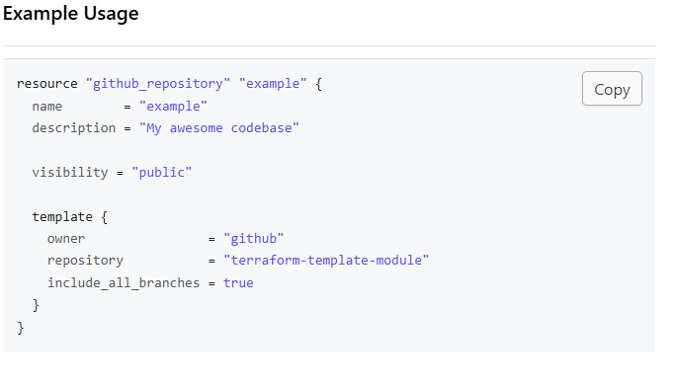

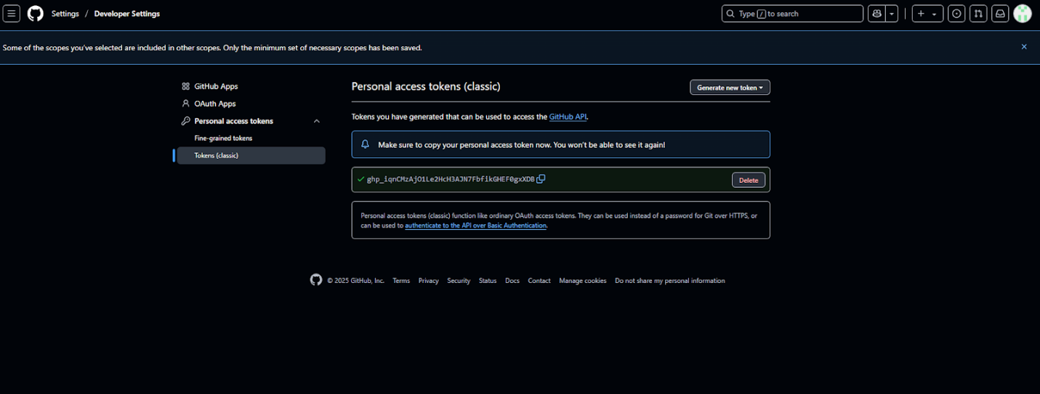

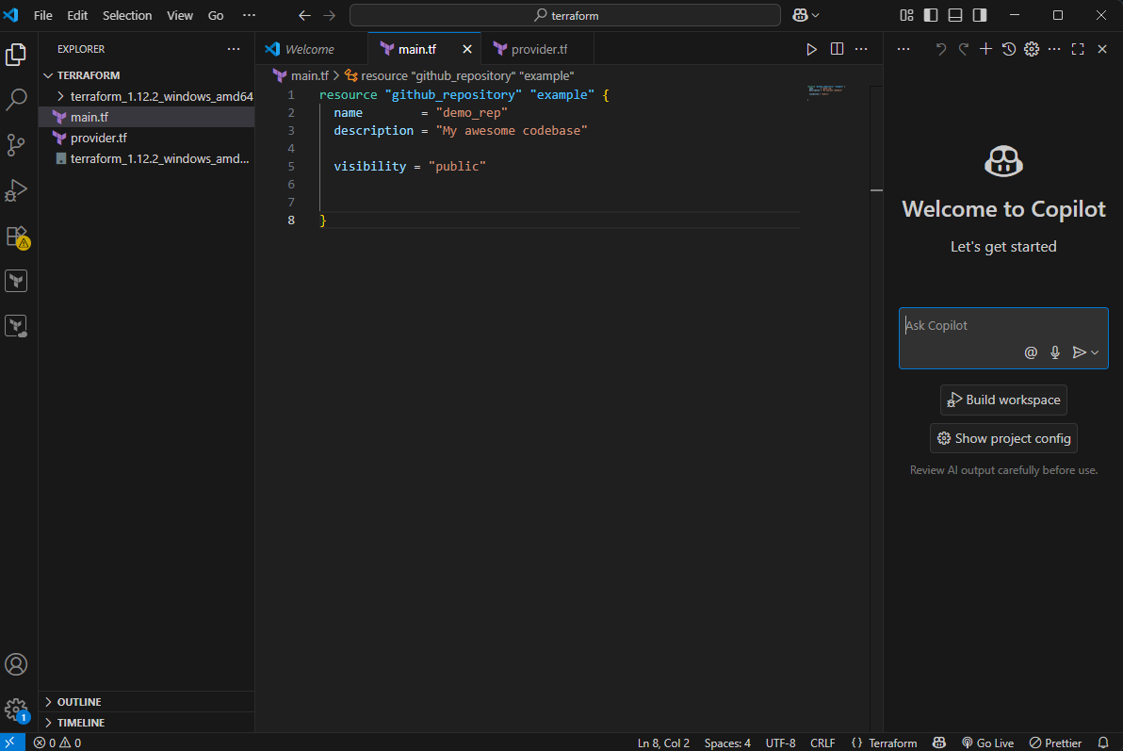

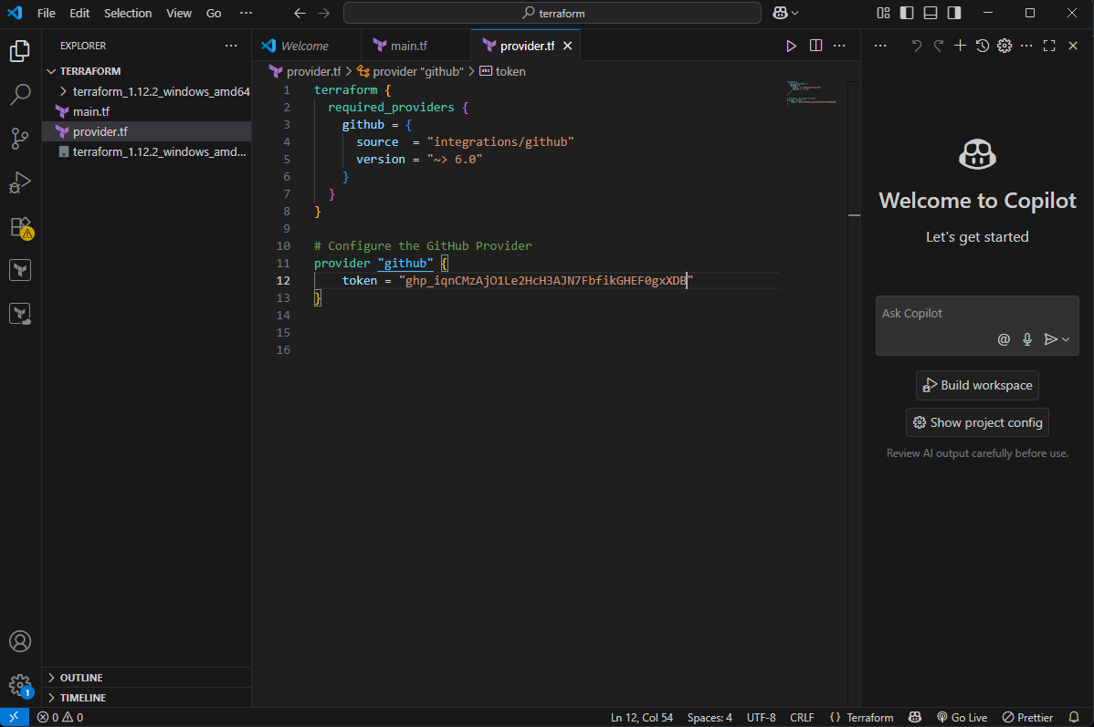

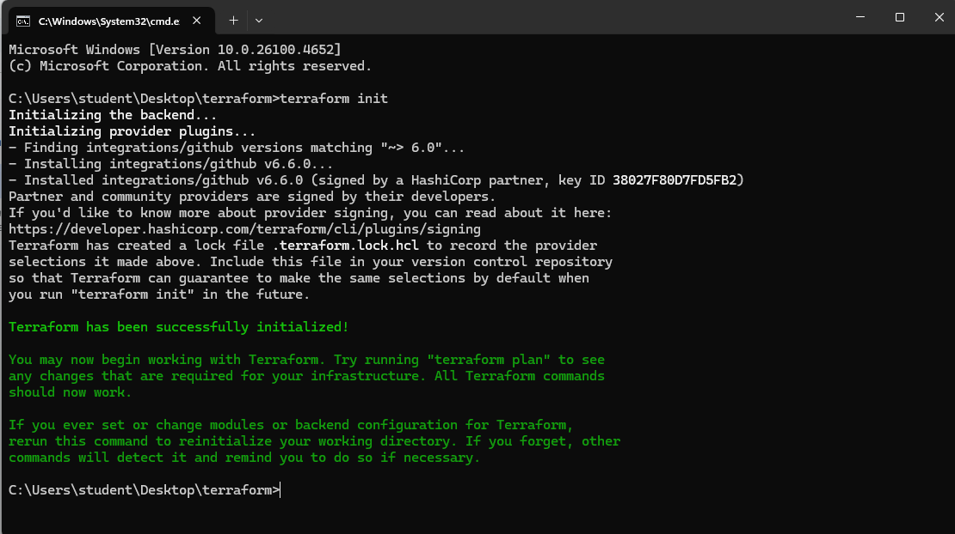

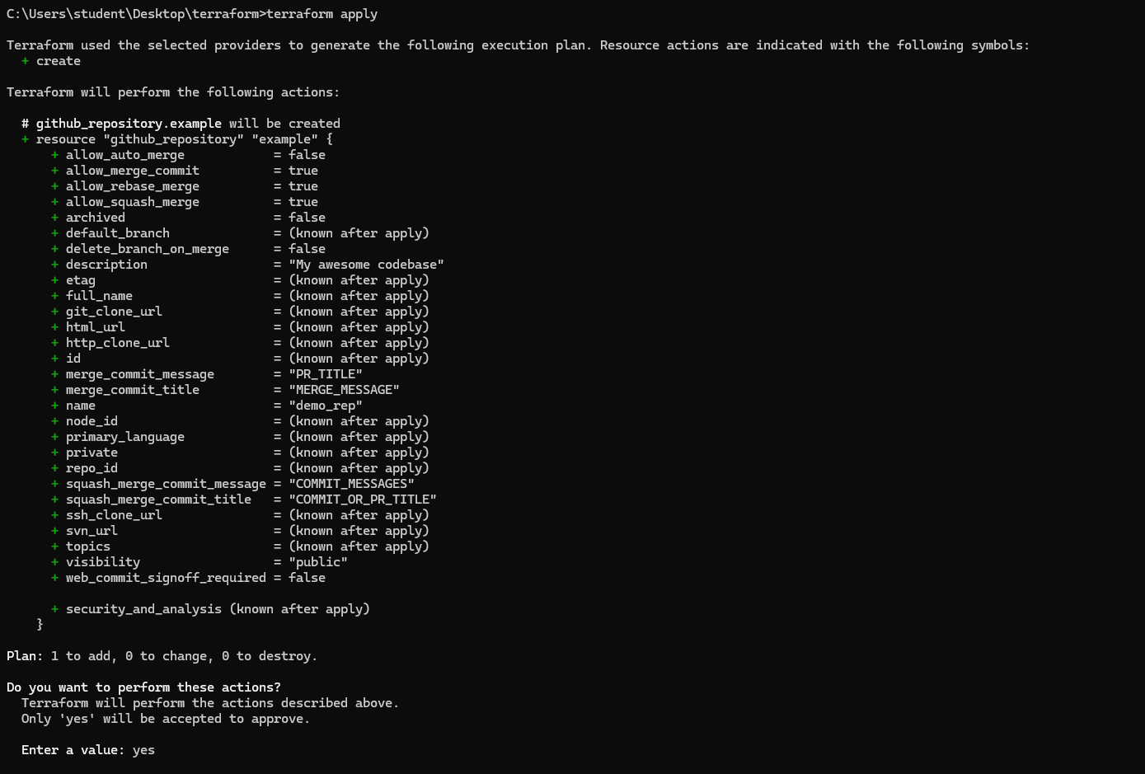

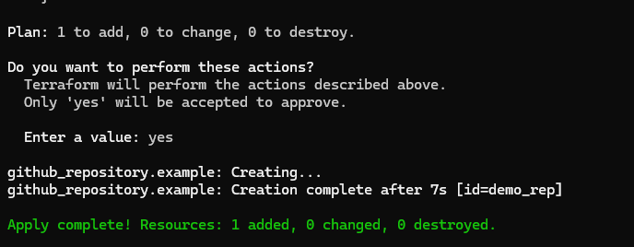

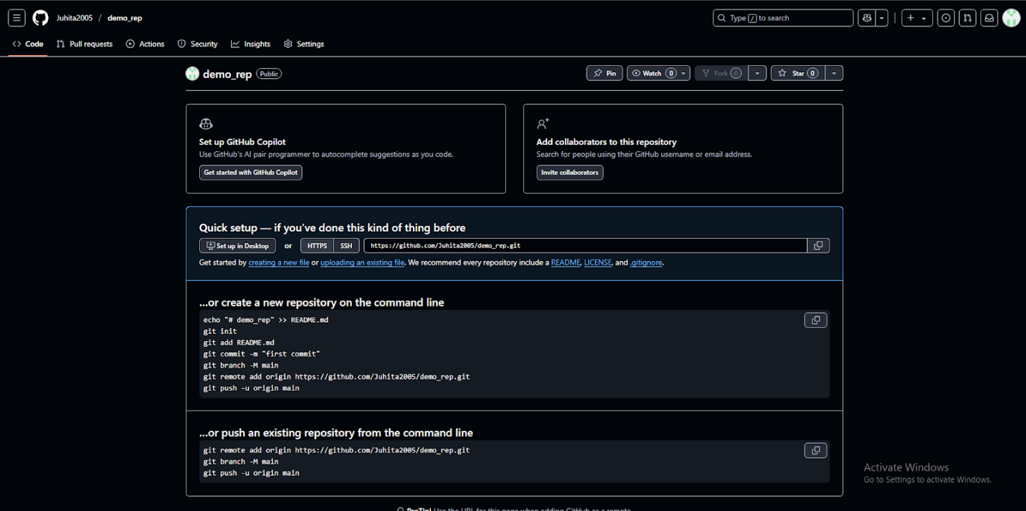

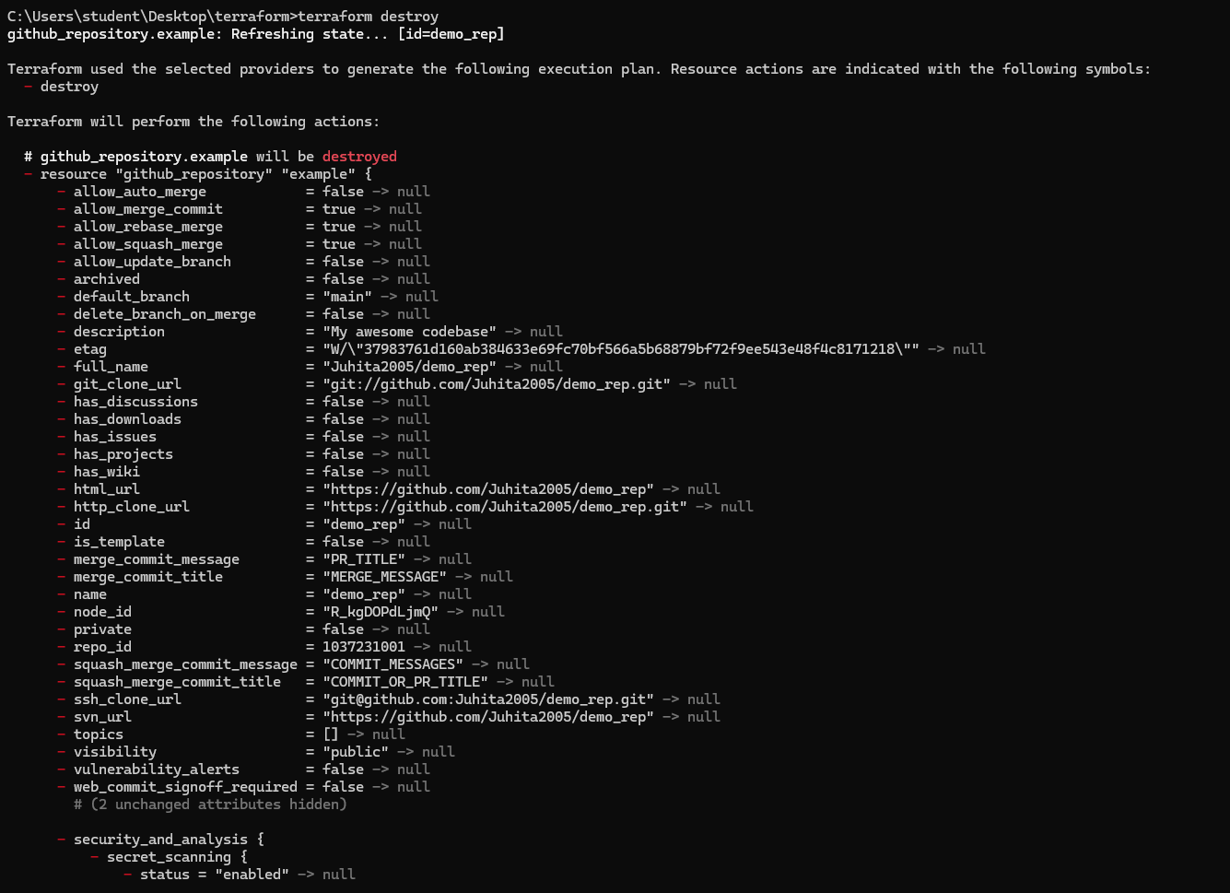

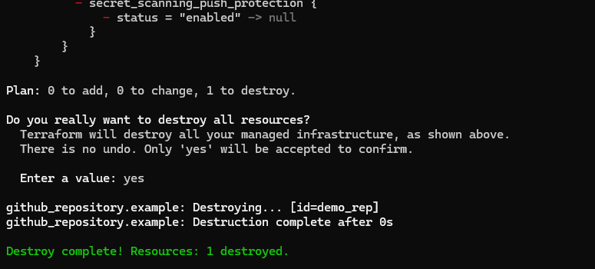

Conclusion :
Terraform is an open-source Infrastructure as Code (IaC) tool developed by HashiCorp. It allows users to define and provision infrastructure resources in a declarative manner using configuration files.

