Experiment no.8
Aim : To understand the Static Analysis SAST process and learn to integrate Jenkins SAST to SonarQube.

Theory :

1. Introduction to Static Application Security Testing (SAST):
Static Application Security Testing (SAST) is a white-box testing technique used to identify vulnerabilities in the source code, bytecode, or binary files of an application without executing theprogram.
It helps developers detect security flaws early in the Software Development Life Cycle (SDLC) — typically during the coding phase — thus saving time, effort, and cost compared to fixing vulnerabilities after deployment.

2. Working Principle of SAST:
- The SAST tool scans the source code or compiled code of an application.
- It analyzes data flows, control flows, and dependencies to find issues such as:
  - SQL Injection
  - Cross-Site Scripting (XSS)
  - Buffer Overflows
  - Hard-coded passwords or secrets
  - Unvalidated inputs and insecure APIs
- The tool then provides reports with line numbers, severity levels, and remediation suggestions.

3. Advantages of SAST:
- Detects security flaws early in development.
- Does not require running the application (can test incomplete code).
- Integrates easily with CI/CD pipelines for continuous security checks.
- Improves code quality and adherence to secure coding standards.

4. SonarQube for Static Analysis:
SonarQube is an open-source platform used for continuous inspection of code quality. It performs static code analysis to detect:
- Bugs
- Code smells (poor design choices)
- Vulnerabilities and security hotspots
SonarQube supports multiple programming languages such as Java, C++, Python, JavaScript, PHP, and more. It provides a dashboard that visualizes code quality metrics, coverage, and risk areas, helping teams maintain clean and secure codebases.

5. Jenkins Integration with SonarQube (SAST Integration):
Jenkins, a popular Continuous Integration (CI) tool, can be used to automate the SAST process by integrating it with SonarQube.
Steps involved:
- Install and Configure SonarQube:
  - Set up the SonarQube server.
  - Generate an authentication token for Jenkins.
- Install SonarQube Plugin in Jenkins:
  - Go to Manage Jenkins → Plugins → Available Plugins → SonarQube Scanner.
- Configure SonarQube in Jenkins:
  - Add SonarQube server details and token under Manage Jenkins → Configure System.
- Set Up Jenkins Pipeline/Job:
  - Add a build step: “Execute SonarQube Scanner.”
  - Define the sonar-project.properties file in your project repository.
- Run the Build:
  - Jenkins will trigger SonarQube analysis during each build.
  - The analysis report is uploaded to the SonarQube dashboard automatically.

6. Benefits of Jenkins–SonarQube Integration:
- Enables automated static analysis in CI/CD pipelines.
- Provides real-time feedback to developers about code security and quality.
- Helps enforce secure coding practices and compliance.
- Reduces manual effort and ensures consistent quality checks across builds.

Procedure:
Step 1 :- Go To https://www.sonarsource.com/products/sonarqube/downloads and download Community Editions.
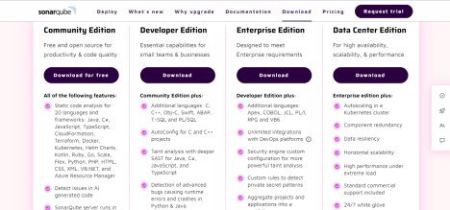
Step 2 :- Now Go To bin/windows-x86-64 and start StartSonar
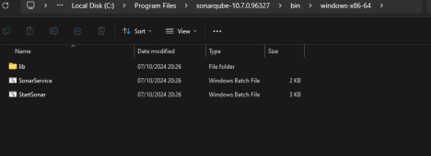

Step 3 :- You Will See Process Is Up & Sonarqube Is Operational

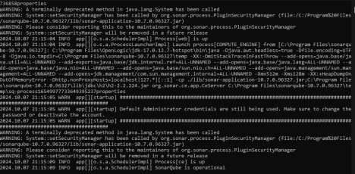

Step 4:- Go to http://localhost:9000 and login to Sonarqube
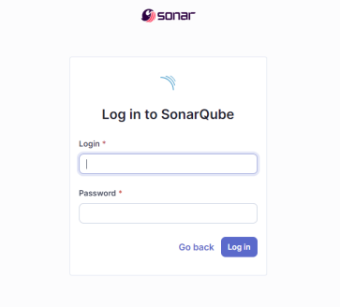Step 5 :- Create A Local Project.

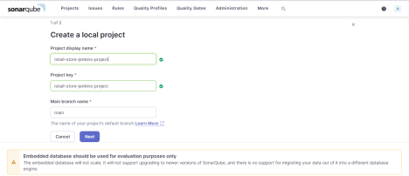

Step 6 :- Choose Global Setting As Baseline

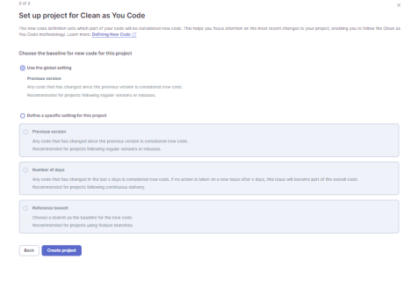

Step 7 :- Now Select Analysis Method As Locally

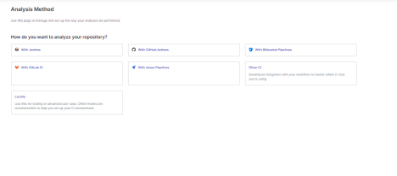

Step 8 :- Generate Token

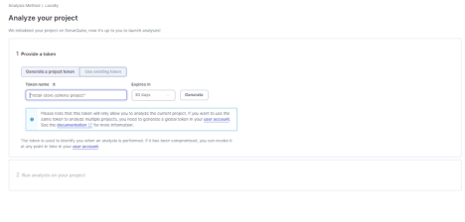

Step 9 :- After Generating Token Continue

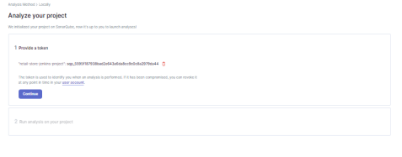

Step 10 :- Now In Jenkins Go To Manage Jenkins/Credential :-

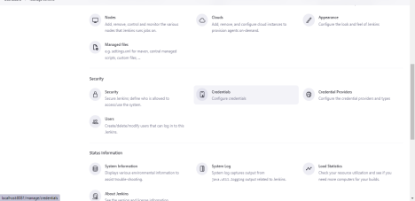

Step 11 :- Now Go To Add Credential

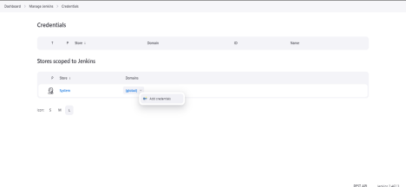

Step 12 :- Now Select “Kind” as Secret Text and Enter Your Token

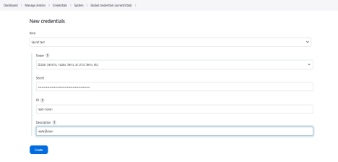

Step 13 :- Now You can see that Your Credential Is Created

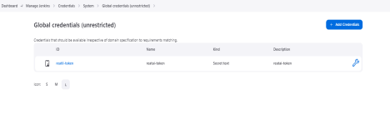

Step 14 :- Go To Manage Jenkins/System/Sonarqube Server

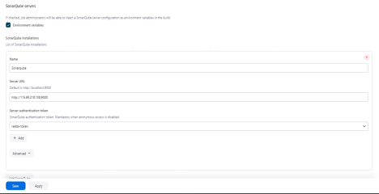

Step 15 :- Create A New Project
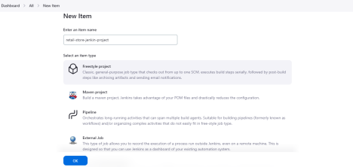
Step 16 :- Add Your Git Repository

Step 17 :- In Build Environment Selecet Prepare Sonarqube Scanner Environment and enter your Token

Step 18 :- In Execute Sonar Scanner Add Your Analysis Properties
Step 19 :- Click On Build Now

Step 20 :- Console Output

Conclusion :
Integrating Jenkins with SonarQube allows organizations to automate the SAST process, ensuring that every code commit is checked for vulnerabilities and quality issues. This integration forms an essential part of DevSecOps, embedding security directly into the software development and delivery pipeline.

