Experiment no.9
Aim : Create a Jenkins CICD Pipeline with SonarQube to perform a static analysis of the code to detect bugs, code smells, and security vulnerabilities on a sample Web / Java / Python application.

Theory :

1. Introduction to CI/CD:
Continuous Integration (CI) and Continuous Deployment (CD) are key practices of modern DevOps workflows.
They help automate the process of:
- Building code
- Running tests
- Analyzing quality
- Deploying applications efficiently and consistently
Jenkins is one of the most popular open-source automation servers used to build CI/CD pipelines.
It helps integrate multiple tools like SonarQube, Git, Maven, Docker, and Kubernetes to automate the software development lifecycle.

2. Continuous Integration (CI):
Continuous Integration focuses on merging code frequently into a shared repository, where each integration triggers an automated build and test process.
This helps detect integration errors early and ensures that the codebase remains stable.

3. Continuous Deployment (CD):
Continuous Deployment automates the release process by automatically deploying verified builds to staging or production environments, reducing manual effort and human error.

4. Introduction to Jenkins:
Jenkins is an open-source CI/CD automation tool written in Java. It provides:
- Automation for building, testing, and deploying code
- Integration with hundreds of plugins (like SonarQube, Git, Docker, etc.)
- Pipeline-as-Code feature through Jenkinsfile
- Web interface for managing jobs and monitoring builds

5. Introduction to SonarQube:
SonarQube is an open-source platform used for static code analysis.
It helps developers identify:
- Bugs – Logic or functional errors
- Code Smells – Maintainability or readability issues
- Security Vulnerabilities – Potential threats or unsafe coding practices
SonarQube supports multiple languages such as Java, Python, JavaScript, C++, PHP, etc., and provides a dashboard to visualize metrics like code coverage, duplications, and maintainability.

6. Static Code Analysis (SAST):
Static Application Security Testing (SAST) is the process of analyzing source code without executing it to detect:
- Security flaws
- Bad coding practices
- Performance and reliability issues
SonarQube performs SAST by scanning the codebase and reporting:
- Bugs → Functional errors
- Code Smells → Poor design/maintenance issues
- Vulnerabilities → Potential security risks

7. Jenkins–SonarQube Integration:
Integrating SonarQube with Jenkins enables automated static code analysis during every CI/CD build.
This ensures that only high-quality and secure code moves forward in the pipeline.
8. Advantages of Jenkins–SonarQube Integration:
- Ensures code quality and security automatically
- Detects bugs and vulnerabilities before deployment
- Enforces coding standards and best practices
- Provides visual reports and metrics for management
- Supports multi-language projects in one platform
Procedure:
1) Create a local project on the localhost dashboard
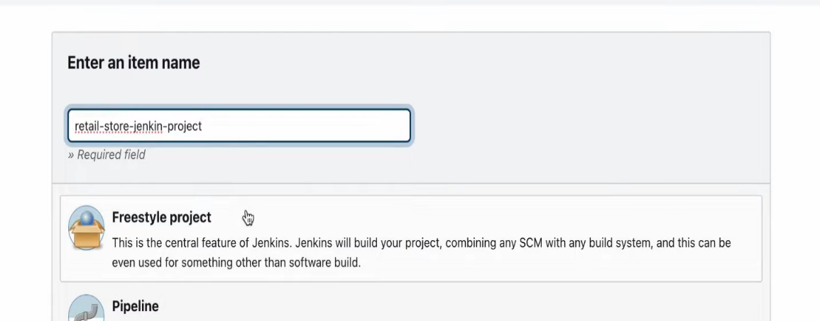

2) Create a folder with the same name as project name in Cdrive and save the
sample code to test
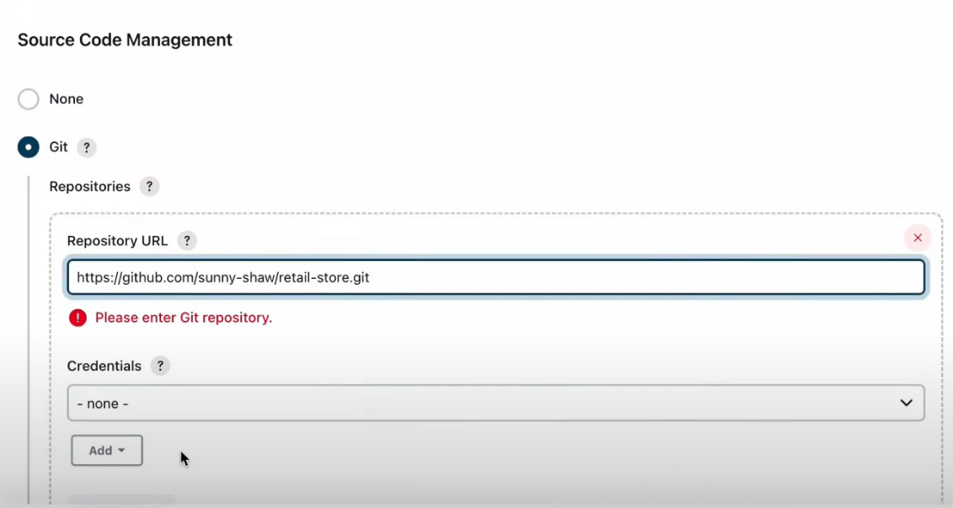

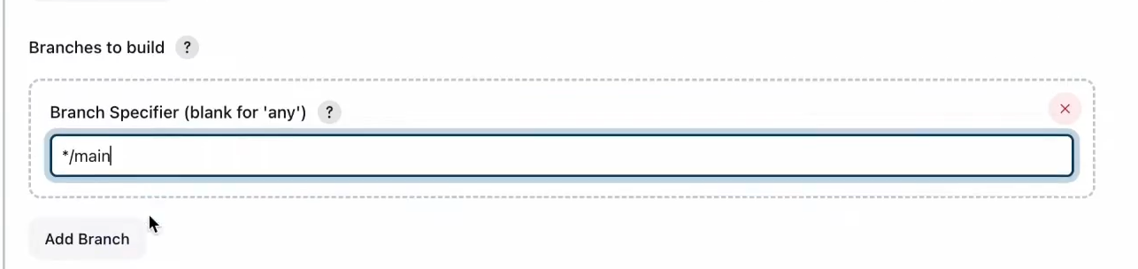
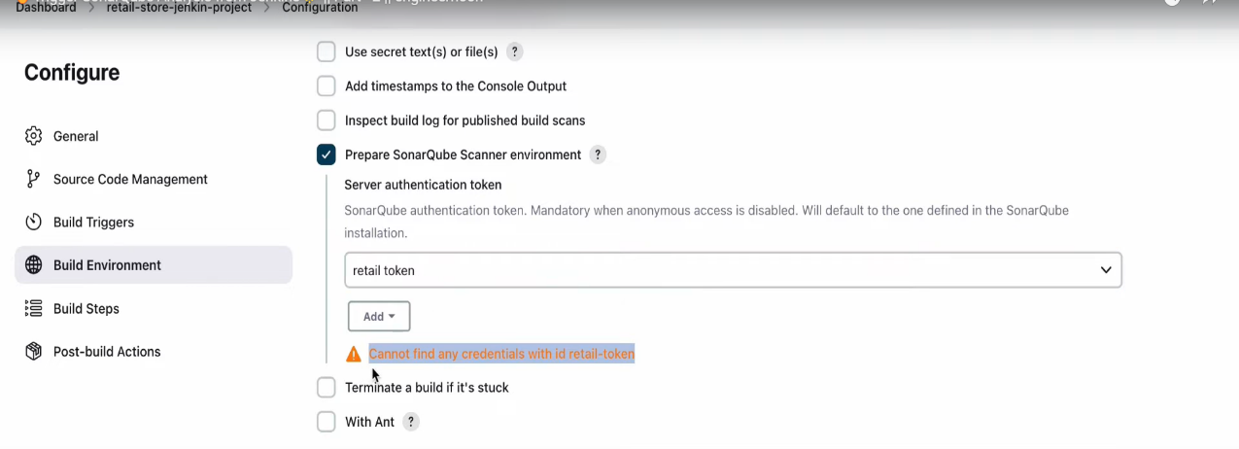

3) Navigate to the same folder on cmd and run
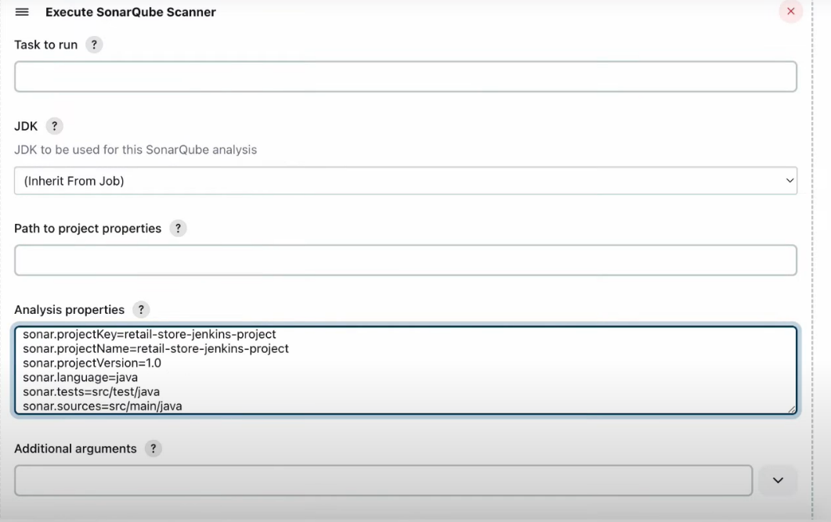
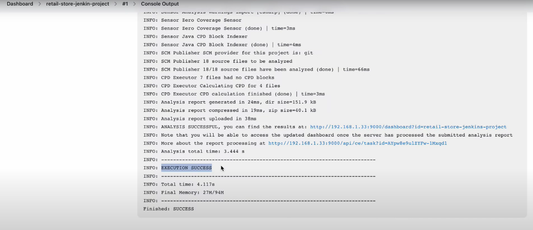

4) Report will be available on the Dashboard.
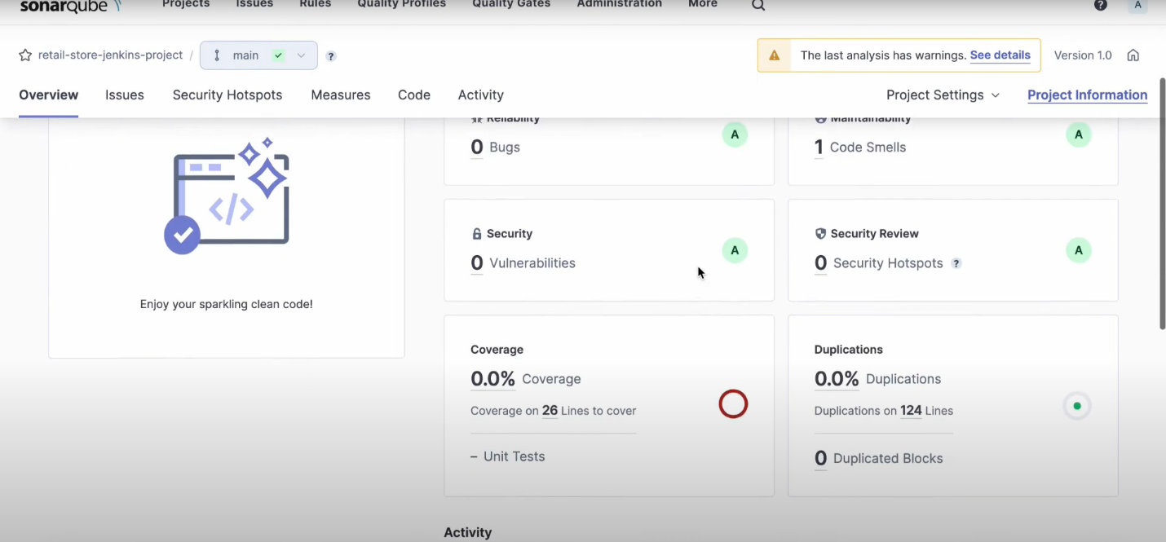
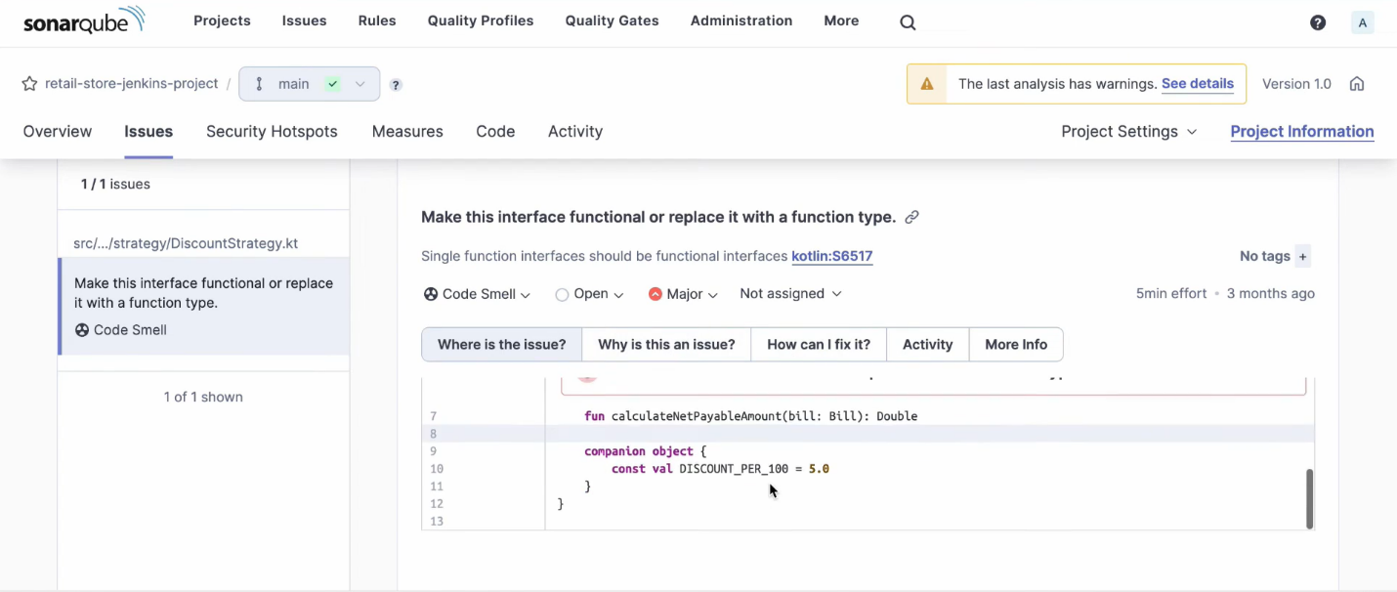

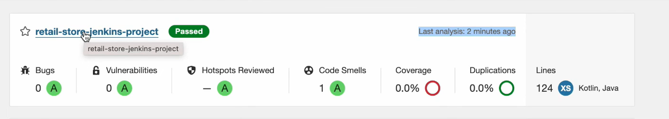

Conclusion :
Integrating SonarQube with Jenkins CI/CD enables continuous and automated static analysis of source code.
This helps developers maintain high code quality, detect security vulnerabilities early, and ensure that only clean, secure, and production-ready code is deployed.
Such automation forms a critical part of DevSecOps, embedding security and quality checks directly into the development pipeline.

